2024

Alireza Moghaddam

Centennial College

3/5/2024

COMP392 – MIDTERM EXAM



**Centennial College**

**Advanced Graphics – COMP392**

**Midterm Exam**

**Required Time: 110 Minutes**

**Question One**: **(25 Marks)**

Draw two squares on the center of the screen, i.e. (0,0).

**Note:** Squares must have the same dimensions = 0.25, but two distinct colors.

**Question Two: (35 Marks)**

Make two squares rotate in-place in different directions, i.e. one rotates clockwise and the other rotates counter clockwise.

**Question Three:** **(35 Marks)**

Make the two rotating squares move away from the center of the screen as they are rotating, until they have reached to (0.5, -0.5) and (-0.5, 0.5), respectively as illustrated below. Once they have reached to these points, the simulation will stop, i.e. none of the squares moves nor rotates.

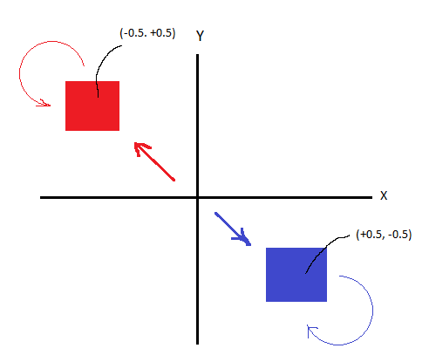

**Correct Submission:** **(5 Marks)**

You will need to submit the two files:

1 – ONLY the cpp file that you have developed. So, do NOT zip your project folder.

2 – A recording from your screen as the squares are rotating and moving toward the center and stop.