**Advanced Graphics**

**Lab Four**

**Due date:** Feb. 19 @ 11:59 PM

For this lab, we are going to implement a square that performs two types of rotations **AT THE SAME TIME** as follows:

1. Rotation about an axis that is located on the center of screen and pops out of the screen
2. Spin about an axis that is located on the center of the square and pops out of the screen

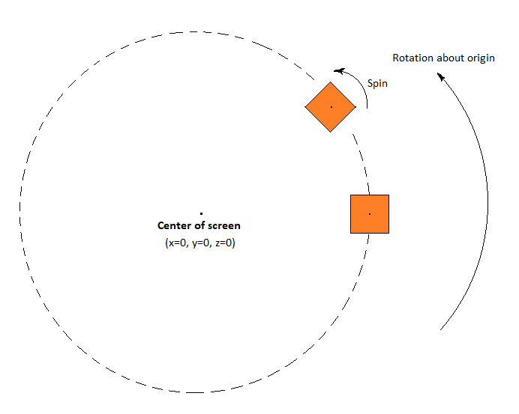

It looks like the earth that rotates around the sun and spins about its own axis. In future, when you learn texture mapping, you will be able to use this technique and simulate the solar system 😉

**Terminology:**

The axes located on the middle of the screen is called “**Global Axes” 😊**

The axes located on the middle of the square is called **“Local Axes” 😊**

**Submission:**

* Take three screenshots from your screen during the rotation to demonstrate your work
* ONLY submit your .cpp file and your screenshot through blackboard before the deadline
* No BB submission before the deadline will receive zero grade