**Hands-On TEST 1 – Friday 3 Nov 2023**

Student: ______________________

**Be sure to read the following general instructions carefully:**

* This hands-on test **must be completed individually** by all the students. **DO NOT** give your solution to others, otherwise there will be serious consequences. See College Academic Policy
* Read the project **naming and submission guidelines** on page 2.
* You should **provide the runtime screenshots** of your solution and **submit the project and screenshots through the assignment link on eCentennial**.
* Create a small demo of the work that you did and demonstrate the application features by running it. You can upload the video(not more than 5 mins) oven any streaming service and provide the link in the submission box.

**Exercise #1**

Create an Android app that allows users to select exercises which help people to challenge their brain. The first activity simply displays the **logo** and an **image button**. The user should click on the image button to display the second activity. The second activity allows the user to select the types of exercises as shown in the picture below. It uses a set of **check boxes** **or** **radio buttons** to allow the user to select which exercises he/she wants.

**Use check boxes** (picture in the middle) **if your first name starts with a letter from A-N inclusive, otherwise, use RadioButton controls** (picture on the right). When user clicks on the button **Next**, the activity should display the selected type(s) of exercises in a **Toast** message.

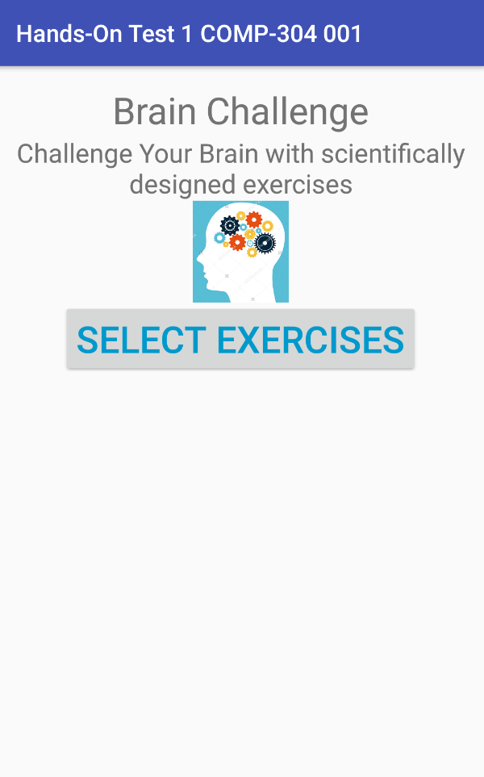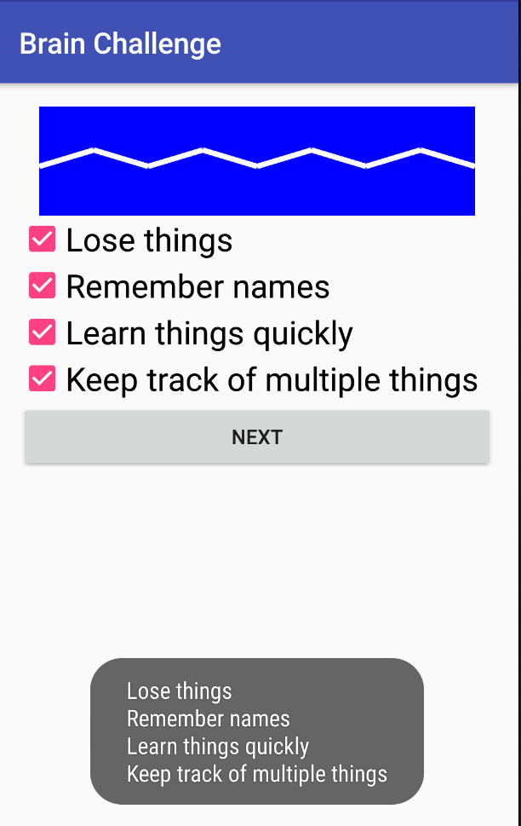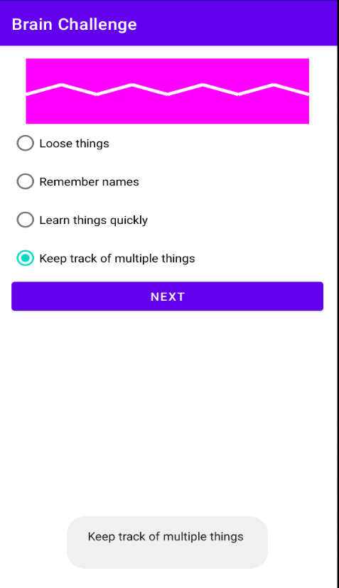

(100 marks)

**Evaluation:**

|  |  |
| --- | --- |
| **Functionality**: |  |
| Main activity (**UI** and **event handling**) | 30% |
| Second activity (**UI**, **event handling,** **drawing/images**) | 20%, 20%, 15% |
| Using ***strings.xml*** to define the resources | 5% |
| **UI friendliness**: | 10% |
| **Total**: | 100% |

**Android Project Naming rules:**

1. You must name your **Android Studio project** according to the following rule:

YourFullName_COMP304_001_Hands-On_Test1_F20

Example: JohnSmith_COMP304_001_Hands-On_Test1_F20

1. **Package name** must be **com.yourfirstname.yourlastname**, for example: com.john.smith
2. **Main activity** should be named: YourFirstNameActivity, for example: JohnActivity.
3. The **second activity** should be named YourLastNameActivity, for example: SmithActivity
4. Provide your **student number as a comment** at the top of each activity

**Submission rules:**

1. Archive your project in a **zip file** named according to the following rule:

**YourFullName_ COMP304_001_Hands-On_Test1_F20.zip**

Example: **JohnSmith_ COMP304_001_Hands-On_Test1_F20.zip**

1. **Use Android Studio Export to zip feature to zip your projects** (File/Manage IDE Settings/Export to Zip file)
2. Upload the project through the assignment link on **eCentennial**.