Mapping Studio (V2) on Google Cloud Run
User & Deployment Manual
Version 0.2 • 2026-01-04

Purpose: A screenshot-driven guide for deploying the Streamlit Mapping Studio to Cloud Run and using it end-to-end (upload → map → validate → export).

Contents
- What this demo is
- Deploying to Cloud Run from the Google Cloud Console (buildpacks, no Dockerfile)
- Using Mapping Studio (V2): end-to-end workflow
- Operating & troubleshooting (logs, auth, scaling)
- Next upgrades (persistent storage with Cloud Storage)

1. What this demo is
Mapping Studio (V2) is a Streamlit web app that turns messy spreadsheets into clean, canonical outputs via a replayable, artifact-driven workflow. In the current demo mode, artifacts and uploads are stored on the Cloud Run instance filesystem (typically under /tmp).
For a durable cloud-native version, the same artifacts should be stored in Cloud Storage (GCS). This manual covers both: the fast Console deployment and the recommended persistence upgrade.

2. Deploying to Cloud Run from the Google Cloud Console (buildpacks, no Dockerfile)
This deployment method uses Google Cloud’s buildpacks (Cloud Build builds a container automatically).

2.1 Prerequisites
1. A Google Cloud project with billing enabled.
2. Cloud Run API and Cloud Build API enabled (Console will offer to enable them if needed).
3. A GitHub repository connected to Cloud Run (or source uploaded via Console).
4. A reliable way for buildpacks to install Python dependencies (see the two options below).

2.2 Two ways to make buildpacks start Streamlit
Cloud Run buildpacks need (a) dependency installation and (b) a start command that binds to the injected $PORT on 0.0.0.0.
- Option A (recommended): add files at repo root
- requirements.txt that points to the demo requirements file:
-r demos/requirements-demo.txt
- Procfile that starts Streamlit correctly:
web: streamlit run demos/streamlit_mapping_studio.py --server.address=0.0.0.0 --server.port=$PORT --server.headless=true
With Option A, you can usually leave Entrypoint blank in the Console because the Procfile defines how to start the service.
- Option B (quick & dirty): set Entrypoint to install deps and start Streamlit
Use this when you don’t want to add requirements.txt/Procfile yet. In the Cloud Run Console, set Entrypoint to a shell command that first installs dependencies and then starts Streamlit.
bash -lc "pip install -r demos/requirements-demo.txt && streamlit run demos/streamlit_mapping_studio.py --server.address=0.0.0.0 --server.port=$PORT --server.headless=true"

2.3 Console deployment steps
Step 1: Open Google Cloud Console → Cloud Run → Create service.
Step 2: Choose deployment from a source repository (connect GitHub and select repo + branch).
Step 3: Build type: Python (buildpacks).
Step 4: Build context directory: / (repo root) unless you intentionally deploy from a subfolder.
Step 5: Entrypoint: use Option A (leave empty) or Option B (set to the bash command above).
Step 6: Function target: leave empty (only for function deployments).
Step 7: Region: choose a region close to you (example: europe-west1).
Step 8: Authentication: for a demo link, allow unauthenticated; otherwise keep it private and grant Invoker to specific users/groups.
Step 9: Click Deploy and wait for the new revision to become Ready.

2.4 Recommended Cloud Run settings for demo mode (local /tmp storage)
• Environment variables: ARTIFACTS_ROOT=/tmp/artifacts and UPLOADS_DIR=/tmp/uploads (or equivalent values your app reads).
• Autoscaling: set Maximum instances = 1 to avoid split-brain state across instances.
• Resources: start with 1 CPU and 1–2 GiB memory (Excel parsing can spike).
• Optional for live demos: set Minimum instances = 1 so the app stays warm (turn off afterwards to save cost).

3. Using Mapping Studio (V2): end-to-end workflow
This section walks through the UI flow as captured in the screenshots (Figures 1–5).
Figure 1. Runs Dashboard and Evidence Preview for a new run (upload → run created).
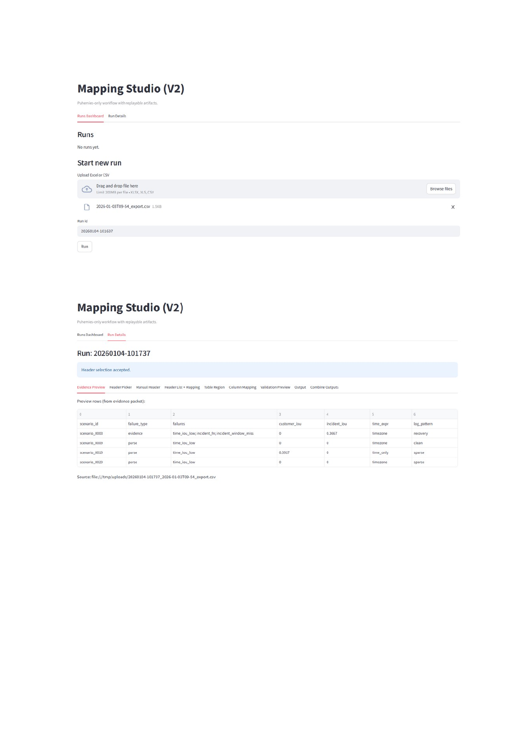

Figure 2. Header Picker (auto-detected candidates) and Manual Header override.
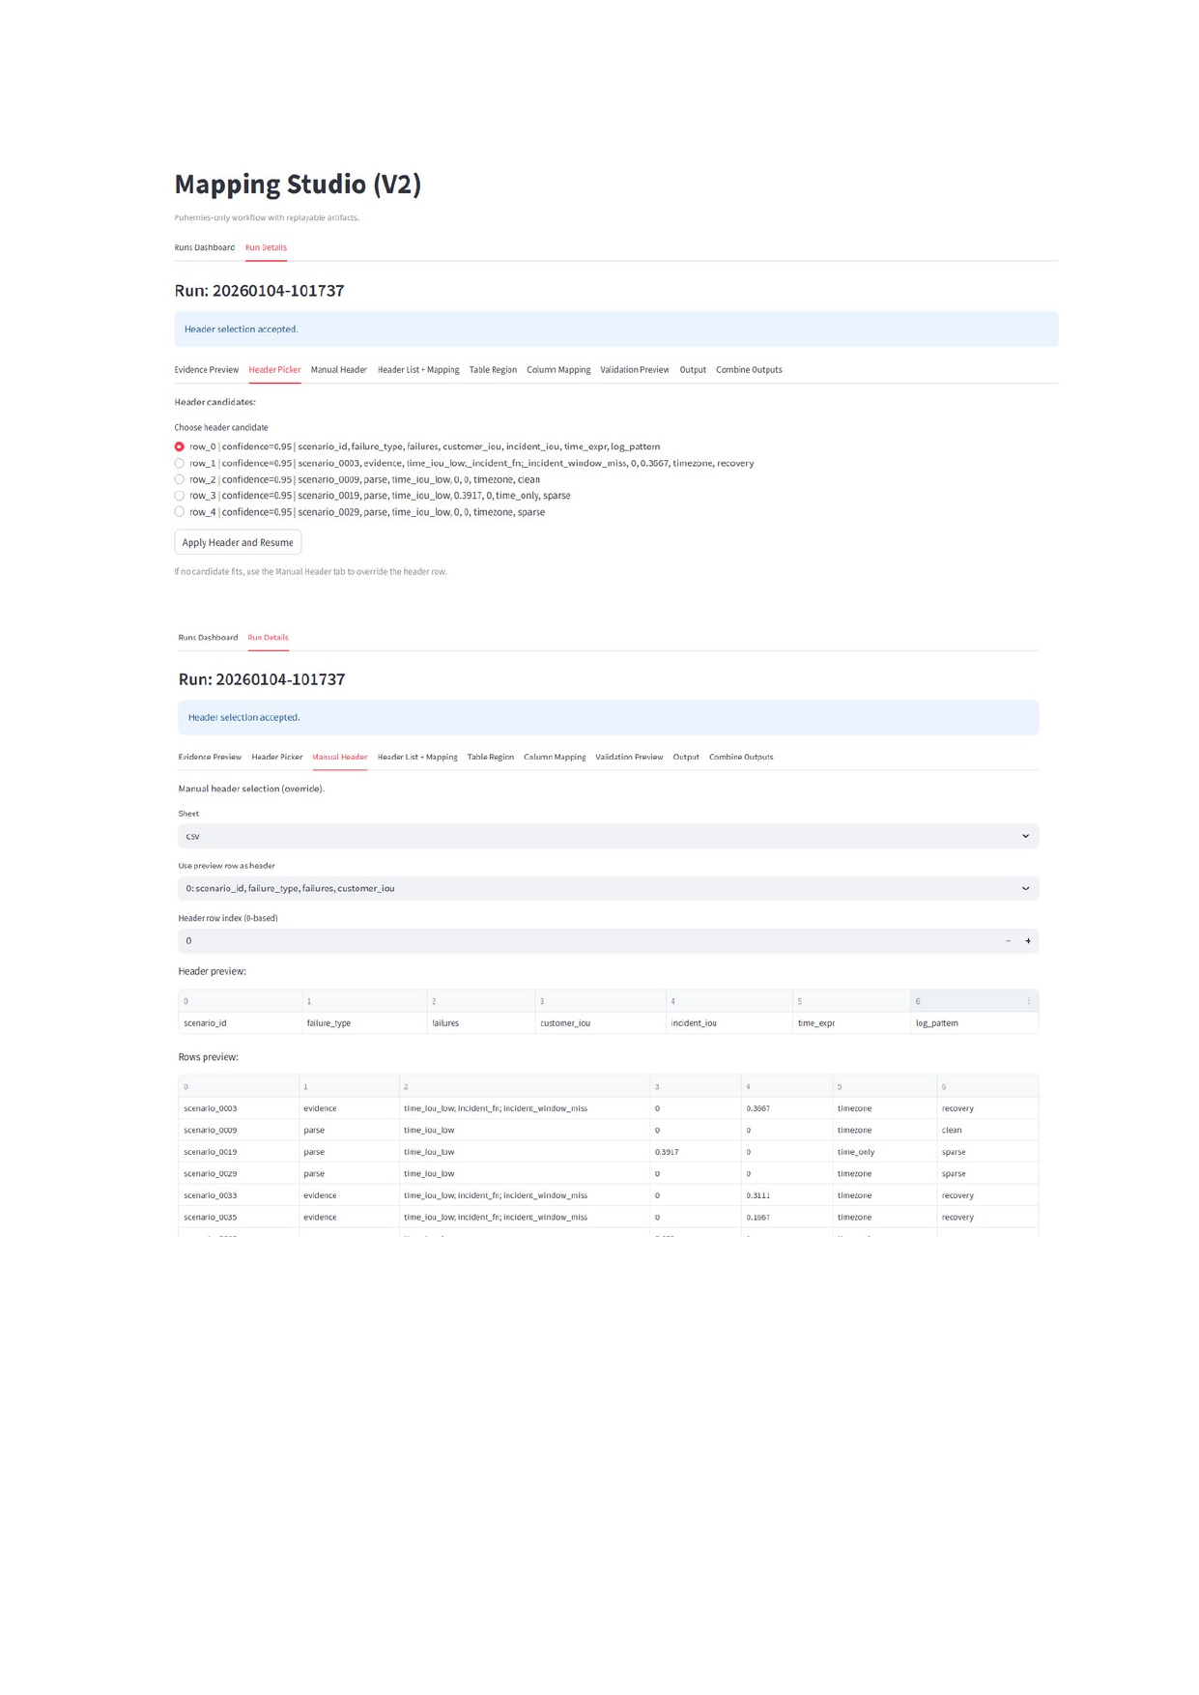

Figure 3. Header List + Mapping, then Table Region selection (optional).
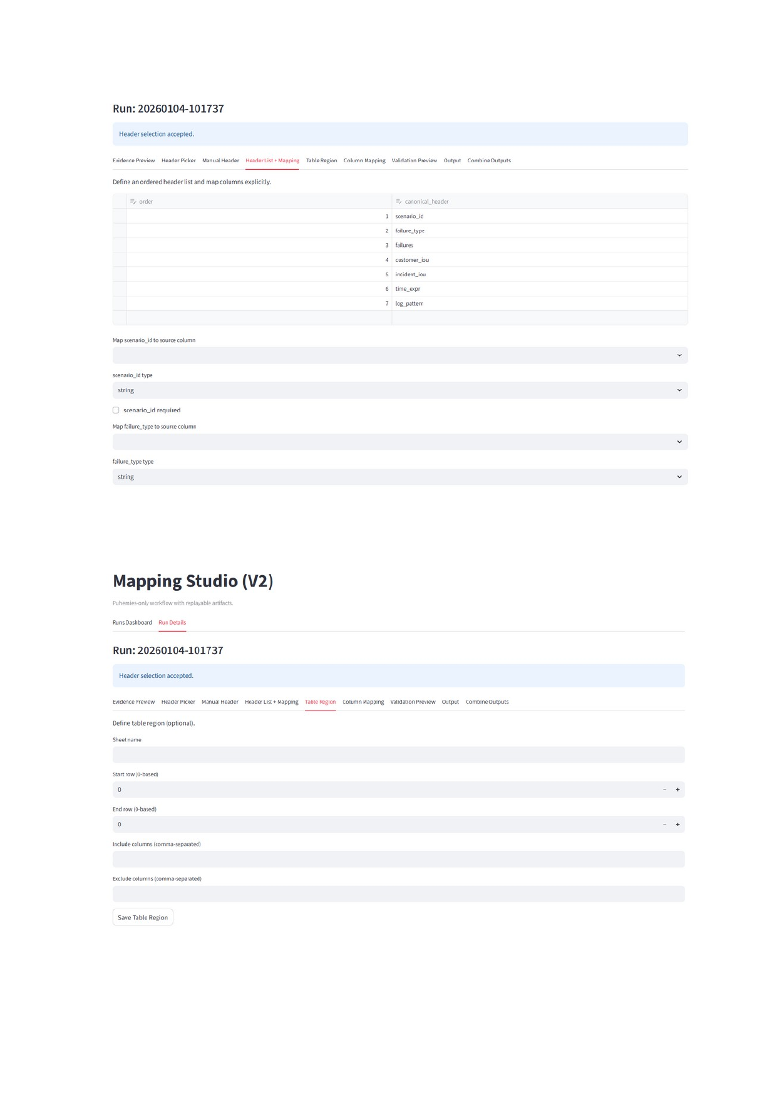

Figure 4. Column Mapping and Validation Preview.
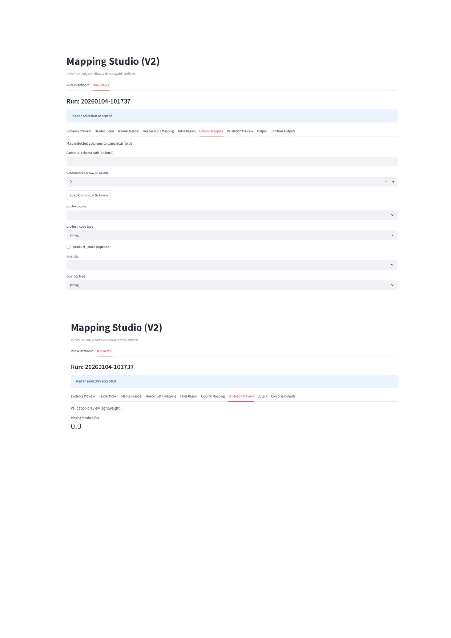

Figure 5. Output tab showing generated clean CSV and download action.
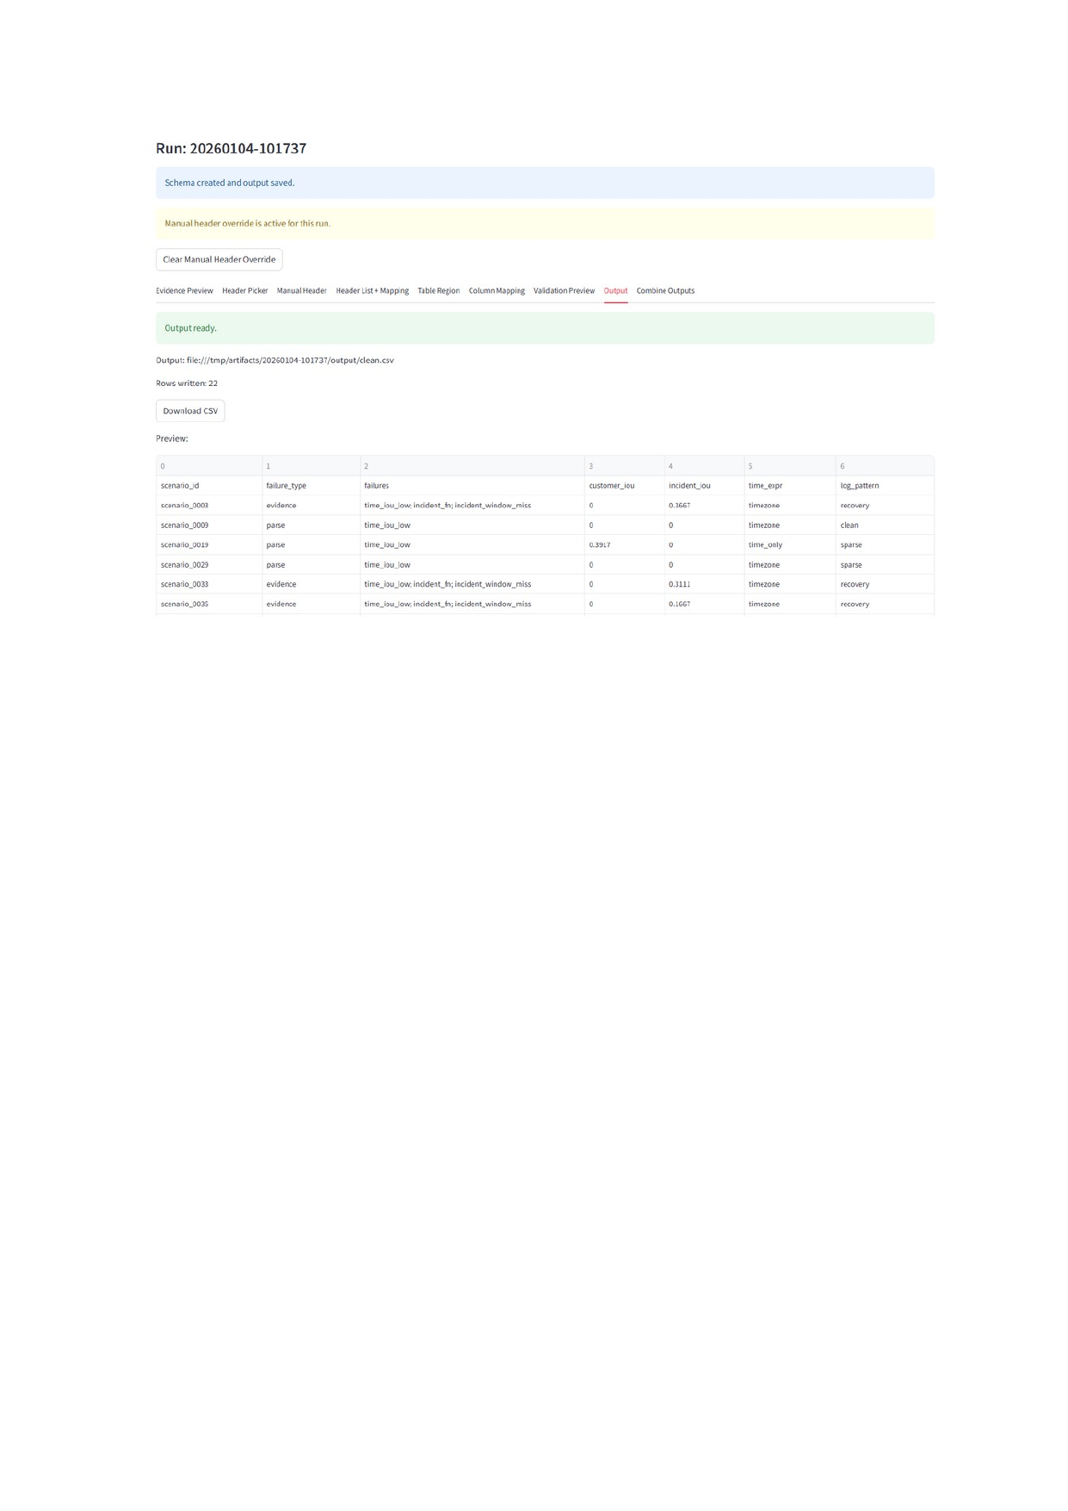

3.1 Start a run
1. Open the Runs Dashboard.
2. Upload an Excel or CSV file.
3. Confirm/enter a Run ID (use a timestamp-based ID for easy sorting).
4. Click Run to create the run artifacts and open Run Details.

3.2 Select the correct header
If the source file has a clean header row, the Header Picker usually detects it. If the header is shifted or malformed, use Manual Header to override the chosen header row.
1. Header Picker: choose the best candidate row and click Apply Header and Resume.
2. Manual Header (override): select sheet (if applicable), pick the preview row as header, set header row index, and confirm the preview looks correct.
3. Proceed only when the header preview matches the columns you expect.

3.3 Map columns to canonical fields
Mapping Studio converts source columns into a canonical schema. The goal is explicit, reproducible mapping.
1. Header List + Mapping: define the ordered header list and map each canonical field to the corresponding source column.
2. Table Region (optional): restrict parsing to a specific row range or include/exclude columns when the sheet contains extra noise.
3. Column Mapping: assign each canonical field a source column and a type (string, number, etc.). Mark required fields if your pipeline enforces them.

3.4 Validate and export
1. Validation Preview: review missing required %, type issues, or other lightweight checks.
2. Output: generate the cleaned output. Use Download to save the resulting CSV/Excel (depending on your app settings).
3. Combine Outputs (if available): merge multiple outputs when you have multiple tables/sheets or multiple runs.

4. Operating & troubleshooting

4.1 Checking logs
Cloud Run → your service → Logs. You should see Streamlit startup messages and your app’s own log lines. When diagnosing issues, look for: missing dependencies, import errors, and port binding problems.

4.2 Authentication and Invoker
If the service is public (unauthenticated), anyone with the URL can access it. If the service is private, users must have the Cloud Run Invoker role for the service.
Common fix for private services:
- Cloud Run → Service → Permissions → Add principal → grant Cloud Run Invoker.

4.3 Common startup failures
• Service deploys but returns 404: start command points to the wrong app. Fix by starting the correct Streamlit entry file.
• Container failed to start and listen on the port: Streamlit is still using default 8501 or bound to 127.0.0.1. Ensure --server.port=$PORT and --server.address=0.0.0.0.
• Runs disappear after a while: Cloud Run instance restarted or scaled to zero; /tmp was cleared. Use Cloud Storage for persistence.

5. Next upgrades (persistent storage with Cloud Storage)
For a durable demo, store run artifacts and uploads in Cloud Storage (GCS) instead of /tmp. This allows restarts, redeploys, and multi-instance scaling without losing state.
1. Create a Cloud Storage bucket (same region as your Cloud Run service, or multi-region EU).
2. Grant the Cloud Run runtime service account permission to write objects to the bucket (for demo: Storage Object Admin on that bucket).
3. Update the app to use an ArtifactStore abstraction (Local + GCS). Replace local file reads/writes with store.list/store.read/store.write.
4. Switch environment variables: ARTIFACTS_ROOT=gs://<bucket>/artifacts and UPLOADS_ROOT=gs://<bucket>/uploads.
5. After this, you can increase Max instances beyond 1 safely.
Appendix: PowerShell quick checks
curl.exe -i "https://<your-cloud-run-url>/"
$TOKEN = gcloud auth print-identity-token
curl.exe -i -H "Authorization: Bearer $TOKEN" "https://<your-cloud-run-url>/"
gcloud run services get-iam-policy <service-name> --region <region> --format json

