题目：

**从键盘读入一个字符串，把它存入一个链表（每个结点存储1个字符），并按相反的次序将字符串输出到显示屏**。

代码：

#include<stdio.h>

#include<stdlib.h>

#include<malloc.h>

#include<string.h>

typedef struct word

{

char c;

struct word* front;//指向前一个结点

struct word* next;//指向后一个结点

}word;

int main()

{

char a[100];

scanf("%s", &a);

int n = strlen(a);

int i = 0;

word* phead = (word*)malloc(sizeof(word));

if (phead == NULL)

{

printf("error\n");

exit(-1);

}

phead->front = NULL;

phead->next = NULL;

word* ptmp = phead;

word* ptail = phead;

for (i = 0; i < n; i++)

{

word* pnew = (word*)malloc(sizeof(word));

if (phead == NULL)

{

printf("error\n");

exit(-1);

}

pnew->c = a[i];

ptail->next = pnew;

ptail = pnew;

pnew->front = ptmp;

pnew->next = NULL;

ptmp = pnew;

}

while (ptmp->front != NULL)

{

printf("%c", ptmp->c);

ptmp = ptmp->front;

}

return 0;

}

运行结果：

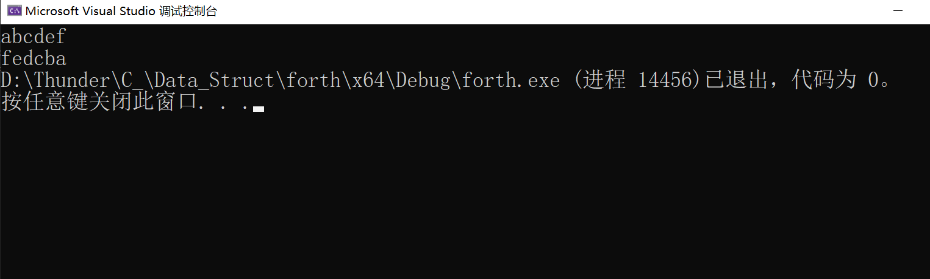

总结：建立双向链表，存储时从链表头部储存，输出时从链表尾部开始遍历输出。