题目：

一堆猴子有m个，编号分别是1，2，3 ...m，这m个猴子按照编号1,2,…,m的顺序围坐一圈，然后从第1开始数，每数到第n个，该猴子就要离开此圈，这样依次下来，直到圈中只剩下最后一只猴子，则该猴子就为大王。

要求：分别采用向量及链表两种存储方式实现该问题的求解，给出一组m和n，输出对应的猴王。

数组：

#include<stdio.h>

void delnode(int*, int, int);

int main()

{

//初始化数组

int m;

printf("m=");

scanf("%d",&m);

int i = 0;//下标0表示第一个位置

int a[50] = { 0 };

for (i = 0; i < m; ++i)

a[i] = 1;

//删除元素

int n;

printf("n=");

scanf("%d",&n);

delnode(a, m, n);

return 0;

}

void delnode(int* a, int m, int n)

{

if (n <= 0)

{

printf("error\n");

return;

}

int total = 0;

int i = -1;

int j = 0;

int temp;

while (total < m)

{

for (j = 0; j < n; ++j)

{

i = (i + 1) % m;

while(!a[i])

i = (i + 1) % m;

}

if (a[i])

{

temp = i + 1;

printf("%d ",temp);

a[i] = 0;

++total;

}

}

return;

}

链表：

#include<stdio.h>

#include<malloc.h>

#include<stdlib.h>

struct monkey

{

int num;

struct monkey* next;

};

struct monkey* creat_list(int);

void delnode(int, int, struct monkey*);

int main()

{

//创建链表

int m;

printf("m=");

scanf("%d", &m);

struct monkey* ptail = creat_list(m);

//删除结点

int n;

printf("n=");

scanf("%d", &n);

delnode(m, n, ptail);

return 0;

}

struct monkey* creat_list(int m)

{

int i = 0;

struct monkey* phead = (struct monkey*)malloc(sizeof(struct monkey));

if (phead == NULL)

{

printf("分配结点失败！\n");

exit(-1);

}

phead->next = NULL;

struct monkey* ptail = phead;

for (i = 1; i <= m; ++i)

{

struct monkey* pnew = (struct monkey*)malloc(sizeof(struct monkey));

if (pnew == NULL)

{

printf("分配结点失败！\n");

exit(-1);

}

pnew->num = i;

pnew->next = NULL;

ptail->next = pnew;

ptail = pnew;

}

ptail->next = phead->next;

return (ptail);//返回的是最后一个结点

}

void delnode(int m, int n, struct monkey* ptail)

{

if (n <= 0)

{

printf("error\n");

return;

}

int i = 1;

int total = 0;

struct monkey* ptemp = (struct monkey*)malloc(sizeof(struct monkey));

while (total != m)

{

for (i = 1; i <= n; ++i)

{

ptemp = ptail;

ptail = ptail->next;

}

printf("%d ", ptail->num);

ptemp->next = ptail->next;

++total;

}

return;

}

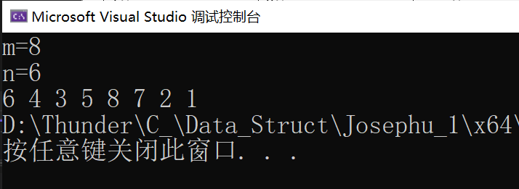

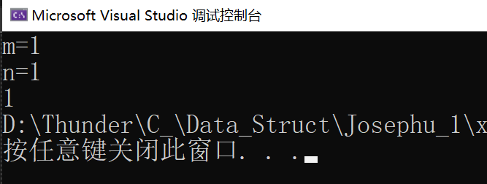

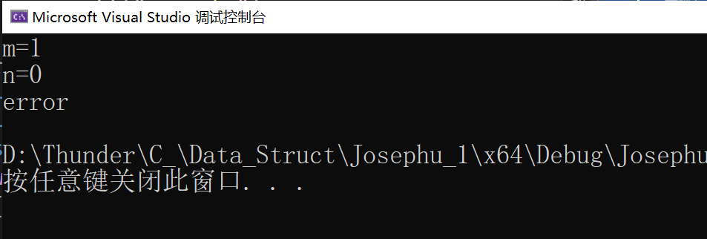

总结：数组方法：利用队头和队尾指针的数学关系，建立循环队列让猴子依次出队即可解决问题。

链表方法：将头节点去掉，建立循环单向链表即可解决问题。