一、实验背景、目的及要求
强化学习属于机器学习的一个分支，其概念在2017年中国浙江乌镇围棋峰会上Alpha Go战胜当时世界排名第一的围棋选手柯洁而被普通大众认识。强化学习就是训练对象如何在环境给予的奖励或惩罚的刺激下，逐步形成对刺激的预期，产生能获得最大利益的习惯性行为，此特性是其在游戏领域发挥巨大作用的重要原因。
该实验将使用基于Value Based策略的Q-Learning强化学习算法实现经典的UC Berkeley CS188项目的Project 3：Reinforcement Learning（项目链接：The Pac-Man Projects。关于Pacman-吃豆人游戏，是20世纪80年代日本南梦宫游戏公司推出的一款街机游戏，后来加州大学伯克利分校（UC Berkeley）将其引进到强化学习的课程中作为实操项目，逐渐成为该领域的经典Project）。
该实验中：Pacman（黄色扇形移动体）作为智能体Agent；游戏中的网格图像布局、静止的“金豆”、随机移动的“Ghost”共同构成环境（Environment）；Pacman和当前Environment所处的状态构成State；Pacman上下左右的平移作为Action；当Pacman吃到“金豆”或者碰触到“Ghost”后得到反馈Reward，并以左下角游戏分数的形式呈现。
实验基于Q-Learning算法，让Pacman（Agent）先自行探索训练2000次。探索训练结束后，重新让Pacman运行10次，测试这10次中Pacman成功吃完屏幕中所有“金豆”的次数，且10次中至少成功8次才算成功。

二、实验设备（环境）及要求（软硬件条件）
硬件：运行在Intel平台上的PC
软件：Ubuntu20.04.2LTS ，Python2.7

- 实验准备、算法实现
- 获取实验中必要的图形界面源文件和定义好的类文件并打开（获取地址），并下载添加mlLearningAgents.py文件到文件夹中，该文件和原文件夹的learningAgents.py文件的代码逻辑存在细微差别，但功能是一样的（以下步骤都指的是mlLearningAgents.py的代码内容）：
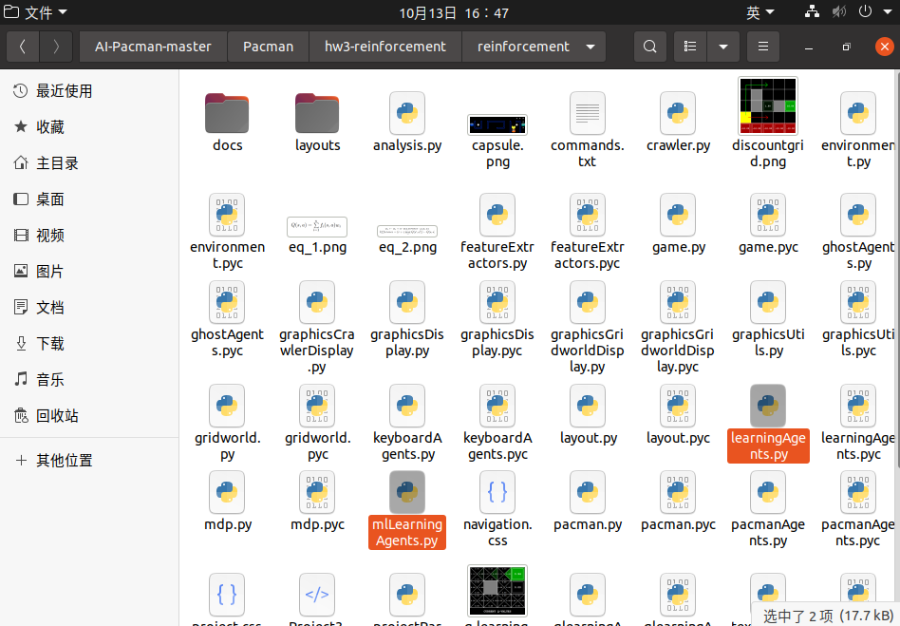
- 用编辑器打开mlLearningAgents.py文件：
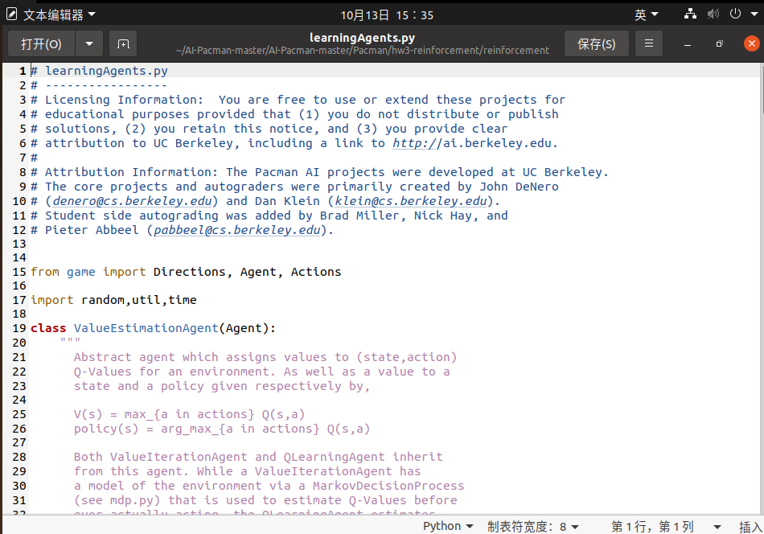
- 设置参数。学习率alpha=0.2，折扣率gamma=0.8，测试次数numTraining=10，探索率epsilon=0.05：
def __init__(self, alpha=0.2, epsilon=0.05, gamma=0.8, numTraining = 10):
# alpha - learning rate
# epsilon - exploration rate
# gamma - discount factor
# numTraining - number of training episodes
# These values are either passed from the command line or are
# set to the default values above. We need to create and set variables for them
self.alpha = float(alpha)
self.epsilon = float(epsilon)
self.gamma = float(gamma)
self.numTraining = int(numTraining)
...
- Q-value表。设置一个用来保存Pacman经历过的状态State、执行的Action以及最终学习产出的Q-value值的Q-value空表：
# Initialize the Qvalue array, the initial Qvalue array is an empty {}
# And fill and update it in the following steps
self.Qvalue = util.Counter()
- 选择Best Move。定义一个Class，在State确认的情况下，先找到最大Q-value值：
#If the state is fixed, loop the all legal actions, return the MaxQvalue
def getMaxQvalue(self, state):
#Get all the legal actions
legal = state.getLegalPacmanActions()
# Remove the Stop
if Directions.STOP in legal:
legal.remove(Directions.STOP)
#The final state is that the program is finished,so it doesn't has the next action
#self.getQvalue can't return Qvalue, it is [], so return 0
if [self.getQvalue(state, action) for action in legal] == []:
return 0
# If it is not final state,just return the max Qvalue in the actions
else:
return max([self.getQvalue(state, action) for action in legal])
...
再找到该Q-value对应的Action：
#Return the best move
def getBestmove(self,state):
legal = state.getLegalPacmanActions()
if Directions.STOP in legal:
legal.remove(Directions.STOP)
#Set the initial bestmove is None
Bestmove = None
#Return the max Qvalue based on state
MaxQvalue = self.getMaxQvalue(state)
for action in legal:
Qvalue = self.getQvalue(state, action)
#Find which action's Qvalue is the max Qvalue, and return this action
if Qvalue == MaxQvalue:
Bestmove = action
else:
continue
return Bestmove
...
- 更新Q-value。用当前的State更新上一步的(State,Action)对应的Q-value：
#According to the Q-learning algorithm, set the Q-learning function
#Becaue I can't know the next state, so I use the current state to replace the next state
#The last state and last action to replace the current state and current action.
#Store the last state by the function:setStateTracker()
#Return the last state by the function:getStateTracker()
def update(self, laststate, lastaction, state, reward):
#Get the last Qvalue based on the laststate and lastaction.
Qvalue_last = self.getQvalue(laststate, lastaction)
#Get the max Qvalue by the function getMaxQvalue based on the current state.
Qvalue_current = self.getMaxQvalue(state)
#The Update algorithm
update = self.alpha * (reward + self.gamma * Qvalue_current - Qvalue_last)
# Update the Qvalue
self.Qvalue[(laststate, lastaction)] += update
...
- 执行Action。将每一步经历的State和采取的Action都保存进对应的Table中。使用项目中现有的Pacman每行动一步Score发生的变化作为Reward，将两个状态变化时Score的差值认为是Reward，这一步可简化大量设置Reward的工作量（设置Reward逻辑的不唯一）：
#Get the action
def getAction(self, state):
legal = state.getLegalPacmanActions()
if Directions.STOP in legal:
legal.remove(Directions.STOP)
# Get the last action
self.lastaction = state.getPacmanState().configuration.direction
# Get the current score
score_current = state.getScore()
# The current reward is that the current score minus the last score
reward = score_current - self.getScoreTracker()
# Store the current score for the next calculation
self.setScoreTracker(score_current)
# Update the Qvalue of last state and last action
self.update(self.getStateTracker(), self.lastaction, state, reward)
# Store the current state for the next calculation
self.setStateTracker(state)
#If it is exploration, just return the random choice
if util.flipCoin(self.epsilon):
print "Legal moves: ", legal
print "Pacman position: ", state.getPacmanPosition()
print "Ghost positions:", state.getGhostPositions()
print "Food locations: "
print state.getFood()
print "Score: ", state.getScore()
return random.choice(legal)
#If it is exploitation, return the best move
else:
print "Legal moves: ", legal
print "Pacman position: ", state.getPacmanPosition()
print "Ghost positions:", state.getGhostPositions()
print "Food locations: "
print state.getFood()
print "Score: ", state.getScore()
return self.getBestmove(state)
...

- 打印训练结束时的message：
def final(self, state):
print "A game just ended!"
# Keep track of the number of games played, and set learning
# parameters to zero when we are done with the pre-set number
# of training episodes
# Get the last action
self.lastaction = state.getPacmanState().configuration.direction
# Get the current score
score_current = state.getScore()
# The current reward is that the current score minus the last score
reward = score_current - self.getScoreTracker()
# Update the Qvalue of last state and last action
self.update(self.getStateTracker(), self.lastaction, state, reward)
if self.getEpisodesSoFar() == self.getNumTraining():
msg = 'Training Done (turning off epsilon and alpha)'
print '%s\n%s' % (msg, '-' * len(msg))
self.setAlpha(0)
self.setEpsilon(0)
...
- 至此，所有的源文件已经准备就绪。

- 实验内容与步骤
- 先测试Pacman游戏能否正常运行，终端输入命令行：python pacman.py
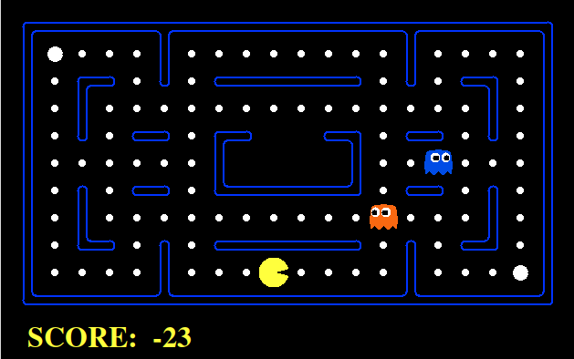
图 1通过电脑键盘的上下左右键，可以指挥Pacman行动
- 在Gridworld上测试代理Agent，可以将它们应用到Pacman上，终端输入：python gridworld.py -m
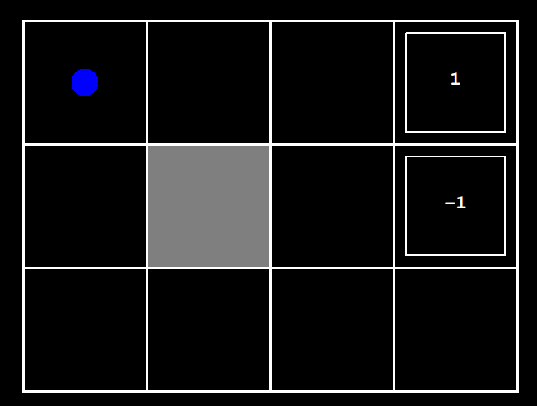
图 2测试智能体Agent
- 检查运行离线规划器（并非强化学习代理），相关的训练选项是它在其初始规划阶段应该运行的价值迭代的迭代次数。终端运行：python gridworld.py -a value -i 5
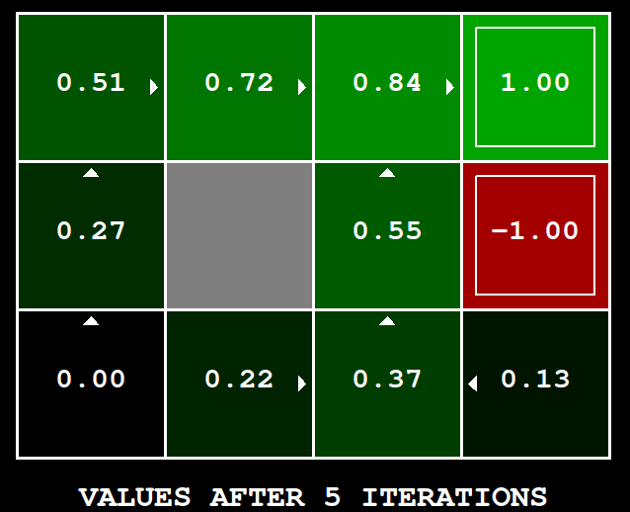
图 3
- 测试Q-Learning agent，它通过与环境的交互来更新State，Action，nextState，Reward，反复试错学习，终端输入：python gridworld.py -a q -k 100
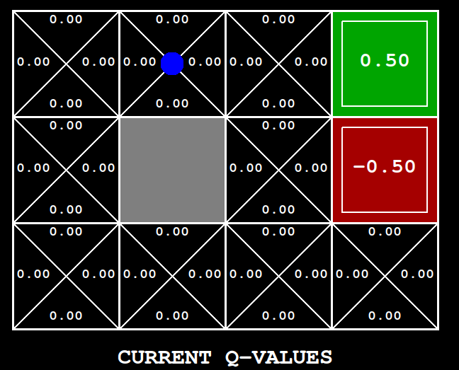
图 4
- 开始训练。选择在smallGrid（界面较小，训练时间短）上训练2000次，测试10次。终端输入：python pacman.py -p QLearnAgent -x 2000 -n 2010 -l smallGrid
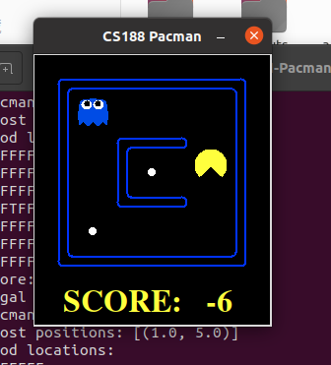
图 5测试过程
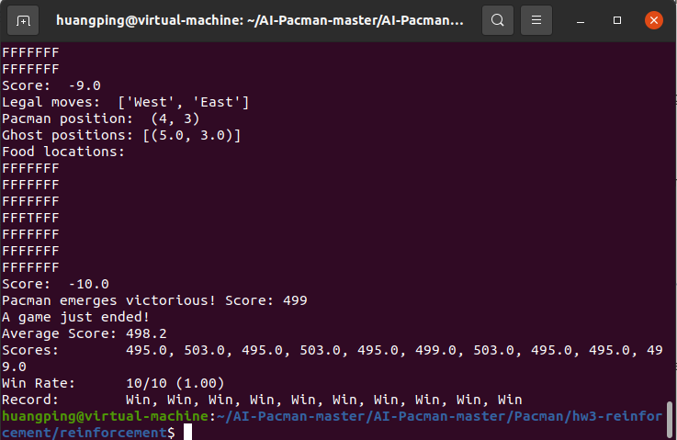
图 6打印出2000条训练结果和10条测试结果，并且都测试成功
- 上面终端执行的命令生效的是mlLearningAgents.py，当然，也可以使用原文件夹提供的learningAgents.py来达到相同的强化学习过程，终端输入：python pacman.py -p PacmanQAgent -x 2000 -n 2010 -l smallGrid
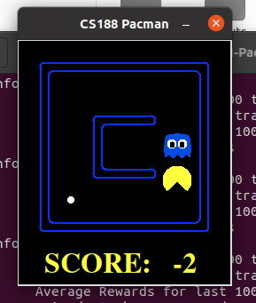
图 7训练过程
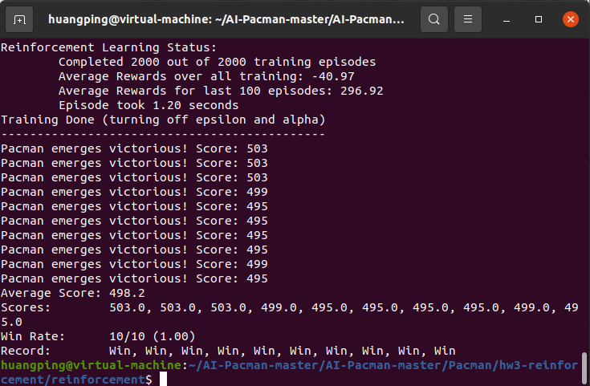
图 8成功完成了10次测试，说明训练效果很好
- 实现Approximate Q-Learning Agent（该算法在learningAgents.py文件内）。训练50次，测试10次，选择mediumGrid。终端输入：python pacman.py -p ApproximateQAgent -a extractor=SimpleExtractor -x 50 -n 60 -l mediumGrid
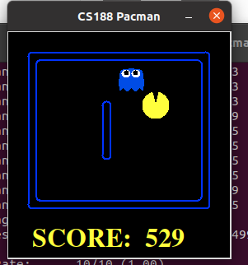
图 9训练过程
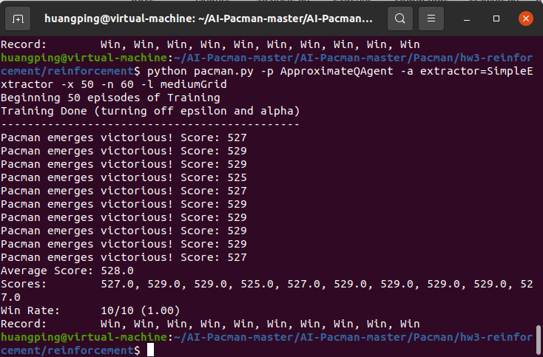
图 10虽然训练次数很少，但依然全部测试成功

五、实验结果分析
虽然在实验过程中三轮训练都使10次测试全部成功，但并不是每一次都能确保100%的成功率，经过多轮的训练，肯定会有成功次数低于8次的情况出现。AI并不能保证万无一失，但是可以大幅提高训练次数来达到更好的学习效果。

