Optimisation task

Identifying the issues:

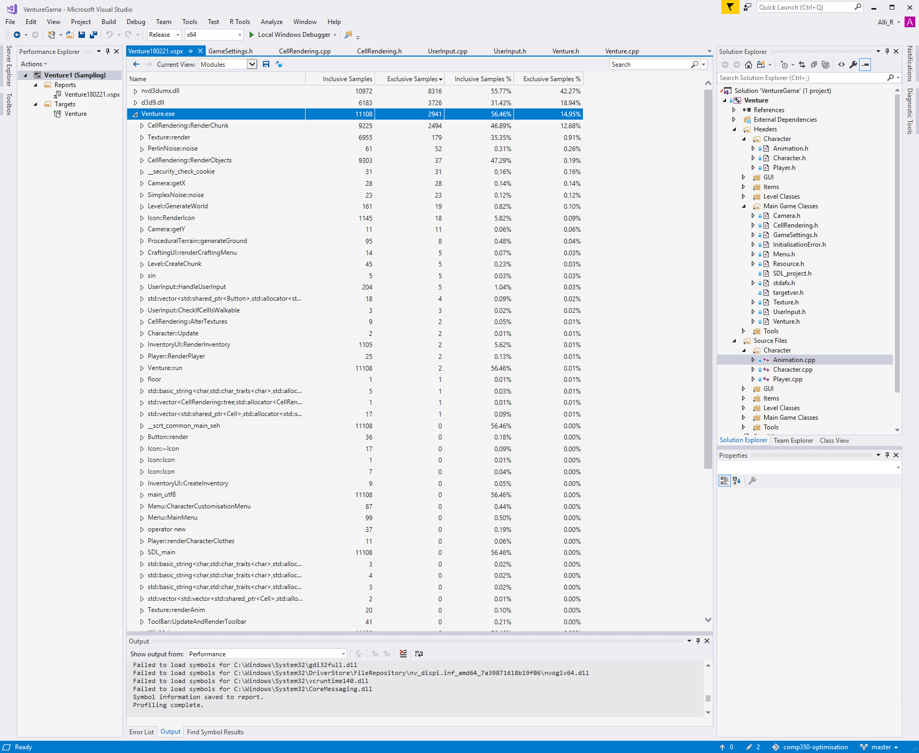

This shows that a lot of time is dedicated to the rendering of the chunks.

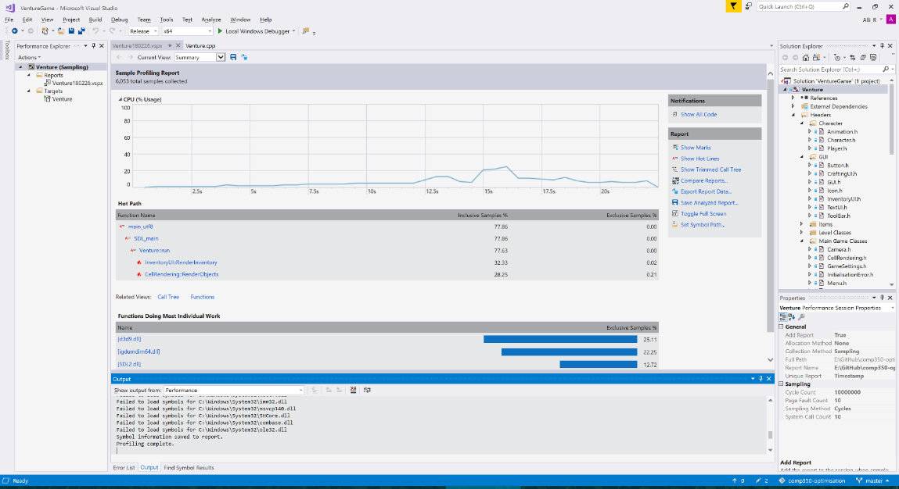This shows the spikes at where I was opening the inventory in the game.

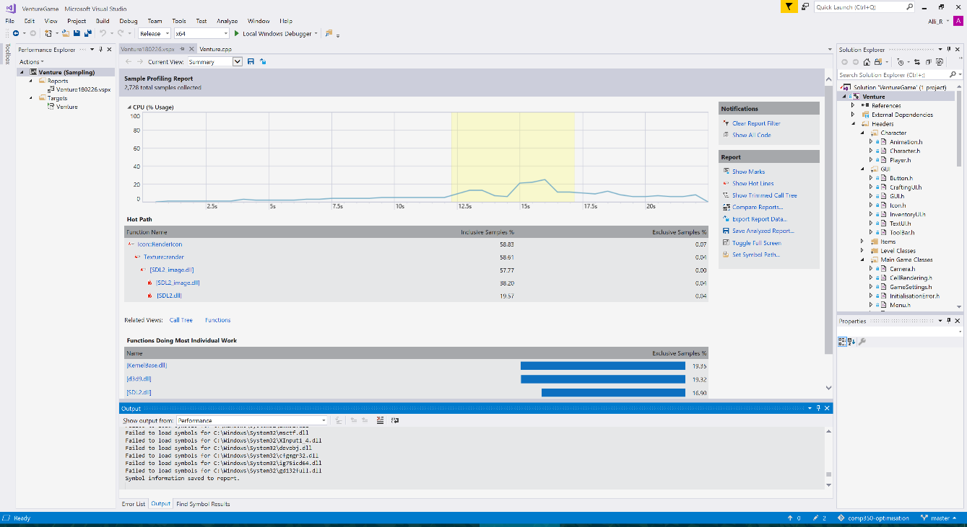

This shows that the renderIcon function is causing a lot of cpu usage, when it shouldn’t be that costly to render some icons.

This is because every time the inventory is opened, it loops through all the icons to see if they have changed.

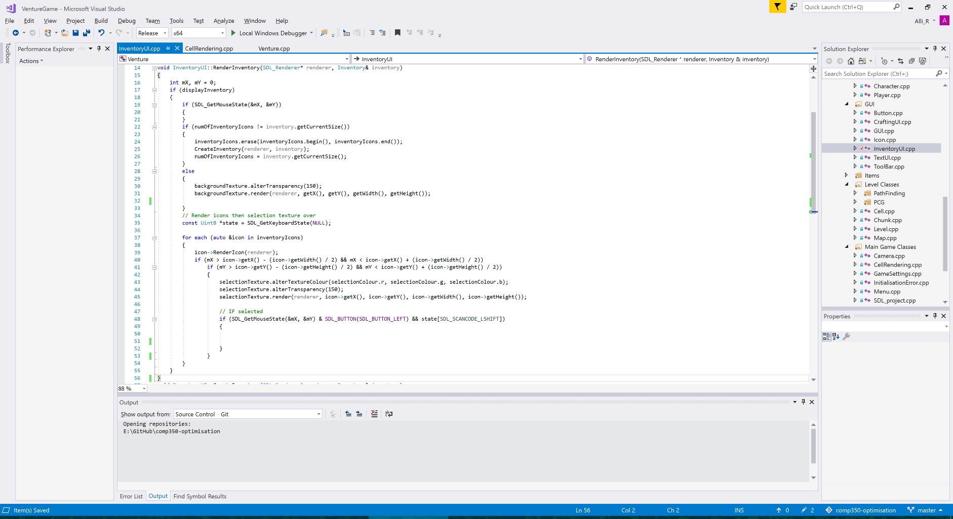This is the code that renders the icons in the toolbar, and this function is being called every time the inventory is opened.

Another issue is that there is not a time out on when the inventory button is opened, so if you hold the button down, it will open and close the inventory each frame.

One optimisation I will do is to remove the chunks that are outside the players range after a set time.

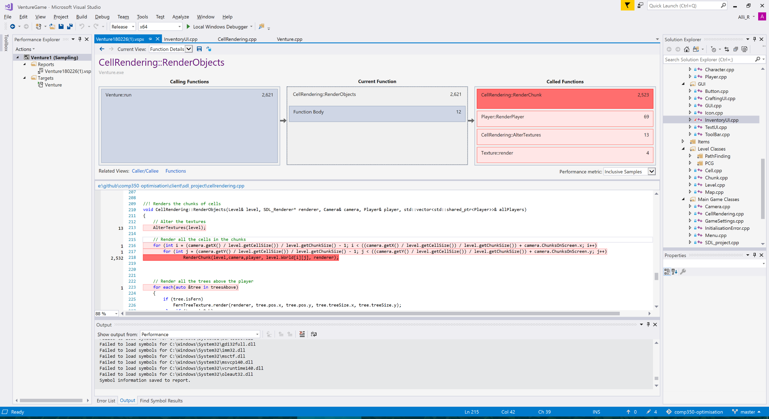

I will also try and reduce the times that RenderChunk gets called.