**Comp350 - Optimisation Task Proposal**

**Project:**

For this optimisation and porting task I will be using a game I was working on over the summer.

The game is a top down open world multiplayer farming game called Venture.

The game is getting roughly 20-30FPS in debug build, which isn’t much considering the content in the game, and in release build the game runs better, but there is memory issues when explore the world.

**Engine:**

The game was developed in C++ with SDL and used the boost::asio library for the networking. However, for the scope of this project and to ease the port to PS4 I will be removing the networking from the game, and focus on the single player optimisations. Furthermore depending on the support for SDL on the PS4 I may be looking into converting to the PhyreEngine for the rendering as that will also improve the performance.

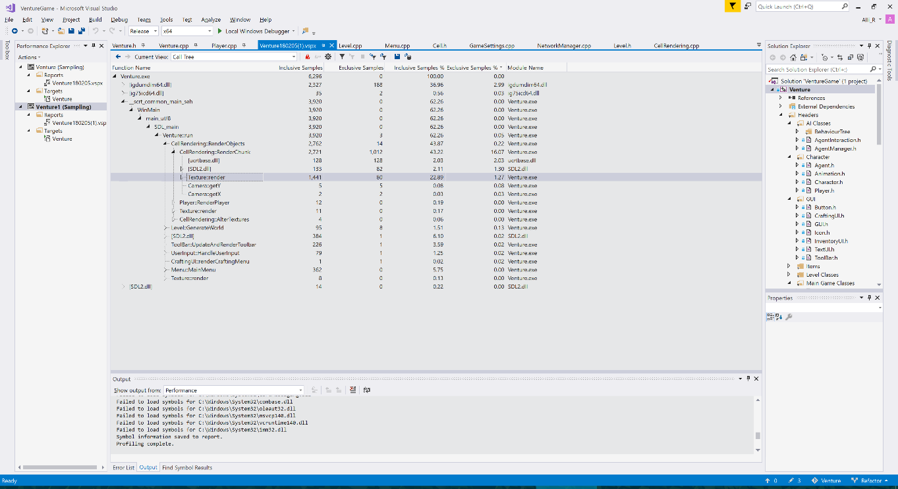

From the initial look at the profiler it appears that the rendering of the cells is one of the largest bottlenecks at the moment. As in the picture above shows that 43% of the CPU time is spent within CellRendering::RenderChunk.

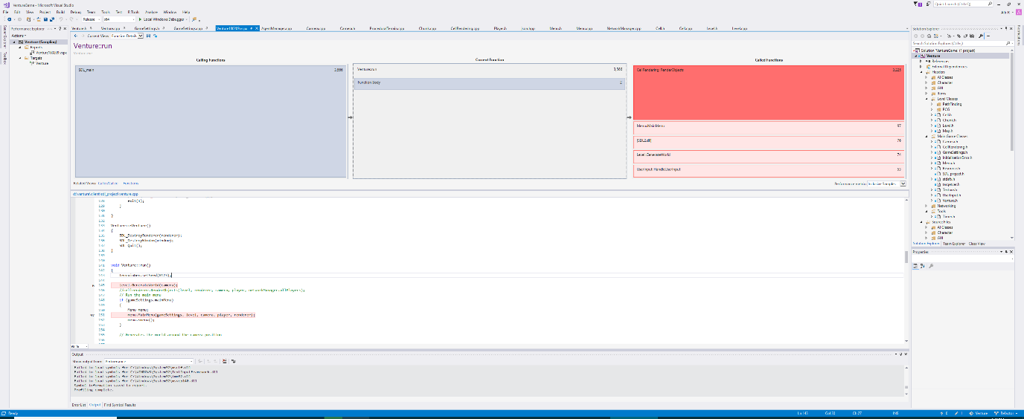

**Profiling Tools:**

**Visual Studio profiler** is a very useful tool within visual studio that can profile the CPU, memory and GPU (only using the directX).

**RenderDoc** may be useful for if I decide to overhaul the SDL rendering and use openGL instead, this will be able to help profile the openGL rendering pipeline.

**MemTrack** isa library for C++ which replaces the standard operator new with a special version that records information about each memory allocation, which may be helpful when debugging and profiling memory related issues.

**Remotery** is a Realtime profiler for CPU and GPU, which supports a variety of graphics APIs, including openGL.

**MTuner** is another C++ memory profiler, however this one has support for the PlayStation 4 and 3.

Sources:

Render Doc - <https://renderdoc.org/builds>

Phyre Engine - <http://rdwest.playstation.com/research-technology/phyreengine/>

Memtrack - <http://www.almostinfinite.com/memtrack.html>

Remotery - <https://github.com/Celtoys/Remotery>

MTuner - <https://github.com/milostosic/MTuner>