1.To display the list of Studentss

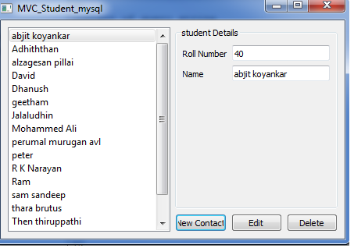

2.To add a new Student

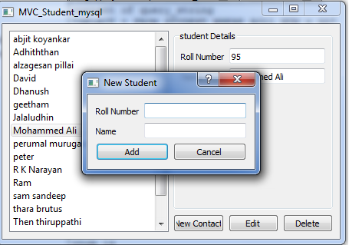

3.To Edit Student Details

