 

Introduction to Dropbox

**March 2018**

# C:\Users\Administrator.SNPC71\Dropbox (SSD)\Stats4SD\Internal Docs\Stationery\Logos\Logo\Stats4SD_Logo_Red_Small.png

This document was produced in collaboration with [Statistics for Sustainable Development](https://stats4sd.org/) and is licensed under a [Creative Commons Attribution-NonCommercial-ShareAlike 3.0 Unported License](http://creativecommons.org/licenses/by-nc-sa/3.0/deed.en_GB).

# What is Dropbox?

Dropbox is a web-based file hosting service that enables you to:

* Access your files from any computer with an Internet connection; and
* Easily share files with others in your team, even if they are on the other side of the world.

Note the images in this document were captured when using Dropbox for Business.

# Getting Started

To start using Dropbox you first need to create an account for yourself. Go to <https://www.dropbox.com/> and enter your first name, last name, email address in the form on the screen

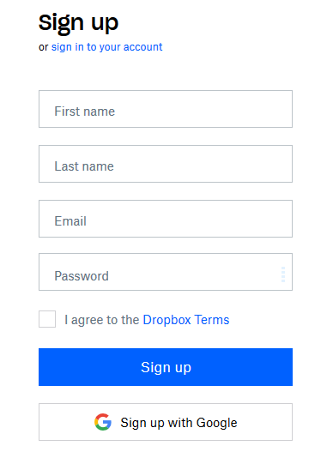

You’ll also need a suitable password – make sure you remember your password! You will also need to agree to the Dropbox Terms and Conditions. Then just click on **Sign up** and you’re ready to go.

# Working through your browser

Once you have signed in, you can manage your files and folders from your web browser. As shown below you’ll initially see a list of files that you have accessed recently. Dropbox allows you to mark items or “star” items so that they will always appear on your home screen when you log in to Dropbox.

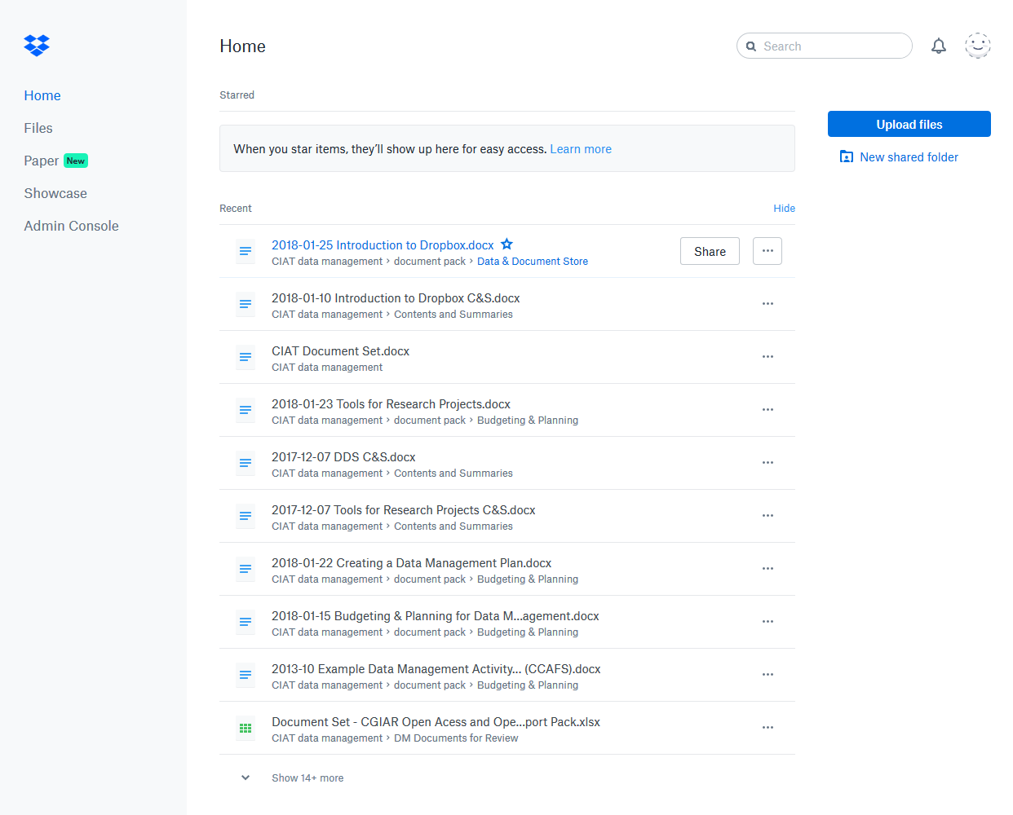

Clicking on **Files** in the left-hand column of the screen will take you to your full list of files and folders, this includes folders that you have created yourself and folders that others have shared with you. The image below shows an example.

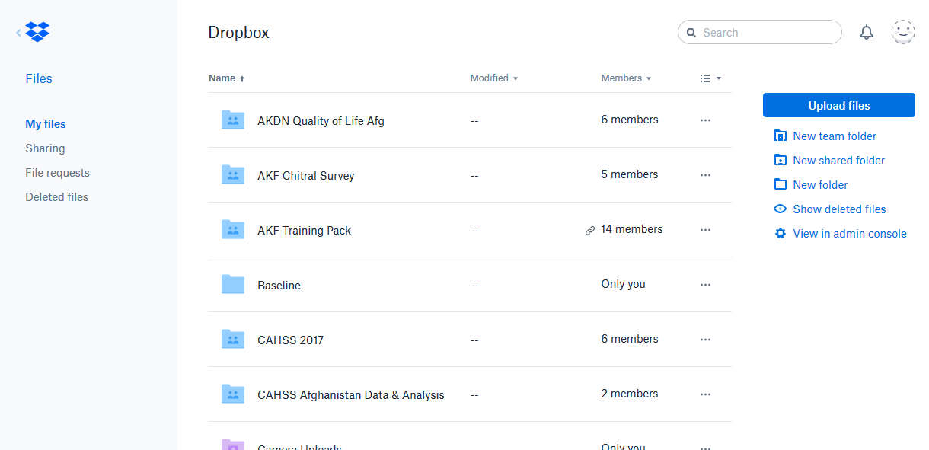

For any files in the list, the date the file was last modified will be shown. The **Members** column shows the number of individuals the folder is shared with – for example the folder “AKF Chitral Survey” is shared with four other people whereas the folder called “Baseline” is not shared at all so is only available to the current user. You will also notice the symbol next to the 14 members of the AKF Training Pack folder; this indicates that a read-only link has been created for this folder so the files within it can be viewed but not edited by anyone with the link.

# Uploading Files

To update a file, click on **Upload files** in the right-hand column. This will take you to the standard Windows Open File dialog from where you can select a file to upload. The file will be uploaded to the current folder. If you later want to move it to a different folder then click the ellipsis (3 dots) at the end of the row (see below) and select **Move** from the pop-up menu. Select the destination folder for the file from the list of folders you have available.

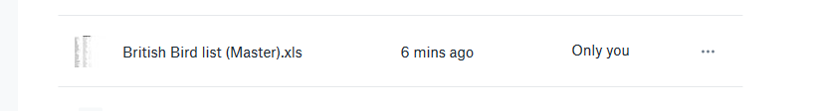

An alternative method for uploading files is simply to drag and drop from Windows Explorer, effectively treating your Dropbox folder as another folder on your hard drive. Remember to hold down the <Ctrl> key if you want to copy rather than move the file.

# Sharing Folders

To share a folder, hover over the folder you want to share and click on **Share** – the Share button will only appear when you hover over the folder. A dialog similar to the one shown below will appear. Here you should enter the email addresses of individuals you wish to share the folder with. If you have Dropbox for Business you can also choose whether you want individuals to be able to edit the folder and files or whether you just want them to be able to view and download the files. The default is to allow others to edit the folder. This includes giving them permission to add and delete files in the folder. For standard Dropbox, the option to allow others to just view the files is not available and you would need to share a link to the file.

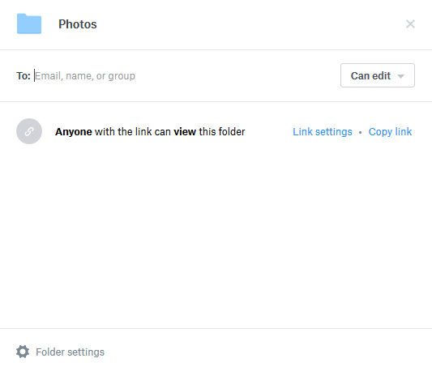

Once you have added at least one email address, a **Share** button will appear at the bottom of the dialog box. There will also be space for you to enter a message should you wish to do so. Each person will receive an invitation email with a link to follow.

## Checking and Changing the Member list

As we saw earlier, when a folder is shared the list will indicate the number of individuals who are currently sharing it. Dropbox refers to these individuals as “members”. To see the current list of members hover over the number of members in the list as shown below.

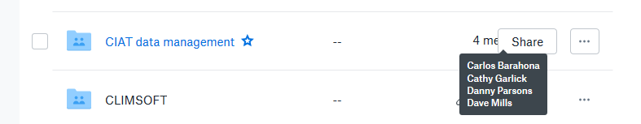

To change permissions for members or to remove a member from the list, click on Share. This gives you a dialog similar to the one shown earlier but this time you will see the current list of members. Next to each member these is a “Can edit” drop-down and by using this drop-down you can change the permissions for an individual member or remove a member. Remember the option for **Can View** is only available in Dropbox for Business.

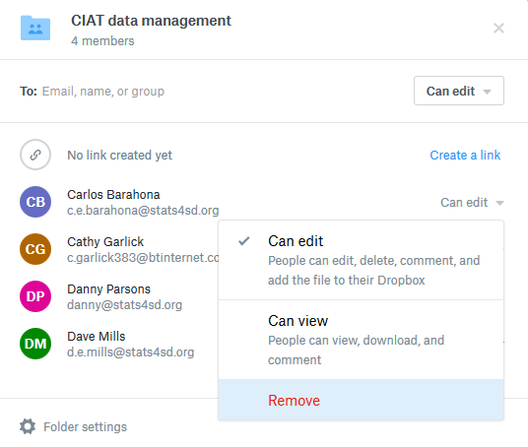

# Events

When you share a folder, those you share it with will have full access; i.e. they can read the files, modify them and even delete them. Dropbox keeps a track of events in your folders such as who edited, added or deleted which file in which folder and when. See the example below.

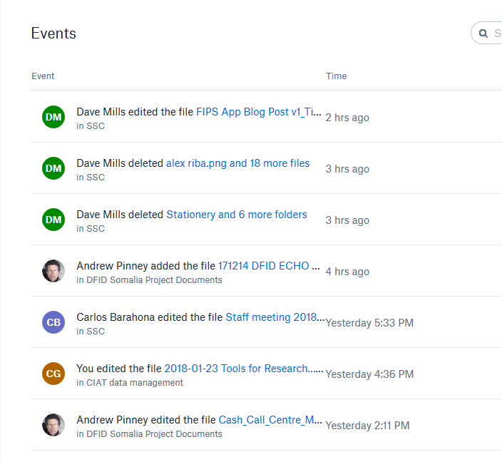

To display this list of events you will need to change the URL to <https://www.dropbox.com/events> Note you will not be able to access this page unless you are already logged in.

# Linking

If you want to be able to share files with others without them being able to make changes, you can create links. In your Dropbox list, items that are linked will be marked with a chain link symbol as we saw earlier.

To create a link to a file or folder open the sharing dialog as though you were going to share the item. Click on **Create a link**. The link is created, and you can then copy the link as shown in the image below. The link will be copied to the clipboard and from there you can email it to individuals. You can share links to users even if they don’t use Dropbox themselves.

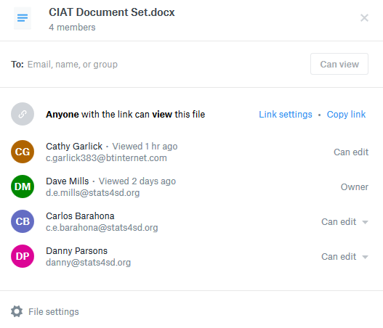

# Installing Dropbox

All the facilities we have looked at so far can be done through the Dropbox website. If you install Dropbox, a folder will appear on your computer which will automatically sync with the web version of your Dropbox.

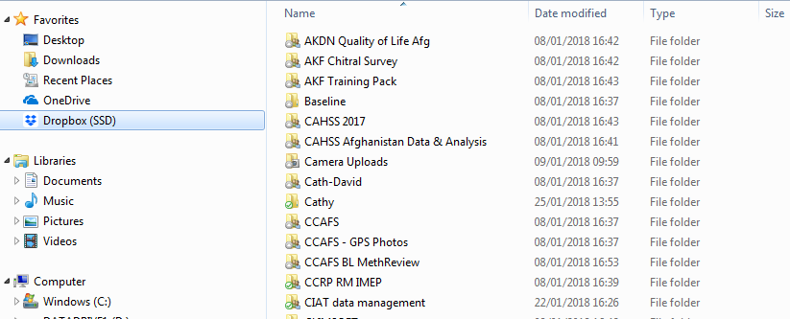

You can use this folder like any other folder on your computer. The only difference being that this folder will be available to you from wherever you are, provided you have an Internet connection. To install Dropbox go to <https://www.dropbox.com/> and click on **Download** to download and run the installer.

# Pricing

A Basic Dropbox account is free and allows you up to 2Gb of storage space, but you can gain extra free space by referring your friends. In this way you can boost your storage space to a maximum of 16Gb.

If you need additional space, then Dropbox Plus allows up to 1Tb of space and also provides offline file access and priority email support. Dropbox Professional also offers 1Tb of storage space but has additional features such as being able to share your work with customised branding, visual previews and informative captions.

As well as these individual plans there are several team plans available as Dropbox Business.

See the website for further information and for up-to-date prices.

# Summary

So, to summarise, Dropbox is an easy to use and very popular file hosting service that gives you access to your files through the web. It enables easy sharing of files both as full access shares or read-only links.

# Associate Videos

Videos accompanying the original release of the CCAFS Data Management Support Pack in 2013 are available as a playlist on the Statistical Services Centre YouTube Channel at <https://www.youtube.com/channel/UCs7EU95YMjhvNozJKCD92xQ/playlists>. These videos have not been updated since the original release but are mostly still relevant.

In particular the playlist includes the following video on Introduction to Dropbox - <https://www.youtube.com/watch?v=kvMkh4slKCU&index=9&list=PLK5PktXR1tmNRaUPsFiYlyhg2lui0xgpj>