 

Introduction to OneDrive

**March 2018**

# C:\Users\Administrator.SNPC71\Dropbox (SSD)\Stats4SD\Internal Docs\Stationery\Logos\Logo\Stats4SD_Logo_Red_Small.png

This document was produced in collaboration with [Statistics for Sustainable Development](https://stats4sd.org/) and is licensed under a [Creative Commons Attribution-NonCommercial-ShareAlike 3.0 Unported License](http://creativecommons.org/licenses/by-nc-sa/3.0/deed.en_GB).

# What is OneDrive?

OneDrive is a file-hosting service operated by Microsoft as part of its suite of online services. It allows users to store files in the cloud. Files can be synced to a PC and accessed from a web browser or a mobile device. Files can also be shared publicly or with specific individuals.

OneDrive is linked to your Microsoft account. It is built into Windows 10 and Windows 8.1 but if you have earlier versions of Windows you can download and install the OneDrive desktop app for Windows. Apps are also available for other platforms, including macOS, Android and iOS.

# OneDrive vs OneDrive for Business

There is often confusion over the different file hosting services offered by Microsoft. OneDrive for Business is a service offered to groups who have an Office 365 Business or Enterprise account, and also includes SharePoint Sites. SharePoint includes a lot of advanced functionality that is beyond the scope of this document and not really important when considering OneDrive as a DDS for research.

The key difference between the services is what accounts they are tied to. OneDrive is linked to a personal Microsoft account (<https://account.microsoft.com/account>), while OneDrive for Business will be linked to an organisation / institutional account. Your local organisational IT support should be able to help you setup OneDrive for Business if your company supports it.

From the view of a researcher using OneDrive as a DDS, both types of OneDrive are similar in functionality. The main differences lie in the options you have for sharing documents. The other features, including synchronising files to your local computer are comparable for both types of account.

# Getting Started

As mentioned above, if you have Windows 10 or Windows 8.1 and are signed in with a Microsoft account, you will automatically have OneDrive on your PC. If you have Office 365, either the personal or business plans, you will also have OneDrive / OneDrive for business. If you are using an earlier version of Windows (Windows 7 for example), you can sign up for a free account. Go to <https://onedrive.live.com> and follow the link to **Plans**. From there you can sign up for a Free account which gives you 5GB of cloud storage space. You can buy additional space – see the various plans for further details.

Once you have an account, you can install the OneDrive application for Windows 7 or earlier, macOS or mobile devices. As mentioned, Windows 10 and Windows 8.1 have OneDrive pre-installed, although you will probably need to install an updated version the first time you log into it.

# Working on your local computer

Once you have installed and signed in to OneDrive on your computer, you will see a folder on your local drive containing all your files and folders in your account.

Anything you add to this folder will be synchronised with your account, and then will be available on other devices or through the browser (see below).

Figure 1 - OneDrive folder on Windows 7

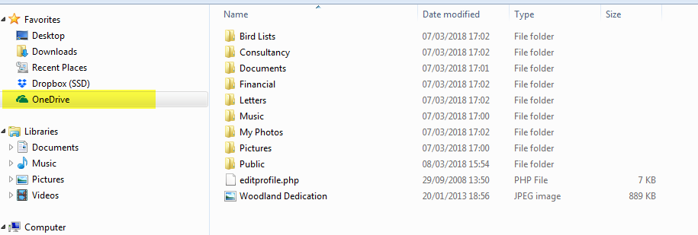

If you have both OneDrive and OneDrive for business, you can add both accounts to the application. You will then see one folder for each linked account:

Figure 2 - OneDrive and OneDrive for Business side-by-side in Windows 10

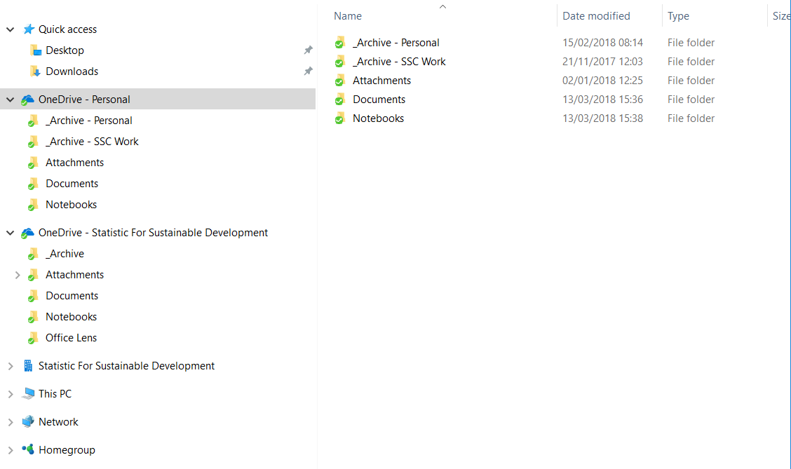

## Managing space on Windows

OneDrive can be setup in 2 different ways, depending on your needs.

The simplest option is to have everything in your OneDrive folder automatically synchronise to your local disk. This means that you can use your OneDrive folder in the same way as you do any other folder on your computer, but with the added benefit that the contents are synchronised and available online.

You can also choose to specify, on a folder or individual document basis, which files you want to store locally, and which you do not want to synchronise. This is very useful if you have a large number of files stored on OneDrive and limited space locally (a common occurrence in 2018, as laptops with small SSDs are now common and online storage is relatively cheap).

To use this feature, do the following:

* Go to the OneDrive settings (right-click on the icon in the Windows taskbar and choose “settings”), then make sure “Files On-Demand” is ticked.

Figure 3 - OneDrive Settings tab

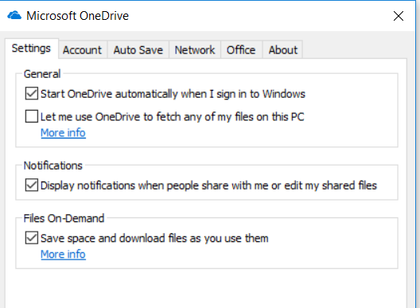

* Then, go to your OneDrive folder and right-click on a file or folder. You will see two options:
* **Always keep on this device:** Click this option to ensure the file or folder is downloaded to your local drive.
* **Free up space**: Click this option to keep the file or folder online. When you choose this, you will still see the file or folder contents in-situ within File Explorer, but it is not actually kept locally. When you click to open the file or try to copy / move it out of OneDrive, it will first be downloaded, then acted on. Large files might take a long time to download, so be aware of this when planning what files to keep where.

When you use this feature, you will see a “Status” column in File Explorer. Files stored locally will show a green tick. Files stored online show a blue cloud symbol. Files/folders in the process of being synchronised will show a pair of arrows in a circle.

Figure 4 - Files and Folders with different status symbols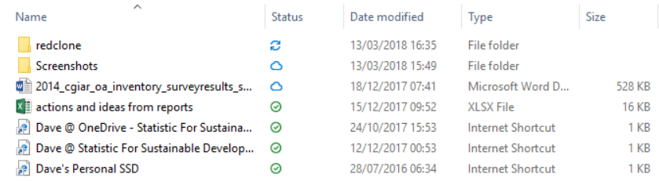

You can change the status of a file or folder at any time, so you can change what is kept locally so you always have the files you are currently working on.

This feature can be very useful when managing large files on a small laptop, but it’s important to remember the limitations of not having files available locally. If you are going to be working offline, or travelling with limited internet access, make sure you have all the files you need stored locally.

## Files-on-Demand vs Choosing Folders to Sync

If you have used OneDrive for a long time, or used similar services like Google Drive or Dropbox, you may be familiar with the option of choosing specific folders to sync to your local machine. This option is still available to you, by going to the “Account” tab in OneDrive and clicking “Choose folders” (see figures 5 and 6).

Unselecting a folder in this interface will remove it entirely from your local drive, but you will still see it online and on other devices.

In most cases, Files-on-demand is a superior option for managing file syncing, as through that method you can still see the entire contents of your OneDrive folder within the File Explorer, even if most of it is only stored online. We include this setting here mainly to clarify that these are 2 different features that provide solutions to similar issues.

Figure 5 - Accounts tab in Windows 10

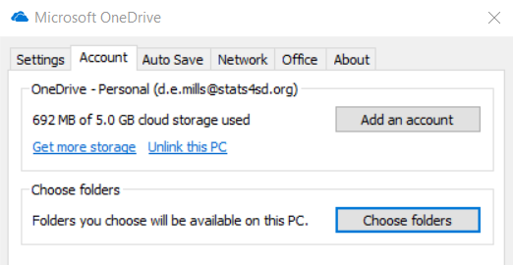

Figure 6 - Choose folders to sync locally

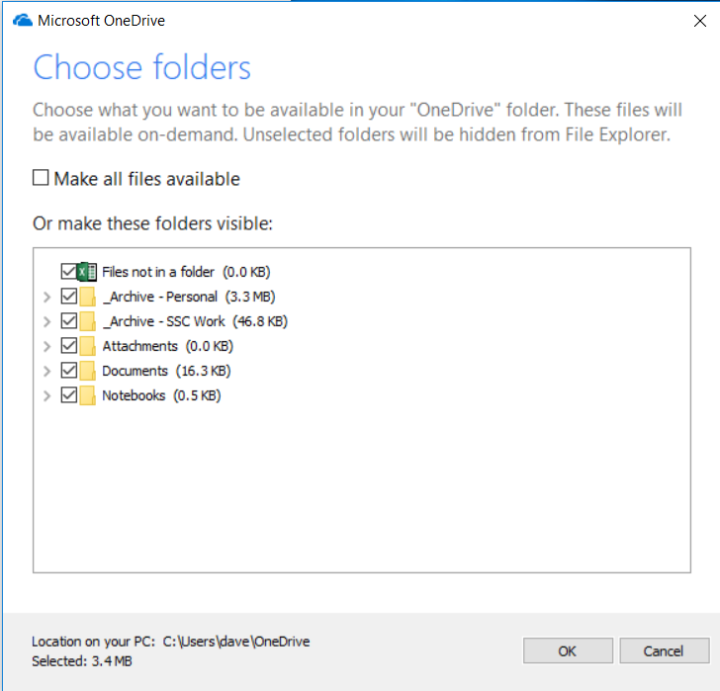

# Working through your browser

While you can use OneDrive entirely through Desktop or mobile applications, your files are also available via a web browser.

Figure 7 shows a typical view of what you will see through your browser.

Figure 7 - OneDrive through the web browser

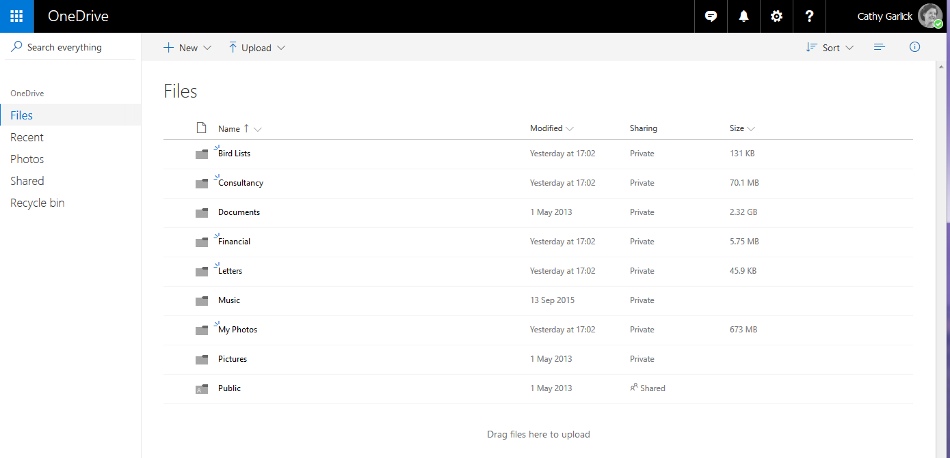

For any file is the list, the last modification date is shown. The **Sharing** column indicates whether the file is shared with others or whether it is private. In Figure 7 the only shared folder is the folder called **Public**.

# Uploading Files

To upload files, click on  and select Files or Folder as appropriate. This will open a typical Windows Open File dialogue box where you can locate and select the files or folder to upload. Note this will add a copy of the files to your OneDrive store. The file will be uploaded to the current folder in your OneDrive.

To update a file, click on **Upload files** in the right-hand column. This will take you to the standard Windows Open File dialog from where you can select a file to upload. The file will be uploaded to the current folder. If you later want to move it to a different folder then hover over the file name, click the 3 vertical dots that appear (see Figure 8) and select **Move to** from the pop-up menu. Select the destination folder for the file from the list of folders you have available.

Figure 8 - Selecting a file in the list

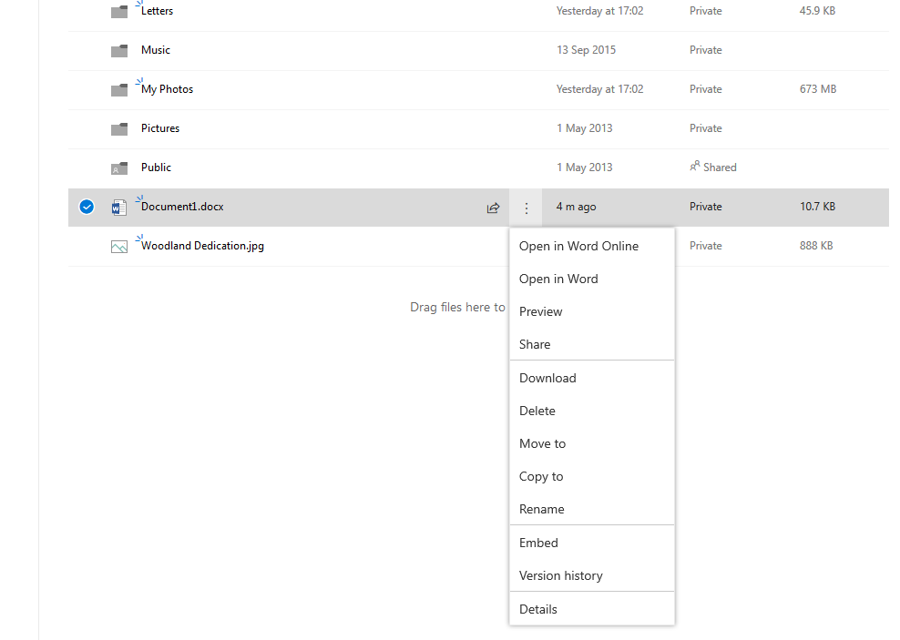

An alternative method for uploading files is simply to drag and drop from Windows Explorer, effectively treating your OneDrive folder as another folder on your hard drive.

# Sharing Folders

## OneDrive

For a personal OneDrive account, you can share a folder by creating a sharing url to an individual file or a folder.

You can either share the folder via email or just create a link to copy and share yourself. You can do this either by right-clicking on a file in your local OneDrive folder, via the mobile app, or through the browser.

Figure 9 shows the view when sharing via the browser. In this case, the Share icon will only appear when you hover over the folder.

Figure 9 - Share Icon

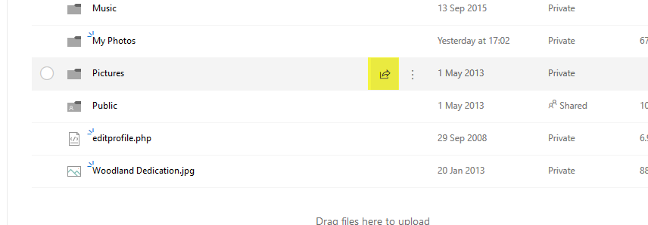

A dialog similar to that shown in Figure 10 will appear.

Figure 10 - Sharing a folder

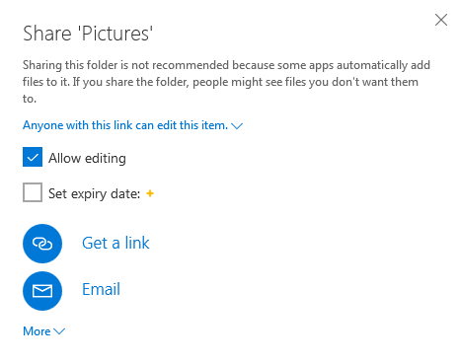

Click on **Get a link** for a unique link to be generated which you can then copy and email to individuals. You can allow or disable editing for users accessing through this link. If you pay for storage, you can also set an expiry date, giving more control over how people can access your files.

When you click on **Email** you can enter one or more email addresses and an optional message. Each person in the list will receive an invitation email with a link to follow.

An important point to note is that**,** even when you send a sharing link to a specific email address, **anyone** with the link contained in the generated email will be able to access the shared folder. For example, if the email recipient forwards the email to a 3rd party, they will also be able to access your shared files.

## Checking and Changing the Member list

Once a folder is shared you can click on **Shared** in the **Sharing** column of the list to see who currently has access to the folder. From there you can easily add others to the shared list and again can choose whether individuals should have read/write access or just read access.

Again, it’s important to note that this list is the list of links you have emailed, but does not currently guarantee that they are the **only** people with access, if they have shared the link they received, for example.

## OneDrive For Business

One of the big advantages of a Business account is the improved sharing options. You can share a file or folder from the same places as for a regular OneDrive account: by right-clicking the file/folder inside your local OneDrive folder, via the mobile app or through the web browser.

When you start sharing, you can choose from the following options:

* **Anyone:** creates a link that anyone can use – essentially public access.
* **People in <organization>** - creates a link that only people in the same OneDrive for Business / SharePoint organisation will be able to use.
* **People with existing access –** creates a link for quick access for people who already have access. This would mainly be used within an organisation to setup quick access to folders shared internally.
* **Specific people –** creates a link that only specific user accounts will be able to access. Users must log in to the specified OneDrive accounts before having access.

This gives you much more control over exactly who has access to different folders. As an individual user, you will likely be using the “Specific people” option most of the time. Your IT department may also use the organisation / existing access options to share internal resources.

As with the regular OneDrive account, you can also specify whether users can edit documents, or are restricted to view-only.

# Pricing & Storage Space

You can sign up to OneDrive for free – all you need is a Microsoft account. With this basic free account, you have up to 5GB of storage space. By paying a monthly fee you can buy 50GB of storage space. As already mentioned, OneDrive comes bundled with Office 365 and this package gives you up to 1TB of storage space.

For the current pricing please see the OneDrive website at <https://onedrive.live.com/about/en-gb/plans/> .