 

Training Manual – Example using ODK

**March 2018**

# C:\Users\Administrator.SNPC71\Dropbox (SSD)\Stats4SD\Internal Docs\Stationery\Logos\Logo\Stats4SD_Logo_Red_Small.png

This document was produced in collaboration with [Statistics for Sustainable Development](https://stats4sd.org/) and is licensed under a [Creative Commons Attribution-NonCommercial-ShareAlike 3.0 Unported License](http://creativecommons.org/licenses/by-nc-sa/3.0/deed.en_GB)

Contents

[Introduction to Fieldworker Section 4](#_Toc508370789)

[Using ODK Collect on the Android Device – for All Field Staff 4](#_Toc508370790)

[If your supervisor sets up ODK collect: 4](#_Toc508370791)

[If you need to sign in with your own account: 4](#_Toc508370792)

[General Use of Android Device 4](#_Toc508370793)

[Navigation 4](#_Toc508370794)

[Battery Conservation 5](#_Toc508370795)

[Using ODK Collect 5](#_Toc508370796)

[Types of Question 6](#_Toc508370797)

[Validation Logic 6](#_Toc508370798)

[Skip Patterns 6](#_Toc508370799)

[Jumping Throughout the Questionnaire 7](#_Toc508370800)

[Navigating a questionnaire with multiple levels 7](#_Toc508370801)

[Saving an Incomplete Questionnaire 7](#_Toc508370802)

[Basic Form Management 7](#_Toc508370803)

[Completing the Questionnaire 8](#_Toc508370804)

[Seeking Consent 8](#_Toc508370805)

[Working through the questionnaire 8](#_Toc508370806)

[End of Interview Checks 8](#_Toc508370807)

[Introduction to Supervisors’ Section 9](#_Toc508370808)

[Supervisors' Tasks 9](#_Toc508370809)

[Preparing the Android Devices for use 9](#_Toc508370810)

[Required Applications 10](#_Toc508370811)

[Installing Application on the Android Device 10](#_Toc508370812)

[Installing Applications from .apk files 11](#_Toc508370813)

[Installing ODK Collect (and other applications) from the Play Store 12](#_Toc508370814)

[Installing ODK Collect from the Play Store 12](#_Toc508370815)

[Preparing ODK Collect (before fieldwork) 12](#_Toc508370816)

[Adding Forms to the Device 12](#_Toc508370817)

[Adding Forms without an Internet Connection 13](#_Toc508370818)

[To add a blank form via Bluetooth connection from another Android device. 13](#_Toc508370819)

[To add a blank form by connecting the device to a Windows PC 14](#_Toc508370820)

[Form management in ODK Collect 14](#_Toc508370821)

[Backups through Bluetooth 14](#_Toc508370822)

[Setting up the Bluetooth connections 15](#_Toc508370823)

[Device Name 15](#_Toc508370824)

[Making the device Visible/Discoverable 16](#_Toc508370825)

[Pairing devices 16](#_Toc508370826)

[Copying via Bluetooth 17](#_Toc508370827)

[Changing ODK Options 18](#_Toc508370828)

[Hiding Buttons on the Main Menu 18](#_Toc508370829)

[Changing General Settings Options 19](#_Toc508370830)

[Changing Form Entry Items 19](#_Toc508370831)

[Uploading Finalised and Checked forms to the server 20](#_Toc508370832)

[Downloading Revised ODK form 20](#_Toc508370833)

Fieldworker Section

# Introduction to Fieldworker Section

This example manual is derived from a training manual used on a research project in which survey data was collected using ODK (Open Data Kit) on hand-held devices. We have indicated places in this manual where a screenshot of the mobile device would be useful.

# Using ODK Collect on the Android Device – for All Field Staff

Data collection will be conducted using the Android device you will be issued with at the start of the training. Please ensure that you take good care of the Android device. Your team supervisor may require the devices to be handed in for safety at the end of each day – this is dependent on the specific project protocol. The process of setting up ODK Collect depends on the exact protocols being used in your project. There are 2 options:

### If your supervisor sets up ODK collect:

The ODK collect app will be present on your main home screen. Tap the symbol  to open the app. The form (questionnaire) will already be loaded and the phone set to connect to your project’s server. Your field supervisor will manage any requirement to load new forms from the server.

### If you need to sign in with your own account:

If you have been given an account on the ODK server being used (e.g. Kobotools, Ona.io, SurveyCTO), you will need to provide your credentials to allow ODK Collect to communicate with the server. Follow the following steps to link ODK Collect to your account and enable data collection:

(updated for ODK Collect v1.13.0)

1. Open ODK Collect, then tap the 3-dot menu button in the top-right of the screen and go to “General Settings”
2. Go to “Server”
3. Enter the server url (including the https:// ), your username and password into the fields. You will have been given these details by your supervisor.
4. Check you can connect to the server by going back to the start menu and tapping “Get Blank Form”. If the server details are correct, you will see the list of forms you have access to on the project server.
5. Check that the displayed form names and IDs are what you expect.
6. Download the forms you require.

# General Use of Android Device

## Navigation

When you open the form on the mobile device you will generally see a screen informing you that you are at the start of the survey. To move forward you should swipe from right to left and to move backwards to the previous question you should swipe from left to right as indicated on the device.

<Useful to insert a screenshot at this point>

The user can decide whether to navigate the form using swipes or using forward and backward buttons. This should be left up to the user to decide what they feel most comfortable with. Users who are not familiar with touch screen devices may prefer to use labelled buttons rather than horizontal swipes.

If using the horizontal swipe option, you may find that the screen moves forward when you are scrolling down a screen. Just move back again and make sure the scrolling down motion is as vertical as possible. To switch between using swipes or using forward and backward buttons do the following:

* Go to **General Settings** (bottom right-hand side of the screen) and scroll down to the **User Interface** section and select **Navigation**.
* Select one of the following options:
  + Use horizontal swipes
  + Use forward/backward buttons
  + Use swipes and buttons

If using the forward/backward buttons they will appear at the bottom of the screen.

The only other setting within this menu that you may change is the **text font** size. DO NOT change any other settings.

## Battery Conservation

The device’s battery should last for most of a day’s work. To help ensure the battery lasts the day, please ensure that the following are switched **off** during the day:

* Wi-Fi
* Bluetooth
* Data Network

It is helpful to leave GPS on during the day. When you first switch GPS on, it takes a while to pinpoint your location. For this reason, please switch on your GPS ~15-30 minutes before you begin the first interview of the day.

During the first few days, you should monitor the device’s battery before and after each interview. If a device is below 50% after ½ the interviews for the day are complete, (or when you take your lunch-break), you should charge your phone during the lunch-break using, in order of preference:

* An available wall plug
* Your team’s in-car charger
* Your portable battery pack

30-60 minutes charging at lunch-time should give enough of a boost to allow you to use the device for the rest of the day. Remember to fully charge your device every evening!

Once you have become familiar with the device, you will get a feel for how often you need to charge it and how long it takes to charge.

# Using ODK Collect

To start a new form, tap the first option ‘**Fill Blank Form’** and choose the appropriate form.

*<Insert screen image here>*

Once the form is loaded, you will see the initial splash screen. As previously instructed swipe right to move to the next question and swipe left to move to the previous question.

## Types of Question

As you work through the questionnaire you may come across the following types of question.

* Integer
  + When a numeric value is expected – e.g. age of respondent – the numeric keypad will appear on the phone
* Text
  + Where a text response is expected – e.g. name of respondent – the standard letter keyboard will appear.
* Multiple Choice (select one)
  + Multiple choice questions where only one response is possible, will have the options displayed with radio buttons (round buttons), or as a dropdown list of items.
* Multiple Choice (select multiple)
  + For questions where several responses are possible, the options will be displayed with check boxes (square boxes).
* GPS
  + When you are required to record the GPS coordinate a button will appear on the screen labelled **Record Location**.
* Image / Multimedia
  + When you are asked to take a photo or record a video / audio, the question will show a link to the inbuilt camera / microphone of your device. Once you have captured the media item, you will have a chance to review it and either record another version or accept the item and continue.
* Barcodes
  + The data collection may involve the use of barcodes, for example to track physical samples being collected, or to get the unique id of a respondent or experimental plot. When this is required, the question will link to the camera of your device, which can be used to scan barcodes and QR codes.

## Validation Logic

The form has been written to include many automatic validation checks. If you enter a response that the form recognises as impossible, you will not be able to continue. An error message will briefly appear indicating the reasons for the invalid answer. To force the message to appear for longer, swipe forwards 3-4 times in a row.

## Skip Patterns

When completing the form, not every question will be relevant to the particular respondent. Questions that should be skipped due to the respondent’s previous answers will not be shown to you.

During the training, you will learn the complete structure of the questionnaire, including the skip patterns.

## Jumping Throughout the Questionnaire

If you need to jump back to change a previous answer, you can access the full list of currently active questions by tapping the ‘Go To Prompt’ icon: 

You will see a list of every question currently active. Any answers you have entered will be shown in small text under the question label text.

Tap any question to be taken to that question.

*<Insert screen image here>*

Note – many questions are only relevant if certain answers are given to previous questions. For this reason, you may not see every single question in this list, as it only shows the *currently relevant* questions (based on answers given so far)

### Navigating a questionnaire with multiple levels

If the questionnaire contains repeat groups, then looking at this question overview will only show the questions at the current level, so you need to have a good understanding of the structure of the questionnaire.

At the top level, repeat groups will appear in-line with the questions, but have a symbol next to them to show they can be expanded. Expanding the group will show 1 row for every ‘repeat’ entered so far. Tap on a repeat to see the questions and responses inside that instance of the repeat group.

Navigating a questionnaire with multiple repeat groups, especially nested repeat groups, can be tricky until you become completely familiar with the questionnaire structure. If you don’t feel confident navigating the form, we recommend running through some practice forms and discussing any questions you have with your supervisor.

## Saving an Incomplete Questionnaire

You may not complete an interview in one sitting. If you need to save an incomplete form, tap the ‘menu’ button on your device and choose ‘save form’. Alternatively click the **Save** icon in the top right-hand corner. It will also prompt you to save your changes when you close a form.

You can close a form by pressing the ‘back’ button on your device. It will give you 2 options – for any real interview, always choose Save Changes. If you choose ‘Ignore Changes’ you will lose all data entered into that form since you last saved.

## Basic Form Management

Incomplete and complete forms are stored on the device. You can access all saved forms within the ODK Collect app by going to the main menu and tapping ‘Edit Saved Form’. This list contains both non-finalised and finalised forms. This way, a form marked as finalised **but not yet uploaded** can still be edited.

The process of uploading forms will be managed by your supervisor. This is likely to be one of 2 options:

1. Your supervisor uploads forms at the end of the day after running through some on-device quality checks. Do not upload the forms during the day.
2. Quality control and record validation is conducted on the server, and you should upload forms as you work during the day.

You will be trained in the correct procedure for form uploading.

# Completing the Questionnaire

*The initial part of any questionnaire is likely to be the identification information most of which can be completed before starting the interview.*

## Seeking Consent

The next section is where you seek consent from the respondent. There will be a separate consent form (on paper) for the most senior household member to sign on arrival at the household. In addition to this household consent, there is a screen on the mobile device with information for you to read. This is the time where you explain to the potential respondent what the survey is all about and ask whether or not they consent to be a part of the study.

You should also be prepared to answer any questions they may have at this stage.

Ask the potential respondent whether she/he consents to be part of this study and record this as appropriate on both the hard copy form and at the bottom of the consent page on the phone screen. If she/he does not wish to be part of the study, see if it is possible for another household member to participate instead and read the same information to them.

*Note: there may be more than one level of consent for a particular survey. For example, you may be collecting information about the household as a whole and in addition collecting demographic information such as heights and weights from individuals in the household. A particular household may agree to answer the questions but not agree for individuals to be measured.*

If the respondent answers **No,** then the next screen will move you to the end of the questionnaire where you will be asked to save the form and exit.

If the respondent answers **Yes**, you will move on to the next section of the questionnaire.

## Working through the questionnaire

*For this section of the training manual it is useful to go through each section and each question in the questionnaire indicating the type of question, detailing any skips and listing the possible options for the question.*

## End of Interview Checks

You have now reached the end of the interview. Remember to thank the respondent.

Finally save and finalise the form. Please make sure you ***only finalise completed forms***; if you need to return to the household at a later time then save the form but do not finalise it.

At the end of the day your supervisor will carry out some checks on the data and will upload it to the aggregate server.

Supervisors’ Section

# Introduction to Supervisors’ Section

The remainder of this manual details the tasks that should be carried out specifically by the Field Supervisors and/or by the teams preparing the mobile devices for use in the field. It includes details about installing the relevant software on the phones, essential checks that need to be carried out at the start and end of each day, including backing up and uploading data from the interviewers’ phones.

# Supervisors' Tasks

Before the start of fieldwork, the supervisor must:

* Ensure the mobile devices are ready for use and have the correct software applications installed, the training team will provide assistance with the initial set up – see section on *Preparing the Android Devices for use;*
* Ensure the mobile devices have the most up to date version of the ODK survey form – see sections on *Preparing ODK Collect* and *Adding Forms to the Device -* if and when updates are released the supervisor will be informed and should ensure the latest version is downloaded to all devices being used by his/her team;
* Ensure that all interviewers know their unique ID;
* Ensure that all phones have been given an appropriate device name (e.g. team code and interviewer code, or interviewer name, etc.) and that all interviewer phones have been "paired" with the supervisor's phone for Bluetooth backups – see section on *Backups through Bluetooth;*

At the start of each day of fieldwork the supervisor should:

* Ensure that all interviewers in their team know which households they have been allocated;
* Ensure that all interviewers have switched off Wi-Fi, Bluetooth and data connections on their phones, but that GPS remains on.

At the end of each day the supervisor should:

* Collect the phones from all team members;
* Carry out checks on all finalised questionnaires;
* Use Bluetooth to take backups of all questionnaires (finalised or just saved) from all phones – see the section *Backups through Bluetooth;*
* If a data network is available upload all finalised and checked questionnaires to the aggregate server – see section on *Uploading finalised and checked forms to the server*;
* Once backups and uploads are complete, hide buttons on the menu for each interviewer phone (see instructions in *Hiding buttons on the main menu*);
* Ensure that all phones are set to fully charge by the morning.

# Preparing the Android Devices for use

Before being distributed for training and fieldwork, each device must be prepared. The initial set up will be done prior to the training. However, it is important that field supervisors understand the process and can complete this in the field as needed. Therefore, this will be included in the training and reviewed with supervisors again at the end of the training, immediately prior to the start of fieldwork, to check that all devices are prepared with the relevant software and settings.

Instructions are included also here, in case of problems in the field resulting in the need to reinstall software or revisit settings.

Each device should be tested to ensure:

* GPS functions (can locate user on a map);
* Wi-Fi works (can connect to a known Wi-Fi network);
* The device charges okay and holds charge (fully charge device and leave it unplugged overnight to test this);
* The SIM is installed correctly and data network functions;
* An SD card is installed and formatted such that it is recognised by the File Manager.

## Required Applications

The following application must be installed on each device to be used for data collection:

* ODK Collect

It may also be useful to have a PDF Reader (for instance “Adobe PDF Reader”) Installed on the devices, with key reference documents saved to the device’s SD card.

## Installing Application on the Android Device

Installing applications on an Android device can be done in two ways.

1. Installing from an Application Package File (.apk)
2. Installing from Play Store

APK files are Application Package Files that have been created for the Android operating system. Files with the .apk extension store all the files needed to run a single Android application on an Android mobile device. Using these files, you can install an application without having to link to the Play Store.

If you are preparing the devices for long term use, we recommend downloading ODK Collect (and any other needed apps) from Play Store, as it is then much easier to keep the applications up-to-date. You might choose to use a default project Google account, or require that each enumerator uses their own account.[[1]](#footnote-1)

For devices being prepared for a single project, or one-time survey, we recommend using the APK files to install needed applications directly. The devices will be reset at the end of the project anyway, and this removes the need to link each device to a Google Account.

**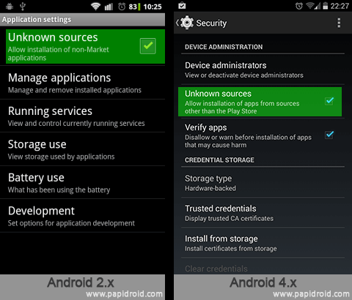**Prior to or during the training, copies of the relevant .apk files will be stored on each phone and the relevant software installed. These instructions here are provided in case a reinstallation is needed while in the field.

### Installing Applications from .apk files

#### 1. Allow application installs from "unknown sources"

To allow installations from .apk files, you need to modify the device’s security settings:

**Android 4.x +**: Go to Settings > Security > tick “”Unknown sources“

If present, you can also tick “Verify apps” for Android to check whether the app you’re trying to install might be dangerous.

**Android 8.x:** Go to Settings > Apps & Notifications. Find your file manager app in the list. In the App Info page, under “Advanced”, enable “Install unknown apps”.

Remember – an Android device is a computer, so be careful when installing applications from unknown sources. While viruses for Android devices are generally less common than for Windows devices, it is still possible to accidentally get viruses, Trojans, malware and other malicious software on your device. Only install .apk files from trustworthy sources!

#### 2. Copying the .apk files to the Android device

You can copy the apk files from a PC by connecting your Android device via a USB cable. For Android 4.x, the device will appear in the “My Computer” list of devices on your Windows PC when you connect the device. You may need to unlock the device before connecting.

You can also download the APK files directly to the device, either through the web browser, or via an application like OneDrive to synchronise the files to the device.

#### 3. Install applications from the .apk files.

The file you need for the required application is:

* ODK Collect < add recent required version here >[[2]](#footnote-2)

Once the .apk file is copied to your Android device, find it in the file manager and tap to open it. You will be prompted to confirm that you wish to install the software. If a different version of the application is already installed, it will ask if you wish to replace it with this version. Usually you will not want to; unless you know you are installing a newer version.

### Installing ODK Collect (and other applications) from the Play Store

Before you can download applications from the Play Store, you need to add a valid Google Account to your Android device. The following information is taken from the Google support article at:

<https://support.google.com/a/users/answer/1738362?hl=en>

“To use the native Google Apps mail, contacts, and calendar apps on your Android, you need to sign in to your Google Apps account. Instructions below are for users with a Nexus or Google Play edition device running Android 4.2 or higher. If you're using a different device, your setup instructions may vary. You only have to do this once:

1. Touch the **Settings** > **Add account** > **Google** to add your Google Apps account.
2. Select **Existing** and enter your full Google Apps email address as your username and enter your password.
3. Set up Google Account on Android SSO, step 3
4. Touch OK to agree to the Terms of Service. The device will sign in to your domain. This process may take a few minutes.

Additional steps for 2-step verification users:

1. You may be presented with additional steps giving you the option to join Google+, opt in to Google Play communications, or set up a credit card to purchase Google Play media. You can choose to set these up or touch **Not now**.

After completing these steps, you should see Account sign-in successful. You can choose which services you want to sync to the device.

That's it! You can now use Google Apps from your Android. Just launch Gmail, Google Calendar, or whichever app you want to use.

And going forward, you can change which services can sync with Google Apps on your device at any time by going to Settings > Google > touch your account. If a service you've selected isn't syncing, check with your administrator to make sure that that service has been enabled for your domain.”

### Installing ODK Collect from the Play Store

To install ODK Collect, go to the Google Play Store and search for “ODK Collect”. Ensure you are installing the version provided by Open Data Kit (with the logo )

# Preparing ODK Collect (before fieldwork)

To facilitate smooth running of the fieldwork, there are a number of steps to complete within ODK Collect before the interviewers are given the mobile devices. These steps should be completed by the field supervisors to ensure they have a clear understanding of the process and that phones are set and ready to be used by interviewers without them needing to go through these steps.

## Adding Forms to the Device

There are 2 ways to add an ODK form to the device. The best method is by connecting to the aggregate server where your project data will be stored:

1. Open ODK Collect and press your device’s **Settings**Button.
2. Choose General Settings then Configure Platform Settings
3. Set the **URL** tothe url of the survey server.
4. If the server is setup to prevent public access to the forms, you will need to enter a valid username and password to connect to the server. You can use your own details to test the settings and download the forms, but we recommend that each enumerator has their own account to allow easy tracking of who uploads which records.
5. Return to the General Settings and ensure that the **Platform** is set to **ODK Aggregate**
6. Return to the main ODK Collect menu and choose **Get Blank Form**
   1. If you receive an error, or do not see any forms here, then check your internet connection.
   2. If you are connected, check the URL you entered in the settings..
7. Tap the form you wish to download and then choose **Get Selected.**
8. You should receive a ‘success’ alert. Once this happens, return to the main menu and choose **Fill Blank Form.** You should see the form(s) you have just downloaded.

The blank forms are now available on the device, ready for completion. You do not need an internet connection to complete forms.

## Adding Forms without an Internet Connection

If you are working without a network connection, you can manually add forms to your Android device either by copying via Bluetooth from another device with the up to date forms or else by connecting the device to a Windows PC.

### To add a blank form via Bluetooth connection from another Android device.

First make sure the devices are visible and paired (see section on *Setting up Bluetooth connections*, below). On the device with the required forms:

1. Go to File Manager, then the **odk folder**, then open the **forms** **folder.** Since there are often problems sending a form via Bluetooth in this format it is best to compress the form file and send as a zipped file.
2. Find the form to transfer and hold your finger on the file until a pop-up menu appears. Select **Compress** (screenshot 1)then **OK** on the compressed file folder path option (screenshot 2)**.**
3. You will then see the zipped form in the folder .
4. Hold your finger on this zipped folder until you obtain the same pop up menu as previously. This time choose **Share** (3) followed by **Bluetooth** (4) to share the file via Bluetooth.

|  |  |  |  |
| --- | --- | --- | --- |
| 1 | 2 | 3 | 4 |
|  |  |  |  |

1. Select the device name of the destination phone from the list of visible devices. You should receive a notification on the source phone telling you that you are sending a file.
2. On the destination phone you should receive a message to say a file is waiting to be transferred and you will need to accept the transfer.
3. The file will be copied to the folder called **Bluetooth** on the destination phone. Extract the folder, open it and copy the ODK form from there to the folder **odk/forms**.
4. Delete the transferred zip folder and extracted folder from the **Bluetooth** folder.

*See instructions in the section below:* ***Copying via Bluetooth****, for additional information on setting up and functioning of Bluetooth copying if needed.*

### To add a blank form by connecting the device to a Windows PC

The blank forms are .xml files. To add a blank form to the Android device, copy it from your PC into the **<root>/odk/forms/** folder. If there are any images or other media associated with the form, it will be in a folder called "<formname>-media. This folder should also be copied to the **odk/forms** folder on your device.

# Form management in ODK Collect

Each time you start a new blank form, ODK collect creates a new instance of that form. Forms are kept organised by a small, internal database, which tags instances with one of the following tags:

* **Saved (not finalized)**: A saved form can be edited by choosing “edit saved form” on the main menu.
* **Finalized**: At the end of the form, you have the option of marking a form as finalized. This indicates that it is ready to be sent to the server. When you mark a form as finalized and attempt to exit, ODK runs the validation for the whole form. If there are required fields left blank, or if a response does not fulfil the pre-programmed constraints, you will not be allowed to exit. The form will not be marked as finalized and you will be taken to the first validation error ODK has found. This prevents any incomplete form from being uploaded.

A finalized form can be edited in the same way as a saved, not-finalized form.

* **Sent**: A form that has been sent to the server no longer appears on the “edit saved form” or “send finalized form” menu. The actual file remains on the phone but cannot be accessed directly within ODK Collect. This prevents multiple submissions of the same instance.
* **Sending failed**: Each time a form is sent, ODK collect attempts to communicate with the server to ensure the upload was successful. If the upload fails, it registers the attempt and marks the form instance as not-sent. Sending can then be tried again at a later time.

A form should be **Saved** by the *interviewer* if the interview is not yet complete – e.g. the respondent has asked him/her to return at a later time.

A form should be **Finalized** by the *interviewer* if the interview is complete; this ensures built in checks are carried out on the data. The options in ODK should be set so that forms are automatically finalized once the interviewer reaches the end of the form.

Forms should be Sent by the supervisor at the end of the day (assuming there is a data connection available) and ***only after further checks and backups*** have been carried out.

# Backups through Bluetooth

In this section of the manual we describe the method of backing up the ODK data using the Bluetooth connection. The plan is for the field supervisor to take a copy of the ODK folder from each of the phones used by the enumerators/interviewers during the day. The backups should be done at the end of each day of fieldwork prior to uploading the finalised forms.

## Setting up the Bluetooth connections

To save battery power you should ensure the Bluetooth function is switched off during the day. To switch this back on:

* Go to **Settings** on the device.
* Under **Wireless and networks** go to **Bluetooth** and make sure **Bluetooth** is turned **ON**.

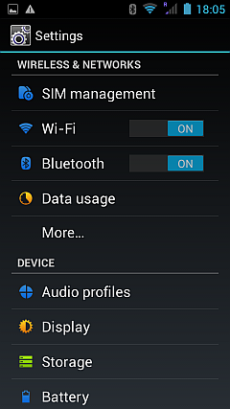

Other settings for Bluetooth include:

* Device name
* Visible

## Device Name

On some devices you can change the name of the device. If this is possible on your device, we suggest you change it to the unique identifier for each team member so you can recognise each of the phones in your team more easily. For example, my phone is called **Cathy's Phone**.

To change the name of the device:

* Click on Device Name
* Overwrite the existing name with your new name and click **OK**.

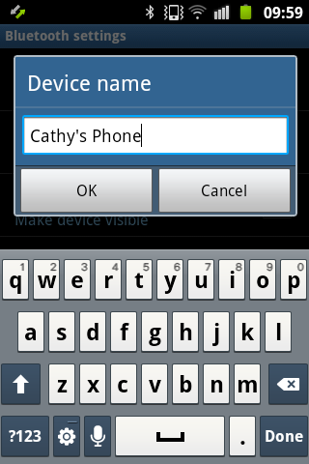

## Making the device Visible/Discoverable

Click on the Bluetooth link above and make sure the device is described as **Visible to all nearby Bluetooth devices**.

You can then use the settings option (bottom right, triple line) to set a time-out for the visibility. This can be set to 2 minutes, 5 minutes, an hour, or Never. We suggest you set the time-out to **Never** for the duration of the fieldwork. Remember this is the "time-out" for the visibility so **Never** means it is **Always** visible whenever Bluetooth is switched on.

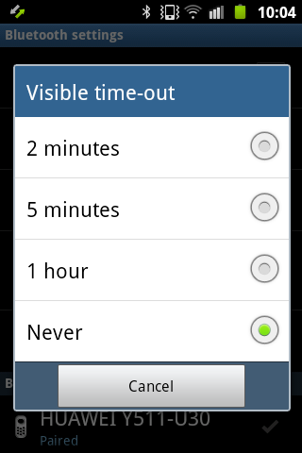

## Pairing devices

The next task is to pair devices. This only needs to be done once. Choose **Search** or **Scan for devices**. After a minute or two you will see a list of Bluetooth enabled devices that are in range. Assuming all members of your team are together you should see the list of phones.

To pair with a device click on the device name where it says **Pair with this device**. You will receive a **Bluetooth pairing request** and the same request will also appear on the device you are trying to pair with. Check that the same **Pass key** appears on both devices and then click on **Accept** or **Pair** depending on your system. If the pairing was successful, the device will appear in the list with a tick by the side.

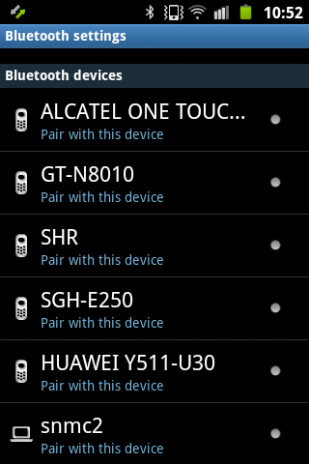 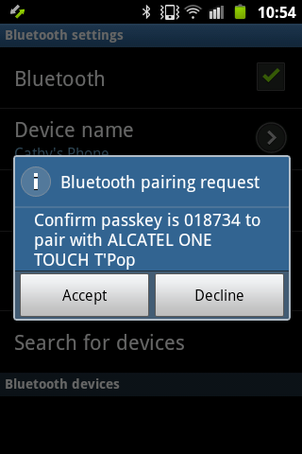 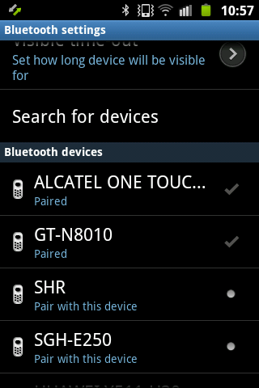

## Copying via Bluetooth

The file manager that is provided with the phones allows you to zip files; this is recommended for backing up.

* Locate the folder ODK; press and hold the main folder (not a sub-folder) until a pop-up menu appears (see the screenshots under the section above on ***Preparing ODK Collect (adding forms to the device)***;
* Choose **Compress**
* The default location and name for the compressed file is shown – change this so that the folder remains the same but change the name of the compressed file to

ODK<##>

Replacing <##> with the unique identification number on the phone (there will be a label on the back of the phone with a number written on it). For example:

ODK09.zip

* Click **OK** to create the zip file.
* Scroll down through the list of folders in File Manager to find the newly generated zip file – this will be at the end of the list.
* Press and hold the zip file until a pop-up menu appears.
* Choose **Share** followed by **Bluetooth** to share the file via Bluetooth.
* Select the device name of the field supervisor's phone from the list of devices. You should receive a notification on the source phone telling you that you are sending a file.
* On the destination phone you should receive a message to say a file is waiting to be transferred and you will need to accept the transfer.

The file will be copied to the folder called **Bluetooth** on the destination phone. You should keep these backup files on your phone until the end of the survey. If you have an opportunity to transfer the files to the fieldwork coordinator at any time during the fieldwork, then this should be done too.

***Note:*** *Sometimes there are problems when trying to send files via Bluetooth; you might not see your device in the list or the notification message may not appear on the destination phone. In these cases you should just try again.*

# Changing ODK Options

By default, ODK has 5 different buttons on the main menu and the **General Settings** allow the user to change the server settings, change navigation options, etc. Most of these options should be hidden to help avoid mistakes. For example, from the buttons on the main menu, the interviewers will only need the first two and their ODK menu should look like this:.

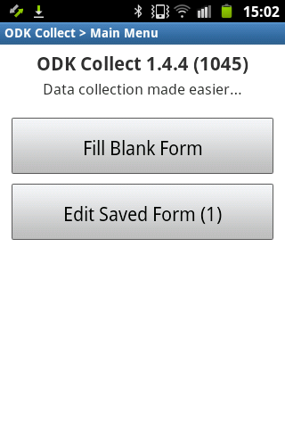

Blank Forms will already be installed on the phones prior to fieldwork and the supervisor will install any updates. The supervisor will be **"Sending the Finalized Forms"** and saved forms should not be deleted; therefore, the interviewer only requires these two options to complete their tasks.

## Hiding Buttons on the Main Menu

To hide buttons on the main menu, click the **Settings** button on your phone and choose **Admin Settings**. Tap “Main Menu Settings” to see a list of menu items that can be hidden from the main menu.

As of v1.13.0, the options are:

* Edit Saved Form
* Send Finalized Form
* View Sent Form
* Get Blank Form
* Delete Saved Form

Leave the first option (Edit Saved Form) ticked but uncheck the other options. Note: when you are uploading checked and finalised forms at the end of the day you will need to temporarily unhide the **Send Finalized Form** option. Also, if you need to download a revised version of the form you will need to temporarily unhide the **Get Blank Form** option.

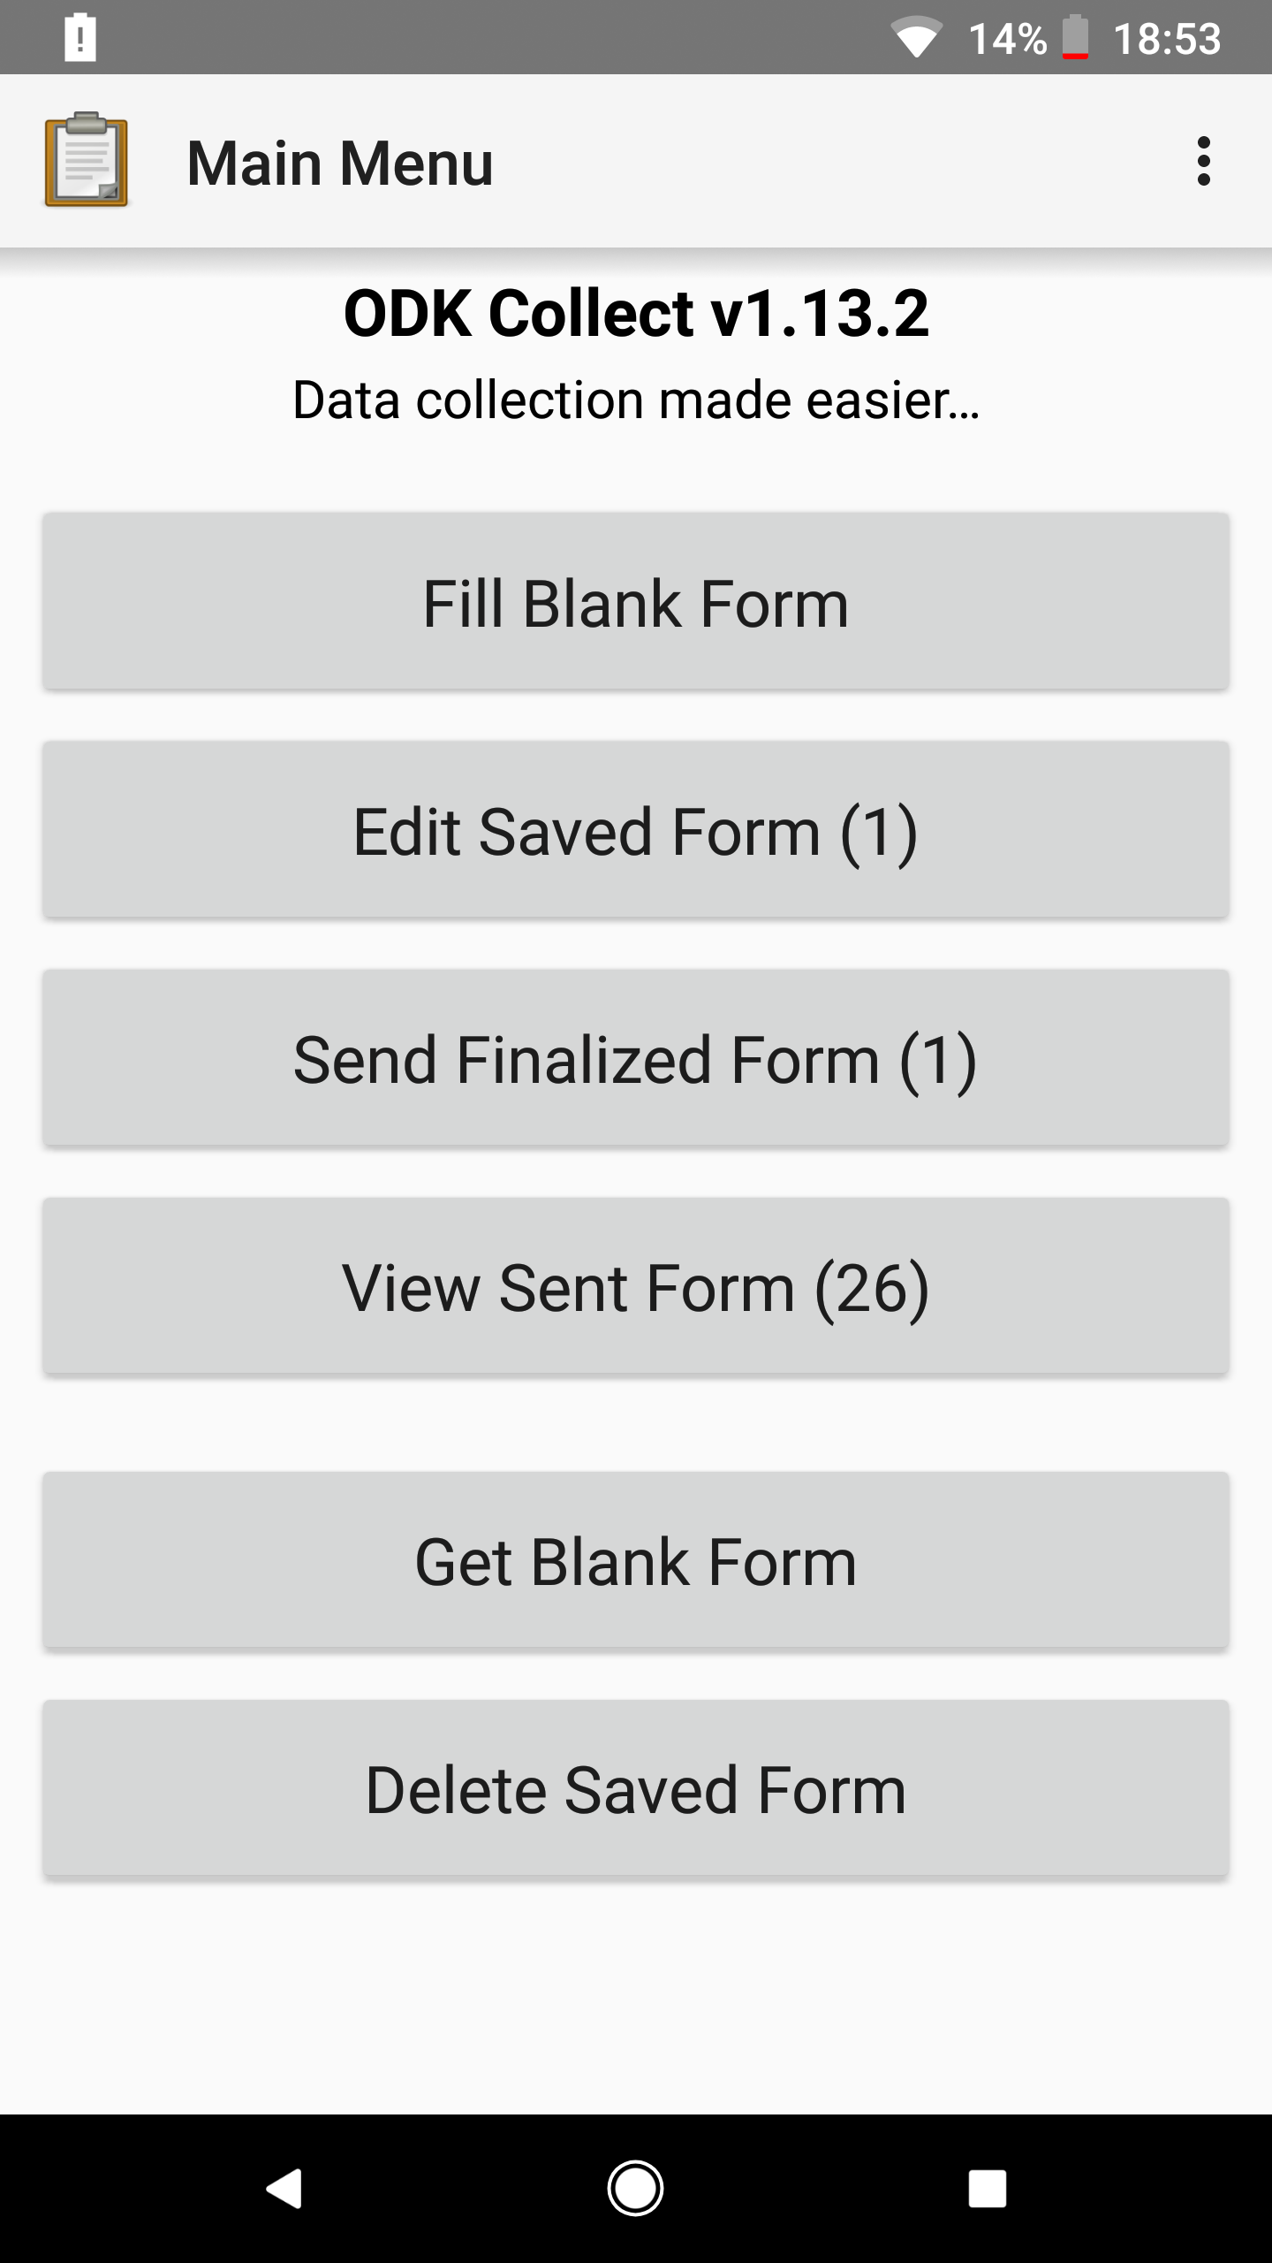 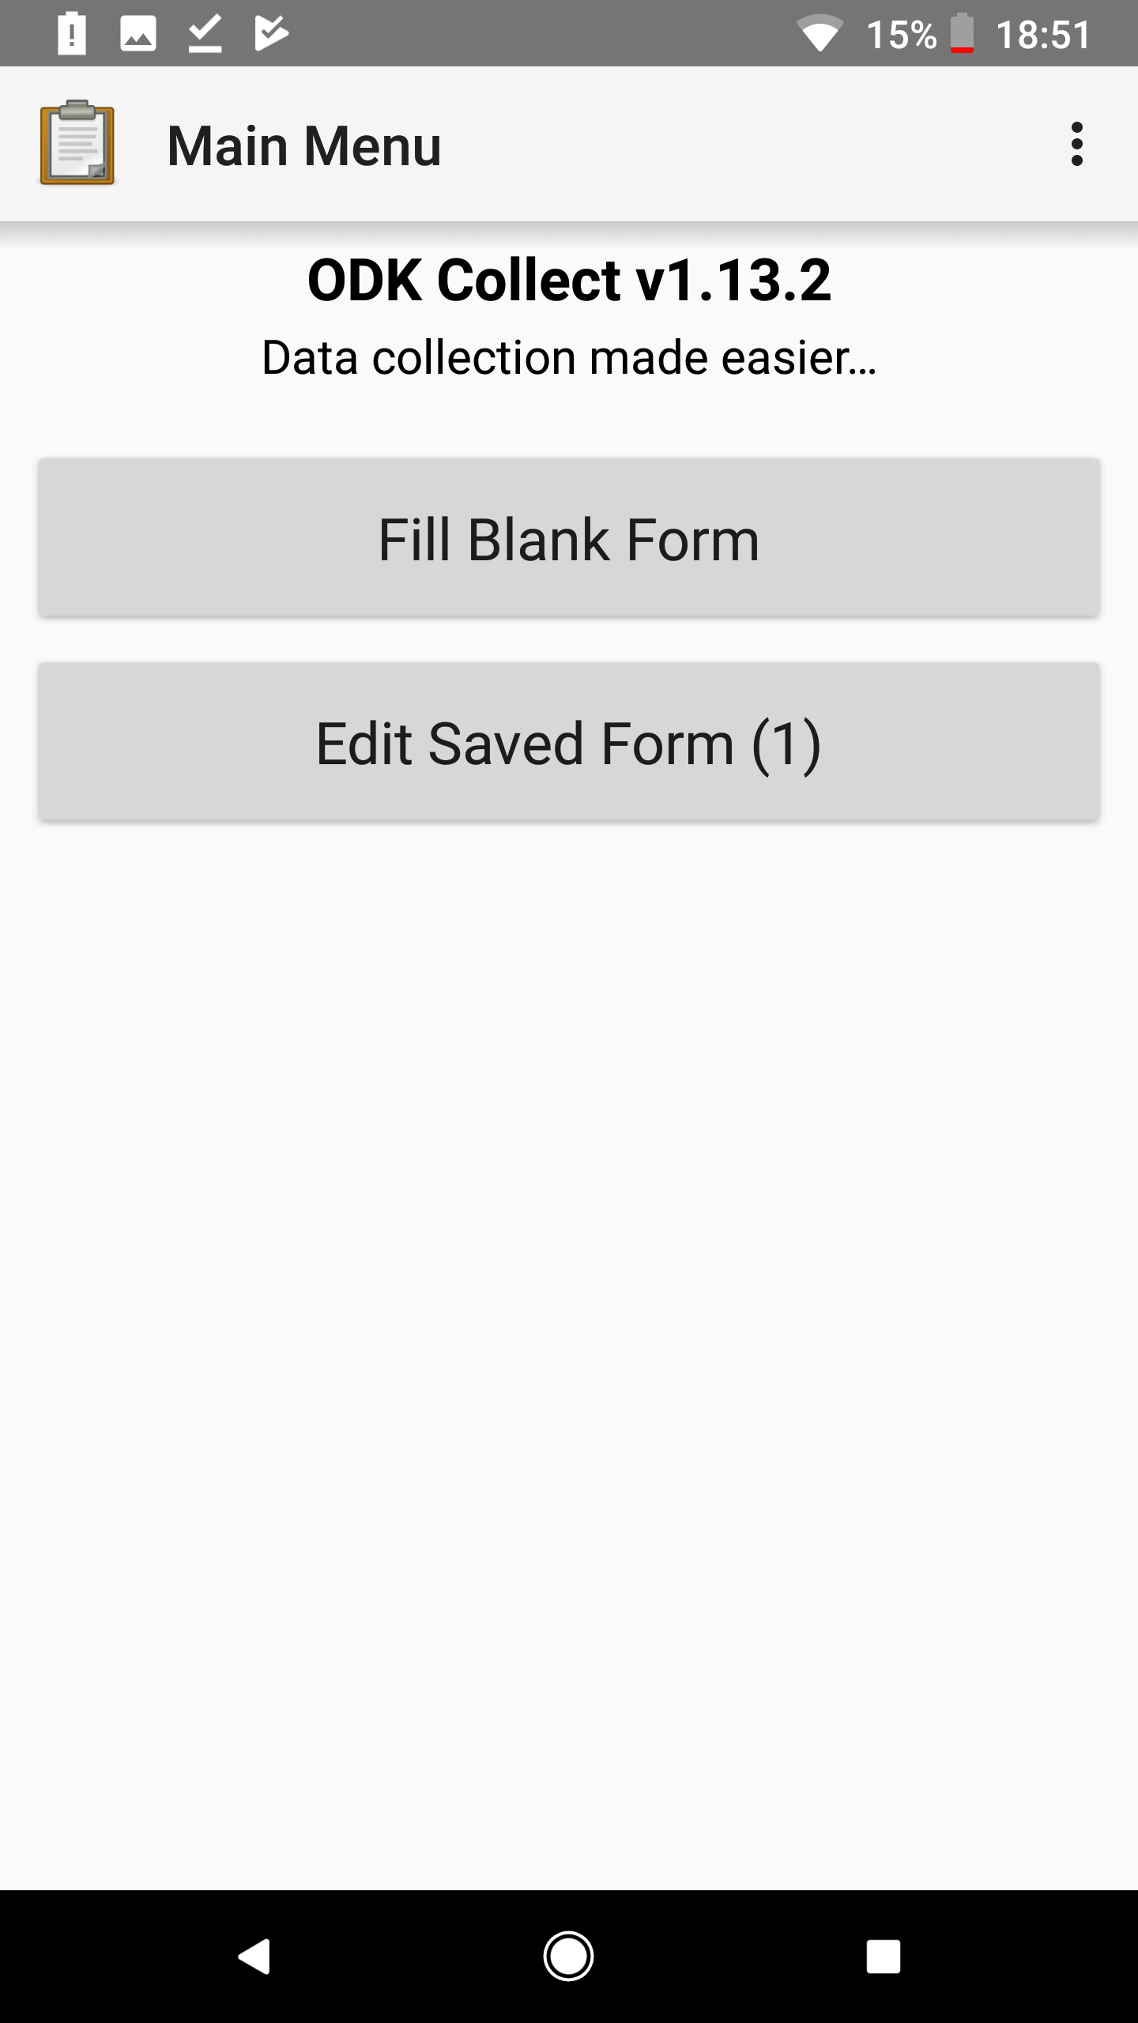

The images above show the default menu and the menu after making these changes (unchecking the 3 boxes).

### Changing General Settings Options

ODK Collect has a lot of general settings, split into 4 main headings:

* **Server**: The configuration settings for connecting to your ODK server.
* **User Interface**: elements that modify the look and navigation methods in the app
* **Form management**: options regarding default behaviour when finalising and sending forms.
* **User and device identity**: device metadata that gets passed to any form that requests it.

We recommend familiarizing yourself with the options available. Most of the ‘default’ settings are suitable for most situations, but there are a few options we recommend considering carefully:

* **User Interface > Navigation** and **Text font size**. These are options the interviewers should be able to set for themselves. The **Navigation** option allows them to choose between using Next/Previous buttons and using forward and backward swipes to navigate.
* **Form Management > Image Size.** If you are collecting photos, this setting is very important. If your team will be working on poor wifi or cellular connections, you will want to limit the size of the images that get attached to the form. We recommend the “Small” size as a good compromise between size and quality, but this is something that should be tested in a pilot survey.

Most of these settings options can be hidden from view by going to the **admin settings** and tapping “User Settings”. You can hide these options and then set an admin password to prevent non-admin users resetting any of the settings if you need more control over the application.

Note: hiding these options from the displayed list of settings doesn't mean they are not set. **Default to finalised** for instance should have been set prior to fieldwork; hiding this option from general settings make it more difficult to accidentally change this setting.

## Changing Form Entry Items

There are some options that appear on the **Settings** menu during form entry. These should all be left as unhidden.

* **General Settings** – allows the user to display the general settings
* **Change language** – allows the user to swap between the available languages in the form.
* **Go To Prompt** – allows the user to display all questions and responses in a list
* **Save Form** – allows the user to save the form at the current position.

Finally, there are two options that appear at the end of the questionnaire. These options are:

* **Name this form** – this should be hidden as we have designed the ODK system to automatically name the instance of the form with the primary key value.
* **Mark form as finalised** – this should happen automatically and we don't want to give the option of not finalising the forms once you reach the end so this option should also be hidden.

# Uploading Finalised and Checked forms to the server

Once you have checked the completed forms and are satisfied that they are correct and after you have shared the compressed folder to your own phone via Bluetooth, you should try to upload these completed forms to the server. This must be done from each **each interviewer’s phone** in turn.

You will first need to temporarily display the relevant menu option:

* Within ODK Collect, click the **Settings** button on the phone and choose **Admin Settings**
* Select the option **Send Finalized Form**
* Go back to the main menu where you should see the option **Send Finalized Form** and there should be a number in brackets indicating the number of forms waiting to be sent.
* Make sure this number tallies with what you expect – then click on the button to upload the forms.
* Go back to **Admin Settings** and hide the **Send Finalized Form** option from the main menu.

# Downloading Revised ODK form

Although we have tried to produce a final version of the ODK system prior to fieldwork there may well be improvements and/or corrections that need to be made once it is fully tested in the field. When this happens, you will receive notification that a new version is available and you will need to download this to all the phones for your team.

* Click the **Settings** button on the phone and choose **Admin Settings**
* Select the option **Get Blank Form**
* Go back to the main menu where you should now see the option **Get Blank form**. Choose this option.
* This will connect you to the server where you will see all versions of the survey form. Select the one with the most recent date and click on **Get Selected**. Hopefully the download will be successful so click **OK** – otherwise please try again later.
* Go back to **Admin Settings** and hide the **Get Blank Form** option from the main menu.
* Instruct the interviewers to use this revised form from this point on reminding them to choose the version with the most recent date.

1. More information about creating a Google Account can be found here: <https://accounts.google.com/SignUp?hl=en> [↑](#footnote-ref-1)
2. At time of writing, this is version 1.13.0. You may require a specific version of the app, but unless your project has specific requirements, we recommend simply using the most up-to-date version of ODK Collect. [↑](#footnote-ref-2)