 

Portals for Archiving and Sharing

**March 2018**

# C:\Users\Administrator.SNPC71\Dropbox (SSD)\Stats4SD\Internal Docs\Stationery\Logos\Logo\Stats4SD_Logo_Red_Small.png

This document was produced in collaboration with [Statistics for Sustainable Development](https://stats4sd.org/) and is licensed under a [Creative Commons Attribution-NonCommercial-ShareAlike 3.0 Unported License](http://creativecommons.org/licenses/by-nc-sa/3.0/deed.en_GB)

# Introduction

This guide distinguishes between repositories for data and those for publications. Although there are numerous repositories available, the ones used most often by CIAT and CCAFS are Dataverse for archiving data and related documents, and DSpace for storing publications. The guide notes the difference between “reports” which should be included with the data archive, and peer-reviewed publications.

# Data Repositories

We start by looking at the main data repositories for CIAT and CCAFS data and related documentation. Note that data reports, fieldwork reports, interim and final analysis reports based on the analysis plan, should be archived along with the data to a data repository.

## Dataverse

Dataverse is an open source web application for sharing, preserving, exploring and analysing research data. It was created by the [Institute for Quantitative Social Science](https://www.iq.harvard.edu/) at Harvard University. A separate document in this pack describes Dataverse in more detail. The website for the Dataverse Project is <https://dataverse.org/>

CIAT Dataverse

The CIAT Dataverse can be found at the following link: <https://dataverse.harvard.edu/dataverse/CIAT> and the image below shows the front page of this Dataverse.

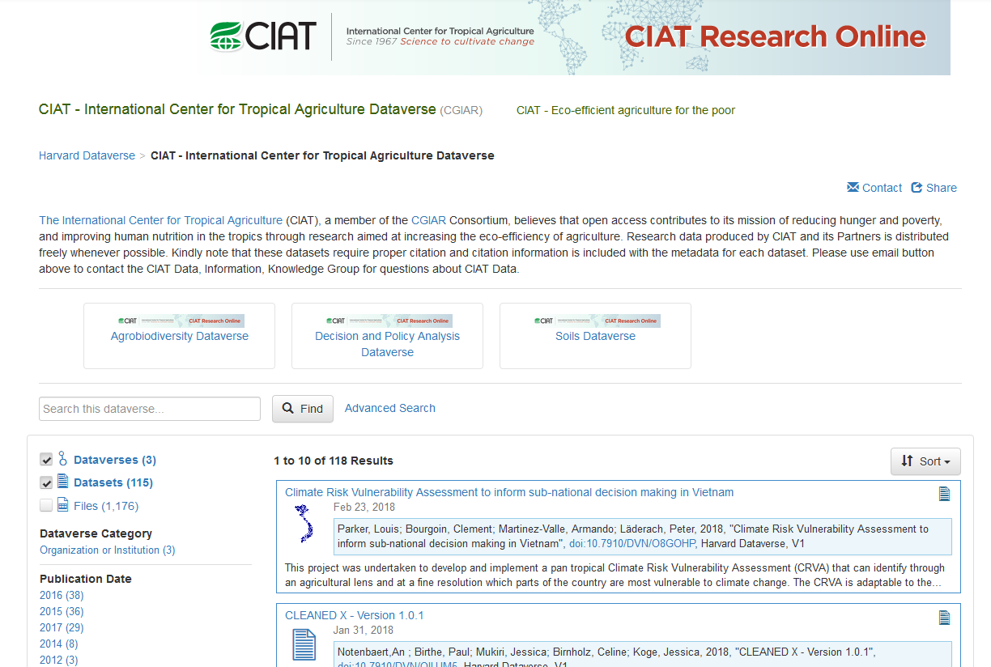

At the time of writing, the CIAT Dataverse houses 118 datasets which are divided among 3 sub-Dataverses: Agrobiodiversity, Decision and Policy Analysis, and Soils. The most recent dataset was published on the Dataverse on 23rd February 2018.

CCAFS Dataverse

The CCAFS Dataverse can be found at the following link: <https://dataverse.harvard.edu/dataverse/CCAFSbaseline> and the image below shows the front page of this Dataverse.

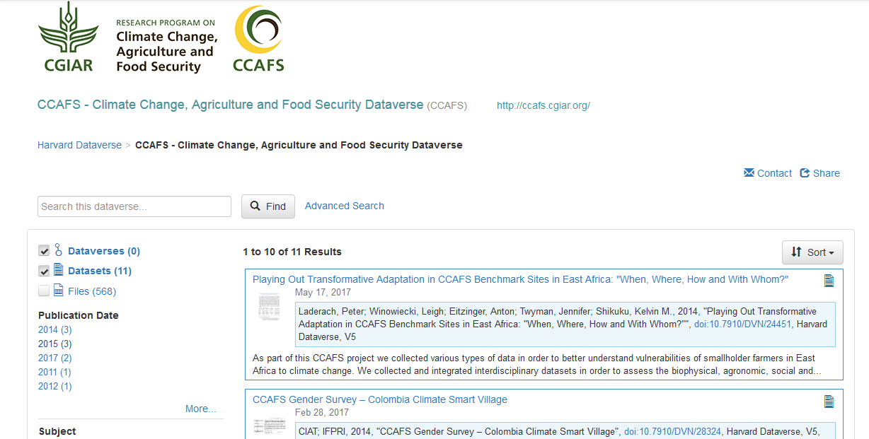

There are currently 11 datasets housed on the CCAFS Dataverse which includes the Households Baseline, Village Baseline and Organisational Baseline Studies.

## AgTrials

AgTrials is the Global Agricultural Trial Repository and Database. This is an information portal developed by CCAFS which provides access to a database on the performance of agricultural technologies at sites across the developing world. It builds on decades of evaluation trials, mostly of varieties, but includes any agricultural technology for developing world farmers.

AgTrials is available at the following link: <http://agtrials.org/> and the front page of the site is shown below. With the interface you can:

* Share data and information on evaluations of agricultural technology;
* Acquire agricultural evaluation datasets for your own research;
* Explore the geographic dimensions of agricultural evaluation.

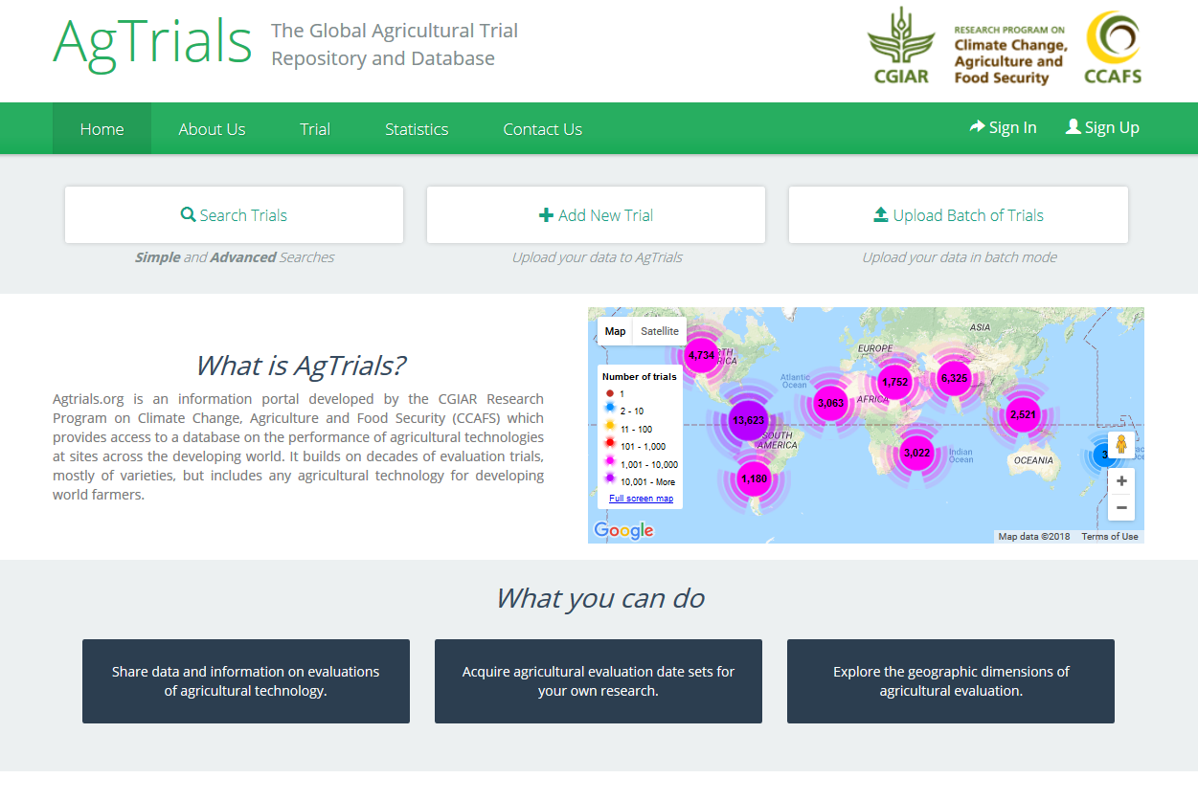

## CCAFS-Climate

The CCAFS-Climate data portal provides global and regional future high-resolution climate datasets that serve as a basis for assessing the climate change impacts and adaptation in a variety of fields including biodiversity, agricultural and livestock production, and ecosystem services and hydrology.

CCAFS-Climate can be found at: <http://www.ccafs-climate.org/> and the image below shows the front page of the site. The site includes a video tutorial showing how to download data from the site.

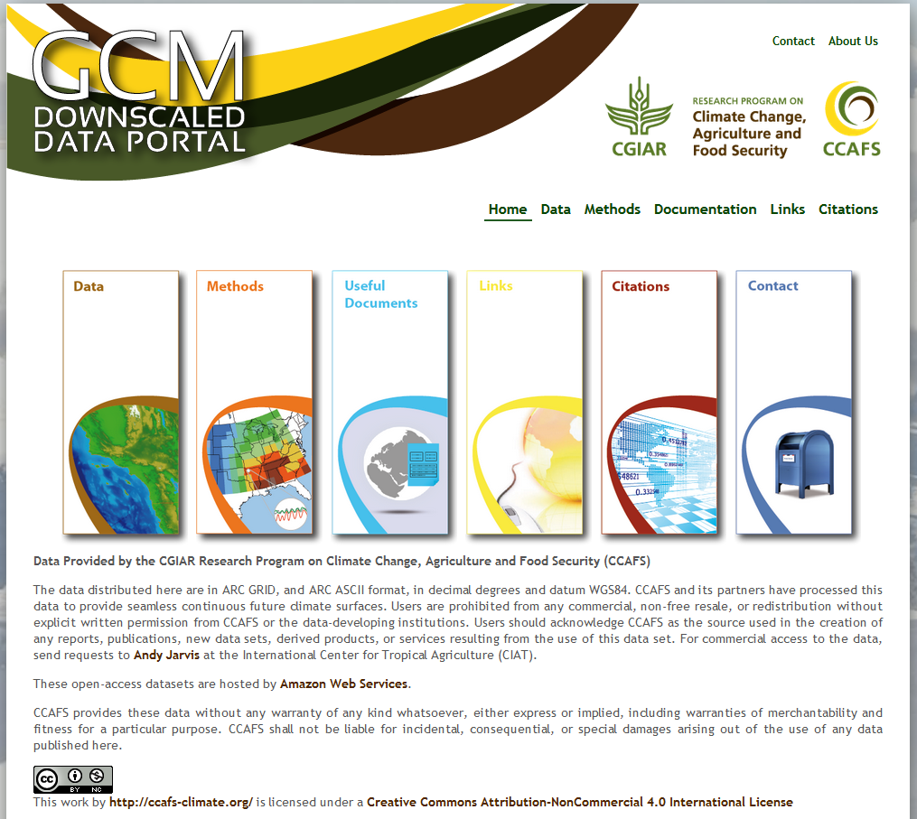

# Publication Repositories

By “publications” in this context we are referring to peer-reviewed publications and articles such as those that might be submitted to journals. These publications should, wherever possible, include a reference to the location of the data used for any analysis within the publication. This adds credence to the results as it is possible for other researchers to download the relevant data and confirm the results.

## DSpace

The main publication repository used by CIAT and CCAFS is DSpace - <http://www.dspace.org/>. DSpace open source software is a repository application used by more than 1000+ organisations and institutions worldwide; it provides durable access to digital resources. DSpace preserves and enables easy and open access to all types of digital content including text, images, moving images and datasets.

CGSpace

CGSpace is a repository of agricultural research outputs and results produced by different parts of CGIAR and partners. It indexes reports, articles, press releases, presentations, videos, policy briefs and more. It is a collaboration of several centres, the CGIAR system management office and research programmes. It is hosted by the International Livestock Research Institute (ILRI).

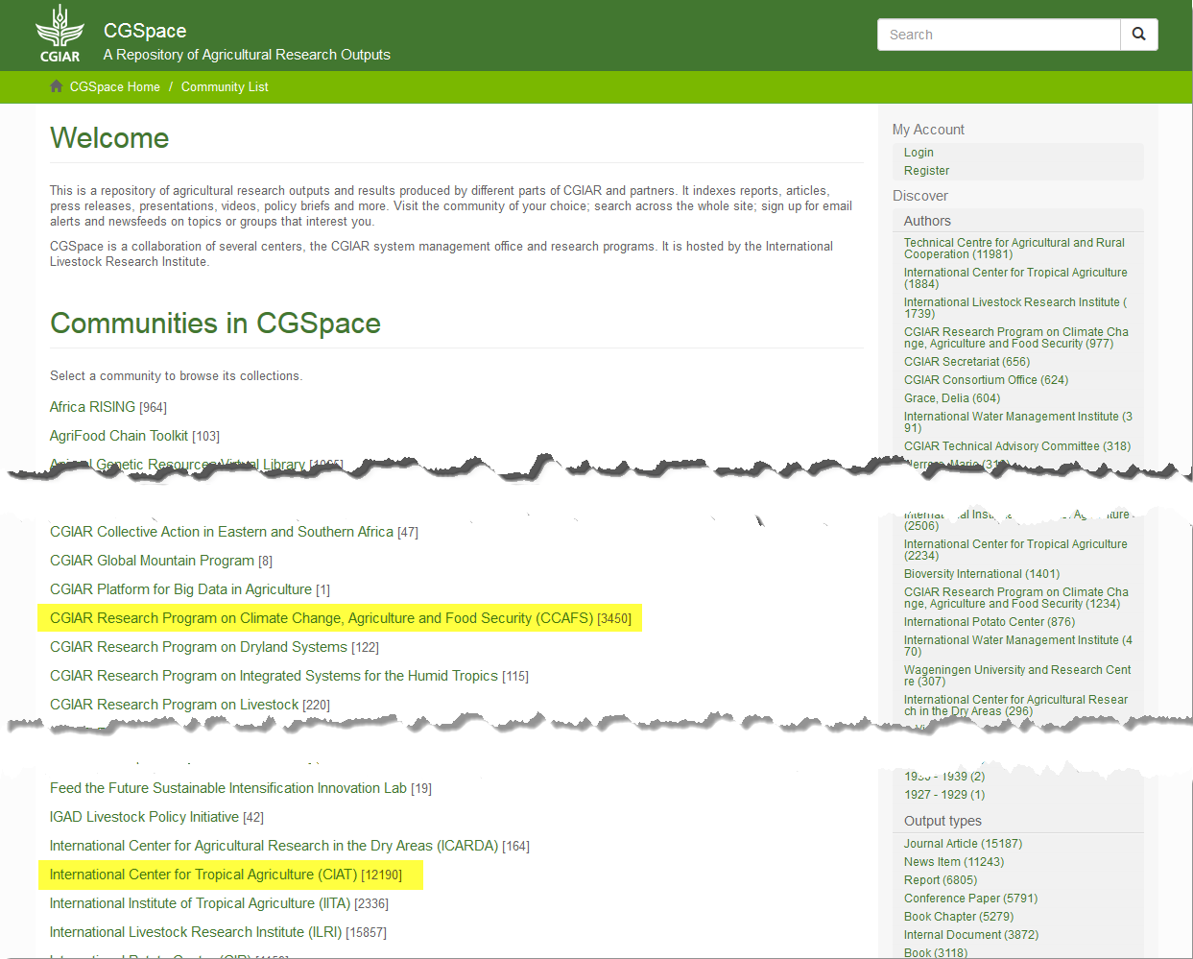

The image above shows the front page of CGSpace - <https://cgspace.cgiar.org/> and we have highlighted both CCAFS and CIAT in the list of Communities in CGSpace.

The image below shows the CCAFS site within CGSpace which currently houses more than 3,400 items. On the site you can search the collection by author, by date, by output type, by region, etc. This makes the site incredibly flexible.

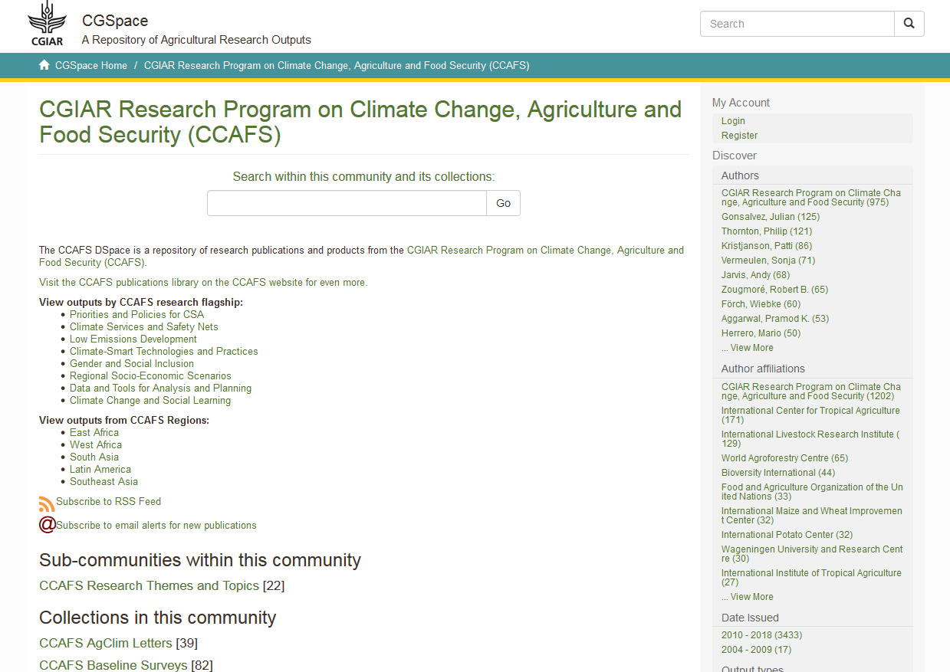

The CIAT site within CGSpace has a similar structure as can be seen from the image below:

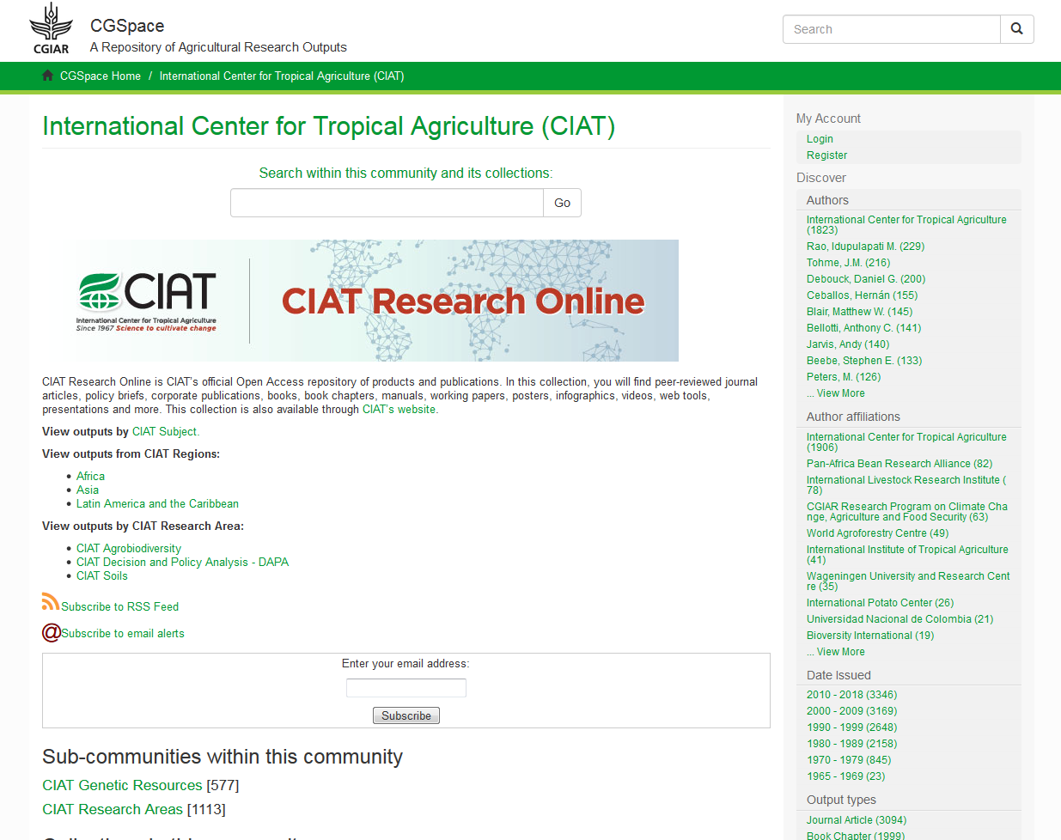

CIAT Library Resources

In additional to the CIAT site within CGSpace, CIAT also has a set of library resources available at the following link: <http://ciat.cgiar.org/publications/ciat-library-resources/> This site provides an overview of CIAT Library resources and provides links to Open Access Research Repositories, to CIAT Repositories, and useful guides and newsletters.

