# Windows 8

Welcome to Windows 8! We will begin by examining the redesigned File Explorer. Although it was known as Windows Explorer in previous editions of Windows, its overall functionality remains the same. File Explorer is most commonly used to manage files and folders on your computer. In this section, we will focus on its interface and the major components of it.

**Tip:** We recommend that you copy the Exercise Files folder to a readily accessible location, such as the desktop. If you do not have permission to store files on a classroom machine, we recommend using a USB flash drive. Please note that some exercises presume that the Exercise Files folder has been added to the desktop.

## 

## Opening File Explorer

Like many of the applications found in Windows 8, File Explorer may be opened in a variety of ways. If you type “File Explorer” with the Start screen open, you will see search results with File Explorer listed. Click this result to open it on the desktop:

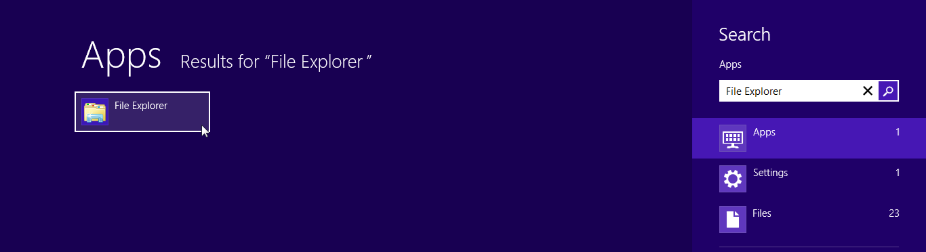

Also using the Start screen, you can open the Apps bar and click “All apps.” Then, click File Explorer from the list:

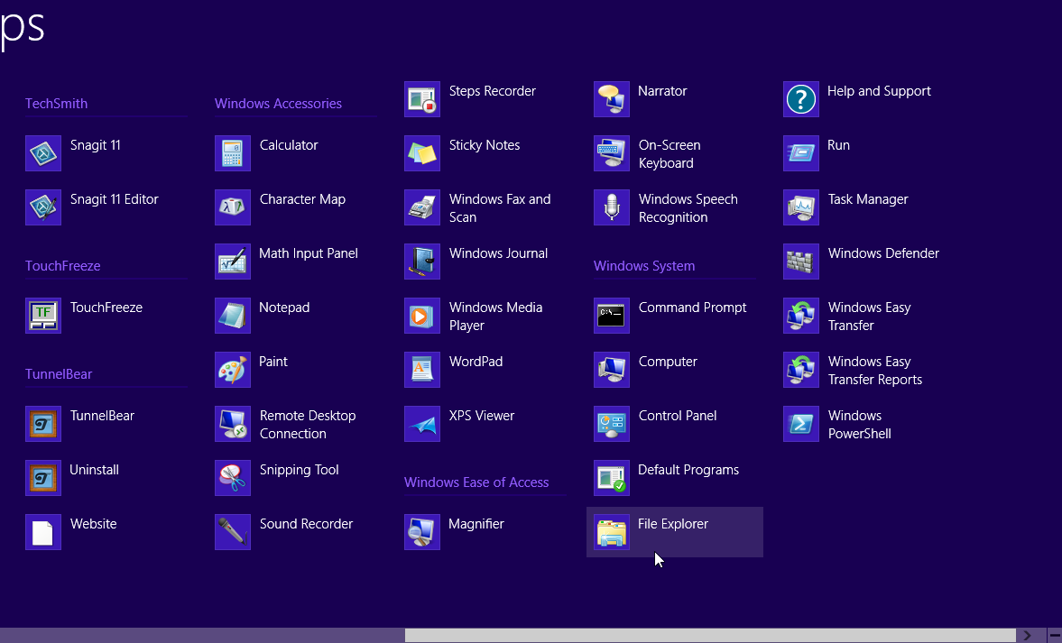

As well, by default File Explorer will also be pinned to the taskbar on the desktop. Click the File Explorer icon to open it:

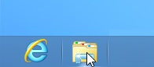

Finally, File Explorer may be opened at any time by pressing Windows + E on your keyboard.

## Interface Overview

When you open File Explorer it will look like this:

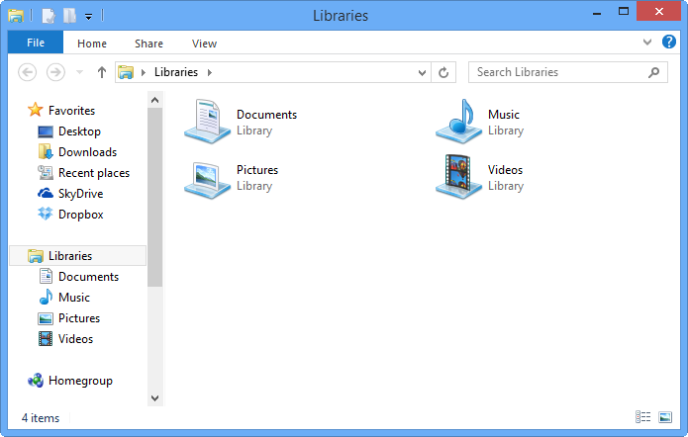

Let’s look at the different components.

|  |  |  |  |
| --- | --- | --- | --- |
| Title Bar | The title bar of the File Explorer window will display the current folder or library that is open, as well as the Minimize, Maximize, and Close buttons. You will also notice that there is also a row of icons on the left. This is the Quick Access toolbar: | | |
| Ribbon Tabs | Click a ribbon tab to display related commands:    Note that additional tabs (called conwtextual tabs) may be available depending on the folder that you are viewing. For example, the Recycle Bin and libraries both have contextual tabs. | | |
|  | | Here you can see the Home tab: |
| Address Bar | | The address bar displays what folder is currently open, as well as a breadcrumb trail showing the parent folder. You will also see some simple navigation controls as well as a search field: |
| Navigation Pane | | The Navigation pane displays a list of favorite locations, such as your desktop, your SkyDrive libraries, network locations, and hard drives: |
| Working Area | | Finally, the working area will display the files or folders within the location you’re currently viewing: |

# About Standard Tabs

You will see four tabs on the File Explorer ribbon: File, Home, Share, and View.

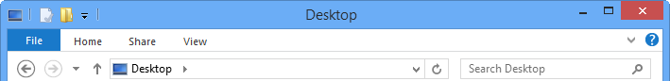

Clicking the Home, Share, or View tabs will display related commands grouped together:

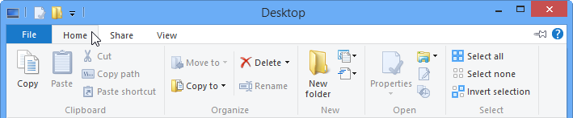

(By default, the ribbon is minimized and commands are hidden. To change this, click the maximize icon next to the help icon.)

The Home tab in File Explorer contains five groups that contain various general productivity and organizational commands. You will find commands to move, copy, delete, and rename selected folders and files:

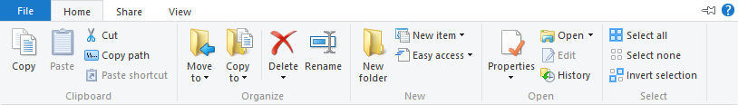

The Share tab in File Explorer contains just two groups with tools to share selected files or folders. For example, you will see commands to fax and burn files on this tab:

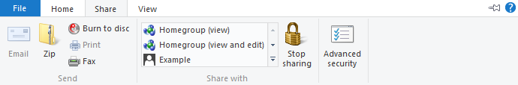

The last tab in the File Explorer window is the View tab. This tab controls how you view, sort, and group files. You can choose new layout options; customize the Navigation pane, and more:

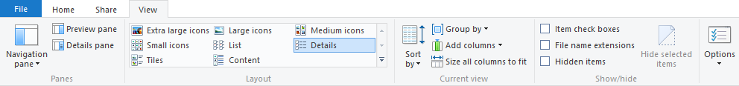

## About Contextual Tabs

Specially colored tabs will appear on the File Explorer ribbon when certain conditions are met. For example, if you open a library, the Library Tools – Manage tab will be displayed:

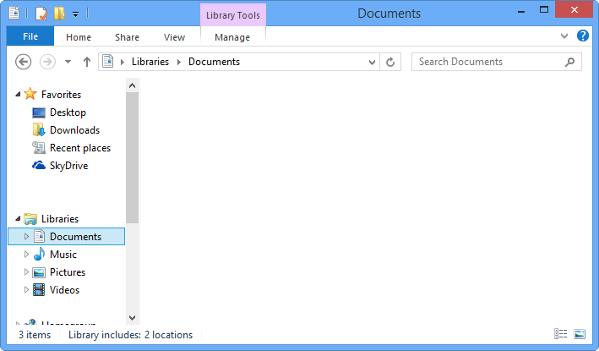

This tab contains commands that are specific to working with a library:

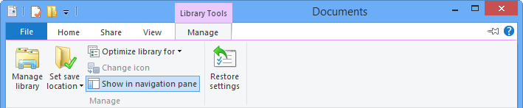

Contextual tabs will also appear if specific files are found or selected in an open library or folder. Here you can see the Music Tools – Play contextual tab that appears when the Music library is opened:

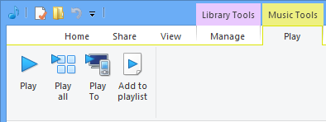

## About the File Menu

When the File tab is clicked, it will display the following menu:

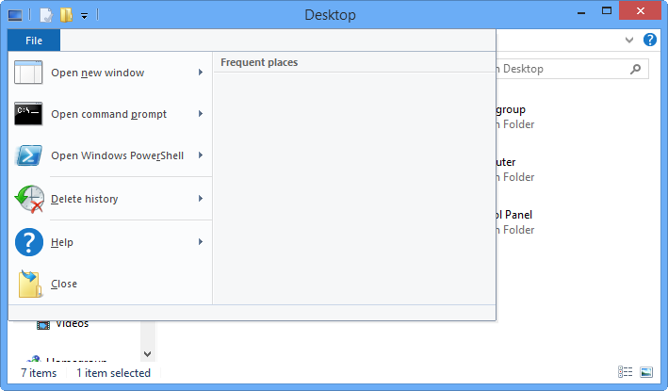

The right-hand side of the File menu will display frequent places. You can click on an item to open that location.

You can also pin frequently visited places to this menu by clicking the pushpin icon to the right of each entry:

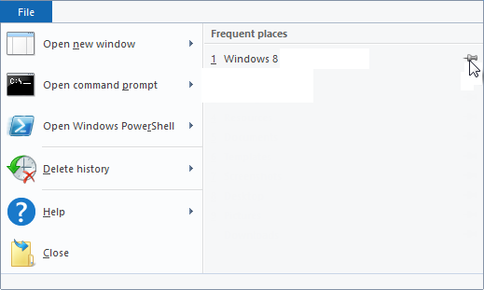

To clear this list, click Delete history → Recent places list:

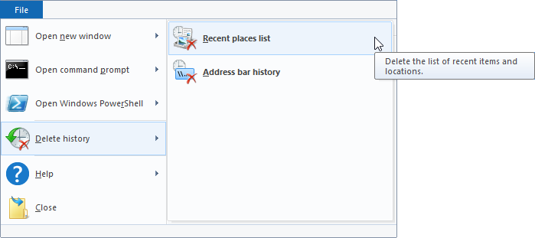

On the left-hand side of the File menu, you will see commands that may be used to open all kinds of different tools in Windows 8, as well as new File Explorer windows. (Note that Command Prompt and Windows PowerShell are advanced tools that should only be used by those with experienced knowledge of these tools.) In addition, you will also see a link to Help, and a command to close the File Explorer window.

# Using the Quick Access Toolbar

The Quick Access toolbar can be found on the left-hand side of the File Explorer title bar:



TheQuick Access toolbarwas a new feature introduced with Microsoft Office 2007. Brought over from the Office environment to Windows, you can find the Quick Access toolbar in the upper left-hand corner of lots of Windows 8 desktop applications. What sets this particular toolbar apart from others is that it is always available and completely customizable.

File Explorer’s Quick Access toolbar contains two default commands: Properties and New Folder.



The Properties command will open the Properties dialog of the currently selected object in File Explorer:

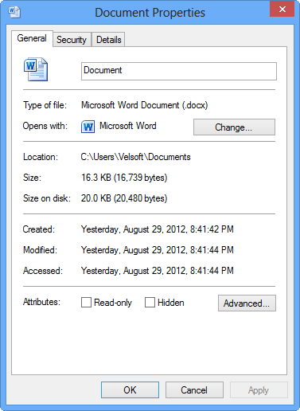

The New Folder command will create a new folder in the current location.

## Customizing the Quick Access Toolbar

The most important aspect of the Quick Access toolbar is that it is completely flexible; you can add or remove commands from it at any time. To the right of the default commands, you will see a pull-down arrow. If you click this, you have the option to add some other common commands to the QAT:

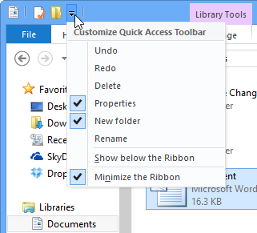

As you can see, there are already checkmarks beside the Properties, and New folder commands. The checkmarks mean that those particular commands are already on the Quick Access toolbar. If you clicked the pull-down arrow and clicked Undo, that command would be added to the right of New Folder:



You’re not limited to this list; you can add nearly any command you like to the QAT. Just right-click a command in the File Explorer window and click “Add to Quick Access Toolbar.” Here, we are adding the Delete command:

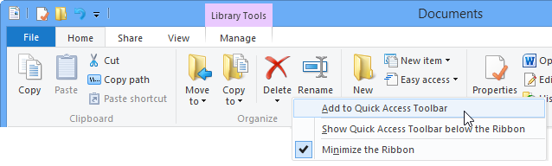

To remove a command from the QAT, right-click the command and click “Remove from Quick Access Toolbar:”

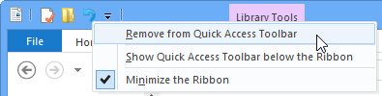

In this example, we’re removing the Undo command.

# Step-By-Step

In this exercise, you will learn how to use File Explorer to complete some basic tasks.

|  |  |
| --- | --- |
|  | To begin, ensure that you’re logged into your Windows 8 account and that the Start screen is displayed. Switch to the desktop by clicking on the Desktop tile or by pressing Windows + D on your keyboard: |
|  |  |
|  | Once on the desktop, click the File Explorer icon on the taskbar:    (If you do not see this icon, press Windows + E.) |
|  |  |
|  | You will now see the File Explorer window displayed on the desktop:  C:\Users\Velsoft\AppData\Local\Temp\SNAGHTML865774.PNG |
|  |  |
|  | Click the pull down arrow beside the Quick Access toolbar. Click Delete to add that command to the toolbar:  C:\Users\Velsoft\AppData\Local\Temp\SNAGHTML879c41.PNG |
|  |  |
|  | The Quick Access toolbar will now look like this:  C:\Users\Velsoft\AppData\Local\Temp\SNAGHTML885e67.PNG |
|  |  |
|  | If it is not displayed already, click the Libraries listing from within the Navigation pane:  C:\Users\Velsoft\AppData\Local\Temp\SNAGHTML89f671.PNG |
|  |  |
|  | Now, click once to select the Pictures library. This will display the Library Tools – Manage tab:  C:\Users\Velsoft\AppData\Local\Temp\SNAGHTML94e284.PNG |
|  |  |
|  | Click this tab to expand it:  WorB783 |
|  |  |
|  | Place your cursor over each command to display a description of that feature:  C:\Users\Velsoft\AppData\Local\Temp\SNAGHTML96da4a.PNG |
|  |  |
|  | Explore the commands in the Home, Share, and View tabs:  C:\Users\Velsoft\AppData\Local\Temp\SNAGHTML995e77.PNG |
|  |  |
|  | Click the File tab to display its menu:  C:\Users\Velsoft\AppData\Local\Temp\SNAGHTML9b4b16.PNG |
|  |  |
|  | Make note of any frequent places listed as well as the commands in this menu. Click the Close button to close File Explorer and complete this exercise:  C:\Users\Velsoft\AppData\Local\Temp\SNAGHTML9dd1d2.PNG |

# Skill Sharpener

|  |  |
| --- | --- |
| Objective | To understand how to use the Quick Access toolbar in File Explorer. |
| Briefing | To help you be more efficient when using File Explorer, you would like to customize the Quick Access toolbar to suit your needs. |
| Task | Add any commands you wish from the ribbon to the Quick Access toolbar. Remove any commands that you will not need. Then, decide if you would like the Quick Access toolbar to be above or below the ribbon. |
| Hints | You can quickly add commands to the Quick Access toolbar by right-clicking on the command on the ribbon and clicking “Add to Quick Access Toolbar” from the context menu. |
| Follow-Up Questions | Do you prefer to have the Quick Access toolbar on top or below the ribbon? Why or why not? |