|  |  |
| --- | --- |
| Mogammad allie Cornelius  Student NO: 16423743 | Assignment 1: Web Development  GitHub URL: <https://alliecornelius.github.io/csy1018-assign1/>  Submission Date: 13/01/2017 |

Contents

0

Initial Stages 2

Designs 2

Wireframes 3

Home 3

Biography 4

Contact 5

CV 6

Development Environment 7

Good Practice 7

Navigation 7

Progression of website over 12 weeks 8

Weeks 1-4 8

Weeks 4-8 8

Weeks 9-12 10

Elements that could be improved 11

Navigation Pane 11

# Initial Stages

To begin the assignment, I had to gain some inspiration for the layout ad style that I would be applying to my own website. For this, I had looked at a range of websites and picked out certain aspects of these that would be useful to include in my own website.

<https://joel.sh/> - This helped me to understand what types of layouts would be suitable for my website.

<http://thrivesolo.com/> - This website contains a header with a navigation bar implemented within it. This would be a vital part of any website as it shows that there is a clear navigation pane.

<http://www.fitbit.com/uk> - The fit bit website shows clear use of page space. As all the space on the pages are utilised. There is also clear colour scheme that is seen across all the pages. This allows for the theme to be kept constant.

<https://material.io/guidelines/style/color.html#color-color-palette> - I had use the colour palette provided from Google to allow me to find a colour scheme or a set of colours that would go well with each other.

# Designs

For the designs of my website I have created a range of wireframes which outlines the layout of the webpages and what will be placed on each webpage. This will be a template that I will be using to base my website around. The final product should follow these wireframe designs. These designs are a combination of elements found from other webpages and I have used these to allow

## Wireframes

### Home

This wireframe refers to my home page:

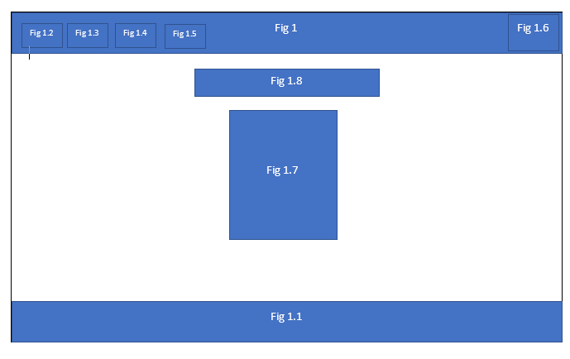

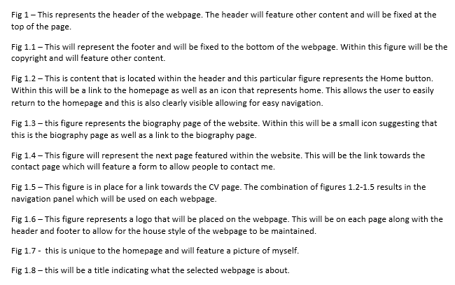

### Biography

This wireframe refers to my biography page:

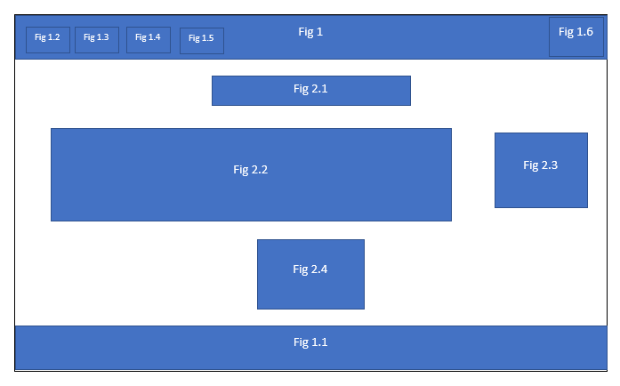

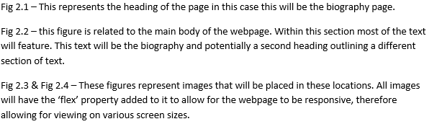

### Contact

This wireframe refers to my contact page:

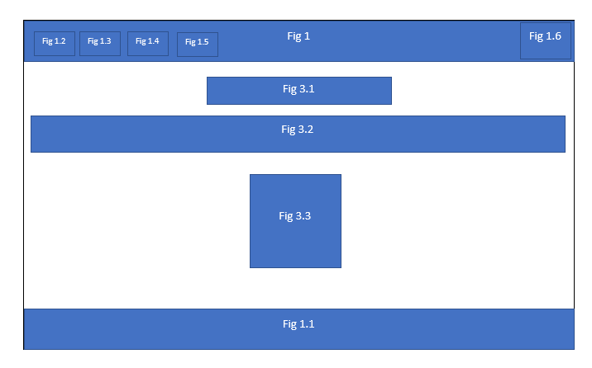

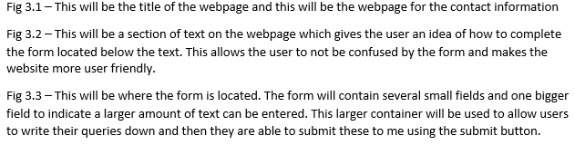

### CV

This is my wireframe for the CV Page:

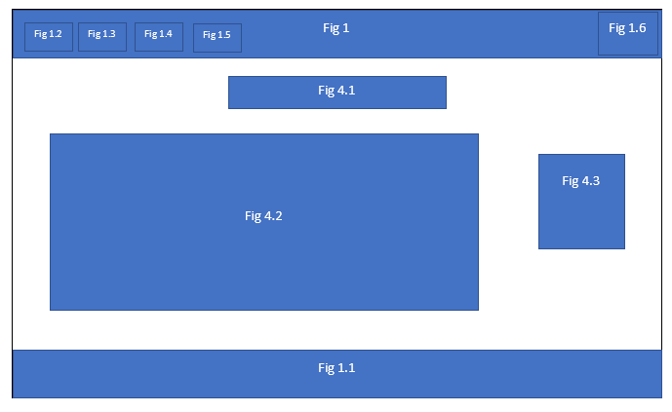

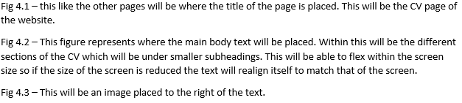

## Development Environment

To create the website, I had used Atom as my development environment. This meant I was freely able to code my HTML and CSS files. With the use of various packages, it helped me to spot errors in my code as well as using the HTML Preview package to have an idea of what the website would look like whilst I was developing it.

Further to this I also used GitHub to allow for the website to be visible as a live URL and GitHub was also an easy way to have access to my documents so I could work through development of my website from various locations.

## Good Practice

### Navigation

An element of good practice is navigation. I have ensured that my navigation bar is clear and visible to the user on every page. This can be seen through the screenshot of my navigation pane which is pictured below;

#### Navigation Pane

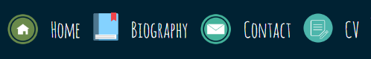

The navigation panel is clear and concise. The icons used are icons that will trigger the mental model of the user as it is an icon that is related to its page.

Navigation is also an important factor as the user should be able to navigate freely between webpages, going from one page to another and then being able to either go back to the page that they have come from or to progress onto another page on the website.

#### Aesthetics

When it comes to creating a website the aesthetics of the site should be good and should follow trends to allow for the user’s mental model to be continuously triggered. I have ensured that this is done by looking at other websites that have used CSS and HTML as well as following colour schemes I had found through <https://www.materialpalette.com/> and then incorporated these into my website. Further to this I had also used <https://fonts.google.com/> to get a aesthetically pleasing font that would be easy to read and also looking stylish to add a more modern look to the website.

To create a better user environment, I also added icons to my navigation pane to allow for usability of the site to be enhanced.

## Progression of website over 12 weeks

### Weeks 1-4

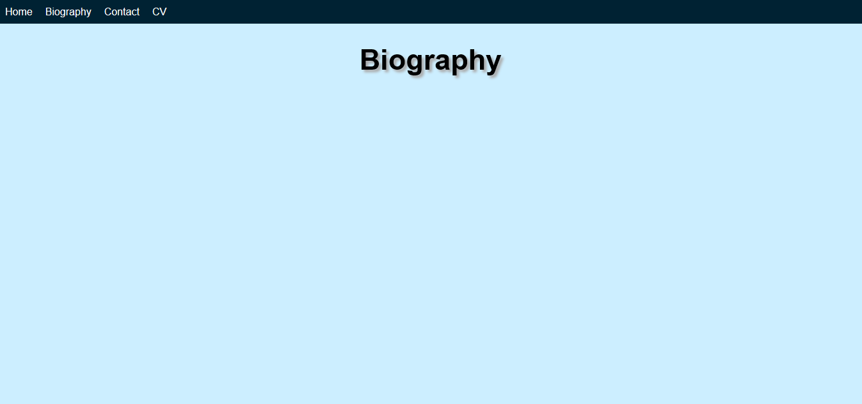

Weeks 1-4 saw the creation of my layout of the website as well as the creation of all the webpages each following the same layout. This meant that I had heading styles set and the colours that I would go on to use throughout the site development.

### Weeks 4-8

#### Home Page

#### 

#### Biography Page

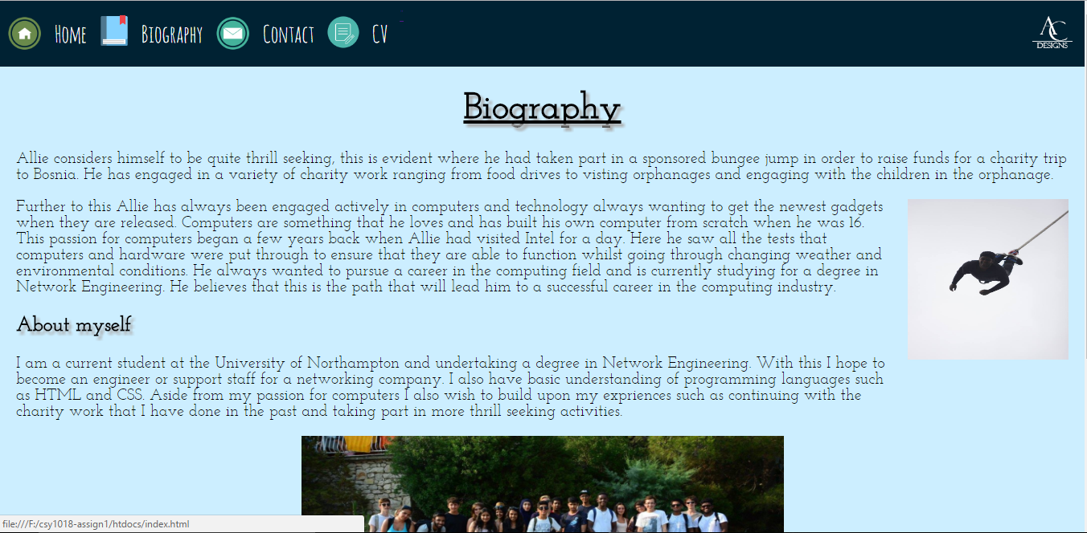

#### Contact Page

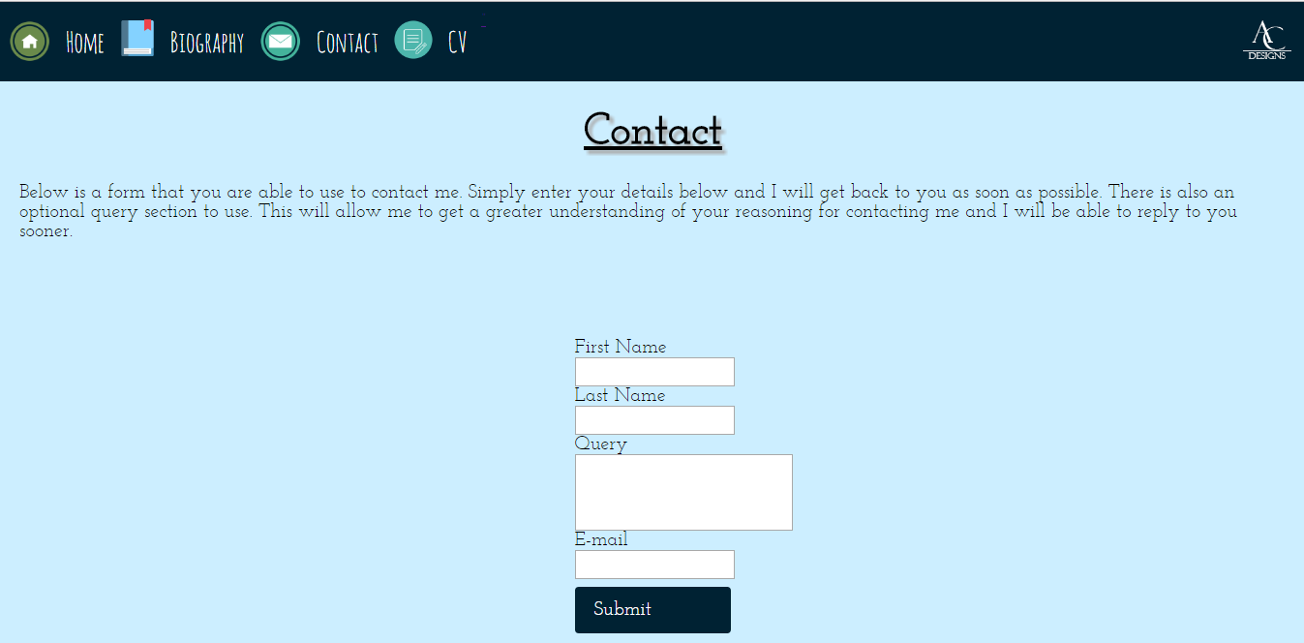

#### CV Page

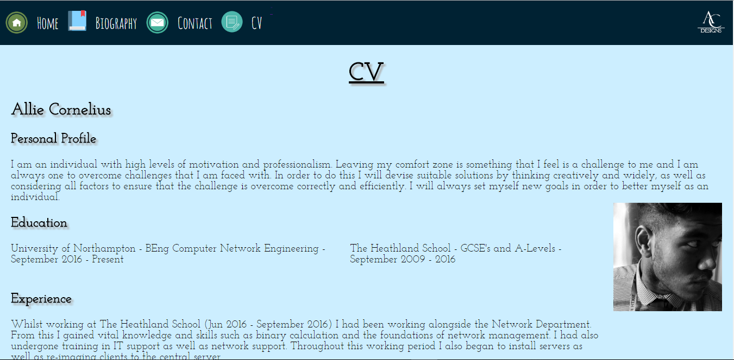

Throughout these weeks, I had developed the site further by adding content to each of the pages and making changes to the CSS. I had used a different set of google fonts and changed the layout of different pages. I had created a logo (featured in the top right of the webpage). I had also changed the navigation pane by adding icons to each of the different webpages to improve user friendliness with the webpage. I also had created subheadings for pages such as the Biography and the CV page.



I had also created a footer which is attached to the bottom of the browser and follows the same styles as the header.

### Weeks 9-12

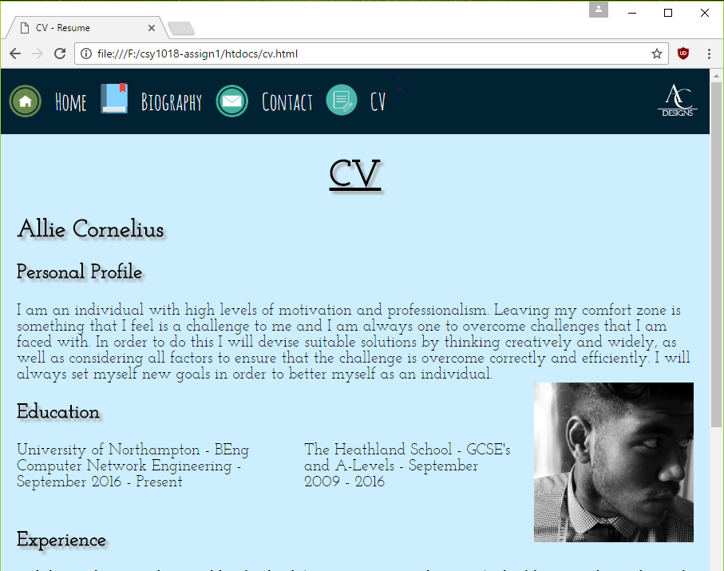

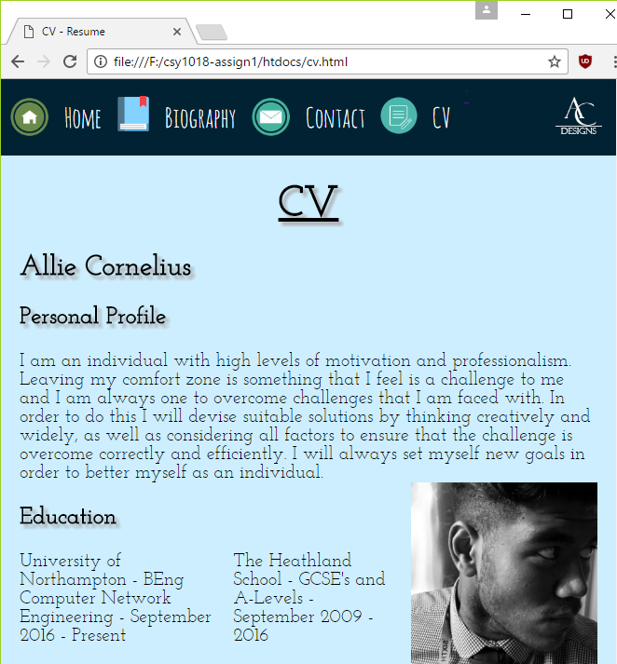

Throughout these weeks, I had worked on making my website responsive so as the size of the window is reduced all content follows the flex property and text and images realigns themselves per the size of the browser window. As you can see the size of the header is reduced and the logo is pushed further left towards the navigation pane.

## Elements that could be improved

### Navigation Pane

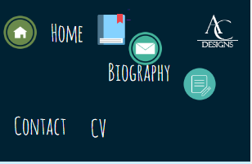

When the browser window is too small the navigation pane does not flex correctly and icons and text are mixed with each other.