**St. Francis Animal Clinic**

*Group SAKA Usability Survey and Findings*

From your initial answers to our questions, we determined that you have several goals in mind for your website and business which could be facilitated by this survey. Community involvement and online presence seem to be important issues and you are looking to attract a younger crowd of pet owners interested in high-end veterinary care from an experienced professional. As such, we specifically recruited participants that fit a young, internet-savvy population with a moderately high income, who were all comfortable with various technologies.

We confirmed demographic information through survey questions. The participants ran a full gamut of income levels, although many did not wish to respond to questions about their income level, and we obtained a good sample of young to middle aged internet-savvy participants. The participants were almost equally divided in age range among those in their 20s, 30s, and 40s, with one participant in the 50s range. We consider this a success, because what matters most is that all of these participants rated themselves as comfortable and above in terms of technology use. The graph below aims to illustrate participants’ technological fluency levels.

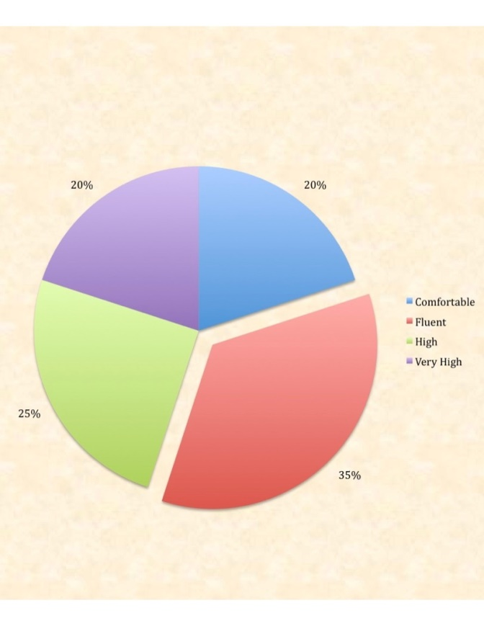

All but two participants use the internet at work, one of whom checked that they are retired or not working in a traditional job. These users almost universally check all available social media platforms for business information. They use Facebook, Twitter, business websites, blogs, and Instagram or other social media. Only one participant did not check that they use blogs, the rest were universally used by our participants. It seems to be important to this demographic that they have multiple contact options in order to verify the legitimacy and currency of a business, based on its Web presence.

Interestingly, every participant uses Google as their preferred search engine. Most participants used a variety of different browsers, with Google Chrome and Internet Explorer (Edge) being the most popular. Although 30% of users also used Firefox 30% used Safari, 90% of participants used either Google Chrome or Internet Explorer. It is important to ensure that your site is readable on multiple platforms and universally accessible in order to reach this demographic the most effectively.

Almost all participants, 90%, had some type of pet, primarily cats and dogs, with 35% having multiple pets. These participants are experienced with pet ownership and likely with veterinarian care. 75% of respondents were confident in the veterinary practice from viewing the site, but only 50% felt that the practice had a community presence. They left some insights on community involvement:

The site seems pretty typical of many sites these days and doesn't show a lot of investment in content but more on appearance. If this is my first impression then I'm going to need a more personal referral to make me bother to go there in person.

I would first need to visit the vet.

This seems to imply that more of an online presence-in the form of community news-and more up to date information would help this demographic feel more confident in your business. For many, online presence is synonymous with credibility when evaluating the quality of a business from its website. As a result, although 75% felt confident in the practice, only 65% would recommend the business to a friend.

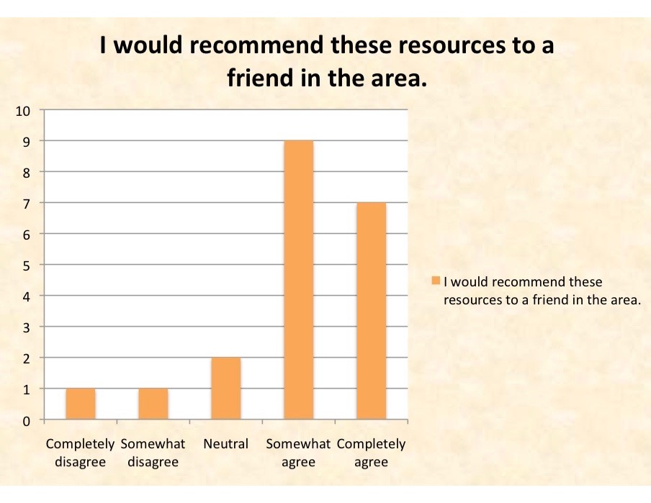

Many participants seemed to confuse the community news with general news, which contains non-local syndicated information. A good percentage could not even find community information. Only 75% found community information, whereas 95% found basic address, phone number, and hours of operation. A couple comments indicated that hours of operation were more difficult to find than expected, whereas several had comments about the lack of recent community information.

While I was able to find the information I expected, some of the link titles were misleading. For example, I looked for community news under the 'News' link located under the 'Pet Health' tag, which contained general articles about pet health. I had to search the site index for local news.

I think a general 'community news' or public relations tab would be helpful. I also think it would be helpful to have information that relates more specifically to the community; there are a lot of general information links on the site that don't seem particularly helpful.

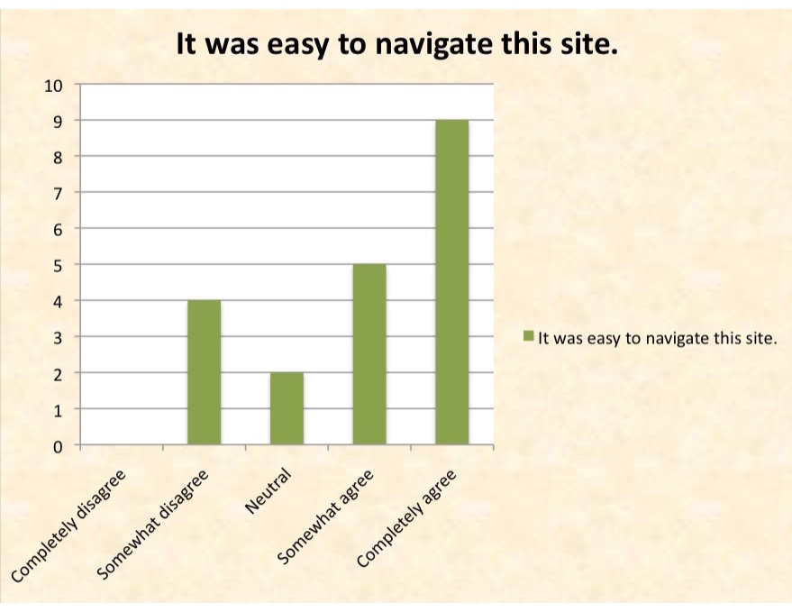

We asked if there were any features which respondents would recommend on the site. While the vast majority did not have any specific recommendations, a few left insightful comments.

Feature no. Just limited textual data for some of the categories. I don't want to have to hit several sites. I want most of the answers at one site if I'm going to visit it.

Layout has to be user friendly.

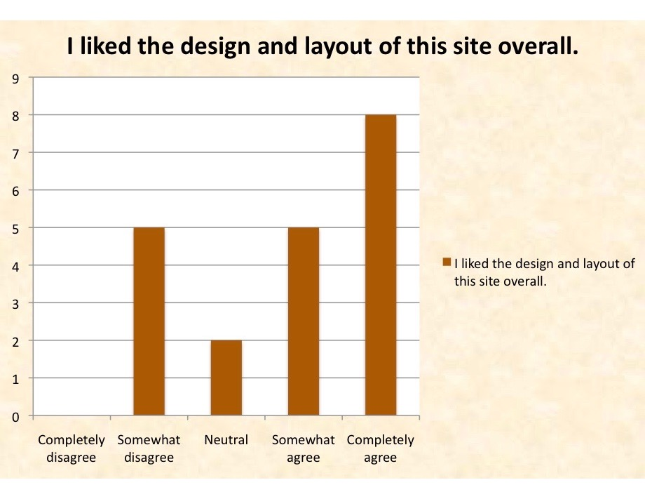

Based on this data and the comments by the participants, we believe that accessibility on multiple platforms is a must for internet presence for a business. This includes optimization for multiple browser, search engine optimization specific to google searches, and multiple platforms of social media such as Facebook, Twitter, blogs, and other social media in addition to the business website. This is a lot to maintain. However, there are tools to link accounts to one another, so that updates can be made, for example, to Facebook and Twitter at the same time, to reduce this burden.

Additionally, respondents enjoyed the interactive features of the site, such as the pet illness assessment tool, if they found it. Many respondents reported being unable to find and use the tool, so featuring it more prominently might be a positive outcome. Those that did find the tool were extremely pleased with it.

**Summary**

We identified three main categories of improvements, based on your goals and the information we gathered from your target demographic. These goals are **online presence**, **community presence**, and **youth appeal**. You specifically wanted to appeal to a young, hip, tech-savvy demographic in your local community in order to build your client base. These goals seem to be complementary ways of appealing to a variety of different clients.

For the goal of online presence, we suggest improved terminology for the various areas of your site, based on the navigation terms. For example, you have two separate news sections. One is local community news, which has not been updated recently; the other appears to be regular corporate-produced news stories updated automatically by your hosting company. This type of generic content does not appeal to a wide variety of clients, nor does it convince users that your content is regularly updated. The tech-savvy user can see that it is just automatically generated content.

Additionally, the company Facebook page is neither linked nor integrated to the company website. Having the two work together can greatly benefit your online presence. The Facebook widget installed on the site is not functional, and there is no link to the website from the Facebook page. The two entities are currently both swimming independently with no clear connection to signify that they represent the same business. We would recommend integrating them as much as possible, so that updates on one show on the other. Of our respondents, 90% use either a company website or Facebook page to determine a business’s credibility online, so having the two updated in concert would be a great first step in building an online presence. Information at [developers.facebook.com/docs/plugins/page-plugin](http://developers.facebook.com/docs/plugins/page-plugin) explains how to add a widget to your site, so that current posts are visible automatically.

One thing that bothered us on looking for the company website and Facebook page using search engines was that the name “St. Francis Animal Clinic” brought up a very large number of veterinary practices, especially on Facebook. We do not believe an average client will go through the effort required to locate the Facebook page independently. Thus, in addition to integrating it with your website, we would advise shifting the naming convention of the Facebook page. An interesting nickname, tagline, or slogan can serve as the name for the Facebook page, with the name of the business as a subtitle, still prominently displayed. For ease of searching, the more distinct the name of the Facebook page, the better. This is one option for creating greater ease of access for the Facebook page.

For both online presence and community involvement, website and Facebook activity are a must. Having the two integrated and updating simultaneously will greatly enhance both the perception of community involvement and online presence. Even updating once a week or once a month can establish an active presence. Several participants commented that the local news section on the website has not been updated since 2013, so they were unsure as to whether the business was still operational.

Another option to establish an involvement in the community is to use a local company or individual contractor for help with the website. The current host for your website, which puts out the generic news posts, actually may harm your online presence. Upon discovering that there is a corporate robot sending out news, tech-savvy users feel the need to look more critically and make sure there really is still a human currently behind the scenes. These news posts, along with being hosted by a faceless corporate conglomerate do your business no good. At the very least we would recommend finding a way to remove the generic news posts and instead begin updating the local news.

Our optimum recommendation would be to use a local web hosting company and establish a partnership. They could offer services to help keep your website up to date, without relying on the automated, robotic updates that users are wary of. They could provide help in integrating your Facebook page with the website as well. This will establish a local connection with another local business. After all, to establish a presence in the community, it is best to do business with the community.

Online presence goes a long way toward youth appeal, but the demographic you wish to cultivate has very strict requirements for how they view websites and assess businesses. They want to be able to shop around from a mobile device and have all relevant information in front of them to make an informed decision. Many users would like to see more of the details of vaccination schedules, types of medication, and price ranges for basic services. This may seem like a lot to provide, but tech-savvy users generally believe that if a price isn’t listed, it’s probably too high. To balance this, you can give a relatively large price range for a few basic services and highlight the quality and care you give your patients. They are paying not just for a shot, but for the care, expertise, and quality that you offer.

Another youth credibility factor is the fact that all contact information contains an AOL email address. AOL is often seen as a generic, outdated form of address, and can imply that the business is not technologically capable or has been inactive for a long time. We would recommend creating an email using your site name (e.g. [lin@stfrancisanimalclinicnaples.com](mailto:lin@stfrancisanimalclinicnaples.com)) for the most reputable, professional option. If you employ a local site hosting company as suggested, they typically offer this service as well and may be willing to assist in forwarding mail to whatever address is desired. A secondary option is to create a Gmail address. As Gmail is currently widely popular and used frequently for both business and personal accounts, having a Gmail account neither adds nor subtracts from your business credibility. However, this is only a temporary measure, as tastes will likely change again within a decade.

Probably the best item of youth appeal is simply to remain active. Post pictures of cute kittens up for adoption. Put up a picture of a smiling dog after a recent visit. Search for your clients on Facebook, from your business webpage. Like and comment on a few pet pictures and soon your business will have a reputation for being active and engaged with the community, with a strong online presence and great youth appeal. A staff member could do this for five minutes a day, or maybe for 30 minutes a week.