UML – Definition
Unified Modeling Language
“UML is a language for specifying, visualizing, constructing, and documenting the artifacts of software systems, as well as for business modeling and other non-software systems."
The Object Management Group adopted UML in 1997 as a standard.

Benefits of UML
- Software system is professionally designed and documented before any code is written
- Reusable code is easily spotted and coded with the highest efficiency (since system design comes first)
- Lower development costs
- Logical ‘holes’ can be spotted in the design drawings

- Fewer surprises – software will behave as you expect it to
- Overall design will dictate the way software is developed - right decisions are made before any code is written
- UML lets you see the bigger picture
- More memory and processor efficient code is developed
- Modifications on the system are easier

- Less ‘re/learning’ of the system takes place
- Diagrams will quickly get any other developer up to speed
- More efficient to communicate with other programmers

Summary of Benefits
Using UML will result in lower overall costs, more reliable and efficient software, and a better relationship with all parties involved.
Software documentation with UML can be modified much more efficiently.

Parties Involved …
The parties involved in developing a software system are:
- Client – the person who has the problem to be solved
- Analyst – documents client’s problem and relays it to:
- Developers – programmers who build the software that solves the problem, test it, and deploy it on computer hardware.

Necessity of this Breakdown
Systems today are so complex that one person can’t:
- Know all the facets of a business,
- Understand the problem,
- Design a solution,
- Translate it into a problem,
- Deploy the program onto hardware,
- Make sure the hardware components all work together correctly

Old Way of System Modeling
Waterfall Method:
Specifies that analysis, design, coding and deployment follow one after the other. Only when one is complete can the next one follow.
Drawbacks
If an analyst hands off analysis to a designer, who hands off a design to a developer, chances are the 3 team members will rarely work together and share important insights. The waterfall method supports a big amount of project time given to coding. This takes valuable time away from analysis and design.

New Way of System Modeling
Continuing interplay among the stages of development is encouraged.
As understanding of the system grows, the team incorporates new ideas and builds a stronger system.

UML Usage
In UML, a certain number of graphical elements are combined into diagrams and because UML is a language, there are rules for combining these elements.
Purpose of diagrams is to present multiple views of a system. This set of multiple views is called a model.
UML model describes what a system is supposed to do; it doesn’t tell how to implement the system.

UML Components
UML provides a standard that enables the system analyst to provide a multi-faceted blueprint that’s comprehensible to clients, programmers and everyone involved in the development process.
UML consists of 9 basic diagrams (hybrids of these diagrams are possible)
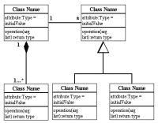 | Class Diagrams  Class diagrams are the backbone of almost every object oriented method, including UML. They describe the static structure of a system. Things naturally fall into categories (books, trees, computers, …). We refer to these categories as classes.
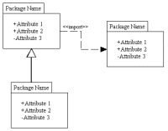 | Package Diagrams  Package diagrams are a subset of class diagrams, but developers sometimes treat them as a separate technique. Package diagrams organize elements of a system into related groups to minimize dependencies between packages.
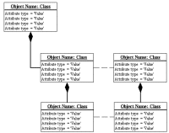 | Object Diagrams  An object is an instance of a class – a specific thing that has specific values of attributes, and behavior. Object diagrams describe the static structure of a system at a particular time. They can be used to test class diagrams for accuracy.
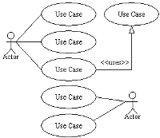 | Use Case Diagrams  A use case is a description of a system’s behaviour from a user’s standpoint. A use case diagram is useful for gathering system requirements from a user’s point of view. Use case diagrams model the functionality of system using actors and use cases.
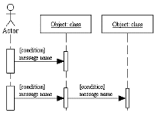 | Sequence Diagrams  Class and object diagrams represent static information. In a system objects interact with one another and these interactions occur over time. Sequence diagrams show the time-based dynamics of interaction. Sequence diagrams describe interactions among classes in terms of an exchange of messages over time.
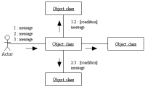 | Collaboration Diagrams  Because large scale system development involves different people working on different components, it’s important to have a diagram to model these. The elements of a system work together to accomplish the system’s objectives; this is depicted with the collaboration diagram. Collaboration diagrams represent interactions between objects as a series of sequenced messages. Collaboration diagrams describe both the static structure and the dynamic behavior of a system.
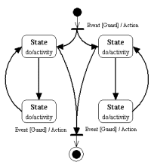 | Statechart Diagrams  At any given time, an object is in a particular state. State diagrams represent these states and their changes over time. Statechart diagrams describe the dynamic behavior of a system in response to external stimuli. Statechart diagrams are especially useful in modeling reactive objects whose states are triggered by specific events.
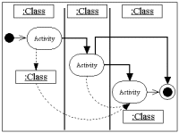 | Activity Diagrams  The activities that occur within a use case or within an object’s behaviour typically occur in sequence, which is represented with activity diagrams. Activity diagrams illustrate the dynamic nature of a system by modeling the flow of control from activity to activity. An activity represents an operation on some class in the system that results in a change in the state of the system. Typically, activity diagrams are used to model workflow or business processes and internal operation.
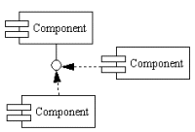 | Component Diagrams  Component diagrams describe the organization of physical software components, including source code, run-time (binary) code, and executables.
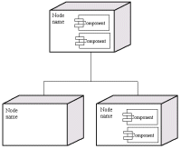 | Deployment Diagrams  This shows the physical architecture of a computer based system. It can depict the computers and devices, show their connectivity, and show the software that sits on each machine. Deployment diagrams depict the physical resources in a system, including nodes, components, and connections.

Rapid Application Development:
Rapid Application Development (RAD) consists of:

- Requirements gathering
- Analysis
- Design
- Development
- Deployment

Each segment consists of a number of actions, and each action results in a work-product.
UML diagrams are work products for many of these actions.

I-Requirements Gathering
Understand what the client wants!

1. Discover Business Processes
Analysts gain an understanding of the client’s business processes by interviewing the client or having the client go through the relevant processes step-by-step.
Activity diagrams
2. Perform Domain Analysis
Analyst makes an understanding of the major entities in the client’s domain. The object 5odeller listens for nouns and starts by making each noun a class. They also listen for verbs which ultimately become operations of the classes.
High-level class diagrams and meeting notes

3. Identify Cooperating Systems
Development team finds out exactly which systems the new system will depend on, and which systems will depend on it. System engineer takes care of this action.
Deployment diagram
4. Discover System Requirements
Team goes through its first Joint Application Development (JAD) session. This brings together decision makers from client’s organisation, potential users and members of the development team. Facilitator elicits from decision-makers and users what they want the system to do, team members take notes and object modeler refines the class diagrams.
Package diagram
5. Present Results to Client
When the team finishes all the Requirements actions, the project manager presents the results to the client.

II-Analysis
1. Understanding System Usage
In JAD session, development team works with users to discover actors who initiate each use case from the Requirements JAD session (actor can be a system as well as a person)
Use case diagrams
2. Flesh Out Use Cases
Analyse each sequence of steps in each use case, while still working with the users
Text description of the steps in each use case diagram
3. Refine the Class Diagrams
During JAD sessions, object 5odeller listens to discussions and refines all the class diagrams. Fills in the names of the associations, abstract classes, multiplicities, generalisations and aggregations.
Refined class diagrams
4. Analyse Changes of State in Objects
Object 5odeller refines the model by showing changes of state whenever necessary.
State diagram
5. Define Interactions Among Objects
Development team has a set of use cases and refined class diagrams. Using these, they define how the objects interact. Object 5odeller develops a set of diagrams which include state changes.
Sequence and collaboration diagrams
6. Analyse Interaction with Cooperating Systems
System engineer uncovers specific details of the integration with the cooperating systems. What type of communication is involved, network architecture, access to databases, what kind of databases, etc.
Detailed deployment diagram and maybe data models

III-Design
1. Develop and Refine Object Diagrams
Programmers take class diagrams and generate any object diagrams by examining each operation and developing a corresponding activity diagram. These serve as the basis for much of the coding in the Development segment.
Activity diagrams
2. Develop Component Diagrams
Programmers visualise the components that will result from the next segment and show the dependencies among them.
Component diagrams
3. Plan for Deployment
System engineer begins planning for deployment and for integration with cooperating systems. Diagrams created here show where the components will reside
Part of the deployment diagram developed earlier
4. Design and Prototype User Interface
Another JAD* session with the users, continuation of previous JAD sessions. Interplay between analysis and design. GUI analyst works with users to create paper prototypes of screens that correspond to groups of use cases.
* Joint Application Development (JAD)is a technique based on intensive brainstorming sessions
Screen shots of screen prototypes
5. Design Tests
Developer or test specialist from outside development team uses the use case diagrams to develop test scripts for automated test tools
Test scripts
6. Begin Documentation
Documentation specialists work with designers to begin documentation and arrive at high-level structure for each document
Document structure

IV-Development
1. Construct Code
With the class, object, activity and component diagrams in hand, programmers construct the code for the system.
The code
2. Test Code
This action feeds back into preceding action and vice versa, until all code passes all levels of testing, developed in previous segment (Design Tests).
Test results
3. Construct User Interfaces, Connect to Code and Test
Connection between Design and Development. GUI specialist constructs approved interface prototypes and connects them to code, also ensures that interfaces work correctly.
Functioning system, complete with user interfaces
4. Complete Documentation
Documentation experts work in parallel with programmers to complete documentation.
System documentation

V-Deployment
1. Plan for Backup and Recovery
System engineer creates a plan for steps to follow in case the system crashes. Can start before the Development segment begins.
Crash recovery plan
2. Install the Finished System on Appropriate Hardware
System engineer will install the system with any necessary help from the programmers.
Fully deployed system
3. Test the Installed System
After installing the software the development team tests the system. Does it perform as it’s supposed to? Does the backup and recovery plan work? Results of this test determine whether future refinement is necessary
Test results

