**COMP 3613 ASSIGNMENT #1**

**NAME:** NIE-L CONSTANCE

**ID#:** 816041818

**ASSIGNED PROJECT:** STUDENT INCENTIVE SYSTEM

**SELECTED PROJECT REQUIREMENTS**

The system is a command-line application for tracking student community service hours with the following main features:

1. (Staff) Log staff hours for student: Staff are able to log a student's community service hours along with details like date, activity, and hours.
2. (Student) Request confirmation of hours: Students can ask their hours be formally confirmed by a staff member. This places the hours in a pending approval state.
3. View Student Leaderboard: Others can view a ranked list of students by their total confirmed community service hours.
4. (Student) View accolades: Students are able to view milestones they have achieved (e.g., 10, 25, 50 hours) based on their total confirmed hours.

**USE CASE DIAGRAM**

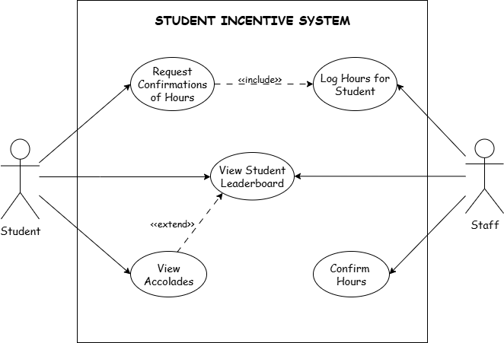

**MODEL DIAGRAM (UML CLASS DIAGRAM)**

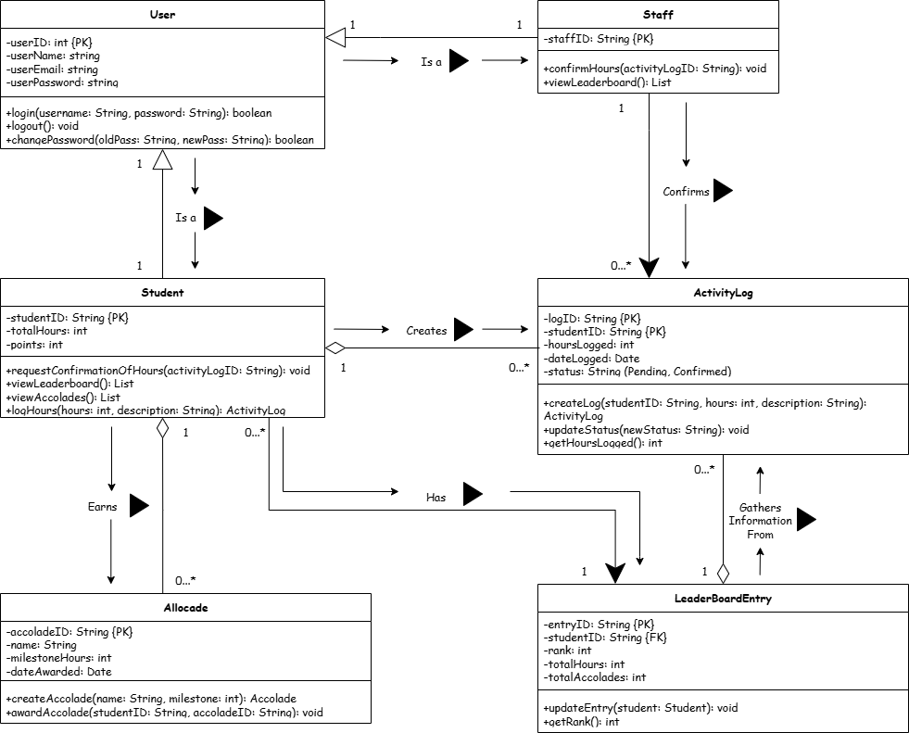

**IMPLEMENTATION**