Team Assignment - Milestone 1 - Requirements Gathering and Wireframes

Review the requirements for the team assignment and develop a series of wireframe sketches for the system.

As a team, you will also review and refine the project requirements and begin the process of breaking them down into actionable user stories.

This document should be submitted as a team submission. Each group member does not need to submit individually.

Deliverables to be submitted for this milestone should be one document that contains:

**- contact information for all of your group members**

|  |  |  |
| --- | --- | --- |
| Name | Email | Phone |
| Allison Bezorudko | [allycm07@gmail.com](mailto:allycm07@gmail.com) | 2062959426 |
| Dylan Riley | [dylan@rileyz.net](mailto:dylan@rileyz.net) |  |
| Alex Sutherland | [AlexanderNSutherland@gmail.com](mailto:AlexanderNSutherland@gmail.com) | 3609088342 |
| Luca Andolina | [luca627@comcast.net](mailto:luca627@comcast.net) | 2538805334 |
| Natnael | <mailto:natashsaya@gmail.com> | 5405141965 |

**- Wireframes for each necessary page in your system**

Admin – workflow

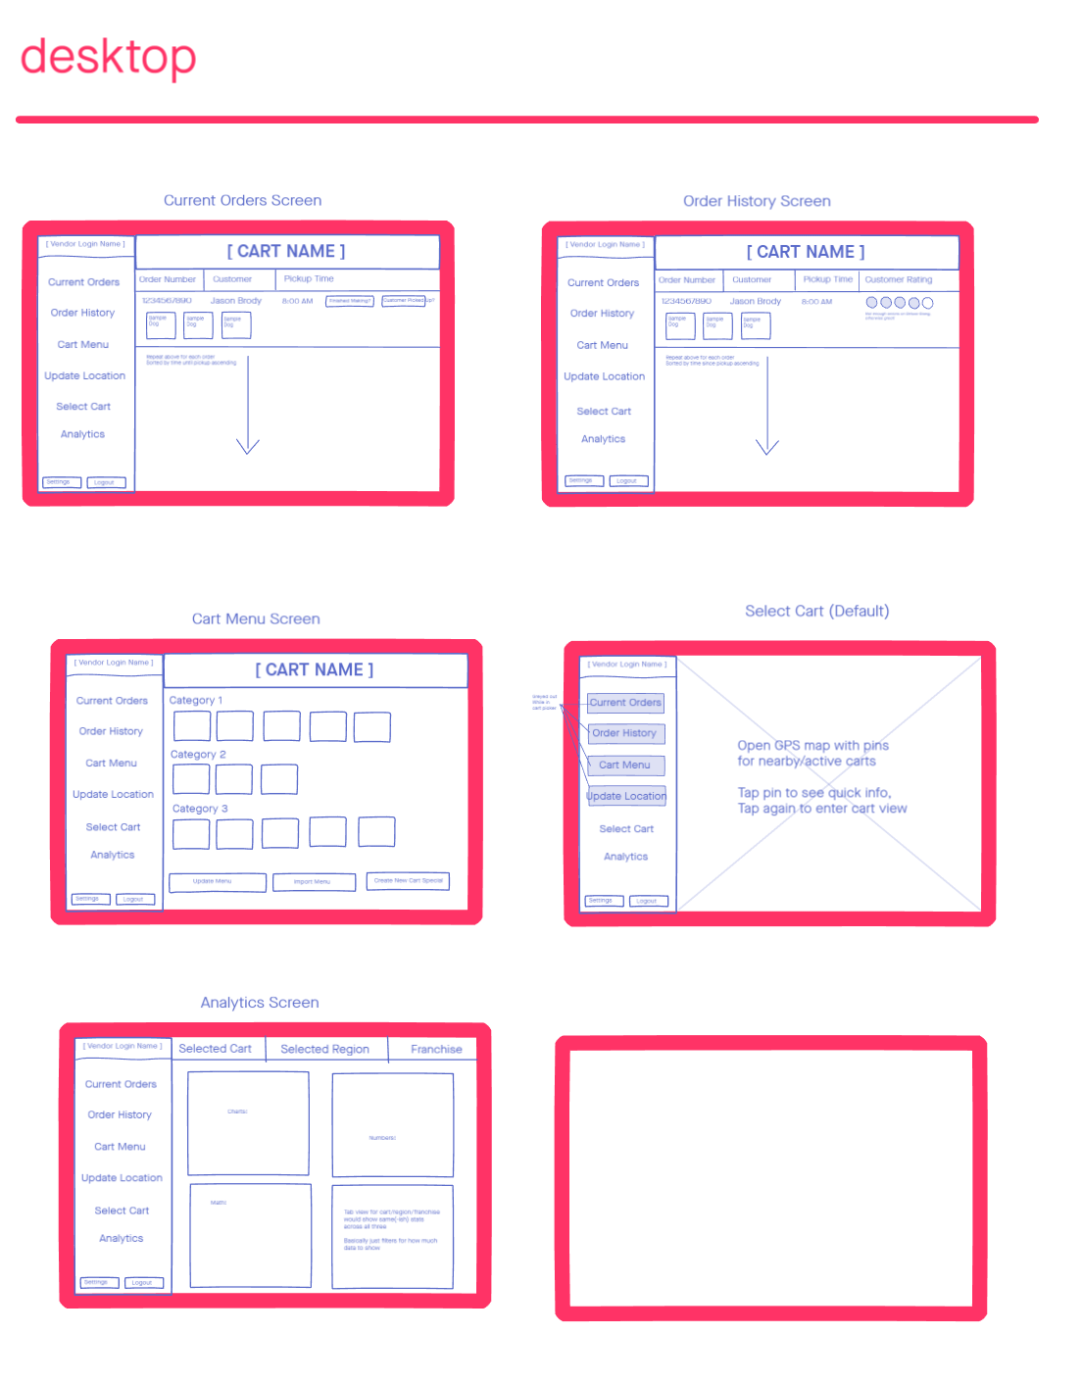

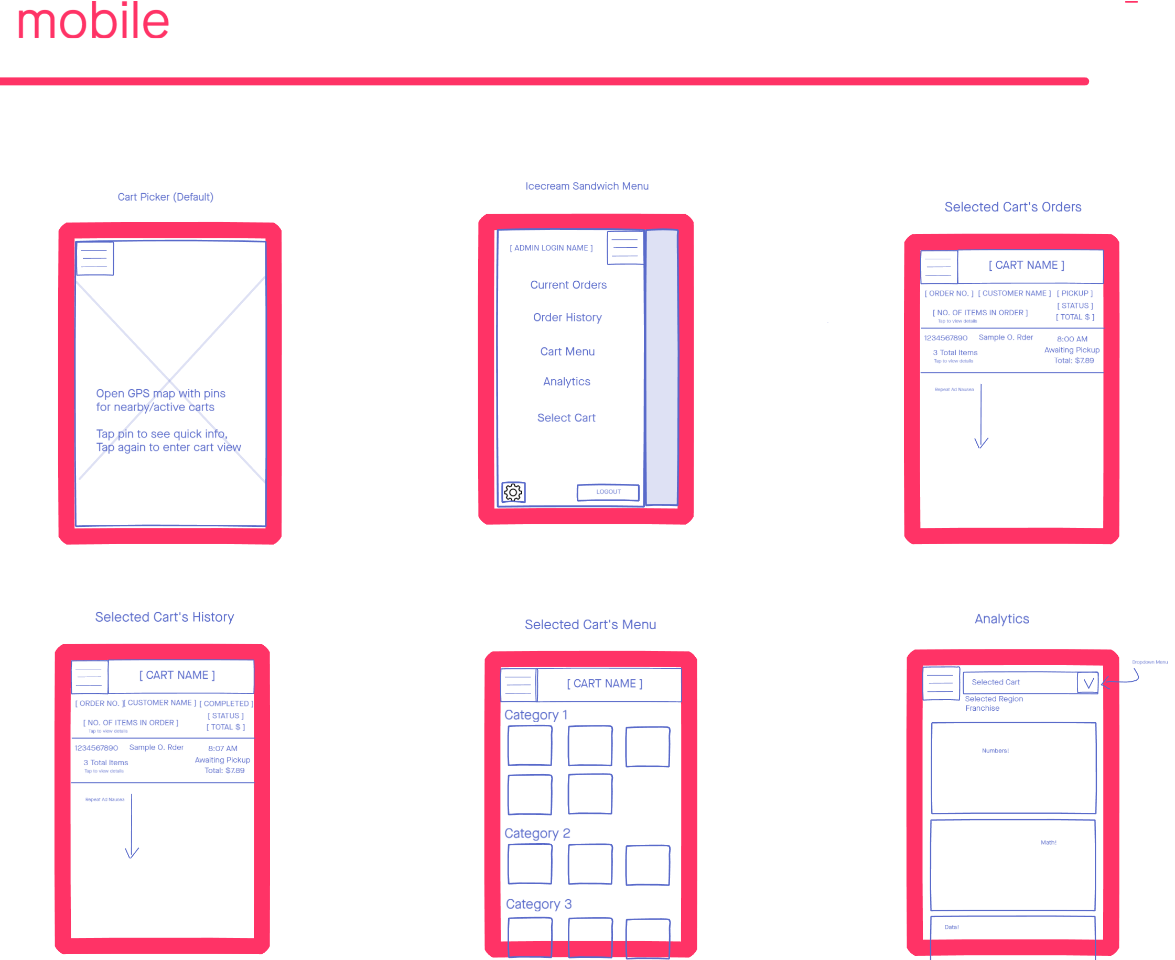

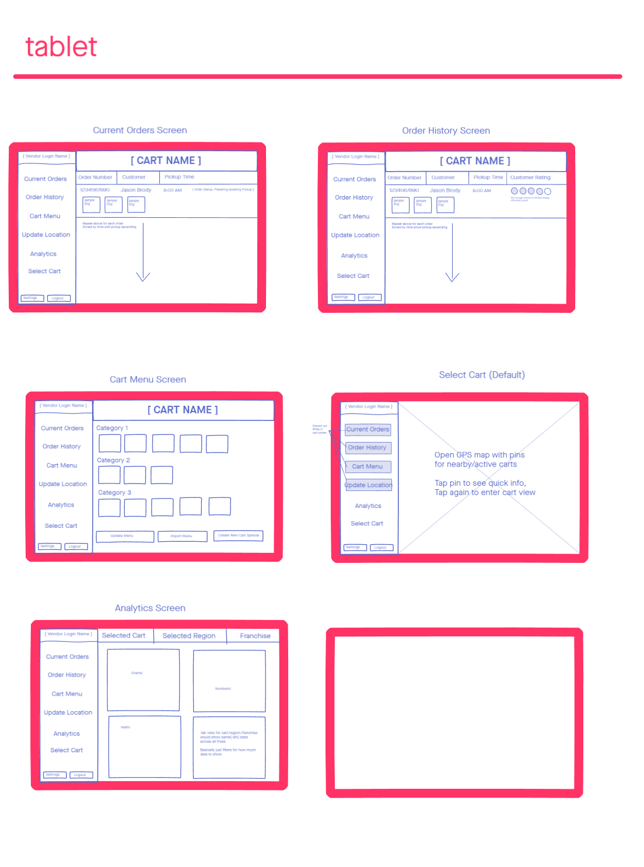

customer – order flow

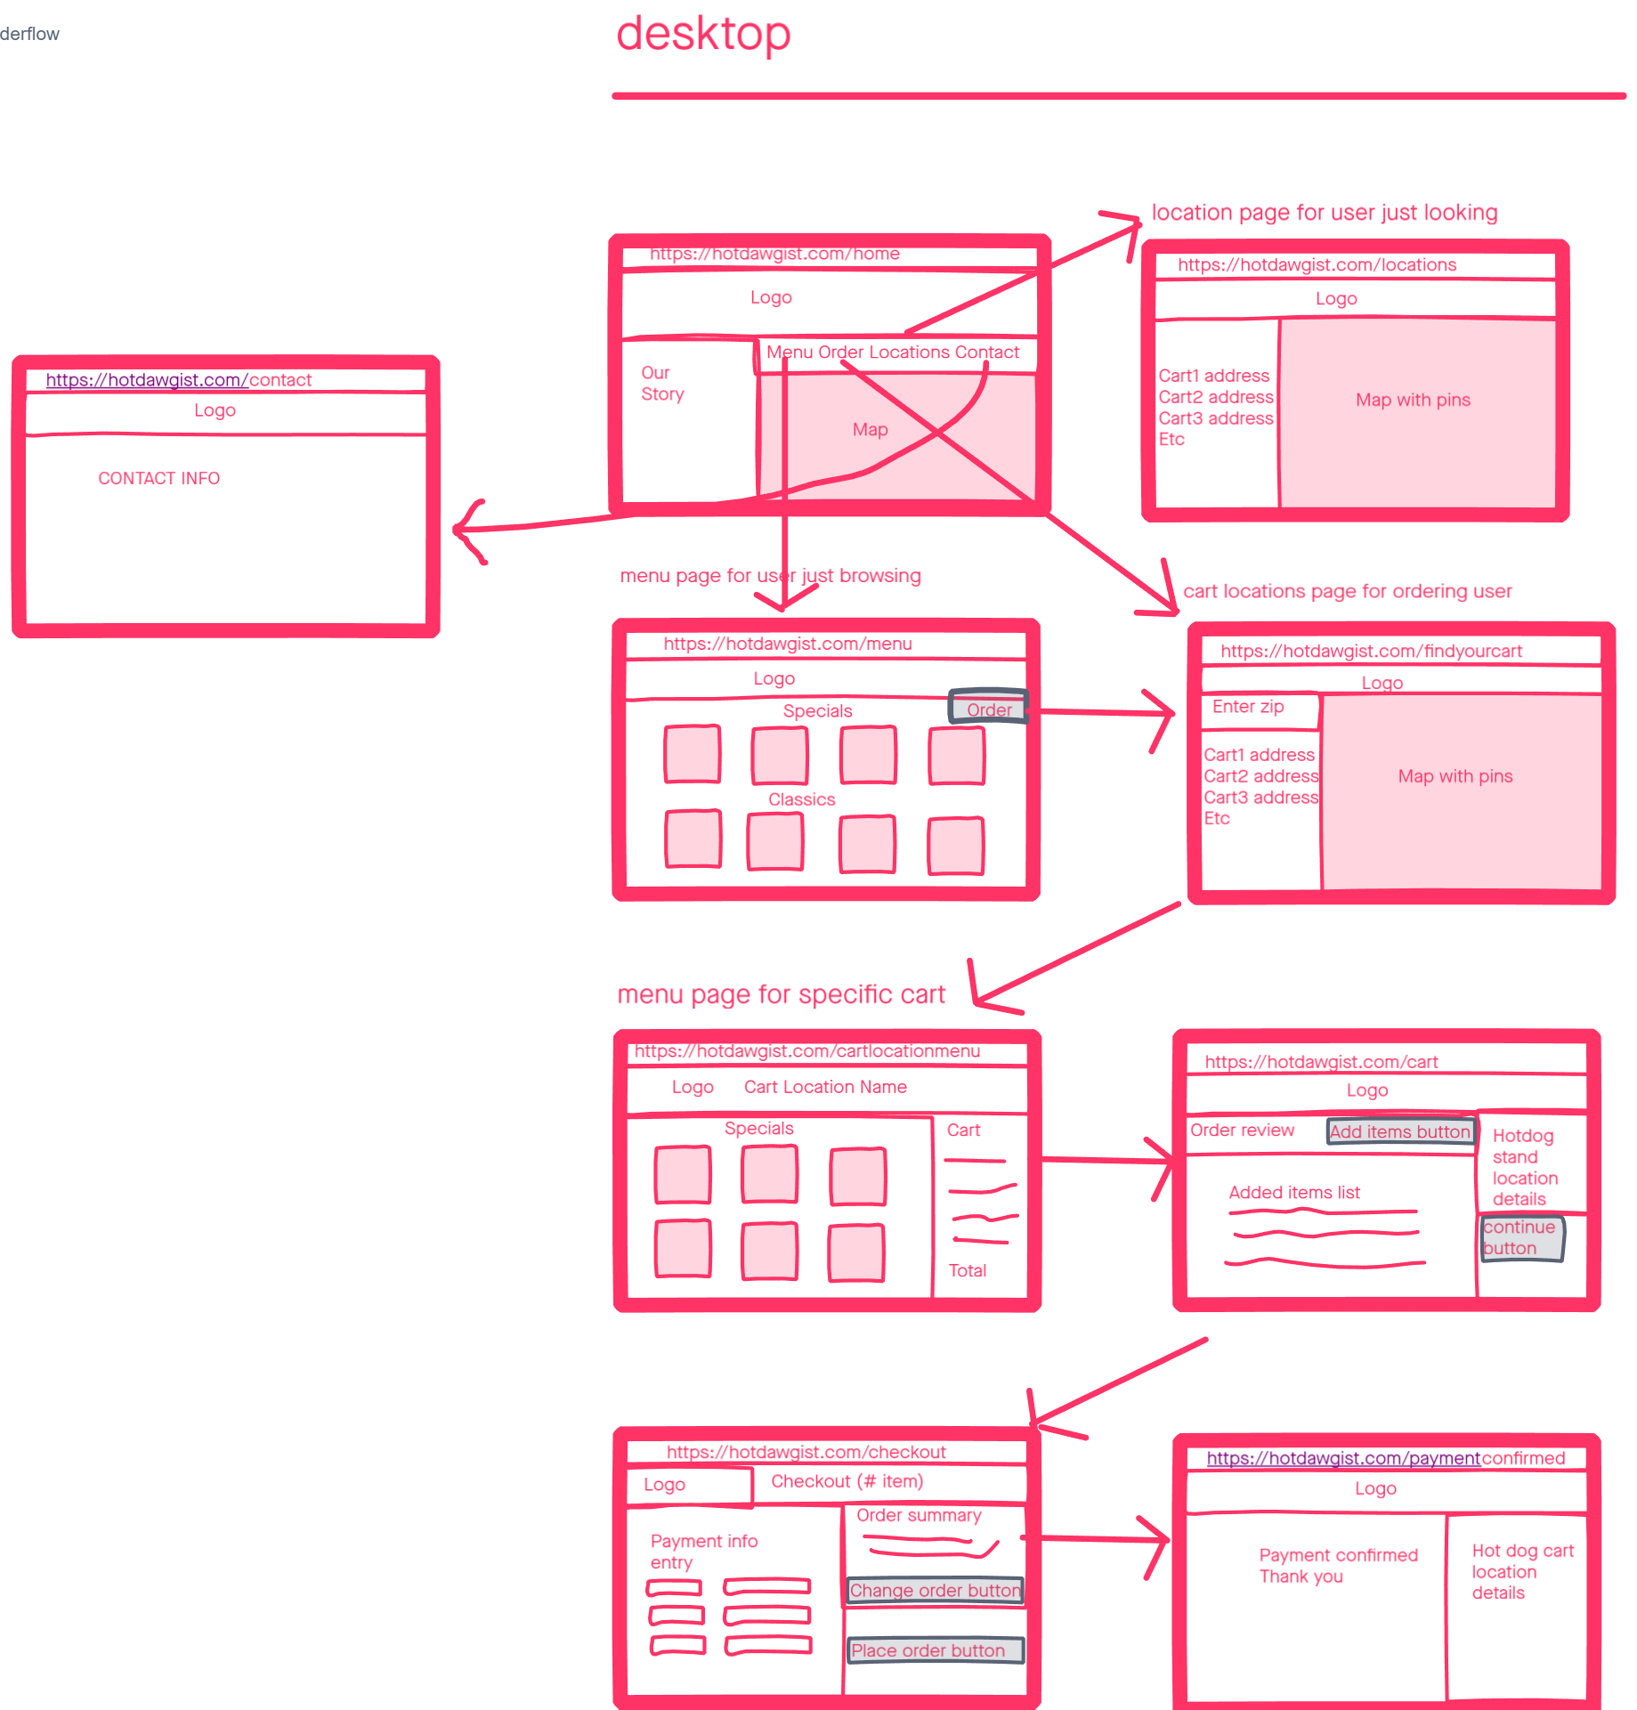

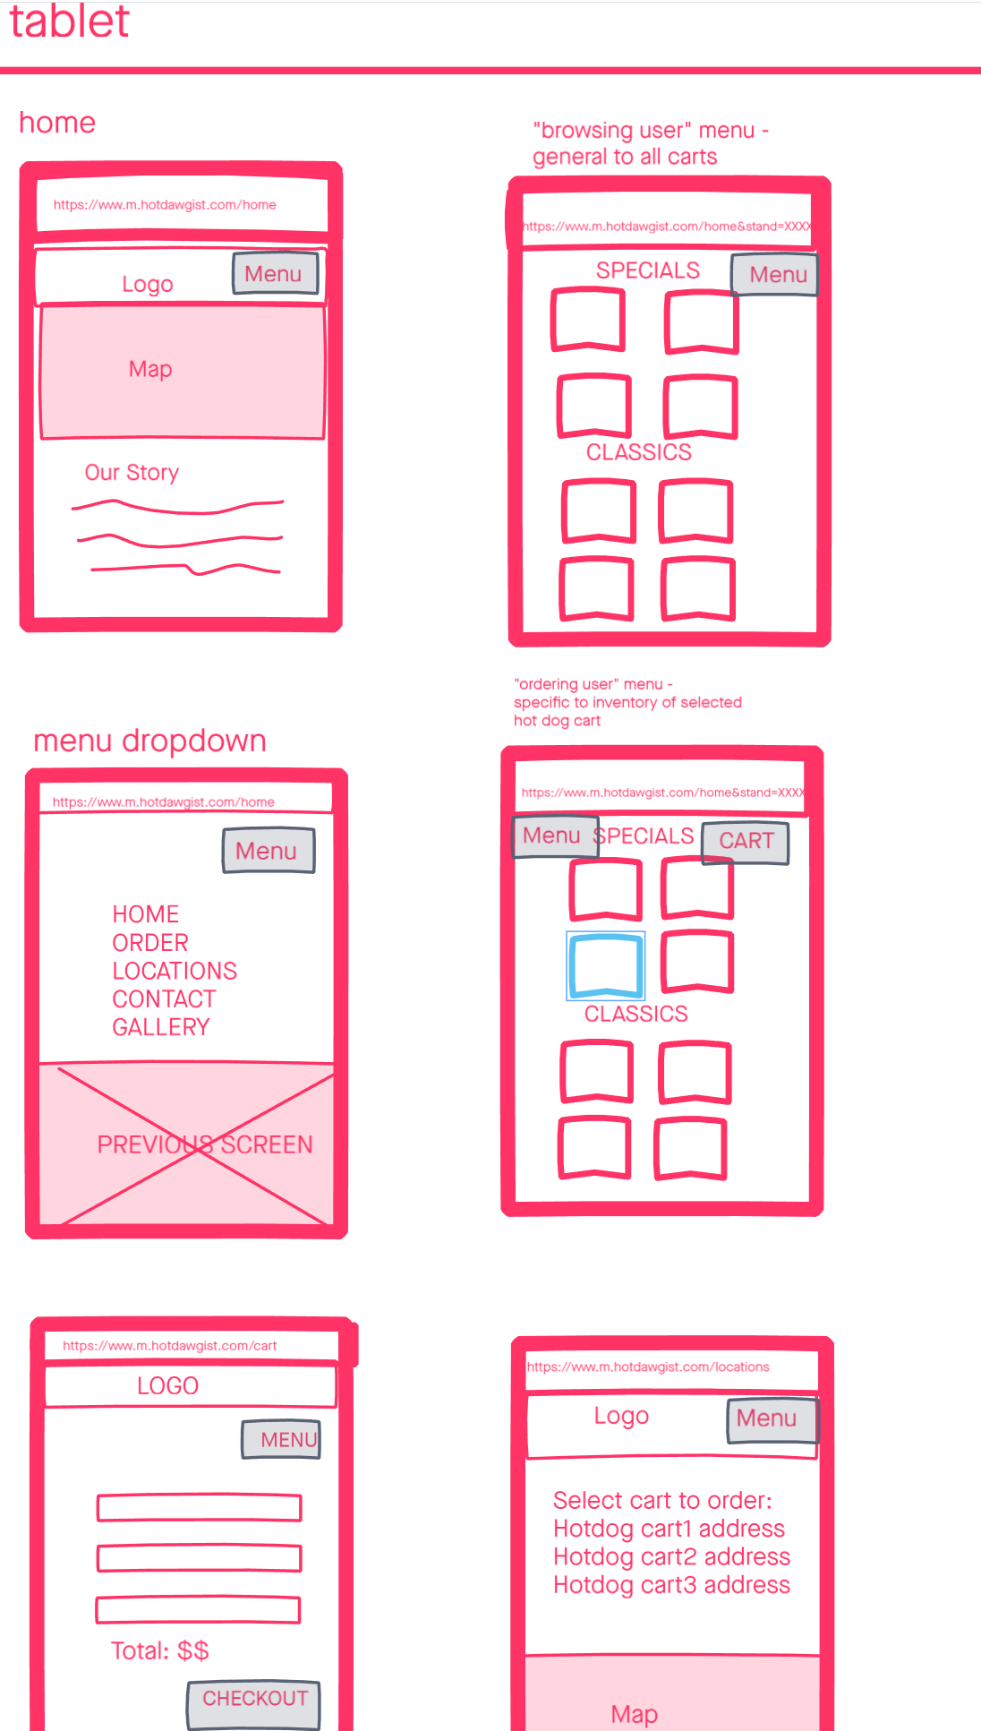

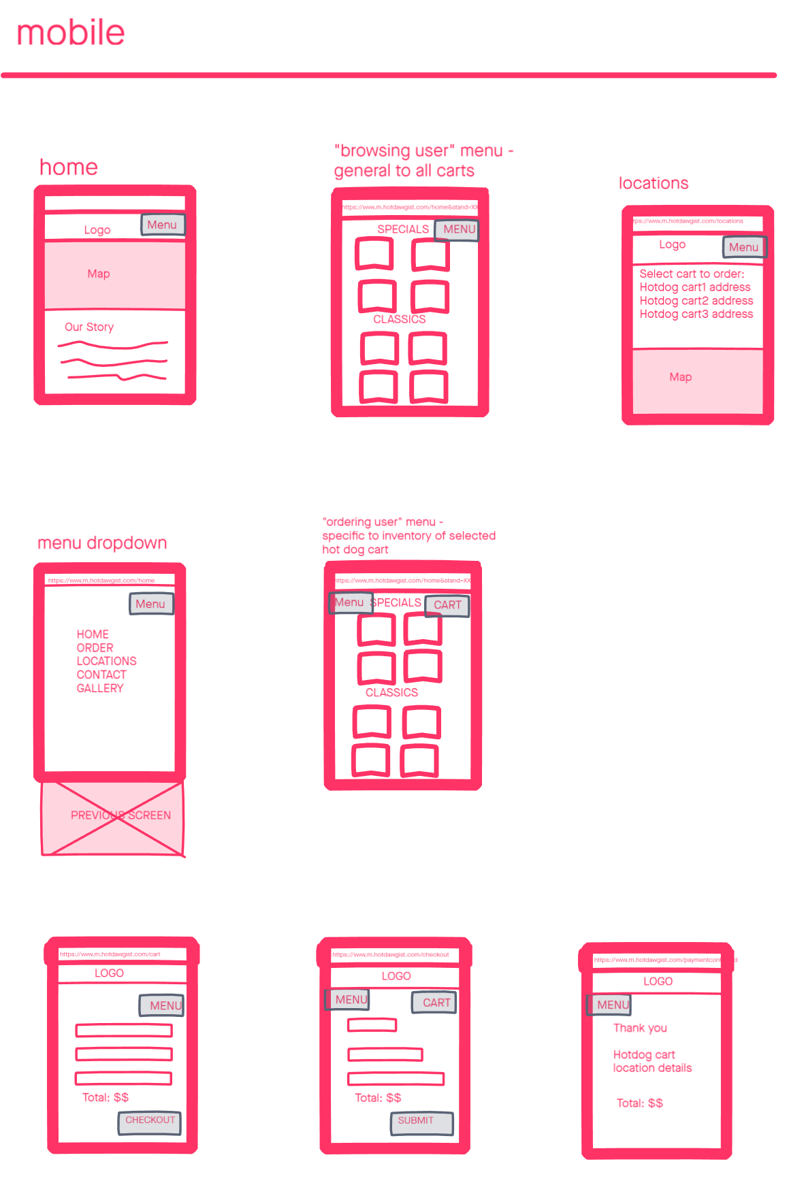

Vendor-workflow

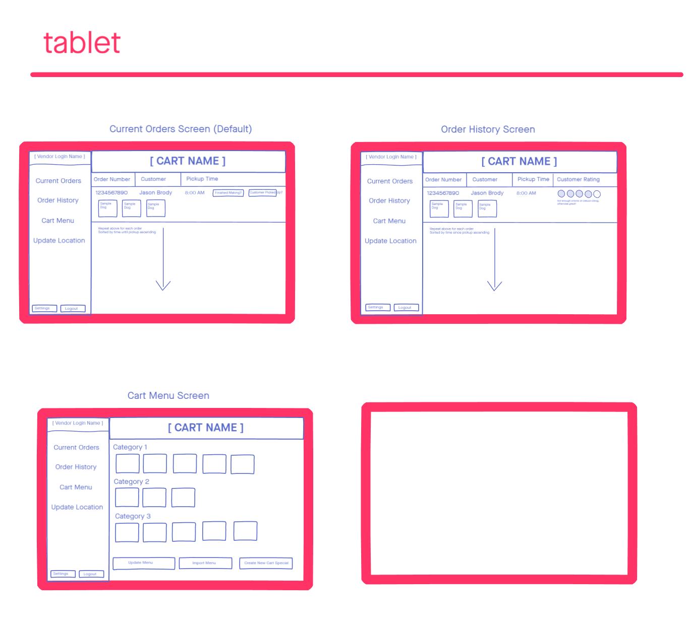

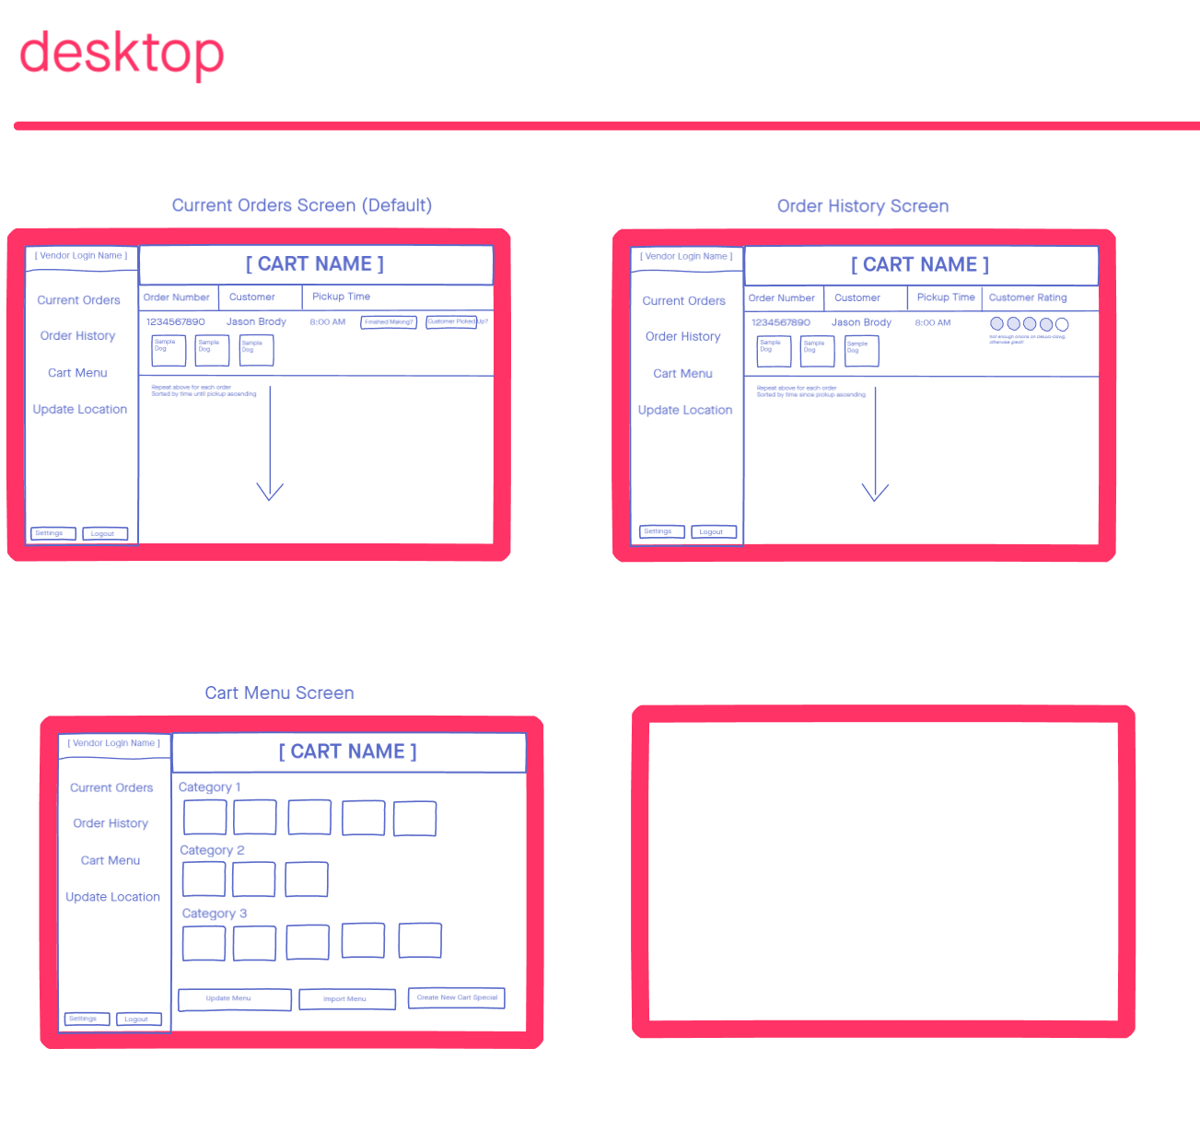

**- A list of expanded requirements to begin design and development of user stories.**

1.) Customers should be able to view a map that shows all current hot dog cart locations.

-Where are all the current hot dog cart locations?

-What data format will the locations be in?

- Do we want the customer to be able to drop pins and openly interact with the map?

-How are the locations filtered? Nearest first? Will it be able to filter out locations closed due to hours and maintenance?

2.) Customers should be able to select a cart from the map, view detailed information about that cart, and place online orders to that cart.

-Hot Dog Vendors should be able to see incoming orders on a tablet display at their cart.

-Vendors should being able to self-update.

-Since the Hot Dog Vendors will be using a Tablet, we should focus on creating more functionality on the tablet user interface for the Vendors.

-Different Themes possibly for each cart?

3.) Hot Dog Vendors should be able to mark menu items as unavailable and orders for unavailable items at that location are blocked.

-Each location on the map needs to have functionality for the Vendors tablet view in

order for them to make changes

-Google Maps API?

-Does the system suggest the nearest location that has it instead?

4.) System Admins should be able to add new carts to the system and update menus.

-System Admins should likely be able to delete new carts from the system as well.

-Or we can make some carts that are ‘out of service’ temporarily flagged on our site.

-When adding carts is Bob planning on keeping the carts in the same location and will they have similar menus?

5.) System Admins should be able to view logs of customer, vendor, and admin system actions.

- Will our app be hosted on a server?

- Do we need to figure out how to make our app live?

-We can likely use JavaScript to keep track of all our logs.

-Do we need a DBMS for that? If so, what kind?

6.) All System Users should be able to view the apps on a desktop, tablet, or mobile browser.

- Are all three formats important for all the user types?

- Are System Admins, Vendors and Customers the only user types?

- Which format is most important for the customer and what will be more centric for the customers functionality?

-Should we give more emphasis on the mobile app since most users prefer using mobile devices for orders? Also, tablet for vendors and desktop for system admins?