## Ch.7- Displaying Information as Floats, Image Styles, and Nav CSS

**We will use semantic elements (<header>, <nav>, <main>, <section>, <footer>) for accessibility and readability.**

1. **Create a folder named “Ch7” on your Desktop.**
2. **Open your code editor and create a new file and name it “sushi.html” .**
3. **Create a media query.**
4. **Upload your work to GitHub.**

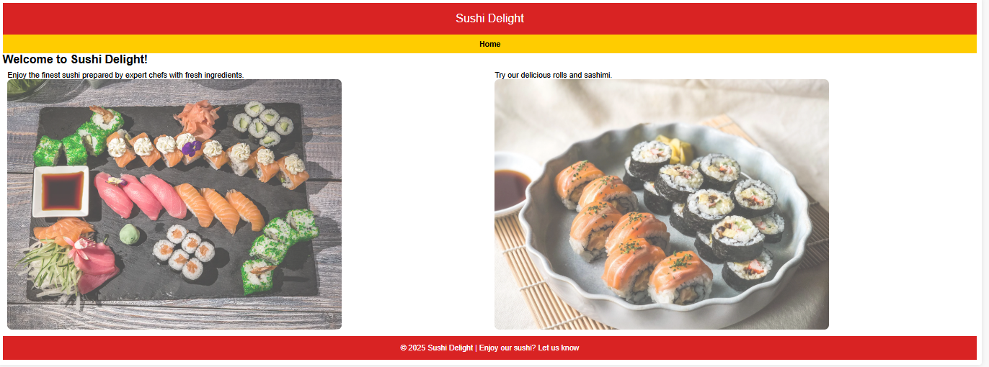The new CSS will show different colors and borders when you mouse over the nav and  the images will zoom and have a rounded edge to them. The web page will look like this when it is done:

## Step 1: Create the Basic HTML Structure

<!—Put your name here and the date you made the file-->

<!-- Ch. 7 Floats hw-->

<!DOCTYPE html>

<html lang="en">

<head>

    <meta charset="UTF-8">

    <meta name="viewport" content="width=device-width, initial-scale=1.0">

    <title>Sushi Delight</title>

    <link rel="stylesheet" href="styles.css"> <!-- External CSS -->

</head>

<body>

    <div class="wrapper">

        <header>

            Sushi Delight

        </header>

        <nav>

            <a href="sushi.html">Home</a>

            <a href="menu.html">Menu</a>

        </nav>

        <h2>Welcome to Sushi Delight!</h2>

        <main>

            <section>

            <p>Enjoy the finest sushi prepared by expert chefs with fresh ingredients.</p>

            <img src="Sushi-Platters.webp" alt="Sushi platter">

            </section>

             <section>

              <p>Try our delicious rolls and sashimi.</p>

              <img src="rolls.webp" alt="Sushi rolls">

            </section>

         </main>

        <footer>

            &copy; 2025 Sushi Delight | Made with love

        </footer>

    </div>

</body>

</html>

1. **Save the file in the Ch.7 folder**

## a

1. Create a **styles.css** file and define styles for each section. Feel free to change color choices or add additional styles to fit your style.

| **Selector** | **CSS Explanation** | **Code** |
| --- | --- | --- |
| **\*** | Resets the browser with margins and padding | margin: 0;      padding:0;      box-sizing: border-box; |
| **.wrapper** | Centers the content, sets max width, and adds padding/shadow. | width: 95%;      margin: 0 auto;      background: white;      padding: 10px;      border-radius: 5px;      box-shadow: 0px 0px 10px #0000001a; |
| **body** | Sets the overall **background color**, removes margin/padding, and applies a font. | background: #d92323;      color: white;      text-align: center;      padding: 20px;      font-size: 1.5em; |
| **header** | Styles the top section with a **red background**, white text, and large font. | background: #d92323;      color: white;      text-align: center;      padding: 20px;      font-size: 1.5em; |
| **nav** | Adds a yellow background and centers navigation links. | background: #ffcc00;      padding: 10px;      text-align: center; |
| **nav a** | Makes links stack naturally on smaller screens. | display: inline;  /* Forces stacking on smaller screens */      text-decoration: none;      color: black;      padding: 5px;      font-weight: bold; |
| **nav a :visited** | Colors nav once the page is visited. | text-decoration: underline;  color:darkgreen; |
| **nav a:hover** | Colors the nav when the mouse is hovered on text. | background-color: #fff;  color:#d92323; |
| **section** | Floats left (50% width), styles the sidebar. | float: left;  width: 50%;   padding: 10px; |
| **main:after** | Clears the floats and returns the page to normal flow. | content: "";  display: table;  clear: both; |
| **img** | Makes images responsive to their containers. | height: 50%;    max-width: 70%;     opacity:.7;     object-fit: cover; |
| **img:hover** | Makes images responsive and change the images on hover | border: 1px solid #ddc10f;  opacity: 1;    transform: scale( 1.2);  transition: transform 0.5s ease-in-out;  /* Smooth scaling effect */ |
| **footer** | Clears floats, applies a **red background**, and centers the white text. | clear: both; /* Fix float issues */  background: #d92323;  color: white;  text-align: center; |

## Step 3: Create a media query

A media query will add CSS depending on the size of the screen. This will stack the nav and images on a small screen like a phone.

/* Mobile Styles: 768px and smaller */

@media (max-width: 768px) {

  section {

    width: 100%;

float: none;

    padding: 10px 0;

  }

  .wrapper {

    width: 100%;

    padding: 10px;

  }

  header {

    font-size: 1.2em;

    padding: 15px;

  }

  nav {

    padding: 8px;

  }

  nav a {

    display: block;

    margin: 5px 0;

    font-size: 1em;

  }

  img {

    max-width: 100%;

    height: auto;

  }

}

The page will look like this on a phone:

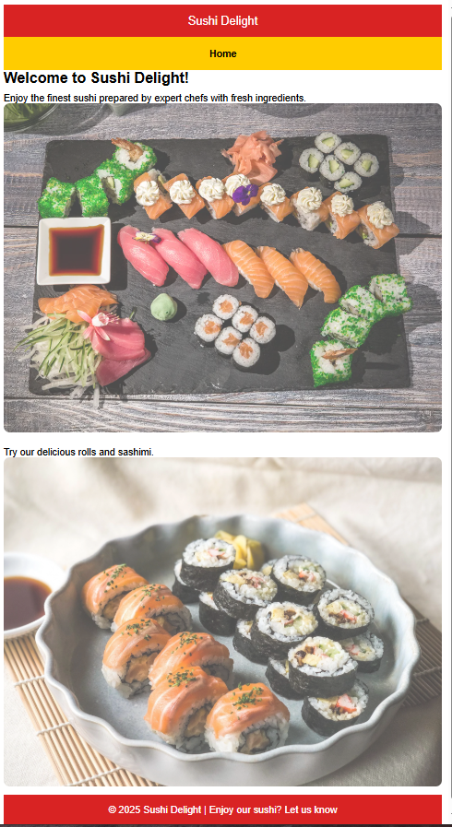

1. Save your page as sushi.html in your Ch.7 folder.
2. Preview the html and CSS pages to make sure everything looks correct.

## Step 4: Submitting your work

1. Upload your Ch7 folder with your sushi.html file, styles.css file, and the two images to your GitHub account.
2. Open a browser and locate your sushi.html page by using your GitHub website.
   1. The link looks something like: webakcat.github.io/Ch7/sushi.html.
   2. GitHub is CASE SENSITIVE.
3. Submit your link to the Canvas drop box.

YOU DID IT!!