Instructions for Your Budget Sheet

For 2 People with Monthly Checks and 1 Working Weekly

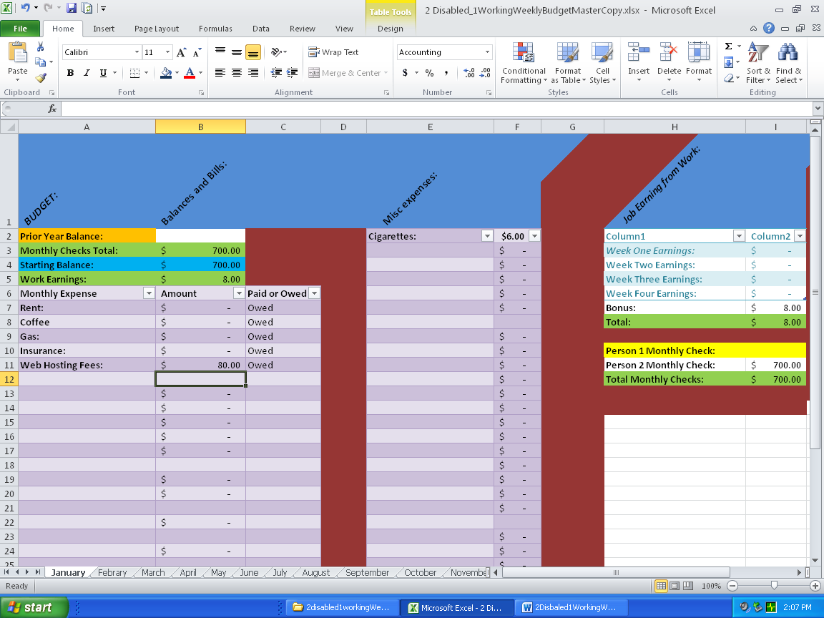

Above you can see the first sheet in the Excel Budget Workbook named January. Below the blue title bar at the top you will see a partial orange row that contains and area that you put your remaining balance from the year before labeled “Prior Year Balance.” In the white beside it is formulated to except the balance you have left from the year before. Below is the cut out of this area.

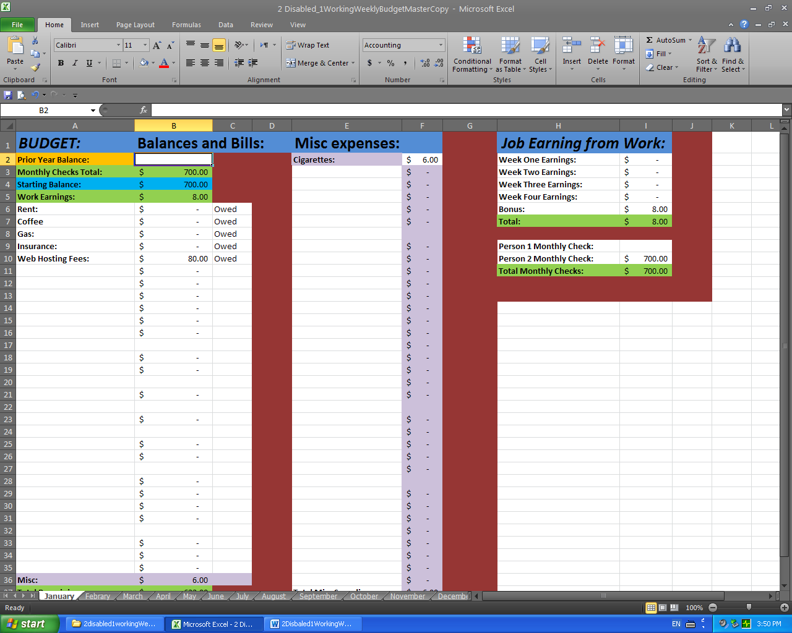

The white box is where you add the money amount you have left from the year before if you start the budget sheet in January. If not starting in January you may use the same cell marked Prior Monthly Balance to input your starting balance before checks are add. In the document, only type your expenses in the two shades of purple spaces provided. Columns “A” and “E” are where you record what you spent your money on and columns “B” and “F” is where you put the cost of the expense.

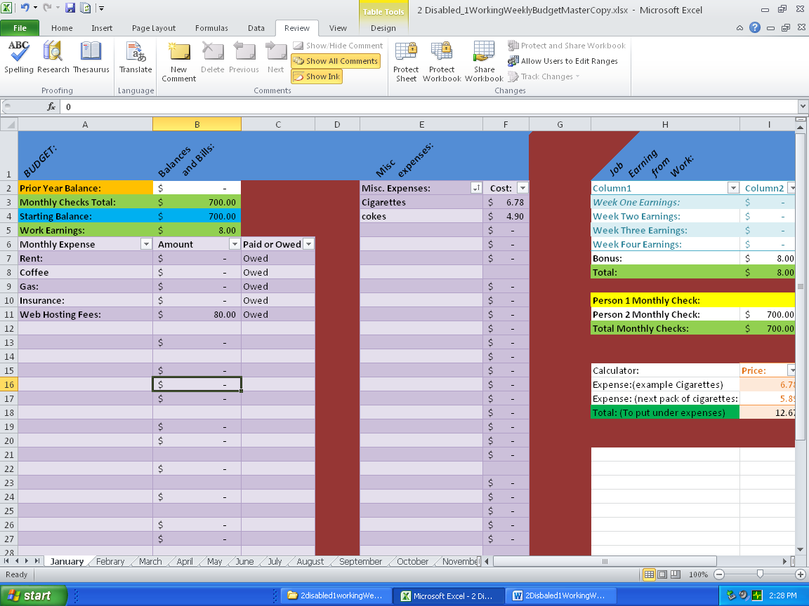

To the right are the areas where you put your incomes. Below you will see the cut out of just this area. The two shades of light blue are where you put the weekly income of the person that is working a job getting paid weekly with any bonuses you get. Then below that in yellow and white you have where you can put in your monthly income for each person. This Budget sheet is designed for one person with a monthly income military, SSI, or SSID income also woirking a job living with someone not working with a monthly income (Military, SSI, or SSID).

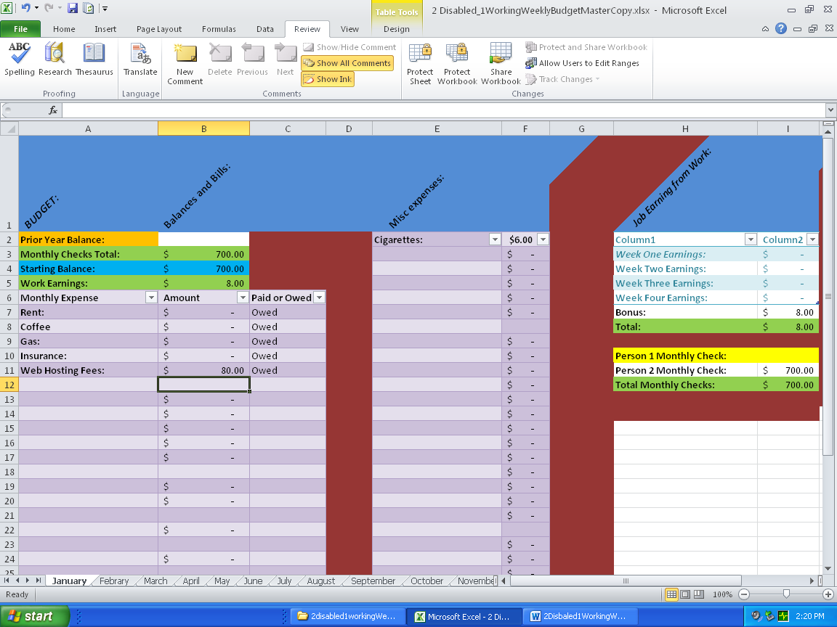

Below you will see a calculator where you can use to add to already added Misc. expenses like when you buy an extra pack of cigarettes. You will find it right below where you put in your incomes.

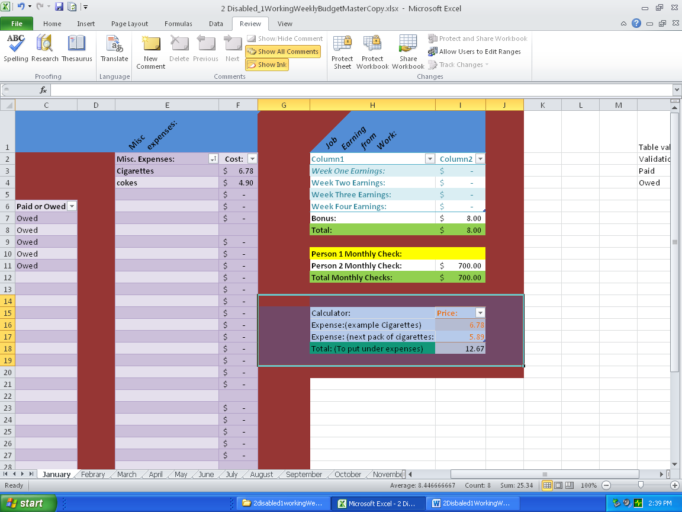

Below you can see where there is green backgrounded totals. These are formulated to calculate out on there own by adding together your expenses and subtracting them from your income. They are shown again below.

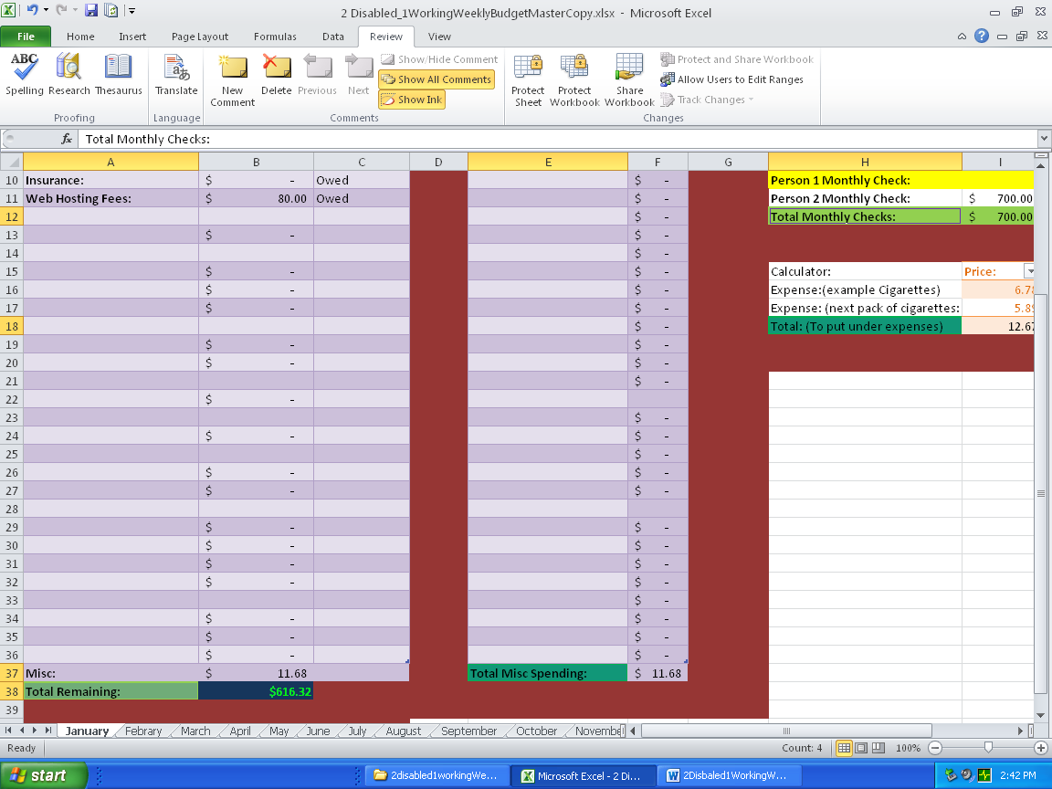

Below is the “C” column or third column where you can use the drop down list to tell whether you have paid your monthly bills or not.

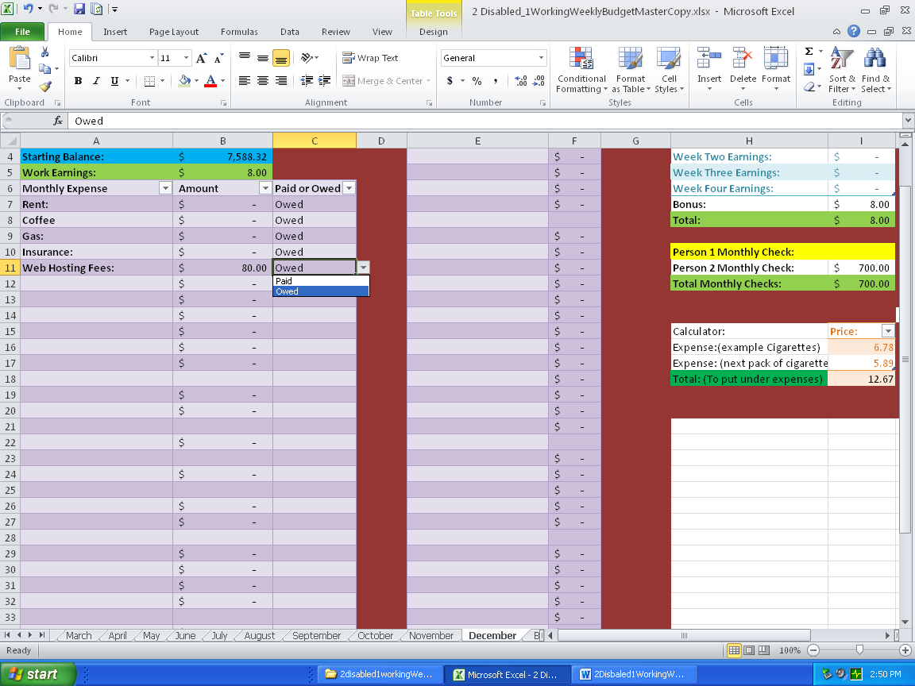

As you can see I placed the ones for the fields I prefilled into the owed position and in the picture you can see when you click the cell the drop down menu appears and shows “paid or owed.” Below you see the cell in the clicked state with the drop down arrow showing.

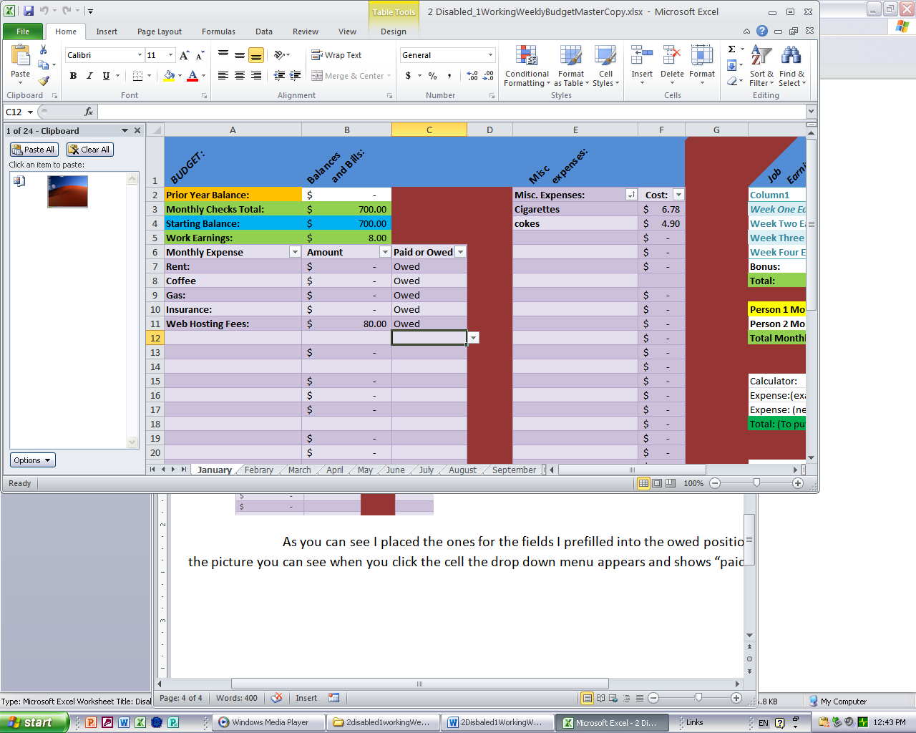

Below I have and area of the worksheet that you do not need to touch. It is used to create the “paid and owed” drop down menu talked about above.

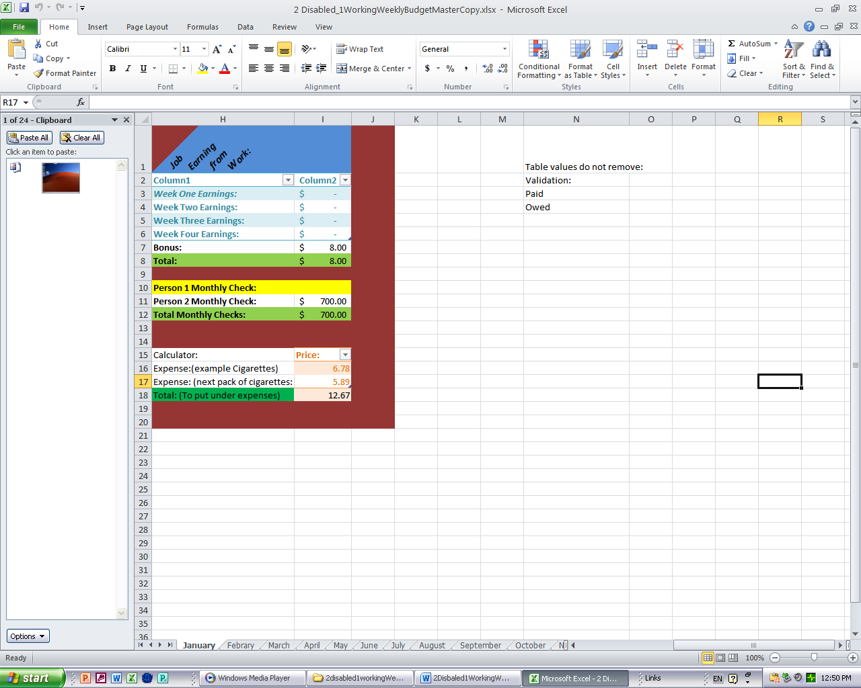

As you can see the Table valuess do not remove warning is where the paid and owed words are stored in the “C” column.

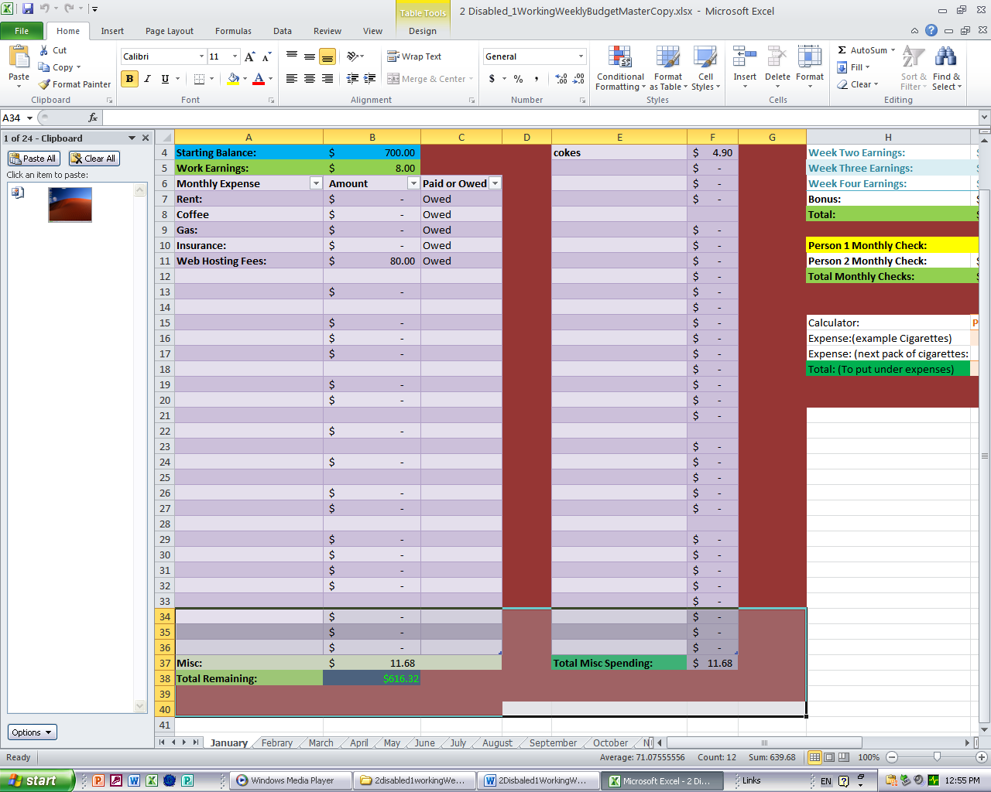

Above you can see Misc: and the Totals remaining at the bottom of the picture.These are pre formulated cells that you should not touch or change. Truly in this picture cells A7 (Rent) over to the C7 paid or owed cell down to A36 just above the Misc. label in A37 are all you change in those rolls and cells E4 (cokes) and F4 ($4.90) down to E36 and F36 should be changed to use this budget calculation spreadsheet correctly. E3 (cigarettes and F3 ($6.78) is not showed in the above picture but can be used and changed as well.

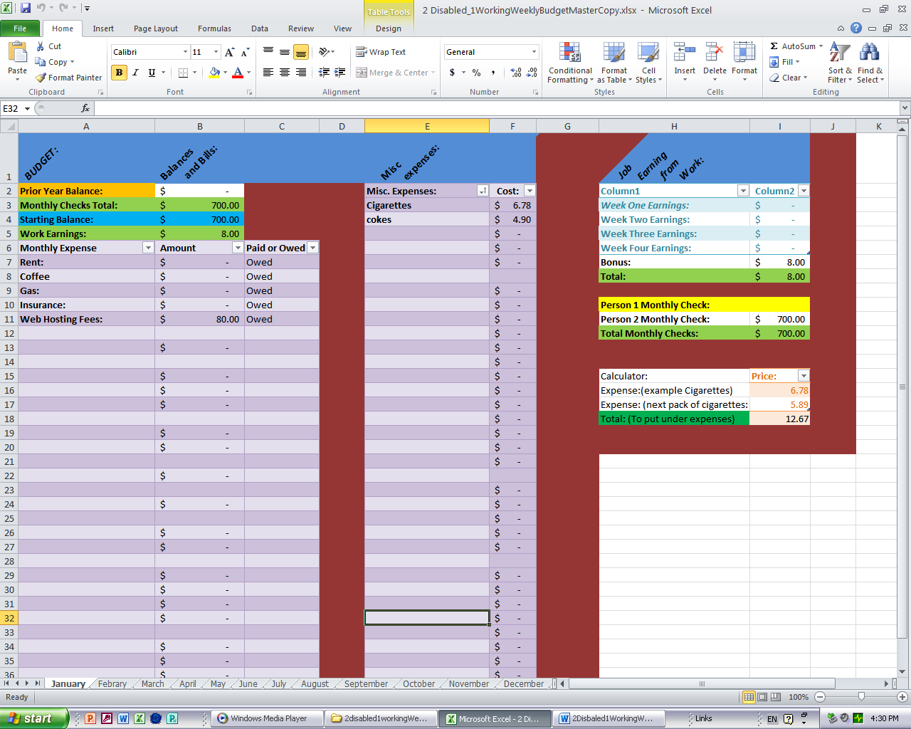

At the bottom of the spreadsheet you can see that there are tabs with each month on them. This is so that you can keep records of all your spending through the months of the year which can help you budget better spending. Keeping records this well will also be helpful in getting a loan to some degree. To help you keep track of your spending …



You should remember to record each month’s bills in the same row so that you can get the summary charts at the end corrected added up. Below you see the pie charts and at the bottom of the picture you see a square where the tab December next has Budget 2018 Totals.

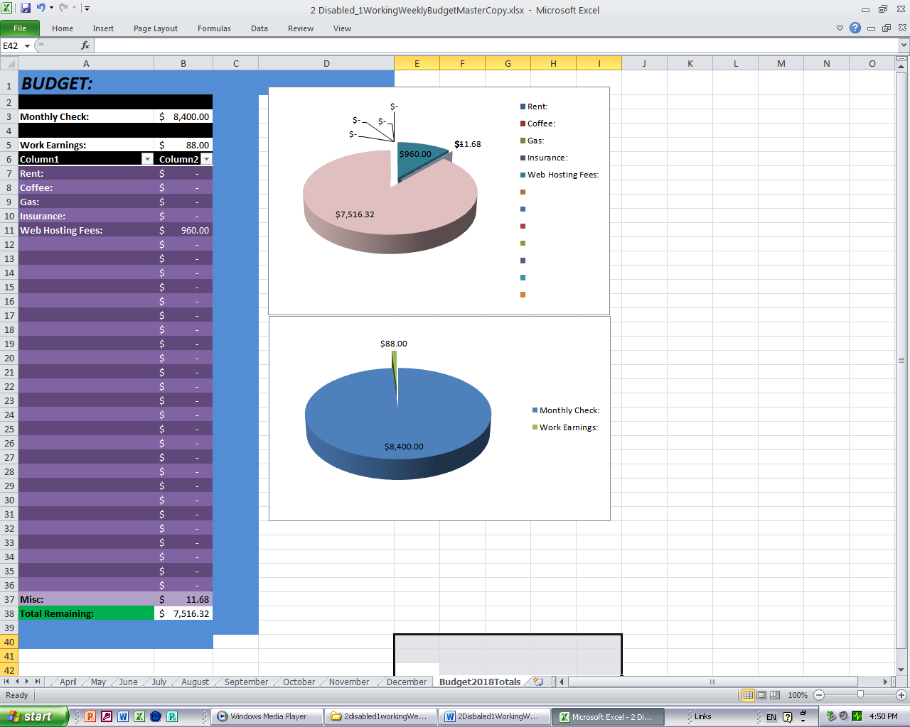

As you can see the bills I filled in this spreadsheet workbook already have totaled up and listed the yearly totals for the rows that they are in. If you keep actuate records and want to get a small loan or even a business loan this can help prove you not only have the money but that you keep good records and are savvy enough to run that business properly enough that the bank should feel safe giving the loan. Besides that you can make sure that you do not over spend and cause yourself headache or a repossession.

Below is a screen shot with the whole January worksheet in the screen where I zoomed out to 70%.

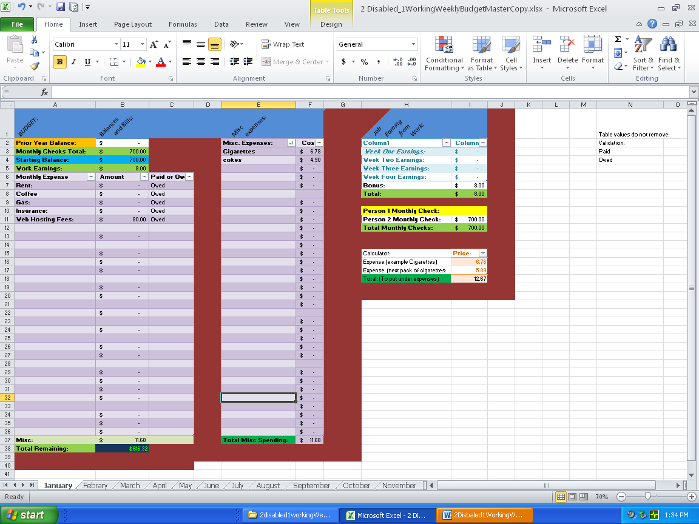

That is all of the worksheet that is used. Thank you for your purchase and I hope that you will use us again.