NAME – Alok Singh

USN- 22BTRAD003

*SCALA PROGRAMMING*

Q. Write a Scala program that creates an abstract class Shape with an abstract method area. Implement subclasses Rectangle and Circle that override the area method.

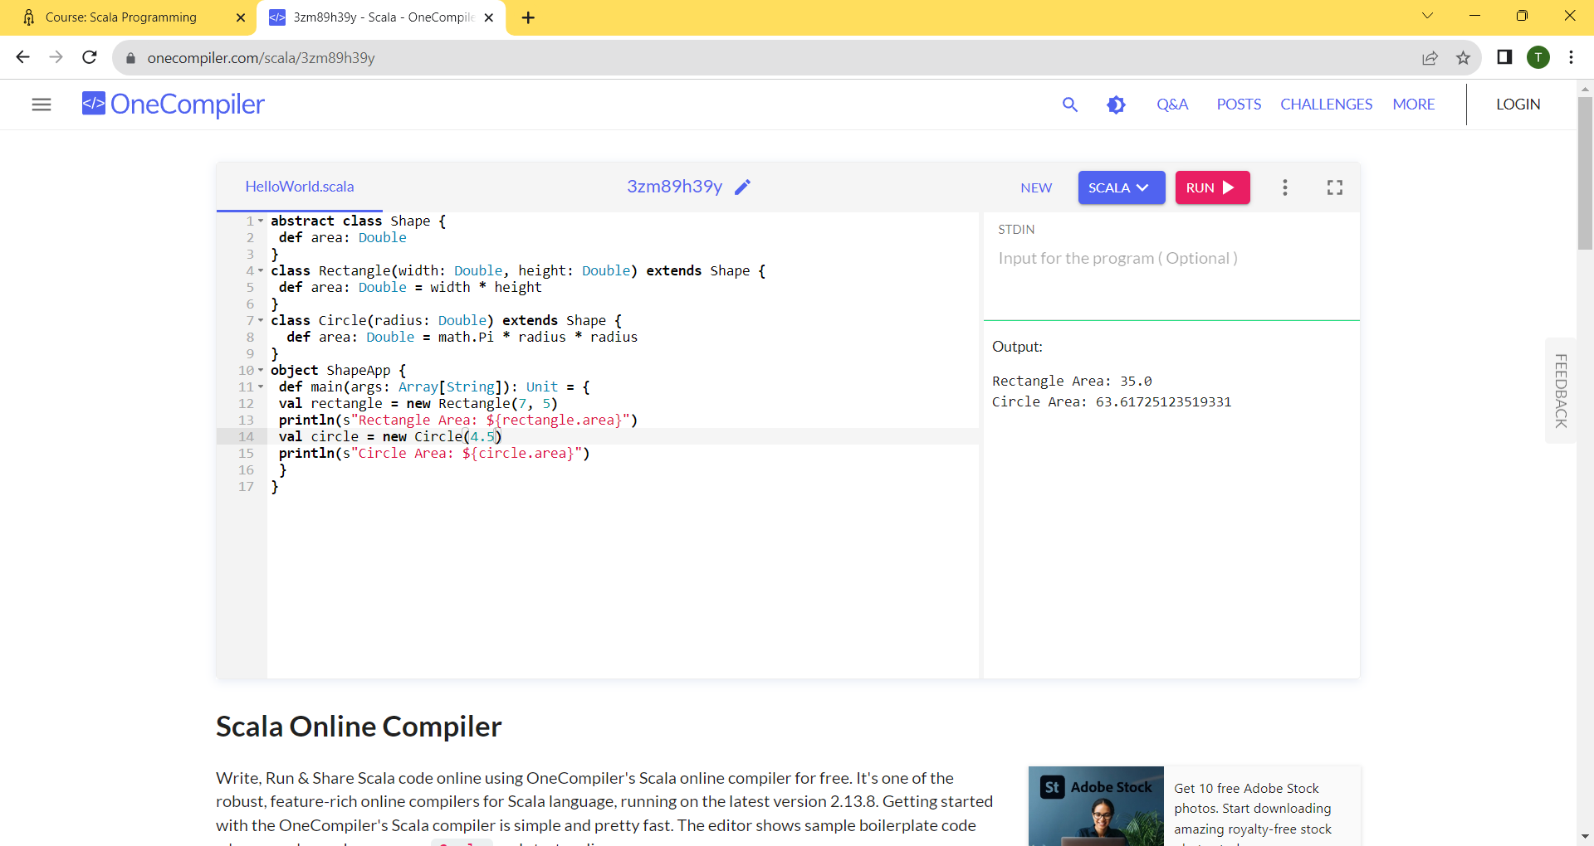

Q. Write a Scala program that creates a class called Person with properties like name, age and country. Implement methods to get and set properties.

