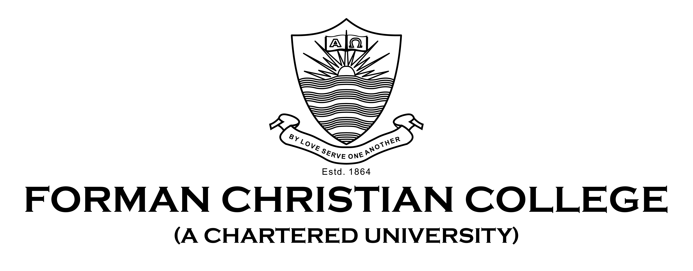

**CSCS 351**

**Software Quality Assurance**

**Spring 2021**

**Assignment 1**

**Test Report**

**Submitted To: Mr. Saad Bin Saleem**

**Submitted By: Anmool Yarmiah**

**Roll Number: 21-11388**

**Section: A**

**Writing a test report with screenshots of all the test cases and programs used for testing.**

1. **Snapshot Of The Code To Be Tested**

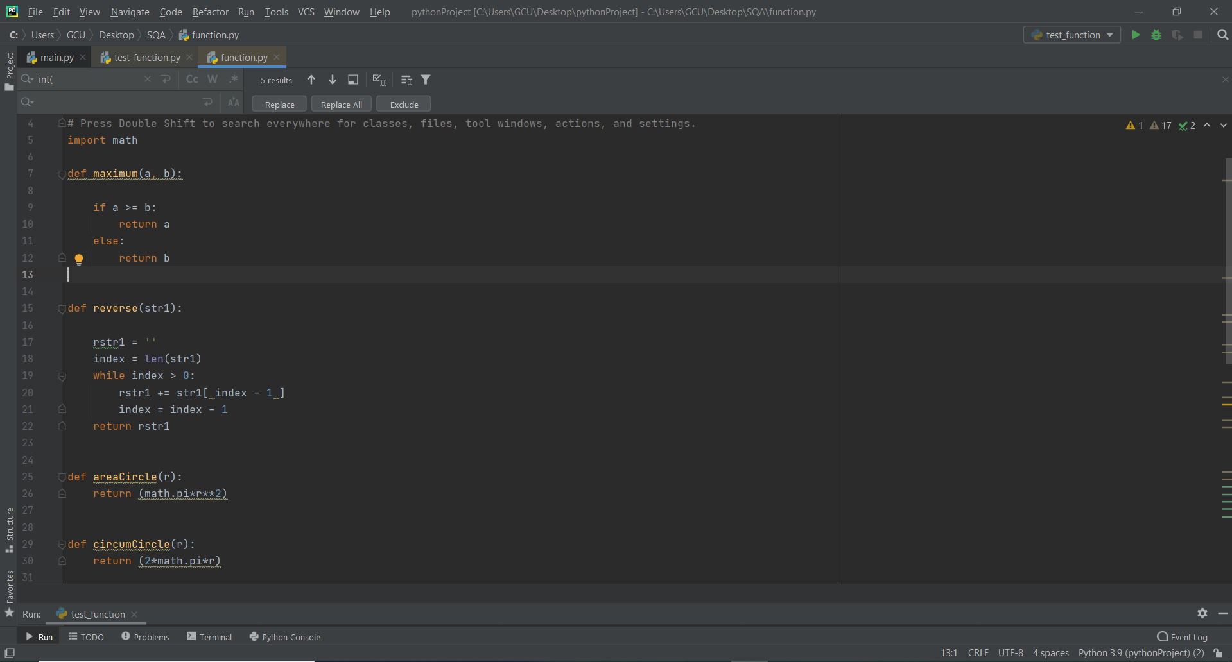

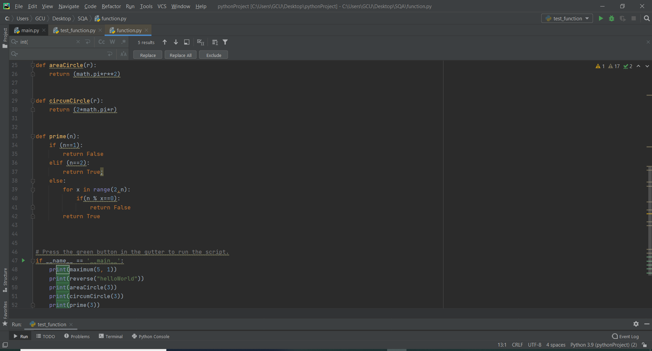

**Output of Code to Be Tested:**

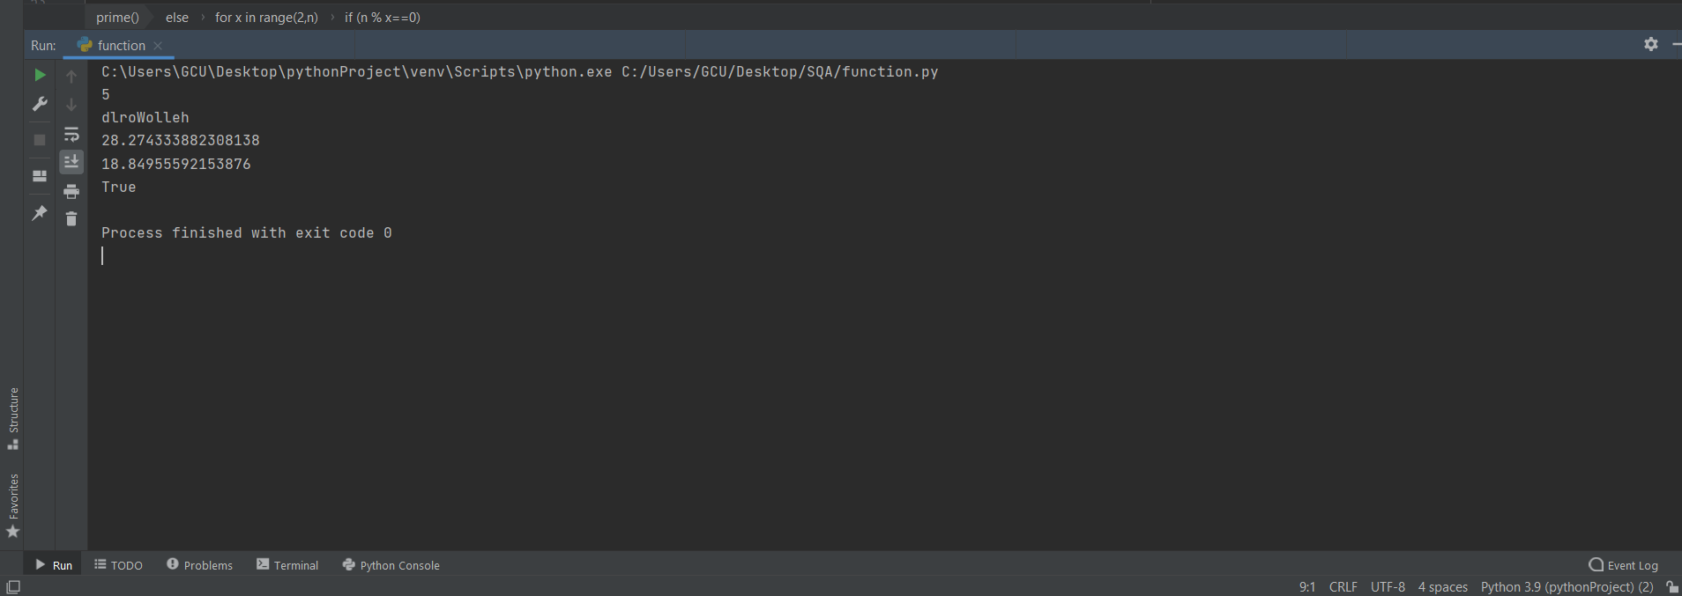

**Code of the Function:**

import math

def maximum(a, b):

if a >= b:

return a

else:

return b

def reverse(str1):

rstr1 = ''

index = len(str1)

while index > 0:

rstr1 += str1[ index - 1 ]

index = index - 1

return rstr1

def areaCircle(r):

return (math.pi*r**2)

def circumCircle(r):

return (2*math.pi*r)

def prime(n):

if (n==1):

return False

elif (n==2):

return True;

else:

for x in range(2,n):

if(n % x==0):

return False

return True

# Press the green button in the gutter to run the script.

if __name__ == '__main__':

print(maximum(5, 1))

print(reverse("helloWorld"))

print(areaCircle(3))

print(circumCircle(3))

print(prime(3)

1. **Snapshot of the Test Functions**

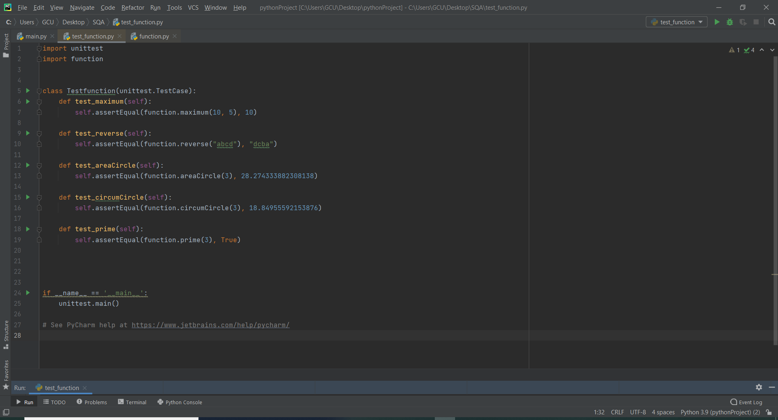

**Test Case Ok Result:**

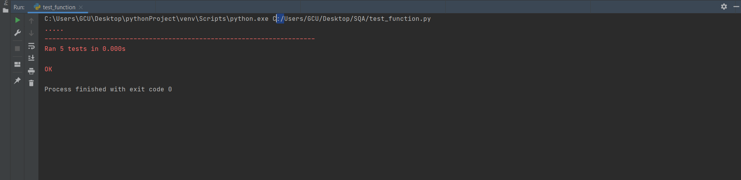

**Test Case Fail Result:**

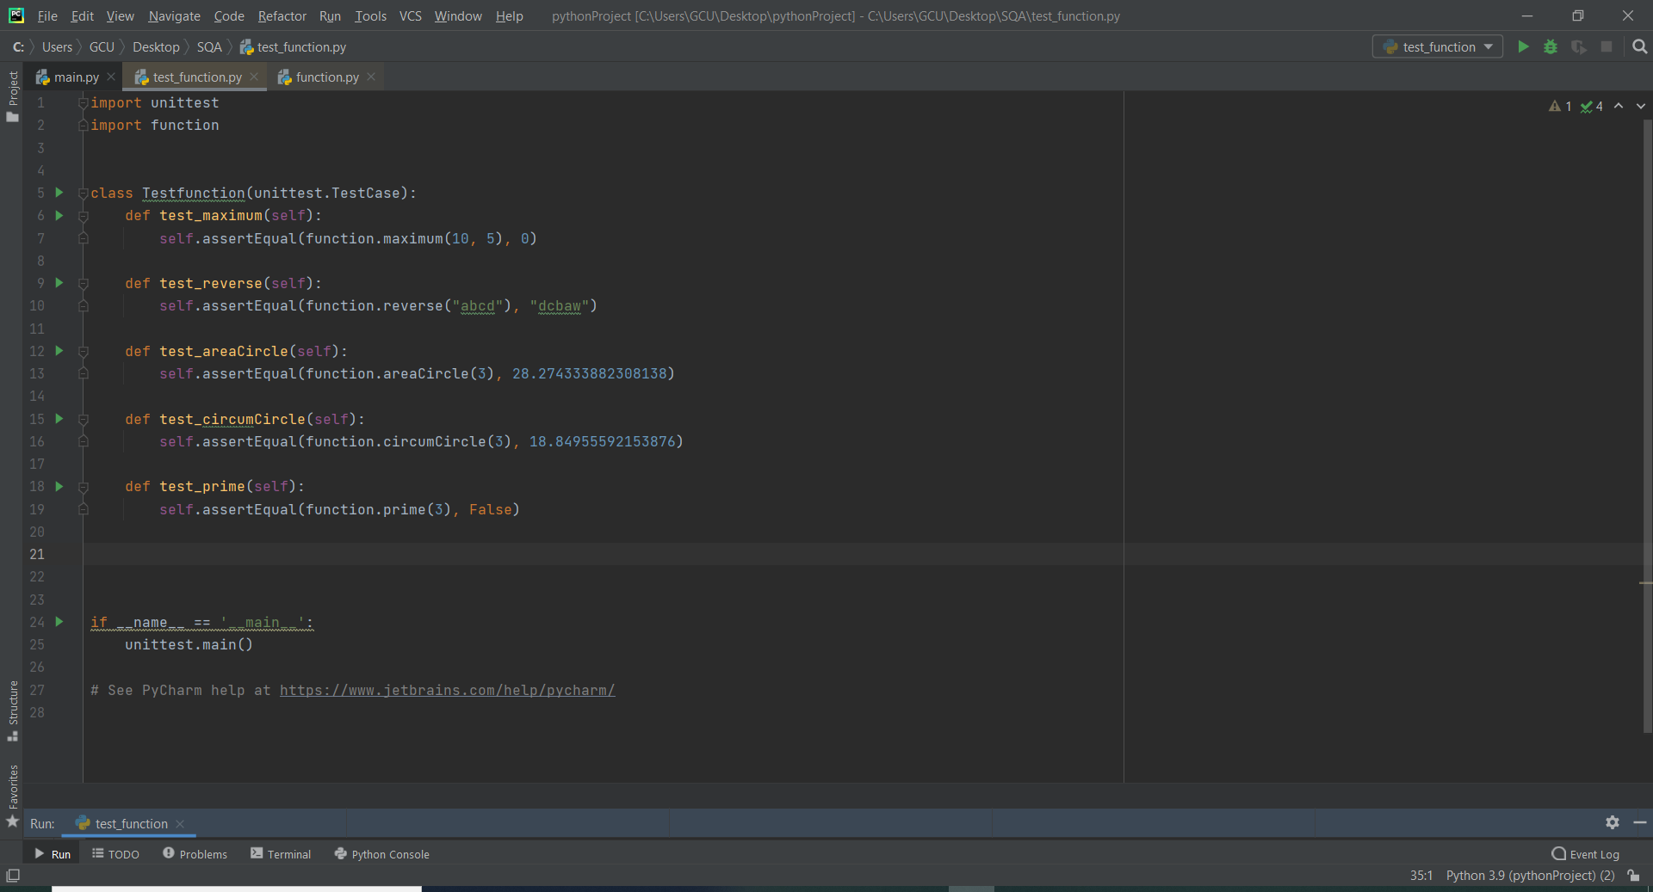

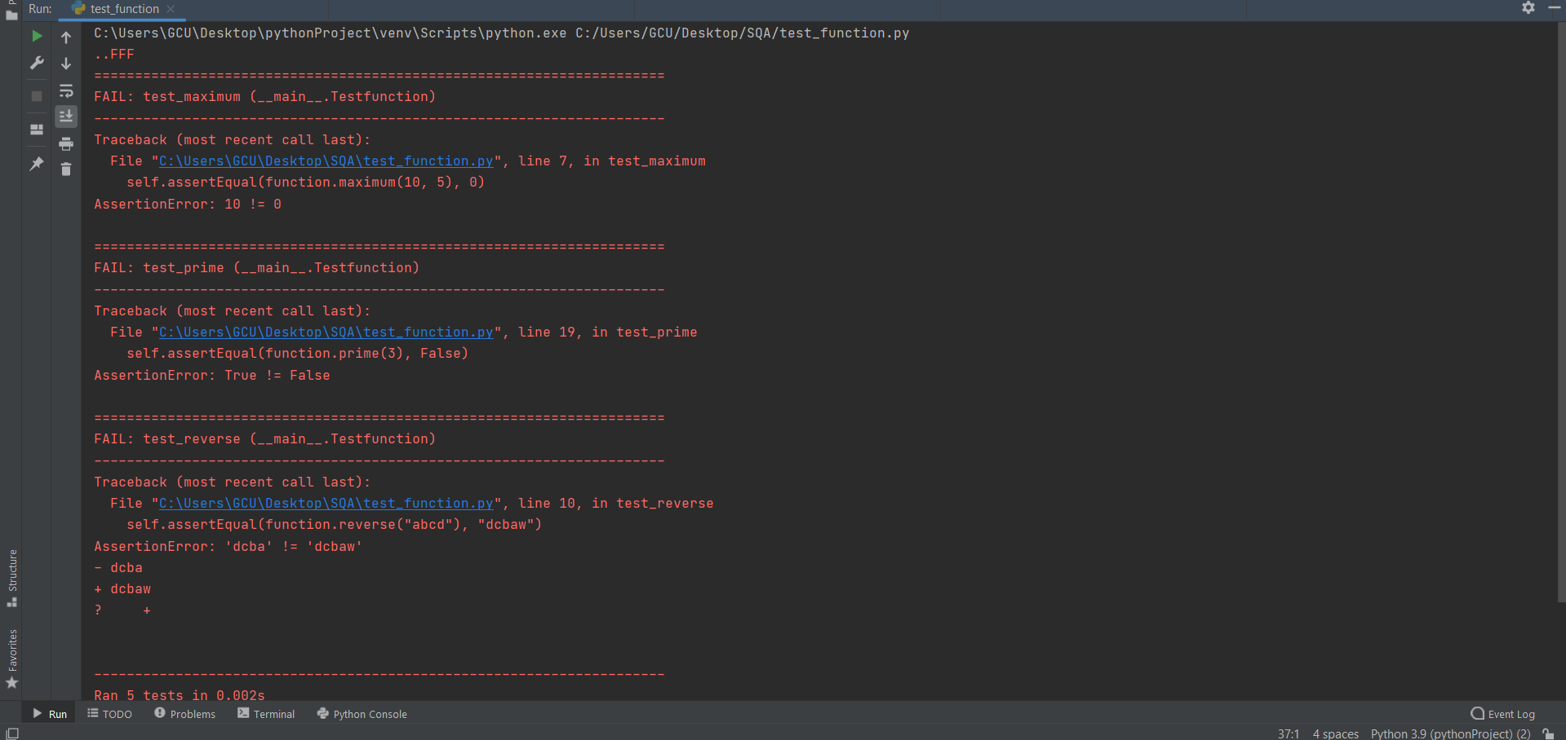

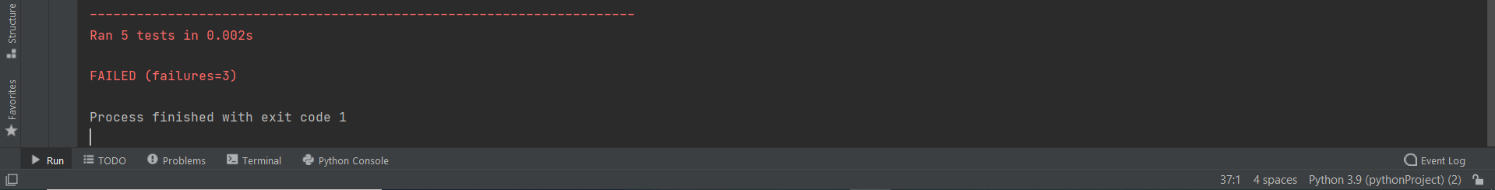

**Test Cases Code:**

import unittest

import function

class Testfunction(unittest.TestCase):

def test_maximum(self):

self.assertEqual(function.maximum(10, 5), 10)

def test_reverse(self):

self.assertEqual(function.reverse("abcd"), "dcba")

def test_areaCircle(self):

self.assertEqual(function.areaCircle(3), 28.274333882308138)

def test_circumCircle(self):

self.assertEqual(function.circumCircle(3), 18.84955592153876)

def test_prime(self):

self.assertEqual(function.prime(3), True)

if __name__ == '__main__':

unittest.main()