“Payroll System – Generic” is selected and there are 8 types of payroll import in use:

* Award Classification
* Award Classification Range
* Employee
* Employee Hours
* Employee Award
* Employee Details
* Employee Address
* Employee Leave Balance

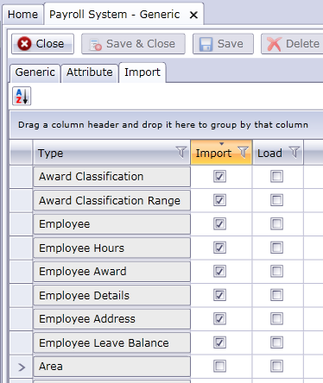

And 8 transforms are implemented accordingly.

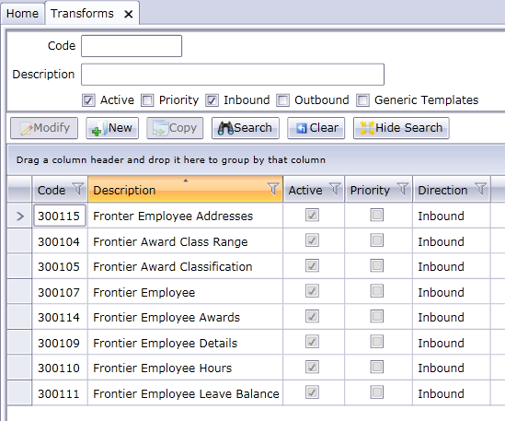

There were several extra components enabled but never contributed to Imports; therefore, they have been disabled:

* Employee Role – There is no PSDET file;
* Employee Data – There is no frequent flyer information in the EMDET file;
* Employee Attribute – There is no attribute data in the EMDET file;
* Employee Area – Area data is not supplied and all existing employee area data has been created by users and not imported;
* Employee Position – There is no position data in the system.