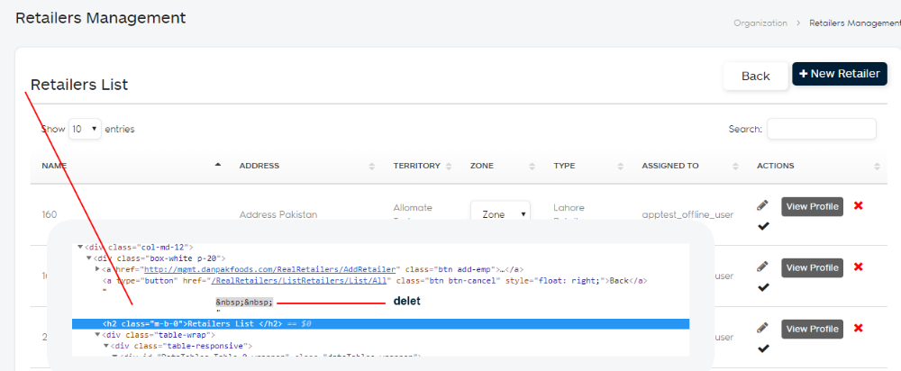-1 Replace style.css
-2 on retailar page, Distributors , action colum
<th style="width: 80px">Actions</th>
