**YOUTH EMPOWERMENT AND TRANSFORMATION TRUST**



Needs Assessment

for an

Integrated Information Management System



Contents

Introduction 3

Methodology: 4

## Introduction

The primary purpose of this assignment was to conduct a comprehensive assessment of the organizational needs for the design of the Data Management Information System (DMIS) and to make recommendations on the system(s) to be adopted.

This study aims to identify and characterize the specific business information management system requirements of the ideal information management solution that could help the organization meet its administrative and programming goals. However, this study does not describe or recommend an elaborate technical infrastructure but rather identifies a practical, incremental approach for meeting the most pressing business requirements for the organization.

For purposes of this research, we assumed that Information Management means identifying what information is needed, who has the information, how the information could be captured and stored, how it could be analyzed and reported of, and finding the best method for its distribution and use. In other words, we took information management to be the process of creating, identifying, collecting, organizing, sharing, adapting and using the information on practices that have produced outstanding results in other situations and that could be adapted to another situation. We took an information management system to therefore be a set of interrelated components working together to collect, classify, store and distribute information to support decision making, coordination and control in an organization. It would be about how effectively data is managed and transformed into information useful for decision making, and how that information eventually becomes knowledge.

The assessment framework was built around self-assessment processes as well as broad consultation with key stakeholders to help collect and validate information recognizing the multiple dimensions of capacity and resources needed to effectively design the Data Management Information System for the organization. The assessment went beyond individual capacity (relevant skills and abilities) to include organizational capacity (governance, processes, etc.) as well as the broader context and environment within which the organization functions (societal capacity).

The assessment results show that overally, there is a shared desire for the organization to have a holistic MIS. It is generally noted that currently there are several silo processes running but there is need for integration and therefore a platform that provides the organization wide view of the processes and achievements. The shared vision is to have a data management information system (DMIS) that is readily available to staff, partners, stakeholders, community based organizations and government departments depending on their different roles. According to the YETT director Rosewita Katsande, notably, as an organization, YETT has done a lot of work, but there is a void in terms of a readily accessible institutional memory, which an integrated MIS should address.

The assessment participants were in tandem on their desire to see a system that is well secured and featuring all work aspects and linkages with what would be happening on the ground, and the full digitalization of all departmental processes including staff activities.

The Director expressed her confidence and support for the vision, including that from all board members. She said that the organization will strive to support the vision and will endeavor to invest in relevant software, hardware and capacity building that will enable the dream to become a reality.

## Methodology:

This assignment was conducted during a Covid 19 lockdown period where movement was restricted and physical visits were discouraged to try and curb the spread of the infection. As such the methodology adopted had to avoid physical interaction and had to resort to online platforms while ensuring that the assessment would remain participatory and consultative. The assessment was investigative in nature and qualitative questions were better suited to give the expected product. The following methodology was therefore applied;

1. ***Interviews with key users***

To get an intimate understanding of the current information management tools, processes and user experiences and expectations, online key informant interviews of the director, departmental heads, IT support person, and of various stakeholders such as donor representatives, youth organization representatives, and…..! were conducted. Kindly refer to Annex for the table of the interview schedule.

*Data Collection Tools Design and Development:*

Data collection tools for the interviews were developed and shared with the YETT focal point person for review before adoption. The Questionnaires were then shared with the Key Informants before the interviews were conducted so that the informants would familiarize and possibly prepare responses before the oral interviews. *The featured questions were on information sources, data collection methods, data quality checking mechanisms, data storage, data processing, data analysis, reporting, and information sharing/dissemination. The questionnaire also probed various other aspects such as the nature of current software and hardware being used and their adequacy in meeting the user expectations. Finally the uestinnairres asked the informants about the kind of MIS they wished for. Refer to Annex for the questionnaires.*

1. ***Literature Review***

Relevant key organizational documents were reviewed with a view to gain a deeper understanding of the organizational implicit MIS strategy and nature of data collected and reported on. The documents reviewed included YETT_ME_Strategy, YETT_Monitoring_and_Evaluation_Framework, Outcome Harvesting, Reporting Matrix and the YETT_Data_Quality_Assessment_Tool. A number of data collection tools and sample reports were also shared for our review by various departments.

1. ***Focus Group Discussions***

**Three**? Focus Group Discussions were held focusing on what the users think could be automated and what reports could be generated, and with whom the reports could be shared.

1. **Qualitative Data Analysis**

The collected, mostly qualitative data was analyzed manually. The processing and analysis of the qualitative data from the key informants and focus group discussions included transcription by the interviewer, keying in of the information verbatim, coding, summarizing, categorizing, direct quoting and comparisons. These were finally organized as per the main themes and sub themes.

# Key Findings

## Information Sources and Consumers

Through various means inclusive of the conducted key informant interviews, focal group discussions, and documentation review, it was established that the sources and consumers for the organizational information include the following;

* YETT staff members, own departments, other departments, departmental and programme managers
* Technical staff, Academics, Consultants
* Partners and other NGOs
* Youths and Youth Organizations
* Ministries, line ministries, government departments
* Legislators/Policy Makers, community leaders
* Local authorities, municipalities, RDCs
* International Donors
* Academic/Educational Institutions
* Training Institutions
* Mass Media (newspapers, radio, TV, internet)
* Social Media (Facebook, Twitter, Youtube, tik tok, etc)

The study showed that the information is generated and used internally and externally. Internally it is used by YETT staff members (the executive(board)/management/and other staff) and other departments. Externally, the information is used by donors/funding partners, implementing partners, policy makers/MPs/councilors/local councils, Zimbabwean youths and youth organizations, traditional community leaders, private sector, SADC community, Academic Research Institutions, etc. Some of the information is however sourced from some of the above mentioned entities.

*The following information map was used to* define the boundaries of information, connecting project information needs with project information sources. It defines what is important and what is not important. Gives a high level definition of where the information is, who has it, what it will take to have it and its relevance. It also maps the users of the information, who are they, when they need the information, how often.

Below is a project Organigraph to chart the relationships the project develops:;

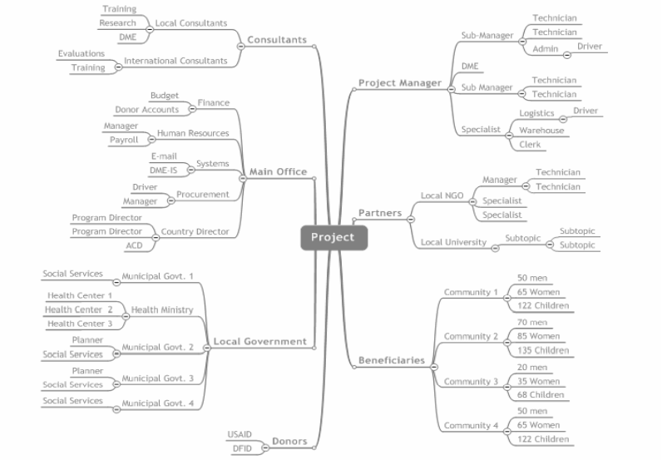

#### Project Information Flows

The following illustrates how project data is shared by different players in the organization

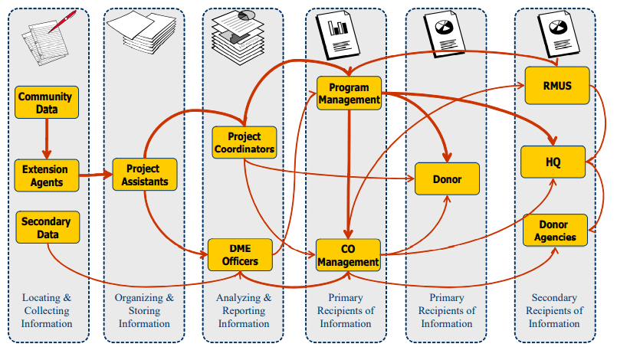

The following classes of information flow were noted from the study:

* Information access
* Information exchange
* Personal communication
* Work process
* Knowledge sharing

## Nature/Type of Information being handled

The assessment shows that the organization’s different departments are dealing with a varied nature of information inclusive of partners and stakeholders details, project proposals, MOUs, Policy documents, budgets, implementation plans, assessments/researches, reports, procurement requisitions, contracts, payroll, staff advance requests and payments, vendor payments, staff leave, vehicle bookings, bank statements, GIS, historical information and trend analysis. The information is in various forms and formats including hard copies and electronic copies. Some information is conveyed or shared verbally including through cellphones.

The table below shows the different departments from the organization and the descriptions of some of the information they are handling;

|  |  |
| --- | --- |
| Department | Description, nature, type of information dealt with |
| Youth and Advisory Services Department | Survey/Assessment data and reports  Policy Documents, Reports, Budgets |
| Partnerships and Grants | Partner and stakeholder details, MOUs, Policy documents, Proposals, Donor Reports |
| Finance and Administration | Contracts, Budgets, journals, cash statements, bank statements, Procurement requisitions, quotations, invoices, service provider/vendor payments, utility bills, staff advance requests and payments |
| Payroll/salaries, staff leave management |
| Vehicle bookings  Assets and Inventory |
| Advocacy and Research | Policies of the institution, Academic researches |
| Monitoring and Evaluation | Theory of Change and M&E framework  YETT_Data_Quality_Assessment_Tool  YETT_ME_Strategy document  Surveys data  Reporting Matrix |

***The nature and type of YETT related information stakeholders handle***

The interviewed YETT stakeholders confirmed handling the following types of information on YETT related projects;

Strategic plans, annual plans, policies, Concept notes/Proposals, funding opportunities, Budgets and Budget reports, tools, consultation reports, activity reports, participant registers, reports on youth empowerment, online news papers about youth issues.

***Generally, the information data types that YETT and its stakeholders handle were found to be in all manner of data types including text, dates, numbers, pictures, audios, videos, GIS coordinates, etc.***

## Data Collection Methods and Tools

The interviewed key informants cited using different data collection methods that included surveys, assessments, researches, desktop reviews, dialogues, meetings, workshops, clusters, focus group discussions, key informant interviews and other methods. The different methods often apply the use of data collection tools that include departmentally customized templates/forms, physical printed questionnaires, online questionnaires, web forms, on-mobile device questionnaires, meeting minutes, narrative reports, stories, recordings, etc. To design the tools the different respondents cited using different applications such as Microsoft Word, Microsoft Excel, Google forms, and other mobile technologies such as ODK and Kobo. Some data is said to be collected using other platforms such as Whatsapp groups, online Zoom meetings, Microsoft teams, and Skype. Some specific tasks cited to be handled by the designed data collection tools included procurement requisition forms, staff advance form, time sheets, vehicle booking forms, etc.

## Data Collection Frequency

Most of the interviewed key informants said that data collection frequencies would depend upon various factors such as the project, the department, and the nature of activity. However, the most common data collection frequencies cited are shown in the table below.

|  |  |  |  |  |  |  |
| --- | --- | --- | --- | --- | --- | --- |
| Department | Frequency | | | | | |
| Daily | Weekly | Monthly | Quarterly | Bi-Annually | Annually |
| Youth and Advisory Services |  |  |  |  |  |  |
| Partnerships and Grants |  |  |  |  |  |  |
| Finance and Administration |  |  |  |  |  |  |
| Advocacy and Research |  |  |  |  |  |  |
| Monitoring and Evaluation |  |  |  |  |  |  |

Notably, in many cases data collected daily would feed to the weekly reports, and that collected weekly would feed to monthly reports, and so on.

## Measures to ensure good data quality

It was acknowledged by the various key informants that at times data would have errors due to various reasons. Errors such as duplicates, typographical errors, mis-calculations, logical errors/incorrectness, incompleteness, etc, would often occur and would need checking on. The different departments have come up with stop gate measures to try and curb errors and improve on data quality. The methods that were cited by the respondents included the following;

1. Recalculations and verification against figures provided where possible
2. Triangulation with other sources such as secondary data
3. Verification with source, and checking with supervisors, where there is need, including through use of follow-up emails seeking clarity. Follow up questions.
4. Sampling part of the records and following up with physical verification
5. Automation of data upon capturing by using skip logic
6. Review meetings
7. Outsourcing experts on data analysis

## Data Processing Methods

Respondents reported that data processing methods would depend on the output or report that would be required from the data. However, it was noted that the processes involved would generally include comparisons, reconciliations, data merging/aggregation, sums, differences, averages, disaggregation, correlations, attribution, etc. Other processes such as verification of approvals involved verification and comparison of authorized signatory signatures.

Various tools are reportedly being applied to aid the data processing. These include computer applications such as Microsoft Excel, SPSS (outsourced), Google forms, etc.

## Progress Tracking

To check and to report on progress, the key informants cited various ways being applied. Those using Google forms said they would go back to the online form responses to check if respondents would have responded to. Another way cited was tracking of time framed milestones set and agreed with donors. It was reported that it is the responsibility of supervisors to check on progress by their subordinates and oftentimes subordinates are required to submit contextual activity and progress reports in Microsoft word for review by the supervisor.

The notable tools being utilized to track and report on activities and progress include electronic calendars especially those embedded onto Microsoft Outlook and Microsoft Teams. Also notable planning and progress tracking tools cited are the annual plan, quarterly plan and the corresponding annual reports and quarterly reports.

## Information Organization

It was noted from the responses that, except where hardcopies, Bellina and Pastel are used, information organization and storage is generally left to the user’s discretion. Some users keep their information on emails, some on Google drive and other cloud based backups, some keep it on their local disks on their laptops, and some information is copied to external hard-drives and flash-disks. It is reported that hard copies, especially those containing ‘sensitive’ and financial data, are often stored in cabinet files. One responded specifically explained that they prefer to keep ‘sensitive’ data on external hard-disks that are easier to keep safe. Various discrete software applications are being applied to collect, process and store/organize the information.

## Approvals and Authorizations

It is generally reported that information is usually collected and processed but the report, policy, social media file or such other file generated from it would need to be reviewed and be approved by line managers and be authorized by the executive director, through their signatures, before it can be shared with external users.

## Information Usage, Reports and Dashboards

The key informants say that information is shared internally with other staff members and other departments and externally with government, donors, and other stakeholders. When asked about how their departments were using information, reports and dashboards (if any), the key informants gave the following examples of how information is being shared and used.

1. Weekly update meetings where progress updates are provided. Meeting minutes are captured and shared.
2. Narrative reports in PDF featuring various info-graphic charts and graphs. Also included, may be, diagrams, data tables,
3. Excel document reports, PowerPoint presentations
4. Payroll summaries
5. Newsletters, Brochures, pamphlets, and booklets
6. hard copies, emails, social media, website,

The nature of information shared include financial reports with budget holding managers and project officers, financial statements shared with auditors and payroll reports shared with executive director. Notably information is often shared with outsiders quarterly or as per request, but it is shared most frequently internally.

## Volume of Information

When asked about the volume of information they are dealing with, all departments except the Monitoring and Evaluation department said they were dealing with high volumes of information. The monitoring and evaluation department said the volume of information they handle is medium, although they said the volume also turns high during reporting periods. The table below shows the indications of the volume of information each department say they are handling.

|  |  |  |  |  |
| --- | --- | --- | --- | --- |
| Department | None | Low | Medium | High |
| Partnerships and Grants |  |  |  |  |
| Youth and Advisory |  |  |  |  |
| Finance |  |  |  |  |
| Advocacy and Research |  |  |  |  |
| Monitoring and Evaluation |  |  |  |  |

## Desktop, Office and Web Applications in Use

|  |  |  |  |  |  |
| --- | --- | --- | --- | --- | --- |
| Software | Youth and Advisory Services | Partnerships and Grants | Finance and Administration | Advocacy and Research | Monitoring and Evaluation |
| Email |  |  |  |  |  |
| Spreadsheets |  |  |  |  |  |
| MS Word |  |  |  |  |  |
| Database Software |  |  |  |  |  |
| Statistical Analysis Software (SPSS) |  |  |  |  |  |
| Accounting Software (Pastel) |  |  |  |  |  |
| Procurement Software |  |  | *Using Excel* |  |  |
| Payroll Software |  |  |  |  |  |
| Asset and Inventory management |  |  | *Using Excel* |  |  |
| Human Resources Management |  |  |  |  |  |
| Fleet Management |  |  |  |  |  |
| Meetings and Presentations |  |  |  |  |  |
| Scheduling |  |  |  | **?** |  |
| Social Media |  |  |  |  |  |
| Facebook |  |  |  |  |  |
| You-tube |  |  |  |  |  |
| Tik tok |  |  |  |  |  |
| Whatsapp |  |  |  |  |  |
| Desktop Publishing |  |  |  |  |  |

It is apparent from the responses on the software usage that the most commonly used software is the emailing software, spreadsheets and Microsoft Word for word processing. The emailing software is used for official communications as it leaves an audit trail and allows for sharing of information which is usually shared in the form of file attachments. Some users reported using scheduling tools such as the calendar for scheduling reminders, appointments and meetings. Other software usage shows to be depend upon the department, and some software are even exclusive to departments. For instance, Pastel is solely used by the Finance department for financial accounting purposes and Bellina by human resources for payroll. With the advent of Covid 19 lockdown restrictions and the working from home scenario, online meeting platforms such as Zoom and Microsoft Teams have become the common platforms where staff and stakeholders are virtually holding meetings in cyberspace. Social media platforms such as Whatsapp, You-tube, Tik Tok, Tweeter, and Facebook have become popular platforms to inform, engage and interact with beneficiaries. Some users reported using online survey applications like Survey Monkey and Goggle forms, and others reported using mobile applications like ODK and Kobo. Remarkably, no one reported using database software, and fleet management software, and procurement and assets inventory information needs are said to be handled Microsoft excel.

Reporting and dashboard software were not explicitly asked about, but suffice to say the respondents did not voluntarily mention using that type of software either.

## Effectiveness and adequacy of the available software

Commenting on the effectiveness and adequacy of the available software, one of the key informants said

***“The available software are not very effective. They are donor driven and duty driven.”***

The respondent went on to add that the organization needed to have its own information management system and to inculcate and promote its usage. This was the general sentiment across the key informants. Another key informant’s comments were;

*“There is need for regular updates for the software to keep in sync with latest*

*versions. For instance, staff some members are still using MS Office 2016 when*

*there now is Office 365.”*

Other comments included that there is need for the organization to secure licensed softwares, and that there is need to purchase more software to manage processes. However, there are some software like Pastel and Bellina that are task specific and the users expressed satisfaction that they are able to adequately address their specific areas of need but the software are discrete and not linked to others. They requested for the possible integration with customized tools such as advance requests and liquidation forms so that their processes would be seamless.

When asked what gaps they could see and what MIS opportunities they could see for their department, most of the informants said there is need for an organization wide integrated software or MIS that is real-time and online, that tracks progress of processes. The respondents expressed their expectation that the integrated MIS would improve coordination and storage of information for institutional memory.

Don’t have an organizational system

Project related information not kept on MIS.. An MIS that keeps institutional memory.. Project information on different players and stakeholders

Coordination that comes with MIS

A system that coordinates activities

Need for realtime online system

## File Management/Document Management System in Place

Describing their file management/document management system, one respondent said they have ‘wardrobes’ of hardcopy files, and another said their file management was unstructured and files are saved unsystematically on individual laptops and external hard-drives.

Individual based

No central file management system --- One man for himself..!

Physical hard copies

Unstructured

Individual based

No server to centralize documents

Stored in individual files of individual laptops

External hard drives

Need for online document management system

## Comments on a paperless department

Need to go paperless considering Covid 19

Possible to have soft copies

Increased efficiency especially with people working from home

No obligations to keep hard copies for as long as even soft copy eveidence is availed

It is good but there I challenges to do with security of documents online

Hard copies needed for auditors and donors.

Its good to go paperless but challenge is to do with security of documents online

Strongly advocates for paperless department

Hardware

The study showed that apart from relevant software computers and Internet are the backbone of the organization’s information management initiatives. Computers are mandatory for most, if not all, of the positions in the organization. The table below examines the importance of various hardware to the different departments.

|  |  |  |  |  |  |
| --- | --- | --- | --- | --- | --- |
| Hardware | Youth and Advisory Services | Partnerships and Grants | Finance and Administration | Advocacy and Research | Monitoring and Evaluation |
| Desktop Computers |  |  |  |  |  |
| Laptops |  |  |  |  |  |
| Tablets and smartphones |  |  |  |  |  |
| Server |  |  |  |  |  |
| Printers |  |  |  |  |  |
| Photocopiers |  |  |  |  |  |
| Projectors |  |  |  |  |  |
| Digital Cameras/web cams |  |  |  |  |  |
| Internet |  |  |  |  |  |
| External Hard-drive |  |  |  |  |  |
| Telephone |  |  |  |  |  |
| Cellphones |  |  |  |  |  |
| LAN/ Office WIFI |  |  |  |  |  |

## ICT Skills Required for the Department

|  |  |  |
| --- | --- | --- |
| Department | Required Skills | Skill Possession |
| Youth and Advocacy | Word processing, spreadsheets, database management, Statistical analysis (SPSS, NVIVO),  Internet, email |  |
| Finance | Excel? |  |
| Advocacy and Research | Report writing  Tablet utilization  Loading of software | Need for capacity building on this regard |
| Monitoring and Evaluation | Data management and analysis | Need for training on SPSS and spreadsheets |
| Partnerships and Grants | Data Management  Graphics Design |  |

## Departmental ICT Capacity

Although they felt that they are handling information management requirements well, on department felt that they would need to increase their personel to cope with any increase in the volume of information in the department.

Machines need to be improved and more digital gadgets required

Under staffed, need for more staff

## Information Security Requirements

Cleaned and uploaded data should be protected. Different users should have different access roles

Need for a more security

Need to have a system where everything is centralized but a system user only sees what is relevant to them.

## Back Up Requirements

Currently rely on manual physical backups done by IT Officer which are doen on external hard-drives. No back-up policy.. individual based?

Finance department Backing up on Pastel and Bellina

## What ICT Support have you required?

|  |  |  |  |  |  |
| --- | --- | --- | --- | --- | --- |
|  | Youth and Advocacy | Finance | Advocacy and Research | Monitoring and Evaluation | Partnerships and Grants |
| Networking/LAN Connectivity |  |  |  |  |  |
| Internet/Emails |  |  |  |  |  |
| Software failure  Software Updates, Installations |  |  |  |  |  |
| Computer hardware malfunction |  |  |  |  |  |
| Antivirus Updates |  |  |  |  |  |
| Printer malfunction |  |  |  |  |  |
| Back-Ups |  |  |  |  |  |

The ICT support person, Etam Nyaruwabvu concurred with the above responses citing that he mostly attends to issues raised on printing, internet server connection, Microsoft office, Pastel and on software compatibility issues (Mac and Microsoft). He further added that the frequency of the calls is quite random.

Recommendations provided by the ICT support person include the following;

1. There is need to improve the network security by including a proper internal firewall
2. The organization should consider domain control based network for easier management fo network resources.
3. With the Covid 19 lockdown restrictions and people working from home, the organization should consider running Pastel from the cloud with proper security installed.
4. There is need for a system that provides offsite back-up service onto a centralized server for Mac and for Windows.
5. The organization should consider sourcing ICT skills capacity building for their staff members especially now that people are working from home and may have to first individually attend to many of the ICT issues they face from home.
6. The organization should seriously consider data access and security issues especially now that there is a lot of data being exchanged online by people working from their different home. Possible option being data encryptioning.
7. Lastly, the organization should consider having a centralized system that manages internal processes like cash requisitions, vehicle request, online filing, and so on.

## Working from Home

Weak internet connections

Inadequate hardware access such as printers, photocopiers

Difficult to collaborate and coordinate activities remotely. Teamwork is threatened ..!??

Need for a system that processes requisitions and manages approvals online

Need for a system that synchronizes processes online

Some files are too big to move over internet

Working from home for Finance department is a nightmare as there is need to come and sign requisitions. Most of the information is only accessible locally from the office computers.

Need for an online system that collects data from the remote users onto a central place and shares.

## MIS Features and Functionalities ‘Wish List’

It has to be YETT driven

Ability to save data across projects

Online

Need for holistic centralized MIS

Central documents portal/repository

Ability to capture documents in retrospect

System that allows for online requisitions and approvals

System should show scheduled activities and show which ones would have been done and which ones would be pending.. taking place on the ground

Secured access

Data security should be highly considered with users having different roles and permissions to access information

Automated analysis, reporting and Dashboard

MIS should be able to send relevant notifications and alerts to staff members and stakeholders

Backups done online

Easier searching of incformation

Donors and other stakeholders need to access reports

Hacking and manipulation concerns

Storage limits

There are donors that are willing to support fund new systems

No clear lines of MIS ownership

Online library for all publications

Need for organization to invest in more reliable hardware such as efficient laptops and tablets for field staff to capture questionnairres

Email server needs upgrading

Internet needs upgrading

Weakness of capacitation on MIS tools

Online payment approvals

Online register for activities

Youths should be able to post their issues online

Real stories, pictures and vidoes, should be uploaded onto the system

System should be able to reach out to youths on social media platforms

Should provide stakeholder access

Access Permissions

It was noted from the study that different datasets and information categories would require different access permissions. There is some information that is confidential and requires high level security so that only privileged users would access it.

Some of the information only requirements permitted viewers to only view without the ability to edit or delete the record. Some of the data would require the record owner or whoever would have captured it, or any other approved person to edit or delete the record.

Audit Trail

Focus Group Discussions

# Analysis and Recommendations

Various respondents cited an automated system could bring in a degree of completeness in terms of efficiency, effectivity and sustainability of existing and relevant information systems

### Challenges with the Current YETT Information Systems

From our analysis of the key informant interviews, the following information management challenges are apparent:

No standard MIS process

the lack of a standard process has led to the development of many systems each with its own processes, all disconnected from each other.

country offices have to deal with information coming from different systems, making the collection and consolidation of information impossible. Systems are tailored to specific project and donor needs. DME perceived as an outside expertise; project data is a byproduct delivered to a donor or an expert who will do the analysis for us, this has created a high dependency on consultants.

**Limited Accessibility**

Information is not accessible in real-time. Some of it exists on hard copies, hard-drives and on flash-disks. There is need to have a system that ensures real-time access to information so that the right information would be availed to the right people at the right time.

**Data Losses**

This is always a looming data loss threat as there is no formal systematic back-up arrangement. Information could be lost in various ways that could include theft of storage media, staff resigning and carrying their storage media containing organizational data, virus attacks, computers crushing, etc. There is therefore a need for the organization to have a formal systematic back-up mechanism such as a central server, or organizational cloud based Google drive, One drive, or such arrangements.

**Integration**

It is difficult to collate data at organizational level as the organization is at best running standalone applications. There is need for the organization to have an Integrated information management system. This will ease data collation and will enable sharing of information, software and hardware.

**Information Security**

There is no mechanism to ensure or to enforce information security apart from clauses on signed contracts or MOUs. There is need for the organization to have a system that enforces data protection measures, ensuring that some people would not be able to access data they would not be privileged to see, and some would have read only rights, while some would have rights to edit and/or delete data, depending with their roles.

**Process Management**

There is need for the organization to have a system that eases process management, ensuring that eligible staff check, approve and authorize various requests and processes. That way the organization will be able to not only ensure security but also simultaneously monitor and report on progress at process level.

**Audit Trail**

While some applications allow tracking of changes on a particular file such as when ‘review’ is activated on a Microsoft Word document, the audit trail is often lacking enough detail. There is need for the organization to consider having a system that shows who did what, in the system, and when they would have done it.

**Reporting Issues**

The lack of a tailor made process tracking system and archiving system is leading to some reporting inconsistencies as staff members are left to rely on their memory in relating files, figures, events, etc… This is leading to inconsistent reporting, over-reporting or under-reporting. There is need for the organization to have a system that provides a thorough report generating mechanism and platform providing standard reports, customizable reports and dashboards, and interactive reports featuring various charts and GIS features.

***Incomplete/Missing/Incorrect Data***

Some data being collected is reportedly incomplete, missing some key details, or would have incorrect/illogical responses. The organization requires applications that enforce some data validation upon data collection/capturing where some fields are made mandatory and users cannot proceed without providing the key entries including application of validation rules that also ensure that appropriate data types and value ranges are applied.

***Non-Standard Tools/Formats***

Non-standard tools/formats cause data collation problems and an integrated MIS ensures that all users use the same forms for specific tasks across departments and across the organization. This helps in easing data collation and reporting at organizational level.

**Data Duplicates, Redundancy & Integrity**

A non-integrated system often leads to data duplicates, redundancy and data integrity issues. Although we could not get a chance to physically inspect this, these are challenges inherent with discrete running applications. An integrated system ensures data reusability and allows data to be linked curbing data duplicates and redundancy and in that way improving data integrity. Also, departments and projects no longer have to duplicate effort committing resources to collecting similar information.

***Information Management Skills***

It can be noted that providing a centralized organizational MIS takes away the need for staff to have special information management skills as the MIS would provide, to some extent, a ‘one stop center’, for organizational information.

***Unstructured Document Management Systems and Qualitative data management***

There is no structured document management defined for the organization. Where staff members store their files and how they store them is more or less at the discretion of the staff member. This results in inefficiencies in retrieving information and may lead to data losses. The organization should consider setting up a structure document management system that defines where what will be stored, how it will be stored, when it will be stored, who will be able to access it, edit it, and/or delete it. This could come in the form of an electronic library featured on the integrated organizational MIS, complemented by some file sharing technology such as SharePoint that allows secured sharing of documents.

### The Information Environment

Notably information is living in an ever changing environment that has direct effect and influence on its context, meaning and purpose. It is acknowledgeable that information is also a system of people, practices, values, and technologies in a particular local environment. In this environment, the attention is not on systems, but on human activities that are served by systems. The environment consists of the numerous interacting and interdependent social, cultural and political subsystems that shape the creation, flow and use of the information. This environment influences what information is collected, how it is organized, stored, what information is made available and to whom, and what information is valuable and which is not. Therefore, the organization ought to invest in an MIS that is flexible to changing information environment, responding to the changing needs of donors, government, youths, and the society in general.

#### Information Economics

We recommend that departments and projects evaluate the cost to identify, acquire, store, disseminate and use each one of the information products it will deliver. From this perspective a project/department manager can view information as an investment made to improve the decision making process. If the information collected does not lead to a decision, then the project needs to determine if it’s worth collecting it at all. Unnecessary duplication can be avoided, and common standards can reduce costs and difficulties. A department head or project manager needs to measure and plan for all these costs and evaluate if the final results are worth the cost and efforts. However, it is encouraging to note that the prevailing global information environment is conducive and supportive to the implementation of information technologies at increasingly cheaper rates than before.

#### Information Logistics

Information needs to be available at the right time, information that is obsolete or late does not help management or donors. Information should be made available to all project stakeholders, depending on priority and situation, with a flexible format customized to each user’s need and capacity to access and interpret the information. The main objective and concern of information logistics is to supply information to all users, not just data but the information that users need, when they need it and in a format that is useful to use.

#### Information Staff

All departmental and project staff are responsible for managing information, whether it would be its collecting, storing, analyzing, reporting or using information. Their role in the overall information management process is critical to the department/project. The staff, including partners are individually and collectively responsible for determining what should be done with the information, and how and when this should be accomplished. The key responsibilities of all information staff are to make information meaningful, accurate, timely, accessible and engaging. In order to achieve this departmental/project staff need to develop information skills required to manage information as a resource, an organizational resource used to make better decisions, improve the impact of our work, inform stakeholders and take action. The skills required are similar to the skills needed to manage financial or human resources and are used to obtain the most benefit from the information resources the department/project and the organization creates.

The basic skills required are

* Ability to articulate ideas clearly in writing and words;
* Understanding the principles and practices of information management.
* Exercise informed judgment to meet the information needs of the project stakeholders.
* Have an understanding of social, political and ethical issues related to information sharing.
* Use, implement and manage appropriate technology in the development of information services.
* Have an awareness of the organizational context in which information is used.
* Have an ability to instruct and train others in the use of information based systems.
* Have an ability to foster a `community space´ that provides a venue for information exchange.
* Can market their knowledge and skills throughout an organizational structure.

The personal qualities required are;

* Effective communication with information users;
* An ability to organize information in a systematic and logical way;
* Curiosity and enjoyment in finding information;
* A creative approach to problem solving;
* An ability to analyze and interpret information

### Establishing the Appropriate Level of Technology

It was noted that within the same organization, there existed different levels of technologies being used by different departments and projects to satisfy their basic information management needs. We noticed that there were different information management tasks that would require different levels of technology. We reckon that there exists about four levels of technology, namely;

1. Level one is a paper based information system for small tasks were use of technology is not required or not available.
2. Level two requires the use of basic computer applications.
3. Level three identifies the use of databases to manage the increased volume of information.
4. Level four will require a fully integrated information management system.

|  |  |  |  |  |
| --- | --- | --- | --- | --- |
|  | Level of Technology | | | |
|  | 1 | 2 | 3 | 4 |
| Complexity | No software necessary (may use), electronic calculator or ‘paper and pencil’. | Word Processor, Spreadsheets | Software examples: SPSS, Strata, LAN | Software plus server software and computers that can support distributed database management system at Country office |
| Requirements | Simple file organization | Safety, backup, storage, retrieval, access, security, flexibility | Software specifically desiged for department/project needs, ability to import/export to/from | Open architecture software with all standard safety features |
| Some Expected Outputs | Manual calculations such as sums, and averages | Texts, simple charts/figures | More complex analysis, charts, maps and analysis, corrections/validations, Listing, Searching, and calculations such as sums, averages, disaggregation etc. | All sorts of required analysis and presentations. Internet based |

In determining the appropriate level of technology required for the organization, the following tool was administered and gave the highlighted results:

|  |  |  |  |  |  |
| --- | --- | --- | --- | --- | --- |
| Department Information Needs | Department | Level 1 | Level 2 | Level 3 | Level 4 |
| Volume of Information handled by department |  |  |  |  |  |
| Data collection frequency |  |  |  |  |  |
| Frequency for data analysis and reporting |  |  |  |  |  |
| Need for complex analysis |  |  |  |  |  |

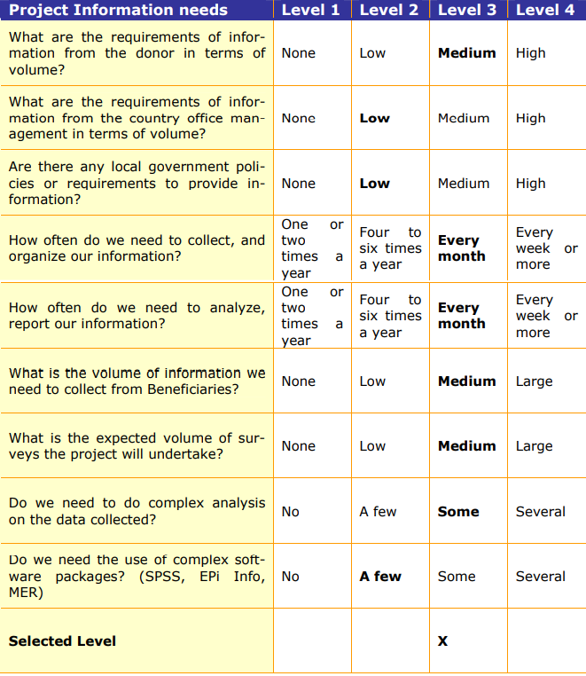

Determining Departmental Technology Capacity

|  |  |  |  |  |  |
| --- | --- | --- | --- | --- | --- |
| Department/Project Technology Capacity | Department | Level 1 | Level 2 | Level 3 | Level 4 |
| Does the department have dedicated IT resources |  |  |  |  |  |
| What is the department’s capacity to manage technology |  |  |  |  |  |
| Does the department site have goo communications, email, internets, etc? |  |  |  |  |  |
| What is the level of computer literacy for the departmental staff? |  |  |  |  |  |
| Will the main office provide IT support? |  |  |  |  |  |
| Current Level |  |  |  |  |  |
| Required Level |  |  |  |  |  |

This will let us know if we have the IT capacity that will satisfy the information requirement level from

Above

|  |  |  |  |
| --- | --- | --- | --- |
|  |  |  |  |
| Information Requirements |  |  |  |
| Technology Capacity |  |  |  |
| Recommended levels |  |  |  |

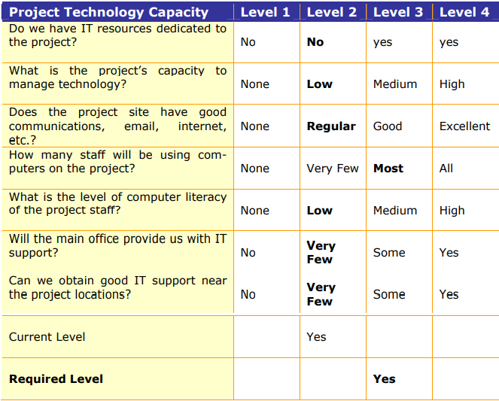

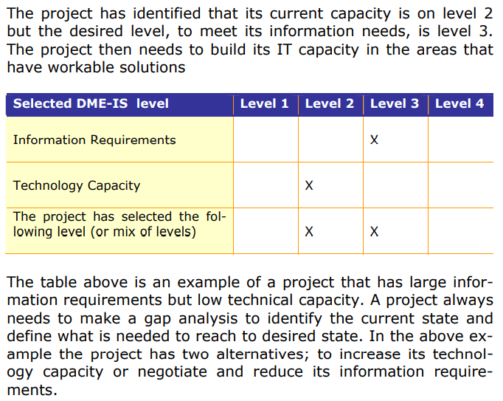

#### Information Standards and Principles

We would prescribe to the organization the following information standards and principles;

* Value of information
* Purpose
* Respect for privacy and dignity of the individual
* Openness
* Accountability
* Confidentiality and Security
* Integrity
* Timely and Accurate

#### Information access

Information access was found to be the most common form currently found in practice. Here project staff searched for what they needed to know to carry out their task. The most common ways to access information were found to be:

* finding some books or documents
* looking up catalogs,
* searching the Internet, Intranet
* searching some specialized database.

#### Information exchange

Information exchange is occurring when people either send information directly to other people or display it for other people to access. The most common are:

* send a message or document to a specific person or to a group of people;
* make a set of documents available for people to access;
* a newsgroup that collects information from a group of people and then mails them to a group;
* an electronic publication usually on the internet advertising products or services;
* a bulletin board where people can post items of interest.

#### Personal communication

Involving an exchange of a number of utterances (or messages) with the same goal in mind

#### Knowledge sharing

This kind of work was noted to concern people getting together from different areas and trying to combine and make sense of their ideas.

# Recommended Components

The diagram below shows the major recommended components for your possible organizational MIS.

Kindly refer to appendices for the detailed on each component.

# Implementation Guidance

1. Keep the effort manageable
2. Use agile development and rapid deployment methods
3. Choose your standards carefully
4. Think about third-party/outsource/cloud-based information technology provisioning
5. Think mobile at the outset
6. Don't overlook the cost/complexity of assembling required data
7. Leverage existing projects to maximum extent possible

Open Source Software

Discuss

Online meetings – audit trail?

Communications

Telephones and Cellphones are used where there is need for urgent communication. However, because the messages are usually not recorded, there is usually no recorded evidence of what would have been communicated or shared.

Emails are usually used to communicate vital information especially where there would need to leave evidence of what would have been communicated.

GIS

Capacity Development

Trainings on

Desktop publishing – communications people

GIS

Dashboards

Mobiles Apps: ODK, Kobo, Survey Monkey, Commcare

Key infomants were asked to present their opinions of what would be an ideal set-up (features and functions) for the collection, collation, storage, analysis, reporting and dissemination of information for YETT and their responses were that

Stakeholders should be able to access

Key Informant Interviews

|  |  |  |  |
| --- | --- | --- | --- |
| Department | Key Informant | Key Informant’s Title | Interview Date |
| Advocacy and Research | Tafadzwa Macheka | Program Manager | 14/07/2021 |
| Finance and Administration Department | W Nhangiwa | Finance and Administration Manager | 13/07/2021 |
| Partnership and Grants | Tatent Madungwe | Partnerships and Networks Manager | 14/07/2021 |
| Youth and Advocacy | Taziwa | Youth Advisor | ? |
| Monitoring and Evaluation Department | Charles | Monitoring and Evaluation Officer | 15/07/2021 |
| Director | Rosewita Katsande | Director | ?/ |

Stakeholders Interviewed

|  |  |  |  |
| --- | --- | --- | --- |
| Stakeholder Organization | Name of Person Interviewed | Title of Person Interviewed | Date Interviewed |
| Women Rise and Excel Alumni | Ska Sebeta |  |  |
| Patsaka Trust | John Chirinda |  |  |
| Women Empowerment Network | Kumbi Kahinga |  |  |
| Winter School Alumni | Onward Chironda |  |  |