Отчет

1,2) Подключение на 1 звезду

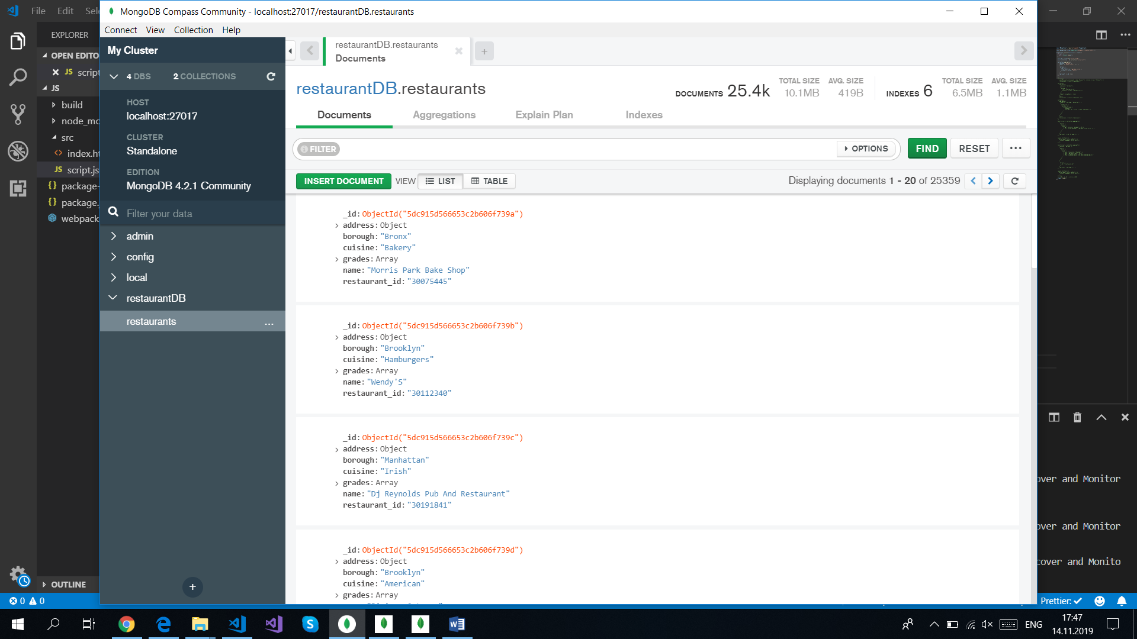

3)

1. db.restaurants.countDocuments({ borough: { $eq: "Queens" }, cuisine: { $eq: "Chinese" } });

728

2. db.restaurants.aggregate([

... { $unwind: "$grades" },

... { $sort: { "grades.score": -1 } },

... {

... $group: {

... _id: null,

... first: { $first: "$grades.score" },

... firstId: { $first: "$_id" }

... }

... },

... { $project: { _id: 0, firstId: 1 } }

... ]);

{ "firstId" : ObjectId("5dc915d566653c2b606f74f8") }

3. db.restaurants.aggregate([

... { $match: { borough: "Manhattan" } },

... {

... $addFields: {

... grades: {

... $concatArrays: [

... "$grades",

... [{ grade: "A", score: 7, date: new Date() }]

... ]

... }

... }

... }

... ]);

Видно, что добавились:

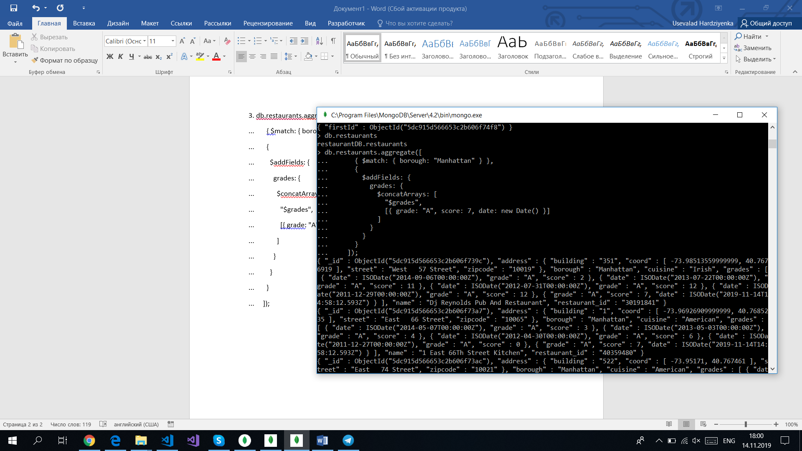

4. db.restaurants.aggregate([

... {

... $match: {

... $expr: {

... $and: [

... { $gt: [{ $size: "$grades" }, 8] },

... { $lt: [{ $arrayElemAt: ["$grades.score", 8] }, 7] }

... ]

... }

... }

... },

... { $project: { _id: 0, name: 1 } }

... ]);

{ "name" : "Silver Krust West Indian Restaurant" }

{ "name" : "Pure Food" }

5. db.restaurants.aggregate([

... { $unwind: "$grades" },

... {

... $match: {

... $expr: {

... $and: [

... { $eq: ["$cuisine", "Seafood"] },

... { $eq: ["$grades.grade", "B"] },

... { $gte: ["$grades.date", new Date("2014-02-01")] },

... { $lte: ["$grades.date", new Date("2014-03-01")] }

... ]

... }

... }

... },

... {

... $group: {

... _id: "$_id",

... borough: { $first: "$borough" }

... }

... },

... { $project: { _id: 1, borough: 1 } }

... ]);

{ "_id" : ObjectId("5dc915d766653c2b606fab6e"), "borough" : "Manhattan" }

{ "_id" : ObjectId("5dc915d766653c2b606fa8f7"), "borough" : "Bronx" }

4)

1.

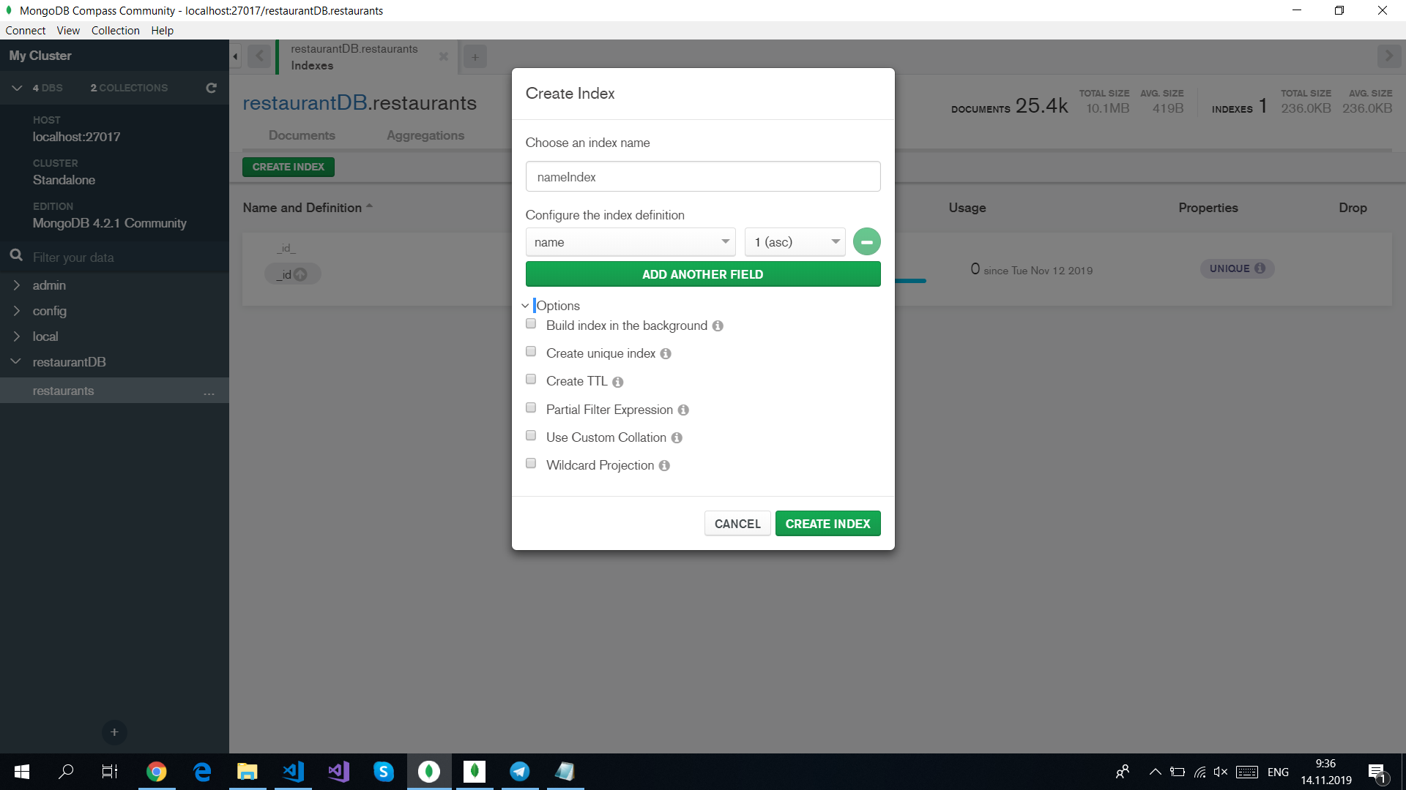

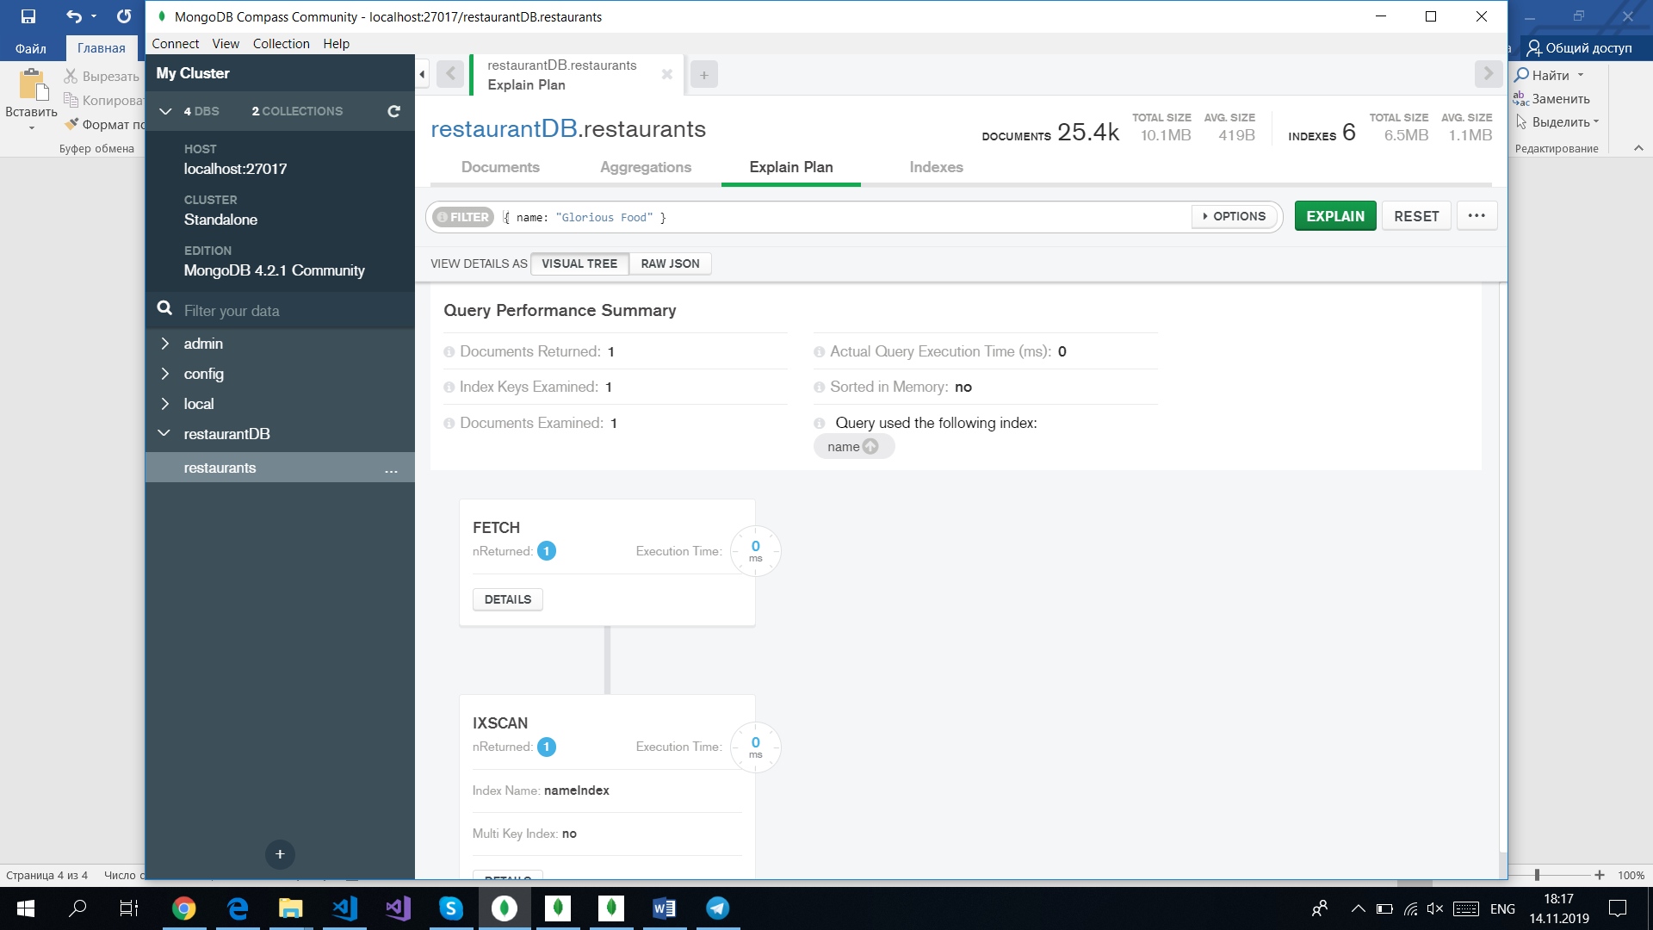

2. Кнопка урны для drop index

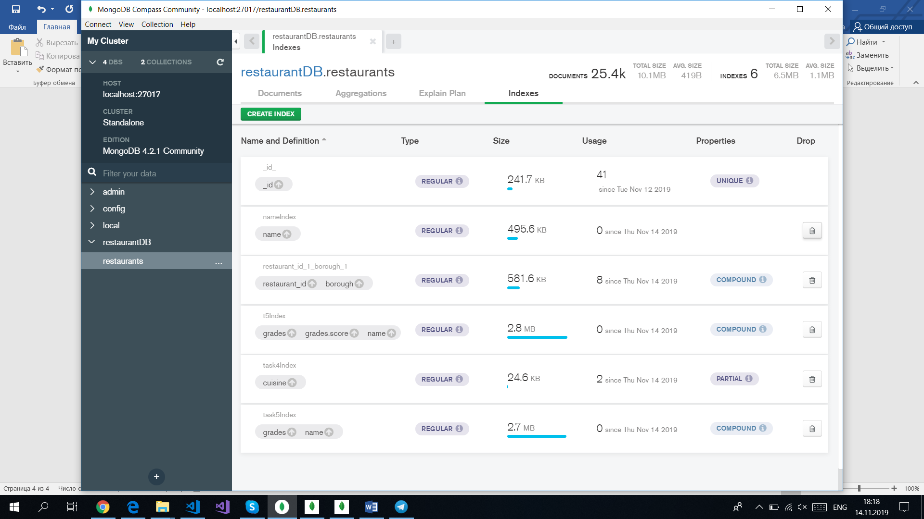

3.

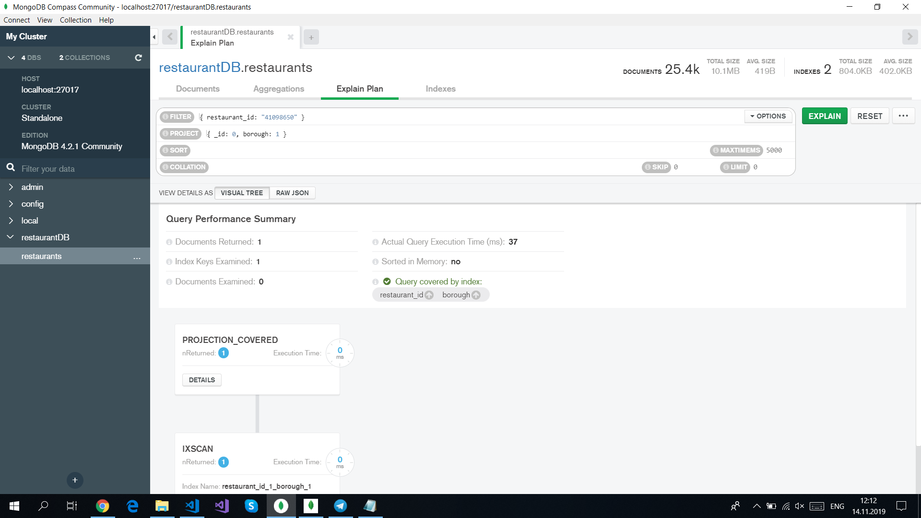

4.

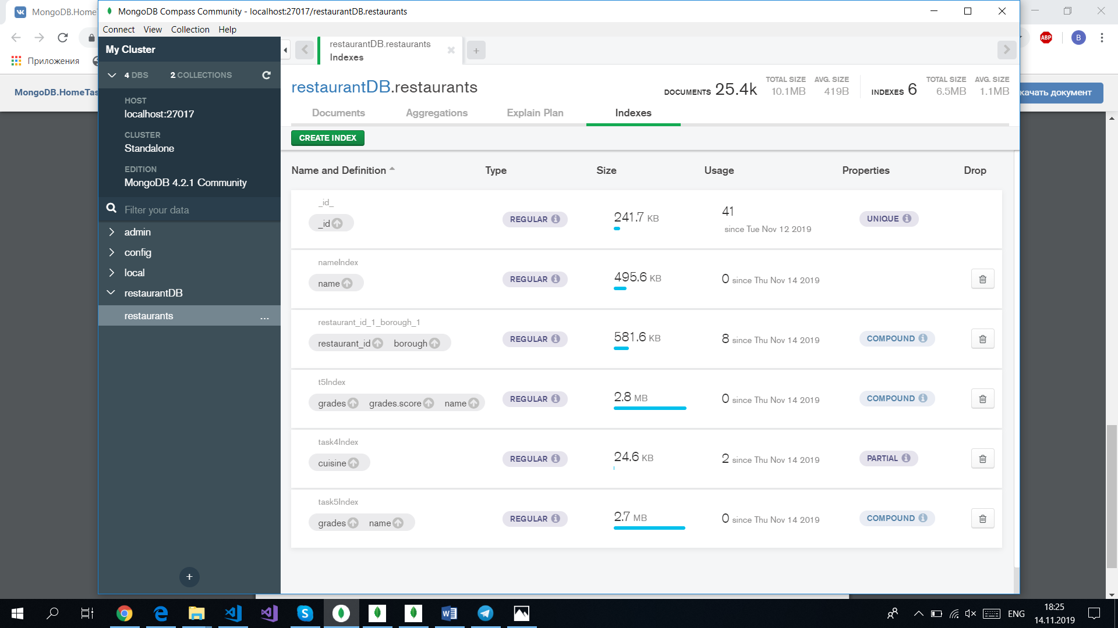

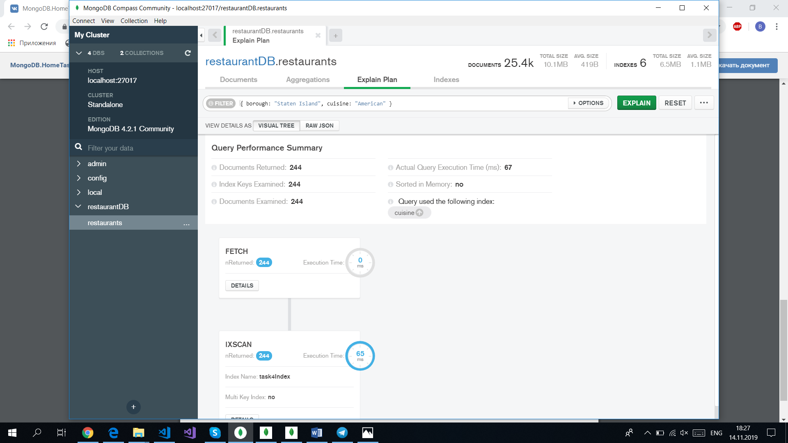

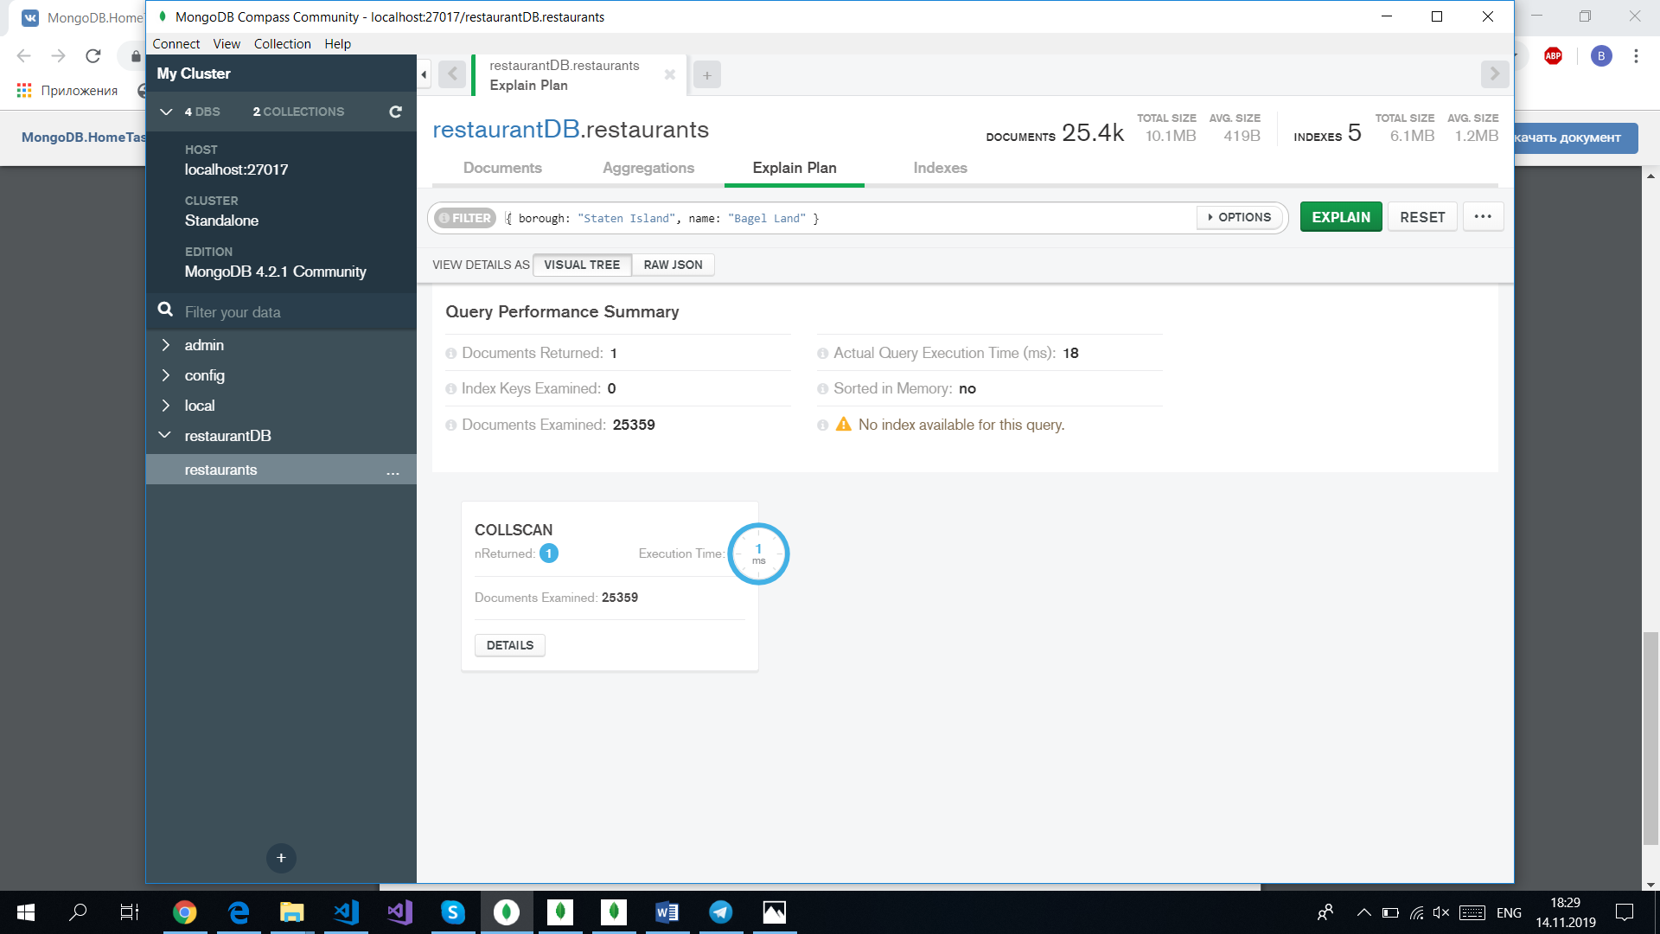

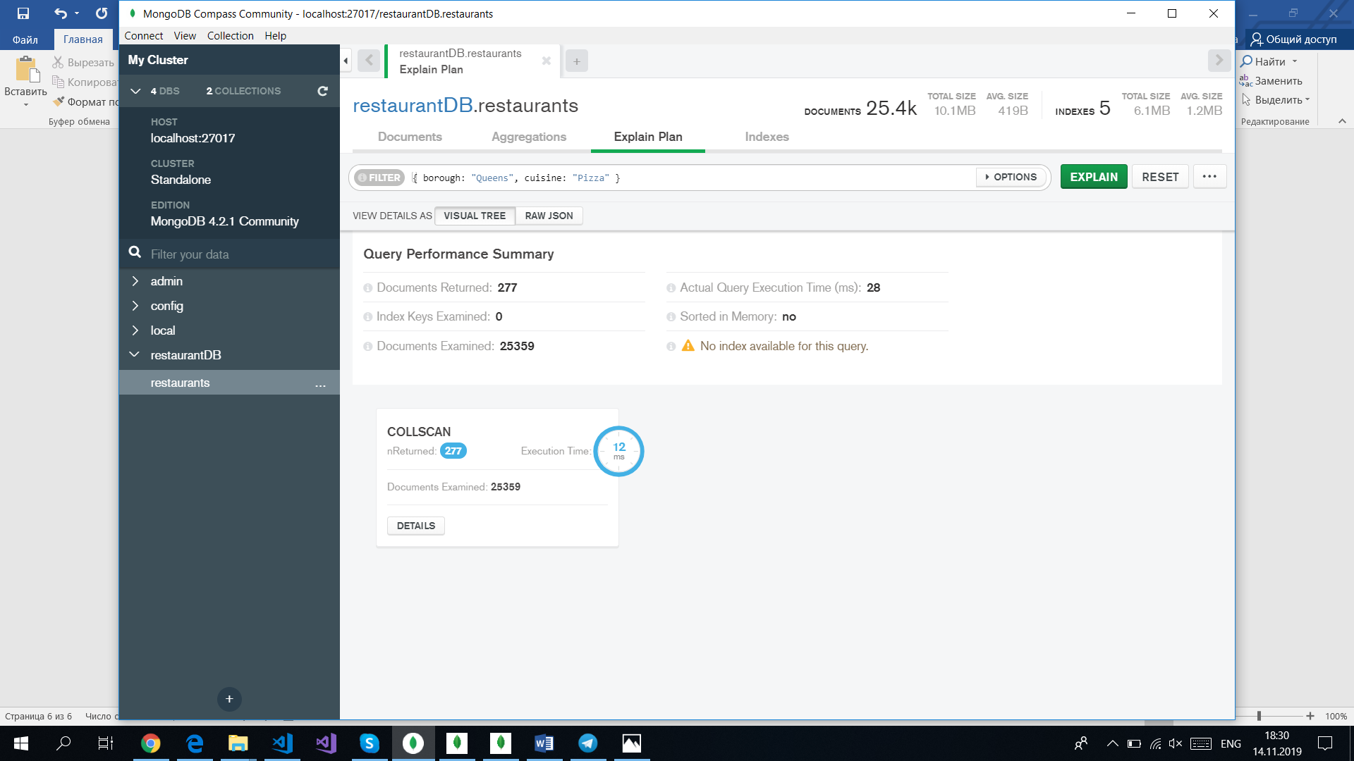

5. Не удалось.