**ASSOCIATION OF SOFTWARE ENGINEERING AND CYBER SECURITY (ASECS)**

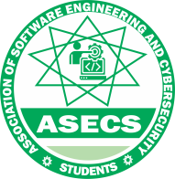

**RESEARCH METHODOLOGY EXAM QUESTIONS PREDICTION**

**PROBABILITY: 70%**

**C:\Users\adamu\Desktop\RPB.pngRPB**

**RESEARCH METHODOLOGY PAST QUESTION AND ANSWERS 2020/2021**

**(SCROLL DOWN FOR CONTENTS)**

**QUESTIONS**

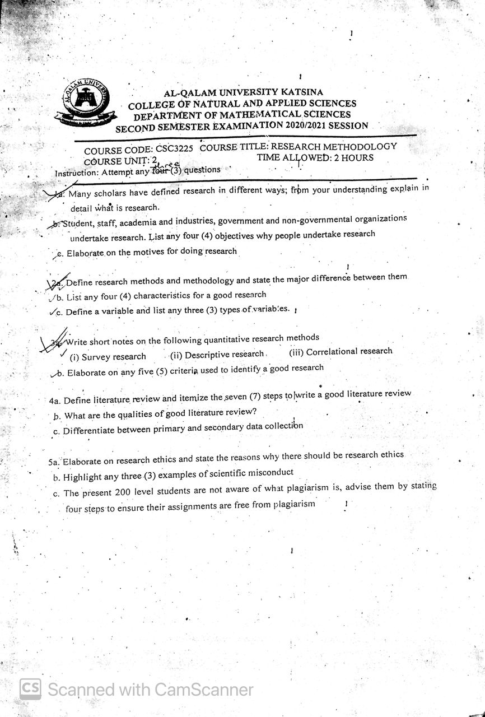

**ANSWERS**

Q1a)

Research is a systematic and methodical investigation or inquiry that aims to discover new knowledge, solve a problem, or answer a question. It is a way of seeking answers to questions or solving problems through the collection, interpretation, and analysis of data or evidence.

Q1b)

1. To gain familiarity with a phenomenon or to achieve new insights
2. To reveal accurately the characteristics of a particular individual, situation or a group
3. To determine the frequency with which something occurs
4. To test a hypothesis of a causal relationship between variables

Q1c)

1. Desire to get a research degree along with its significant benefits;
2. Desire to face the challenge in solving the unsolved problems
3. Desire to get intellectual joy of doing some creative work;
4. Desire to be of service to society;
5. Desire to get respectability.

Q2a)

**Research Methods:** are tools and instruments used in the selection and construction of the research techniques.

**Research Methodology:** is the science of understanding how research is performed methodically.

**Differences:**

* Research methods are focused on the techniques or tools used to collect and analyze data, while research methodology is focused on the overall plan or approach for the research study.

Q2b)

1. A good research study should have a clear and specific research question or hypothesis that guides the study.
2. A systematic approach must be followed for accurate data.
3. Research creates a path for generating new questions.
4. Research is based on logical reasoning and it involves both inductive and deductive methods.

Q2c)

**Variables:** A **variable in research** simply refers to a person, place, thing, or phenomenon that you are trying to measure in some way.

**Types Of Variables:**

1. Dependent Variable
2. Independent Variable
3. Controlled

Q3a)

Survey Research — A survey is a process of data gathering involving a variety of data collection methods, including a questionnaire.

Descriptive Research — Descriptive research is a method which identifies the characteristics of an observed phenomenon and collects more information.

Correlational Research— [Correlational research](https://www.questionpro.com/blog/correlational-research/) examines the relationship between two or more variables.

Q3b)

1. The purpose of the research should be clearly defined and common concepts be used.
2. The research procedure used should be described in sufficient detail to permit another researcher to repeat the research for further advancement.
3. The procedural design of the research should be carefully planned to yield results that are as objective as possible.
4. The researcher should report with complete frankness, faults in procedural design and estimate their effects upon the findings.
5. Conclusions should be confined to those justified by the data of the research and limited to those for which the data provide an adequate basis.

Q4a)

A **literature review** is a **survey** of scholarly sources on a specific topic.

**Steps to write literature review:**

1. Narrow your topic and select papers accordingly.
2. Search for **literature**.
3. Read the selected articles thoroughly and evaluate them.
4. Organize the selected papers by looking for patterns and by developing subtopics.
5. Develop a thesis or purpose statement.
6. **Write** the paper.
7. **Review** your work.

Q4b)

1. Comprehensive: It should cover a wide range of sources that are relevant to the topic being investigated.
2. Current: It should be based on the most recent research and should include sources published within the last 5-10 years, depending on the field of study.
3. Properly cited: It should follow the appropriate citation style and should include complete and accurate citations for all sources.
4. Clearly written: It should be written in clear, concise language and should be easily understandable to the intended audience.

Q4c)

For primary it is a process of collecting the original data collected by a researcher for a specific research purpose through

* Interviews
* Focus group
* Panel sampling or panel survey

**Secondary data collection** on the other hand, is referred to as the gathering of second-hand data collected by an individual who is not the original user. It is the process of collecting data that is already existing.

* published books,
* journals and/or
* online portals.

Q5a)

**Research Ethics:**

are set of principles that guide your research designs and practices

**Why there should be research ethics:**

Research ethics matter for scientific integrity, human rights and dignity, and collaboration between science and society.

Q5b)

1. Plagiarism
2. Falsification
3. Fabrication

Q5c)

1. Understand what plagiarism is: Plagiarism is the act of presenting someone else' work or ideas as your own.
2. Use citations and references correctly: When you use ideas or information from a source, it is important to give credit to that source.
3. Use quotation marks and paraphrase appropriately: If you are using a direct quote from a source, be sure to use quotation marks and cite the source.
4. Use plagiarism detection tools: There are several tools available that can help you check your work for plagiarism.

**COMPUTER SCEINCE TEST QUESTIONS AND ANSWERS**

(Note: Questions that are not answered in this test are already answered in the examination past question above)

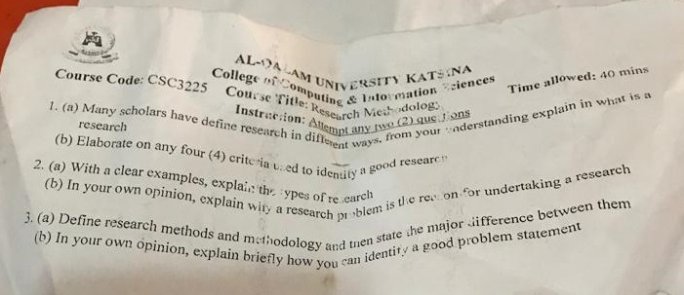

Q2a)

1. Basic Research

This research is conducted largely for the enhancement of knowledge, and is research which does not have immediate commercial potential.

* How did the universe begin?
* What are protons, neutrons, and electrons composed of?

1. Applied Research

Applied Research is designed to solve practical problems of the modern world, rather than acquiring knowledge for knowledge sake

* Improve agricultural crops production.
* Treat or cure a specific disease.
* Improve the homes, offices or mode of transport.

**SOFTWARE ENGINEERING TEST QUESTIONS AND ANSWERS**

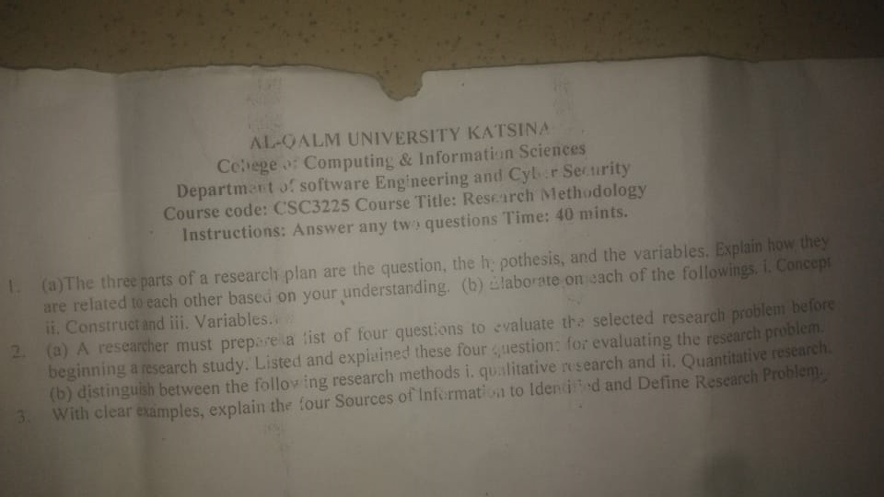

Q1a)

**Research questions:** specify what we want to find in the study

**The research hypotheses:** is our prediction of what we believe the study will find. It is the predicted answer to the research questions.

**The independent and dependent variables:** are the component of our study that we manipulate and watch for outcomes

Q1b)

**Concept:** A Concepts is generalize (Generally accepted ) meaning, properties or characteristic of people, places, events or objects.

**Construct:** A construct is a concept that is consciously modified, adopted invented or constructed by researcher for research purpose.

Q2a)

**Is the research problem significant?:**

The significance of a research problem relates to its social and practical utility.

It usually specifies what a researcher hopes to accomplish in a particular study.

**Is the problem new?**

There is no justification in undertaking research on a problem, which had already been adequately investigated by other researchers.

**Is the problem researchable?**

The researcher should not select a problem for research for which the data are not available because of certain technical, political or security reasons.

**Is the problem feasible for the particular researcher?**

A research problem may be good one from the point of view of the three criteria listed and-discussed above, yet it may not be feasible

Q2b)

* **Quantitative Method**

Quantitative methods are presented in numbers and require a mathematical calculation to deduce.

* **Qualitative Research Method**

The qualitative research methods of data collection is based on the non-quantifiable elements like the feeling or emotion of the researcher.

Q3b) Define research problem:

A research problem is a specific issue, difficulty, contradiction, or gap in knowledge that you will aim to address in your research.

**ALL THE BEST**

**- ASECS**

**WARNING**

**This is just a prediction, it’s possible none of the question will be asked.**

**Risk what you can afford to lose.**

**- ASECS, AUK**