**CHAPTER THREE (3)**

**System Analysis and Design**

**3.0 Introduction:** This chapter presents the Software Development Model, Requirement Engineering, System Design and summary of the chapter.

**3.1 Software Development Model:** Software development (SDM) is a framework defining tasks performed at each step in the software development process. SDM is a structure followed by a development team within the software organization and consists of detailed plan describing how to develop, maintain and replace software.

In this project the SDM chosen is the Incremental development method because the processes are agile, therefore planning should be incremental to change the process to reflect changing staff requirement in order to reduce risk of changing requirements.

**3.1.0 Incremental Development Model**

This is a process of software development method of building software products in which a system is built piece-by-piece. There are several types of SDM which choose to take up some number of factors based on the project e.g. Requirement elicitation during the development, complexity of the system, agile process between the NSUBEB managements and developer, time management. These related models give the idea on the process that can be used to help user understand how different approaches are carried out during software development. They can be seen as process frameworks to create more specific software engineering processes. (Turner 1975)

**3.1.1 Justification for choosing incremental Model**

1. It generate working software quickly and early during the software life cycle

2. this model is more flexible and its less costly to change scope and requirement

3. It is easy to test and debug during a smaller iteration.

4. easier to manage risk because risky piece is identified and handled during it’d iteration.

**3.2 Requirement Engineering:** Requirement engineering is the process of determining the belief of a user to carry out the process of creating a new or modified application. It involves the process of studying all the task conducted to identify the needs of different stakeholders with their goals and purposes of creating systems and procedures that will achieve them in an efficient way.

**3.2.0 Feasibility Study:** The main objectives of the feasibility study are to practically assessed the proposed Employee Management System (EMS) method. This is done by analyzing Technical and Operational feasibility factors of developing the computerized system.

**3.2.0.1 Technical Feasibility:** this involve the evaluation of the hardware, software and other technical requirement of the proposed Employee Management System (EMS) this include Risk Resources availability and technologies. The tools used to system is available through internet and they can be gotten easily.

1. the system have the capacity to handle the problems of the organization.

2. the EMS is feasible within the limits of the current system.

3. the system will be available within the organization

**3.2.0.1 Operational Feasibility:** in the existing manual system it is very difficult to maintain and update huge amount of information. The development of the system was started because of the requirement put forward by Niger State Universal Basic Education Board (NUBEB). this system, will handle the request in a better way and make the process easier thus, it is sure that the system developed is operational feasibility

1 the system mode of operation provides adequate throughput and response time.

2. the system provide cost-efficient information services to the organization.

3. the system mode of operation provide effective security and data information.

4. the system will help to manage staff information digitally.

5. the system mode will be using a networking tools.

**3.2.1 Requirement Elicitation and Analysis**: The existing system comprises of a system in which detail are to be handled manually. And this system is not user friendly i.e.

1. Inconsistency in data Entry.

2. Large ongoing staff training cost.

3. System is dependent on good individuals.

4. Time consuming and costly to produce reports.

5. Lack of security

6. Duplication of data entry

While the Proposed System will be able to manage NSUBEB information about employee in more user friendly way. This system will manage NSUBEB employee’s information at various field offices. User ID and password will be given to the field offices so that they can enter their employee’s information into central database. Their access to the central database is restricted to their information only. Various reports based on the data entered by employees at field offices are generated at the Admin Department. Below are some of the benefits of the proposed system

1. Efficiency and better accuracy
2. Reduce Manual Errors
3. Higher productivity
4. Data Security
5. Increased employee engagement

**3.2.1.0 Functional Requirement:** Functional requirement defines the function of a system and its corresponding components. It deals with the service the system should deliver to the user.

* the application shall include a user interface.
* the system shall allow user to login or prompt error based on the login credentials.
* the system shall allow update and retrieval from the database.
* the system shall allow the administrator to manage the user logins.
* the system shall allow administrator to add or delete user credentials.
* the system shall allow administrator to add, update, and delete staff details.
* the system shall allow administrator to keep track of Employee payment and, leave management and generate report.
* the system shall allow the staff to apply form leave.

**3.2.1.1 Non Functional Requirement:** Non-Functional Requirement defines the requirement that specify criteria that can be used to judge the operation of a system.

1. Security: The system should be secured to avoid unwanted access.

2.Performance:the system shall stay running unless there is an intentional shutdown of the application or the platform.

3.Scalability:the system should be able to handle the task as number of user increases.

**3.2.2 Requirement Verification and Validation**

It involves the process of studying all the task conducted to identify the needs of different stakeholders with their goals and purposes of creating systems and procedures that will achieve them in an efficient way, also consist of all the necessary requirement needed to build or develop a project. It describes the software system in details and capture the goal of the system to be developed and creates a connection between the stakeholders and users to be part of the development. And bring out a successful result.

**3.3 System Design:** system design is the process of describing the components, interfaces and architecture of a system that meet or satisfy the required specifications. It defines how the system operates and interacts with external users with the intention of describing how the system is in nature and what it does which in general captures the system’s behavior.

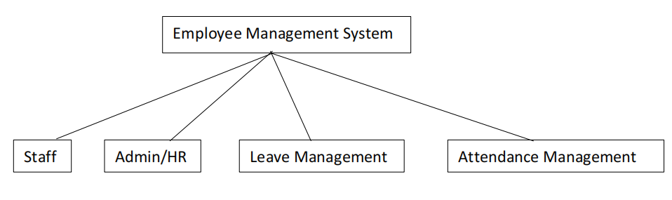

**3.3.1 Use Case Diagram:** use case diagram identify the interaction between the system and its user.

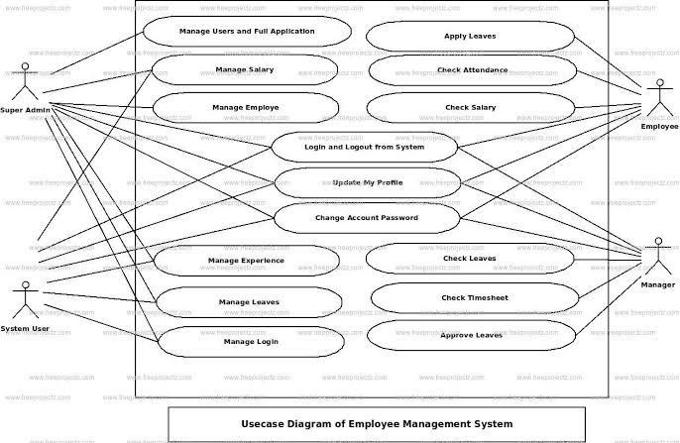

|  |  |
| --- | --- |
| **ACTORS** | **DESCRIPTION** |
| Super Admin | Use cases of Super Admin Are Manage Employee, Manage Salary, Manage Leaves, Manage Experience, Manage Login, Manage Users and Full Employee Management System Operations. |
| System User | Use cases of System User are Manage Employee, Manage Salary, Manage Leave, Manage Experience, Manage Login. |
| Employee | Use cases of Employee are Apply Leaves, Check Salary, Check Attendance. |
| Manager | Use cases of Manager are check Leaves, Approve Leaves, Check Timesheets, Approve Timesheet. |
| **CASES** | **DESCRIPTION** |
| Login and logout from System |  |
| Update my profile |  |
| Change Account password |  |
| Manage User and full Application |  |
| Manage Salary |  |
| Manage Employee |  |
| Manage Experience |  |
| Manage Leave |  |
| Manage login |  |
| Apply Leave |  |
| Check Attendance |  |
| Check Salary |  |
| Check Leave |  |
| Check Timesheet |  |
| Approved Leave |  |

**3.3.2 Entity Relationship Diagram:** Describe the structure of a database with the help of a diagram.

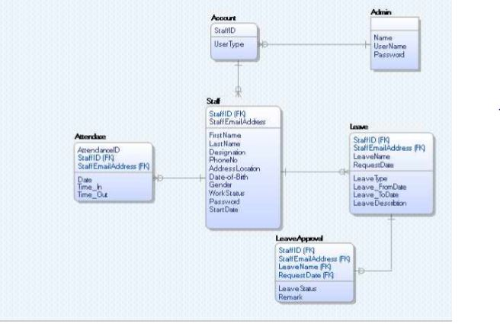

This Entity-relationship diagram represents the model of NSUBEB Employee Management System entity. It shows all the visual instrument of database tables and the relationship between Attendance, leaves, account, staff, Admin and leave approval.

**3.3.3 Activity Diagram:** Represents a series of actions or flow of control in a system.

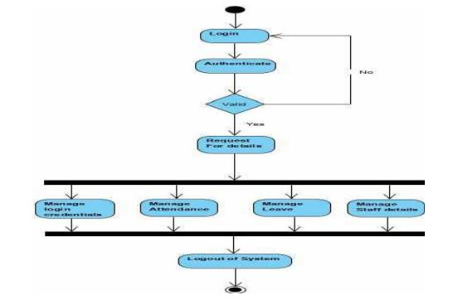

**Admin Activity Diagram**

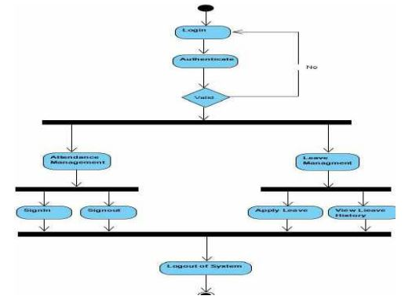

**Staff Activity Diagram**

This is the Admin and Staff Activity Diagram for NSUBEB Employee Management System, which shows the flow of Login Activity, where admin will be able to login using their username and password. After login user can manage all the operations on, login credentials, Attendance, leave, staff details etc.

**3.4 Summary**

Using the Incremental Model as the SDM, the approach to carry out each phase of the chosen methodology is define listing the set of activities carried out below and stating the chosen method used for each stage. Incremental Phases Activities Carried out Requirement Analysis for this project, Requirements and specifications where obtained using interview and observation technique. Design in this project, some high-end functions are used to design the system in terms of objects and classes and how their interaction was carried out, explaining the structure of the Entity Relationship Diagram (ERD) and Use case activity. Code The coding of the project was conducted during this stage using Python programming as the code and finally the testing phase will be carried out after the system was deployed.