

**2.21 Write a program in C to find the number and sum of all integer between 100 and**

**200 which are divisible by 9.**

**Expected Output :**

**Numbers between 100 and 200, divisible by 9 :**

**108 117 126 135 144 153 162 171 180 189 198**

**The sum : 1683**

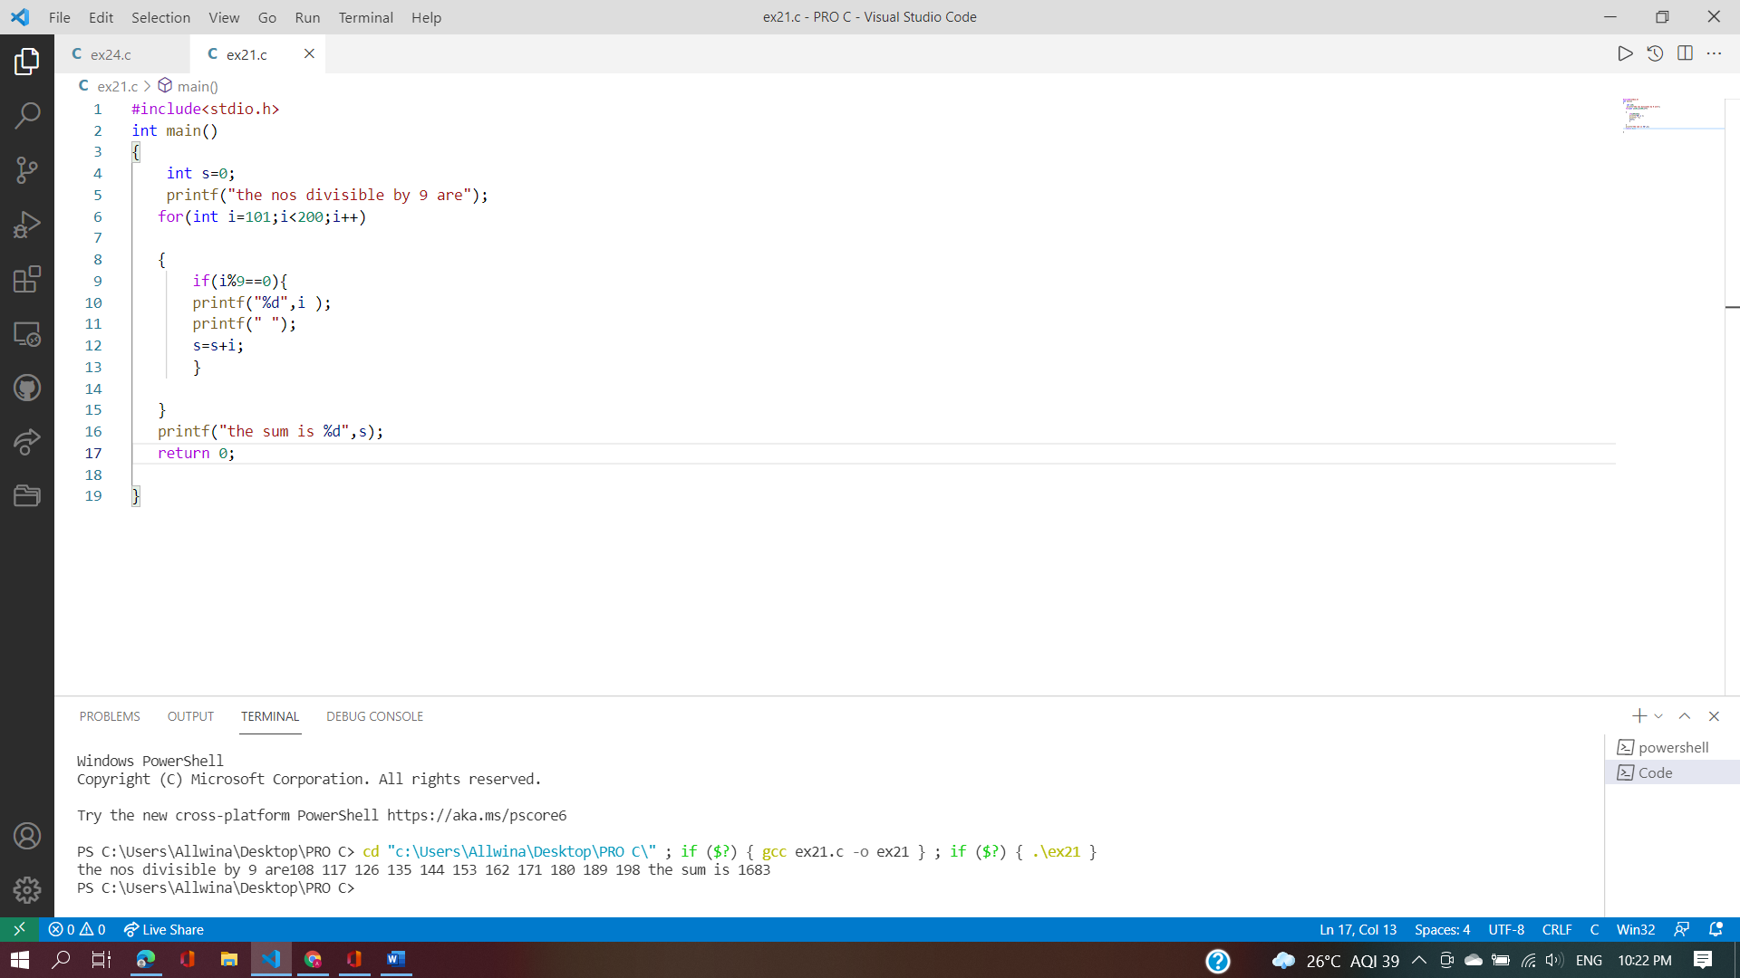

**2.23 Write a program in C to find the prime numbers within a range of numbers.**

**Test Data :**

**Input starting number of range: 1**

**Input ending number of range : 50**

**Expected Output :**

**The prime number between 1 and 50 are :**

**2 3 5 7 11 13 17 19 23 29 31 37 41 43 47**

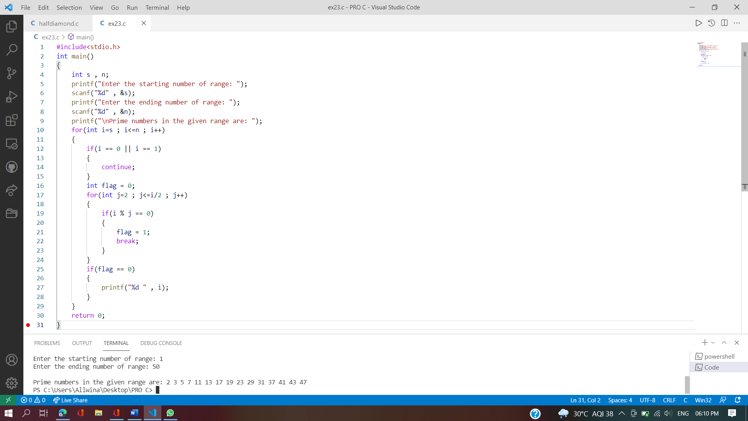

**2.24 Write a C program to display Pascal's triangle**

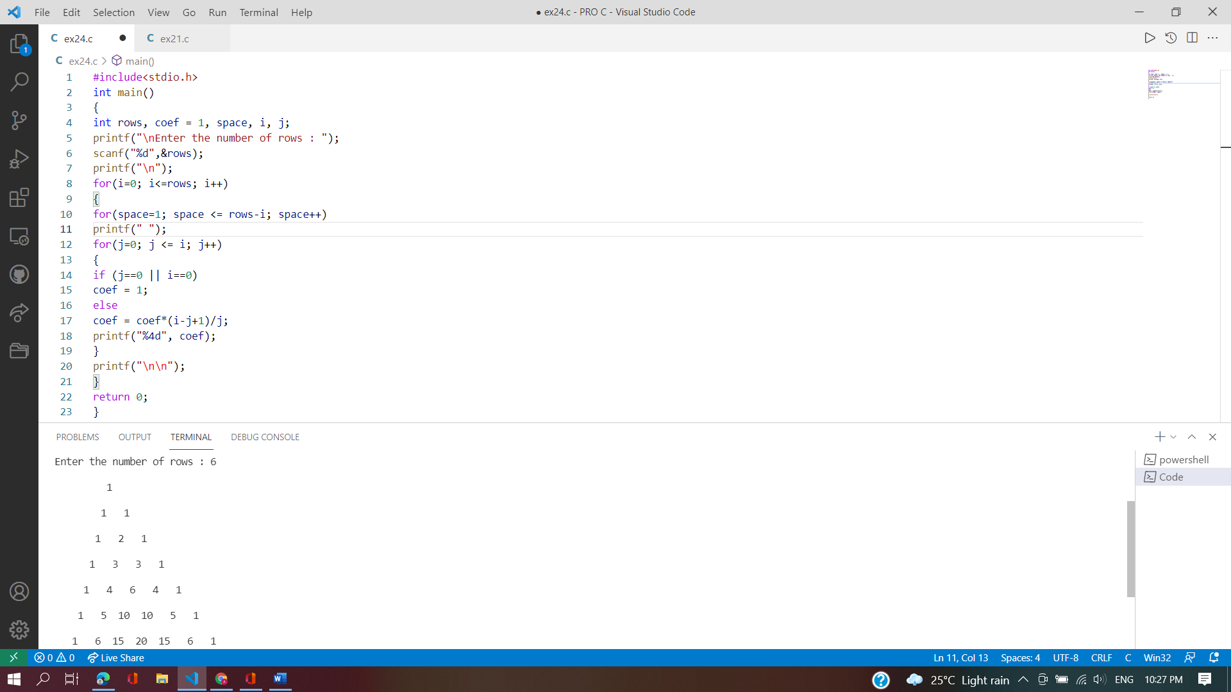

2.25 Write a program in C to display the cube of the number upto given an integer

Test Data :

Input number of terms : 5

Expected Output :

Number is : 1 and cube of the 1 is :1

Number is : 2 and cube of the 2 is :8

Number is : 3 and cube of the 3 is :27

Number is : 4 and cube of the 4 is :64

Number is : 5 and cube of the 5 is :125

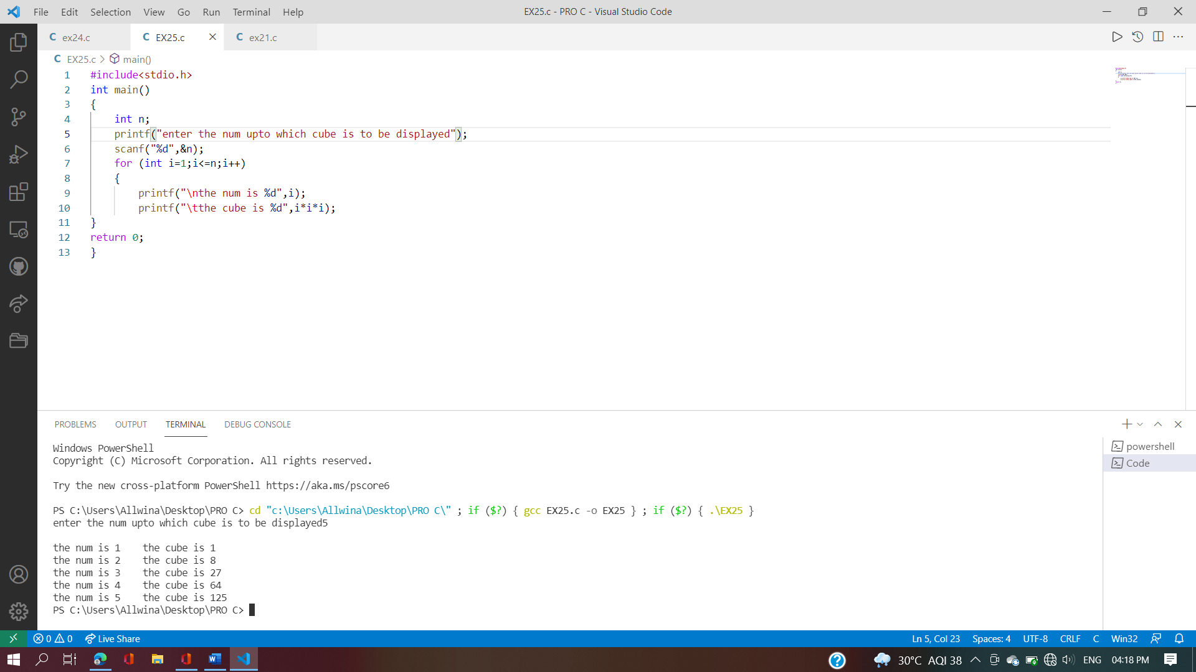

**2.26 Write a C program to read a Binary Number from the user and Convert it into**

**Decimal.**

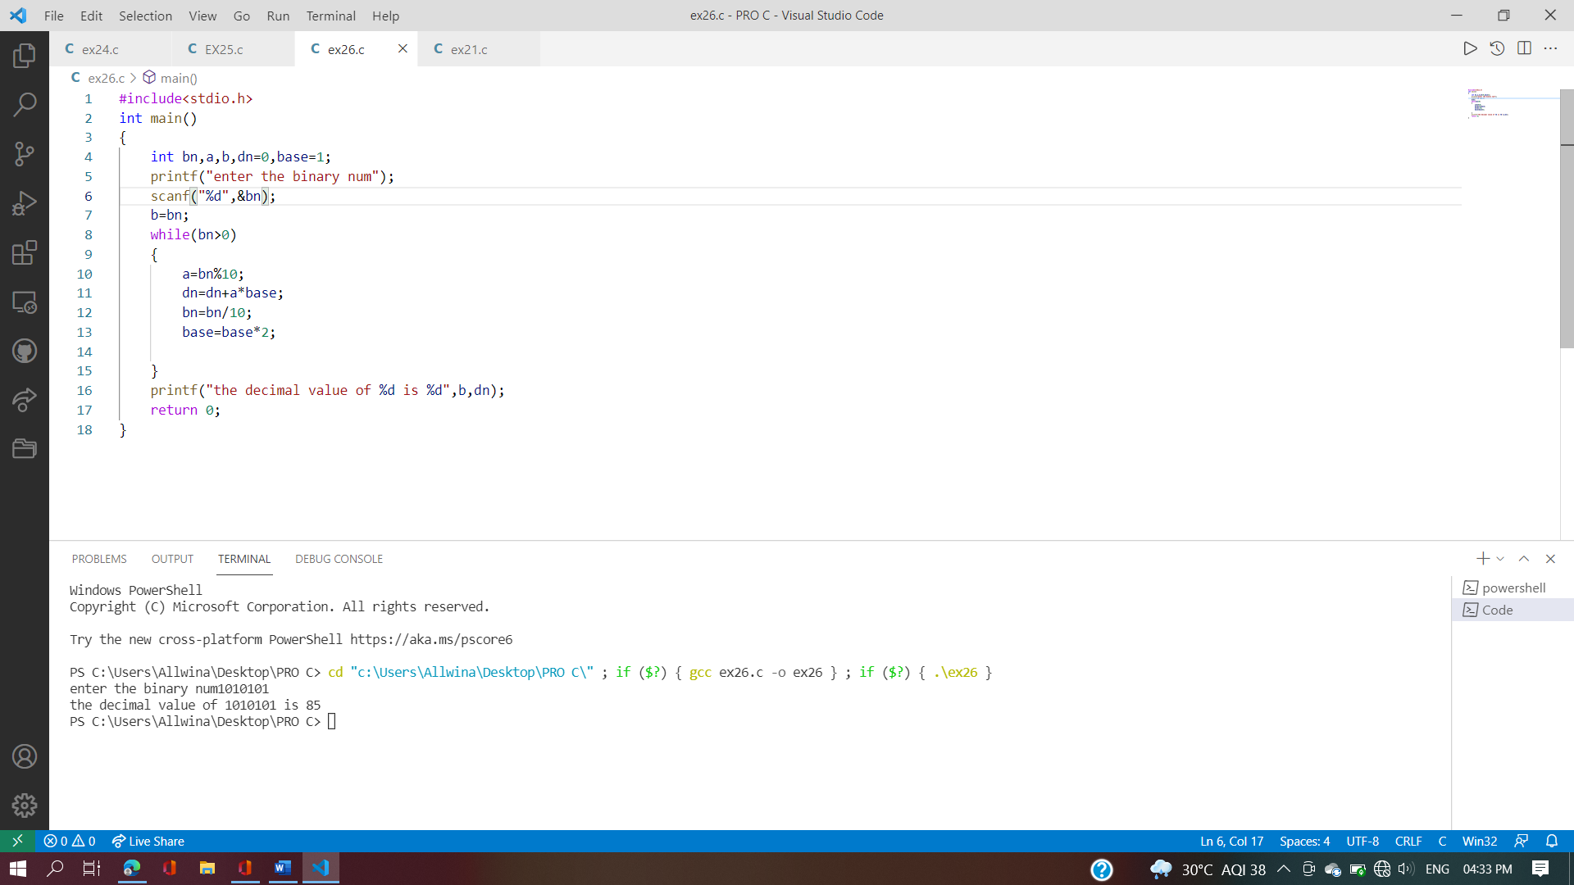

**2.29 Write a C Program to check the given number is a Perfect Number or Not.**

**A perfect number is a positive integer number in which sum of all positive divisors**

**excluding the number itself is equal to that number. For example: 28 is perfect**

**number since its divisors are 1, 2, 4, 7 and 14. Sum of divisors is: 1+2+4+7+14=28**

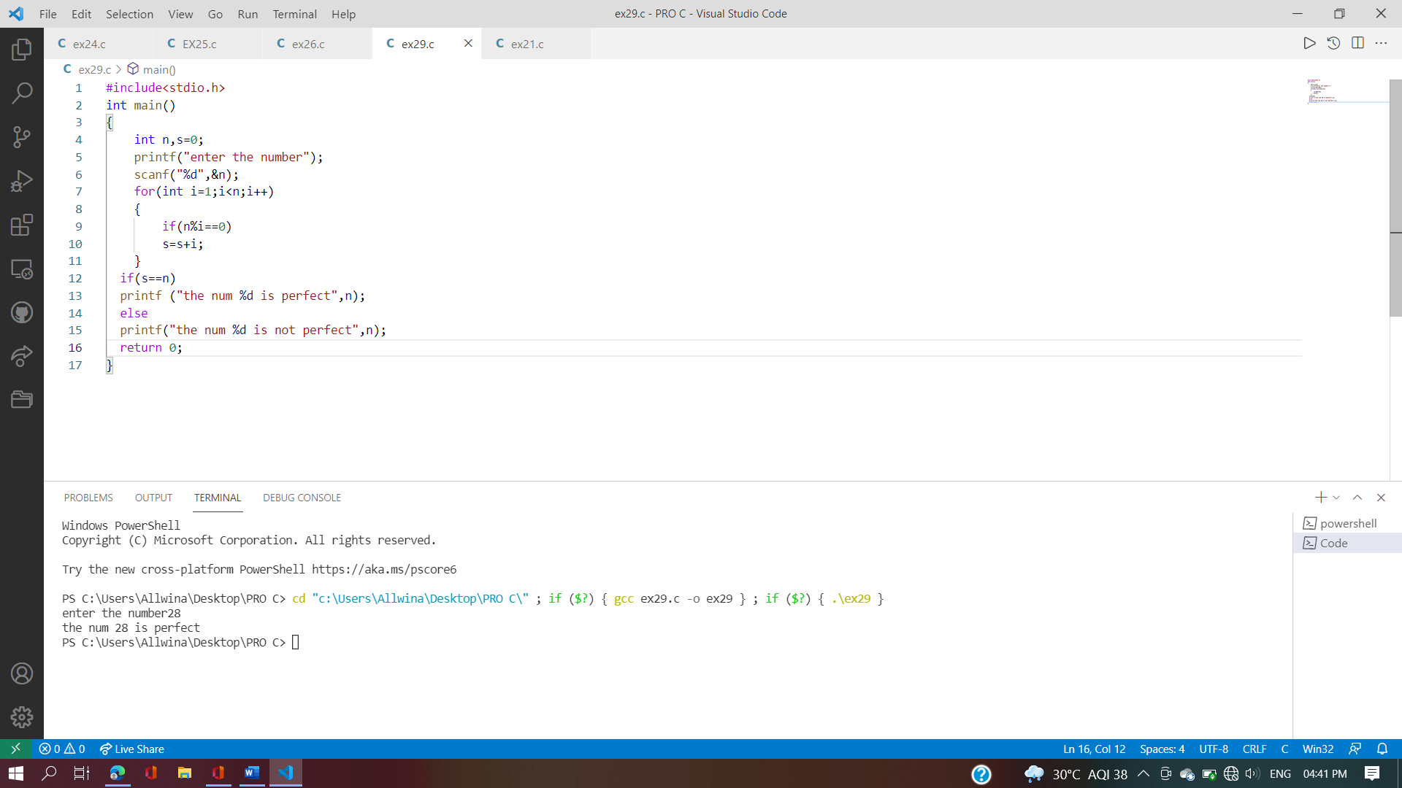

**2.30 Program to print diamond star patterns is discussed here. Given a number n,**

**write a program to print a diamond shape with 2*n rows**

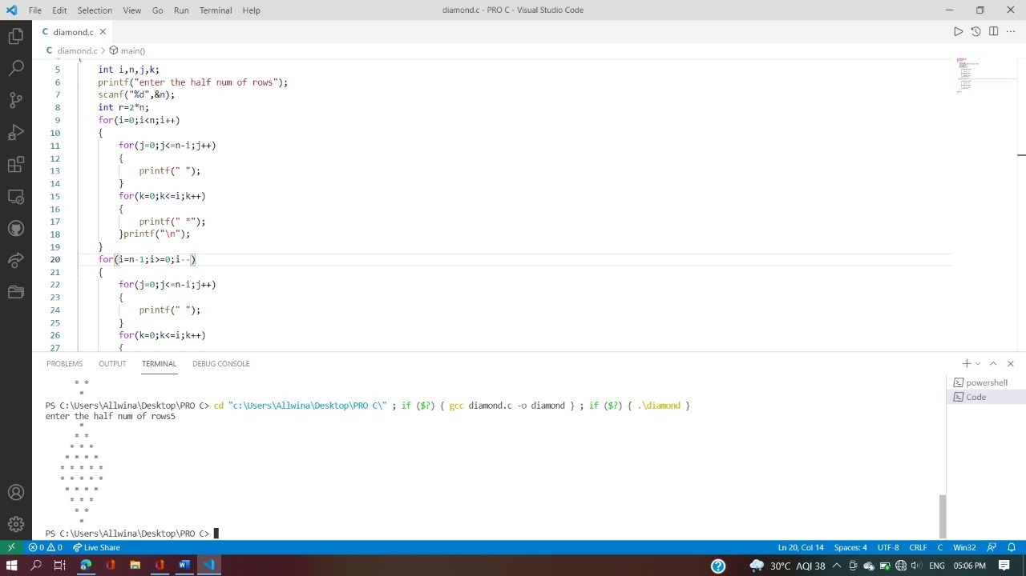

**2.32 Write a C Program to print Solid Half Diamond pattern printing using stars**

