Exam 3 research Project: 8x8x8 Led Cube

For the Research project I decided to challenge myself with a design project. Ever since Professor DeGroot showed the small one from a previous semester I have wanted to attempt one. I have never handled hardware before but had always wanted to so the project was the perfect opportunity to try. I started out by researching all the parts needed and the process. Once I had everything I needed and after watching some very helpful videos I got started by testing each led to make sure there were no broken or wrong lights. Now that I had tested each light, I needed to start making the led cube layers. I created a wooden template for the 8x8 layers to keep my squares evenly spaced. It was sturdy enough to solder on making the process must easier. Making the squares was the most tedious task but not too difficult once I got the soldering skill down. After finishing the eight layers I got to work on the PCB board. Soldering on the PCB was a very challenging thing to learn, I had to try a few techniques before I found one that worked well for me. I made sure to research each piece, so I knew exactly what it did and where it needed to go. Once I had the pcb board mostly finished I started to put in the layers vertically so that positive side went into the board and the negative stuck one side. After I had each layer in I took the negative legs and bent them horizontally to connect each layer, once that was finished the cube was complete. The last thing I had to do was use connecting wires to connect the negative legs on each layer to the pcb board, this is how which horizontal layer is chosen. It was very exciting to see the finished result on the project and know that the hard work paid off. All in all it was an incredibly challenging and fun project, and I am very happy with the results. There are definitely some things I would do differently next time, including soldering my leds a little different for aesthetic purposes and connecting some push buttons to add multiple light programs. On the next page I have added some photos documenting the process.

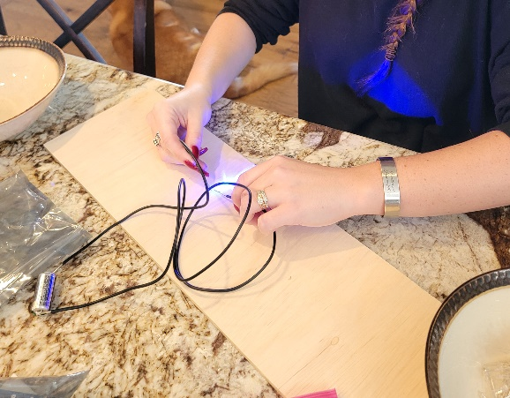Here I am testing the lights.

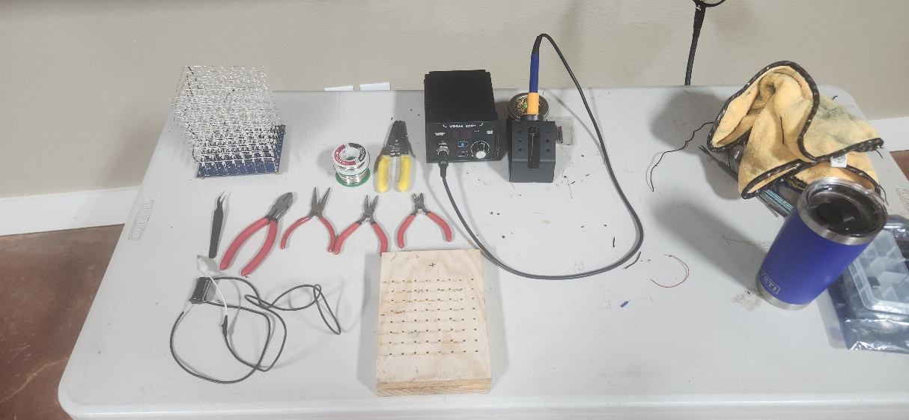

Here are the tools and template I used for the project.

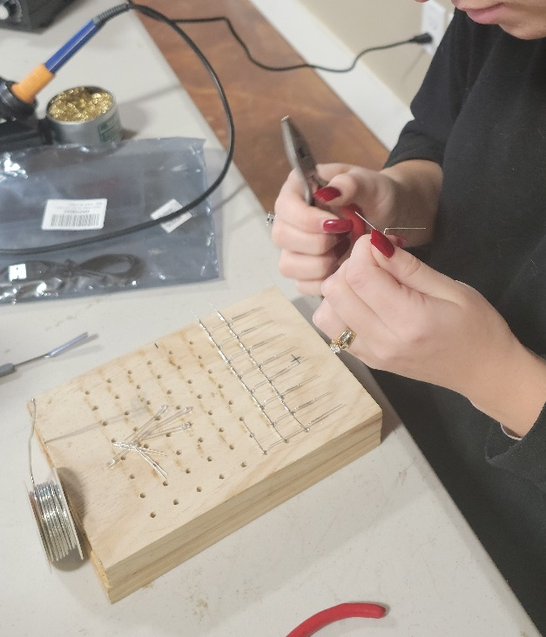

Here I am working on an individual layer. As you can see in the photo I am bending all the positive legs one way and the negatives legs another.

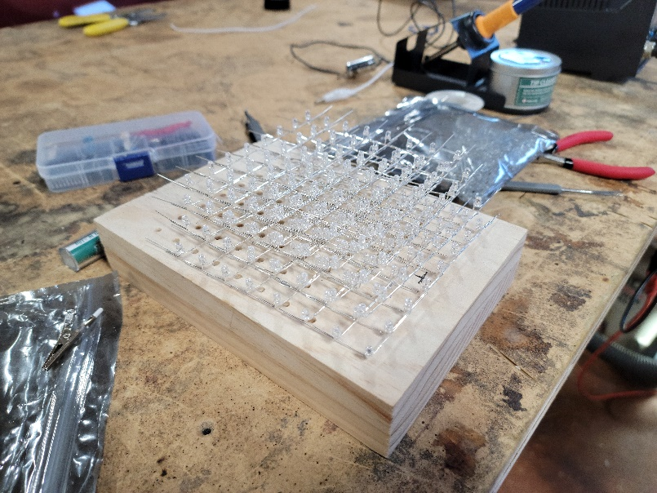

This was taken after I finished the first few layers of the LED cube.

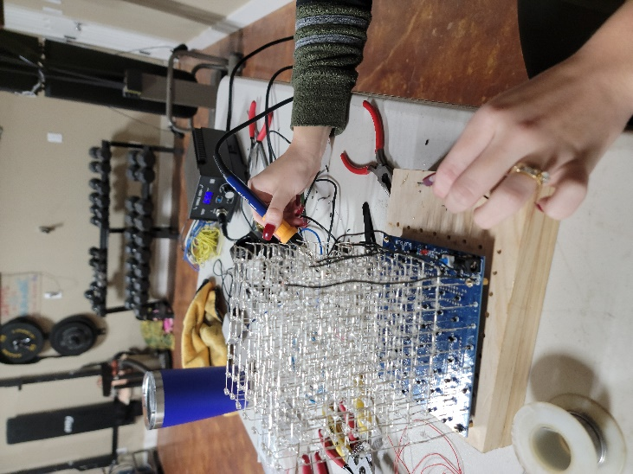As you can see in this photo I have the cube complete and am connecting the negative layers to the board with wires.