Training for Countdown

Highlighting solutions and bringing hope. Content that inspires action.

Local credible solutions.

https://www.ted.com/participate/organize-a-local-tedx-event/tedx-organizer-guide/audience-experience/virtual-event-experience

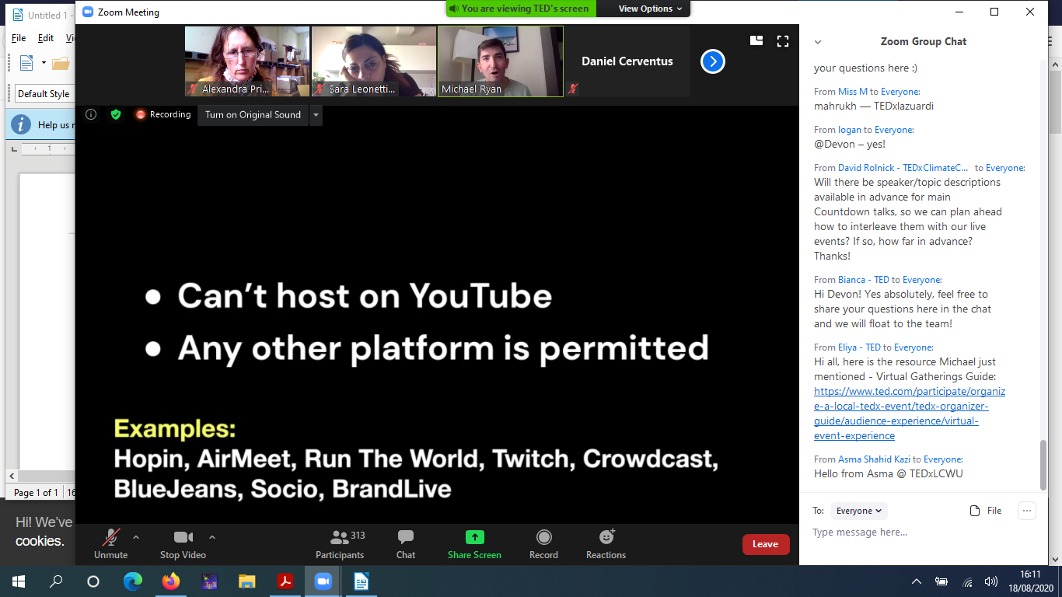

https://docs.google.com/document/d/15uVN5kvrohEYTdegxmkTHXB1VChwlDSLAMwjwTyZiWI/edit?ts=5e98953d

they recommend zoom. Good for breakout features.

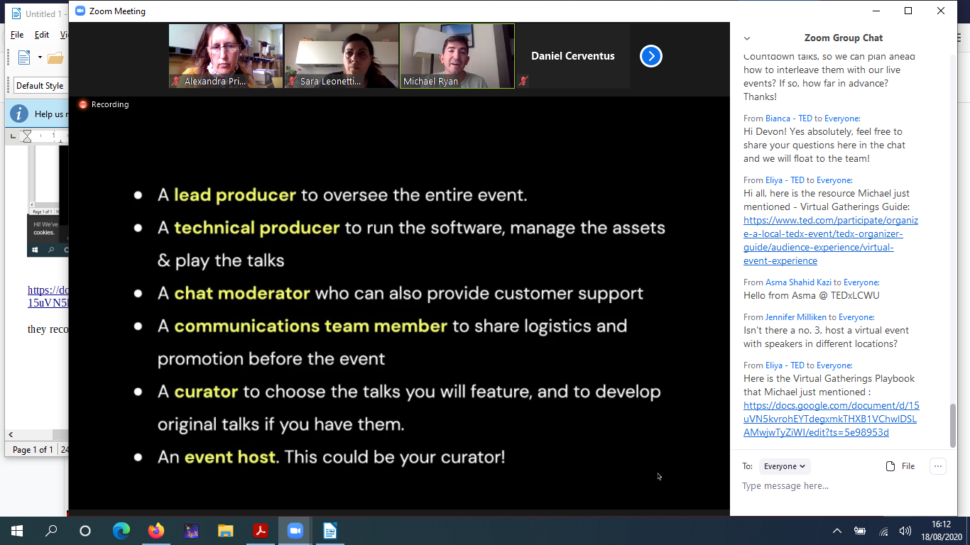

Tech producter: strong itnernet connection, Download before.
Host and lead producter should be different people.

Add a buffer before and after video.
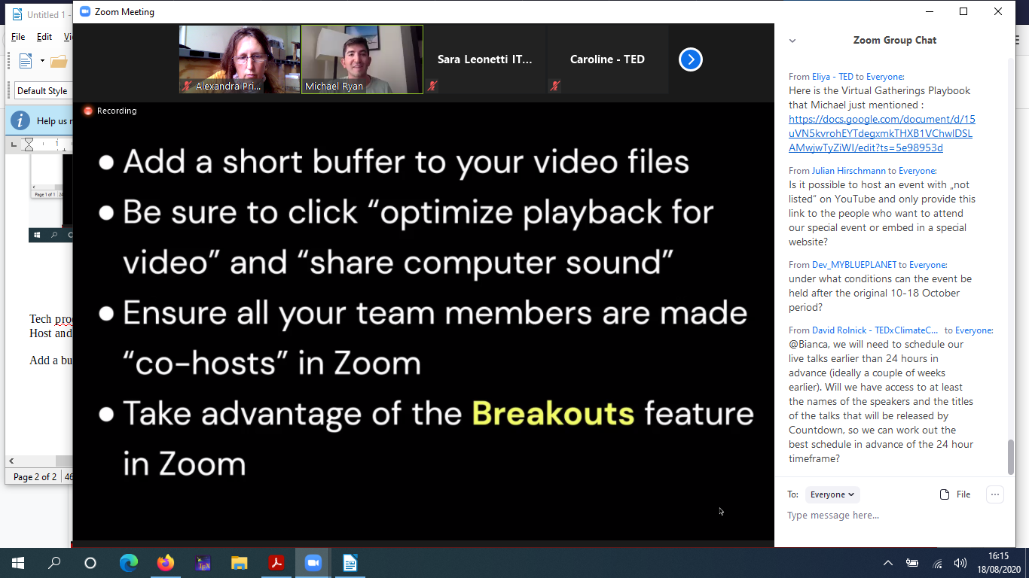
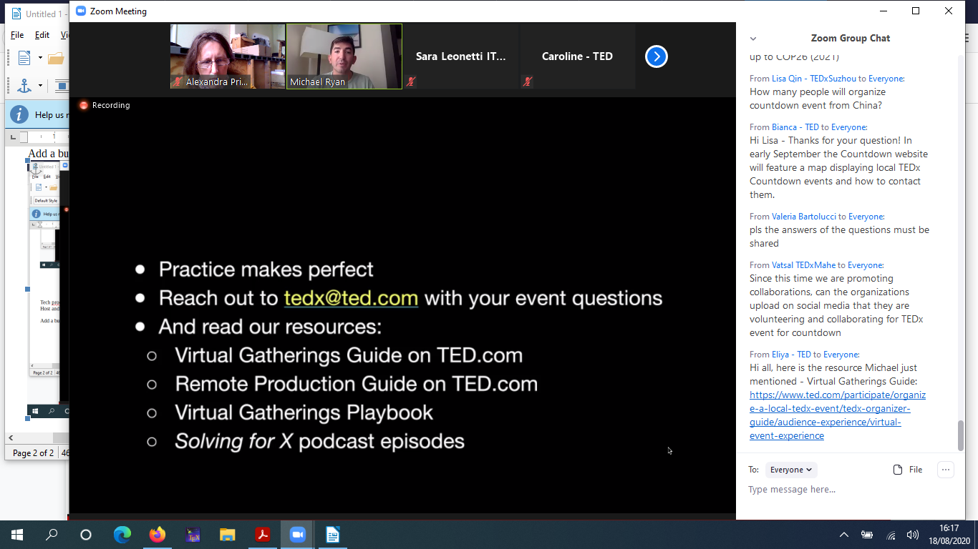
https://soundcloud.com/solvingforx/tracks
https://docs.google.com/document/d/15uVN5kvrohEYTdegxmkTHXB1VChwlDSLAMwjwTyZiWI/edit?ts=5e98953d
https://www.ted.com/participate/organize-a-local-tedx-event/tedx-organizer-guide/video-photography/video/remote-production-guide
https://www.ted.com/participate/organize-a-local-tedx-event/tedx-organizer-guide/audience-experience/virtual-event-experience
https://www.ted.com/participate/organize-a-local-tedx-event/tedx-organizer-guide/audience-experience/virtual-event-experience

https://www.ted.com/participate/organize-a-local-tedx-event/tedx-organizer-guide/audience-experience/virtual-event-experience

technical role: join early, play something prerecorded, have a second person with all presentaitons in case internet goes.

https://www.techrepublic.com/article/how-to-prevent-zoom-bombing-5-simple-tips/

