01. Active Minutes
Environment Specifics
Please be aware that every JS environment may behave differently when executing code. Certain things that work in the browser are not supported in Node.js, which is the environment used by Judge.
The following actions are NOT supported:
- .forEach() with NodeList (returned by querySelector() and querySelectorAll())
- .forEach() with HTMLCollection (returned by getElementsByClassName() and element.children)
- Using the spread-operator (...) to convert a NodeList into an array
- append() in Judge (use only appendChild())
- prepend()
- replaceWith()
- replaceAll()
- closest()
- replaceChildren()
- Always turn the collection into a JS array (forEach, forOf, et.)
If you want to perform these operations, you may use Array.from() to first convert the collection into an array.
Use the provided skeleton to solve this problem.
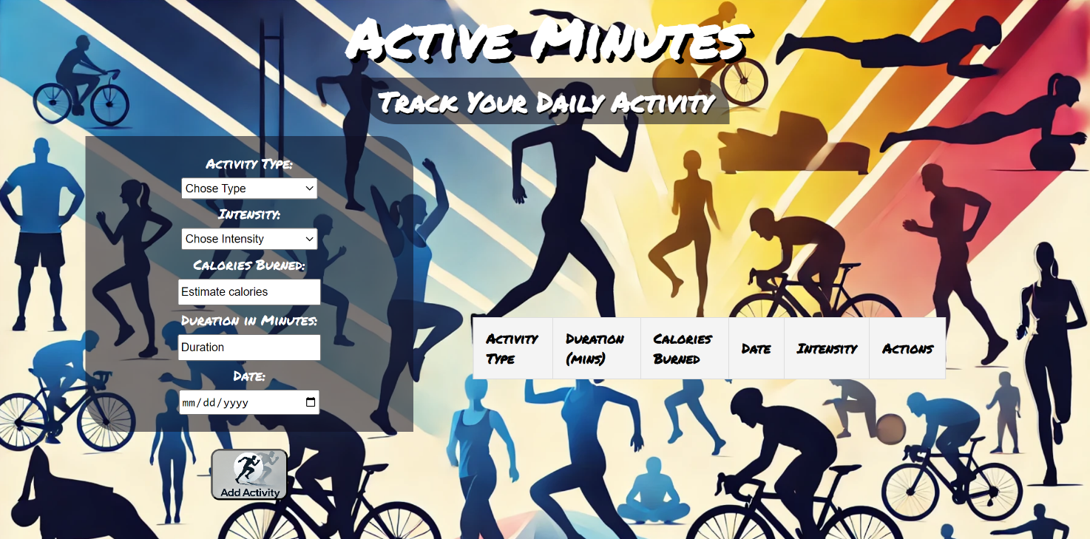
Write the missing functionality of this user interface. The functionality is divided in the following steps:

Your Task
Write the missing JavaScript code to make the Active Minutes work as expected:
All fields (Activity Type, Intensity, Calories Burned, Duration in Minutes and Date) are filled with the correct input
- Activity Type, Intensity, Calories Burned, Duration in Minutes and Date are non-empty strings. If any of them is empty, the program should not do anything.

1.Getting the information from the form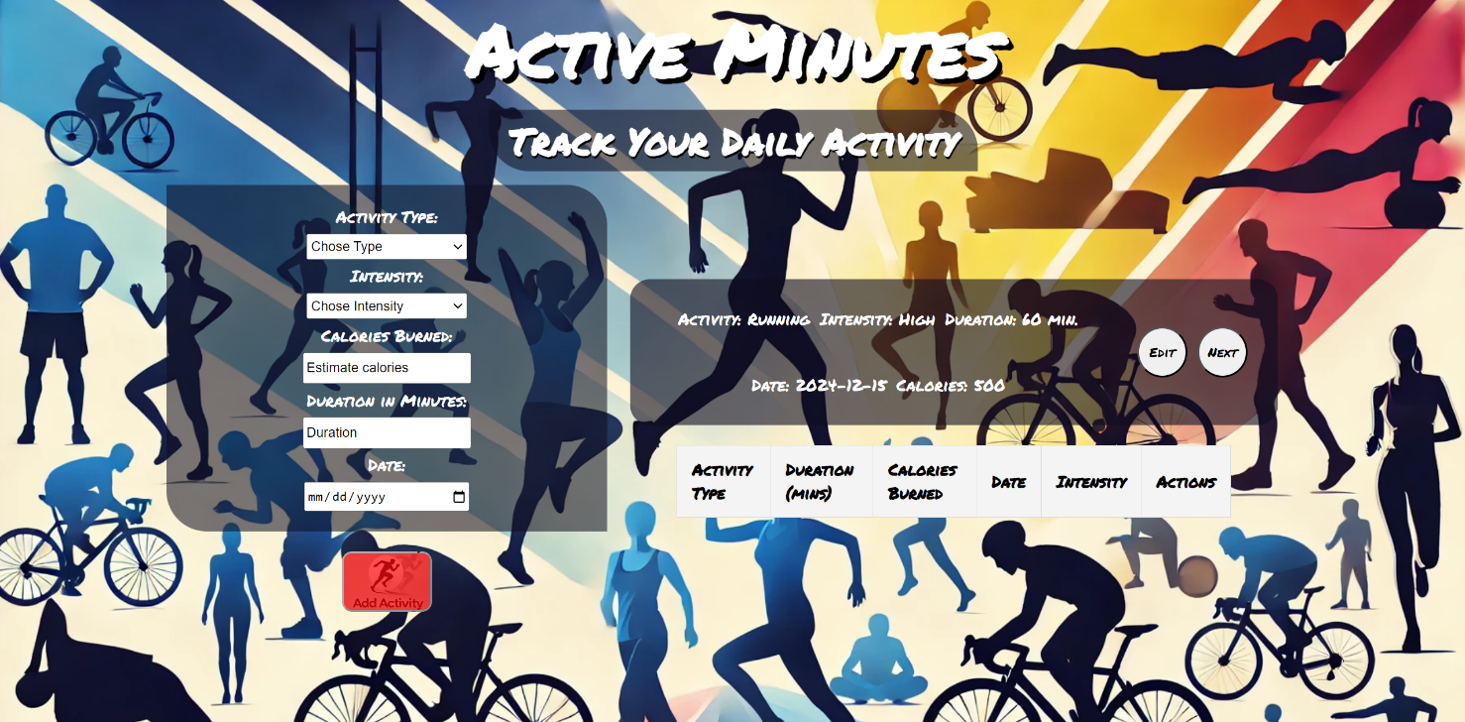
• When the ["Add Activity"] button is clicked, the information from the input fields is listed in the unordered list. A list item is added to the "preview-activity" unordered list.
- The list item should follow the same text format and order as shown in the provided picture.
- When the button is clicked, the input fields must be cleared, and the ["Add Activity"] button should be disabled. Additionally, the "Edit" and "Next" buttons need to be added.
The HTML structure looks like this:
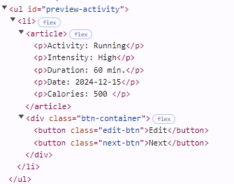

2.Edit Activity Info
The functionality here is the following:
- When the "Edit" button is clicked, all of the information is loaded in to the input fields from step 1 and the list item is removed, while the ["Add Activity"] button is enabled again.
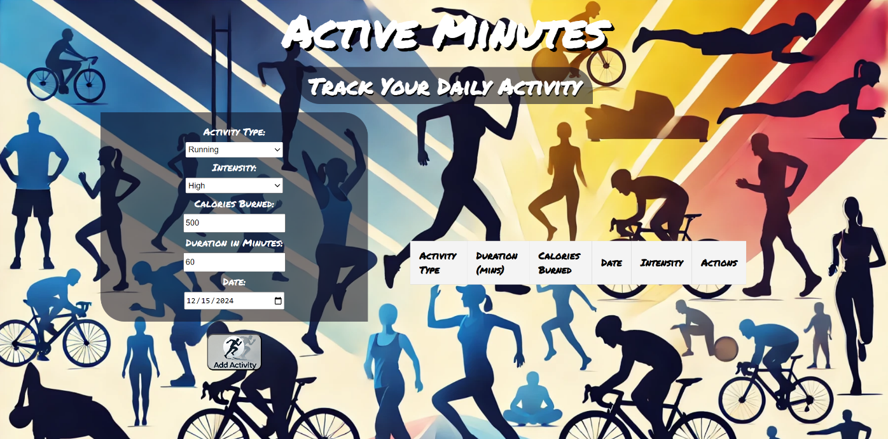
- The list item must be removed from the "preview-activity"

3.Next
- When the "Next" button is clicked, the information from "preview-activity" unordered list must be transferred to "activities-table". For you, this means removing everything inside of the <ul> with class = "preview-activity" and adding the info in "activities-table" table body.
For each peace of information, you must create a cell in the table, and a Delete button in cell. The ["Add Activity"] button shoud be enabled again, so that the user can add another activity.
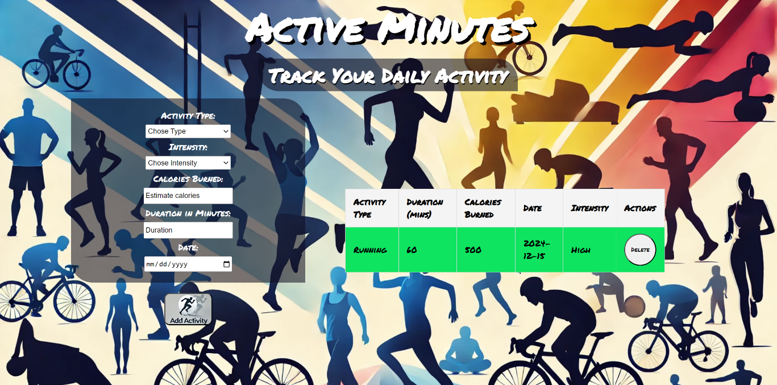

- This is the HTML structure of the "activities-table" table body when it has one activity:
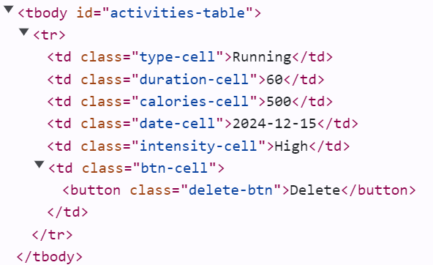

4.Delete

- When you click the "Delete" button, you must remove the respective table row from the "activities-table" table body.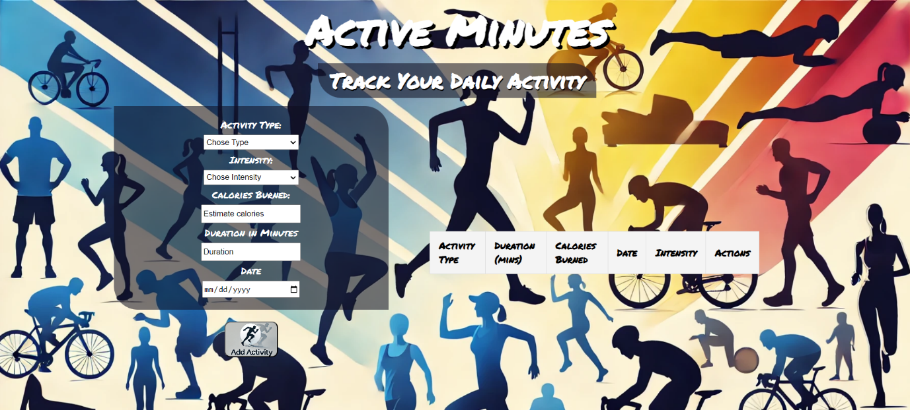
- This is the resulting HTML structure when there was a single activity in ther table:

Submission
Submit only yours solve() function.

GOOD LUCK…

