Exercise: Unit Testing and Error Handling
Submit your solutions in the SoftUni judge system at:
https://alpha.judge.softuni.org/contests/unit-testing-and-error-handling-exercise/2767

Request Validator
Write a function that validates an HTTP request object. The object has the properties method, uri, version, and message. Your function will receive the object as a parameter and has to verify that each property meets the following requirements:
- method - can be GET, POST, DELETE or CONNECT
- uri - must be a valid resource address or an asterisk (*); a resource address is a combination of alphanumeric characters and periods; all letters are Latin; the URI cannot be an empty string
- version - can be HTTP/0.9, HTTP/1.0, HTTP/1.1 or HTTP/2.0 supplied as a string
- message - may contain any number of non-special characters (special characters are <, >, \, &, ', ")
If a request is valid, return it unchanged.
If any part fails the check, throw an Error with the message "Invalid request header: Invalid {Method/URI/Version/Message}".
Replace the part in curly braces with the relevant word. Note that some of the properties may be missing, in which case the request is invalid. Check the properties in the order in which they are listed above. If more than one property is invalid, throw an error for the first encountered.

Input / Output
Your function will receive an object as a parameter. Return the same object or throw an Error as described above as an output.

Examples
Input | Output
{  method: 'GET',  uri: 'svn.public.catalog',  version: 'HTTP/1.1',  message: ''  } | {  method: 'GET',  uri: 'svn.public.catalog',  version: 'HTTP/1.1',  message: ''  }
{  method: 'OPTIONS',  uri: 'git.master',  version: 'HTTP/1.1',  message: '-recursive'  } | Invalid request header: Invalid Method

{  method: 'POST',  uri: 'home.bash',  message: 'rm -rf /*'  } | Invalid request header: Invalid Version

Hints
Since validating some of the fields may require the use of RegExp, you can check your expressions using the following samples:
URI
Valid | Invalid
svn.public.catalog  git.master  version1.0  for..of  .babelrc  c | %appdata%  apt-get  home$  define apps  "documents"
- Note that the URI cannot be an empty string.
Message
Valid | Invalid
-recursive  rm -rf /*  hello world  https://svn.myservice.com/downloads/  %root% | <script>alert("xss vulnerable")</script>  \r\n  &copy;  "value"  '; DROP TABLE
- Note that the message may be an empty string, but the property must still be present.

Unit Testing
You are required to submit only the unit tests for the object/function you are testing.

Even or Odd
You need to write unit tests for a function isOddOrEven() that checks whether the length of a passed string is even or odd.
If the passed parameter is NOT a string return undefined. If the parameter is a string return either "even" or "odd" based on the length of the string.

JS Code
You are provided with an implementation of the isOddOrEven() function:
isOddOrEven.js
function isOddOrEven(string) {
if (typeof(string) !== 'string') {
return undefined;
}
if (string.length % 2 === 0) {
return "even";
}
return "odd";
}

Hints
We can see there are three outcomes for the function:
- Returning undefined
- Returning "even"
- Returning "odd"
Write one or two tests passing parameters that are NOT of type string to the function and expecting it to return undefined.
After we have checked the validation it's time to check whether the function works correctly with valid arguments. Write a test for each of the cases:
- One where we pass a string with even length;
- And one where we pass a string with an odd length;
Finally, make an extra test passing multiple different strings in a row to ensure the function works correctly.

Char Lookup
Write unit tests for a function that retrieves a character at a given index from a passed-in string.
You are given a function named lookupChar(), which has the following functionality:
- lookupChar(string, index) - accepts a string and an integer (the index of the char we want to lookup) :
  - If the first parameter is NOT a string or the second parameter is NOT a number - return undefined.
  - If both parameters are of the correct type but the value of the index is incorrect (bigger than or equal to the string length or a negative number) - return "Incorrect index".
  - If both parameters have correct types and values - return the character at the specified index in the string.

JS Code
You are provided with an implementation of the lookupChar() function:
charLookUp.js
function lookupChar(string, index) {
if (typeof(string) !== 'string' || !Number.isInteger(index)) {
return undefined;
}
if (string.length <= index || index < 0) {
return "Incorrect index";
}
return string.charAt(index);
}

Hints
А good first step in testing a method is usually to determine all exit conditions. Reading through the specification or taking a look at the implementation we can easily determine 3 main exit conditions:
- Returning undefined
- Returning an "Incorrect index"
- Returning the char at the specified index
Now that we have our exit conditions we should start checking in what situations we can reach them. If any of the parameters are of incorrect type, undefined should be returned.
If we take a closer look at the implementation, we see that the check uses Number.isInteger() instead of typeof(index === number) to check the index. While typeof would protect us from getting past an index that is a non-number, it won’t protect us from being passed a floating-point number. The specification says that the index needs to be an integer, since floating-point numbers won’t work as indexes.
Moving on to the next exit condition - returning an "Incorrect index" if we get past an index that is a negative number or an index that is outside of the bounds of the string.
For the last exit condition - returning a correct result. A simple check for the returned value will be enough.
With these last two tests, we have covered the lookupChar() function.

Math Enforcer
Your task is to test an object named mathEnforcer, which should have the following functionality:
- addFive(num) - A function that accepts a single parameter:
  - If the parameter is NOT a number, the function should return undefined.
  - If the parameter is a number, add 5 to it, and return the result.
- subtractTen(num) - A function that accepts a single parameter:
  - If the parameter is NOT a number, the function should return undefined.
  - If the parameter is a number, subtract 10 from it, and return the result.
- sum(num1, num2) - A function that accepts two parameters:
  - If any of the 2 parameters is NOT a number, the function should return undefined.
  - If both parameters are numbers, the function should return their sum.

JS Code
You are provided with an implementation of the mathEnforcer object:
mathEnforcer.js
let mathEnforcer = {
addFive: function (num) {
if (typeof(num) !== 'number') {
return undefined;
}
return num + 5;
},
subtractTen: function (num) {
if (typeof(num) !== 'number') {
return undefined;
}
return num - 10;
},
sum: function (num1, num2) {
if (typeof(num1) !== 'number' || typeof(num2) !== 'number') {
return undefined;
}
return num1 + num2;
}
};
The methods should function correctly for positive, negative, and floating-point numbers. In the case of floating-point numbers, the result should be considered correct if it is within 0.01 of the correct value.

Screenshots
When testing a more complex object write a nested description for each function:
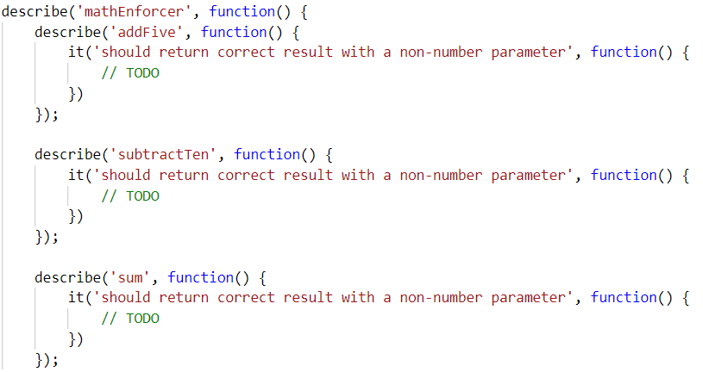
Your tests will be supplied with a variable named "mathEnforcer" which contains the mentioned above logic. All test cases you write should reference this variable.

Hints
- Test how the program behaves when passing in negative values.
- Test the program with floating-point numbers (use Chai’s closeTo() method to compare floating-point numbers).

DOM Error Handling
The following problems must be solved using DOM manipulation techniques.
Environment Specifics
Please, be aware that every JS environment may behave differently when executing code. Certain things that work in the browser are not supported in Node.js, which is the environment used by Judge.
The following actions are NOT supported:
- .forEach() with NodeList (returned by querySelector() and querySelectorAll())
- .forEach() with HTMLCollection (returned by getElementsByClassName() and element.children)
- Using the spread-operator (...) to convert a NodeList into an array
- append() in Judge (use only appendChild())
- prepend()
- replaceWith()
- replaceAll()
- closest()
- replaceChildren()
- Always turn the collection into a JS array (forEach, forOf, et.)
If you want to perform these operations, you may use Array.from() to first convert the collection into an array.

Notification
Write a JS function that receives a string message and displays it inside a div with id "notification. The div starts hidden and when the function is called, reveal it. After the user clicks on it, hide the div. In the example document, a notification is shown when you click on the button ["Get notified"].

Example
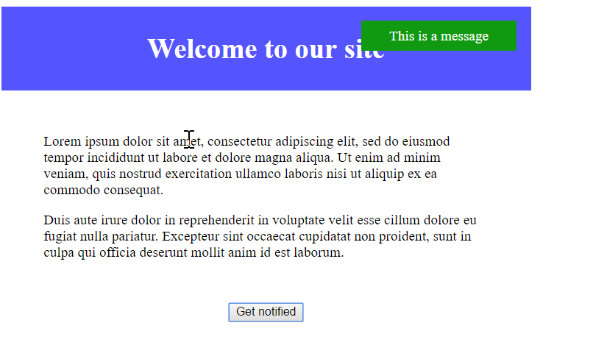

Dynamic Validation
Write a JS function that dynamically validates an email input field when it is changed. If the input is invalid, apply to it the class "error". Do not validate on every keystroke, as it is annoying for the user, consider only change events.
A valid email will be in format: <name>@<domain>.<extension>
Only lowercase Latin characters are allowed for any of the parts of the email. If the input is valid, clear the style.

Input/Output
There will be no input/output, your program should instead modify the DOM of the given HTML document.

Example
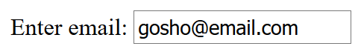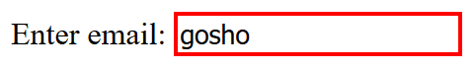

Form Validation
You are given the task to write validation for the fields of a simple form.

HTML and JavaScript Code
You are provided a skeleton containing the necessary files for your program.
The validations should be as follows:
- The username needs to be between 3 and 20 symbols inclusively and only letters and numbers are allowed.
- The password and confirm-password must be between 5 and 15 inclusively symbols and only word characters are allowed (letters, numbers, and _).
- The inputs of the password and confirm-password field must match.
- The email field must contain the “@” symbol and at least one "."(dot) after it.
If the "Is company?" checkbox is checked, the CompanyInfo fieldset should become visible and the Company Number field must also be validated, if it isn’t checked the Company fieldset should have the style "display: none;" and the value of the Company Number field shouldn’t matter.
- The Company Number field must be a number between 1000 and 9999.
- Use addEventListener() function to attach an event listener for the "change" event to the checkbox.
Every field with an incorrect value when the [Submit] button is pressed should have the following style applied border-color: red;, alternatively, if it’s correct it should have style border: none;. If there are required fields with an incorrect value when the [Submit] button is pressed, the div with id="valid" should become hidden ("display: none;"), alternatively if all fields are correct the div should become visible.

Constraints
- You are NOT allowed to change the HTML or CSS files provided.

Screenshots
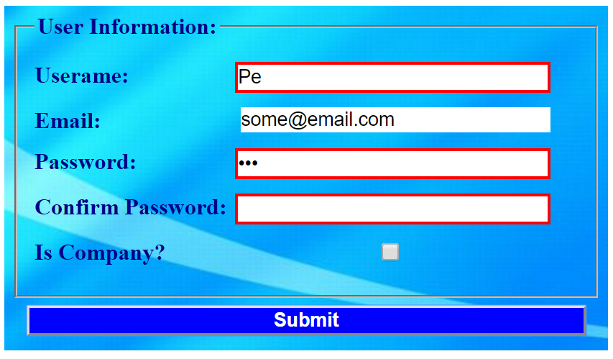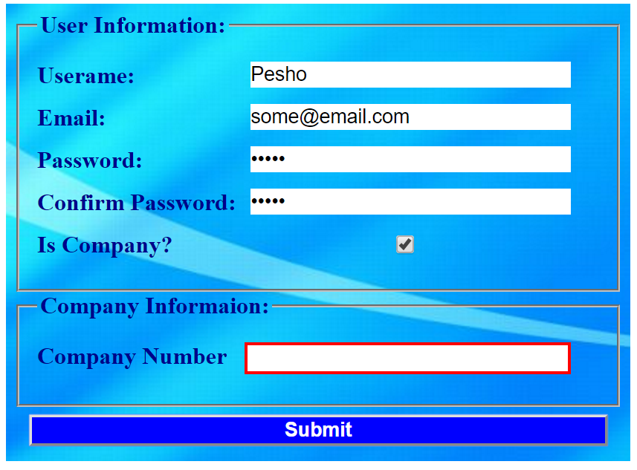
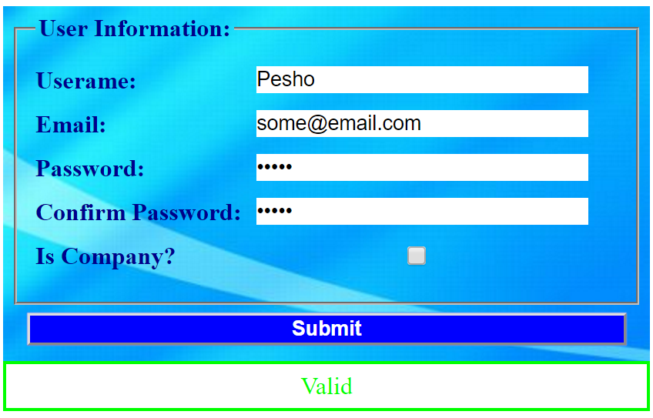
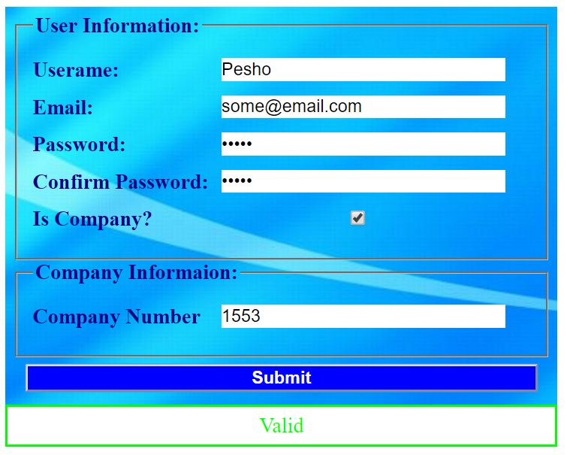

Hints
- All buttons within an <form> automatically work as submit buttons, unless their type is manually assigned to something else, to avoid reloading the page upon clicking the [Submit] button you can use event.preventDefault()
- The validation for the separate fields can be done using regex.

