JS Advanced: Exam Preparation 1
Link to contest: https://alpha.judge.softuni.org/contests/js-advanced-retake-exam-3-april-2024/4536

Problem 01.Ticket Rift Rock
Environment Specifics
Please be aware that every JS environment may behave differently when executing code. Certain things that work in the browser are not supported in Node.js, which is the environment used by Judge.
The following actions are NOT supported:
- .forEach() with NodeList (returned by querySelector() and querySelectorAll())
- .forEach() with HTMLCollection (returned by getElementsByClassName() and element.children)
- Using the spread-operator (...) to convert a NodeList into an array
- append() in Judge (use only appendChild())
- prepend()
- replaceWith()
- replaceAll()
- closest()
- replaceChildren()
- Always turn the collection into a JS array (forEach, forOf, et.)
If you want to perform these operations, you may use Array.from() to first convert the collection into an array.
Use the provided skeleton to solve this problem.
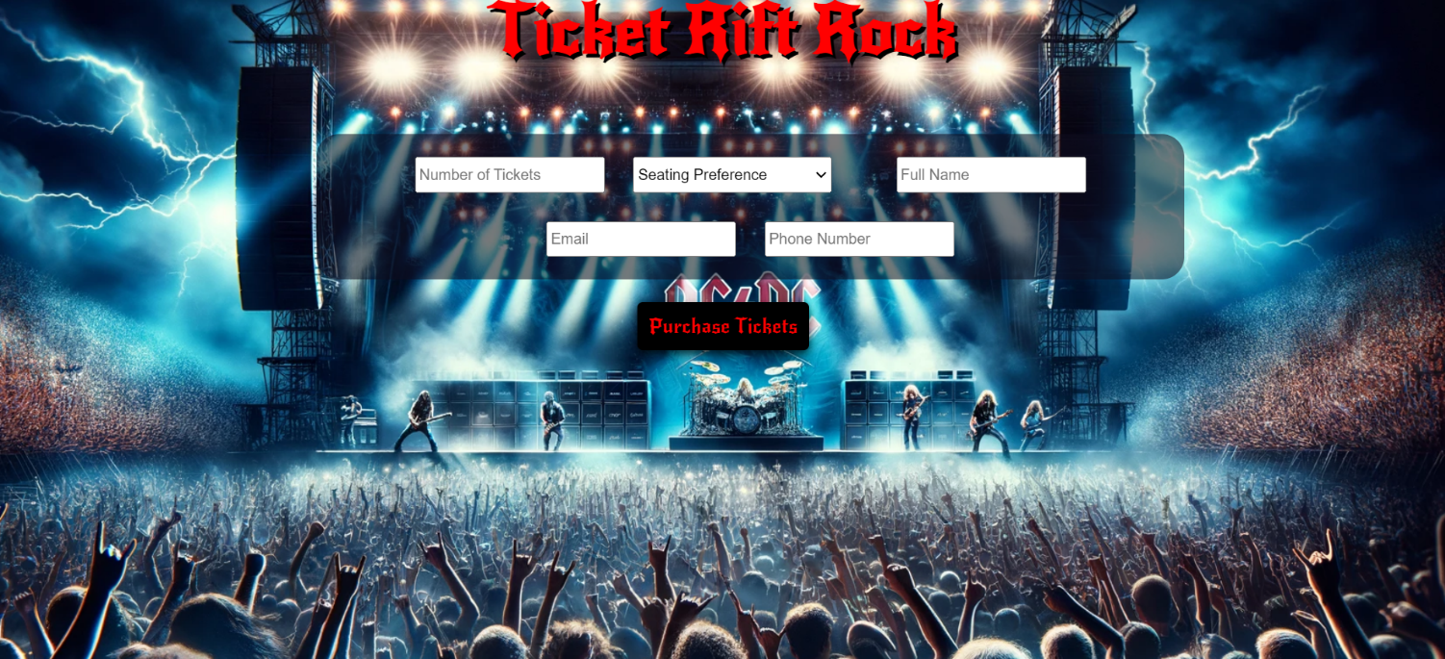
Write the missing functionality of this user interface. The functionality is divided in the following steps:

Your Task
Write the missing JavaScript code to make the Ticket Rift Rock work as expected:
All fields (Number of Tickets, Seating Preference, Full Name, Email, and Phone Number) are filled with the correct input
- Number of Tickets, Seating Preference, Full Name, Email, and Phone Number are non-empty strings. If any of them is empty, the program should not do anything.

1.Getting the information from the form 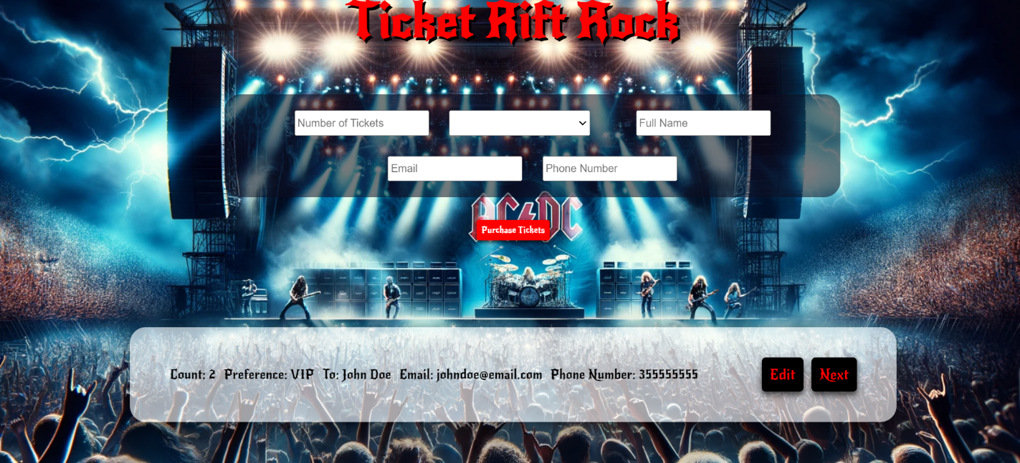
• When the ["Purchase Tickets"] button is clicked, the information from the input fields is listed in the unordered list. A list item is added to the " ticket-preview" unordered list.
- The list item should follow the same text format and order as shown in the provided picture.
- When the button is clicked, the input fields must be cleared, and the ["Purchase Tickets"] button should be disabled. Additionally, the "Edit" and "Next" buttons need to be added.
The HTML structure looks like this:
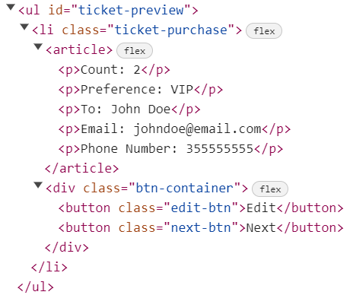

2.Edit Ticket Info

The functionality here is the following:
- When the "Edit" button is clicked, all of the information is loaded in to the input fields from step 1 and list item is removed while the ["Purchase Tickets"] button is enabled again.
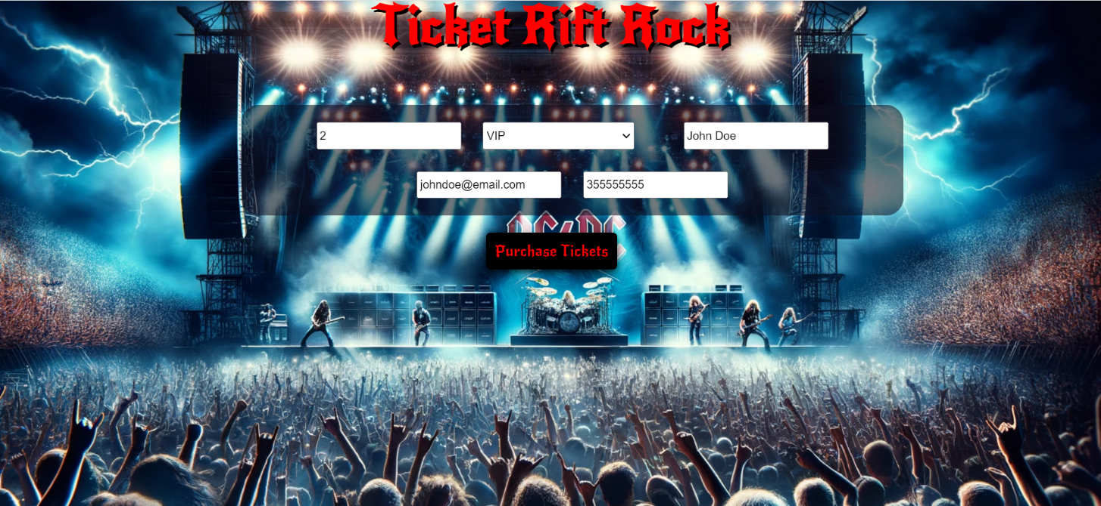
- The list items must be removed from the "ticket-preview"
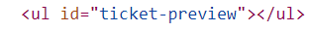

3.Next
- When the "Next" button is clicked, the information from "ticket-preview" unordered list must be transferred to "ticket-purchase". For you, this means removing everything inside of the <ul> with class = "ticket-preview" and adding in "ticket-purchase", the list item with same information The "Buy" button must be added.
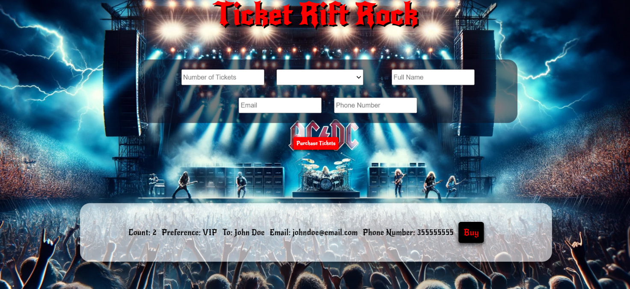

- This is the HTML structure of the "ticket-purchase" unordered list:
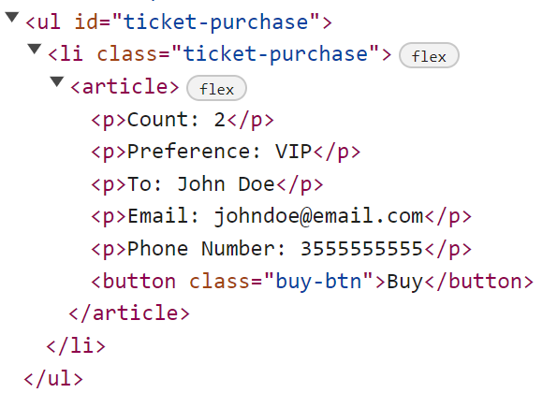

3.Buying

- When the "Buy" button is clicked, you must remove list item from "ticket-purchase" unordered list and then add h2 element with text "Thank you for your purchase! " and "Back" button
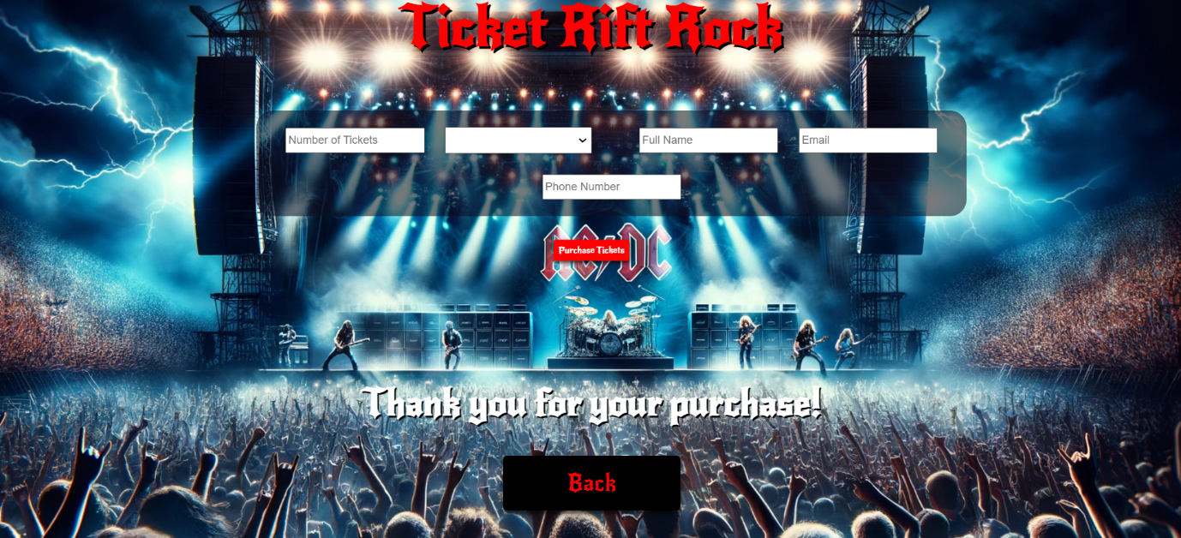
- This is the HTML structure:
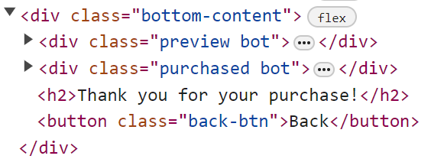

4.Back

- When the "Back" button is clicked, you must reload the page or remove h2 element with text "Thank you for your purchase! " and ["Back"] button while the ["Purchase Tickets"] button is enabled again.
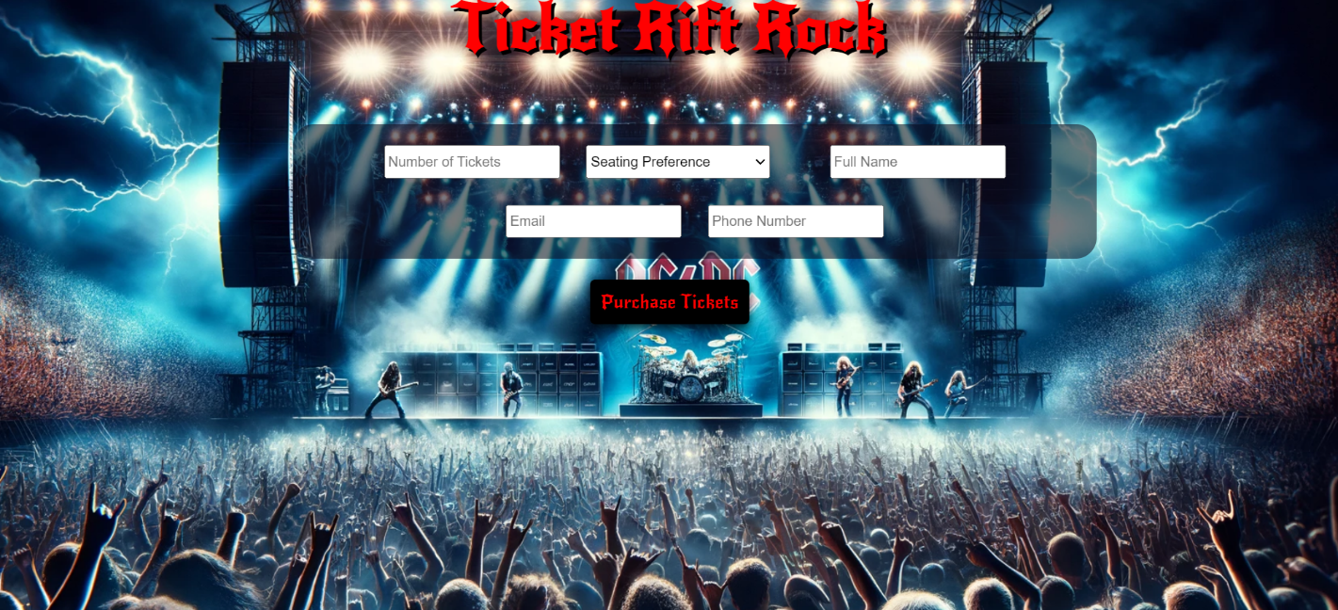

Submission
Submit only yours solve() function.

Problem 2.Bike Rental Service
class BikeRentalService {
//TODO...
}

Write a class BikeRentalService, which supports the described functionality below.

Functionality
Constructor
Should have these 3 properties:
- name - string
- location - string
- availableBikes - empty array
At the initialization of the BikeRentalService class, the constructor accepts the name and location.
Hint: You can add more properties to help you finish the task.

addBikes (bikes)
This method adds bikes to the bike rental service. The method takes 1 argument: bikes (array of strings).
- Every element into this array is information about the bike in the format:
"{brand} {quantity} {price}"
- They are separated by a dash.
Example: ["Mountain Bike-5-150", "City Bike-10-100", "Electric Bike-3-200"...]
- If the brand of the current bike is already present in availableBikes array, add the new quantity to the old one and update the old price per bike only if the current one is higher.
- Otherwise, add the bike, with properties: {brand, quantity, price} to the availableBikes array.
- In all cases, you must finally return a string in the following format:
`Successfully added {brand1}, {brand2}, …{brandN}`
Note: When returning the string, keep in mind that the different brands of bikes must be:
- Unique - for instance:
"Successfully added Mountain Bike, City Bike, Electric Bike" - is a correctly returned string
"Successfully added Mountain Bike, City Bike, Mountain Bike" - is not a correctly returned string

Separated by comma and space (, )

rentBikes(selectedBikes)
- With this method, users can rent bikes from the rental service. The method takes 1 argument: selectedBikes (array of strings).
- Every element in this array is information about the rented bikes in the format:
"{brand} {quantity}"
- They are separated by a dash.
Example: ["Mountain Bike-5", "City Bike-10", "Electric Bike-3"...]
- For each element of the array selectedBikes, check:
- Note: It is crucial to return one of the strings ("Some of the bikes are unavailable..." or "Enjoy your ride! You must pay the following amount $${totalPrice.toFixed(2)}.") after the function goes through every element of the selectedBikes array and updates the bike quantities that match the criteria.
  - If the brand of the current bike is not present in the availableBikes array, or if the brand is present but the quantity selected by the customer exceeds the available quantity recorded in the availableBikes array, the following message should be returned:
"Some of the bikes are unavailable or low on quantity in the bike rental service."

  - Otherwise, if the above conditions are not met, you have to calculate the price for the given bike by multiplying the price per bike for the given brand by the quantity desired by the user. Then reduce the quantity recorded in the availableBikes array.
  - Note: Add a variable that will calculate the total price obtained from the individual prices of each bike in the array and return this string in the following format:

` Enjoy your ride! You must pay the following amount $${totalPrice.toFixed(2)}.`
Note: The totalPrice must be rounded to the second decimal point and before the price must have a dollar sign ($).

returnBikes (returnedBikes)
This method allows users to return bikes to the rental service. The method takes 1 argument: returnedBikes (array of strings).
- Every element in this array is information about the returned bikes in the format: "{brand} {quantity}"
- They are separated by a dash.
Example: ["Mountain Bike-5", "City Bike-10", "Electric Bike-3"...]
- For each element of the array returnedBikes, check:

- Note: It is crucial to return one of the strings ("Some of the returned bikes are not from our selection" or "Thank you for returning!") after the function goes through every element of the returnedBikes array and updates the bike quantities that match the criteria.

  - If the brand of the current bike is not present in availableBikes array, the following message should be returned:
"Some of the returned bikes are not from our selection."
  - Otherwise, increase the quantity recorded in the array availableBikes with the quantity obtained as a parameter, and return:
"Thank you for returning!"

revision ()
- This method returns all available bikes in the store in the following format:
- The first line shows the following message:
"Available bikes:"
- On the new line, display information about each bike sorted in ascending order of price and must have a dollar sign ($):
`{brand} quantity:{quantity} price:${price}`
- The last line shows the following message:
`The name of the bike rental service is {name}, and the location is {location}.`

Example
Input 1
const rentalService = new BikeRentalService("MyBikes", "CityCenter");

console.log(rentalService.addBikes(["Mountain Bike-5-150", "City Bike-10-100", "Electric Bike-3-200", "Electric Bike-8-400"]));

Output 1
Successfully added Mountain Bike, City Bike, Electric Bike

Input 2
const rentalService = new BikeRentalService("MyBikes", "CityCenter");

console.log(rentalService.addBikes(["Mountain Bike-5-150", "City Bike-10-100", "Electric Bike-3-200", "Electric Bike-8-400"]));
console.log(rentalService.rentBikes(["Mountain Bike-2", "City Bike-5"]));

Output 2
Successfully added Mountain Bike, City Bike, Electric Bike
Enjoy your ride! You must pay the following amount $800.00.

Input 3
const rentalService = new BikeRentalService("MyBikes", "CityCenter");

console.log(rentalService.addBikes(["Mountain Bike-5-150", "City Bike-10-100", "Electric Bike-3-200", "Electric Bike-8-400"]));
console.log(rentalService.rentBikes(["Mountain Bike-2", "City Bike-5", "Stunt Bike-5"]));
console.log(rentalService.returnBikes(["Mountain Bike-1", "City Bike-3", "Race Bike-5"]));
console.log(rentalService.revision());

Output 3
Successfully added Mountain Bike, City Bike, Electric Bike
Some of the bikes are unavailable or low on quantity in the bike rental service.
Some of the returned bikes are not from our selection.
Available bikes:
City Bike quantity:8 price:$100
Mountain Bike quantity: 4 price:$150
Electric Bike quantity:11 price:$400
The name of the bike rental service is MyBikes, and the location is CityCenter.

Input 4
const rentalService = new BikeRentalService("MyBikes", "CityCenter");

console.log(rentalService.addBikes(["Mountain Bike-5-150", "City Bike-10-100", "Electric Bike-3-200", "Electric Bike-8-400"]));
console.log(rentalService.rentBikes(["Mountain Bike-5", "City Bike-5"]));
console.log(rentalService.returnBikes(["Mountain Bike-1", "City Bike-3"]));
console.log(rentalService.revision());

Output 4
Successfully added Mountain Bike, City Bike, Electric Bike
Enjoy your ride! You must pay the following amount $1250.00.
Thank you for returning!
Available bikes:
City Bike quantity:8 price:$100
Mountain Bike quantity:1 price:$150
Electric Bike quantity:11 price:$400
The name of the bike rental service is MyBikes, and the location is CityCenter.

Problem 3.Workforce Management
Using Mocha and Chai write JS Unit Tests to test a variable named workforceManagement, which represents an object. You may use the following code as a template:
describe("Tests …", function() {
describe("TODO …", function() {
it("TODO …", function() {
// TODO: …
});
});
// TODO: …
});

The object should have the following functionality:
recruitStaff (name, role, experience) - A function that accepts three parameters: string, string, and number.
- If the value of the string role is different from "Developer", throw an error: `We are not currently hiring for this role.`
- To be hired, the employee must meet the following requirements:
  - If the experience is greater than or equal to 4, return the string:
`{name} has been successfully recruited for the role of {role}.`
- Otherwise, if the above conditions are not met, return the following message:
`{name} is not suitable for this role.`
- There is no need for validation for the input, you will always be given a string, string, and number.

- computeWages (hoursWorked) - A function that accepts one parameter: number.
- Workers in this company receive equal pay per hour and this is BGN 18.
- You need to calculate the salary by multiplying the pay for one hour by the number of hours.
- Also, if the employee has been working for more than 160 hours, he must receive an additional BGN 1500 bonus.
- Finally, return the employee's salary.
- You need to validate the input, if the hoursWorked are not a number, or are a negative number, throw an error: "Invalid hours".

- dismissEmployee (workforce, employeeIndex) - A function that accepts an array and number.
  - The workforce array will store the names of its employees (["Petar", "Ivan", "George"…]).
  - You must remove an element (employee) from the array that is located on the employeeIndex specified as a parameter.
- Finally, return the changed array of workforce as a string, joined by a comma and a space.
  - There is a need for validation for the input, an array and index may not always be valid. In case of submitted invalid parameters, throw an error "Invalid input":
    - If passed workforce parameter is not an array.
    - If the employeeIndex is not a number and is outside the limits of the array.

JS Code
To ease you in the process, you are provided with an implementation that meets all of the specification requirements for the workforceManagement object:
workforceManagement.js
const workforceManagement = {

recruitStaff(name, role, experience) {
if (role === "Developer") {
if (experience >= 4) {
return `${name} has been successfully recruited for the role of ${role}.`;
} else {
return `${name} is not suitable for this role.`;
}
}
throw new Error(`We are not currently hiring for this role.`);
},

computeWages(hoursWorked) {
let hourlyRate = 18;
let totalPayment = hourlyRate * hoursWorked;

if (typeof hoursWorked !== "number" || hoursWorked < 0) {
throw new Error("Invalid hours");
} else if (hoursWorked > 160) {
totalPayment += 1500;
}
return totalPayment;
},

dismissEmployee(workforce, employeeIndex) {
let updatedStaff = [];

if (!Array.isArray(workforce) || !Number.isInteger(employeeIndex) || employeeIndex < 0 || employeeIndex >= workforce.length) {
throw new Error("Invalid input");
}
for (let i = 0; i < workforce.length; i++) {
if (i !== employeeIndex) {
updatedStaff.push(workforce[i]);
}
}
return updatedStaff.join(", ");
}
};

Submission
Submit your tests inside a describe() statement, as shown above.

