01. Motorcycle Showroom
Environment Specifics
Please be aware that every JS environment may behave differently when executing code. Certain things that work in the browser are not supported in Node.js, which is the environment used by Judge.
The following actions are NOT supported:
- .forEach() with NodeList (returned by querySelector() and querySelectorAll())
- .forEach() with HTMLCollection (returned by getElementsByClassName() and element.children)
- Using the spread-operator (...) to convert a NodeList into an array
- append() in Judge (use only appendChild())
- prepend()
- replaceWith()
- replaceAll()
- closest()
- FormData()
- replaceChildren()
- Always turn the collection into a JS array (forEach, forOf, et.)
If you want to perform these operations, you may use Array.from() to first convert the collection into an array.
Use the provided skeleton to solve this problem.
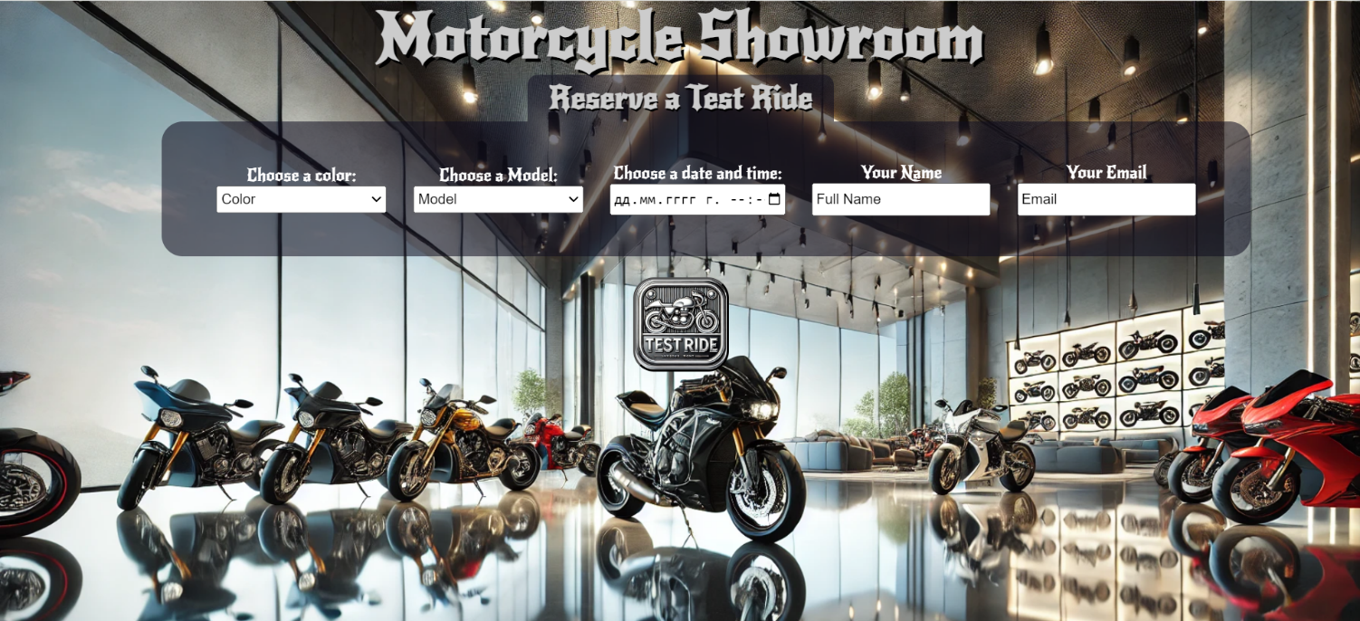
Write the missing functionality of this user interface. The functionality is divided in the following steps:

Your Task
Write the missing JavaScript code to make the Motorcycle Showroom work as expected:
All fields (Color, Model, Date and Time, Full Name and Email) are filled with the correct input
- Color, Model, Full Name, Email, and Date and Time are non-empty strings. If any of them is empty, the program should not do anything.

1.Getting the information from the form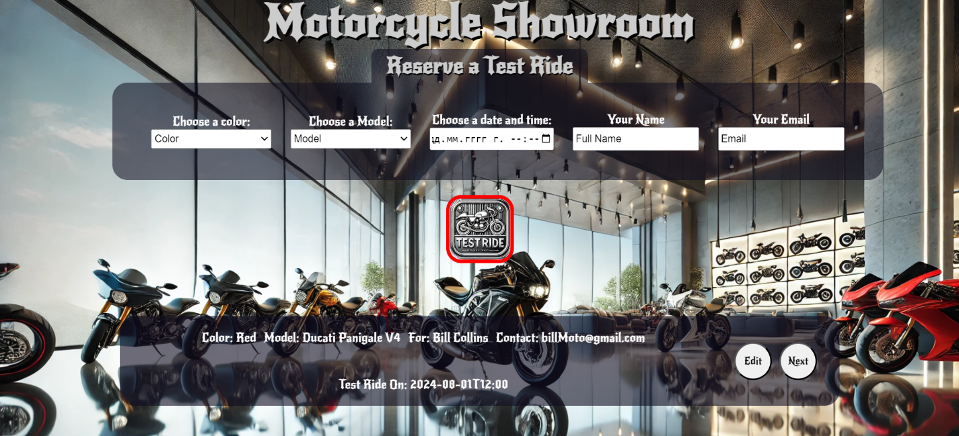
• When the ["Test Ride"] button is clicked, the information from the input fields is listed in the unordered list. A list item is added to the "preview-list" unordered list.
- The list item should follow the same text format and order as shown in the provided picture.
- When the button is clicked, the input fields must be cleared, and the ["Test Ride"] button should be disabled. Additionally, the "Edit" and "Next" buttons need to be added.
The HTML structure looks like this:
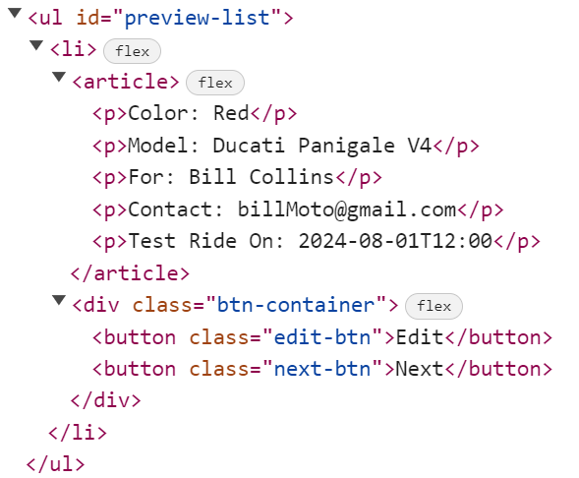

2.Edit Test Ride Info

The functionality here is the following:
- When the "Edit" button is clicked, all of the information is loaded in to the input fields from step 1 and list item is removed while the ["Test Ride"] button is enabled again.
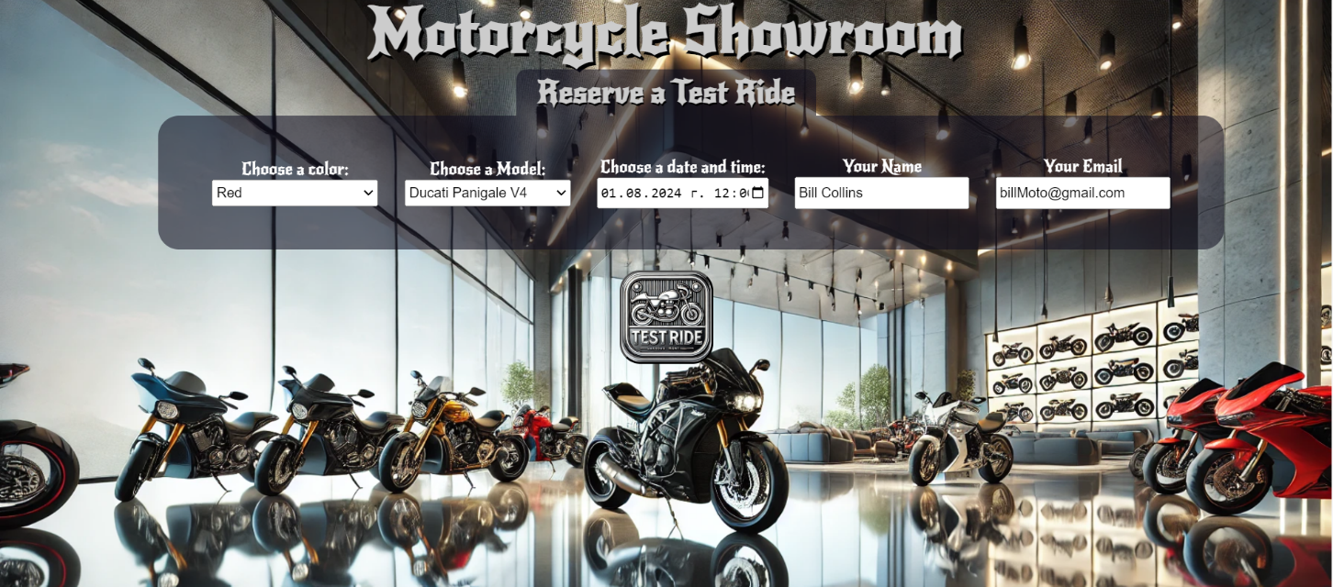
- The list items must be removed from the "preview-list"

3.Next
- When the "Next" button is clicked, the information from "preview-list" unordered list must be transferred to "complete-list". For you, this means removing everything inside of the <ul> with class = "preview-list" and adding in "complete-list", the list item with same information The "Complete" button must be added.
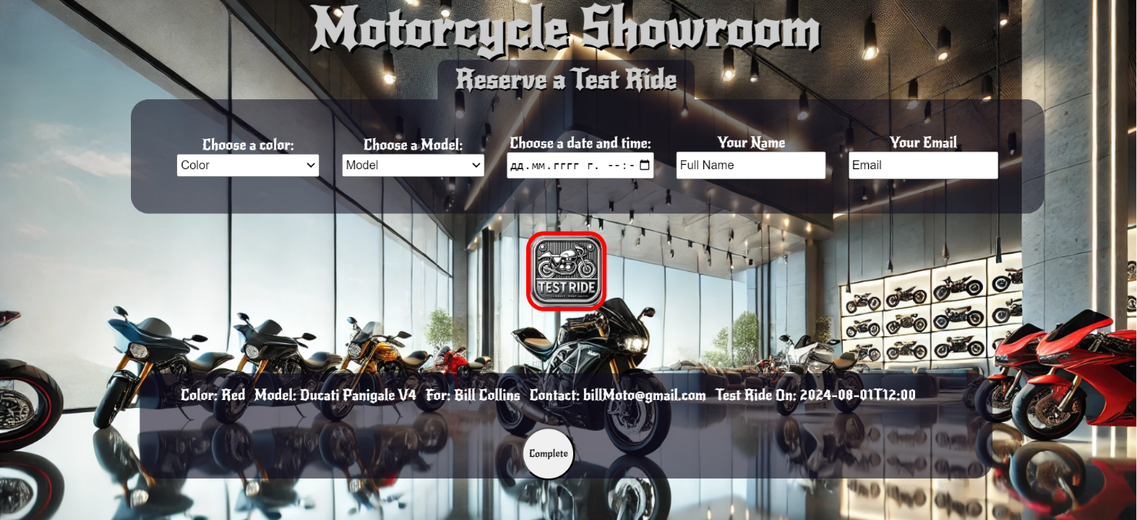

- This is the HTML structure of the "complete-list" unordered list:
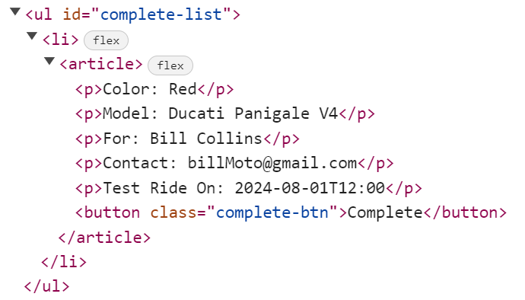

3.Completing

- When the "Complete" button is clicked, you must remove list item from "complete-list" unordered list and then add "Your Test Ride is Confirmed" button
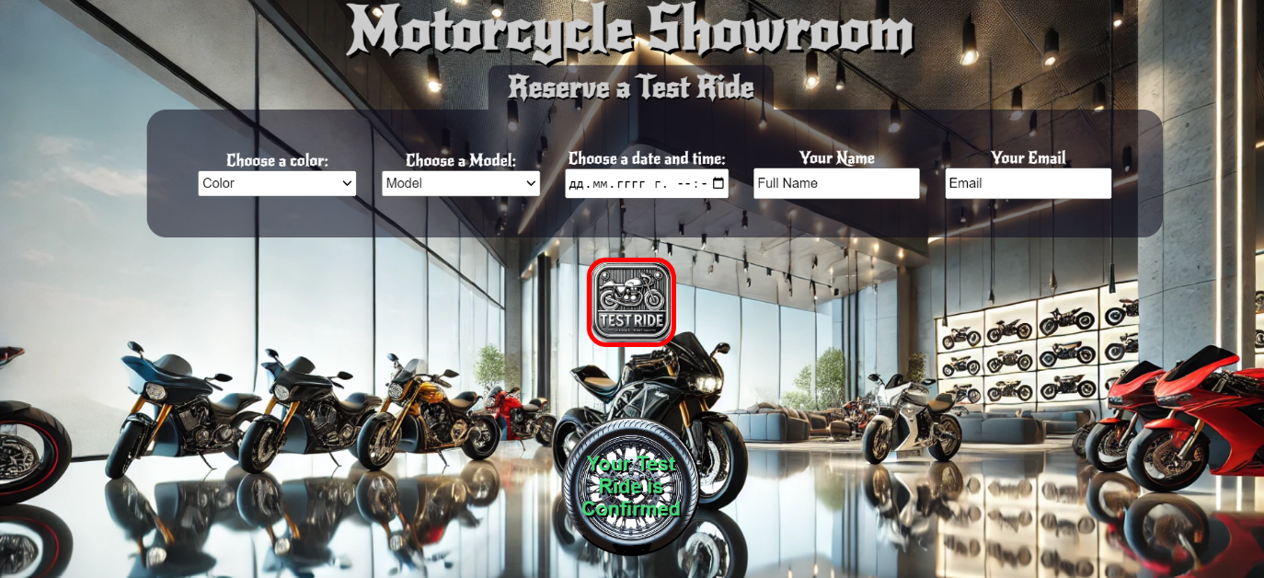
- This is the HTML structure:
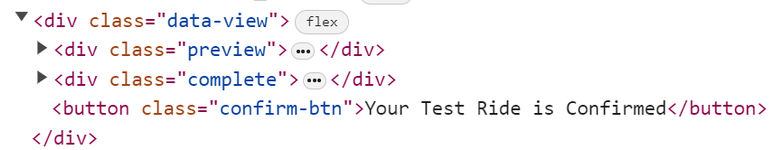

4.Confirm

- When the "Your Test Ride is Confirmed" button is clicked, you must reload the page.
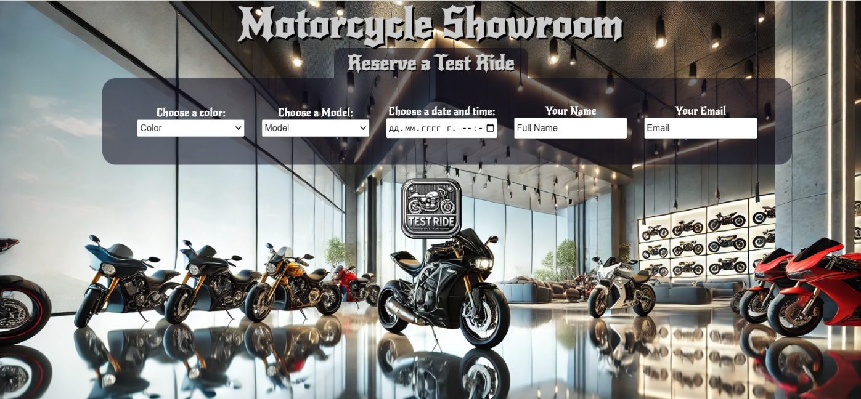

Submission
Submit only yours solve() function.

GOOD LUCK…

