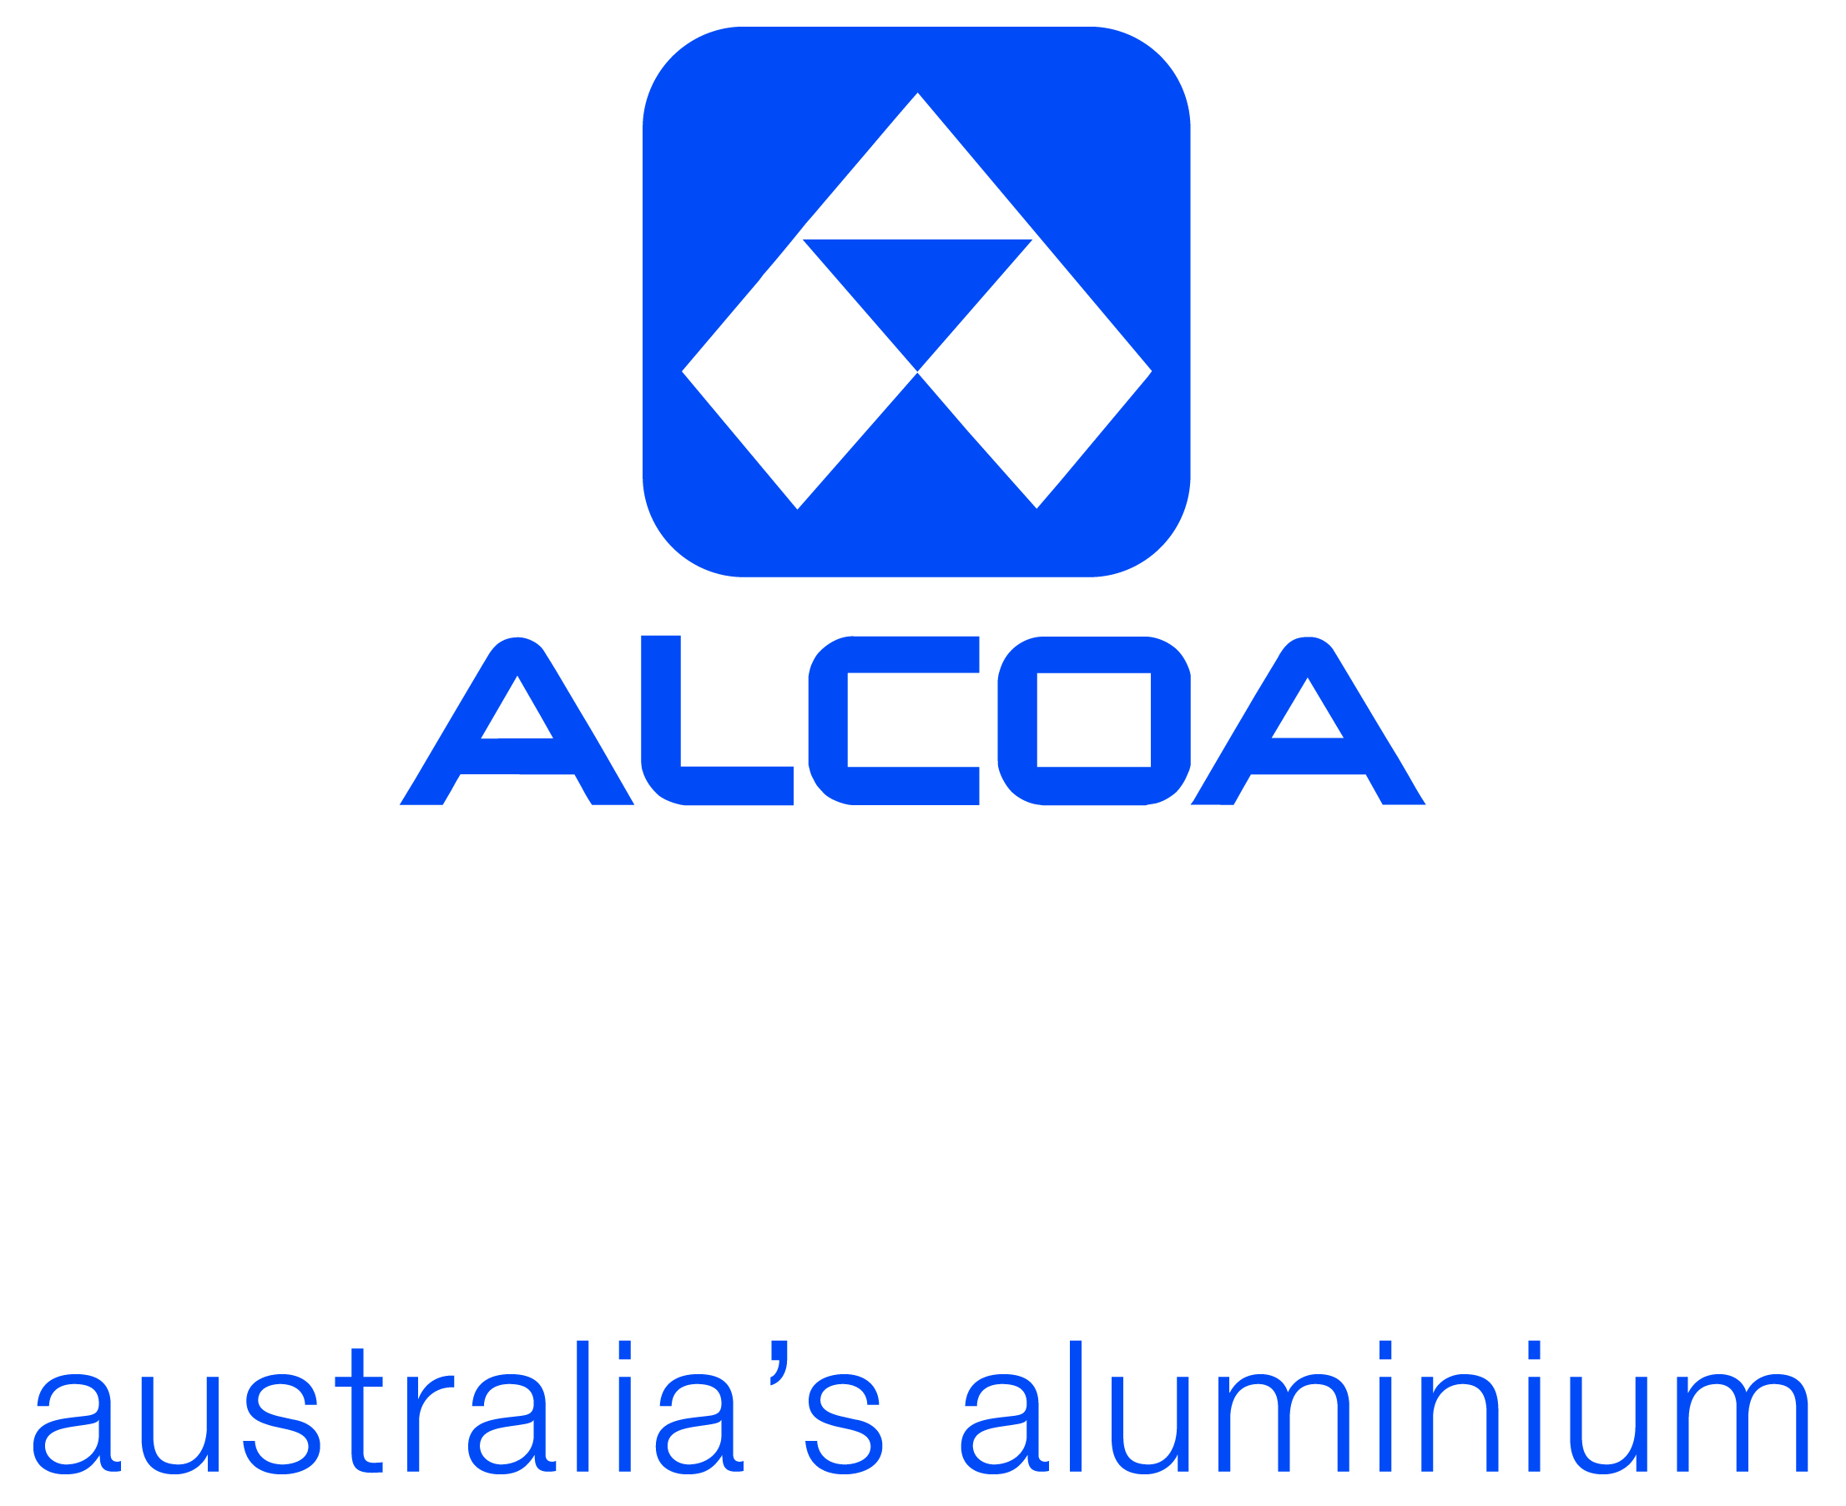

**Contents Page:**

Page 1: Cover page- ALCOA logo

Page 2: Contents page

Page 3: Picture of ALCOA mine site

Page 4: Part 1- Plan

Page 5: Plan (part 1) and part 2: notes, observations, evidence.

Page 6:Notes, observations, evidence.

Page 7:

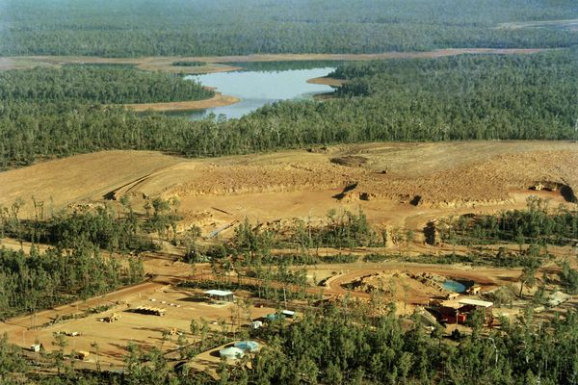

**Plan**

The purpose of this geographical inquiry is to record information and answer the inquiry questions about the rehabilitation processes used at the ALCOA mine site in Huntly,Western Australia, and include any relevant information about these rehabilitation strategies used at ALCOA Huntly. This information can be recorded in a variety of ways including; normal written notes, diagrams, maps, statistics, graphs, photographs, videos, quotesand tables.Finally this inquiry is to prepare for the in class validation questions, where we will have to answer the following 3 questions which I will also be answering in this inquiry;

**Question 4:** Making reference to Alcoa, discuss the environmental, economic and social costs and benefits of mining and subsequent land cover change in Western Australia. *This section can include diagrams, maps, statistics, graphs, and tables and refer to population change, technology, industry and mining, loss of habitat and soil degradation.*

**Question 5:** Describe the rehabilitation and restoration strategies used by ALCOA to minimise the impact of land cover change.

**Question 6:** Evaluate the effectiveness (strengths and weaknesses) of the rehabilitation and restoration strategy implemented by ALCOA to mitigate the adverse effects of land cover change.

This inquiry follows 4 steps;

* The first step is this planning stage.
* The second is the recording observations/note taking space where I record all of the information and notes I have obtained from a wide range of primary and secondary sources, I.e. from our textbook, internet and the excursion to ALCOA mine site we went on.
* The third stage is where I answer the following 7 inquiry questions using the info I have gathered;

Question 1:Describe the processes used prior to the commencement of mining activity to mitigate potential land cover change.

Question 2: Describe the rehabilitation process.

Question 3: What research is undertaking to mitigate potential impacts on biodiversity?

Question 4: How have approaches to rehabilitation changed since the commencement of ALCOA mining operations in Western Australia?

Question 5: Describe strategies that have been introduced to minimise potential impacts prior to rehabilitation.

Question 6: In addition to site rehabilitation, what additional programs exist to address impacts of land cover change on local and regional environments?

Question 7: Including an annotated sketch, compare and contrast an area of mining rehabilitation to an area not cleared for mining.

* The final stage is answering the 3 validation questions listed above.

**Evidence, notes, observations**

This is the information and notes I recorded from a range of primary and secondary sources.

* 1 in 20 relocated 100 year old grass trees live- relocating them is a very difficult process.
* 23 trucks on site. $3.5 million each. $40,000 just for a wheel. 190-200 tonnes (t) of ore can be carried per truck.
* The land ALCOA mines is owned by the state government. ALCOA have a mining lease until 2045.
* Small tractor style drills-move through forest without clearing vegetation.
* Water harvested from rainfall-rain tanks.
* Social impact- they pour water onto the ground which is used to stop dust getting everywhere, hence stops it spreading to neighbouring farmers etc, as the roads are very dusty.
* Social- they mine daytime Monday-Friday, no weekends or public holidays. Prevents noise pollution/disturbing neighbours.
* They use thin roads to prevent clearing and deforestation.
* Dirty water runs off road into a sub, prevents it running off into the forest and into water system, preventing the water they use from becoming contaminated.
* They know there is bauxite where they mine, they don’t just choose somewhere random to mine and see if there’s bauxite there, it’s all planned.
* When granite weathers over over a period of millions of years it turns to bauxite.
* 3 pre-mining surveys they conduct; 1) flora & fauna survey-cannot mine if there’s endangered or threatened species in that habitat, e.g. the black cockatoo’s (red tailed black cockatoo, carnaby’s cockatoo, both threatened species) nesting ground of tall, hollow, 100 year old trees. 2) Heritage survey; check with Noongar community, can’t mine at cultural Aboriginal sites that have an importance to indigenous people, and at sites archaeologists have declared as heritage listed, such as the Prisoners of War camp from World War 2 in Marrinup. This former prison sits on top of 5 million tonnes of bauxite that will never be mined. 3) Dieback survey- is the area dieback free or not.
* Dieback likes warm wet weather.Phytophthora dieback is ****a deadly****, introduced plant pathogen and is unusual as it has animal, fungal and plant characteristics. Scientifically known as Phytophthora cinnamomi, it is classified as a water mould belonging to the new ancestral kingdom Chromista. Phytophthora dieback lives in soil and attacks the roots of many native plants. It is spread from area to area by people’s shoes or the wheels of vehicles carrying and spreading it from an infested area to an uninfested one. It is microscopic and cannot be seen with naked eye.
* It is a plant disease that came from the tropics. It is frequent in spring and autumn.
* All top soil is put to one side then put back on the surface once mining in that particular area is finished. Top soil most important soil-rely on it for 90-100% of species return. They need the top soil for the direct return of species.
* Drilling and blasting techniques used to obtain bauxite.
* 4.5 metre deep over 20 hectares pocket of ore is being mined.
* Remote control dozer, hook is lowered through the earth’s surface to mine. Lowers the noise/doesn’t disturb near by neighbours. Social-noise management process.
* Bauxite is the ore of aluminium. Alumina-aluminium and oxygen chemically combined.
* 3 tonnes of bauxite equals 1 tonne of aluminium. Chemical reaction is required to get aluminium out of dirt.
* 15% iron, 33% alumina- the company wants.