XiangqiMaster
Complete Project Guide
A Comparative Study of Deep Reinforcement Learning Approaches for Xiangqi (Chinese Chess)

Alma Nurul Salma (L25020007) - Dual-degree UII x NXU

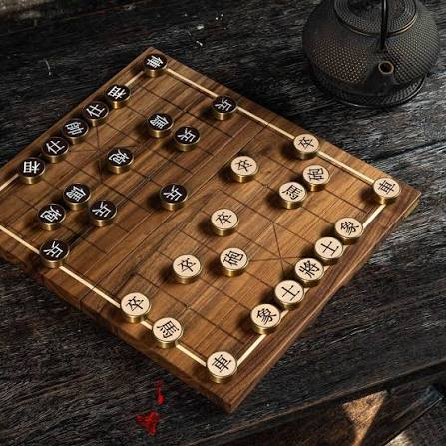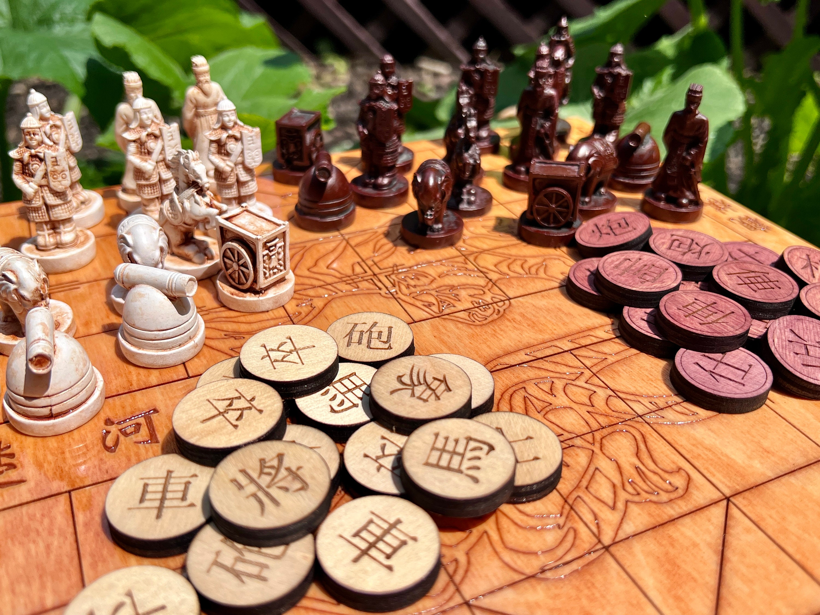

A detailed, self-contained learning resource for the whole project: what it is, why it exists, the game it plays, the AI concepts behind it, how every part of the code works, worked examples that trace real data through the system, what is done, and what remains. This is the long, teach-me-everything document. For a 1-minute overview see `README.md`; for the formal specs see `docs/`. How to read it: - *New to the whole thing?* Read §1 → §2 → §3 (Xiangqi) → §4 (AI concepts) top to bottom, then skim the rest. - *Know the game, want the code?* Jump to §7 (architecture) and §8 (every file). - *Preparing for the thesis defense?* §4, §9 (worked examples), §12 (experiments), and §15 (design decisions + rationale) are the meat.

Table of Contents
- What this project is (plain words)
- The research questions
- A Xiangqi primer — the game itself
- The AI concepts, explained from zero
- The four agents — what each is and what it tests
- Why we benchmark against ElephantEye + how Elo works
- System architecture (the layers)
- Project structure — every folder and file
- Worked examples (trace real data through the system)
- The data pipeline in depth
- The neural network in depth
- Training in depth
- Evaluation in depth
- The five experiments
- Key design decisions and why
- Testing & reproducibility
- Status: done vs. remaining
- The plan going forward
- Requirements & command cheat-sheet
- Glossary (plain language)
- FAQ
- "Where do I look for X?" index

1. What this project is
XiangqiMaster is a bachelor's-thesis research project (dual degree, UII × NXU) that studies how different deep-reinforcement-learning (RL) methods learn to play Xiangqi (Chinese Chess), and which method works best.
Xiangqi is one of the most-played board games on Earth (~600 million players), yet — unlike Go, Chess, and Shogi, which got AlphaGo/AlphaZero — nobody has published a systematic, apples-to-apples comparison of modern deep-RL methods on Xiangqi. This project fills that gap.
Concretely it builds four game-playing agents, each using a different approach, trains them, and measures each one's playing strength on a common scale (Elo) so they can be compared fairly. It also asks two deeper questions: does *learning from human games first* make an agent stronger/faster than *learning purely from self-play*? And does a self-taught agent *rediscover* classical Xiangqi opening theory?
In one sentence: *design, train, and scientifically compare four RL approaches to Xiangqi.*
Why it's a legitimate research contribution:
- No prior systematic comparison of PPO (Proximal Policy Optimization) / imitation-learning / MCTS+NN (Monte Carlo Tree Search + Neural Network)/
Minimax on Xiangqi under one standardized Elo framework.
- Imitation-learning transfer is unvalidated for Xiangqi — AlphaGo showed it
helps in Go, but Xiangqi has unique mechanics (the Cannon's jump-capture, the River, the Palace) that could behave differently.
- Emergent opening theory — whether self-play rediscovers openings like the
Central Cannon (当头炮) is genuinely open and interesting.

2. The research questions
Everything is organized to answer these (they map to experiments/):
# | Question | Experiment(s)
RQ1 | Does imitation learning (pre-train on humans) beat pure self-play, in final strength and convergence speed? | Exp 1, Exp 2
RQ2 | Which RL method is strongest for Xiangqi (PPO vs MCTS+NN vs Minimax)? | Exp 1
RQ3 | Does self-play rediscover classical opening theory? | Exp 3
RQ4 | Does a curriculum of stronger opponents beat plain self-play? How does MCTS strength trade off vs. its simulation count? | Exp 4, Exp 5

3. A Xiangqi primer
You cannot fully understand the code without understanding the game, because the environment (src/environment/) *is* the rules. Here is exactly what the code implements.

3.1 The board
- 10 rows × 9 columns = 90 intersections (pieces sit on line intersections, not
in squares). In code: BOARD_ROWS = 10, BOARD_COLS = 9.
- Coordinates are (row, col), 0-indexed. **Row 0 is Red's back rank at the
bottom; row 9 is Black's back rank at the top.** Column 0 is leftmost.
- The River runs between row 4 and row 5. Red's half is rows 0–4; Black's is
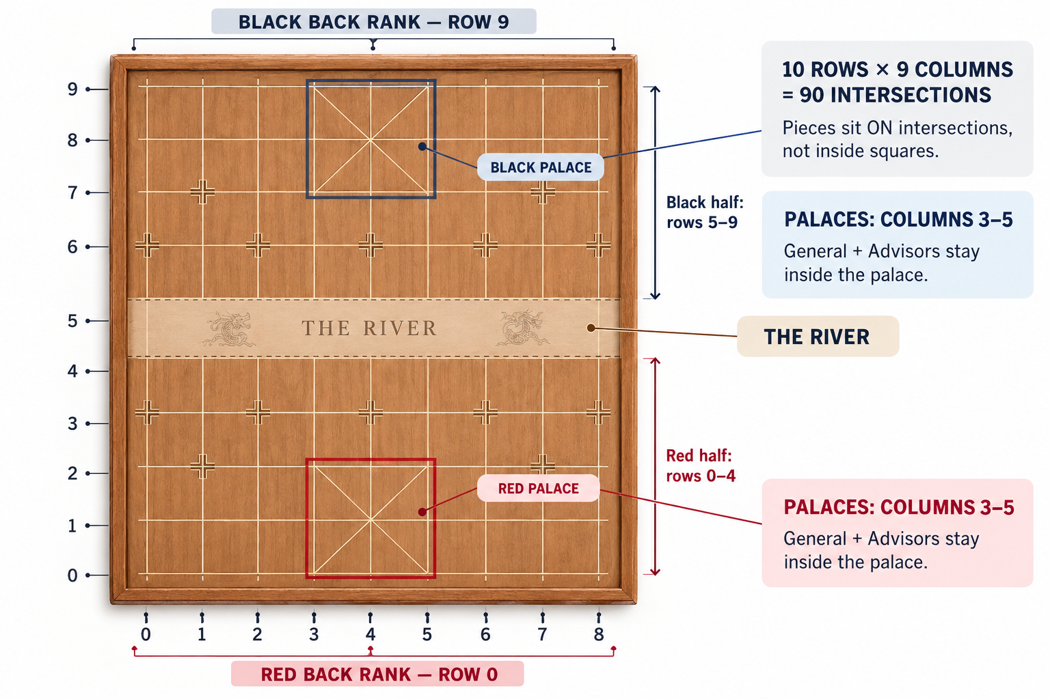

rows 5–9.
- The Palace is a 3×3 box (columns 3–5) on each side (Red rows 0–2, Black rows
7–9). The General and Advisors can never leave it.

3.2 The pieces and their exact movement rules
Each side has 16 pieces of 7 types. In code, a piece is a signed integer: Red = +type, Black = −type, empty = 0. The type codes (config.py) and values (used by the Minimax evaluation) are:
Piece | Code | Value | How it moves (as implemented in pieces.py)
General (将/帅)  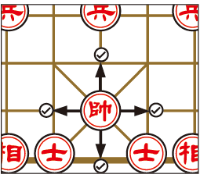 | 1 | 10000 | One orthogonal step, confined to the Palace. Plus the "flying general" rule (below).
Advisor (士/仕) / Shì    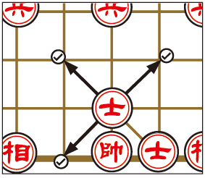 | 2 | 2 | One diagonal step, confined to the Palace.
Elephant (象/相) / Xiàng    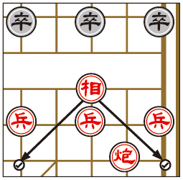 | 3 | 2 | Exactly two points diagonally; cannot cross the River; blocked if the midpoint ("eye", 塞象眼) is occupied.
Horse (马) / Mà / Mǎ    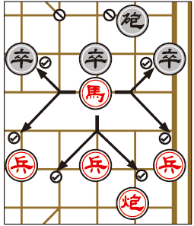 | 4 | 4 | L-shape (like a knight), but blocked at the "leg" (蹩马腿): the orthogonal point it steps through must be empty.
Chariot (车) / Jū    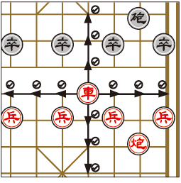 | 5 | 9 | Slides orthogonally any distance until it hits a piece; captures an enemy, blocked by a friend. (Like a chess rook — the strongest piece.)
Cannon (炮) / Pào    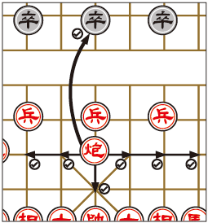 | 6 | 4.5 | Moves like a Chariot over empty points, but captures only by jumping exactly one "screen" piece and landing on an enemy beyond it.
Soldier (兵/卒) / Bīng / Zú    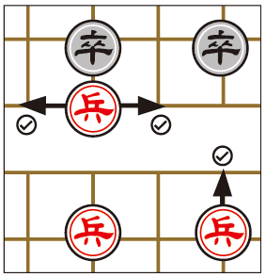 | 7 | 1 | One point forward only; after crossing the River it may also move sideways; never backward, never diagonal.

The general_moves, advisor_moves, … functions each return the *pseudo-legal* destinations for one piece (geometry only). "Pseudo-legal" = doesn't yet check whether the move leaves your own General in check; that filtering is done later.
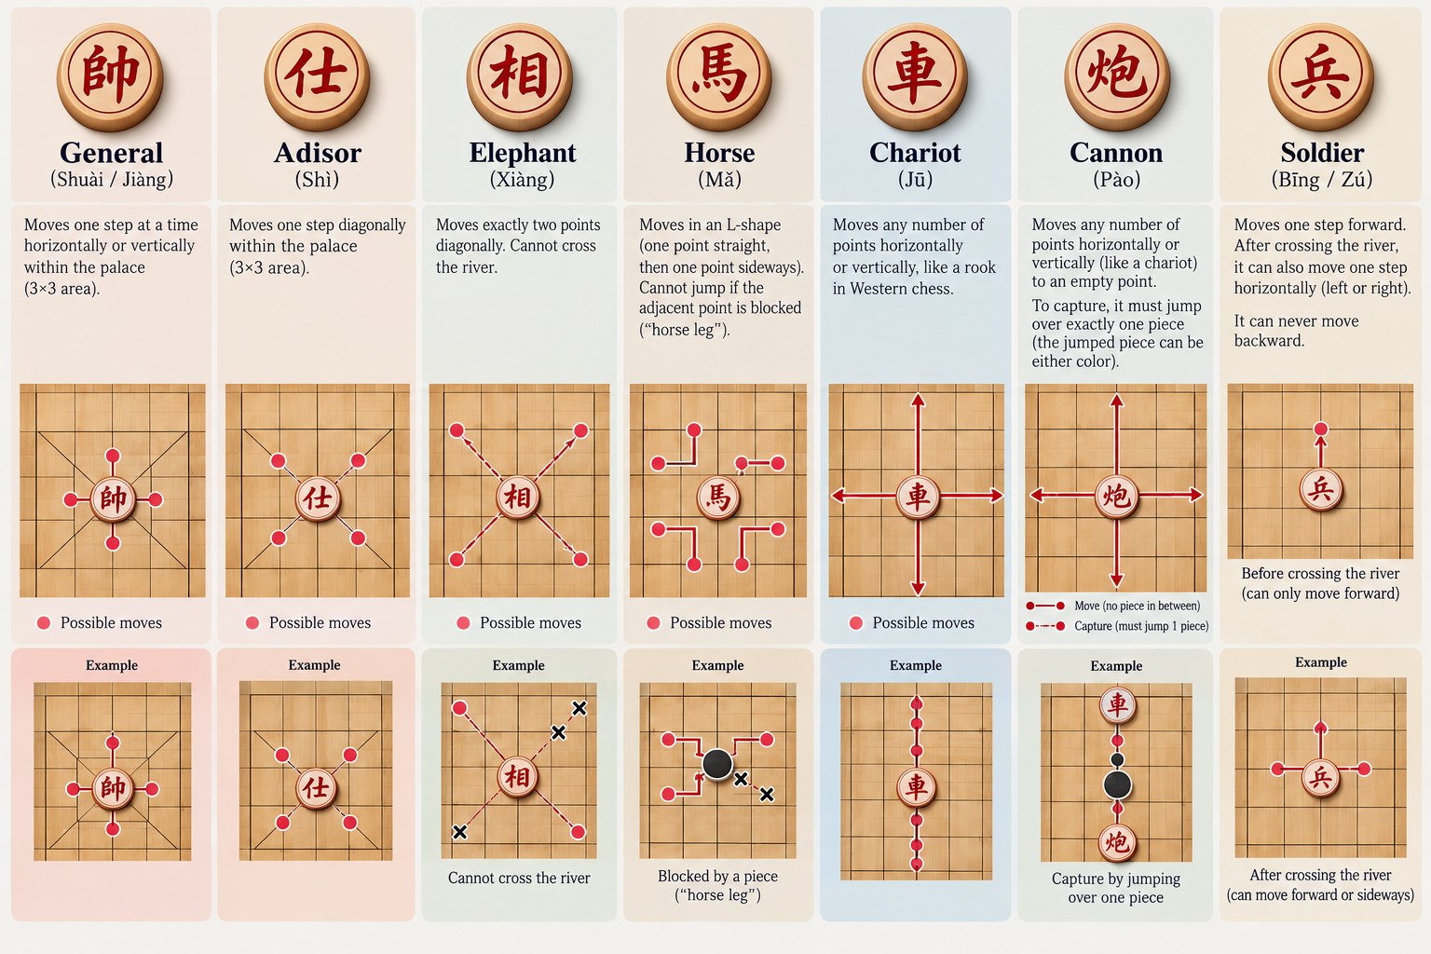

3.3 Special rules the code enforces (and where)
- Check (rules.is_in_check): your General is under attack if any enemy piece
can reach its point.
- Flying General / facing generals (rules.generals_face): the two Generals may
not face each other down an open file with nothing between them. This is treated as check, so any move creating it is illegal.
- Checkmate = loss, Stalemate = loss (rules.is_checkmate, is_stalemate):
This is the biggest difference from chess. In chess, stalemate (no legal move but not in check) is a draw; in Xiangqi it is a loss. So the referee only needs to ask "does the side to move have any legal move?" — if not, that side loses, whether it's checkmate or stalemate.
- Draws: threefold repetition (REPETITION_LIMIT = 3) or the move cap
(MAX_PLIES = 300). *(Note: real tournament "perpetual check/chase" rules are more nuanced; this project uses the simpler repetition + ply-cap draw model.)*
- Legal move generation (move_generator.generate_legal_moves): take all
pseudo-legal moves, and for each, play it on a *clone* and discard it if it leaves your own General in check. What survives is the legal move list — the single source of truth.

3.4 The starting position (what Board.reset() builds)
Standard opening setup, Red to move:
- Row 0 (Red back rank): Chariot, Horse, Elephant, Advisor, General, Advisor,
Elephant, Horse, Chariot. Row 9 mirrors it for Black.
- Cannons: row 2, columns 1 and 7 (Red); row 7 for Black.
- Soldiers: row 3, columns 0, 2, 4, 6, 8 (Red); row 6 for Black.
From this position there are exactly 44 legal moves for Red — a number the tests use as a correctness anchor.

4. The AI concepts, explained from zero
This section explains the ideas the four agents rely on. No prior RL knowledge assumed.

4.1 The game as a "Markov Decision Process" (MDP)
RL frames a game as: an agent observes a state, picks an action, and gets a reward and a new state. In our project:
- State = the board position (encoded as a tensor — see §11).
- Action = one of 2086 possible moves (an integer index).
- Reward = sparse and only at the end: +1 for winning, −1 for losing,
+0.1 for a draw; 0 on every non-terminal move. (Draws get a small positive value because draws are relatively rare in Xiangqi and better than losing.)
- Episode = one full game.
- Goal = learn a policy (a rule for choosing actions) that maximizes expected
reward — i.e., wins more.
A ply = one half-move (one side moving once). "300 plies" = 150 full moves each.

4.2 The neural network: a policy + a value in one
Instead of a lookup table (impossible — there are astronomically many positions), we use a neural network that *generalizes* from positions it has seen to ones it hasn't. Ours is a Policy-Value network with two outputs:
- Policy head → a score for each of the 2086 moves ("which moves look good?").
- Value head → one number in [−1, 1] ("am I winning from here?").
The same network is the shared "brain" used by imitation learning, PPO, and MCTS.
[AI] IMAGE PLACEHOLDER - AI-GENERATE
What to show: The Policy-Value neural network (shared body → two heads).
AI generation prompt: A clean, flat vector technical diagram on a plain white background showing a neural-network architecture read left to right. LEFT: a small stack of labeled input planes captioned '14 x 10 x 9 board tensor'. CENTER: a rounded rectangle labeled 'Input Conv (14 to 64)', followed by a vertical stack of N identical rounded rectangles labeled 'Residual Block x10' with a curved skip-connection arrow bypassing each block. RIGHT: the tower splits into TWO branches with arrows: the top branch is a box labeled 'Policy Head -> 2086 move logits'; the bottom branch is a box labeled 'Value Head -> scalar in [-1, 1] (tanh)'. Use a calm blue-and-grey palette, thin dark-grey arrows, rounded corners, generous white space, and clear sans-serif labels. Minimalist, textbook-quality, no photorealism, no clutter, no logos, spelling exactly as given. Landscape 16:9.
(Replace this box with the image.)

Details in §11.

4.3 Imitation Learning (IL) = "copy the experts" (supervised learning)
Show the network millions of positions from real human games and train it to:
- predict the move the human played (a classification problem → **cross-entropy
loss** on the policy head), and
- predict who eventually won (a regression problem → mean-squared-error loss
on the value head).
This is ordinary supervised learning — no game-playing during training, just "here's a position, here's the right answer." It gives the network a strong starting point (it already plays like a decent human) before any RL. This is the crux of RQ1.

4.4 PPO (Proximal Policy Optimization) = "learn by playing"
PPO is a policy-gradient RL algorithm. The agent plays games, and for each move it estimates an advantage (how much better that move turned out than expected). Moves with positive advantage are made more likely; negative, less likely. Key ideas, in plain terms:
- Advantage / GAE (Generalized Advantage Estimation): a smoothed estimate of "was
this move better than the value head predicted?" (PPO_GAE_LAMBDA = 0.95, PPO_GAMMA = 0.99 — the discount that makes near-term rewards matter more).
- Clipped surrogate objective: PPO's signature trick — it limits how far the
policy can change in one update (PPO_CLIP_RANGE = 0.2), which keeps training stable (no wild swings).
- Entropy bonus (PPO_ENT_COEF = 0.01): rewards keeping some randomness, so the
agent keeps exploring instead of prematurely committing to one plan.
- Value loss (PPO_VF_COEF = 0.5): trains the value head alongside the policy.
We use MaskablePPO (from sb3-contrib) so illegal moves are masked out before the
[SEARCH] IMAGE PLACEHOLDER - FIND ONLINE
What to show: The PPO / reinforcement-learning training loop (collect → estimate advantage → update policy).
Search keywords: PPO reinforcement learning loop diagram | policy gradient agent environment reward loop diagram | actor critic training cycle diagram
(Replace this box with the image.)

agent chooses — essential with 2086 candidate actions.

4.5 MCTS (Monte Carlo Tree Search) + network = "think ahead, guided by intuition"
Instead of trusting the policy in one shot, MCTS builds a search tree by running many simulations (MCTS_SIMULATIONS = 400). Each simulation:
- Selection — walk down the tree, at each node choosing the child with the best
PUCT score, which balances *"this move looked good so far"* (exploitation) against *"we haven't tried this much"* (exploration):
PUCT(child) = −Q(child) + c_puct · P(child) · √(ΣN) / (1 + N(child))
where Q = the child's average value (negated because it's from the opponent's view), P = the network's prior for that move, N = visit counts, and c_puct = 1.5 tunes the exploration strength.
- Expansion — at a new leaf, ask the network for priors over the legal moves and
create child nodes.
- Evaluation — use the network's value head to score the leaf (AlphaZero
replaced slow random rollouts with this).
- Backpropagation — send that value back up the path, **negating it at each
level** (what's good for me is bad for my opponent).
After all simulations, play the most-visited move (more robust than the raw
[SEARCH] IMAGE PLACEHOLDER - FIND ONLINE
What to show: The four phases of Monte Carlo Tree Search: Selection, Expansion, Evaluation, Backpropagation.
Search keywords: monte carlo tree search four phases diagram | MCTS selection expansion simulation backpropagation diagram | alphazero MCTS tree diagram
(Replace this box with the image.)

value). More simulations = stronger but slower — exactly what Experiment 5 measures.

4.6 Minimax = the classical, no-learning approach
Search the game tree assuming both sides play optimally, scoring leaf positions with a handcrafted material count. It doesn't learn; it's the baseline the learners must beat. Details in §5.

5. The four agents
All four implement the same interface — BaseAgent.select_move(board, legal_mask) -> action_index (src/agents/base_agent.py) — so the tournament and dashboard treat them identically. What differs is *how each chooses a move*.

Agent 4 — Minimax (classical baseline; no learning)
- File: src/agents/minimax_agent.py.
- Mechanism: alpha-beta game-tree search to depth MINIMAX_DEPTH = 4, in the
negamax formulation (_negamax) — one recursive routine that always scores from the side-to-move's view and negates for the opponent. Leaf positions are scored by material balance (_evaluate: sum of PIECE_VALUES, mine minus opponent's). Moves are ordered captures-first (_ordered_moves) so alpha-beta pruning (if alpha >= beta: break) skips large parts of the tree. A position with no legal move = a loss, scored near ±MATE_SCORE with a depth term so quicker mates are preferred.
- What it tests / why it exists: the reference floor — "how much better are
the learning agents than 30-year-old classical search?" It also doubles as an environment correctness test: if Minimax plays legal, sensible Xiangqi, move generation and rules are sound.

Agent 1 — PPO self-play (learns from scratch)
- Files: src/agents/ppo_agent.py (play-time wrapper), trained by
src/training/ppo_train.py on src/training/self_play_env.py.
- Mechanism: starts from random weights and improves by playing many games via
PPO (§4.4). SelfPlayEnv turns two-player Xiangqi into the single-agent env SB3 expects by baking the opponent in: on each step() the learner moves, the opponent immediately replies, and the returned observation is again the learner's turn. Reward is sparse, from the learner's perspective. Opponent starts as a RandomAgent (simplest bootstrap) and can be swapped for a frozen self-copy.
- What it tests: the "pure RL, no human knowledge" data point (AlphaZero
philosophy). Central to RQ1 and RQ2.

Agent 2 — Imitation Learning + PPO (learn from humans, then self-play)
- Files: Phase 1 (imitation) src/training/imitation.py +
src/training/il_train.py; the trained network plays via src/agents/neural_agent.py. Phase 2 (RL) reuses ppo_train.py.
- Mechanism — two phases:
- Phase 1 (Imitation): train the network on 141k human games to predict human
moves (cross-entropy) and outcomes (MSE). See §4.3.
- Phase 2 (PPO fine-tune): transfer that network's shared body into the PPO
features extractor (ppo_train.transfer_il_weights) and refine with self-play. (SB3's own policy/value heads start fresh; only the convolutional body transfers.)
- What it tests: the headline question (RQ1) — does human pre-training make
the agent stronger/faster than pure self-play? Never formally studied for Xiangqi.

Agent 3 — MCTS + Neural Network (AlphaZero-style; strongest, slowest)
- Files: src/agents/mcts.py (search core), src/agents/mcts_agent.py (wrapper).
- Mechanism: for each move, run MCTS_SIMULATIONS = 400 simulations of
network-guided PUCT search (§4.5) and play the most-visited move. Uses Board.clone() to explore without touching the real position.
- What it tests: the other modern paradigm (AlphaZero). Central to RQ2;
Experiment 5 studies strength vs. simulation count.
Also present: RandomAgent (random legal move — the simplest opponent/sanity baseline) and EngineAgent (wraps ElephantEye as a BaseAgent).

6. ElephantEye and Elo

6.1 Why benchmark against ElephantEye
The agents can play *each other* (round-robin), but that only ranks them relative to the group. To make an absolute claim, and a reproducible one, we benchmark against a fixed strong external opponent — ElephantEye:
- A — absolute measuring stick: one of the strongest open-source Xiangqi
engines, adjustable by search depth; beating it (and at what depth) is a real, absolute statement of strength.
- B — anchors the Elo scale: Elo is relative; playing a known-rating opponent
pins our agents onto a real scale ("≈1800 Elo") rather than "beat Agent 1."
- C — reproducibility (the academic reason): free, open-source, deterministic —
an examiner can download it and reproduce the numbers. A human or closed app could not be reproduced.
How it's wired: src/environment/elephanteye.py speaks UCCI (Universal *Chinese* Chess Interface) — *not* the UCI used by international-chess engines. It serializes the board to a Xiangqi FEN (board_to_fen), sends it to the engine subprocess, and reads the best move back (bestmove). src/agents/engine_agent.py wraps that as a BaseAgent, so the engine drops straight into the same tournament. Pikafish (stronger, modern) plugs in identically.

6.2 How Elo works (src/evaluation/elo.py)
Elo turns "win/lose/draw" records into a single skill number. A 400-point gap ⇒ the stronger player is expected to score ~10× as often.
- expected_score(a, b) = 1 / (1 + 10^((b−a)/400)) — predicted score of A vs B.
- Approach A (estimate_rating_from_score): invert the formula to rate an agent
from its score vs a known-rating opponent — rating = opp + 400·log10(s/(1−s)).
- Approach B (fit_ratings): given all round-robin results, iteratively fit a
consistent rating for every agent at once, recentred on an anchor.
- elo_confidence_interval(score, n_games): 95% CI half-width (delta method) —
roughly ±40–50 Elo at 400 games, which is *why* matches use ~400 games.
[SEARCH] IMAGE PLACEHOLDER - FIND ONLINE
What to show: The Elo expected-score logistic curve (score vs. rating difference).
Search keywords: elo rating expected score logistic curve | elo rating difference win probability graph | elo formula sigmoid curve
(Replace this box with the image.)

7. System architecture
Code is organized into dependency layers (`docs/02-ARCHITECTURE.md`). The rule: a layer may import from layers below, never above. This prevents circular dependencies and keeps each layer independently testable.
Layer 4 Applications experiments/ , dashboard/
Layer 3 Agents & Training src/agents/ , src/training/ , src/evaluation/
Layer 2 Learning src/models/ (network) , src/data/ (pipeline)
Layer 1 Core (foundation) src/environment/ (rules, board, encoder, action space)
Layer 0 Shared src/utils/ (config, seeding, checkpoint, logging, render)
Everything rests on Layer 1, the game engine. If it's correct, everything above can trust it — which is why the environment is the most heavily tested layer.
[AI] IMAGE PLACEHOLDER - AI-GENERATE
What to show: The four-layer software architecture stack.
AI generation prompt: A clean, flat vector diagram of a five-tier software architecture stack, drawn as five horizontal layers stacked vertically like a layer cake, each a full-width rounded rectangle, top to bottom in this exact order and text: (1) 'Layer 4 - Applications: experiments/, dashboard/'; (2) 'Layer 3 - Agents & Training: agents/, training/, evaluation/'; (3) 'Layer 2 - Learning: models/ (neural network), data/ (pipeline)'; (4) 'Layer 1 - Core: environment/ (rules, board, encoder, action space)'; (5) 'Layer 0 - Shared: utils/ (config, seeding, logging)'. Draw a downward arrow along the left side labeled 'depends on / imports from layers below only'. Use a soft gradient from light blue at the top to light green at the bottom, thin dark labels, rounded corners, plenty of white space, minimalist textbook style, no photorealism, no logos, spelling exactly as given. Portrait or square orientation.
(Replace this box with the image.)

A subtle but important detail: the encoder lives in environment/ (Layer 1), not data/, even though it "feels" like data code. Reason: the environment must emit observations, and the dependency rule forbids environment importing data. The data pipeline imports the *same* encoder, guaranteeing training data and self-play observations are byte-for-byte identical.

8. Project structure
Every folder and file, what it contains, and the key functions/logic.

src/environment/ — Layer 1: the game engine
- `board.py` — Board: a NumPy 10×9 grid of signed ints (sign = owner).
Methods: reset() (standard start), apply_move() (move a piece, capture the destination, flip side to move, return the captured code — *no legality check here*), clone() (independent deep copy — essential for search/legality tests), find_general(), pieces_of(color), position_key() (hashable snapshot for repetition detection: grid.tobytes() + side to move), to_ascii().
- `pieces.py` — one function per piece type (general_moves, advisor_moves,
elephant_moves, horse_moves, chariot_moves, cannon_moves, soldier_moves), dispatched by piece_moves(). Encodes the exact rules from §3.2 (horse leg-block, cannon screen, elephant eye + no river crossing, palace confinement, soldier forward/sideways). Returns pseudo-legal destinations.
- `move_generator.py` — generate_legal_moves(board, color): filters pseudo-legal
moves, discarding any that leave your own General in check (tries each on a clone). The single source of truth for legality.
- `rules.py` — the referee: is_in_check, is_checkmate, is_stalemate,
has_legal_moves, get_game_result, generals_face. Enforces stalemate-is-a-loss and the flying-general rule.
- `action_space.py` — the fixed 2086-move map. _build_moves() enumerates
every geometrically possible move (all straight-line moves per point + 8 horse jumps + the 16 fixed advisor diagonals + 32 fixed elephant diagonals) in the "cchess-zero" order; INDEX_TO_MOVE/MOVE_TO_INDEX are the lookup tables (built once, asserted == 2086). legal_mask(board) → boolean array of length 2086 marking legal indices — the mandatory mask.
- `encoder.py` — encode(board) → the 14×10×9 tensor (see §11.1), with the
player-relative convention (rotate 180° for Black so the mover always "moves upward"; _orient).
- `xiangqi_env.py` — XiangqiEnv, the Gymnasium env. step(action) validates
against the legal mask, applies the move, updates repetition/ply counters, and returns (obs, reward, terminated, truncated, info); info always carries legal_mask. clone() deep-copies (for MCTS).
- `elephanteye.py` — the UCCI engine interface: board_to_fen, move_to_ucci
/ ucci_to_move, and the ElephantEyeEngine subprocess driver (start, bestmove, close; usable as a context manager).

src/models/ — Layer 2: the neural network
- `blocks.py` — ConvBlock (Conv3×3→BN→ReLU; the 14→C input conv, padding keeps
10×9) and ResidualBlock (Conv→BN→ReLU→Conv→BN + skip → ReLU).
- `heads.py` — PolicyHead (Conv1×1→BN→ReLU→flatten→Linear → **2086 raw
logits) and `ValueHead` (Conv1×1→BN→ReLU→flatten→Linear→ReLU→Linear→tanh → scalar in [−1,1]**).
- `network.py` — PolicyValueNetwork: input conv → N residual blocks → two
heads. Defaults C=64, N=10 (~1.15M params). forward(x) → (logits, value).
- `sb3_extractor.py` — XiangqiResNetExtractor: the same body packaged as a
stable-baselines3 features extractor, so PPO learns on the same representation. This is what the IL body is transferred *into* for Agent 2 Phase 2.

src/data/ — Layer 2: the data pipeline
- `wxf_parser.py` — parses move notation to absolute moves and replays games.
parse_wxf_move (Roman WXF C2.5, with front/rear disambiguation), parse_iccs_move (coordinate notation, both UCCI h2e2 and xqbase-ICCS C3-C4), detect_notation (auto-pick), parse_game (replay + optional legality validation, raising on illegal moves). Game = a validated (moves, outcome) record.
- `pgn_adapter.py` — standard PGN text → (result, tokens) records
(split_pgn_games, parse_tags, extract_move_tokens — strips move numbers, comments, NAGs, results, and the ... placeholder — pgn_to_records, load_games_from_pgn).
- `game_loader.py` — parse_game_records (validate + length-filter a batch into
Games, tracking LoadStats), parse_result ("1-0"/"red"/"1/2-1/2" → RED/BLACK/DRAW).
- `dataset.py` — XiangqiILDataset (eager: all tensors in RAM; small data only)
and `LazyXiangqiILDataset` (encodes each position on access by replaying to that ply; O(games) memory via a prefix-sum bisect index). Both yield (tensor, action_index, value) and optionally add a left-right mirror (Xiangqi symmetry; mirror_move, mirror_board). _value_for = outcome from that ply's mover's view.
- `data_loader.py` — split_games (game-level train/val/test split, seeded —
never split by position or data leaks) and make_dataloader (torch DataLoader).
- `pipeline.py` — the orchestrator. build_dataset(): scan data/raw/
recursively (find_raw_files), parse everything (load_raw_records), length-filter, split by game, compute DatasetStats, and persist splits as JSONL (save_split_jsonl/load_split_jsonl) without materializing tensors. Because full validation of 141k games ≈ 22h, it defaults to *not* validating and instead spot-checks a random sample (spot_check_validity). CLI: python -m src.data.pipeline.

src/agents/ — Layer 3: the players
base_agent.py (ABC), minimax_agent.py, ppo_agent.py, neural_agent.py (plays a network's policy head greedily/sampled — used to evaluate the *raw* IL network before RL), mcts.py + mcts_agent.py, random_agent.py, engine_agent.py. All covered in §5.

src/training/ — Layer 3: the learning procedures
- `self_play_env.py` — SelfPlayEnv (two-player → single-agent for PPO; §5).
- `ppo_train.py` — build_model (wires the ResNet extractor + PPO
hyperparameters), transfer_il_weights (the IL→PPO body bridge), train(..., il_checkpoint=...), CLI main.
- `imitation.py` — run_epoch (policy CE + value MSE), evaluate (top-1 move
accuracy on val), train_imitation (loop with an on_epoch_end checkpoint callback + start_epoch for resume), save_checkpoint/load_network.
- `il_train.py` — the entry point for Agent 2 Phase 1: JSONL splits →
LazyXiangqiILDataset → DataLoaders → train_imitation → checkpoint. Writes a checkpoint every epoch and supports --resume (Colab disconnects). CLI main.
- `callbacks.py` — EloEvalCallback: measures the training policy's Elo vs a fixed
opponent every eval_freq steps and records (timesteps, elo) — the raw material for Experiment 2's learning curves.

src/evaluation/ — Layer 3: measuring strength
- `elo.py` — Elo math (§6.2).
- `metrics.py` — GameOutcome (one game from A's view) and MatchStats
(aggregate: score, win/draw/loss rates, decisiveness, avg length, win-rate as Red/Black); summarize().
- `tournament.py` — play_game (one game), play_match (N games, **alternating
colours** to cancel Red's first-move edge), estimate_elo (rate vs a known opponent), round_robin (everyone vs everyone).
- `opening_analysis.py` — RQ3 tools: opening_signature, build_distribution,
kl_divergence (compare an agent's opening distribution to the professional one — small KL = plays "book"), classify_opening (name Red's first move: central cannon, flying elephant, …), plus game collection helpers.

src/utils/ — Layer 0: shared helpers
config.py (all fixed constants and hyperparameter defaults — no magic numbers in logic), seeding.py (set_seed), checkpoint.py (generic save/load with optimizer + step + metadata), logging_utils.py (Logger for W&B/TensorBoard with graceful fallback + git_commit), render.py (board_to_plotly for the dashboard).

experiments/ — Layer 4: the five thesis experiments
exp1_main_comparison.py, exp2_training_efficiency.py, exp3_opening_theory.py, exp4_curriculum.py, exp5_mcts_ablation.py. Each runs one experiment and writes a CSV. Detailed in §14. (Coded + unit-tested; not yet run on trained agents.)

dashboard/ — Layer 4: the Streamlit web app
app.py + five pages (01_live_game, 02_elo_comparison, 03_learning_curves, 04_opening_analysis, 05_game_explorer) + reusable components/ (results I/O, game playback, agent pickers). Visualizes results and lets you watch agents play. Boots locally; public deployment planned.

docs/ — the formal specs
13 markdown documents (game rules, architecture, environment, data pipeline, neural network, agents, training, evaluation, experiments, dashboard, coding standards, glossary) + a master index. Authoritative design specs; this guide connects them.

notebooks/xiangqi_colab_training.ipynb
The Colab workflow: GPU check → clone/mount → install → download data → build splits → IL → PPO Phase 2 → PPO Agent 1, checkpointing to Google Drive.

tests/ — 221 tests, all passing
Mirrors src/ (test_environment, test_models, test_agents, test_data, test_training, test_evaluation, test_experiments, test_dashboard, test_utils). python -m pytest -q from the repo root. These are what let us trust the code before spending money on GPU training.

Root files
README.md, this PROJECT_GUIDE.md, requirements.txt / environment.yml, LICENSE (MIT), configs/ (per-experiment YAML), data/ (gitignored raw/splits; only dataset_manifest.json committed), results/ (checkpoints/outputs, gitignored).

9. Worked examples
These trace real data through the actual code, step by step.

9.1 Encoding the opening position into a tensor
encoder.encode(Board()) with Red to move produces a (14, 10, 9) float array:
- For Red's General at (0, 4): color == perspective (Red), piece_type = 1, so
base = 0, channel = 0. _orient leaves Red coordinates unchanged → set tensor[0, 0, 4] = 1.0.
- For Black's General at (9, 4): opponent, type 1 → base = 7, channel = 7.
(Perspective is Red, so no rotation.) → tensor[7, 9, 4] = 1.0.
- If it were Black to move, the board would be rotated 180° first, so Black's
pieces occupy channels 0–6 and sit at the bottom — the network always sees "me below, opponent above."

9.2 One move, end to end
- env.reset() → standard board, info["legal_mask"] has 44 True entries.
- An agent's select_move(board, mask) returns an action index, say the Central
Cannon C2.5 → (2, 7, 2, 4) → action_space.move_to_index(...).
- env.step(action): index_to_move decodes it, checks it's in the legal set
(raises if you forgot to mask), board.apply_move(2,7,2,4) moves the cannon and flips to Black, ply counter and repetition counter update.
- It then checks: does Black have a legal reply? Yes → reward = 0, game continues.
(If Black had none → reward = +1 for Red, terminated = True.)

9.3 One imitation-learning training step (run_epoch)
- A DataLoader batch = 512 triples (tensor[512,14,10,9], action[512], value[512])
from LazyXiangqiILDataset (each encoded on the fly by replaying its game to the right ply).
- logits, value_pred = network(tensors).
- Policy loss = CrossEntropy(logits, action) — push the network toward the
human's move. Value loss = MSE(value_pred, value) — push it toward the true outcome. loss = policy_loss + value_loss.
- loss.backward(); optimizer.step() (AdamW, lr 1e-3, weight decay 1e-4).
- After the epoch, evaluate() reports top-1 accuracy on validation (fraction of
positions where the network's top move == the human's). ~40–55% is expected and sufficient — the RL phase does the rest.

9.4 One MCTS simulation (_simulate)
Starting at the root (already expanded with priors):
- Select: _select_child picks the highest-PUCT child; board.apply_move(...)
descends; repeat until reaching a node with no children.
- Expand/Evaluate: generate_legal_moves at the leaf. If none → terminal, value
= −1. Else _evaluate runs the network → priors + a value; create children.
- Backpropagate: _backpropagate walks the path in reverse, adding the value and
negating it each step, incrementing visit counts. After 400 of these, visit_count_policy(root) gives visit counts; the agent plays the most-visited action.

9.5 One Elo estimate
Agent scores 0.65 over 400 games vs an opponent rated 1500:
- estimate_rating_from_score(1500, 0.65) = 1500 + 400·log10(0.65/0.35) ≈ **1500 +
107 = 1607 Elo**.
- elo_confidence_interval(0.65, 400) ≈ ±33 Elo → report "1607 ± 33".

10. The data pipeline in depth

10.1 The dataset
Source: CGLemon/chinese-chess-PGN (the source docs/04 anticipated) — two collections, both standard PGN in ICCS coordinate notation with illegal moves pre-filtered, hosted on Google Drive:
- World Xiangqi Federation: 41,743 games.
- DPXQ (东萍) archive: 99,813 games.
[AI] IMAGE PLACEHOLDER - AI-GENERATE
What to show: The end-to-end data pipeline (raw games → validated splits → training).
AI generation prompt: A clean, flat vector flowchart on a plain white background, left to right, with labeled rounded-rectangle stages connected by thin arrows, in this exact order: 'Raw human games (PGN, ICCS notation)' -> 'Parse & replay-validate' -> 'Filter by length' -> 'Game-level split 80/10/10' -> 'train / val / test JSONL' -> 'Lazy dataset (encode on the fly)' -> 'Imitation Learning' -> 'PPO fine-tune'. Below the 'train / val / test JSONL' stage, add a small callout box reading '141,356 games / 11.6M positions'. Calm blue-grey palette, rounded corners, thin arrows, clear sans-serif labels, generous spacing, minimalist textbook quality, no photorealism, no logos, spelling exactly as given. Wide landscape orientation.
(Replace this box with the image.)

10.2 Move notation (the same move, three ways)
The Red Central Cannon opening — cannon from column 7 to the central column 4, on row 2 — appears as:
- WXF (Roman): C2.5 (cannon on Red's file 2 traverses to file 5). Handled by
parse_wxf_move. Human-relative file numbering (Red counts files from the right), with front/rear (+/−) disambiguation for stacked pieces.
- UCCI: h2e2 (lowercase file letters a–i, no separator). Handled by
parse_iccs_move.
- xqbase ICCS: H2-E2 (uppercase + dash) — the dataset's format. Same parser
(normalized to lowercase, dash stripped).
All three decode to the absolute move (2, 7, 2, 4) and are verified equivalent.

10.3 What the pipeline does, and the real numbers
python -m src.data.pipeline --raw data/raw --out data/splits --notation iccs --spot-check 500 produced:
- 141,556 games seen → after filters, 141,356 kept (26 too short < 10 plies,
174 too long > 300 plies, 0 illegal).
- 11,624,921 training positions (one per ply).
- Outcome distribution Red / Black / Draw = 53,764 / 39,860 / 47,732 (Red's
first-move advantage is visible), avg game length 82.24 plies.
- Spot-check: 500/500 legal (100%) — the dataset is clean, which is why full
validation is safely skipped.
- Split: train 113,084 / val 14,135 / test 14,137 games (80/10/10, at
the game level).

10.4 Output files
data/splits/{train,val,test}.jsonl — one game per line as {"o": outcome, "m": [[fr,fc,tr,tc], …]} (moves, not raw tokens, so training needs no re-parsing). Plus dataset_manifest.json (the stats above + seed/fractions — the reproducibility record, and the only data file committed to git). The big JSONL files are gitignored (reproducible from raw + seed).

10.5 Why game-level split (not position-level)
If two positions from the *same* game landed in both train and test, the model could "memorize" that game and inflate its test accuracy — data leakage. Splitting whole games into disjoint sets prevents this. The split is seeded so it's identical every run.

11. The neural network in depth

11.1 The input: 14 planes of 10×9
encoder.encode builds 14 binary planes (each 10×9), from the mover's perspective:
- Channels 0–6: the current player's 7 piece types (General, Advisor, Elephant,
Horse, Chariot, Cannon, Soldier) — a 1.0 wherever such a piece sits.
- Channels 7–13: the opponent's 7 piece types.
- When Black is to move, the whole board is rotated 180° so "my pieces" are always at
the bottom moving up. No separate "side to move" plane is needed — it's baked into the my-vs-opponent split.
[AI] IMAGE PLACEHOLDER - AI-GENERATE
What to show: The 14-channel board encoding (7 planes for the mover, 7 for the opponent).
AI generation prompt: A clean, flat vector diagram showing a neural-network input encoding as a set of 14 stacked translucent grid planes drawn in isometric perspective, each plane a 10-row by 9-column grid. Group them into two labeled bundles: the front bundle of 7 planes labeled 'Current player: General, Advisor, Elephant, Horse, Chariot, Cannon, Soldier'; the back bundle of 7 planes labeled 'Opponent: same 7 piece types'. A few cells in the front planes are highlighted to suggest piece positions. Add a small caption '14 x 10 x 9, player-relative (board rotated 180 degrees for Black)'. Soft blue and grey tones, thin outlines, clean sans-serif labels, white background, minimalist technical-illustration style, no photorealism, no logos, spelling exactly as given. Landscape orientation.
(Replace this box with the image.)

11.2 The body: an AlphaZero-style ResNet
input conv (14→C) → N residual blocks (each: Conv→BN→ReLU→Conv→BN + skip → ReLU). The skip connections (ResidualBlock) let gradients flow through a deep stack without vanishing — the standard trick that makes deep nets trainable. Padding keeps the 10×9 board size throughout. Defaults C=64 width, N=10 blocks.
[SEARCH] IMAGE PLACEHOLDER - FIND ONLINE
What to show: A single ResNet residual block with its skip connection.
Search keywords: resnet residual block diagram skip connection | residual block conv batchnorm relu skip connection diagram
(Replace this box with the image.)

11.3 The two heads
- PolicyHead → 2086 raw logits (not probabilities). Logits are kept raw so the
agent can set illegal moves to −∞ *before* softmax — guaranteeing legality.
- ValueHead → one tanh scalar in [−1, 1] estimating the game outcome from the
mover's view (+1 winning, −1 losing).

11.4 How it's trained / used by each consumer
- Imitation: supervised — CE on the policy vs human moves, MSE on the value vs
outcomes.
- PPO: the body becomes the SB3 features extractor; PPO trains policy + value via
the clipped surrogate + value loss + entropy (§4.4).
- MCTS: the policy head gives priors P, the value head evaluates leaves.
One shared architecture across all three is what makes the IL→PPO transfer and the whole comparison coherent.

12. Training in depth

12.1 Imitation Learning (Agent 2 Phase 1)
- Entry: `python -m src.training.il_train --splits data/splits --epochs 30 --device
cuda --save results/checkpoints/il_agent2_phase1.pt (add --resume` to continue).
- Hyperparameters (config.py): lr 1e-3, 30 epochs, batch 512, AdamW, weight
decay 1e-4.
- Uses LazyXiangqiILDataset (can't fit 11.6M tensors in RAM). Data-loading cost ≈
20 min/epoch of encoding, negligible next to GPU compute. Checkpoints every epoch to survive Colab disconnects. Success metric: val top-1 accuracy ~40–55%. Estimated ~6–8 h for 30 epochs on a Colab T4.

12.2 PPO self-play (Agent 1, and Agent 2 Phase 2)
- Agent 1 (random init): `python -m src.training.ppo_train --timesteps 500000 --save
results/checkpoints/ppo_agent1`.
- Agent 2 Phase 2 (IL-initialized): add `--il-checkpoint results/checkpoints/
il_agent2_phase1.pt — transfer_il_weights` copies the IL body into the extractor.
- Hyperparameters (config.py): lr 3e-4, n_steps 2048, batch 512, 4 epochs
per update, clip 0.2, γ 0.99, GAE-λ 0.95, entropy 0.01, value coef 0.5, grad clip 0.5, features dim 256. Estimated ~15–20 h for 500k steps.

12.3 MCTS self-play (Agent 3)
- The search core and agent exist; a dedicated self-play *training loop* (like
il_train/ppo_train) is not yet finalized — the most compute-heavy piece and the first fallback candidate if time runs short.

12.4 Checkpointing philosophy
Colab disconnects, so training must be resumable. IL checkpoints every epoch to Google Drive; --resume reloads the latest weights. PPO uses SB3's .zip save/load. This is why the notebook writes to Drive, not Colab's ephemeral disk.

13. Evaluation in depth

13.1 Playing a match (tournament.play_match)
N games between two agents, alternating which colour agent A plays each game, to cancel Red's first-move advantage. Each game → a GameOutcome (WIN/LOSS/DRAW from A's view + plies + A's colour). summarize() aggregates to MatchStats (score, win/draw/ loss rates, decisiveness, avg length, win-rate as Red vs as Black).

13.2 Two ways to get Elo
- vs a known opponent (estimate_elo): play a match vs e.g. ElephantEye, invert
the score to a rating + CI. Absolute.
- round-robin + fit (round_robin → elo.fit_ratings): everyone plays everyone;
fit consistent ratings for all agents at once. Relative unless anchored by including a known-rating engine.

13.3 Statistical honesty
Every rating comes with a 95% confidence interval; ~400 games/matchup targets ±40–50 Elo, so the thesis can state differences that are actually significant.

14. The five experiments
Each is a script in experiments/ that runs the analysis and writes a CSV.
- Exp 1 — Main comparison (exp1_main_comparison.py, run_exp1): colour-balanced
round-robin among all agents → fit_ratings → `exp1_elo.csv` (fitted Elo + CI + score + games) and `exp1_head_to_head.csv` (win-rate matrix). Answers RQ2 (and RQ1 once IL and pure-RL agents are both in). Engine anchoring plugs in by adding ElephantEye to the agents dict.
- Exp 2 — Training efficiency (exp2_training_efficiency.py, run_exp2): **the
thesis's central experiment. Trains two PPO agents — `scratch` (random init) and `il_init` (IL body transferred) — while an `EloEvalCallback` records Elo vs a fixed opponent over training. → exp2_learning_curves.csv (variant, timesteps, elo). Answers RQ1**: does IL start higher and reach a given Elo in fewer steps?
[AI] IMAGE PLACEHOLDER - AI-GENERATE
What to show: ILLUSTRATIVE MOCK-UP of the Experiment 2 learning curves (not real data yet).
AI generation prompt: A clean, flat vector line chart (illustrative mock-up, not real data) on a white background. X-axis labeled 'Training steps' (0 to 500k), Y-axis labeled 'Elo rating' (roughly 800 to 2000). Draw TWO smooth rising curves that both start low and plateau high: an orange curve labeled 'IL-initialized (Agent 2)' that starts clearly HIGHER and rises FASTER, and a blue curve labeled 'From scratch (Agent 1)' that starts near the bottom and rises more slowly, ending slightly lower. Include a legend, light gridlines, and a small watermark-style note 'Illustrative - awaiting training results'. Minimalist, clean sans-serif labels, no photorealism, no logos, spelling exactly as given. Landscape 16:9.
(Replace this box with the image.)

- Exp 3 — Opening theory (exp3_opening_theory.py, run_exp3): for each agent,
play games, collect opening signatures (first n_plies), build a distribution, and compute KL divergence vs a professional reference (small KL = plays "book"). Also classifies Red's first move (central cannon, flying elephant, …). → `exp3_openings.csv`. Answers RQ3.
- Exp 4 — Curriculum vs self-play (exp4_curriculum.py, run_exp4): train PPO
against progressively stronger opponents (Minimax at increasing depth, or ElephantEye at increasing depth), advancing a stage once a win-rate threshold (0.6) is met. → `exp4_curriculum.csv` (stage, opponent, timesteps, win_rate). Compare final Elo/efficiency to plain self-play. Answers RQ4.
- Exp 5 — MCTS ablation (exp5_mcts_ablation.py, run_exp5): run an MCTS agent at
several simulation counts (e.g. 100/400/800/1600) vs a fixed opponent, recording score/Elo and average thinking time per move (a _TimedAgent wrapper). → `exp5_mcts_ablation.csv`. Reveals the strength-vs-speed sweet spot. Answers the MCTS part of RQ4.

15. Key design decisions
Each major decision and the reason:
- Custom environment instead of `gym-xiangqi`. The existing package is on the
*legacy* Gym API and didn't fit our action-masking/dependency needs; a clean Gymnasium env we control also serves as a thesis artifact.
- Player-relative 14×10×9 encoding (rotate for Black). One network plays both
colours ("me at bottom vs. opponent at top"), halving what must be learned.
- Fixed 2086-move action space + mandatory legal mask. A policy head needs a fixed
output size; masking illegal moves to −∞ before softmax means an agent can never play illegal — solving the proposal's #2 risk via MaskablePPO + legal_mask.
- One shared Policy-Value network for all learning agents. Enables the IL→PPO
transfer and makes the comparison coherent.
- Stalemate = loss, flying-general illegal. Real Xiangqi rules that differ from
chess; getting them wrong would silently corrupt everything. Enforced in rules.py, covered by tests.
- Negamax + captures-first ordering (Minimax). One clean recursive routine; move
ordering makes alpha-beta pruning far more effective.
- AlphaZero-style value evaluation (no random rollouts) in MCTS. The value head
replaces slow simulations — faster and stronger.
- Lazy dataset + skip full validation for the big corpus. 141k games ≈ 11.6M
positions; materializing tensors needs tens of GB and full validation ≈ 22h. So: persist JSONL, encode on the fly, spot-check legality.
- Game-level split, seeded. Prevents data leakage; reproducible.
- Checkpoint every epoch + resume. Colab disconnects; per-epoch Drive checkpoints
make training survivable.
- Colour-balanced matches + confidence intervals. Red moves first (an edge), so
matches alternate colours; every Elo comes with a CI for honest claims.
- ElephantEye via UCCI, wrapped as a BaseAgent. Reproducible absolute-Elo anchor
that reuses the same tournament code.
- All constants in `config.py`. No magic numbers scattered through logic.

16. Testing & reproducibility
- 221 automated tests (tests/, mirroring src/) cover: rule correctness (e.g.
the opening has exactly 44 legal moves; stalemate is a loss; horse-leg/cannon-screen behavior), the action-space round-trip (2086, no duplicates), encoder shape, parser/pipeline (WXF/ICCS, replay validation, split reproducibility), datasets (lazy == eager), network shapes, each agent plays only legal moves, Elo math, tournament, and every experiment on tiny synthetic data. Run: python -m pytest -q.
- Reproducibility: set_seed() seeds Python/NumPy/torch; the split is seeded and
recorded in dataset_manifest.json; logging_utils.git_commit() can stamp runs with the code version. Re-running the pipeline on the same raw files + seed yields the identical split.
- Why so many tests before training? GPU training is slow and costs money; a bug
in the environment or encoder would waste hours and corrupt results. The tests let us trust Layer 1–2 completely before spending on Layer 3–4.

17. Status
The key distinction: all the CODE is built and tested (221 tests green), but no agent has been TRAINED yet.

✅ Done (code & foundation)
- Full game engine (board, pieces, move generation, rules) — Layer 1.
- Encoder + 2086-move action space + legal masking; Gymnasium env + self-play wrapper.
- Policy-Value network (ResNet body + heads) + SB3 extractor.
- All four agents (Minimax, PPO, IL/Neural, MCTS) + Random + Engine wrapper.
- Evaluation stack: Elo, metrics, tournament/round-robin, opening analysis.
- Data pipeline + a real 141k-game dataset built and split (train 113,084 / val
14,135 / test 14,137; ~11.6M positions; spot-checked 100% legal). Manifest committed.
- Lazy dataset + IL training entry point + IL→PPO transfer + per-epoch checkpoint/resume.
- All 5 experiment scripts (coded + unit-tested).
- Streamlit dashboard (boots locally); Colab notebook; public repo with README + this guide.

⏳ Not done (the execution phase — needs a GPU)
- Training runs: IL (Agent 2 P1), PPO fine-tune (Agent 2 P2), PPO self-play (Agent
1), MCTS (Agent 3) — none trained yet.
- ElephantEye binary: interface exists; engine must be compiled for absolute Elo.
- MCTS training script: search + agent exist; a dedicated self-play training entry
point is not finalized.
- Experiment results: scripts exist but haven't run on trained agents — no Elo
tables / curves / opening analyses yet.
- Thesis document: proposal done; the 5-chapter thesis is not written.

Timeline mapping (proposal's 6 phases)
Phase 1 (Foundation) ✅ complete · Phases 2–3 (train agents) ← you are here (code ready, not run) · Phase 4 (experiments + dashboard) → dashboard ✅, experiments await agents · Phases 5–6 (writing + revision) → not started.

18. The plan
Critical path (mostly *running* things, not coding):
- Train Agent 2 IL (Phase 1) on Colab (~6–8 h), checkpoint to Drive.
- Train Agent 2 PPO fine-tune (Phase 2) from that checkpoint.
- Train Agent 1 PPO from scratch (~15–20 h, split across sessions).
- Train Agent 3 MCTS (heaviest; de-scope per fallback if too slow).
- Compile ElephantEye, wire EngineAgent for absolute Elo.
- Run Experiments 1–5 → Elo tables, learning curves, opening analysis.
- Write the thesis using those results; deploy the dashboard.
Fallback plan (from the proposal), if compute/time runs short: drop Agent 3 → drop Agent 2 → fine-tune an existing net → minimum viable thesis (one PPO agent + Minimax + Elo vs ElephantEye). The non-negotiable core: *one RL agent + one baseline + standardized Elo evaluation.*

19. Requirements & commands
Requirements
- Python 3.10+ (conda env create -f environment.yml or `pip install -r
requirements.txt`).
- Core: PyTorch, gymnasium, stable-baselines3 + sb3-contrib, NumPy, pandas. Optional:
wandb/TensorBoard (logging degrades gracefully), Streamlit + Plotly (dashboard).
- A GPU for training (practically, Google Colab). CPU is fine for code, tests, and
building the dataset.
- Raw game files in data/raw/; ElephantEye/Pikafish binary optional (absolute Elo).
Command cheat-sheet
# Run the whole test suite
python -m pytest -q
# Build dataset splits from raw games in data/raw/
python -m src.data.pipeline --raw data/raw --out data/splits --notation iccs --spot-check 500
# Agent 2 Phase 1 — imitation learning (GPU); --resume to continue after a disconnect
python -m src.training.il_train --splits data/splits --epochs 30 --device cuda \
--save results/checkpoints/il_agent2_phase1.pt
# Agent 2 Phase 2 — PPO fine-tune from the IL checkpoint
python -m src.training.ppo_train --timesteps 500000 \
--il-checkpoint results/checkpoints/il_agent2_phase1.pt --save results/checkpoints/ppo_agent2
# Agent 1 — PPO self-play from scratch
python -m src.training.ppo_train --timesteps 500000 --save results/checkpoints/ppo_agent1
# Launch the dashboard
streamlit run dashboard/app.py
# Quick local IL smoke test (cap games, 1 epoch)
python -m src.training.il_train --limit-train 2000 --limit-val 500 --epochs 1

20. Glossary
- Action / action index — a move, encoded as an integer in [0, 2086).
- Action masking — forcing illegal moves to be unselectable (logits → −∞).
- AdamW — the optimizer used for imitation learning (Adam + weight decay).
- AlphaZero — DeepMind's algorithm: one network + MCTS, trained purely by
self-play; the model for Agent 3.
- Advantage — how much better an action turned out than the value head expected;
what PPO's updates are proportional to.
- Alpha-beta pruning — skipping game-tree branches that can't change the result;
makes Minimax feasible.
- BatchNorm — a layer that normalizes activations to stabilize/speed up training.
- cchess-zero label scheme — the standard ordering of the 2086 moves we follow, for
compatibility with other Xiangqi AlphaZero code.
- Checkpoint — saved model weights, so training can resume / the model can be
reused.
- CI (confidence interval) — the ± range on an Elo estimate (95%).
- Convolution (Conv2D) — a neural layer that scans local patterns over the board;
the backbone of the network.
- Cross-entropy — the loss for "predict the right class" (here, the human's move).
- Elo — a relative skill rating; 400 points ≈ 10× expected-score ratio.
- Episode — one full game.
- FEN — a compact text string describing a board position (used to talk to the
engine).
- GAE (Generalized Advantage Estimation) — a smoothed advantage estimate used by
PPO.
- Gymnasium — the standard RL environment interface (reset/step) our env
implements.
- ICCS / UCCI / WXF — three Xiangqi move notations (see §10.2); UCCI is also the
engine protocol.
- Imitation Learning (IL) — supervised pre-training from human games.
- KL divergence — a measure of how different two probability distributions are;
used to compare opening styles.
- Logits — raw, unnormalized network scores (before softmax).
- MaskablePPO — PPO variant (sb3-contrib) that supports action masking.
- MCTS — Monte Carlo Tree Search; look-ahead search guided by the network.
- MDP (Markov Decision Process) — the state/action/reward framing of the game.
- Minimax / negamax — classical adversarial search; negamax is its one-function
form.
- PGN — a standard text format for recording games.
- Ply — one half-move (one side moving once).
- Policy — the rule for choosing moves (here, the policy head's distribution).
- Policy-Value network — one network with a move-scoring head and a
position-scoring head.
- PPO (Proximal Policy Optimization) — the RL algorithm for Agents 1 & 2 Phase 2.
- PUCT — the formula MCTS uses to balance exploration vs. exploitation.
- Pseudo-legal move — a geometrically valid move, before checking self-check.
- Replay validation — replaying a recorded game move-by-move to confirm every move
is legal.
- Residual block / skip connection — the ResNet unit that makes deep nets
trainable.
- Reward — the +1/−1/+0.1 signal an agent maximizes.
- Round-robin — a tournament where everyone plays everyone.
- Self-play — an agent improving by playing against itself (or a copy).
- Softmax — turns logits into a probability distribution.
- Tanh — squashes the value head's output into [−1, 1].
- Tensor — a multi-dimensional array (here the 14×10×9 board representation).
- Top-1 accuracy — fraction of positions where the network's #1 move matches the
human's; the IL success metric.
- Value — the network's estimate of the outcome from the current position.

21. FAQ
Q: Why not just use one strong engine instead of training four agents? A: The research question isn't "make the strongest Xiangqi bot," it's "compare how different learning methods perform on Xiangqi." The four agents *are* the experiment.
Q: Why is stalemate a loss here? Isn't that a bug? A: No — it's a real Xiangqi rule (unlike chess). It's deliberately enforced in rules.py and tested.
Q: 2086 moves — where does that number come from? A: It's every *geometrically possible* move on the board (all straight-line moves, all horse jumps, and the fixed advisor/elephant diagonals), following the standard "cchess-zero" enumeration. Most aren't legal in a given position — that's what the legal mask handles.
Q: Why does the network see the board "rotated" for Black? A: So one network can play both sides. It always sees "me at the bottom moving up," so it never has to learn two mirror-image strategies.
Q: Why can't I train on my laptop? A: The code and dataset build fine on CPU, but training touches ~11.6M positions per epoch (IL) or hundreds of thousands of self-play steps (PPO) — that needs a GPU (Colab). CPU would take days per epoch.
Q: Is the 141k-game dataset in the repo? A: No — the raw files and the big JSONL splits are gitignored (they're large and reproducible). Only the tiny dataset_manifest.json (the stats record) is committed.
Q: What happens if MCTS is too slow to train in time? A: The fallback plan drops Agent 3 (and Experiments 4–5) — the three-agent comparison is still a complete, publishable contribution (§18).
Q: How do I know the environment is correct if nothing's trained? A: 221 tests, plus the Minimax agent playing legal, sensible games, plus the dataset's 141,356 human games all replaying legally (0 illegal in the spot-check) — three independent confirmations that the rules and move generation are right.

22. Where do I look for X?
I want to… | Look at
Understand the rules of Xiangqi | §3, src/environment/pieces.py, rules.py, docs/01-GAME-RULES.md
See how a position becomes a tensor | §11.1, src/environment/encoder.py
Understand the move numbering (2086) | §8 (action_space), src/environment/action_space.py
Change a hyperparameter | src/utils/config.py
Build the dataset | §10, src/data/pipeline.py
Train imitation learning | §12.1, src/training/il_train.py
Train / fine-tune PPO | §12.2, src/training/ppo_train.py
Understand MCTS | §4.5, §9.4, src/agents/mcts.py
Measure strength / Elo | §6.2, §13, src/evaluation/
Run an experiment | §14, experiments/
Talk to the ElephantEye engine | §6.1, src/environment/elephanteye.py
See results visually | dashboard/, streamlit run dashboard/app.py
Trust the code | tests/, python -m pytest -q

*This guide reflects the codebase as implemented. For authoritative per-topic detail see `docs/`; for the current build state, see the commit history.*

