Escuela Particular Mixta Justo Rufino Barrios

Evaluación de PÁRVULOS

**Name:**__________________________________________

**Date____/____/____ Teacher’s name____________________________**

I SERIES . 20 POINTS

Listen to the instructions and do as follow.

Paint with RED color “THE OCTOPUS”

Paint with YELLOW color “THE SEAHORSE”

Paint with GREEN color “THE STARFISH”

Paint with BLUE color “THE TURTLE”

Paint with BROWN color “THE HAMMERHEAD SHARK ”

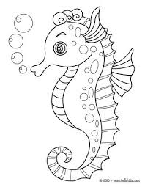 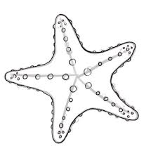

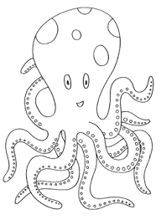 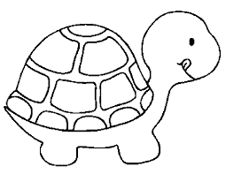

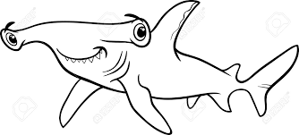

II SERIES. 10 POINTS

Circle the right Word:

1. Which one is “AVOCADO”?

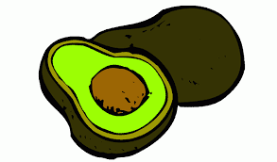 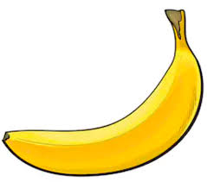

1. Which one is “PINEAPPLE”?

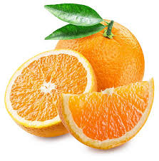 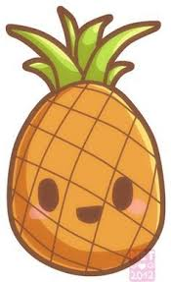

1. Which one is “STRAWBERRY”?

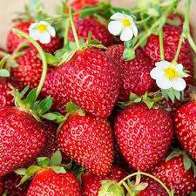 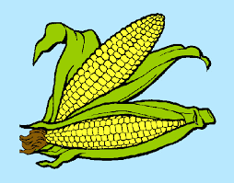

SERIE III 20 POINTS:

Listen and do as follow

Circle the image representing the EYES

Mark with an “ X” the image representig the NOSE

Paint with yellow color the image representig the MOUTH

Paint with the color red the imagen representing the EARS

Mark with a line the image representing the HANDS

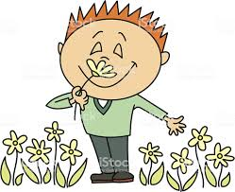 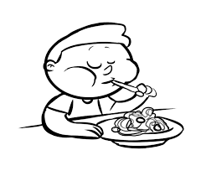 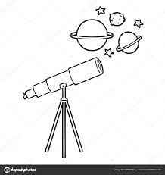 

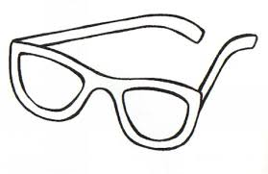  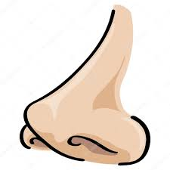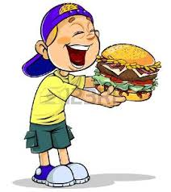

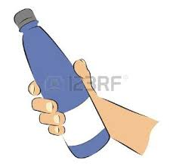 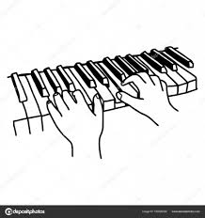

Escuela Particular Mixta Justo Rufino Barrios

Evaluación de PREPA

**Name:**__________________________________________

**Date____/____/____ Teacher’s name____________________________**

I SERIES 25 POINTS

Match with a line the Word with their corresponding name.

BEE 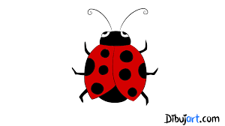

BUTTERFLY 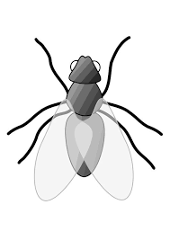

FLY 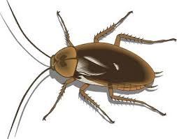

COCKROACH 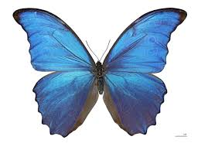

LADYBUG 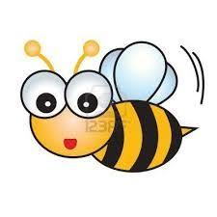

SERIE II: 15 POINTS

Complete with the missing letter the word as follow

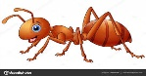 AN_

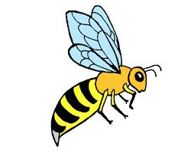W_SP

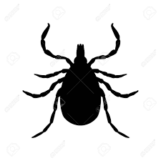_ICK

*SERIE III: 10 POINTS*

Look at the picture, read and write (T) for true or (F) for false

IS THIS FRUIT AN ORANGE?  ( )

IS THIS INSECT AN ANT? 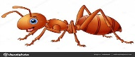 ( )

IS THIS INSECT A BUTTERFLY?  ( )

IS THIS FRUIT A APPLE? 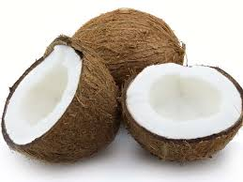 ( )

IS THIS INSECT A TICK?  ( )