Software Requirements Specification

for

<SMART ONLINE GROCERY STORE>

Version 1.0 approved

Prepared by <Almas Nasir>

**<COMSATS INSTITUTE OF INFORMATION TECHNOLOGY>**

<9-11-2019>

Contents

1.1 Purpose 2

1.2 Document Conventions 3

1.3 Intended Audience and Reading Suggestions 3

1.4 Product Scope 3

1.5 References 3

2. Overall Description 4

2.1 Product Perspective 4

2.2 Product Functions 4

2.3 User Documentation 4

2.4 Constraints, Assumptions and Dependencies 5

Software Requirement Specification 5

3.1 *Functional Requirements* 5

3.1.1 Login 5

3.1.2 Registration 5

3.1.3 Social media login 6

3.1.4 Authentication 6

3.1.5 Complete Catalogue 6

3.1.6 Featured Products 6

3.1.7 Cart 6

3.1.9 Cancelling Order 6

3.1.10 Collaborative Filtering 6

3.1.11 Search bar 6

3.1.12 Admin Accounts 6

3.1.12 Product Management 7

3.1.14 Activity Log 7

3.1.15 Purchased History 7

3.1.16 Navigation Bar 7

3.2 Non-Functional Requirement 7

3.2.3 Availability 7

4 Project Design 8

4.1 Methodology 8

4.1.1 Agile Methodology 8

*4.2 Architecture Overview* 9

9

4.3 *Design Description* 10

**1.Introduction:**

Many people around the world prefer to shop online and buy products from several companies that they cannot find or are not available for purchase in their cities. Our project intends to create a website for online shopping store that is Smart Online Grocery Store. The purpose of this website is to offer a platform for people to get rid of time-consuming market analysis. It is now playing a very important role in everybody’s especially elderly people, as well as people with a very busy life schedule. It provides a very comfortable service for its customers, by being able to save the item in the personal shopping bag, and but it later on. Online shopping is the mechanism using which a customer can buy goods and services using electronic means of communications. Internet is used by customer to place order online without physically moving to a store. In such way they captured market available on internet. Consumers feel comfort with just placing an order while sitting in front of computer screen at their homes. Rather than getting stuck in traffic and going to markets shoppers like to visit web stores with more comfort.

If a person goes for shopping, first he/she has to leave his home or office. Then he needs a convince for travelling to market. On road he must face traffic. Chances of some accident also occur there. Traffic signals and noise pollution irritate him badly. After reaching the market he/she has to find a parking for vehicle. After parking vehicle then he/she has to face crowd in the market. Most of time people like to just buy a thing immediately due to noise in market. After purchasing a product customer pay bill and parking charges and the again must face traffic, signal and risks. After wasting a lot of time someone may leave with a single packet of oil. So why not to eliminate all these factors?

Online shopping allows customer to shop while staying at home. One can visit multiple sites and can compares rates of same product in very short time. No need to carry a shopping bag with you. No need exhale carbon dioxides on road. No need to get stuck in traffic. No need to getting tired of driving. Just search and click. You can find your appropriate product order it. Beside convenience and effortless way, online shopping is not depicted by some people because while purchasing something online they cannot touch the object they want to purchase. They want to check physical structure of products. In Pakistan this problem is common. People are afraid of online stores and they think it is something like fraud. They also criticize that quality of products available on web stores is not so good. But now it’s time to change the trend and we should say bye to physical shopping. And meet the modern world where trend is shop online.

## Purpose

In Pakistan Market is rapidly moving towards online business. In Pakistan, we have not such system that recommend new item of interest. To make shopping easier and more interesting some new features are demanded. It was noticed that customer needs to find their favorite products instantly ad easily. To engage and interact customer’s recommendation system are needed. On the other hand, many websites are already working in Pakistan. To make shopping easier and more interesting some new features were demanded. Customers mostly have demanded some new and interesting features. To engage and interact customers recommendations is very important in online system.

## Document Conventions

It was noticed that customer needs to find their favorite products instantly and easily. To engage and interact customer’s recommendation system are needed. To engage and interact customers recommendations is very important in online system.

## Intended Audience and Reading Suggestions

Developer must read objectives of the system for making another system like this. Customer read its purpose why they use this system. All customer or people those are interested in online shopping can use this system.

## Product Scope

Smart Store is accessible from any part of the world. People interested in shopping will find their desired products. People belong to any community and can use internet with basic knowledge can easily use this application. Store customers will use it for buying products.

* User Friendly Interfaces
* Customer and Admin panel
* Complete Product Catalogue
* Recommendation Systems
* Cart
* Order
* Order History
* Product Management
* Activity Log

## References

This data is collected using different websites, documents and Book (Software Engineering).

IEEE Std 830-1998: IEEE Recommended Practice for Software Requirements Specifications.

<http://user.ceng.metu.edu.tr/~e1560549/documents/SRS.pdf>

# Overall Description

## Product Perspective

In Pakistan Market is rapidly moving towards online business. In Pakistan, we have not such system that recommend new item of interest. To make shopping easier and more interesting some new features are demanded. It was noticed that customer needs to find their favorite products instantly and easily. To engage and interact customer’s recommendation system are needed. On the other hand, many websites are already working in Pakistan. To make shopping easier and more interesting some new features were demanded. Customers mostly have demanded some new and interesting features. To engage and interact customers recommendations is very important in online system.

“The SOGS Store”, which comprises online shopping, Featured items. Different methods for getting registered are provided for ease of users. Authenticated users can only get logged-in. Customer can maintain their cart. They also can place order for products existing in their cart. Customer can see his previous orders and can cancel their order before confirmation stage. Complete order history is also available for customers. Simple front end is selected for ease of customers. It is also kept in notice that customers can find and get desired products easily.

This system will lead customers to purchase their desired products using web based. It will help the customers to find quality as well as featured. This platform will be enough smart to recommend appropriate product to customers by analyzing their behavior. We have used the collaborative filtering technique to recommend products to user.

Admin panel is also developed to generate add/delete or update product. Complete history of orders will be maintained. Admin panel will also be used to add and update products, view and update products.

## Product Functions

* To provide smart online grocery store.
* Offer a platform for people to get rid of time-consuming market analysis.
* To be able to provide recommendations on the basis of historic behaviour of the product.
* Design an efficient rating system that satisfies the customer needs.
* Aim to target the people who lead a busy lifestyle to shift them from the traditional method of grocery procurement to a more advance online mode.
* To be able to provide friendly (GUI).
* Admin can update the website time to time according to customer past behaviour.

## User Documentation

## Constraints, Assumptions and Dependencies

* Products can be recognized up to 1 meter.
* Products will be uniquely defined by geometric shape and colour couple.
* Different qualifications of the same type of product information will be obtained by letters on them.
* Rayon flags will have the form of square marker patterns.
* Sales person is assumed to wear a unique colour that no product has the same colour on it.
* Sales person will be recognized up to 3 meters.

# Software Requirement Specification

This chapter explains the functional and non-functional requirements of the system. Functional requirement will explain what our system is supposed to do. Functional requirements will also be explained in upcoming chapter graphically using Use Case diagrams. Functional requirements will explain the behaviour of our system while non-functional requirements have environmental constraints. Non-functional requirements will be fulfilled to make our system more efficient and effective. Before going for functional and non-functional requirements let discuss some terminologies we will use frequently.

* **Customer**

Customer will be the one who have completed registration process on “Grocery Store”

* **Visitor**

Visitor is a person who has not registered himself on “Grocery Store”.

* **Products**

All the products are available on Grocery store.

* **Admin**

Admin is the person who is authorized to deal with admin panel. Admin can have multiple roles and roles could be assigned to different people.

## *Functional Requirements*

### 3.1.1 Login

Customer logins to the system by entering valid user id and password for the shopping

### 3.1.2 Registration

If customer wants to buy the product then he/she must be registered, unregistered user can’t purchase a product.

### Social media login

For the ease of user. Login via Face book or Gmail will be provided.

### Authentication

On stage of registration only authentic users should be allowed to create their accounts to minimize the risk of fake accounts.

### Complete Catalogue

Customer should be able to find all the products available on web store and should also be provided with available sizes and color.

### Featured Products

Mostly sold items should also show to customer in separate portion.

### Cart

A register member possesses a lifetime cart and can add multiple items to it which should be provided by option of runtime update i.e. customers can update quantity and can also remove item(s) from their cart.

**3.1.8 Placing Order**

A registered member can only place an order, by clicking checkout button available in the cart. On clicking the button all items present in the cart will be order after confirmation. In case of visitor, system will ask him to get register before placing order.

### 3.1.9 Cancelling Order

A buyer can cancel his/her order within a limited time span.

### Collaborative Filtering

Both the visitor and member will find the recommendations using the technique of collaborative filtering (i.e. people who buy this also buy this). Results of Collaborative filtering will be displayed with every product.

### Search bar

Search bar should have option of auto complete property so that user can easily search the seeking product.

### 3.1.12 Admin Accounts

Only Admin can add an account for his new team member

### Product Management

Admin or his authorized team member will have access to add a new product, update price and available quantity of an existing product and can also make a product active or in active.

### Activity Log

Each activity of admin should be recorded in separate file. So that Admin can check it when needed.

### Purchased History

System will have record of all purchases. And recommendations will be provided to every member, based on his purchases record.

### Navigation Bar

Navigation bar should be provided with all possible categories for easy filtration of products

* + 1. **Update profile**

Customer can update their profile.

## 3.2 Non-Functional Requirement

#### 3.2.1 Performance

The system shall accommodate high number of users connected at the same time.

* + 1. **Usability**

System will be easy and understandable by user to use.

### 3.2.3 Availability

The system shall be accessible from anywhere in the world 24/7.

**3.2.4 Security**

Authentication will be needed for user access. Email verification will be ensured at time of Sign-up.

* + 1. **Reliability**

System will be able to be use for long time.

* 1. **Software Specification**

**OS:** Windows

**Front End:** HTML5, Bootstrap, CSS

# 4 Project Design

## Methodology

Software development methodology is the art of splitting the software development work into different stages containing activities with the target of better planning and management.

## 4.1.1 Agile Methodology

We have used Agile Methodology in building our application. We have built our application in different layers. While building each layer we have discussed each and every thing with our Supervisor and observe its solution. We shared our ideas and after discussing each idea we had work on the best idea. We have followed each sequence of agile methodology while building each layer of our project.

We have created an Online Shopping website for grocery purpose. The website has different layers:

* Interface
* Login
* View products
* Order
* Cancel order
* Add to cart

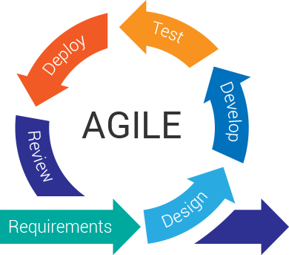

**Figure 1: Agile Development process**

* **Requirements:**

Before starting our project development work, we had discussed our idea with the supervisor in that meeting we wrote down certain requirements and then we discussed some queries we had about the requirements. So finally, we did understand the requirements.

* **Plan:**

After knowing the requirements, started planning that how we are going to develop our project we discuss our planning ideas with our supervisor.

* **Design:**

After planning we started designing our projects such that how we are going to develop our project, which techniques and methods we are going to use our projects.

* **Develop:**

After designing our project, we have started developing our first layer according to requirements.

* **Test:**

After developing we will check that the layer, we have developed contains error or not.

* **Release:**

After developing first layer we have released the first layer of our project.

* **Feedback:**

After releasing our first layer know it was the time to check whether our project layer is working according to requirements or not.

## *4.2 Architecture Overview*

The architecture design of our website is described with the help of figure.

## 

Login/

Registration

Complete Catalogue

Featured Product

Add to Cart

Collaborative Filtering

Place order

Logout

**Figure 2: Architecture overview**

## *Design Description*

The different diagrams related to our project are given below.

**4.3.1 Use cases**

**Use case for Admin**

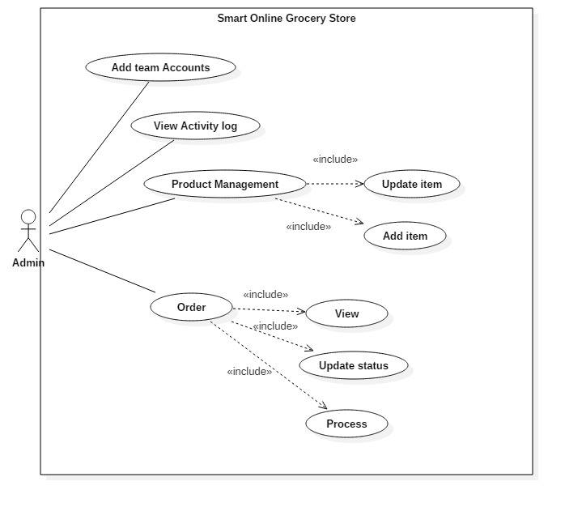

**Fig 4-1 Use case for Admin**

**Use case for Customer**

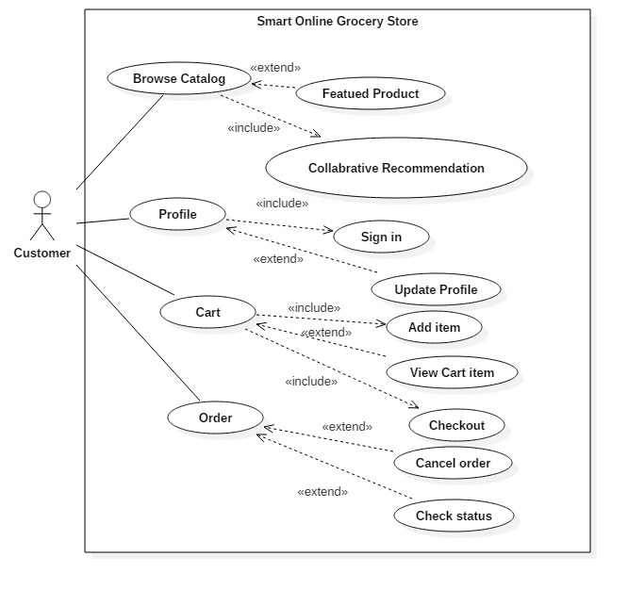

**Fig 4-2 Use case for Customer**

**Use case for Visitor**

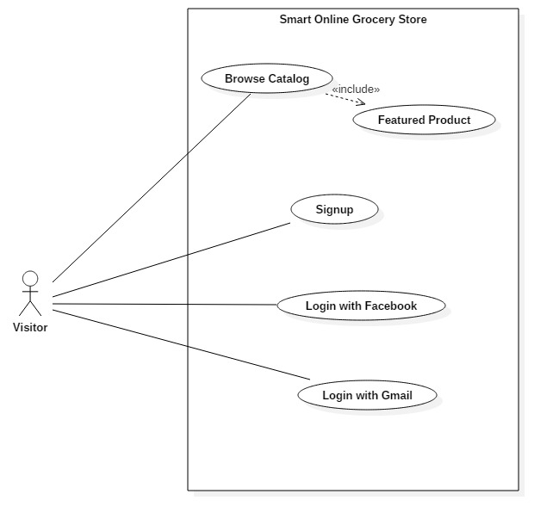

**Fig 4-3 Use case for Visitor**

**4.3.2 Sequence Diagrams**

**Sequence diagram for login**

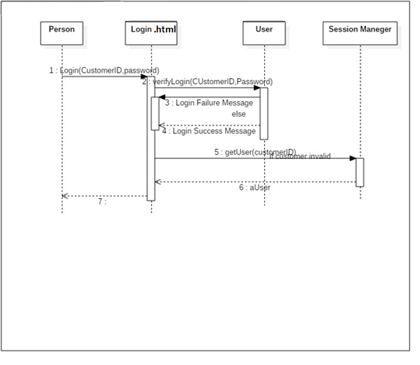

Figure 0‑4 Login Sequence Diagram

The Figure 4- 4 shows the flow of log-in. A person either who is admin or customer have to log-in to access his account. Login function will get user ID and password to verify him. If ID and password exists in Database, the verify Login method will be called to check the permissions assigned to user. Session manager will assign session to that user.

**Sequence diagram for search product**

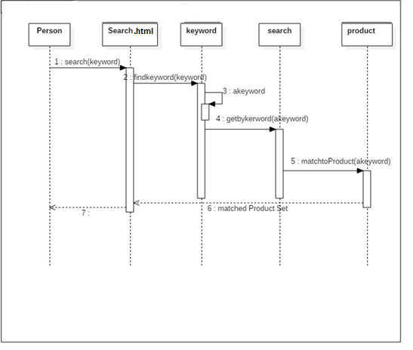

Figure 0‑5 Search Product Sequence Diagram

The figure 4-5 shoes the sequence diagram for searching the product. When a user type words in search box, he will get auto complete extender and after firing the search button these keywords get by function and used to match the products with database.

**Sequence diagram for update profile**

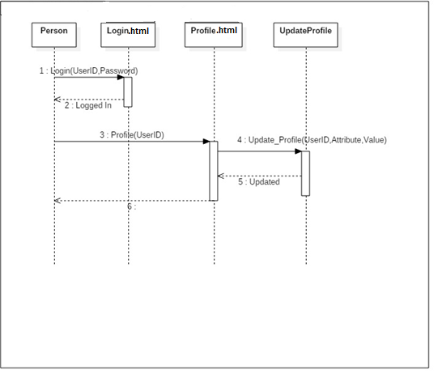

Figure 0‑1 Update Profile Sequence Diagram

The figure 4-6 shows the process for update profile. When user is logged in, he can update his profile. When we want to update the update profile () event is called and gets the user data which need to be update. After updating he will tell user for this update successfully or not.

**Sequence diagram for Admin**

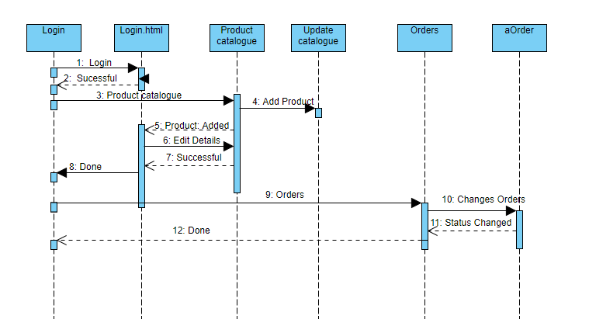

Figure 0‑7 Admin Sequence Diagram

The figure 4-11 shoes the admin sequence of activities. First admin needs to login and authenticate by system. After authentication he would perform any further activity. He would have access to product catalogue. From product catalogue he can add product, update product. From order, admin have to view the order and change the status of order.

**4.3.3 Data Flow Diagram**

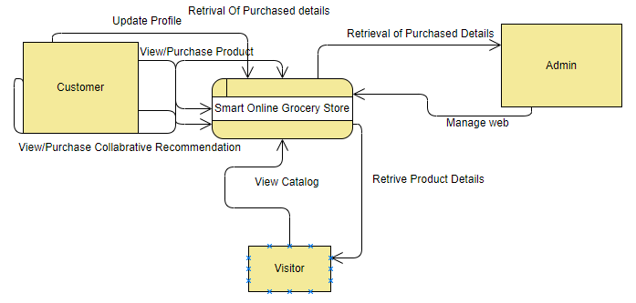

Figure 0‑8 DFD

Figure 4-1 shows the Data flow diagram of whole project. We have basically three categories of entities visitor, customer, and admin. Visitor has to access to view catalogue. Member can have access to View/Purchase product, view/purchase collaborative recommended products, view/purchase content based recommended products and member also have access to update his/her profile information. Admin can manage the complete web and can also analyses the web activities.

**4.3.4 Activity diagrams**

**Activity diagram for Admin**

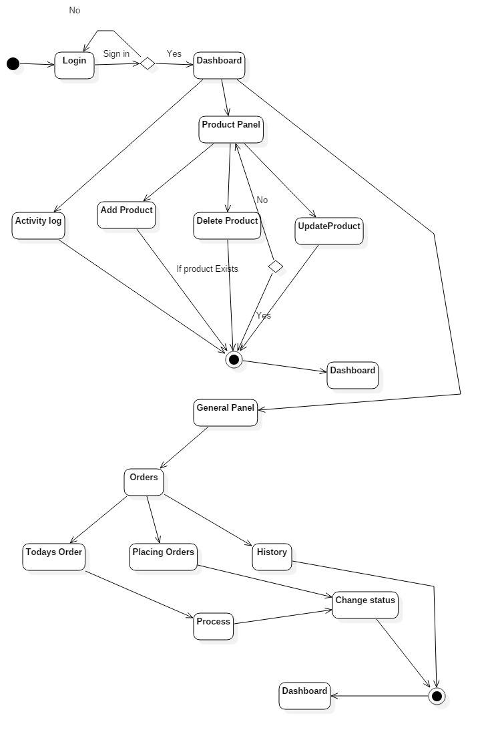

Figure 0‑9 Admin Activity Diagram

Admin have Dashboard after signed in. From dashboard he has access to product panel, orders and also have access to activity log. In product panel, he can add new product, update the product. Admin can make new admin accounts also. In order admin can check the orders list. Admin also have activity log.

**Activity Diagram for Customer**

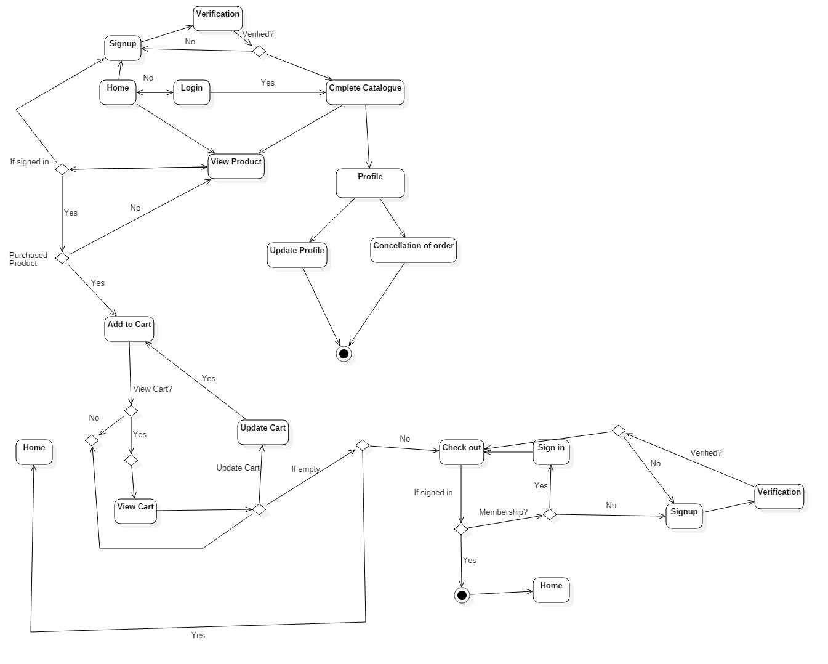

Figure 0‑10 Customer Activity Diagram

The figure4-10 shows the complete activity of customer and visitor. Visitor after sign-up/sign-in get the facilities of cart, update product, collaborative filtering and after being member he has access to checkout process. Visitor first sign in, retrieve product details, add to product to cart after being placed product in cart he has the checkout process. He can go with checkout to purchase the product. In profile, customer has complete history of his purchased products. He can also update profile.

**4.3.5 Class Diagram**

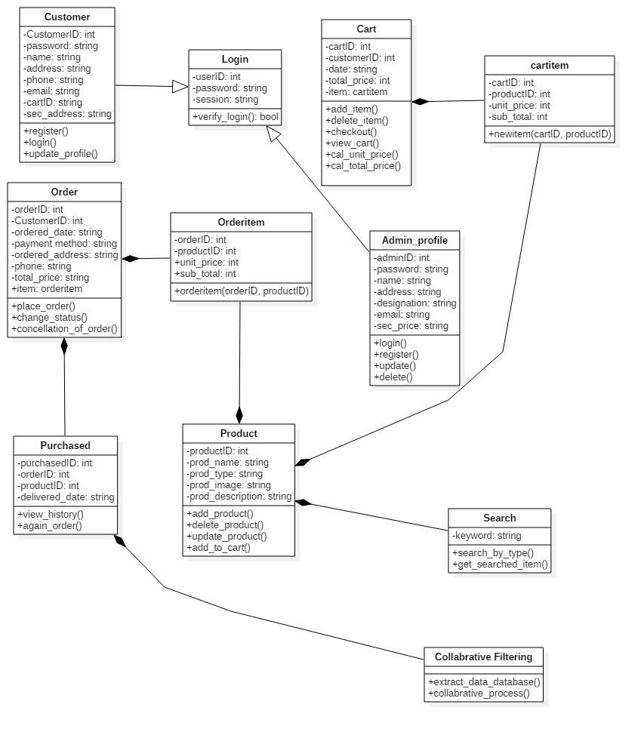

<https://github.com/Almas5143/SRS>