


Lab No. 8

BS Computer Science

EL2003 Computer Organization and Assembly Language BATCH SECTION (BCS-3A/5A)

Course Instructor | Dr. Aatira Anum
Lab Instructor | Ms. Almas Aina
Department | Computer Science

Lab No. 8
Objective:
- Learn to directly access the display memory at segment 0xB800 to print characters, strings and numbers with different attributes on the screen.

Instructions:
- Submit a separate .asm file for each task using the format:
ROLLNO SECTION TASK-NO_LAB-NO.asm.
- Submit one Word document containing all codes and required AFD Debugger screenshots, using the format:
SECTION_ROLLNO_LAB-NO.docx.
- Plagiarism, copying from fellow students, and submitting AI-generated work as your own are strictly prohibited.
Instructions

Important Note: The screen is 80 columns × 25 rows. Make proper subroutines for every task.
Important Instructions:
- Make proper subroutines
- Use Delay Function, that we did in class (if required)
Take a Look at the Delay Function
A delay function makes the program wait for a short time. The computer is very fast. Without a delay, things on the screen happen so quickly that we cannot see them.
delay: push cx ; save CX
mov cx, 0xFFFF ; CX = 65535
d1: loop d1 ; count down until CX = 0
pop cx ; get CX back
ret ; go back

Line by line:
1. push cx: Save the old value of CX, because we are going to change it.
2. mov cx, 0xFFFF: Put 65535 in CX. This is our counter.
3. loop d1: Subtract 1 from CX. If CX is not 0, go back to d1 and do it again. The CPU just counts down from 65535 to 0. This takes time, and that time is the delay.
4. pop cx: Put the old value back in CX.
5. ret: Go back to where the function was called.
Remember:
- loop d1 = dec cx + jnz d1.
- Always use push cx and pop cx, so the delay function does not change your own CX.
- Need a longer delay? Put one loop inside another loop.
Easy Level
Task 1: (Easy)
Code to clear screen is given in example 7.1. Your task is to modify this code and print ‘_’ (underscore) on first 13 rows of screen and ‘.’ In rest of the rows. Required output is given below. Properly calculate the cells required with each character.
Required Output:
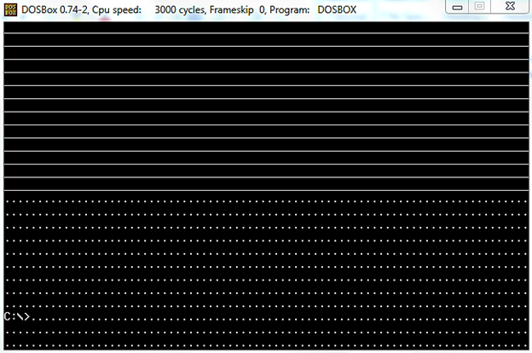

We did following code in class:
; clear the screen
[org 0x0100]

mov ax, 0xb800 ; load video base in ax
mov es, ax ; point es to video base
mov di, 0 ; point di to top left column
; es:di pointint to --> 0xB800:0000 (B8000)

nextchar: mov word [es:di], 0x0720 ; clear next char on screen
add di, 2 ; move to next screen location
cmp di, 4000 ; has the whole screen cleared
jne nextchar ; if no clear next position

mov ax, 0x4c00 ; terminate program
int 0x21

Task 2: (Easy)
Update above code such that it prints all characters (ASCII 0 to 255) on screen starting from location zero onwards and fills all the screen as shown in the figure below:
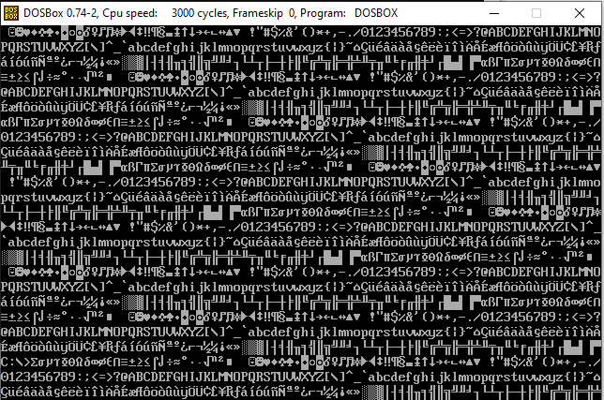
Task 3: (Easy)
Update the code written in Task 1 to print blinking characters with high intensity as shown in the figure below:
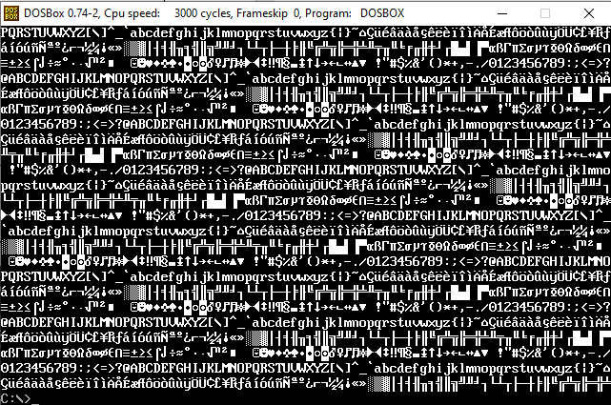

Task 4: (Easy)
Write a program that clears the screen and then prints your name in the exact center of the screen in yellow foreground on blue background. Then print your roll number one row below it in blinking white on red.

Medium Level
Task 5: (Medium)
Write a subroutine printstr that takes four parameters via the stack: row, column, attribute and the address of a null-terminated string.
- If the string reaches the last column (79), it should continue from column 0 of the next row.
- If it reaches the bottom-right cell of the screen, it should continue from the top-left cell (0, 0).
msg1: db 'Hello COAL', 0
msg2: db 'This string is long enough to wrap onto the next line of the screen', 0
Start:
call clrscr
push 0 ; row
push 0 ; column
push 0x07 ; attribute
push msg1 ; address of string
call printstr
push 5
push 40
push 0x4E
push msg2
call printstr
push 24
push 70
push 0x1F
push msg2 ; must wrap to the top of the screen
call printstr
; Termination code here

Task 6: (Medium)
Write a subroutine printhex that prints a 16-bit number in hexadecimal. The subroutine receives three parameters through the stack: row, column, and number.
The subroutine must print exactly 4 hexadecimal digits with the prefix 0x, including leading zeros and using capital letters A–F.
Call the subroutine with the following numbers and verify the output on screen:
i. 0x1234
ii. 0xBEEF
iii. 0x00A5

Task 7: (Medium)
Write a subroutine drawBox that takes five parameters via the stack: top, left, bottom, right and attribute. The function should draw a box border using the character ‘#’ and fill the inside of the box with the character ‘.’ with a different background color.
Start:
call clrscr
push 5 ; top
push 10 ; left
push 15 ; bottom
push 50 ; right
push 0x2F ; attribute (white on green)
call drawBox
; Termination code here

Task 8 [Moving Star]: (Medium)
Write a function MovingStar that moves an asterisk ‘*’ by one cell following these rules:
- If current location of star is i^{th} row and j^{th} column, next location will be i^{th} row and (j+1)^{th} column i.e. the star will be moved rightward by one cell.
- CurrentRow and CurrentCol (global variables) will be (1,0) initially i.e. 2nd row and 1st Column. Global variable Direction will be ‘R’ (Rightward) initially.
- Call your subroutine MovingStar from main 80 times (with delay), it should show the star moving in 1st row. Call clrscr function (available in book) before testing MovingStar function. You are not required to pass any parameter to MovingStar or return anything. Your subroutine will update the global variables as required.
Modify the MovingStar function with following rules:
- If ‘*’ is at rightmost column then next location will be j^{th} column and (i+1)^{th} row, i.e. if star is in last column it should move downward by one cell (Direction ‘D’).
- Call your function MovingStar from main (80+24) times (with delay), it should start ‘*’ from top-left cell, show it moving through first row then traversing the last column.
Modify the MovingStar function with Leftward (‘L’) and Upward (‘U’) traversal by one cell in last row and first column respectively.
Call your function from main (80+24+80+24) times (with delay). It should show the star moving in the boundary of the screen.

Task 9: (Medium)
Call your function MovingStar in infinite loop (with delay). Your program will display the star traversing the boundary for indefinite interval of time and command prompt will not come back.
Hard Level
Task 10: (Hard)
Write a subroutine BouncingChar that moves the character ‘@’ diagonally on the screen. When the character hits any edge of the screen, it should bounce back (reverse its row or column direction).
- Use global variables CurrentRow, CurrentCol, RowDir (+1 / -1) and ColDir (+1 / -1). Initial position (0, 0), direction (+1, +1).
- Call BouncingChar from main 500 times with a delay subroutine in between so the movement is visible.

Task 11: (Hard)
Write a subroutine RotateBorder that receives four parameters through the stack: top, left, bottom, and right. It must rotate all characters on the rectangle’s border clockwise by one cell, moving each character along with its attribute. The characters inside the rectangle must remain unchanged.
- Use the printstr function to repeatedly print COAL-LAB- around the border of the rectangle from (5, 10) to (15, 50), using a different color for each side.
- Do not use any global or local array to store the border. Use only registers and the stack.
- Call RotateBorder 300 times, with a delay between calls, to create a marquee effect.
- Verify that after 100 rotations, the border returns to its original arrangement.
Start:
call clrscr
; fill the border with 'COAL-LAB-' here
mov cx, 300
again: push 5 ; top
push 10 ; left
push 15 ; bottom
push 50 ; right
call RotateBorder
call delay
loop again
; Termination code here
Verify: after exactly 2 × (bottom − top) + 2 × (right − left) = 100 calls, the border must look exactly like it did at the start.
Practice Problems
Draw Rectangle, Triangle, Diamond on Display memory.

