National University of Computer and Emerging Sciences

Laboratory Manuals
for
Data Structures Lab (CL-2001)

Course Instructor | Mr. Waqas Rana
Lab Instructor | Ms. Almas Aina
Section | BSE-3A1
Semester | Fall 2026

Department of Computer Science
FAST-NU, Lahore, Pakistan
Lab Manual 06

Objectives:
- Represent a binary tree using an array and move between parent, children and siblings using index formulas.
- Apply recursion (already studied) to process an array-based binary tree: counting, height, searching and paths.
- Solve scenario-based problems adapted from GeeksforGeeks / LeetCode using an array tree.
Binary Tree
A binary tree is a hierarchical (non-linear) data structure in which every node has at most two children, called the left child and the right child. Real-life examples are family trees, tournament brackets and organisation charts.
Terminology
- Root: the top-most node (has no parent).
- Parent / Child: a node directly above / below another node.
- Siblings: two nodes having the same parent.
- Leaf: a node with no children.
- Level: root is at level 0, its children at level 1, and so on.
- Height: number of levels in the tree (in this lab, a tree with only the root has height 1).
Binary Tree using Array
Instead of pointers, the nodes are stored in an array level by level, from left to right. The root is stored at index 0 and the position of every child, parent or sibling is calculated with simple formulas (0-based indexing):
Relation | Formula | Example (i = 1, Bilal)
Left child of i | 2i + 1 | index 3 → Danish
Right child of i | 2i + 2 | index 4 → Erum
Parent of i | (i - 1) / 2 (integer division) | index 0 → Ahmed
Sibling of i (i > 0) | i odd → i + 1, i even → i - 1 | index 2 → Kamran

A position that has no node is filled with a special empty marker (for example "-" for strings or -1 for positive integers). A tree of height h needs an array of size 2^h - 1.
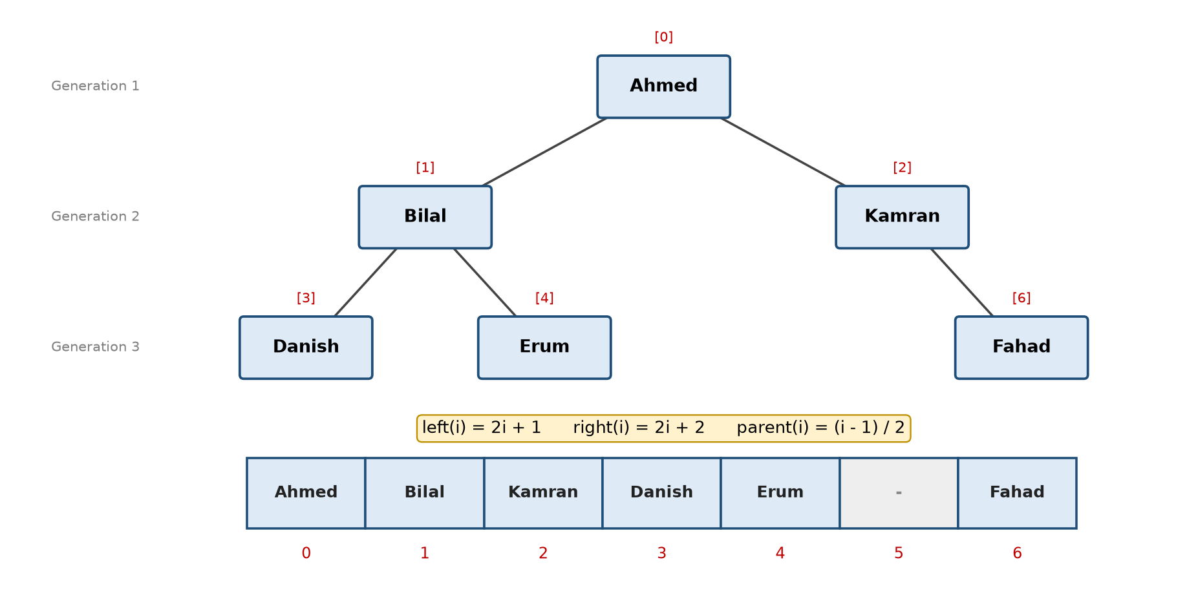
Figure 1: A family tree and its array representation. Index 5 (left child of Kamran) is empty.
Advantages and Disadvantages
- Advantages: no pointers needed, any node is reached in O(1), the parent is easy to find, ideal for complete trees (heaps, tournament brackets).
- Disadvantages: fixed size, and a lot of memory is wasted when the tree is skewed or sparse (many empty slots).
Recursion on an Array Tree
You have already studied recursion. A tree is a recursive structure: every node is the root of its own smaller left subtree and right subtree. So most tree operations are written recursively by passing the index of the current node:
- Base case: the index is outside the array, or the position is empty. Return 0 / false / nothing.
- Recursive case: solve the problem for the left child (2i + 1) and the right child (2i + 2), then combine the two answers with the current node.
int countNodes(int i) {
if (i >= MAX || tree[i] == "-") // base case: no node
return 0;
return 1 // current node
+ countNodes(2 * i + 1) // left subtree
+ countNodes(2 * i + 2); // right subtree
}
// First call: countNodes(0) (start from the root)
Height, number of leaves, searching, printing a level and root-to-leaf paths all follow the same pattern. You will use it in every task of this lab.
Lab Tasks

Task 1: Family Tree Record (5)
The NADRA office wants a small program to store the family tree of a citizen for three to four generations. Each person can have at most two children recorded (left and right). Because the size is small and fixed, the tree is stored in an array of strings (MAX = 15) where "-" means an empty position.
Implement a class FamilyTree with the following operations and provide a menu:
- addHead(string name): store the head of the family at index 0 (error if a head already exists).
- addLeftChild(string name, int parent) / addRightChild(string name, int parent): store the child at 2 × parent + 1 or 2 × parent + 2.
  - Show an error if the parent does not exist, the position is already occupied, or the index is out of bounds.
- showParent(int i), showChildren(int i), showSibling(int i): display the related person or a proper message (e.g. "Ahmed is the head of the family and has no parent").
- display(): print the complete array with indexes, including empty "-" positions.
Build the family shown in Figure 1 and test every option.
Sample Run
1.Add Head 2.Add Left Child 3.Add Right Child 4.Parent 5.Children 6.Sibling 7.Display 0.Exit
Choice: 1 Name: Ahmed
Choice: 2 Name: Bilal Parent index: 0
Choice: 3 Name: Kamran Parent index: 0
Choice: 2 Name: Danish Parent index: 1
Choice: 3 Name: Erum Parent index: 1
Choice: 3 Name: Fahad Parent index: 2
Choice: 2 Name: Hina Parent index: 5
Error: no person exists at parent index 5.
Choice: 7
Index : 0 1 2 3 4 5 6
Name : Ahmed Bilal Kamran Danish Erum - Fahad
Choice: 4 Index: 6
Parent of Fahad is Kamran (index 2)
Choice: 6 Index: 3
Sibling of Danish is Erum (index 4)
Choice: 5 Index: 2
Children of Kamran: Left = none, Right = Fahad

Task 2: Family Tree Statistics using Recursion (5)
The NADRA officer now wants some statistics about the family stored in Task 1. Add the following recursive functions to your FamilyTree class (each one starts from index 0 and must not use any loop over the array):
- countMembers(int i): total number of people in the family.
- countLeaves(int i): number of people who have no children recorded.
- generations(int i): number of generations (height of the tree).
- printGeneration(int i, int level): print all people of a given generation, from left to right.
- findPerson(int i, string name): return the index of the person or -1 if not found. Then print the person's ancestors up to the head of the family (use the parent formula).
Sample Run
Total family members : 6
Members with no children : 3
Number of generations : 3
Enter generation number : 3
Generation 3: Danish Erum Fahad
Enter name to search : Erum
Erum found at index 4
Ancestors of Erum: Bilal -> Ahmed
Enter name to search : Zara
Zara is not part of this family tree.

Task 3: Sports Week Knockout Tournament (10)
FAST-NU is organising its annual Sports Week. The table-tennis event is a knockout tournament: players are paired, the winner of every match moves to the next round and the loser is eliminated, until only the champion remains. The organisers want a program that builds the complete bracket automatically.
A knockout bracket is a perfect binary tree, so it can be stored in an array:
- For n players (n must be a power of 2) the array size is 2n - 1.
- The players are stored in the leaves, at indexes n - 1 to 2n - 2.
- Every internal node i stores the winner of the match between its children 2i + 1 and 2i + 2. The player with the higher score wins; on a tie the left player wins.
- Index 0 (the root) finally stores the champion.
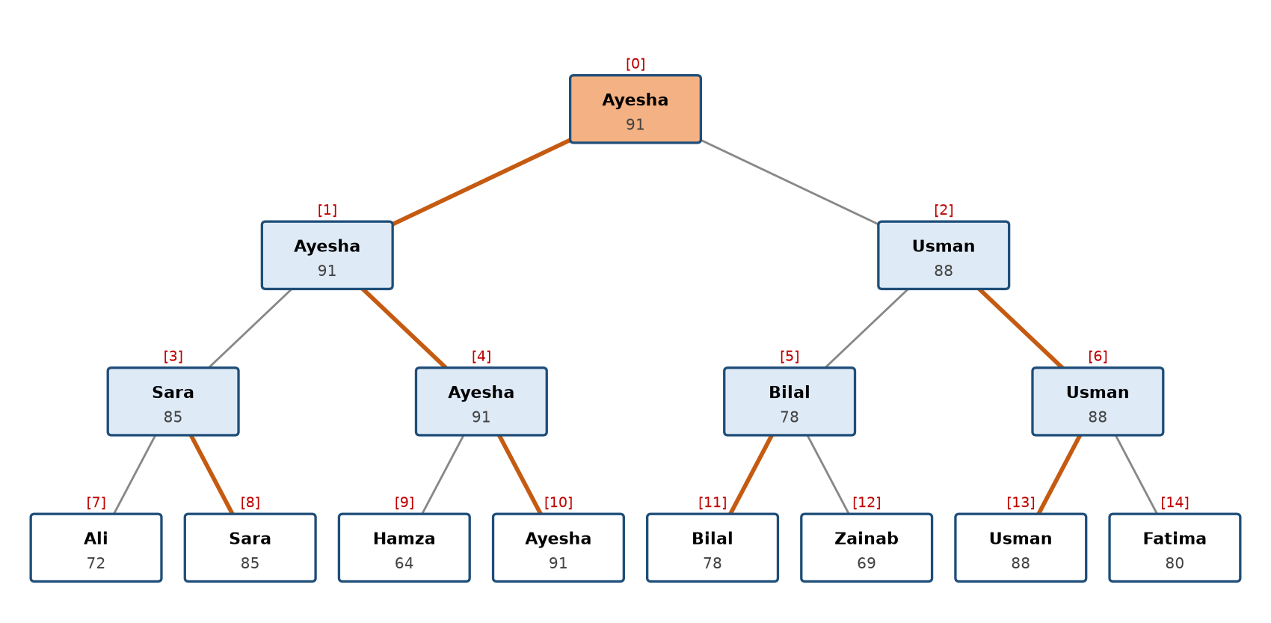
Figure 2: Tournament tree for 8 players. Orange edges show the path of each winner; index 0 holds the champion.
Requirements
- Take n from the user. Reject the input if n is less than 2 or is not a power of 2.
- Take the name and score of every player and store them in the leaves.
- Write a recursive function playMatch(int i) that fills node i: if i is a leaf return; otherwise call playMatch on both children first and then store the winner at i.
- Print the winners of every round (from the first round up to the final).
- Print the champion, the runner-up (the finalist who lost the final) and the total number of matches played (n - 1).
Sample Run
Enter number of players: 6
Invalid! Number of players must be a power of 2.
Enter number of players: 8
Player 1 name and score: Ali 72
Player 2 name and score: Sara 85
Player 3 name and score: Hamza 64
Player 4 name and score: Ayesha 91
Player 5 name and score: Bilal 78
Player 6 name and score: Zainab 69
Player 7 name and score: Usman 88
Player 8 name and score: Fatima 80

Round 1 winners : Sara(85) Ayesha(91) Bilal(78) Usman(88)
Semi-final : Ayesha(91) Usman(88)
Final : Ayesha(91)

Champion : Ayesha (91)
Runner-up : Usman (88)
Total matches played: 7

Task 4: Hiking Trail Energy Planner (5)
(Adapted from LeetCode 112: Path Sum and GeeksforGeeks: Root to leaf path sum equal to a given number)
The FAST Adventure Club is planning a hike in the northern areas. The trail starts at the base camp and splits at every checkpoint into at most two routes (left and right). Each checkpoint has an energy cost, and a route ends at a checkpoint with no further routes (a leaf, the summit). The map is stored in an integer array where -1 means "no checkpoint".
A student has exactly E units of energy and wants to know whether there is a complete route from the base camp (root) to a summit (leaf) whose total energy cost is exactly E. If yes, print the route.
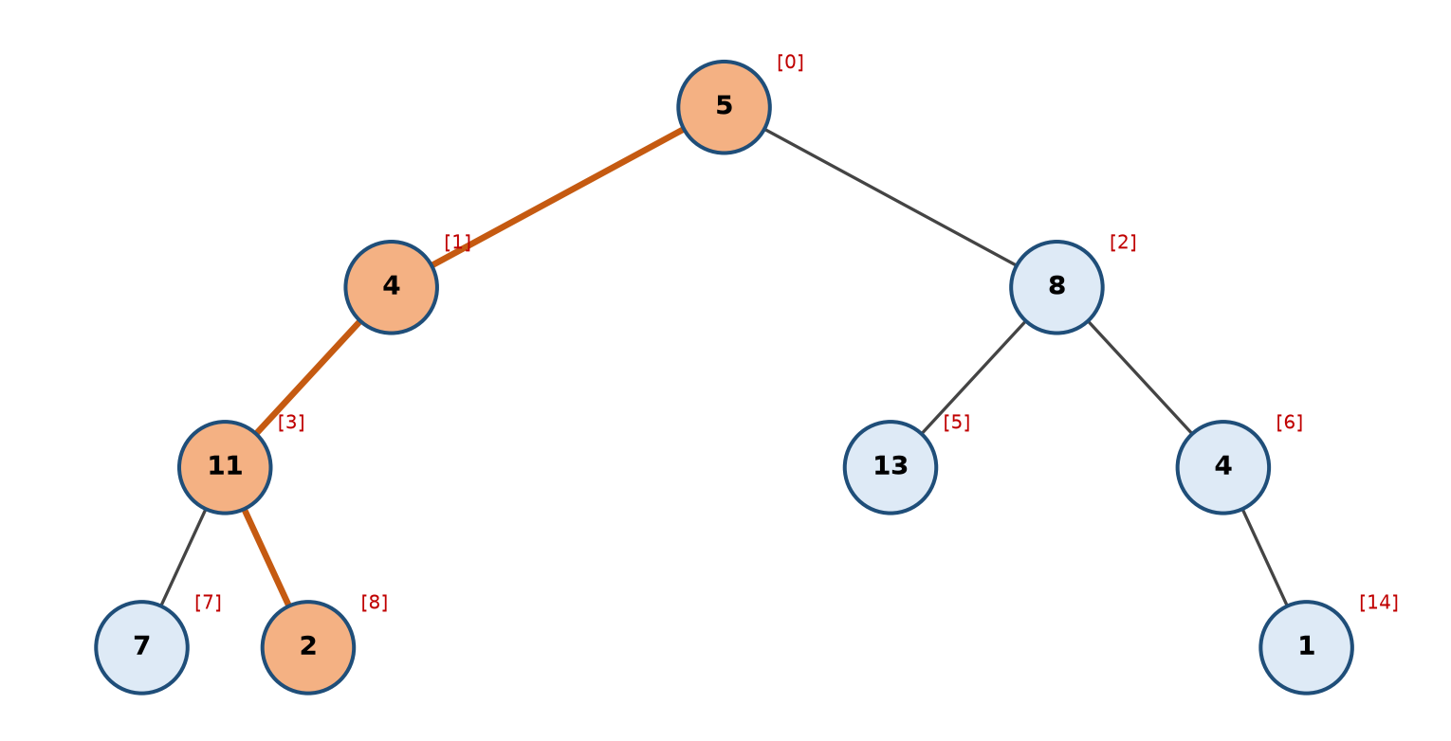
Figure 3: Trail map. The orange route 5 → 4 → 11 → 2 costs exactly 22 units of energy.
Requirements
- Write a recursive function bool hasRoute(int i, int remaining) that subtracts tree[i] from remaining and checks if a leaf is reached with remaining = 0.
- Store the checkpoints of the current route (e.g. in a small array) while going down so that the route can be printed when it is found.
- Also write a recursive function that prints all root-to-leaf routes with their total cost.
Input: tree = [5, 4, 8, 11, -1, 13, 4, 7, 2, -1, -1, -1, -1, -1, 1], E = 22
Output: true Route: 5 -> 4 -> 11 -> 2
Input: Same trail, E = 10
Output: false No route costs exactly 10 units
Explanation: The four routes cost 27 (5-4-11-7), 22 (5-4-11-2), 26 (5-8-13) and 18 (5-8-4-1).

Task 5: Hospital Emergency Priority Board (5)
(Adapted from GeeksforGeeks: Check if a given array represents a Binary Heap)
In the emergency ward of a hospital, every incoming patient is given a priority score (higher score = more serious). The hospital software keeps the scores in an array arranged as a binary tree, and the rule is that every patient must have a priority greater than or equal to the patients below them (their children). This arrangement is called a Max-Heap, and it guarantees that the most serious patient is always at index 0.
After a power failure the board was restored from a backup and the staff are not sure the data is still valid. Write a recursive function bool isValidBoard(int arr[], int i, int n) that checks the rule at index i and then recursively for both of its children. If the board is invalid, print the first index where the rule is broken.
Input: arr = [90, 15, 10, 7, 12, 2]
Output: Valid priority board. Most serious patient score: 90
Input: arr = [90, 15, 10, 7, 12, 2, 17]
Output: Invalid board! Patient at index 6 (17) has higher priority than its parent at index 2 (10).

Task 6: Campus Garden Symmetry Check (5)
(Adapted from LeetCode 101: Symmetric Tree)
The FAST horticulture team is designing a decorative garden in front of the main building. The flower beds are arranged as a binary tree: the fountain is at the root and the paths divide into left and right flower beds. Every bed is identified by a flower code (integer) and -1 means an empty position. For the design to be approved it must look the same from both sides, i.e. the left half must be the mirror image of the right half.
Write a recursive function bool isMirror(int i, int j) that compares the left subtree at index i with the right subtree at index j: both empty means true, one empty means false, otherwise the values must be equal and isMirror(left of i, right of j) and isMirror(right of i, left of j) must both be true. Call it as isMirror(1, 2).
Input: garden = [1, 2, 2, 3, 4, 4, 3]
Output: Design approved: the garden is symmetric.
Input: garden = [1, 2, 2, -1, 3, -1, 3]
Output: Design rejected: the garden is not symmetric.
Explanation: Both flower beds with code 3 are on the right side of their parents, so the two halves are not mirror images.

Submission Guidelines
Submit only the following files, strictly following the naming convention (replace the roll number with your own):
- l261234.cpp (all tasks in one file, each task in its own clearly commented function / section)
- l261234.docx (screenshots of the output of every task)
- Copied / plagiarised code will be awarded zero marks.

