National University of Computer and Emerging Sciences

Laboratory Manuals
for
Data Structures Lab (CL-2001)

Course Instructor | Mr. Waqas Rana
Lab Instructor | Ms. Almas Aina
Section | BSE-3A1
Semester | Fall 2026

Department of Computer Science
FAST-NU, Lahore, Pakistan
Lab Manual 07

Objectives:
- Understand the Binary Search Tree (BST) property and the linked (node-based) representation of a tree.
- Implement BST insertion in two ways: using a loop (iterative) and using recursion.
- Implement the three depth-first traversals: Inorder, Preorder and Postorder.
- Use recursion (already studied) to solve scenario-based BST problems adapted from GeeksforGeeks / LeetCode.
Binary Search Tree (BST)
A Binary Search Tree is a binary tree in which every node follows the BST property:
- All keys in the left subtree of a node are smaller than the node's key.
- All keys in the right subtree of a node are greater than the node's key.
- Both the left and right subtrees are also BSTs.
- In this lab duplicate keys are not allowed (an insert of an existing key is rejected).
Think of a dictionary: to find a word you open the middle, and depending on whether your word comes before or after, you only search the left half or the right half. A BST does the same thing at every node, which is why searching is fast.
Node Structure
struct Node {
int data;
Node* left;
Node* right;
Node(int val) : data(val), left(nullptr), right(nullptr) {}
};
Insertion in a BST
A new key is always inserted as a leaf. Starting from the root, compare the key with the current node and move left if it is smaller or right if it is greater, until an empty (nullptr) position is found.
A) Insertion using a Loop (Iterative)
- Create a new node. If root is nullptr, make the new node the root and stop.
- Set curr = root and parent = nullptr.
- While curr is not nullptr: set parent = curr; if key < curr->data move curr = curr->left, else if key > curr->data move curr = curr->right, else the key is a duplicate, so stop.
- Attach the new node as parent->left if key < parent->data, otherwise as parent->right.
B) Insertion using Recursion
- Base case: if the current node is nullptr, create and return a new node.
- If key < node->data then node->left = insert(node->left, key).
- If key > node->data then node->right = insert(node->right, key).
- Return node (unchanged pointer) so that the links are kept.
Dry Run
Insert the keys 45, 25, 65, 15, 30, 55, 75, 10, 50, 70 into an empty BST (both methods give the same tree):
Key | Nodes compared (path) | Placed as
45 | - | Root
25 | 45 | Left child of 45
65 | 45 | Right child of 45
15 | 45 → 25 | Left child of 25
30 | 45 → 25 | Right child of 25
55 | 45 → 65 | Left child of 65
75 | 45 → 65 | Right child of 65
10 | 45 → 25 → 15 | Left child of 15
50 | 45 → 65 → 55 | Left child of 55
70 | 45 → 65 → 75 | Left child of 75
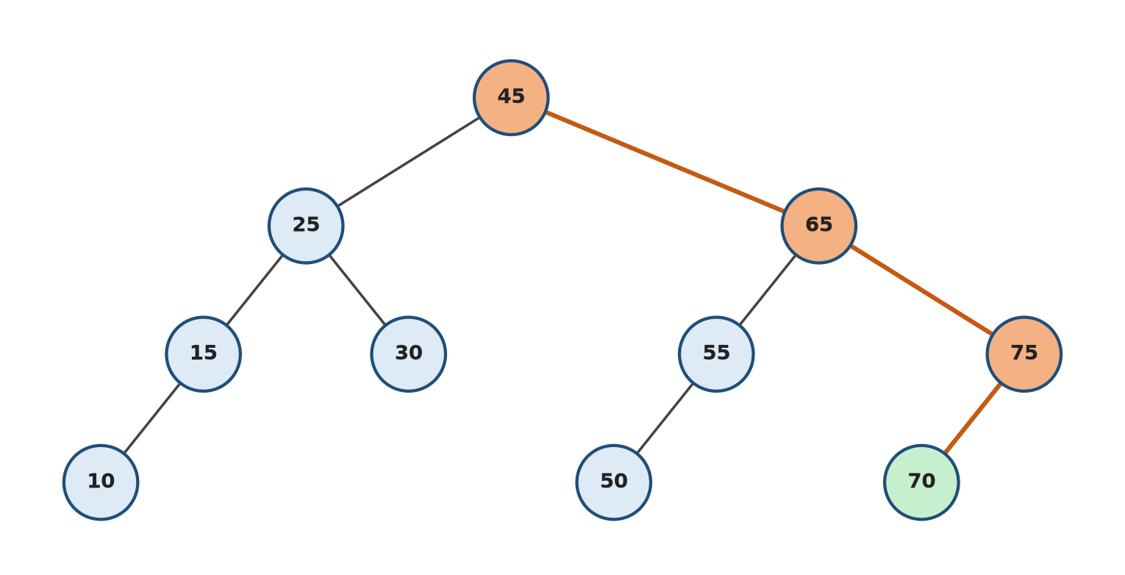
Figure 1: Final BST. The orange path shows how 70 is inserted: 70 > 45 go right, 70 > 65 go right, 70 < 75 go left (empty), so 70 becomes the left child of 75.
Tree Traversals (Depth First)
Traversal means visiting every node exactly once. The three depth-first traversals differ only in when the root (current node) is visited. All three are naturally written using recursion.
Traversal | Order | Output for Figure 1 | Common Use
Inorder | Left → Root → Right | 10 15 25 30 45 50 55 65 70 75 | Gives keys in sorted (ascending) order
Preorder | Root → Left → Right | 45 25 15 10 30 65 55 50 75 70 | Copy / save a tree, rebuild the same BST
Postorder | Left → Right → Root | 10 15 30 25 50 55 70 75 65 45 | Delete / free all nodes (children first)

void inorder(Node* root) {
if (root == nullptr) return; // base case
inorder(root->left);
cout << root->data << " ";
inorder(root->right);
}
Note: Preorder and Postorder are written in the same way, only the position of the cout statement changes.
Time Complexity
- Insertion and search take O(h) time, where h is the height of the tree.
- Best / average case: balanced tree, h = log n, so O(log n).
- Worst case: keys inserted in sorted order produce a skewed tree (like a linked list), h = n, so O(n).
- Every traversal visits each node once: O(n).
Lab Tasks

Task 1: Exam Hall Seating Plan (5)
The examination department of FAST-NU receives the roll numbers of students in random order as they register for a re-take exam. The department wants to store them in a BST so that it can quickly produce a seating plan in ascending order of roll number.
Implement a class BST (using the Node structure above) with:
- insertIterative(int roll): insert using a loop (used for normal registrations).
- insertRecursive(Node* node, int roll): insert using recursion (used for late registrations), called through a public wrapper insertRecursive(int roll).
  - Both functions must display "Roll number already registered" for a duplicate.
- inorder(), preorder(), postorder(): recursive traversals.
Insert the roll numbers 2045, 2012, 2078, 2003, 2030 using insertIterative and 2060, 2091 using insertRecursive into the same tree. Then display the seating plan (Inorder), the record-saving order (Preorder) and the order in which records are cleared after the exam (Postorder).
Sample Run
Registering (loop) : 2045 2012 2078 2003 2030
Registering (recursion) : 2060 2091
Registering (loop) : 2030 -> Roll number already registered

Seating plan (Inorder) : 2003 2012 2030 2045 2060 2078 2091
Saving order (Preorder) : 2045 2012 2003 2030 2078 2060 2091
Clearing order (Postorder): 2003 2030 2012 2060 2091 2078 2045

Task 2: Library Book Finder (5)
The FAST library stores its books in a BST using the Book ID as the key (each book also has a title). The librarian needs a few quick queries. Add the following functions to your BST (store a title in each node):
- searchIterative(int id) and searchRecursive(Node* node, int id): display the title or "Book not found". Both must give the same answer.
- oldestBook() / newestBook(): the smallest and largest Book ID (left-most and right-most nodes).
- countBooks(Node* node): recursive count of all books.
- shelfLevels(Node* node): recursive height of the tree (number of levels).
Insert the books in this order: 1050 Data Structures, 1020 Clean Code, 1080 Intro to Algorithms, 1010 C++ Primer, 1030 Discrete Maths, 1065 Operating Systems, 1095 Computer Networks.
Sample Run
Search 1030 (loop) : Discrete Maths
Search 1030 (recursion) : Discrete Maths
Search 1040 (recursion) : Book not found
Oldest book : [1010] C++ Primer
Newest book : [1095] Computer Networks
Total books : 7
Shelf levels: 3

Task 3: Clinic Appointment Scheduler (10)
Dr. Sana runs a busy clinic from 09:00 to 17:00. Patients call at random times to book appointments, and the receptionist must keep the schedule sorted, prevent two patients from getting the same time slot, and quickly answer questions like "What is the next free/booked slot after 12:15?". The receptionist decides to store the appointments in a BST keyed by time in HHMM format (e.g. 9:30 is stored as 930, 14:00 as 1400). Each node also stores the patient name.
Your program should provide a menu with the following options:
Book Appointment
- Input: time (HHMM) and patient name. Reject invalid times (outside 0900 to 1700, or minutes greater than 59).
- Insert using recursive insertion. If the slot is already taken, display "Slot already booked".
Day Schedule
- Display all appointments in time order (Inorder). Print times as HH:MM.
Next Appointment
- Input: a time t. Display the first appointment at or after t (the ceil of t, GeeksforGeeks: Floor and Ceil from a BST). Solve recursively.
Previous Appointment
- Input: a time t. Display the last appointment at or before t (the floor of t). Solve recursively.
Morning Patients
- Count the appointments before 12:00 recursively, skipping subtrees that cannot contain morning slots.
Check Slot
- Input: a time. Display who is booked at that time or "Slot is free" (use a loop to search).
Exit: free all nodes using Postorder traversal and terminate the program safely.
Sample Run
1.Book 2.Schedule 3.Next 4.Previous 5.Morning 6.Check Slot 0.Exit
Choice: 1 Time: 1030 Name: Ali
Choice: 1 Time: 930 Name: Sara
Choice: 1 Time: 1400 Name: Hamza
Choice: 1 Time: 1100 Name: Ayesha
Choice: 1 Time: 900 Name: Bilal
Choice: 1 Time: 1530 Name: Zainab
Choice: 1 Time: 1200 Name: Usman
Choice: 1 Time: 1100 Name: Fatima
Slot already booked
Choice: 1 Time: 1875 Name: Omer
Invalid time
Choice: 2
09:00 Bilal | 09:30 Sara | 10:30 Ali | 11:00 Ayesha | 12:00 Usman | 14:00 Hamza | 15:30 Zainab
Choice: 3 Time: 1215
Next appointment: 14:00 Hamza
Choice: 4 Time: 1215
Previous appointment: 12:00 Usman
Choice: 5
Morning patients: 4
Choice: 6 Time: 1000
Slot is free
Choice: 0
Freeing schedule (Postorder): 900 930 1200 1100 1530 1400 1030

Task 4: Bank Transaction Audit (5)
(Adapted from LeetCode 938: Range Sum of BST)
An auditor at a bank stores the amounts of the day's transactions in a BST (all amounts are different). The State Bank asks for the total value of all transactions between low and high (inclusive) to monitor medium-sized transfers. Write a recursive function int rangeTotal(Node* root, int low, int high) that uses the BST property to skip subtrees that cannot contain amounts in the range (for example, if a node is smaller than low, its whole left subtree can be skipped). Also print the amounts that were added.
Input: Amounts inserted: 5000, 2500, 8000, 1200, 3700, 9500 low = 2000, high = 8000
Output: Transactions in range: 2500 3700 5000 8000 Total = 19200

Task 5: University Merit List (5)
(Adapted from LeetCode 230: Kth Smallest Element in a BST and GeeksforGeeks: Kth Largest Element in BST)
The admissions office stores the entry-test scores of applicants in a BST (all scores are different). A programme has only k seats, so the office needs the closing merit: the score of the k-th highest applicant. Write a recursive function that performs a reverse inorder traversal (Right → Root → Left), which visits scores from highest to lowest, and stops as soon as k scores have been counted. Also print the k selected scores. Show an error if k is larger than the number of applicants.
Input: Scores inserted: 78, 92, 65, 85, 99, 71, 88, 60 k = 3
Output: Selected: 99 92 88 Closing merit = 88
Input: Same scores, k = 5
Output: Selected: 99 92 88 85 78 Closing merit = 78

Task 6: Restore Catalogue from Backup (5)
(Adapted from LeetCode 1008: Construct Binary Search Tree from Preorder Traversal)
The library server crashed last night. Fortunately, every evening the system saves a backup of the catalogue BST as its Preorder traversal (Task 2). Write a program that reads the backup array, rebuilds the BST using your recursive insertion, and then proves that the restore was correct by printing the restored tree's Preorder (it must match the backup), Inorder (must be sorted) and Postorder.
Hint: in a preorder traversal the first value is always the root, so inserting the values in the given order rebuilds exactly the same tree.
Input: backup = [50, 30, 20, 40, 70, 60, 80]
Output: Preorder : 50 30 20 40 70 60 80 (matches backup)
Inorder : 20 30 40 50 60 70 80
Postorder: 20 40 30 60 80 70 50

Submission Guidelines
Submit only the following files, strictly following the naming convention (replace the roll number with your own):
- l261234.cpp (all tasks in one file, each task in its own clearly commented function / section)
- l261234.docx (screenshots of the output of every task)
- Copied / plagiarised code will be awarded zero marks.

