Internet / google / AI use is not allowed
Team members (full names)
__________________________________________________________________
_________________________________________________________________
_________________________________________________________________
_________________________________________________________________
_________________________________________________________________

1:
65 50 43 62 50 43 61 60 57 57 62 61 43 61 56 57 44 57 46 67 61 47 47 61 51 61 62 43 54 54 47 60 62 50 43 56 62 60 47 47 61 63 58 63 58 51 62 49 57 47 61 43 56 46 67 47 62 56 47 64 47 60 49 60 57 65 61

What is the answer to the riddle?

2:
W D N H F R O R X U I I I I I I D Q G U H P R Y H I I I I I I W K H Q Z K D W F R O R X U G R \ R X J H W

The first world is “take”. What is the answer to the question?

3:
3,4,5
8,6,10
5,12,13

What is the question?

4:
START 0 LOAD 1 LOAD 3
ADD 5
MUL 6
MEM #1
LOAD 10
ADD 10
ADD #1

What is the final answer?

5:
T E C H N O L O G Y S N O W F L A K E
R A M C O D E S N O W M A N A I D E E
E L D E N R I N G C H A R L E D C P U
E R A C I C E B I T S A N T A C L A W
S N O W B O O T S D A T A S T R E A M
T R E E S T L C K S N O W C R A F H E
S A N T A C O D E F R O S T Y B L T S
A R R A Y S N O W S T O R M C O O E R
C O D E F E G T I V A L S N O W A E N
K E Y B O A R D S N O W M A N S T A R
S N O W F L A K E S T R I N G S N O W
C O M P I L E R S N O W B A L L S N O
S N B W S H O V E L S N O W D R I F T
S D O U B L E E S N O W S T A C K S N
E R O C I C E B I N T A N T A C L A W
S N L W B O O T S D A T A S T R E A M
T R E E S T A C K S H O R T R A S H E
S A A T A C O D E F R O S T Y B Y T E
A R N A Y S N O W S T O R M C O D E R
C O D E F E S T I V A L S N O W D E N

Find 8 primitive data types that are commonly used in C-based family of languages, written either horizontally or vertically.

6:
Draw a single unbroken path between two circles inside the maze. You may wish to use Paint to draw.

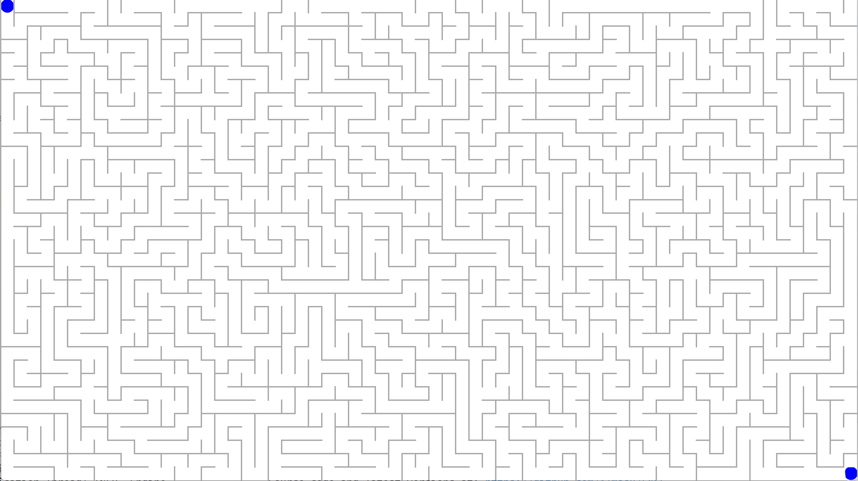

7:
1,4 is 4
2,4 is 6
4,4 is 1
2,5 is 10

What is the question?

8:
a,b,c and a,b,c = 0
a,b,c and b,c,d = 2
a,c,f and a,b,d = 4

What is the question?

9:
Fill table cells with a colour to separate each group of non-filled cells. One group of non-filled cells can only have one cell with a value. The number of cells in the group must match that value.

Example grid:
2 |  |  |  |  | 3
 |  | 1
 | 5 |  |  | 4

Example solution:
2 |  |  |  |  | 3
 |  | 1
 | 5 |  |  | 4

Puzzle:
3 |  |  | 1 |  |  |  |  | 1
5 |  |  |  |  |  |  |  | 7
 |  | 5 |  |  |  | 6
2 |  |  |  |  | 1 |  |  | 2

10:
You are standing in a field and facing a direction. You rotate 180 degrees to look behind you. You now rotate 90 degrees to look left. You rotate 180 degrees to look behind you.

What direction are you facing, in relation to the starting direction?

11:
1590233, 8537369 = 7067136
510885549, 497981190 = 187104459

What is 8134772, 3726139?

12:
There are ten mysterious boxes🎁with cryptic tags. There is only one coin and it’s inside one of these boxes. Each tag contains a clue about where the coin might be. The ten boxes are located in a single horizontal row from left to right in some non-natural (i.e. not 1,2,3...) order. The term “adjacent” means immediately to the left or immediately to the right.

- Box 1 does not have the coin.
- Box 4 is immediately to the left of Box 1.
- Box 8 is the leftmost box in the row and there is no box to its left.
- Box 10 and Box 4 are not adjacent.
- Box 4 is located adjacent to either Box 3 or Box 5.
- Box 7 and Box 9 are adjacent.
- Box 9 does not have the coin.
- Box 2 is located adjacent to the box that has the coin.
- Box 6 is closer to the rightmost box than it is to the leftmost.
- Box 3 is adjacent to only one box.
- There are fewer boxes between Box 7 and the leftmost, than between Box 10 and the leftmost.
- Box 2 and Box 6 are not adjacent.
- There are two other boxes between Box 8 and Box 1.
- Box 9 is located in the 7th position from the left.
- Box 6 is adjacent to either Box 1 or Box 3.

Which box has the coin?

13:
1,2,3 = 4
2,5,8 = 11
9,3,11=5

What is 5,9,3?

14:
1 4 9 25 64 169 441 1156 3025 ?

What is the last number?

15:
G F K K P is H E L L O

What is S G F Q F J T B E P Q L, S G F Q F J T B L M J E F, S G F Q F J T M P T O P P M?

16:
0,0,20,20 = 400
15,10,30,15 = 75
5,20,10,30 = 50

What is 10,5,20,20?

17:
A priceless gem was stolen from a museum. There are six rooms in the museum. At the time of theft, there were six people in the museum, and each room had exactly one person in it. Each person had exactly one item on them, a tool, which was possibly used to steal the gem.

You have been given the following facts:
Room 1. OUTDOORS
Room 2. INDOORS
Room 3. INDOORS
Room 4. INDOORS
Room 5. INDOORS
Room 6. INDOORS

Person 1. 5'10" and RIGHT-HANDED
Person 2. 5'0" and RIGHT-HANDED
Person 3. 5'11" and LEFT-HANDED
Person 4. 5'2" and LEFT-HANDED
Person 5. 5'9" and RIGHT-HANDED
Person 6. 6'4" and RIGHT-HANDED

Tool 1. LIGHT-WEIGHT
Tool 2. MEDIUM-WEIGHT
Tool 3. MEDIUM-WEIGHT
Tool 4. MEDIUM-WEIGHT
Tool 5. MEDIUM-WEIGHT
Tool 6. LIGHT-WEIGHT

You have found the following clues:
- The tallest person had Tool 4.
- Person 1 did not have Tool 6.
- Person 2 was in Room 1.
- The gem was stolen at midnight.
- Room 2 did not have Tool 1.
- The tallest person was not in Room 3.
- Tool 5 was in Room 1 or in Room 4 or in Room 6.
- A medium-weight tool was in Room 4.
- Person 5 was in Room 2.
- Tool 1 was used to steal the gem.
- Tool 6 was in a room indoors.
- Tool 2 was used by Person 2 or by Person 3 or by Person 4.
- Tool 3 was in Room 3.
- Person 3 was in Room 6.
- A left-handed person was in Room 3.
- Tool 5 was in a room outdoors.
Who is the thief?

You may find this grid useful when solving.

 | P1 | P2 | P3 | P4 | P5 | P6 | R1 | R2 | R3 | R4 | R5 | R6
T1
T2
T3
T4
T5
T6
R1
R2
R3
R4
R5
R6

18:
PAHYPDESOTCEFEENOVYERAKTNHOUYROFPICGIANPATTIROJNYEHETCNOGUMIPNEDFOEMTR.
5 8 8 5 3 3 13 5 3 8 3 2 4

Decode the message.

~THE END~

Please complete the event survey (takes only a minute). The more responses we get, the more likely it is that we are approved to run another event like this before the Easter break.

Link:

https://forms.office.com/Pages/ResponsePage.aspx?id=kLsAqf6UWEaLNN1yCExQZKOiufZwk75JshrPy0bLphRUMUE0QjhGTEJLTkkwTk1QOFlBSUNENlgzTi4u

When asked “Which activity or event did you attend?” Please type Codefest December.

