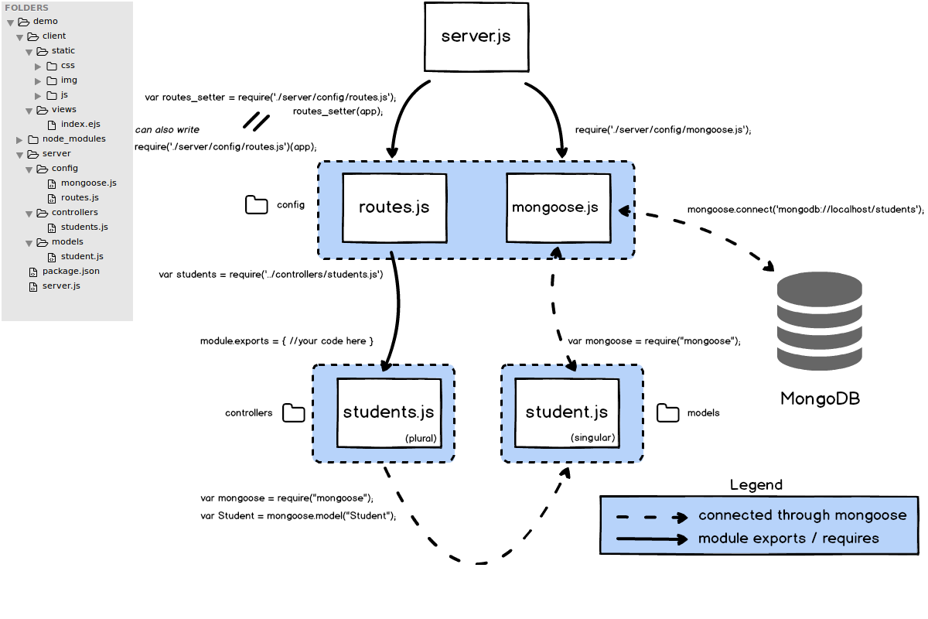

Handy snippets:

var PostSchema = new mongoose.Schema({

text: String,

comments: [{type: Schema.Types.ObjectId, ref: 'Comment'}]

}, {timestamps: true})

var CommentSchema = new mongoose.Schema({

text: String,

_post: {type: Schema.Types.ObjectId, ref: 'Post'}

}, {timestamps: true})

// the populate method grabs all of the comments using their IDs stored in the comment

// property array of the post document!

Post.find({}).populate('comments').exec(function(err, posts){

res.render(‘index’, {posts: posts});

}

res.render(‘index’, {posts: posts});

res.redirect(‘/’);

res.json({key: value});