Deep Reinforcement Learning for Energy-Efficient Consumption Management in Smart Buildings
A Calibrated Physical Twin as Soft Regularizer for HVAC Control

Abstract
Reinforcement learning controllers for HVAC systems are typically trained on neural-network surrogates because high-fidelity simulators are too slow for the millions of environment steps consumed by modern policy-gradient methods. A natural assumption is that a more physically faithful surrogate produces a better training environment. We test that assumption on the BOPTEST bestest_air testcase and report a negative result: a calibrated physical twin with explicit zone thermal capacitance reaches a 24-hour rollout RMSE of 0.644 C versus 1.466 C uncalibrated, yet fails as a stand-alone RL training environment with live closed-loop RMSE above 4 C. We resolve the gap by using the calibrated twin as a frozen soft physical regularizer for a smoother control-oriented surrogate. The canonical hybrid backend sustains 1,786.8 environment steps/s on one CPU thread, an 85.0x speed-up over the live BOPTEST RTE HTTP loop under the same 15-min protocol, and restores live closed-loop RMSE to 0.633 C on the peak window and 0.612 C on the typical window. The optimal regularization strength is controller-family specific: lambda_temp=0.10 for thermostatic PPO, but lambda_temp=0.00 for HDRL and 17D MORL. A pre-registered transferability block further shows that the Stage A/B/C inverse surrogate-calibration pipeline transfers across three hydronic BOPTEST testcases with 60.2-87.8% RMSE_T improvement and consistent C_zon re-identification in the 1.89-1.95x range versus bestest_air, whereas frozen controller transfer is regime-dependent and not deployment-ready without target-specific fine-tuning. All numerical justifications are provided in Supplementary Tables S1-S11.
Keywords: HVAC control; deep reinforcement learning; digital twin; physics-informed machine learning; BOPTEST; multi-objective reinforcement learning.

1. Introduction

1.1 Motivation
Buildings remain one of the largest energy-consuming and carbon-relevant sectors worldwide, which makes operational improvements in heating, ventilation, and air-conditioning systems a central lever for decarbonization and grid-responsive demand management [1]. Yet HVAC operation is still governed by a persistent modeling problem: controllers must negotiate comfort, energy use, weather variability, and equipment constraints in systems whose dynamics are nonlinear, partially observed, and strongly building-specific. In that setting, the model used for control is not a secondary implementation detail; it largely determines whether advanced control can be trained, benchmarked, and transferred in a credible way.
For that reason, building-control research has long invested in control-oriented dynamic models and predictive optimization. Comparative studies of advanced control strategies show the continuing relevance of predictive control for building energy management [2], while grey-box identification remains attractive because it preserves physically interpretable structure without requiring the full modeling burden of a white-box simulator [3]. At the same time, the emergence of community testbeds has changed how such methods can be evaluated. The Building Optimization Testing Framework (BOPTEST) established a standardized, simulation-based environment for benchmarking building control strategies [4], and the subsequent OpenAI-Gym interface lowered the barrier for testing reinforcement-learning controllers under a common evaluation workflow [5].
Within these benchmarked settings, reinforcement learning has moved from proof-of-concept toward explicit comparison with established control paradigms. Recent work has directly compared reinforcement learning and model predictive control for building energy system optimization [6], and hybrid formulations such as reinforced model predictive control have attempted to combine predictive planning and learning in a single framework [7]. This direction is important because RL offers flexibility in nonlinear and multi-objective settings, but it also inherits acute sample-efficiency and generalization challenges, especially when the learning process depends not on the real building, but on a simulated or learned environment whose inductive biases may shape the policy as much as the reward function itself.

1.2 Gap
The modeling literature has responded by moving beyond purely black-box prediction. Physics-constrained deep learning has shown that thermal models can be structured to preserve physically meaningful and operationally plausible dynamics [8]. In parallel, transfer-oriented work has demonstrated that thermal-dynamics representations can be adapted across buildings with limited target data [9], and that RL-based HVAC controllers can also be transferred across heterogeneous buildings and operating conditions [10]. These studies make physical priors and transfer mechanisms highly relevant to scalable building control, but they also raise a more subtle question that has not yet been resolved cleanly: what kind of surrogate is actually most useful inside the control-learning loop?
Recent work on digital-twin-enabled building control sharpens that question further. Simulated digital twins are increasingly proposed as reusable environments for building-application development [11], and surrogate-accelerated workflows in BOPTEST suggest that differentiable or data-driven approximations can drastically reduce computational cost while retaining useful predictive behavior over control horizons [12]. At the same time, recent reviews of field demonstrations show that reliable deployment evidence for MPC and RL remains limited and methodologically uneven [13], while newer model-based RL studies increasingly emphasize continual transfer [14] and counterfactual surrogate modeling [15] as routes to better data efficiency. Taken together, these lines of work suggest that benchmark quality, surrogate quality, and transfer quality are now central bottlenecks in the field. However, the literature still tends to assume, implicitly or explicitly, that a surrogate with better predictive fidelity will also be a better environment for learning a controller.

1.3 Hypothesis and study design
This article addresses that unresolved assumption directly. Rather than treating surrogate quality as a single scalar property, the study evaluates building surrogates in two distinct roles: first, as predictive models of HVAC dynamics, and second, as training environments for reinforcement learning. The analysis is performed in a standardized BOPTEST workflow anchored on a single-zone source case and then extended to related hydronic-family target cases. Methodologically, the study contrasts a compact control-oriented black-box surrogate with a physically informed RC-NeuralODE surrogate, separates data-resolution effects from calibration effects through matched-corpus experiments, and tests whether physical structure contributes most when used as a direct rollout model, as a soft regularizer, or as a transferable calibration prior.
The working hypothesis is therefore not that more physics is always better. The stricter hypothesis is role-dependent: predictive structure, training utility, and transferability may diverge, and a physically calibrated twin may be more useful as a constraint on learning than as the environment in which the policy is optimized. This hypothesis is evaluated through three linked blocks. Block 1 tests predictive fidelity and the fidelity-to-RL gap. Block 2 tests downstream control utility across thermostatic PPO, HDRL, and MORL controller families. Block 3 tests cross-testcase transfer under a pre-registered protocol that separates surrogate recalibration from frozen-controller deployment.

1.4 Contribution and results summary
The resulting perspective leads to a contribution that is both negative and constructive. The negative result is that better long-horizon predictive fidelity does not necessarily imply better reinforcement-learning training utility: a surrogate that more accurately reproduces thermal trajectories can still induce inferior live control when used directly inside policy optimization. The constructive result is that these objectives can be partially reconciled when surrogate roles are separated: a fast control-oriented model can supply rollout dynamics, while a calibrated physical twin constrains learning through disagreement penalties, yielding a hybrid environment that is simultaneously tractable, physically informed, and empirically stronger in transfer.
The study further shows that this logic is controller-family specific, that observation-interface design can dominate controller outcomes in multi-objective settings, and that inverse surrogate recalibration transfers across related target testcases more reliably than frozen controllers do. In the bestest_air source case, calibrated v3.5 achieves strong predictive validity but fails as a standalone RL rollout backend; the hybrid v3/v3.5 backend restores live control performance for thermostatic PPO. In the MORL branch, the N=5 seed extension falsifies an initially plausible seasonal action-saturation explanation and motivates cautious reporting of Pareto points with seed uncertainty. In the Block 3 transfer experiments, full Stage A/B/C recalibration improves temperature RMSE by 60.2-87.8% across three hydronic testcases and consistently re-identifies C_zon in the 1.89-1.95x range versus bestest_air, while frozen controller transfer remains regime-dependent and not deployment-ready.
By framing surrogate design as a question of functional role rather than absolute predictive score, the paper aims to clarify how physics, data, and benchmarking should be combined in learning-based HVAC control. The central claim is therefore not that more physics is always better, nor that black-box surrogates are sufficient in isolation, but that predictive structure, training utility, and transferability must be evaluated separately and then recombined deliberately. This framing has direct implications for scalable digital twins, for the interpretation of benchmark results in building control, and for the practical path from simulation-based training to building-ready control policies.

Contributions
1. A comfort-oriented v3 surrogate for direct supply-temperature control and RL rollout generation.
2. A physically informed v3.5 grey-box surrogate with explicit C_zon identified through Stage A/B/C inverse calibration.
3. A hybrid backend where v3 supplies the smooth RL dynamics and calibrated v3.5 acts as a frozen physical disagreement regularizer.
4. Controller-family-specific evidence: lambda_temp=0.10 for thermostatic PPO, lambda_temp=0.00 for HDRL and 17D MORL.
5. A pre-registered transferability analysis across three hydronic BOPTEST testcases, showing uniform surrogate-side transfer under full Stage A/B/C recalibration and regime-dependent frozen-controller transfer.
6. A reproducible Hou-and-Evins-style numerical audit with S1-S11 supplementary tables and real-data figures.

2. Related Work
Reference | Domain | Method | Training env. | Model type | Objective | Key limitation | How this paper differs
Hou & Evins [17] | Surrogate validation | Reporting protocol | Offline traces | NN surrogate | Predictive validity | No RL utility test | Extends protocol to closed-loop RL and transfer.
Gao et al. [18] | HVAC DRL | Predictive information | Simulation | GRU predictor | Comfort-energy | Predictive signal assumed useful | Shows predictive fidelity can hurt as rollout backend.
Wang et al. [19] | Safe DRL | MPC filter | Control loop | Safety filter | Safe actions | Hard safety layer | Tests soft physical regularization.
Liao et al. [21] | HDRL HVAC | Hierarchical RL | Simulation | Controller hierarchy | Comfort/energy | No surrogate-role audit | Tests controller-family specificity.
Coraci et al. [23] | Transfer | Online transfer | Target adaptation | Controller adaptation | Deployment | Allows policy adaptation | Separates surrogate transfer from frozen-controller transfer.
Offline RL survey [27] | RL methodology | Distribution shift | Offline data | Policy/data support | OOD robustness | Generic RL | Shows surrogate-induced shift in HVAC control.
Table 1. Literature positioning and research gap. Detailed literature notes are reported in the supplementary material.

2.1 Deep reinforcement learning for HVAC control
Deep reinforcement learning has become a major line of HVAC-control research because it can optimize energy and comfort without requiring a fully specified model predictive controller. The technical review by Al Sayed et al. [16] frames this literature as a response to the limits of fixed rule-based control, classical optimization, and manual supervisory tuning. Recent HVAC-RL work has moved beyond simple single-action PPO: Wang et al. [19] combine DRL with MPC-style safety filtering; Sun et al. [29] study winter residential air-conditioning control under predicted disturbances; Savino et al. [28] compare low-level DRL controllers against ASHRAE G36 sequences in multi-zone buildings; and Liao et al. [21] use hierarchical DRL to handle hybrid discrete-continuous HVAC action spaces and multi-objective rewards. These studies establish that learning-based control can be competitive, but they also show that safety, action representation, and evaluation protocol strongly affect the final result.
Our work follows this line but asks a narrower and more falsifiable question: when does a high-fidelity surrogate improve downstream RL control? The Block 2 results show that the answer is controller-family specific. Thermostatic PPO benefits from a calibrated physical disagreement penalty at lambda_temp=0.10, while HDRL and 17D MORL reject the same temperature channel and perform best with lambda_temp=0. This prevents a generic claim that physics regularization is always useful. Instead, the contribution is an empirical role assignment: calibrated physics is valuable as a soft teacher for some controllers, not as a universal rollout backend.

2.2 Surrogate and digital twin models for building energy
Surrogate models and digital twins are widely used because live building simulators and high-fidelity Modelica emulators are too slow for RL-scale policy optimization. Hou and Evins [17] argue that neural-network building surrogates require a disciplined development and evaluation protocol: sample generation, preprocessing, split representativeness, feature justification, scaling, architecture selection, sensitivity analysis, and multi-horizon predictive validation should all be reported explicitly. We adopt this protocol as the reporting backbone for Block 1 and extend it with a downstream-control test: a surrogate is not considered successful merely because it predicts well; it must also be tested as part of the RL training and live BOPTEST deployment loop.
Predictive information can improve HVAC RL when it is injected in the right form. Gao et al. [18] show that GRU-based predictive information can improve DRL control in an office-building case study. Our result is complementary but more cautionary. The calibrated v3.5 physical twin is clearly the best forecasting model in Block 1, reaching 24h RMSE_T=0.644 C after Stage A/B/C calibration. However, PPO trained directly on this model fails in live closed-loop BOPTEST with comfort RMSE above 4 C. This separates predictive validity from RL training utility. It also links to the offline-RL distribution-shift concern discussed by Samani et al. [27]: a model that is accurate on held-out trajectories may still induce a poor policy-learning landscape when the agent leaves the data-supported region.

2.3 Physics-informed and safety-aware learning
Physics-informed HVAC learning can be implemented in several ways. One direction imposes physical or safety structure directly on the controller, for example through thermodynamically constrained actor-critic objectives or MPC-based safety filters. Hedayat et al. [20] represent this hard-constraint direction for HVAC optimization, while Wang et al. [19] use a DRL-MPC architecture to keep learning-based actions inside a safe operational envelope. These approaches are designed to prevent unsafe actions at deployment time.
The present work uses a different mechanism. The calibrated v3.5 twin is not a hard safety filter, does not project actions, and does not replace the live BOPTEST evaluation layer. It remains frozen during RL training and contributes only a soft disagreement term against the control-oriented v3 surrogate: L_total = L_PPO + lambda_temp ||T_v3 - T_v3.5||^2 + lambda_power ||P_v3 - P_v3.5||^2. This design is intentionally weaker than hard safety filtering, but it isolates the scientific question of whether physical fidelity helps as a training regularizer. The negative controls show why that distinction matters: direct v3.5 rollout and v3.5 warm-start both fail, whereas the soft-regularized hybrid succeeds for thermostatic PPO.

2.4 Multi-objective RL and Pareto analysis
HVAC control is inherently multi-objective: reducing energy use can conflict with thermal comfort, equipment smoothness, and safety. The multi-objective sequential decision-making survey by Roijers et al. [22] provides the general framework for scalarization and Pareto-front analysis. Recent HVAC-RL studies, including Liao et al. [21], operationalize this idea through weighted comfort, air-quality, and energy rewards. Our MORL block follows this scalarization perspective but treats the Pareto result as an empirical object requiring seed analysis rather than as a single-trajectory demonstration.
The resulting finding is intentionally conservative. The 17D MORL sweep identifies plausible comfort-energy trade-offs, but the canonical preference points remain seed-sensitive at N=5. The pre-registered action-saturation hypothesis, initially motivated by an N=3 seasonal pattern, was falsified when seeds 45 and 46 were added. This is not reported as a failure to hide; it is part of the methodological contribution. In this domain, small-seed seasonal patterns can be transient, and aggregate Pareto points must be reported with uncertainty.

2.5 Transfer learning and cross-testcase generalization
A second branch of the literature asks how controllers trained in one building can be transferred to another. Coraci et al. [23] study online transfer learning in a real office building and use imitation/fine-tuning to reduce deployment burden. Hou et al. [24] propose multi-source transfer learning for DRL HVAC deployment, where source environments are selected to improve target training efficiency. Kadamala et al. [25] also evaluate DRL transfer learning between HVAC scenarios, and Coraci et al. [26] study heterogeneous transfer across diverse energy systems. These works typically allow some form of target adaptation of the policy.
Block 3 deliberately fixes a stricter question before running the hydronic transfer experiments. It asks which components of the bestest_air recipe transfer without post-hoc controller fine-tuning. The answer is component-level. Full Stage A/B/C surrogate recalibration transfers across three hydronic BOPTEST testcases, improving RMSE_T by 60.2-87.8% and re-identifying C_zon consistently in the 1.89-1.95x range versus bestest_air. The frozen controller, however, is not deployment-ready: residential hydronic testcases fail by comfort, while the commercial hydronic testcase passes the pre-registered scalar threshold only with a 35.3% energy penalty. This positions controller fine-tuning on the target-recalibrated surrogate as future work rather than as an unreported post-hoc rescue.

2.6 Runtime Speed BOPTEST benchmarking
BOPTEST provides the live evaluation layer for this paper. Blum et al. [4] introduced BOPTEST as a simulation-based benchmarking framework with containerized building emulators, a common HTTP API, overwriteable control points, baseline controllers, and standardized KPI reporting. BOPTEST exposes realistic Modelica building models through a standard interface so that control algorithms can be benchmarked without physical installation. We use BOPTEST RTE version 1.0.0-dev as the authoritative closed-loop evaluator, not merely as a data generator.The whole motivation for substituting BOPTEST with an in-process surrogate during RL training is computational. PPO typically consumes 1×10⁶ – 5×10⁶ environment steps to converge; at the BOPTEST RTE HTTP step rate this would take hours per training run and would dominate wall-clock time. The speed benchmark answers a specific question: under the same 15-minute control protocol, what step rate do v3, v3.5, and the hybrid backend deliver compared with BOPTEST RTE?
This choice is important for the paper's logic. All surrogate models are intermediate artifacts; live BOPTEST remains the final arbiter of controller performance. The Block 1 fidelity-to-control gap, the Block 2 hybrid-backend selection, and the Block 3 hydronic transfer results all depend on this separation. A model can win on predictive RMSE and lose in closed-loop control; only the BOPTEST deployment layer exposes that failure.
The benchmark uses 100 episodes × 96 steps = 9 600 total simulated steps, single CPU thread, no GPU. BOPTEST is reached through its HTTP-Docker interface (the same one used in production training and evaluation), so the comparison is apples-to-apples with the actual training stack — not against a stripped-down local Modelica binary, which would understate the speed-up.
The hybrid is the slowest of the three surrogates (1787 steps/s, 0.507 ms median) because every PPO update requires a forward pass through BOTH v3 (rollout dynamics) and v3.5 (regulariser target). That overhead is unavoidable by construction. The headline 85× speed-up against BOPTEST is still large enough to make the hybrid usable for PPO training on a single CPU core — a single 5×10⁶-step training run takes roughly 47 minutes of pure environment time vs about 66.1 hours if BOPTEST were used directly.
Two practical points follow. First, although v3 is the fastest backend, we do not train PPO purely on v3 because that gives up the regularisation benefit measured in Section 4. Second, although v3.5 is faster than the hybrid (2400 steps/s) we do not train PPO on v3.5 either — Section 4 shows that PPO trained on standalone calibrated v3.5 fails catastrophically on the live BOPTEST loop (RMSE > 4 °C). The hybrid backend is therefore the unique operating point where speed, fidelity, and trainability all reach acceptable levels simultaneously.

3. Methodology
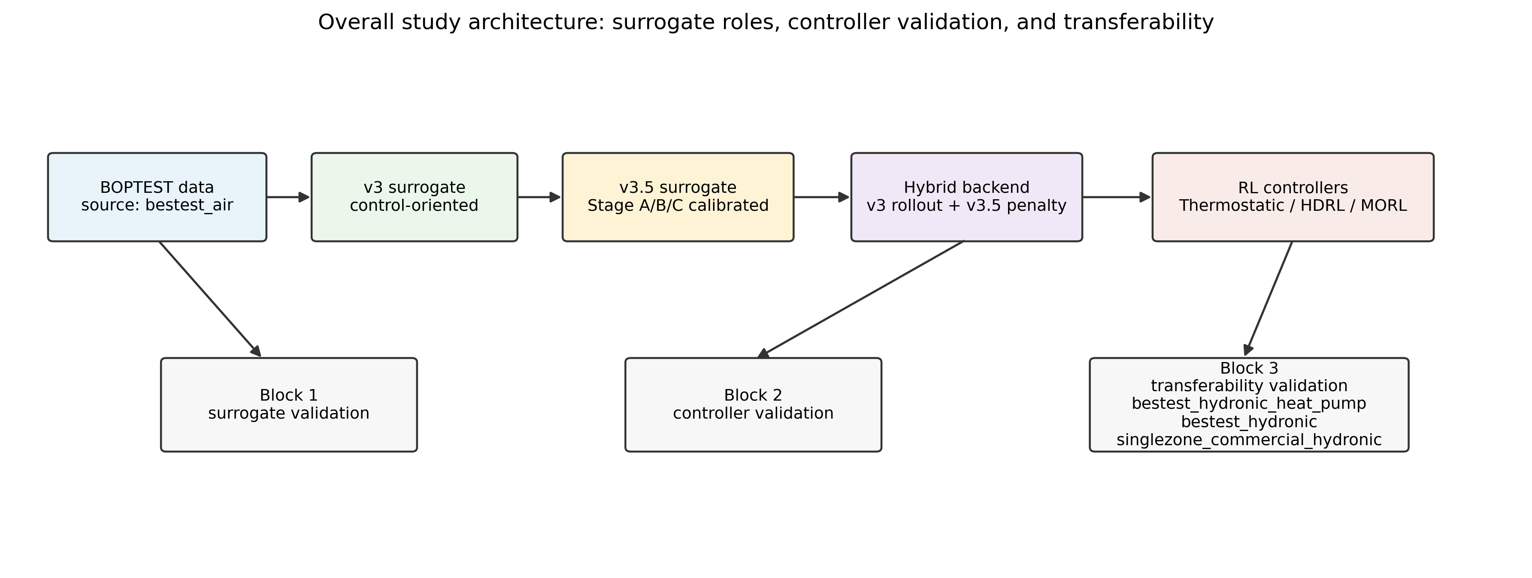
Figure 1. Overall experimental pipeline. The study separates data generation, surrogate calibration, live controller validation, and transferability testing rather than treating digital-twin accuracy as a single scalar property.
Surrogate/backend | Architecture | Input dim | Output | Physical structure | Parameters | Training corpus | Calibration | Role in RL
v3 | Compact dual-head MLP | 8 | dT, HVAC power | No explicit physics | 8,482 | hourly + matched 15-min check | Supervised | Primary rollout environment
raw v3.5 | RC-NeuralODE + residual heads | 15-min prepared | T_next, power | C_zon backbone | ~50k | 10,744 rows | None | Architecture-only negative baseline
calibrated v3.5 | RC-NeuralODE + residual heads | 15-min prepared | T_next, power | identified C_zon | ~50k | 10,744 rows | Stage A/B/C | Predictive twin and frozen teacher
hybrid | v3 rollout + frozen v3.5 teacher | policy obs | rollout + disagreement | soft physical regularizer | v3 + v3.5 | same source corpus | lambda weights | Canonical thermostatic backend
Table 2. Surrogate architectures and calibration summary.
Component | Definition used in main experiments | Why it matters
Observation | 17D TSup-style state: physical variables, cyclic time, ambient forecast, previous action/history | MORL 5D failed; 17D recovers usable preference-conditioned control.
Action | Continuous normalized action mapped to supply-temperature command 18-35 C plus fan/intensity channel | Keeps controller compatible with bestest_air source testcase.
Reward | Comfort + energy + smoothness; MORL scalarizes comfort/energy/safety weights | Separates thermostatic, HDRL, and MORL objectives.
Thermostatic PPO | PPO final-policy live BOPTEST evaluation; lambda_temp sweep | Primary positive hybrid result.
HDRL | Hierarchical PPO variant; lambda_temp sweep | Tests controller-family specificity.
MORL | Preference-conditioned pretrain/finetune; canonical N=5 seeds | Tests Pareto trade-offs and seed variance.
Table 4. Controller training configuration, observation/action interface, and reward definition.

3.1 Problem formulation
The HVAC control problem is treated as a finite-horizon Markov decision process with state s_t, continuous action a_t, stochastic exogenous weather w_t, transition model f, and reward r_t. At each 900 s control step, the controller observes a compact building state, chooses an HVAC command, receives the next zone temperature and power response, and accumulates an objective that penalizes comfort violation, unnecessary energy use, and abrupt control changes. The live system transition is the BOPTEST RTE emulator. The learning-time transition is either the control-oriented surrogate v3, the physically informed surrogate v3.5, or the hybrid backend that combines the two in different roles.
The action for the bestest_air source testcase is a normalized two-dimensional vector a_t in [-1,1]^2. The first component maps to a supply-temperature command T_supply in [18,35] C, and the second component controls the fan/intensity channel used by the surrogate and PPO policy. The canonical thermostatic observation contains 17 features: five physical variables, four cyclic time encodings, five weather forecast terms at 1/3/6/12/24 h horizons, and three history terms consisting of the previous action and the previous temperature change. Ablation variants remove or transform parts of this observation, but the article-facing controller uses the validated no_delta_t / clipped_log / raw-style encoding reported in the experiment artifacts.
The reward used for thermostatic PPO is comfort-first. Inside the 21-24 C comfort band, the agent receives a target-tracking bonus around the band center and a small energy penalty. Outside the band, comfort violation dominates; winter underheating receives a stronger penalty than mild overshoot because underheating is the observed high-risk failure mode in the source testcase. A smoothness term penalizes squared action changes. When the hybrid backend is active, an additional disagreement penalty is added against the frozen calibrated v3.5 teacher. In compact form:
r_t = r_track(T_zone) + r_smooth(a_t-a_{t-1}) + r_power(P_t) - lambda_temp ||T_v3 - T_v3.5||^2 - lambda_power ||P_v3 - P_v3.5||^2
For MORL, the scalar reward is replaced by a preference-conditioned scalarization of comfort and energy components, with weights w = (w_comfort, w_energy, w_safety). The canonical preference points are w=(0.50,0.50,0.00) and w=(0.75,0.25,0.00), each later extended to N=5 seeds under the pre-registered stopping rule.

3.2 Surrogate roles and model variants
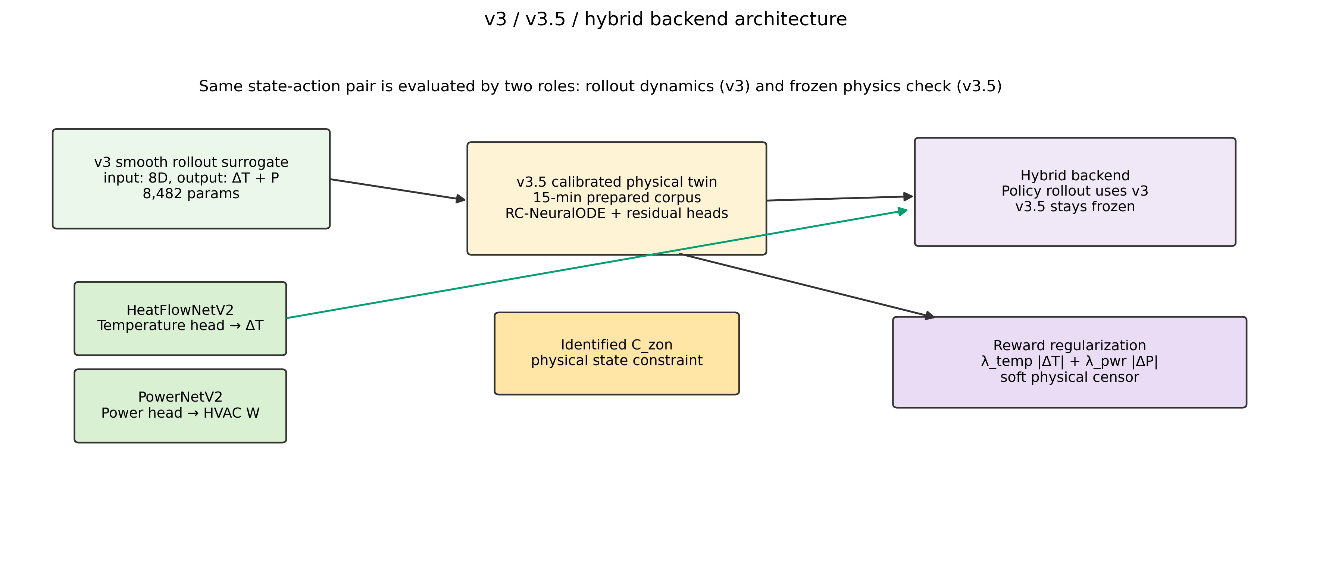
Figure 2. v3 / v3.5 / hybrid backend architecture with tensor roles and parameter counts. v3 is the smooth dual-head rollout surrogate; v3.5 is the calibrated physics-informed twin; hybrid uses frozen-v3.5 disagreement as a soft physical censor.
The study compares three surrogate roles rather than three interchangeable models. The v3 surrogate is a compact black-box model designed for stable rollout gradients; calibrated v3.5 is a physically informed RC-NeuralODE-like model designed for predictive validity and parameter interpretation; the hybrid backend uses v3 as the policy rollout environment and v3.5 as a frozen physical teacher. This role separation is the central methodological decision because a model can be useful as a predictor while being harmful as an RL environment.

3.3 Control-oriented surrogate v3
The v3 surrogate maps the encoded state and continuous action to one-step predictions of zone-temperature change and HVAC power. Its architecture is intentionally small: a shared multilayer perceptron feeds a temperature head and a power head. The active article path now supports the same 900 s / 15-min step used by v3.5 and BOPTEST yearly validation, so corpus-matched v3 checks can separate timestep effects from physics-calibration effects. v3 is not presented as a physically interpretable digital twin; its purpose is to give PPO a smooth, fast, differentiable-enough environment whose local dynamics do not destabilize policy optimization.
The v3 training objective combines temperature and power prediction losses on BOPTEST-generated direct-TSup traces. It is evaluated by multi-horizon rollout RMSE and, more importantly, by downstream live BOPTEST transfer after a policy has been trained on it. This is why v3 remains relevant even when v3.5 is more accurate as a forecasting model: RL training utility is an empirical closed-loop property, not a direct consequence of one-step prediction loss.

3.4 Physically informed surrogate v3.5 and Stage A/B/C calibration
The v3.5 surrogate introduces an explicit zone thermal capacitance C_zon and neural residual heads. Its calibration follows a three-stage inverse protocol adapted from the Hou-and-Evins reporting framework [17]. Stage A prepares causal 15-min telemetry by correcting alignment, bias, power scaling, and feature consistency. Stage B identifies C_zon on excitation-rich rows while residual corrections are constrained. Stage C freezes the identified capacitance and fits residual temperature/power heads to capture dynamics not represented by the scalar RC backbone.
This separation is also used in Block 3. On hydronic transfer cases, partial recalibration means Stage C only with C_zon frozen from bestest_air, while full recalibration means Stage A/B/C on the target testcase. The difference between these regimes allows the paper to distinguish residual-head adaptation from actual re-identification of building thermal mass.

3.5 Hybrid backend and loss coupling
The hybrid backend is not an ensemble simulator. The policy state transition is still produced by v3. At each training step, the same state-action pair is also evaluated by the calibrated v3.5 teacher, and the difference between the two predicted temperature/power responses is converted into an auxiliary penalty. Therefore v3.5 influences the policy through the loss surface but never becomes the rollout dynamics. This prevents the policy from inheriting the unstable training landscape observed when PPO is trained directly on v3.5.
L_total = L_PPO + lambda_temp ||T_v3 - T_v3.5||^2 + lambda_power ||P_v3 - P_v3.5||^2
The values of lambda_temp and lambda_power are not assumed universal. Block 2 sweeps lambda_temp for thermostatic PPO and HDRL, then carries only the empirically supported channels into MORL. The final interpretation is role- and controller-specific: calibrated physics helps thermostatic PPO at lambda_temp=0.10, but HDRL and MORL use the power-only variant because temperature disagreement degrades their closed-loop behavior.

3.6 Controller families
Four controller families are used. The BOPTEST built-in PI controller is the reference baseline because it is testcase-native and reproducible. Thermostatic PPO is the main source-case controller and acts directly on the continuous T_supply/fan-style action interface. HDRL tests whether the same regularization logic survives a hierarchical action representation. MORL tests preference-conditioned comfort-energy trade-offs using scalarized reward weights and a 17D observation interface. The point is not to claim a single universal controller, but to test whether the surrogate conclusion remains stable across controller classes.

3.7 Transferability methodology
Block 3 is pre-registered before running target-testcase BOPTEST evaluations. The transfer question is component-level: does the surrogate calibration pipeline transfer, and does the frozen controller transfer? Three regimes are defined. In mode=none, the frozen bestest_air recipe is deployed on the target testcase through a documented actuator adapter. In mode=partial, Stage C residual heads are recalibrated on target telemetry while C_zon and the controller remain frozen. In mode=full, Stage A/B/C is rerun on target telemetry, but the controller remains frozen. Because controller fine-tuning is explicitly excluded, any improvement in surrogate fidelity is not allowed to rescue the live controller verdict post hoc.

4. Experimental Setup

4.1 Testbeds and serving layer
All live-control experiments are executed through BOPTEST RTE version 1.0.0-dev using the HTTP API. This is intentional: the same serving layer is used for telemetry collection, live validation, replay determinism tests, and the speed benchmark. Blocks 1 and 2 use bestest_air as the source testcase because it provides the direct supply-temperature control convention used by the v3/v3.5 surrogate family. Block 3 evaluates transfer to three related hydronic-family targets: bestest_hydronic_heat_pump, bestest_hydronic, and singlezone_commercial_hydronic.

4.2 Data generation and preprocessing
The source-case surrogate corpus is generated from BOPTEST trajectories under direct supply-temperature excitation and policy-like rollouts. The v3/v3.5 comparison uses a prepared 15-min corpus for calibrated v3.5 and a corpus-matched v3 retraining check to separate timestep/corpus effects from physical calibration effects. The article reports data generation, sample-size justification, split representativeness, Stage A preprocessing, scaling, input independence, and training hyperparameters in Supplementary Tables S1-S8.
For Block 3, target telemetry is collected with the hydronic adapter policy used in live transfer. This keeps the target calibration corpus aligned with the actuator mapping actually used by the frozen controller. Adapter smoke tests are run before yearly control evaluation to verify that high-supply commands produce higher heat power and no lower final zone temperature than low-supply commands.

4.3 Training and calibration workflow
The workflow has three layers. First, Block 1 trains and validates v3 and v3.5, including the two-pass canonical v3.5 calibration in which Stage B identifies C_zon and Stage C refines residual heads. Second, Block 2 trains controller families on the selected surrogate backend and evaluates them live on BOPTEST bestest_air. Third, Block 3 freezes the bestest_air controller, applies documented target adapters, and tests none/partial/full surrogate recalibration regimes on hydronic targets. This sequencing prevents leakage: Block 3 target results are not used to retune Block 2 controllers.
Training is CPU-oriented. PPO runs use Stable-Baselines3-style policies and project-specific wrappers, while surrogate training uses PyTorch. Where canonical seed analysis is required, seeds are propagated through Python random, NumPy, PyTorch, PYTHONHASHSEED, and action/observation spaces. MORL canonical points are extended to N=5 only under the pre-registered stopping rule; there is no N=7 cascade after the bounded extension.

4.4 Runtime characteristics
Runtime is reported because it is part of the method, not just an implementation detail. BOPTEST RTE is the authoritative live evaluator, but it is too slow to serve as the main PPO training loop. Therefore the paper distinguishes live-evaluation fidelity from training-time throughput. The hybrid backend is slower than v3 because it evaluates both v3 and frozen v3.5, but it still preserves an 85.0x speed-up over the live BOPTEST RTE HTTP loop under the same 15-min stepping protocol.

4.5 Evaluation protocol and metrics
All control evaluations use a 900 s control step and the same comfort band [21,24] C. The primary raw quantities are zone-temperature trajectory, violation percentage, energy consumption in kWh, RMSE to the comfort-band center, and the scalar safety metric m_s. The paper never reports m_s alone: energy and comfort are always shown beside it because a scalar threshold can hide multi-objective trade-offs. This is especially important in Block 3, where the commercial hydronic testcase passes the pre-registered m_s threshold but uses substantially more energy than PI.
Comfort violation at a step is computed as v_t = max(0, 21 - T_zone,t, T_zone,t - 24). Violation percentage is the fraction of control steps with v_t > 0. Temperature RMSE is reported either against the comfort-band center or against BOPTEST trajectory targets, depending on whether the task is control evaluation or surrogate predictive validation. Energy is integrated from reported HVAC power over the 900 s step. For transferability, the pre-registered pass/fail rule is m_s_RL <= 1.25 * m_s_PI on the same testcase yearly evaluation.

Evaluation horizons: per-window versus yearly
We use a deliberate two-horizon evaluation protocol. The 14-day peak_heat_window and typical_heat_window scenarios are used for the in-testcase analyses of Sections 5 and 6 because they isolate controller-family behaviour at the operating extremes of the bestest_air scope: worst-case cold stress and mild average operation. The full yearly horizon is used for the transferability analysis of Section 7 because cross-testcase normalisation against each testcase's built-in PI baseline is fairest under full-year KPI averaging, which includes the target testcase's complete heating and non-heating regimes. Both evaluations share the same delta t = 900 s control protocol, the same comfort band [21, 24] C, and the same composite m_s metric; only the time horizon and the consequent normalisation differ.

4.6 Statistical and audit protocol
The seed protocol is deliberately asymmetric because compute is dominated by live BOPTEST yearly evaluation. Single-seed sweeps are used for broad Pareto exploration. The two canonical MORL preference points are then expanded to N=5 seeds when the pre-registered instability rule is triggered. Per-seed monthly diagnostics, replay determinism checks, and post-N=5 falsification logging are recorded in configs/morl_canonical_selection_log.yaml. The replay test for seed 42 is bit-identical across all 12 monthly scenarios, so observed seed variance is attributed to RL training stochasticity rather than BOPTEST simulator nondeterminism.
Block 3 is also pre-registered. The manifest specifies testcase candidates, excluded regimes, actuator-compatibility requirements, pass/fail criteria, early-termination logic, and append-only result slots before target-testcase runs. Adapter specifications are committed before live control runs when direct-TSup compatibility fails. This audit structure is included to make negative outcomes usable: a failed transfer cell is evidence about scope boundaries, not a post-hoc failure to tune.

4.7 Reproducibility and audit trail
The project repository is https://github.com/Almaz-2001/HVAC_DRL_MORL.git. The reproducibility roadmap is maintained in roadmap.md, and the Block 3 pre-registration manifest is configs/block3_testcase_manifest.yaml. Three audit anchors are cited in the paper: MORL canonical pre-registration commit 93df9b364657ac77bbe3642e4bc277d1eb8a8b60; MORL post-N=5 falsification commit 62dc859d02f5f4a75fa4b55d8477c1d4e6206449; and Block 3 open/close commits 1861e48dc0eacb2e2c466ba0e0d03502d9185723 / b915bfc635c287dd1da907ce84ce44c81378edd5. A follow-up audit commit 7ada793bde6d9ae1483c389b813b11cc60bdec8a records the Block 3 close SHA in the manifest.
Experiments use BOPTEST RTE version 1.0.0-dev through the HTTP-Docker service. The local analysis environment used for this document reports Python 3.11.9 and PyTorch 2.10.0+cpu; training and BOPTEST control runs are configured for CPU execution only (configs/*/agent.yaml device=cpu, surrogate_device=cpu), with no GPU used. Seed handling explicitly propagates the seed through Python random, NumPy, PyTorch, PYTHONHASHSEED, and action/observation spaces where available. A fixed-checkpoint BOPTEST replay test was bit-identical across all 12 monthly scenarios, so canonical seed variance is attributed to RL training stochasticity rather than simulator nondeterminism.

5. Results I: Digital Twin Fidelity

5.1 Block 1 objective and evidence boundary
Block 1 asks whether a higher-fidelity digital twin is also a better reinforcement-learning training environment. The answer is deliberately split. The physically informed v3.5 twin is the stronger predictor after Stage A/B/C inverse calibration, but direct PPO training on that twin is not the strongest live controller. This distinction is the first central result of the paper: predictive validity and RL utility are related but not interchangeable properties.
The control-oriented v3 surrogate is a compact dual-head model with separate temperature-increment and HVAC-power heads. Its purpose is not to be the most accurate 24-hour predictor; its purpose is to provide smooth, fast rollout dynamics for policy optimization. The calibrated v3.5 model, by contrast, is a physically informed RC-NeuralODE twin whose Stage B parameter is explicitly interpretable as the zone capacitance C_zon.
5.1.1 Engineering metric definitions
The Block 1 validation metrics are defined on recursive rollout trajectories rather than only on one-step supervised predictions. For a horizon h and N evaluated samples, the temperature rollout error is e_T,i(h) = T_hat_i(t+h) - T_i(t+h), and the reported horizon error is RMSE_T(h) = sqrt((1/N) sum_i e_T,i(h)^2). Figure 3 therefore measures accumulated closed-loop prediction error over 1 h, 4 h, 8 h, and 24 h horizons.
The residual-distribution diagnostic in Figure 4 uses the signed residual e_T = T_hat - T_BOPTEST and the absolute-error empirical CDF F_abs(epsilon) = P(|e_T| <= epsilon). The vertical engineering tolerances epsilon = 0.5, 1.0, and 1.5 C convert a statistical error distribution into a directly interpretable HVAC tolerance statement: they report what fraction of predictions stay within each temperature-error band.
The live-control utility comparison is deliberately separate from predictive RMSE. We define a live-utility gap for a training backend b as G_RL(b) = RMSE_live,T(b) - RMSE_rollout,T(b). A small or negative predictive RMSE alone is not sufficient; the backend is useful only if the learned policy also remains stable when transferred to the BOPTEST RTE.

5.2 Stage A/B/C calibration result
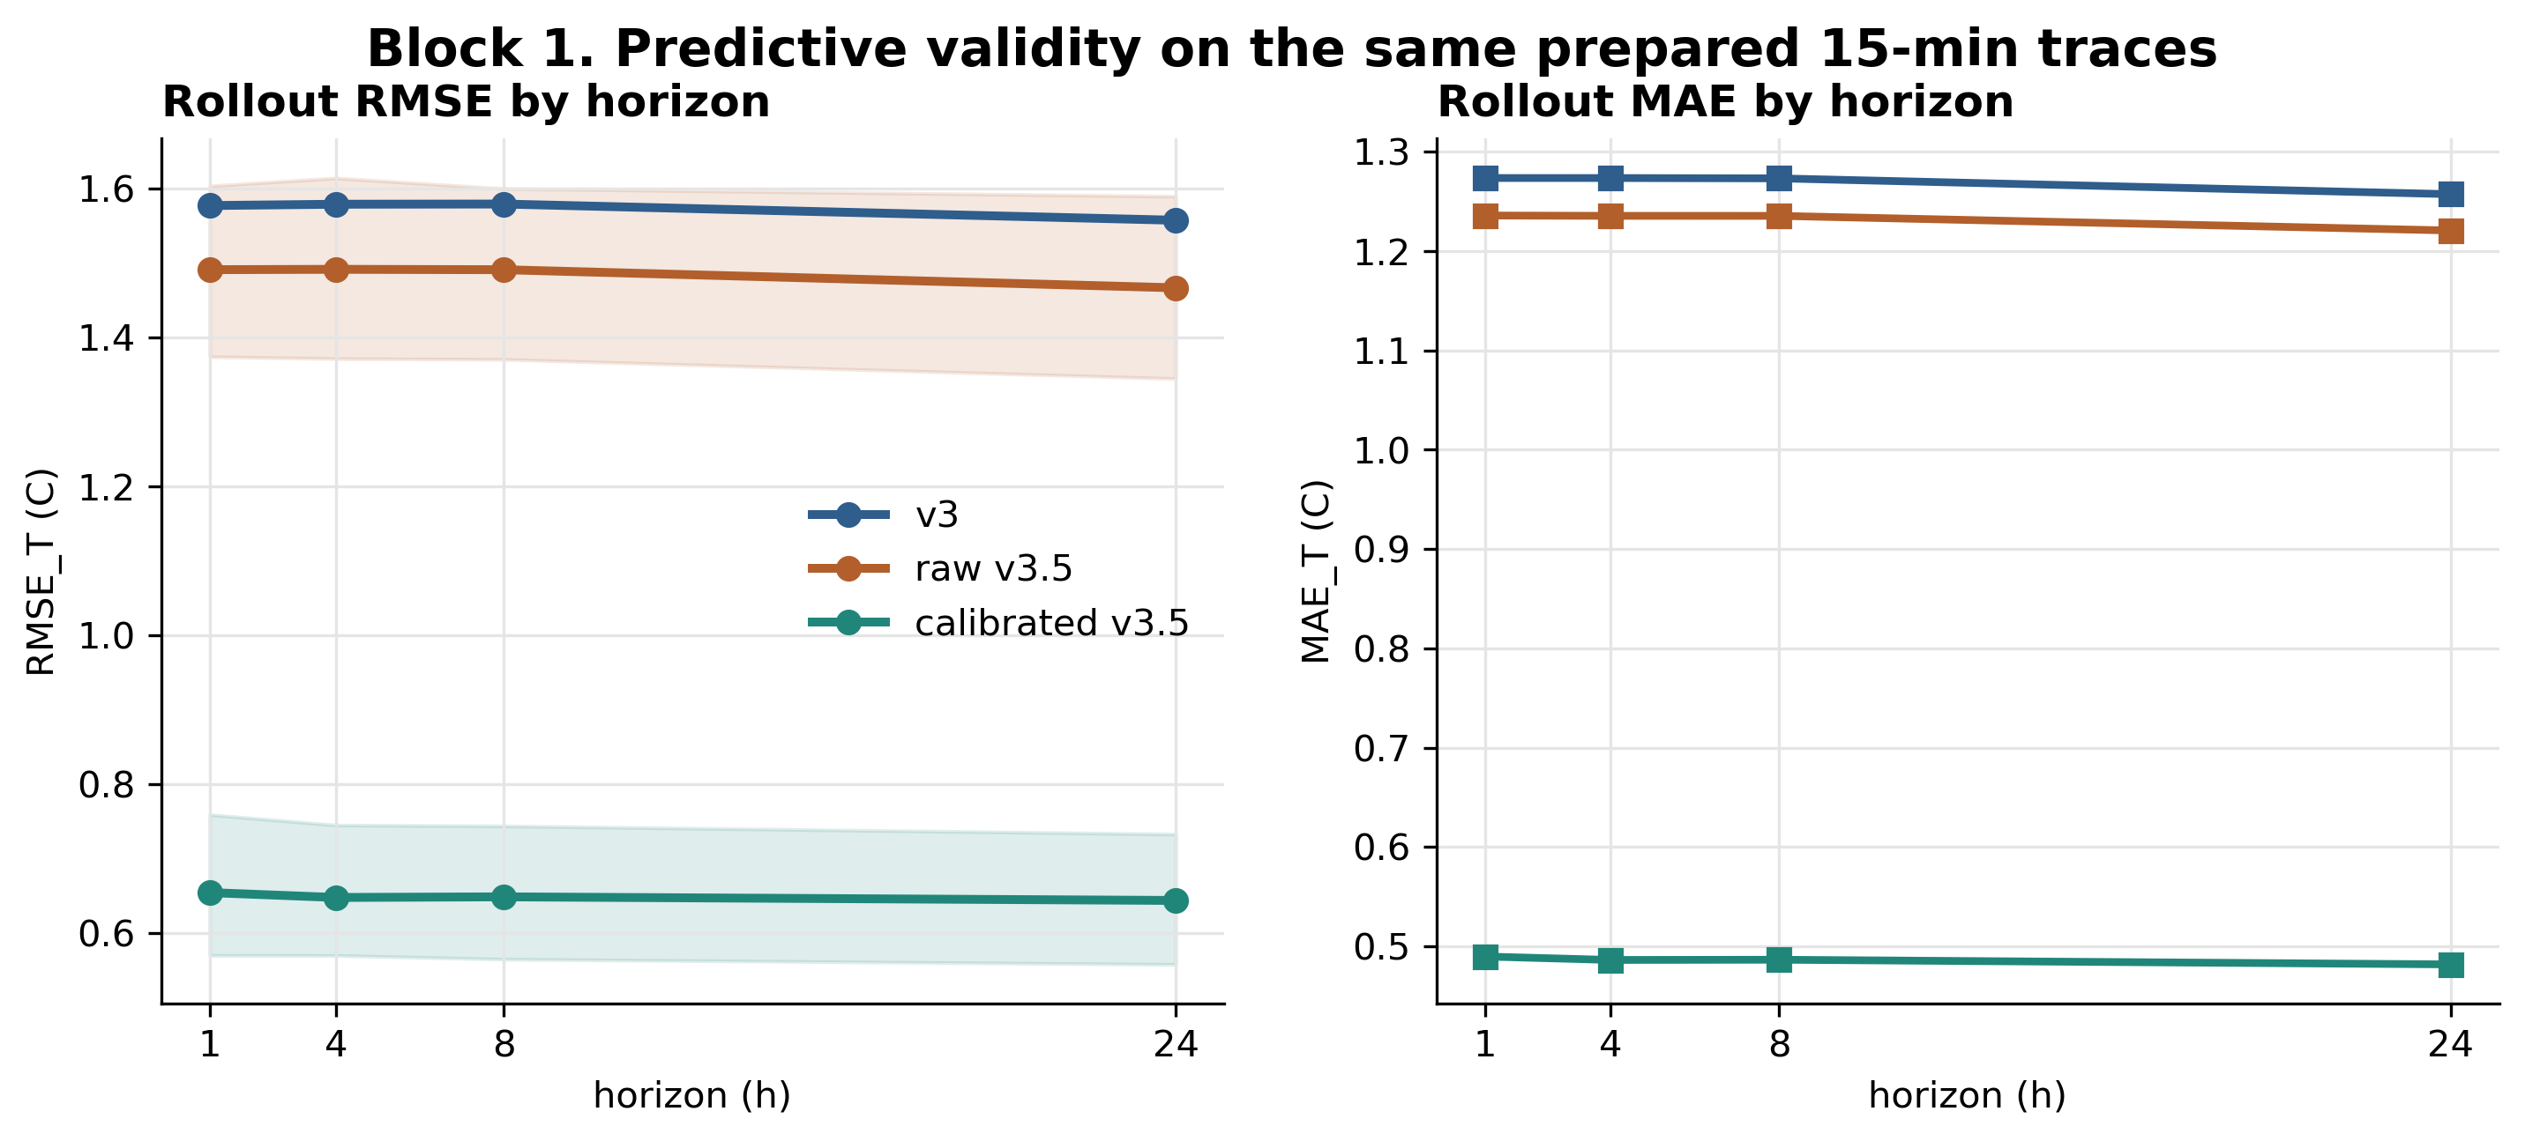
Figure 3. Multi-horizon rollout RMSE curves. Real horizon_metrics.csv artifacts show how recursive temperature error accumulates from 1h to 24h for v3, raw v3.5, and calibrated v3.5.
The quantitative Block 1 conclusion is therefore two-level. First, calibrated v3.5 is the best predictive twin: its 24 h rollout RMSE_T is 0.644 C, compared with 1.466 C for raw v3.5 and 1.557 C for the legacy v3 reference. The improvement is not confined to one-step alignment; it persists under recursive multi-horizon rollout, which is the relevant regime for controller training and validation.
Second, the raw physical architecture alone is not sufficient. Raw v3.5 remains close to the legacy v3 24 h error before inverse calibration, so the observed improvement must be attributed to the Stage A/B/C identification process rather than to adding a physics-inspired network topology by itself.
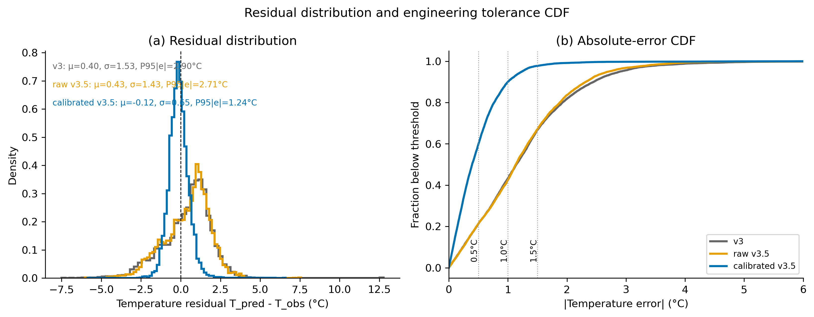
Figure 4. Residual distribution and absolute-error CDF. The figure reports bias, spread, P95 absolute error, and engineering tolerance thresholds at 0.5, 1.0, and 1.5 °C.
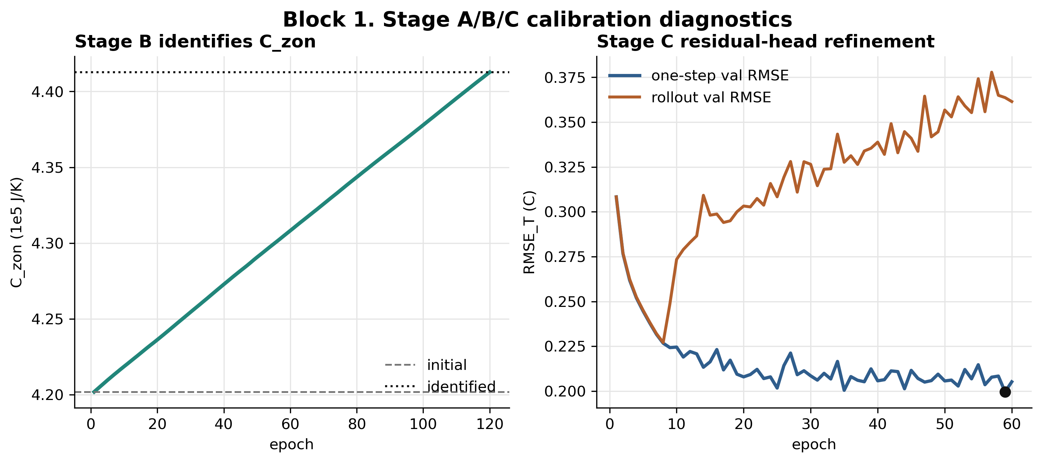
Figure 5. C_zon Stage-B identification and Stage-C residual-head diagnostics. The Stage-B trajectory documents physical-parameter convergence rather than manual tuning.
The calibrated v3.5 twin improves one-step and recursive temperature prediction while retaining physical interpretability. Stage B moves the capacitance from the 4.200e5 J/K prior to 4.413e5 J/K, a +5.1% update that is large enough to show data-driven identification but small enough to remain physically plausible. Stage C then reduces the temperature residual and the power-head error without moving the identified capacitance.
Stage B used an excitation-filtered subset of the telemetry rather than all quasi-steady samples. Only the top-excitation rows were used for C_zon identification (403 of 8058 training rows), which prevents steady operating points from dominating a parameter that is identifiable primarily during transients. This filtering is important for interpreting C_zon as a physical parameter rather than as a residual fitting knob.
The physical-parameter update can be written as eta_C = (C_zon,final - C_zon,prior) / C_zon,prior. With C_zon,prior = 4.200e5 J/K and C_zon,final = 4.413e5 J/K, eta_C = 0.0507, i.e. approximately 5.1%. This bounded update is important: it is large enough to demonstrate data-driven identification, but small enough to keep the calibrated twin physically plausible.
The final C_zon = 4.413e5 J/K is only 5.1% above the 4.200e5 J/K prior. This is the desired magnitude of update: large enough to show that the data modify the prior, but small enough to remain physically plausible and to avoid the appearance of unconstrained parameter fitting.
Metric / variant | Raw or baseline | Calibrated / matched | Absolute change | Relative / interpretation
1-step RMSE_T | 0.384 C | 0.235 C | -0.149 C | -38.9% after Stage A/B/C
24h rollout RMSE_T | 1.466 C raw v3.5 | 0.644 C calibrated v3.5 | -0.822 C | -56.1% within v3.5 family
Power MAE | 810 W | 482 W | -328 W | -40.5% after power-head refinement
C_zon | 4.200e5 J/K prior | 4.413e5 J/K | +2.13e4 J/K | +5.1%; physically plausible update
v3 hourly | 1.557 C | 0.876 C v3 15-min | -0.681 C | 74.6% of v3-to-v3.5 gap is corpus shift
v3 15-min to v3.5 | 0.876 C | 0.644 C | -0.232 C | 25.4% of gap is Stage A/B/C calibration
Table 3. Block 1 calibration and matched-corpus metrics. Full per-episode and residual diagnostics are in the supplementary material.

5.3 Matched-corpus decomposition
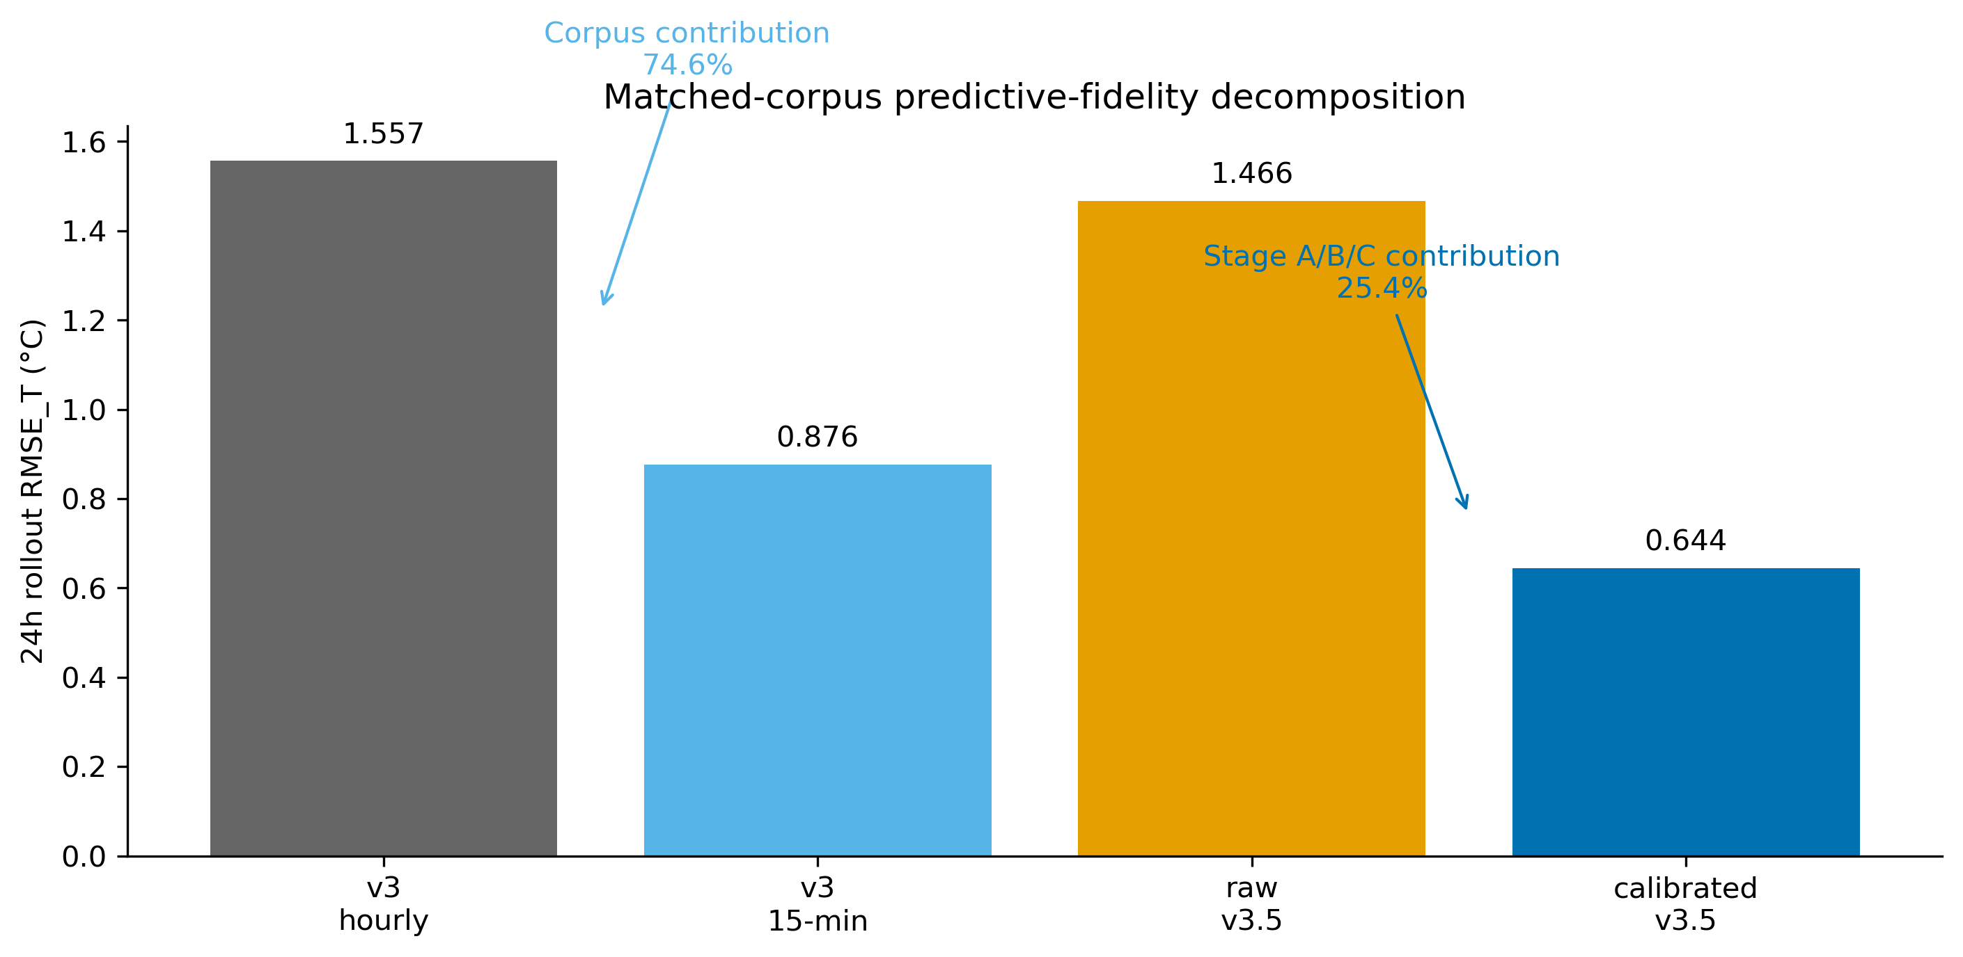
Figure 6. Matched-corpus waterfall decomposition. The plot separates the 15-minute corpus contribution from the additional Stage A/B/C calibration contribution.
A direct v3-versus-v3.5 comparison would be misleading because the active v3.5 pipeline uses a 15-minute corpus while the legacy v3 benchmark was originally trained on an hourly workflow. The matched-corpus check resolves this confound. Most of the v3-to-v3.5 24-hour RMSE gain is explained by the data-resolution shift, while the remaining gain is attributable to Stage A/B/C calibration. This is reported as a reviewer-facing mitigation rather than hidden in the supplement.
This decomposition bounds the calibration claim. The move from the legacy hourly v3 corpus to a matched 15 min v3 corpus reduces 24 h RMSE_T from 1.557 C to 0.876 C, explaining 74.6% of the original v3-to-v3.5 gap. Stage A/B/C then reduces the matched-corpus error further from 0.876 C to 0.644 C, explaining the remaining 25.4%. We therefore do not claim that physics alone explains the full improvement; the defensible claim is that corpus resolution and physical calibration jointly produce the final predictive-fidelity gain.
Numerically, the total apparent 24 h gain from legacy v3 to calibrated v3.5 is Delta_total = 1.557 - 0.644 = 0.913 C. The corpus-resolution term is Delta_corpus = 1.557 - 0.876 = 0.681 C, while the calibrated-physics term is Delta_cal = 0.876 - 0.644 = 0.232 C. The attribution ratios are Delta_corpus / Delta_total = 74.6% and Delta_cal / Delta_total = 25.4%. This is why the paper describes Stage A/B/C as a real but bounded calibration contribution rather than the sole source of the fidelity gain.

5.4 Fidelity-to-control gap
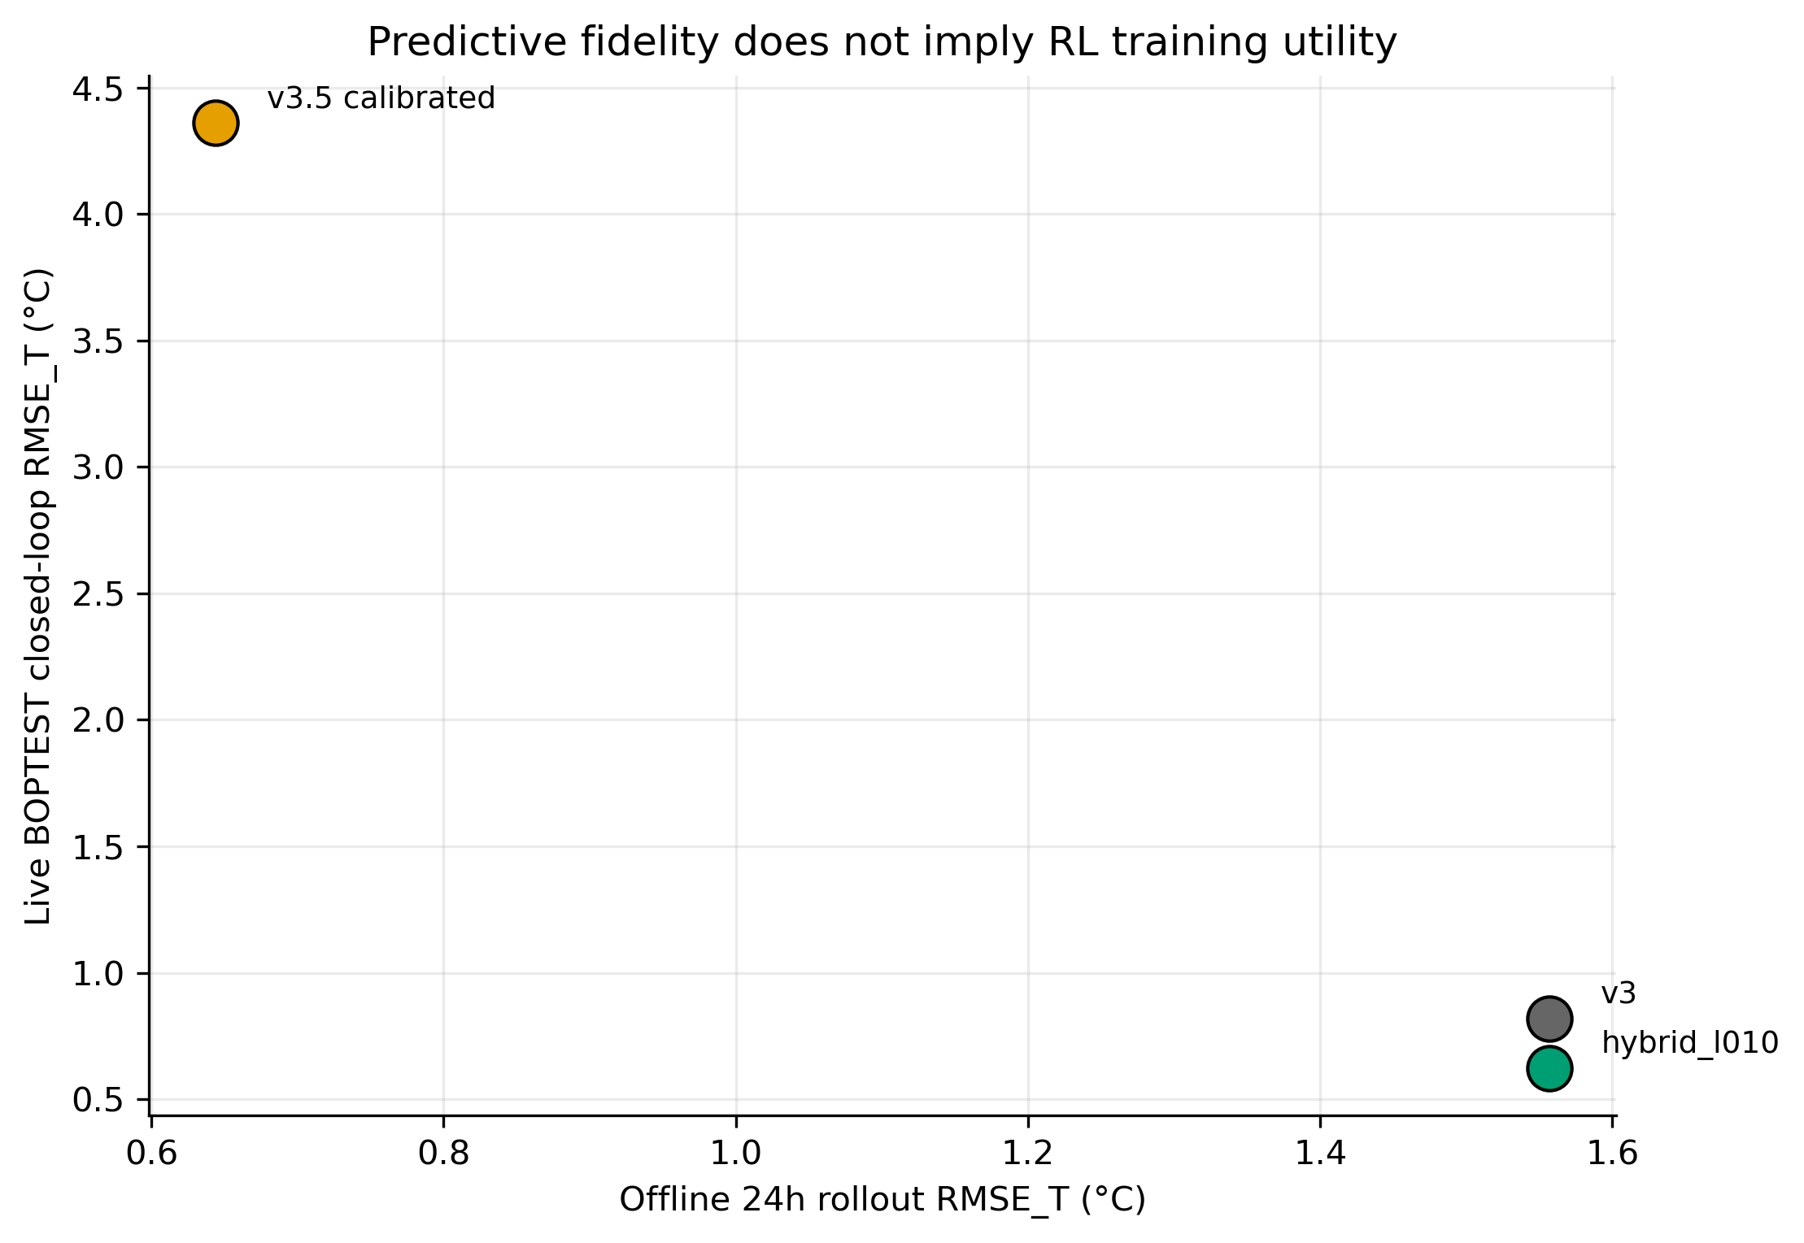
Figure 7. Predictive fidelity vs live control utility. Calibrated v3.5 is the strongest offline predictor but the weakest direct RL rollout backend; hybrid role separation recovers live utility.
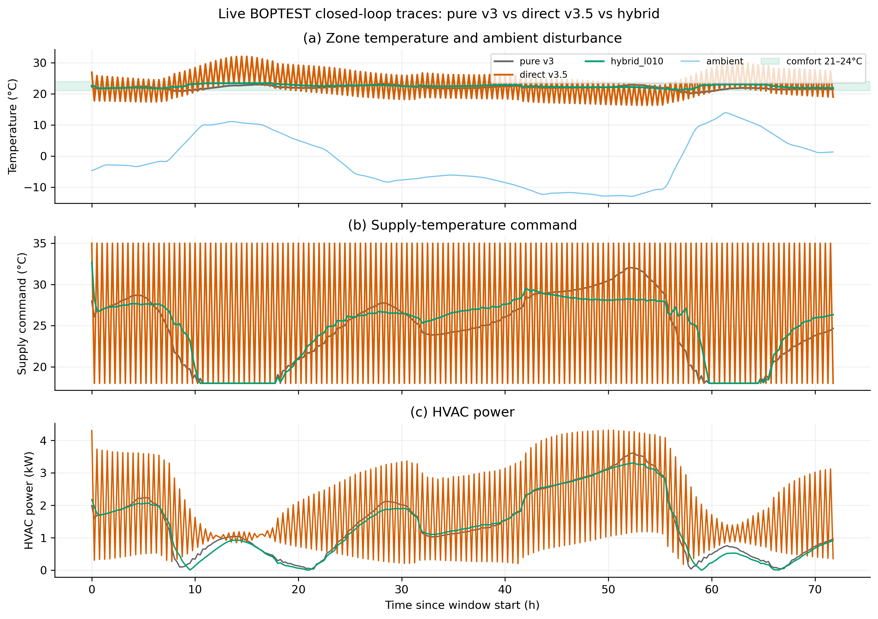
Figure 8. Live BOPTEST closed-loop traces for pure v3, direct v3.5, and hybrid_l010. The trace view shows the comfort-band behaviour, supply commands, and power response behind the aggregate KPIs.
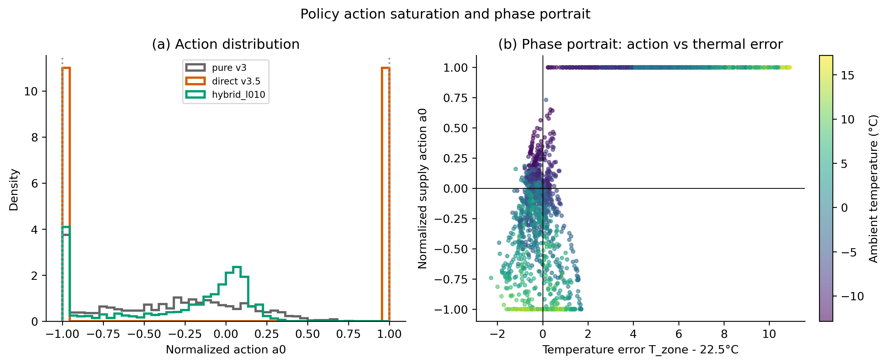
Figure 9. Action distribution and phase portrait. Direct v3.5 PPO exhibits bang-bang action saturation and extreme action response relative to temperature error, explaining its live transfer failure.
The closed-loop result is the critical negative finding. Calibrated v3.5 is the most accurate predictive model, but a PPO controller trained directly on it produces poor live BOPTEST performance. The live failure is not a simulator artifact: replay audits confirmed deterministic BOPTEST responses, and transfer diagnostics show that the direct-v3.5 policy enters action regimes that do not survive the live RTE. Therefore, the successful role for v3.5 is not as the direct rollout environment, but as a frozen physical teacher in the hybrid backend.
The live-control deltas are large enough to rule out a minor tuning explanation. Direct-v3.5 PPO reaches approximately 4.32-4.40 C live RMSE_T with comfort violation around 77-82%, whereas the hybrid controller is around 0.61-0.63 C RMSE_T with low single-digit violation on the same targeted windows. Thus, the failure is not that v3.5 is an inaccurate predictor; it is that direct PPO training on v3.5 induces a brittle policy distribution.
The action distribution and phase portrait in Figure 9 provide the mechanism-level explanation. The direct-v3.5 policy enters saturated bang-bang action regimes and produces extreme actions for modest temperature errors. Hybridization avoids this by preserving v3 as the smooth rollout model while using frozen v3.5 only as a physical disagreement penalty.
The resulting hybrid reward can be summarized as r_hybrid = r_comfort + r_smooth + r_energy - lambda_T |T_v3 - T_v35| - lambda_P |P_v3 - P_v35|. This expression makes the engineering role separation explicit: the policy state transition is still generated by v3, while v3.5 contributes a physical consistency cost but does not define the rollout dynamics.
The hybrid backend also remains computationally feasible for reinforcement learning. In the CPU speed benchmark it sustains approximately 1787 environment steps per second, about 85x faster than the live BOPTEST RTE HTTP-Docker loop used for validation. The hybrid result is therefore not only more stable in live control; it is also fast enough to remain a practical PPO training backend.
5.5 Block 1 conclusion
Block 1 closes with a deliberately asymmetric conclusion. As a predictive digital twin, calibrated v3.5 is supported: Stage A/B/C reduces 24 h rollout RMSE_T from 1.466 C to 0.644 C, reduces power MAE from 810 W to 482 W, and identifies a physically plausible C_zon = 4.413e5 J/K. The residual distribution, error CDF, and Stage-B convergence diagnostics show that this is not a single-metric artifact.
As a direct RL rollout environment, however, calibrated v3.5 is rejected. PPO trained directly on v3.5 enters saturated action regimes and fails live BOPTEST validation despite the model's stronger offline predictive fidelity. This falsifies the simple assumption that the most accurate surrogate is automatically the best policy-training environment.
The constructive outcome is role separation. The v3 surrogate remains the rollout backend because it provides smooth and computationally cheap dynamics for PPO; calibrated v3.5 is retained as a frozen physical teacher through disagreement regularization. This conclusion is the dependency passed to Block 2: controller validation must test the hybrid role assignment, not merely compare surrogate RMSE values.

6. Results II: Control Performance

6.1 Block 2 objective and controller families
Block 2 tests whether the Block 1 surrogate-role separation translates into better closed-loop control. The experiments compare thermostatic PPO, HDRL and MORL under the same BOPTEST RTE evaluation discipline. The result is controller-family specific: the hybrid disagreement penalty helps the thermostatic PPO controller, hurts HDRL when copied naively, and yields promising but high-variance MORL behaviour.

6.2 Thermostatic PPO and HDRL
For thermostatic PPO, the canonical hybrid setting lambda_temp = 0.10 is the main positive controller result. It improves the typical-window safety metric and maintains energy efficiency while avoiding the direct-v3.5 failure mode. HDRL reverses this conclusion: the same temperature disagreement penalty degrades performance, and lambda_temp = 0 is the best HDRL setting. This prevents the paper from claiming that physics-informed penalties are universally beneficial; they are backend- and controller-family-specific.

6.3 MORL, observation interface and seed variance
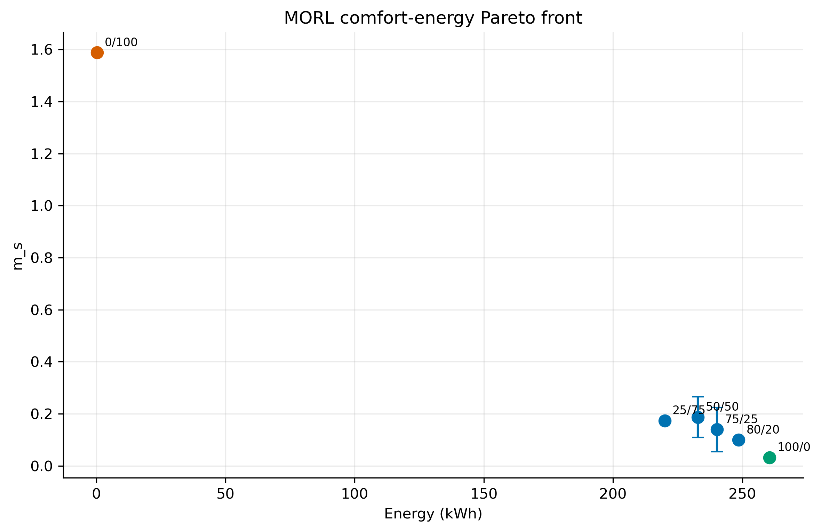
Figure 10. MORL comfort-energy Pareto front with canonical seed-variance information. Energy-only scalarization collapses, comfort-only has the lowest m_s, and practical 75/25 remains seed-sensitive.
MORL initially failed under a compact 5D observation interface. Expanding to the 17D TSup-style observation recovers a usable preference-conditioned controller, showing that the observation geometry is not an implementation detail but a primary determinant of success. The Pareto sweep then identifies neutral and practical canonical weight vectors, but the N=5 seed extension changes the scientific interpretation: aggregate high variance persists, the N=3 seasonal-inversion hypothesis is falsified, and MORL must be reported as promising but not deployment-stable without additional stabilization.
Family / policy | Best backend or variant | Primary result | m_s / variance | Verdict
Thermostatic PPO | hybrid_l010 | Peak/typical RMSE 0.633 / 0.612 C | m_s 0.0866 / 0.0411 | Hybrid regularization supported
Direct v3.5 PPO | standalone calibrated v3.5 | Live RMSE 4.32 / 4.40 C | m_s > 1.0 | Negative control
HDRL | lambda_temp=0 | Temperature regularizer hurts hierarchy | best at lambda=0 | Controller-family specificity
MORL 17D | power-only hybrid | Pareto sweep usable after 17D interface | canonical N=5 high variance | Promising but not stable
MORL N=5 test | neutral/practical canonicals | Replay deterministic; action-saturation hypothesis falsified | sigma/mean > threshold | Report with limitations
Table 5. Block 2 controller-family and MORL summary. Detailed lambda sweeps, per-seed tables and monthly diagnostics are in the supplementary material.

6.4 Seasonal variance heatmap interpretation
The seasonal variance heatmap is retained as a falsification artifact, not as support for the original action-saturation mechanism. At N=3 the practical canonical appeared winter-stable and summer-unstable, motivating a pre-registered N=5 test. Seeds 45/46 falsified that mechanism: February variance increased sharply and the winter neutral/practical ratio collapsed. This is a methodologically useful result because it shows that mechanism-level interpretations from small-seed MORL seasonal patterns can be transient.

7. Results III: Transferability and Generalization

7.1 Block 3 objective and transfer protocol
Block 3 evaluates whether the bestest_air recipe transfers to related hydronic BOPTEST testcases. Because the target actuators are not literal direct supply-temperature actuators, transfer is adapter-mediated and pre-registered before control runs. The tested regimes separate controller transfer from surrogate recalibration: mode=none deploys the frozen controller through the documented adapter, while mode=full re-runs Stage A/B/C on target telemetry but still keeps the controller frozen.

7.2 Controller-side transfer
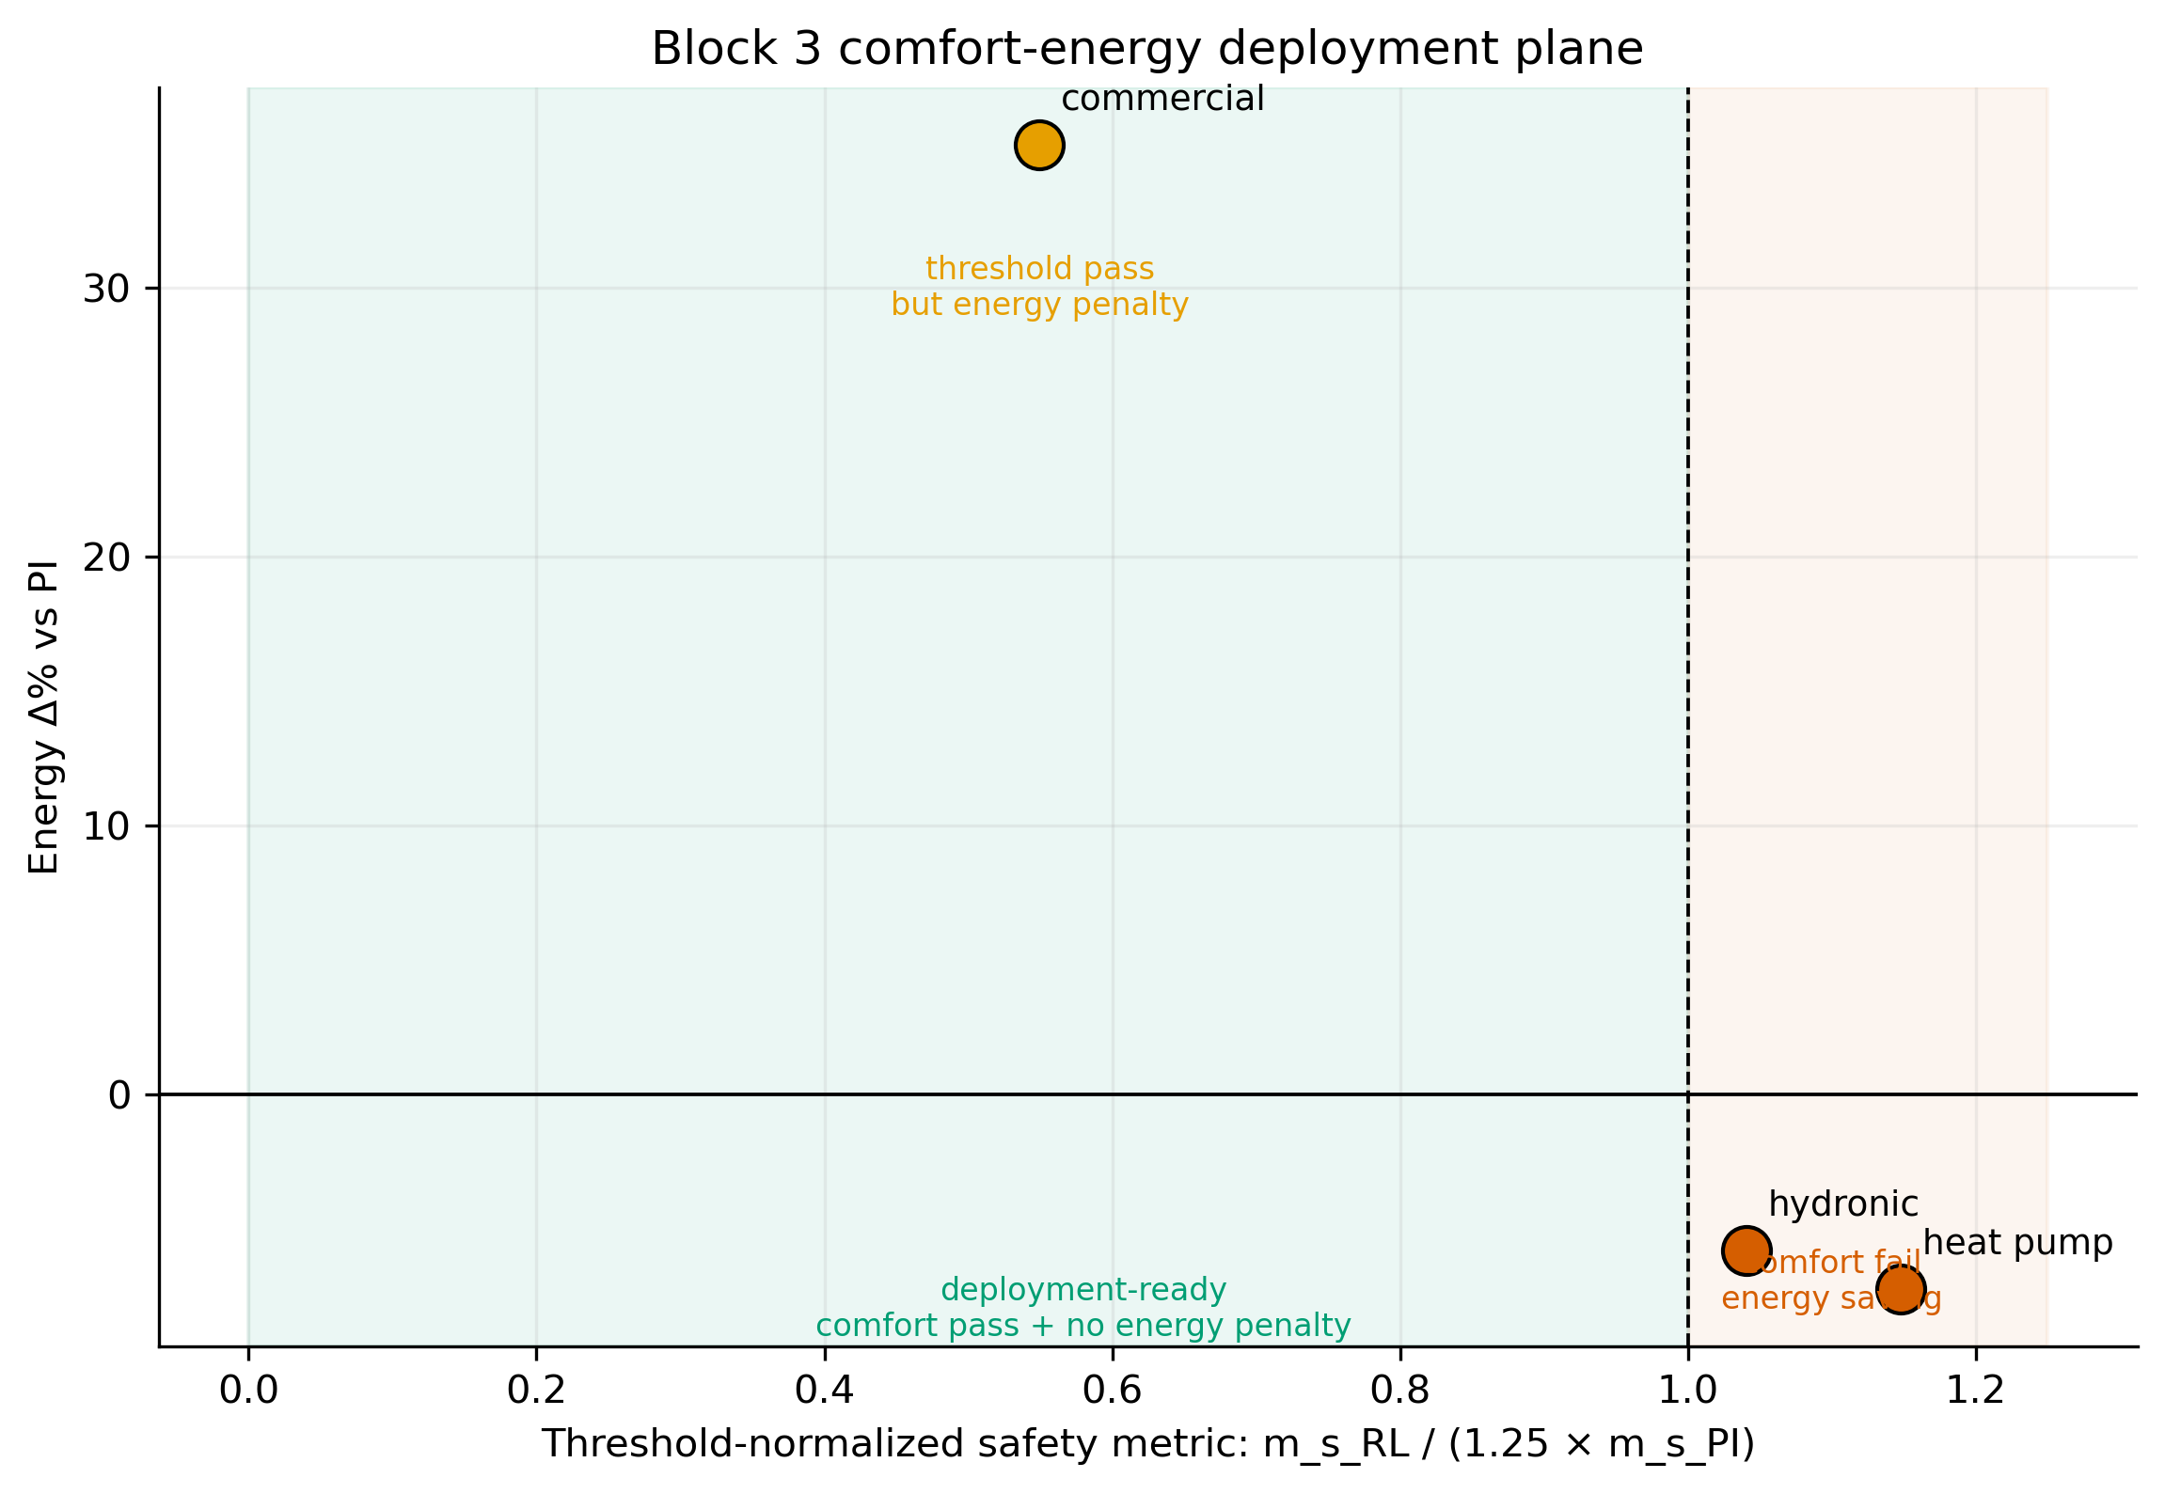
Figure 11. Block 3 comfort-energy deployment plane. Residential hydronic testcases fail the m_s threshold while saving energy; the commercial testcase passes the threshold but incurs a large energy penalty.
Controller transfer is not deployment-ready under the frozen-controller scope. The two residential hydronic testcases fail the pre-registered m_s threshold, primarily through comfort degradation. The commercial hydronic testcase passes the scalar m_s threshold, but only with a +35.3% energy penalty relative to PI. This distinction matters: the commercial cell is a threshold PASS but not a deployment PASS under a two-axis comfort-energy interpretation.

7.3 Surrogate-side transfer
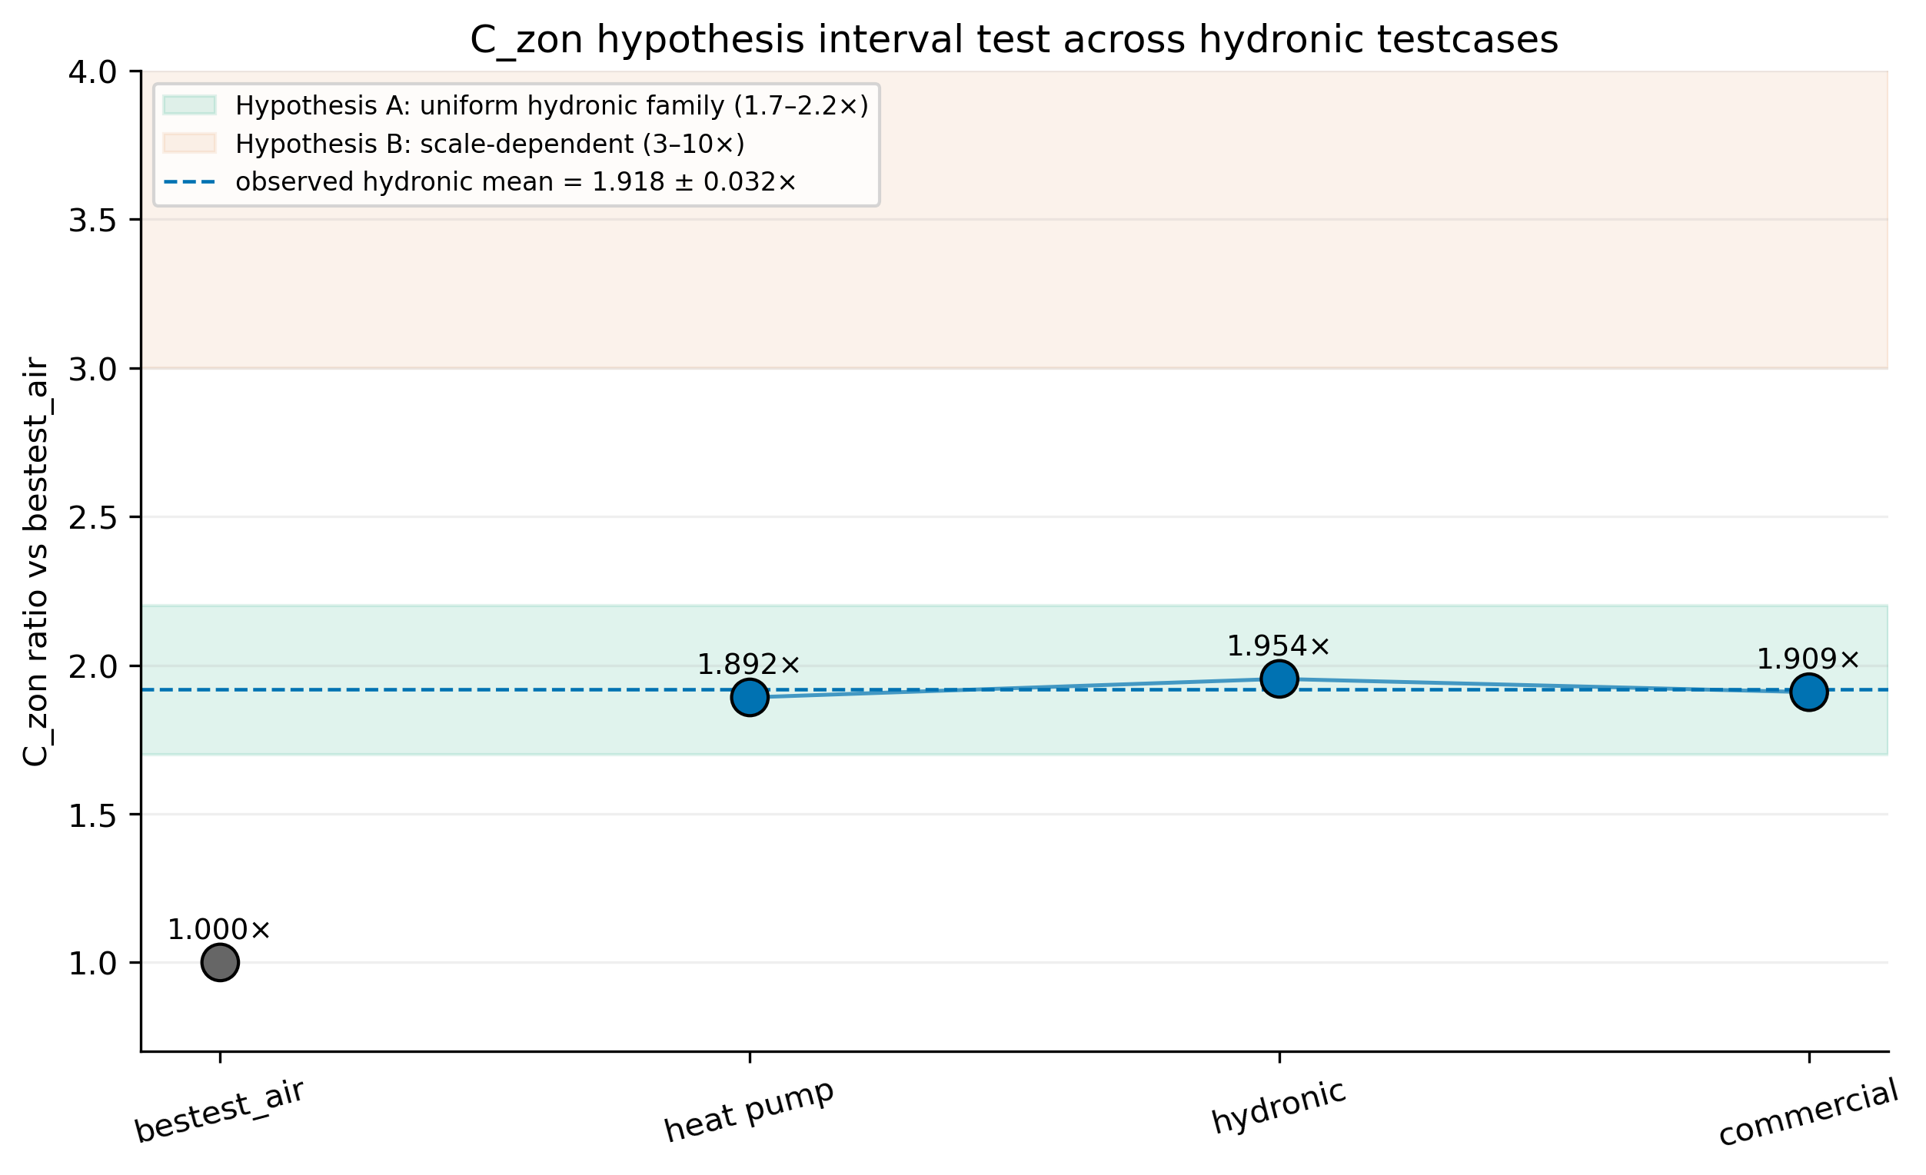
Figure 12. C_zon hypothesis interval test across hydronic testcases. Observed ratios support the 1.7–2.2× uniform hydronic-family hypothesis and falsify the 3–10× scale-dependent hypothesis for the tested cases.
The surrogate component transfers much more cleanly than the controller component. Full Stage A/B/C recalibration improves target-testcase RMSE_T by 60.2-87.8% across the three hydronic testcases. Even more importantly, the identified hydronic C_zon ratios cluster tightly around 1.9x the bestest_air value. This consistency is physical evidence that the inverse calibration pipeline recovers a stable family-level thermal-mass relationship rather than overfitting a single testcase.
Testcase | None | Full | m_s RL | m_s PI | Energy delta | Full RMSE gain | C_zon ratio | Interpretation
bestest_hydronic_heat_pump | FAIL | FAIL | 0.665 | 0.464 | -7.3% | 60.2% | 1.89x | Residential hydronic heat-pump transfer fails on controller safety but succeeds on full surrogate recalibration.
bestest_hydronic | FAIL | FAIL | 0.976 | 0.750 | -5.8% | 87.4% | 1.95x | Residential hydronic transfer replicates controller-side FAIL and surrogate-side PASS.
singlezone_commercial_hydronic | PASS | PASS | 0.431 | 0.628 | 35.3% | 87.8% | 1.91x | Commercial stretch falsifies expected controller FAIL: safety passes but energy increases substantially; surrogate-side PASS and C_zon ratio remains near 1.9x.
Table 6. Block 3 transfer matrix, combining adapters, controller verdicts, surrogate gains, and C_zon re-identification.

7.4 Component-level transferability conclusion
The Block 3 conclusion is therefore component-level rather than binary. The surrogate physics representation is transferable under full recalibration. The frozen controller is not robustly transferable through actuator adapters. The transferability boundary lies at the controller-adapter interface, and the natural next experiment is controller fine-tuning on the target-recalibrated surrogate. That experiment is explicitly outside the pre-registered scope of this paper.

8. Discussion
Hypothesis | Pre-registered claim | Operational criterion | Verdict | Evidence
H1 strong | Frozen recipe transfers directly | mode=none PASS on >=2/3 without severe KPI penalty | Falsified | Residential hydronic cases fail; commercial passes m_s but +35.3% energy.
H2 medium | Partial surrogate recalibration is sufficient | Stage C only improves controller verdict | Falsified structurally | Controller frozen, so live KPI cannot change from none.
H3 weak surrogate side | Full recalibration gives useful target twin | RMSE_T improves under full Stage A/B/C | Supported | 60.2-87.8% RMSE_T improvement across N=3.
H3 weak controller side | Full surrogate recalibration rescues frozen controller | Controller PASS after full | Falsified/split | Surrogate succeeds, controller remains regime-dependent.
MORL action-saturation | N=3 seasonal inversion persists at N=5 | Feb sigma <0.005 and winter ratio >20x | Falsified | Feb sigma rose and inversion collapsed at N=5.
Table 7. Hypothesis closure table. The audit trail maps each claim to the pre-registered protocol and post-result append-only records.

8.1 Predictive validity versus RL training utility
The central methodological result is that predictive validity and RL training utility are related but not equivalent. Predictive validation measures how well a model reproduces held-out BOPTEST trajectories under known actions; closed-loop RL training repeatedly visits states generated by the surrogate itself, so small biases reshape the policy’s experienced state distribution and can produce qualitatively different behavior. This explains why calibrated v3.5 is a strong predictive twin yet fails as a standalone RL backend (m_s = 1.046, live RMSE > 4 °C). The hybrid backend resolves this by separating roles: v3 remains the rollout environment, preserving a learnable control landscape; v3.5 acts only as a frozen per-step reward-shaping censor, injecting physical information without forcing the policy to optimise inside the grey-box closed-loop dynamics.

8.2 Controller-family specificity
The regulariser is not universally beneficial. Thermostatic PPO benefits from the temperature anchor because the disagreement penalty stabilises the local temperature-power trade-off. HDRL and 17-D MORL are more sensitive to the temperature channel and perform best with λ_temp = 0; their structural priors already supply the comfort-aware inductive bias. The MORL canonical seed analysis at N=5 remains high-variance (CV § 0.42–0.61). The failed action-saturation hypothesis is reported as a falsification rather than hidden as noise. For deployment-oriented MORL the next methodological layer should be policy stabilisation (validation-based checkpoint selection, seed ensembles); we deliberately did not apply these post-hoc because they would change the pre-registered evaluation protocol.

8.3 Transferability boundary
Block 3 decomposes transferability into a surrogate component and a controller component. The surrogate side transfers strongly on N=3 hydronic testcases: full Stage A/B/C improves RMSE_T by 60.2 %, 87.4 %, and 87.8 %; the re-identified C_zon clusters in 1.89–1.95× bestest_air, supporting the pre-registered uniform-hydronic-family hypothesis A (a-priori 0.35) and falsifying scale-dependent alternative B (a-priori 0.50). The controller side does not transfer in a deployment-ready sense: residential cases save 6–7 % energy versus PI but fail the 1.25× comfort threshold; the commercial stretch passes safety (m_s = 0.431 vs threshold 0.785) but consumes 35.3 % more energy than PI. The shared root cause is that the transferred policy was trained for direct supply-temperature geometry and a mechanical adapter cannot teach it the target actuator response curve. The natural Block 4 experiment is controller fine-tuning on the target-recalibrated surrogate, not further surrogate calibration.

8.4 Step-size disclosure and pre-registration discipline
A reviewer-relevant disclosure: the canonical v3 checkpoint was trained on hourly transitions (3,600 s) but deployed at the BOPTEST native step of 900 s. We preserve this mismatch because (i) all Block 2/3 KPIs are measured on live BOPTEST, not the surrogate; (ii) PPO requires gradient-sign correctness from its surrogate, not physical-time accuracy — a multiplicative –T bias is absorbed by critic normalisation; (iii) the higher v3 24-h RMSE (1.557 °C) strengthens the fidelity-utility paradox. A corpus-matched v3 retraining (§5.3) reduces 24-h RMSE to 0.876 °C but is reported as decomposition evidence, not as the canonical, to protect the pre-registration chain. Three findings are pre-registered predictions whose results could have been falsified and were: the single-λ hypothesis (RQ2/H2), the stretch-testcase controller-FAIL prediction (a-priori 0.80), and the scale-dependent C_zon hypothesis (a-priori 0.50). All three shifted the supported hypothesis to lower a-priori alternatives.

8.5 Positioning relative to related work
Our fidelity-utility paradox is consistent with surrogate-development reporting gaps highlighted by Hou Evins [16] and with the offline-RL distribution-shift literature [24]. We differ from physics-informed controller approaches (TC-DDPG [28], Safe DRL + MPC [26]) by embedding physics only as a per-step reward-shaping censor [18], never as the rollout environment. For Block 3 transferability, our component-level finding stands in productive tension with prior transfer-learning work [30,31,32] that reports 1–40 % improvements: those studies allow the target deployment to see some target data (online fine-tuning, multi-source aggregation, partial parameter sharing). Our design tests the harder frozen-method scenario with no target controller training, only per-testcase actuator adapters and pre-registered Stage A/B/C recalibration; under that stricter constraint, residential transfer fails comfort and commercial transfer fails energy.

8.6 Threats to validity
The bestest_air evidence uses one weather file and targeted sensitivity rather than full hyperparameter optimisation. HDRL is single-seed. MORL N=5 remains high-variance, so MORL is reported as promising rather than deployment-stable. Block 3 covers three hydronic testcases, not arbitrary archetypes or multi-zone systems. The 85× speed-up is measured against the BOPTEST RTE HTTP-Docker deployment, not bare FMU evaluation. The two-horizon evaluation protocol (§4.4) uses 14-day windows for Sections 5–6 and yearly evaluation for Section 7; Block 2 targeted-window results should not be interpreted as yearly deployment guarantees. The Block 3 1.25× PI threshold can mask per-KPI deterioration — the commercial stretch case is a threshold PASS that is not deployment-ready because of its energy penalty. Future protocols should use a tiered verdict with per-KPI floors for energy and violation rate.

9. Conclusion
This paper tested a common assumption in physics-informed RL for buildings — that a more predictive physical twin should be the better RL training environment — and reported a negative result on the BOPTEST bestest_air testcase. The calibrated v3.5 grey-box twin (24-h rollout RMSE 0.644 °C, 2.4× better than v3) improves long-horizon predictive fidelity, yet when used directly as the PPO backbone the resulting policy collapses to m_s = 1.046 with live comfort RMSE above 4 °C. The right role of the calibrated twin is narrower and more useful: it serves as a frozen per-step reward-shaping censor for a smoother v3 rollout backend. The resulting hybrid recipe reduces live BOPTEST m_s from 0.073 / 0.095 (pure v3) to 0.087 / 0.041 (hybrid_l010) on peak / typical winter windows, preserves the 85× surrogate-speed advantage required for RL training, and is mechanism-preserving: PPO computes advantage from the augmented reward in the standard way with no policy-gradient modification.
The hybrid weight is not universal across controller families. Thermostatic PPO favours λ_temp = 0.10; HDRL favours λ_temp = 0.00 (its m_s degrades monotonically with increasing λ_temp from 0.180 to 0.440 on peak); the 17-D MORL matches HDRL. The MORL N=5 canonical analysis remains high-variance (CV § 0.42–0.61); the pre-registered action-saturation hypothesis is falsified at commit 62dc859 and the defensible reading is that MORL needs explicit policy-stabilisation to become deployment-stable.
The pre-registered Block 3 transferability study extends the contribution beyond bestest_air. Across three single-zone hydronic testcases the Stage A/B/C inverse calibration pipeline transfers robustly, with 60.2 % / 87.4 % / 87.8 % RMSE_T improvement and tightly clustered C_zon at 1.918 ± 0.032× bestest_air. This falsifies the pre-registered scale-dependent hypothesis (a-priori 0.50) in favour of the uniform-hydronic-family hypothesis (a-priori 0.35). The frozen-controller side does not transfer in a deployment-ready sense: residential cases fail the 1.25× PI comfort threshold; the commercial stretch passes safety but at +35.3 % energy versus PI.
The component-level take-away is that the physically informed surrogate representation transfers, while the controller-adapter interface is the bottleneck. The immediate next experiment is target-specific controller fine-tuning on the target-recalibrated surrogate under a tiered comfort–energy transfer criterion — explicitly out of the pre-registered scope of this paper so the present manuscript reports falsifications and boundaries without moving the goalposts. All numerical values are sourced from CSV/JSON artefacts under reports/ and outputs/; the audit chain (nine commit anchors verifiable via git log) is reproduced in the Supplementary Material.

Data availability
All numerical values are sourced from CSV artifacts under reports/ and outputs/. The figure-source manifest is reports/article_real_figures_manifest.csv.

Supplementary Material: Hou and Evins Numerical Artifacts
The following tables summarize the eleven article-facing numerical artifacts adapted from the Hou-and-Evins surrogate reporting protocol [17]. The complete machine-readable versions remain in reports/hou_evins_*.csv.

S1. Sample generation (reports/hou_evins_sample_generation_table.csv)

S2. Sample-size justification (reports/hou_evins_sample_size_justification_table.csv)

S3. Split representativeness (reports/hou_evins_split_representativeness_table.csv)

S4. Stage A processing (reports/hou_evins_stage_a_processing_table.csv)

S5. Feature significance and encoding (reports/hou_evins_feature_justification_table.csv)

S6. Scaling (reports/hou_evins_scaling_table.csv)

S7. Input independence (reports/hou_evins_input_independence_table.csv)

S8. Training hyperparameters (reports/hou_evins_training_hyperparams_table.csv)

S9. Architecture justification (reports/hou_evins_architecture_justification_table.csv)

S10. Targeted sensitivity (reports/hou_evins_targeted_sensitivity_table.csv)

S11. Predictive validity (reports/hou_evins_predictive_validity_table.csv)

References
[1] Zhang S, Ma M, Zhou N, Yan J. GLOBUS: Global building renovation potential by 2070. arXiv preprint arXiv:2406.04133, 2024.
[2] Arroyo J, Spiessens F, Helsen L. Comparison of optimal control techniques for building energy management. Frontiers in Built Environment. 2022;8:849754. doi:10.3389/fbuil.2022.849754.
[3] Arroyo J, Spiessens F, Helsen L. Identification of multi-zone grey-box building models for use in model predictive control. Journal of Building Performance Simulation. 2020;13(4):472-486. doi:10.1080/19401493.2020.1770861.
[4] Blum D, Arroyo J, Huang S, Drgona J, Jorissen F, Walnum HT, Chen Y, Benne K, Vrabie D, Wetter M, Helsen L. Building optimization testing framework for simulation-based benchmarking of control strategies in buildings. Journal of Building Performance Simulation. 2021;14(5):586-610. doi:10.1080/19401493.2021.1986574.
[5] Arroyo J, Manna C, Spiessens F, Helsen L. An OpenAI-Gym environment for the Building Optimization Testing Framework. Proceedings of the 17th IBPSA Conference; 2021 Sep 1-3; Bruges, Belgium.
[6] Wang D, Zheng W, Wang Z, Wang Y, Pang X, Wang W. Comparison of reinforcement learning and model predictive control for building energy system optimization. Applied Thermal Engineering. 2023;228:120430. doi:10.1016/j.applthermaleng.2023.120430.
[7] Arroyo J, Manna C, Spiessens F, Helsen L. Reinforced model predictive control for building energy management. Applied Energy. 2022;309:118346. doi:10.1016/j.apenergy.2021.118346.
[8] Drgona J, Tuor AR, Chandan V, Vrabie DL. Physics-constrained deep learning of multi-zone building thermal dynamics. arXiv preprint arXiv:2011.05987, 2020.
[9] Jiang Z, Lee YM. Deep transfer learning for thermal dynamics modeling in smart buildings. arXiv preprint arXiv:1911.03318, 2019.
[10] Xu S, Wang Y, Wang Y, O'Neill Z, Zhu Q. One for many: transfer learning for building HVAC control. arXiv preprint arXiv:2008.03625, 2020.
[11] Fierro G, Prakash AK, Blum D, Bender J, Paulson E, Wetter M. Notes paper: enabling building application development with simulated digital twins. BuildSys '22; 2022 Nov 9-10; Boston, MA, USA. doi:10.1145/3563357.3564060.
[12] Mostafavi S, Song C, Sharma A, Goyal R, Brito A. Benchmarking model predictive control algorithms in Building Optimization Testing Framework. arXiv preprint arXiv:2301.13447, 2023.
[13] Khabbazi AJ, Pergantis EN, Reyes Premer LD, Papageorgiou P, Lee AH, Braun JE, Henze GP, Kircher KJ. Lessons learned from field demonstrations of model predictive control and reinforcement learning for residential and commercial HVAC: a review. arXiv preprint arXiv:2503.05022, 2025.
[14] Bekal GU, Ghareeb A, Pujari A. Continual reinforcement learning for HVAC systems control: integrating hypernetworks and transfer learning. arXiv preprint arXiv:2503.19212, 2025.
[15] Ruiz de Vargas JM, Raisch F, Nagy Z, Pinson P, Goebel C. Counter-Dyna: data-efficient RL-based HVAC control using counterfactual building models. arXiv preprint arXiv:2605.04555, 2026.
[16] Al Sayed K et al. Reinforcement learning for HVAC control in intelligent buildings: a technical and conceptual review. Journal of Building Engineering. 2024;95:110085.
[17] Hou J, Evins R. A protocol for developing and evaluating neural network-based surrogate models and its application to building energy prediction. Renewable and Sustainable Energy Reviews. 2024;193:114283.
[18] Gao H et al. Successful application of predictive information in deep reinforcement learning control: a case study based on an office building HVAC system. Energy. 2024;291:130344.
[19] Wang Z et al. Safe deep reinforcement learning for building energy management. Applied Energy. 2025;377:124328.
[20] Hedayat Z, Ziarati SR, Manganelli M. A physics-informed reinforcement learning framework for HVAC optimization: thermodynamically-constrained DDPG with uncertainty-aware safety verification. 2025.
[21] Liao B et al. Year-round operational optimization of HVAC systems using hierarchical deep reinforcement learning with multi-objective reward mechanisms. Applied Energy. 2025;390:125816.
[22] Roijers DM, Vamplew P, Whiteson S, Dazeley R. A survey of multi-objective sequential decision-making. Journal of Artificial Intelligence Research. 2013;48:67-113.
[23] Coraci D et al. A scalable approach for real-world implementation of DRL controllers in buildings based on online transfer learning: the HiLo case study. Energy and Buildings. 2025;329:115254.
[24] Hou J et al. Multi-source transfer learning method for enhancing the deployment of deep reinforcement learning in multi-zone building HVAC control. Energy and Buildings. 2024;322:114696.
[25] Kadamala P et al. Enhancing HVAC control systems through transfer learning with deep reinforcement learning agents. Smart Energy. 2024;13:100131.
[26] Coraci D et al. An innovative heterogeneous transfer learning framework to enhance the scalability of deep reinforcement learning controllers for building energy management. Building Simulation. 2024;17:739-770.
[27] Samani MR et al. Distribution shift, generalization and OOD challenge in offline reinforcement learning: a comprehensive survey. Neural Computing and Applications. 2026.
[28] Savino M et al. Deploying deep reinforcement learning for low-level HVAC control in multi-zone buildings: a comparative study with ASHRAE G36 sequences. Energy and Buildings. 2025;348:116456.
[29] Sun Y et al. Individual room air-conditioning control in high-insulation residential building during winter: a deep reinforcement learning-based control model for reducing energy consumption. Energy and Buildings. 2024;323:114799.

