Supplementary Material

Supplementary organization map
This supplementary file holds detailed numerical artifacts that were intentionally removed from the main Q1 paper to keep the main body within a compact figure/table budget. The main paper keeps only eight high-impact figures and seven consolidated tables; detailed per-block tables, traces, variance diagnostics, and supporting figures remain here.

S1. Block 1 detailed surrogate-fidelity evidence
Includes v3 dual-head architecture details, C_zon Stage-B trajectory, backend speed benchmark, per-episode 24h rollout RMSE, residual distributions, action-saturation diagnostics, and literature-positioning graphics. These support Results I without duplicating the main-paper figures.

S2. Block 2 detailed control and MORL evidence
Includes thermostatic hybrid traces, direct-v3.5 negative-control details, HDRL lambda sweep, MORL 5D vs 17D ablation, MORL seasonal and seed-variance diagnostics, Pareto sweep details, and surrogate-to-live transfer-gap tables. These support Results II.

S3. Block 3 detailed transferability evidence
Includes testcase selection, actuator-adapter checks, recalibration-regime definitions, per-testcase transfer summaries, hydronic C_zon re-identification details, stretch-testcase prediction closure, and hypothesis-status audit records. These support Results III.

Traceability note
The standalone block result documents remain preserved as docs/block1_complete_results.docx, docs/block2_complete_results.docx, and docs/block3_complete_results.docx. The main document docs/hvac_paper_final_q1.docx now references only the compact main-paper subset; this supplementary file retains the detailed artifacts.
Deep Reinforcement Learning for Energy-Efficient Consumption Management in Smart Buildings: A Calibrated Physical Twin as Soft Regularizer for HVAC Control
Almaz Sapargali
Target journal: Results in Engineering (Elsevier, Q1)

This supplementary document accompanies the main manuscript and contains six categories of additional material that did not fit within the main paper page budget: (S1) Block 1 supplementary figures covering surrogate fidelity diagnostics; (S2) Block 2 supplementary figures covering controller-side validation traces, MORL seed variance, and HDRL tracking detail; (S3) Block 3 supplementary figures covering pre-registration protocol schematics and hypothesis closure tables; (S4) the eleven Hou-and-Evins Reporting-Level-3 numerical-justification tables (S4.1–S4.11); (S5) the full pre-registration audit chain with verbatim git commit messages; (S6) per-seed MORL yearly metrics for the N=5 falsification test. All numerical values trace to CSV/JSON artifacts under reports/ and outputs/ in the project GitHub repository (https://github.com/Almaz-2001/HVAC_DRL_MORL.git).

S1. Block 1 supplementary figures
These figures support the surrogate-fidelity analysis in Section 5 of the main paper. They include architecture diagrams (S1.1, S1.2), the Stage B C_zon inverse-identification trajectory (S1.3), per-episode rollout RMSE distributions (S1.4–S1.5), runtime benchmarks (S1.6), action-saturation diagnostics (S1.7), and a positioning map relative to related surrogate-modelling work (S1.8).
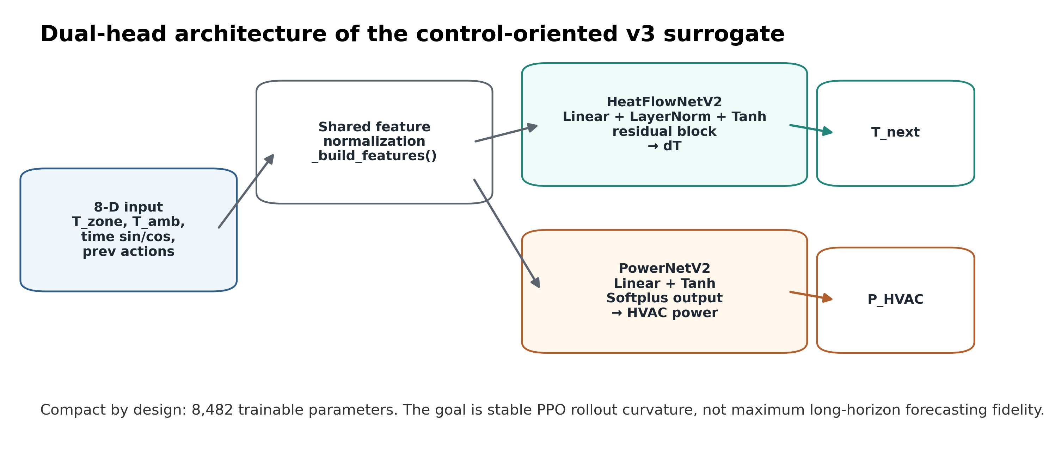
Figure S1.1. v3 dual-head architecture (temperature + power heads; 8,482 total parameters; 7,105 temp head, 1,377 power head).
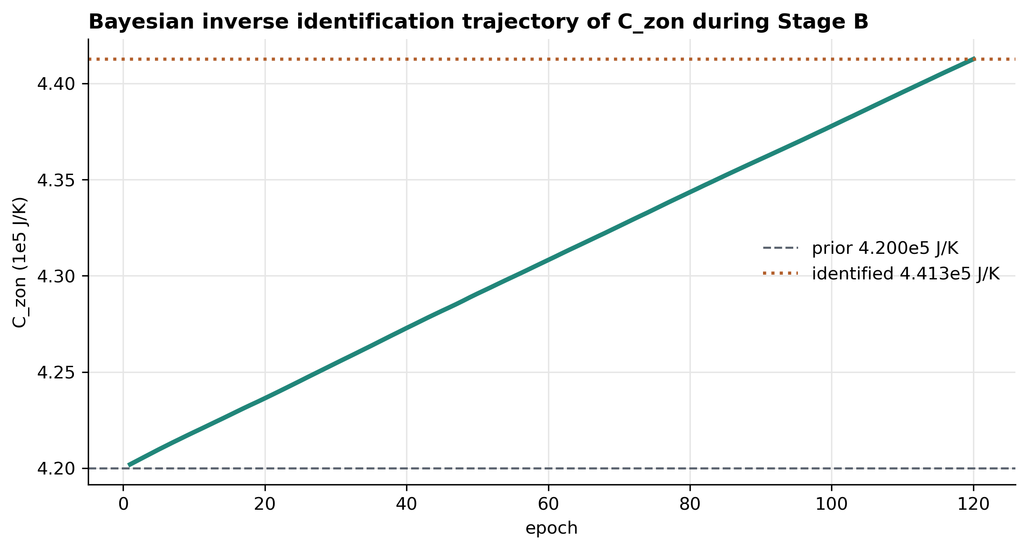
Figure S1.2. Stage B C_zon inverse identification trajectory. The 120-epoch solve converges from the 4.200×10⁵ J/K prior to the identified 4.413×10⁵ J/K (+5.06%).
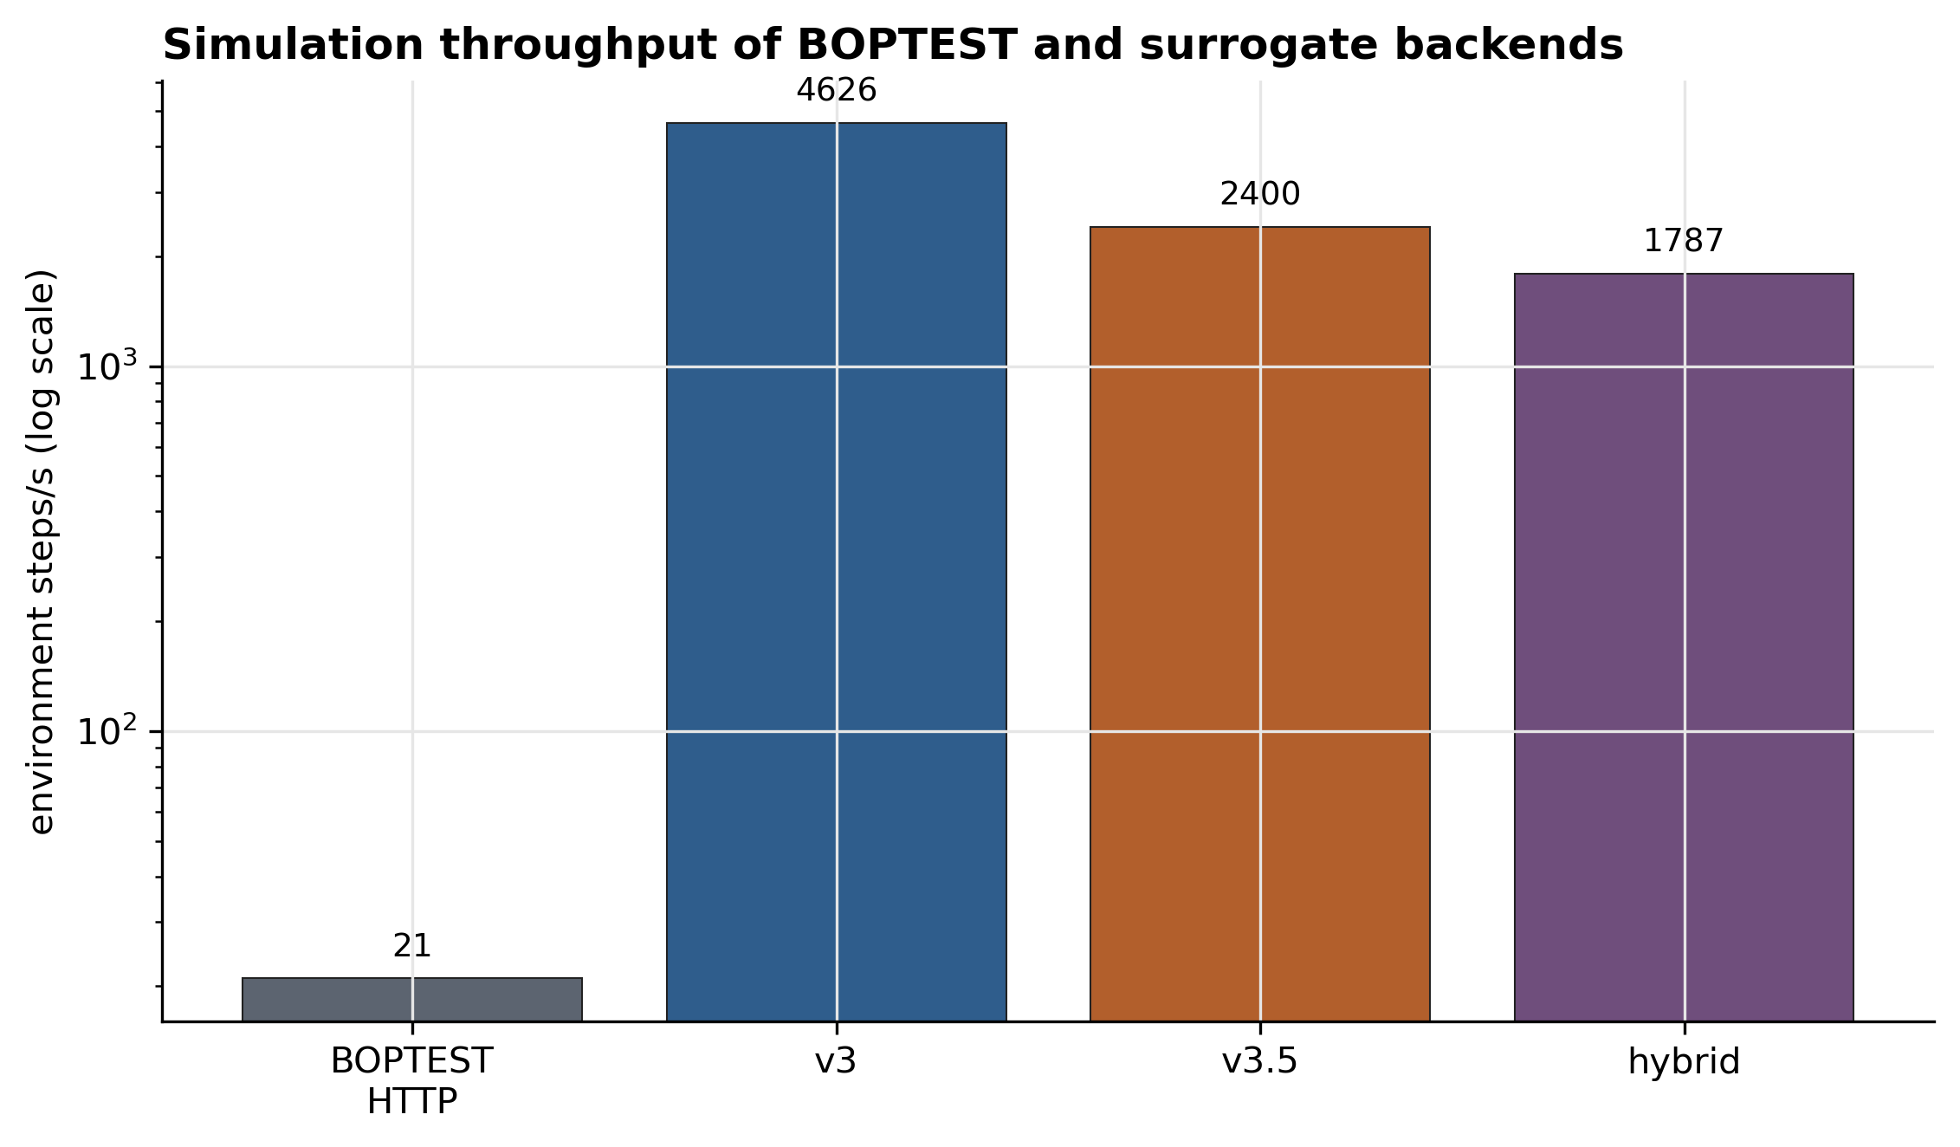
Figure S1.3. Backend speed benchmark across surrogate variants. The hybrid backend sustains 1,786.8 environment steps/s on a single CPU thread (85.0× the live BOPTEST RTE).
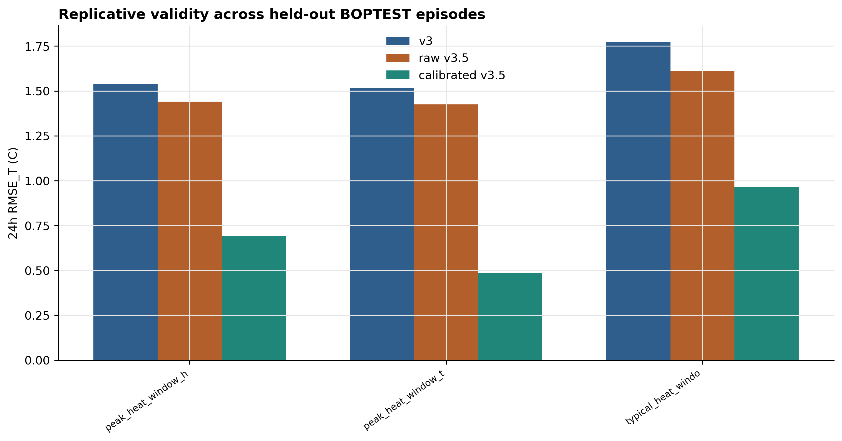
Figure S1.4. Per-episode rollout RMSE distributions for v3, raw v3.5, calibrated v3.5, and corpus-matched v3.
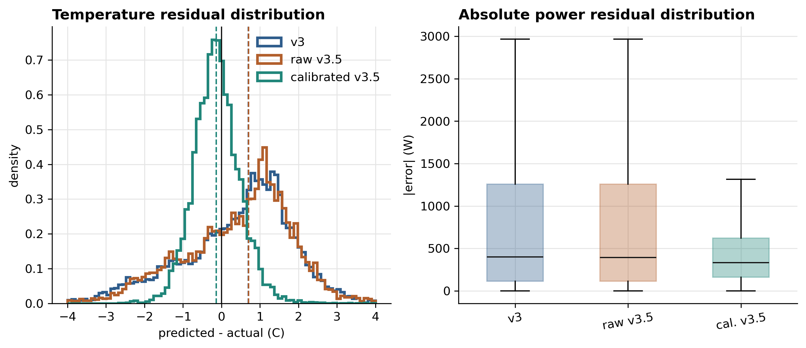
Figure S1.5. Temperature residual distributions across the four surrogate variants.
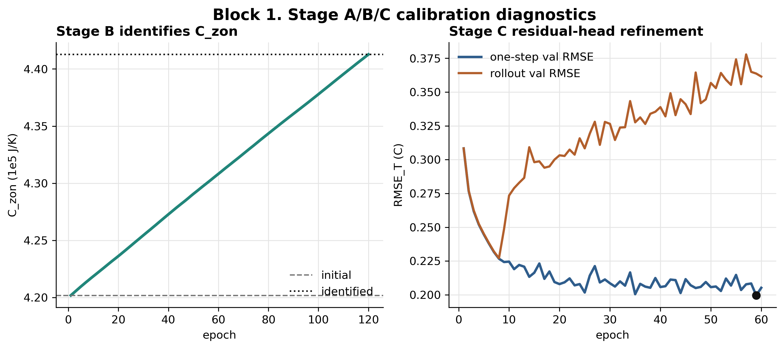
Figure S1.6. Stage A/B/C calibration diagnostics, including telemetry-preprocessing artefacts and per-stage RMSE deltas.
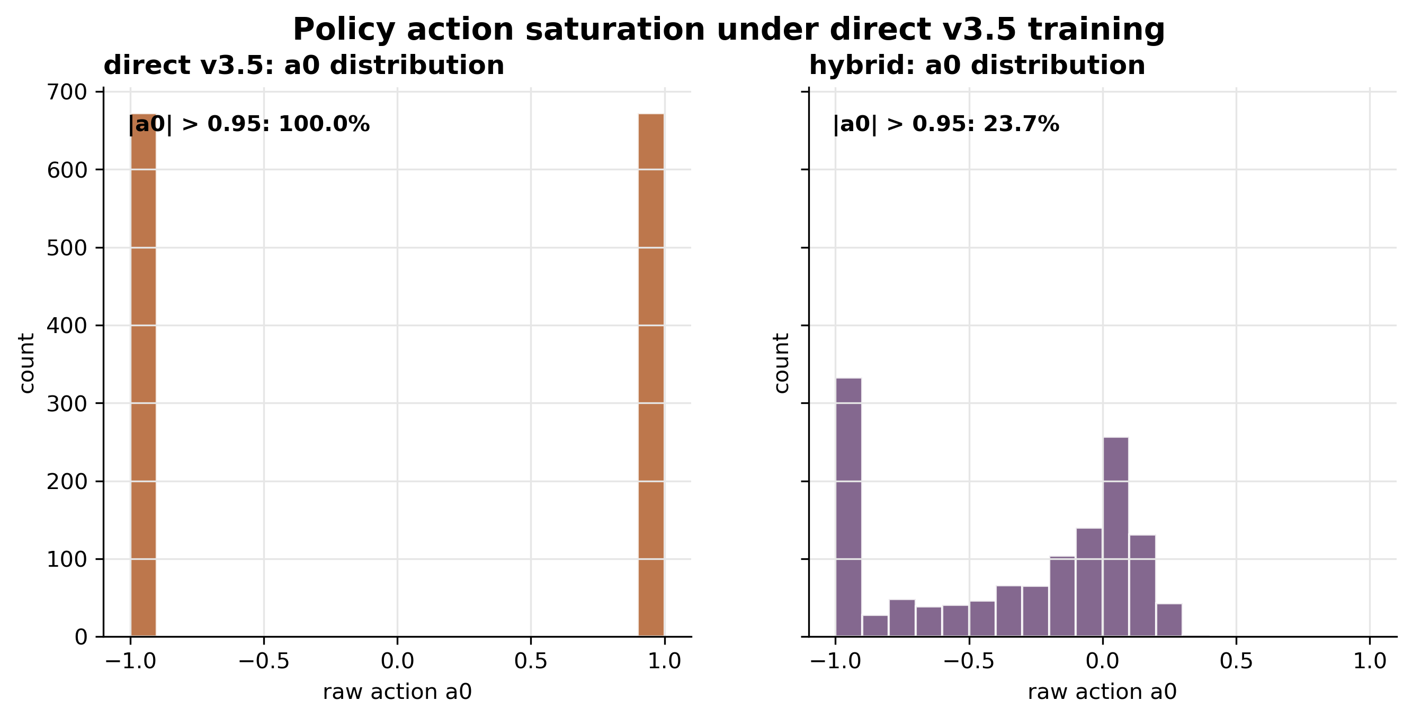
Figure S1.7. Action-saturation diagnostic. Direct v3.5 PPO drives the actuator into saturation early; hybrid_l010 holds policy fidelity through step 16 on the typical winter window.
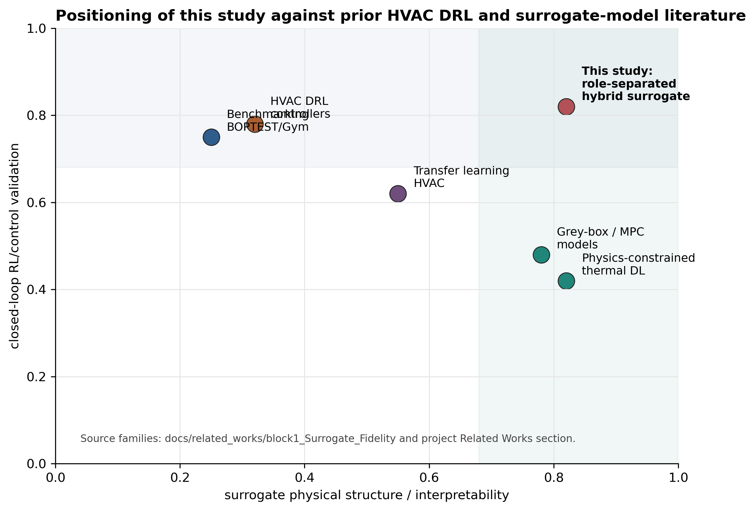
Figure S1.8. Literature positioning map. Our work occupies the (low predictive fidelity + high RL utility) quadrant via deliberate role separation; existing physics-constrained surrogate work targets the (high fidelity + unknown RL utility) corner.

S2. Block 2 supplementary figures
These figures support the controller-side analysis in Section 6. They include conceptual pipeline schematics (S2.1, S2.2), live BOPTEST traces (S2.3–S2.6), MORL observation-interface ablation (S2.7–S2.9), hybrid-disagreement bounds (S2.10), HDRL tracking detail (S2.11), and three-panel hybrid-vs-PI comparison (S2.12).
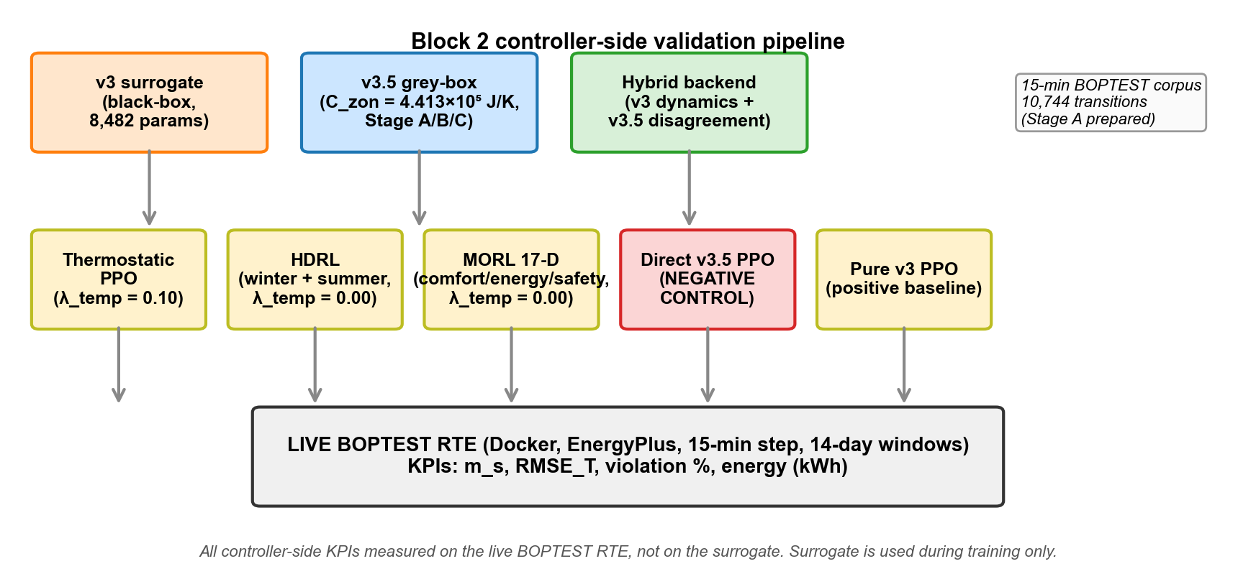
Figure S2.1. Block 2 controller-side validation pipeline: three surrogate backends feed five training stacks; all controller KPIs measured on live BOPTEST RTE.
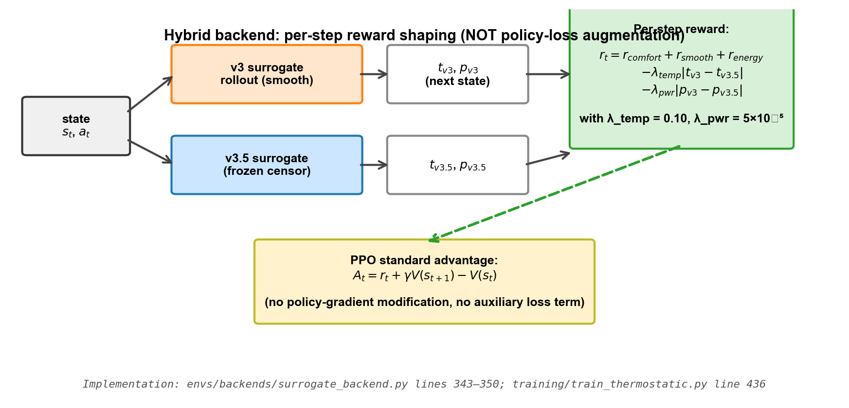
Figure S2.2. Hybrid backend reward-shaping mechanism. v3 supplies rollout dynamics; v3.5 contributes per-step disagreement penalties subtracted from the comfort+energy reward.
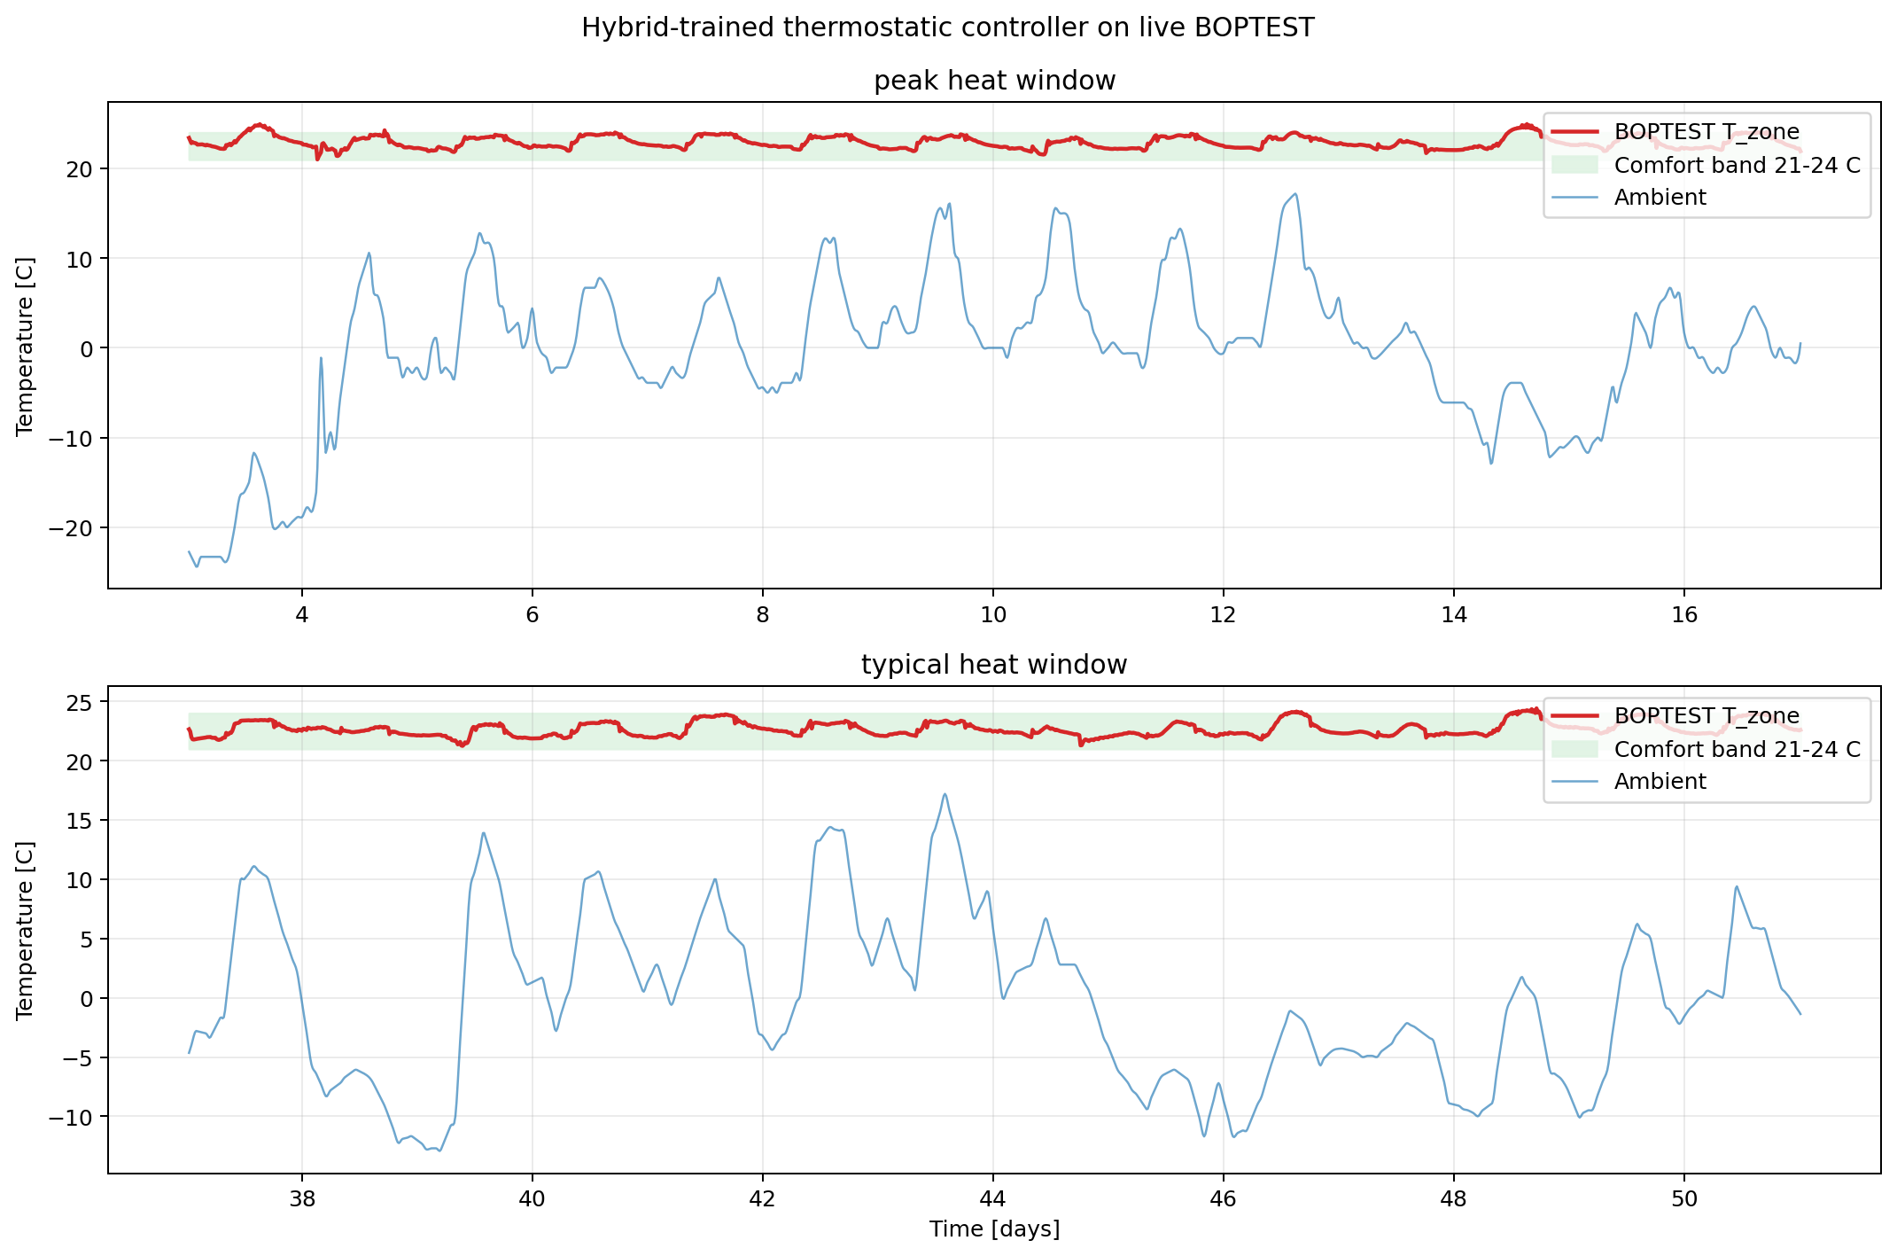
Figure S2.3. Hybrid_l010 live BOPTEST comfort traces on peak and typical winter windows. The hybrid policy stays close to the 21–24 °C comfort band.
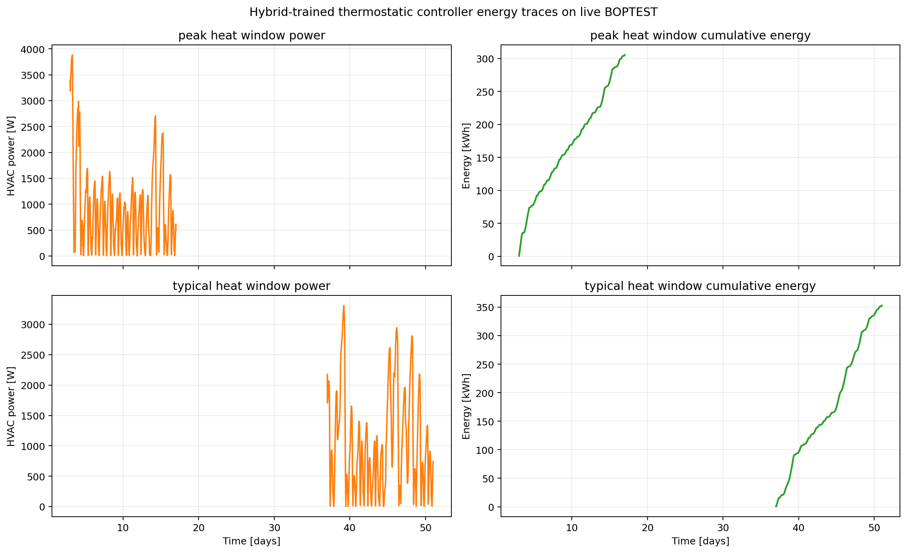
Figure S2.4. Hybrid_l010 power and cumulative-energy traces. Energy advantage over pure v3 is comparable; the hybrid achieves better comfort at no energy cost.
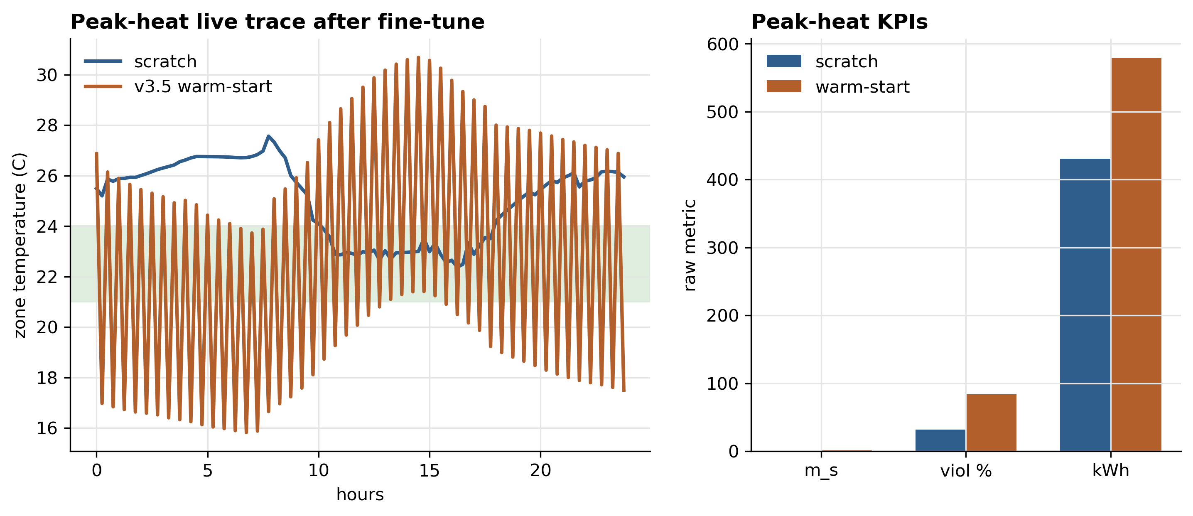
Figure S2.5. Direct v3.5 warm-start negative control. Pre-training from v3.5 hurts subsequent hybrid training compared to scratch initialisation.
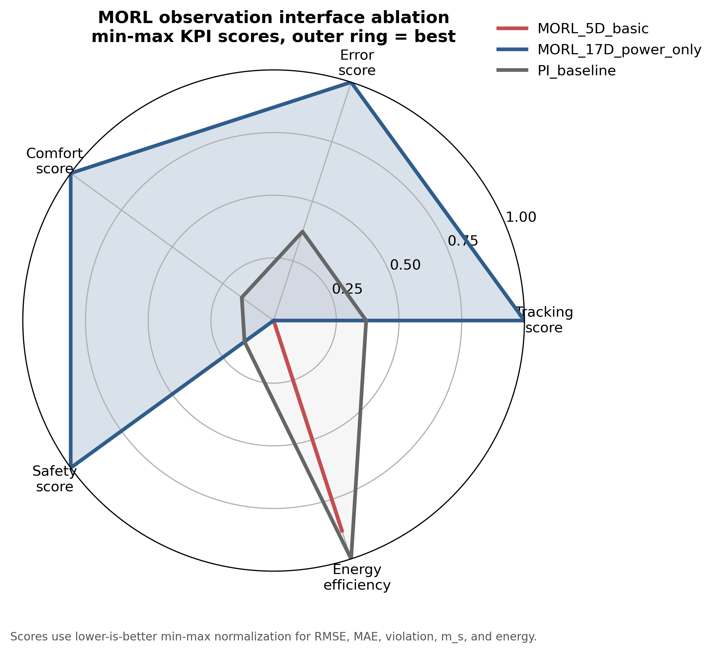
Figure S2.6. MORL 5D vs 17D observation-interface ablation. The 5D path collapses (m_s = 1.046); the 17D path recovers a usable MORL policy (m_s = 0.099).
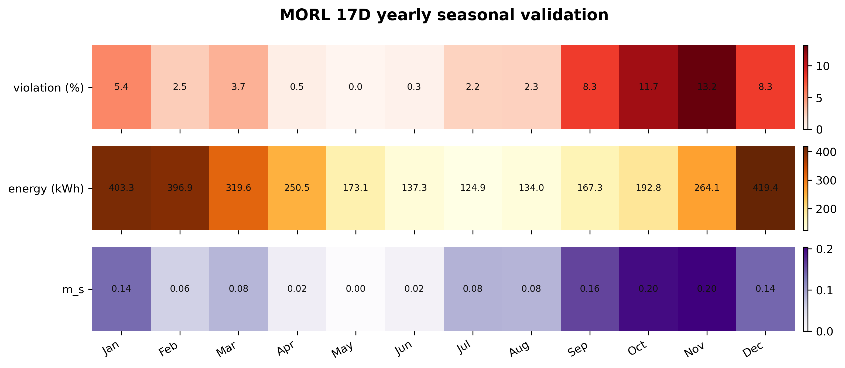
Figure S2.7. MORL 17D monthly seasonal performance heatmap. Performance varies across the calendar year but stays within the pre-registered safety band.
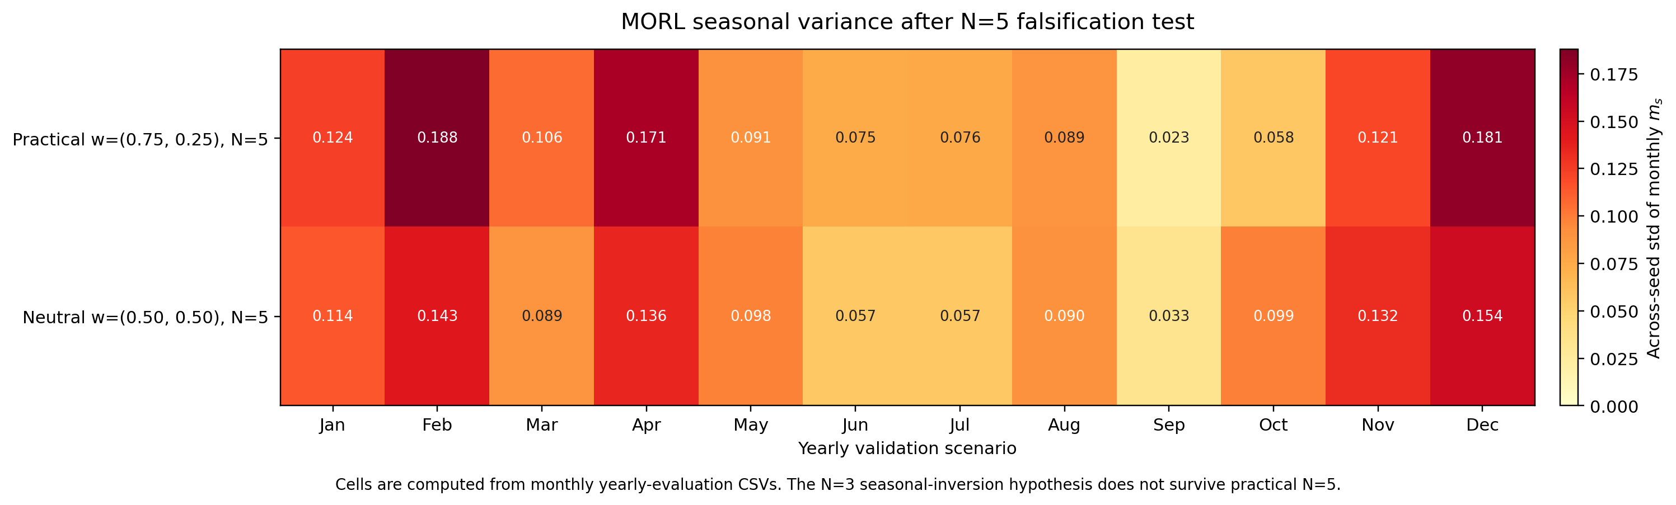
Figure S2.8. MORL seasonal seed-variance heatmap after the N=5 falsification test. The original N=3 seasonal-inversion mechanism does not survive.
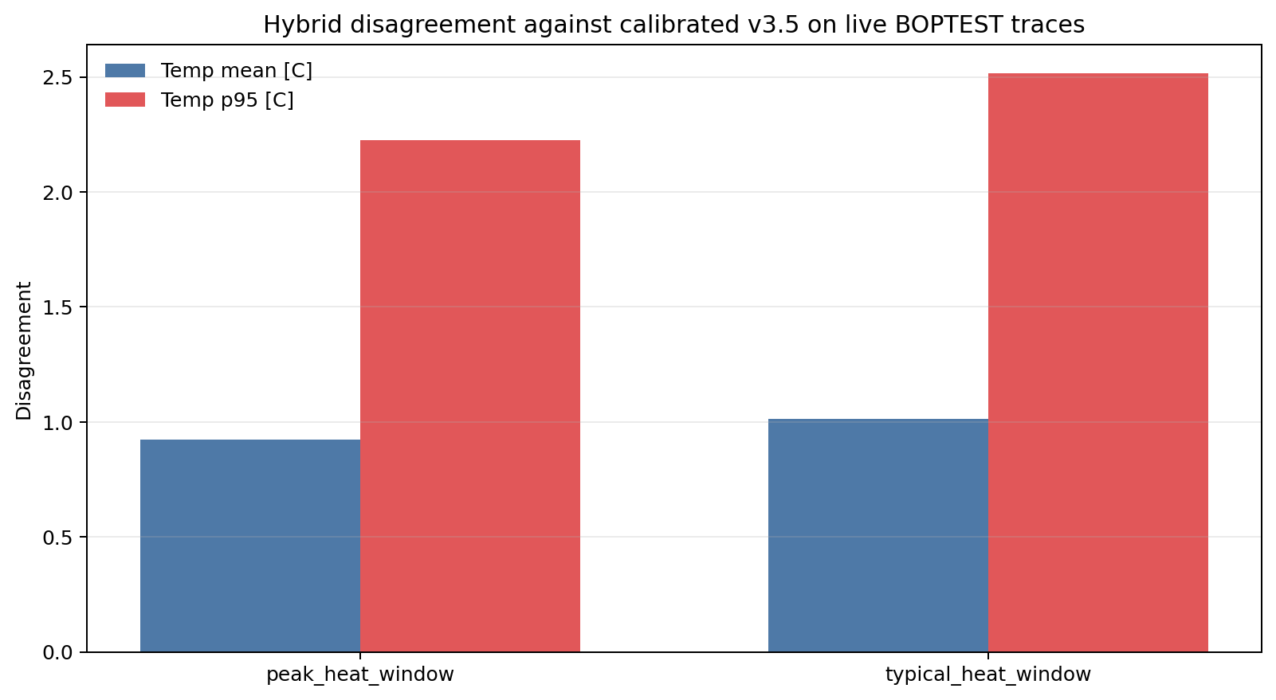
Figure S2.9. Hybrid disagreement bounds: mean v3–v3.5 temperature disagreement 0.969 °C (p95 2.516 °C); mean power 708.4 W (p95 1,236 W). Bounded rather than chaotic divergence.
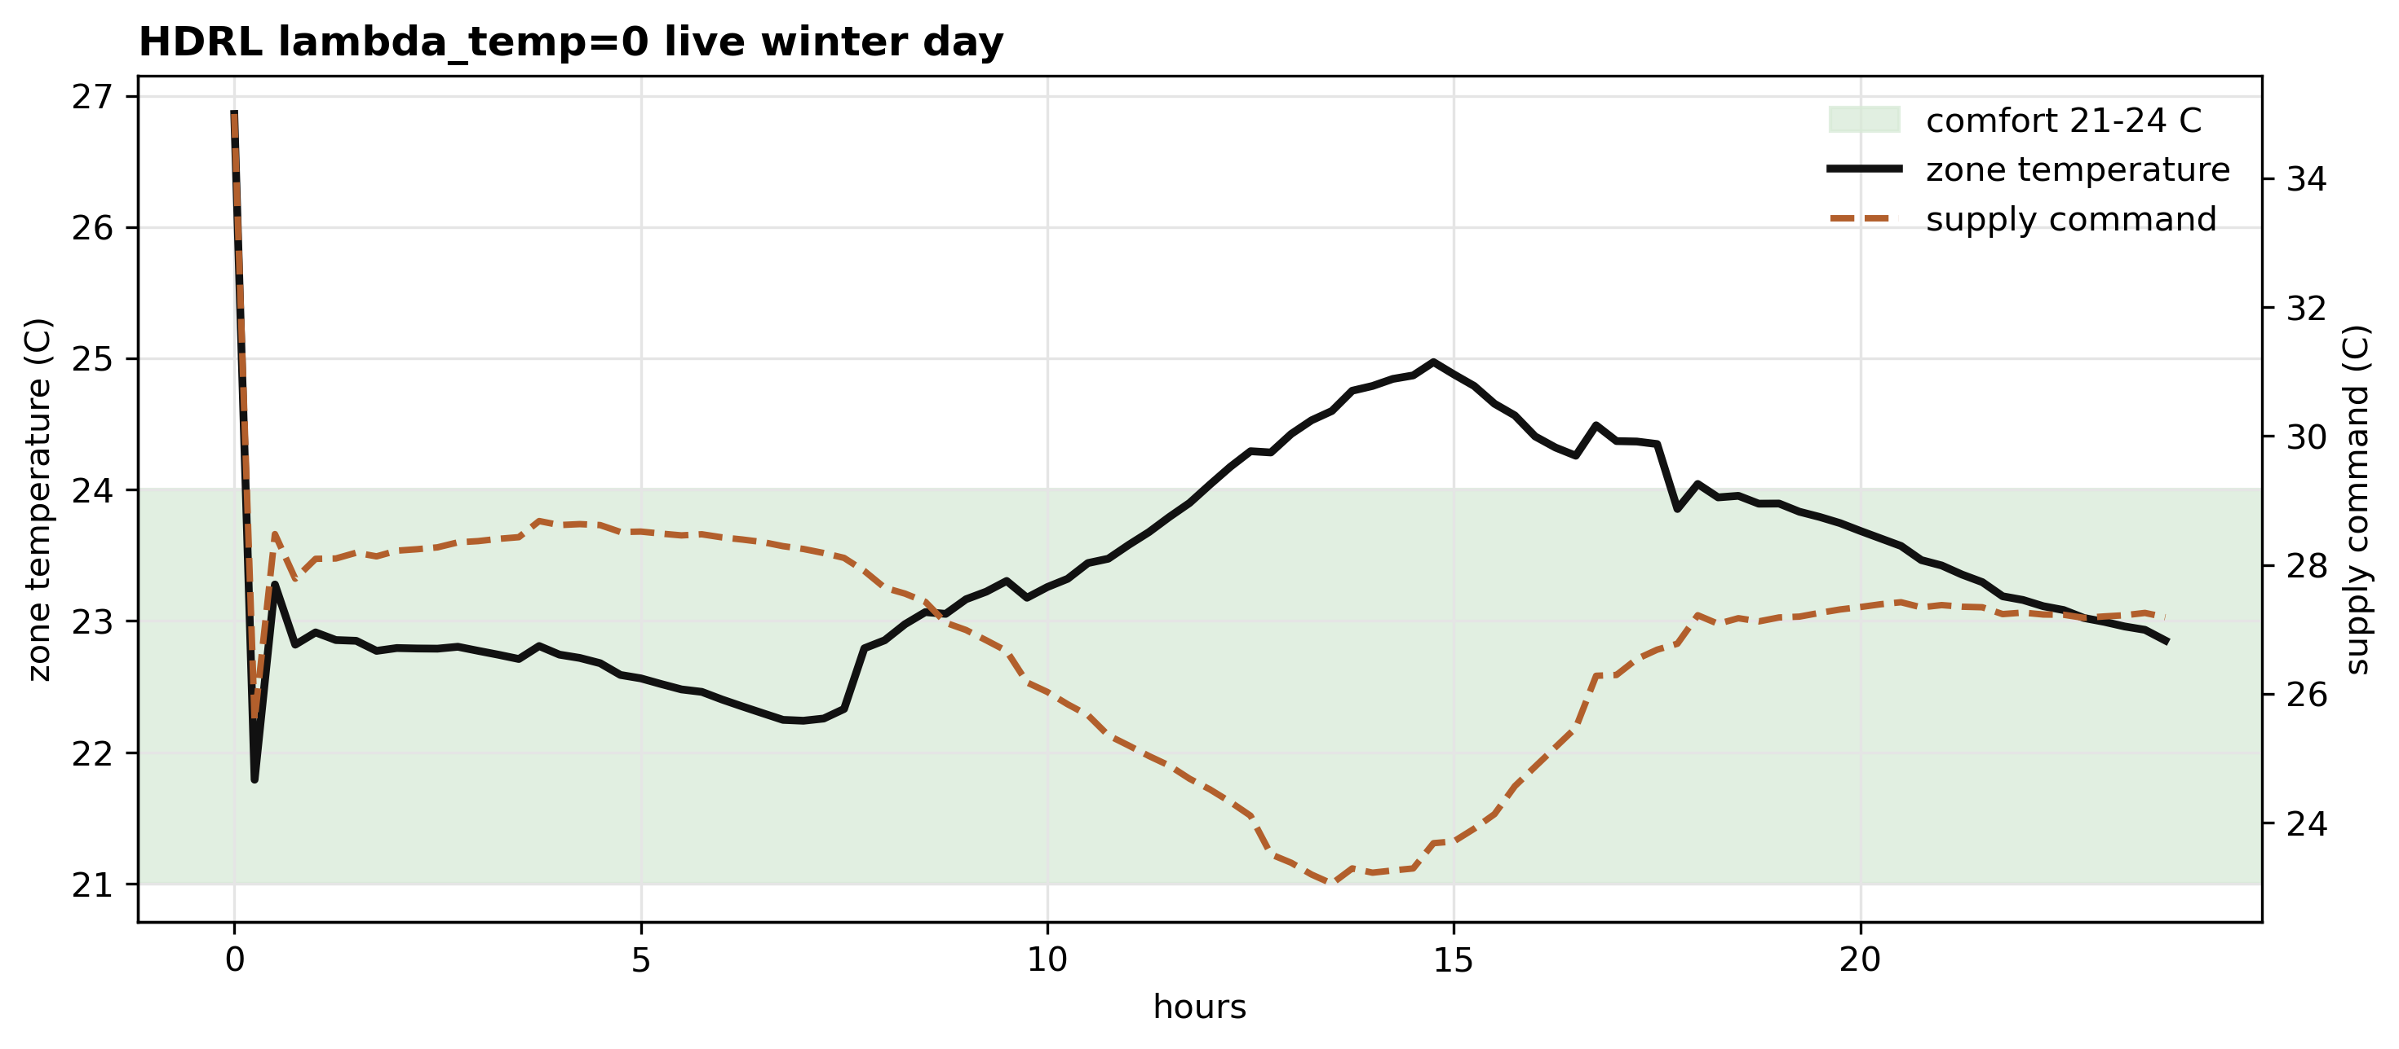
Figure S2.10. HDRL l000 representative winter trace. The hierarchical winter specialist tracks the lower edge of the comfort band closely with low energy expenditure.
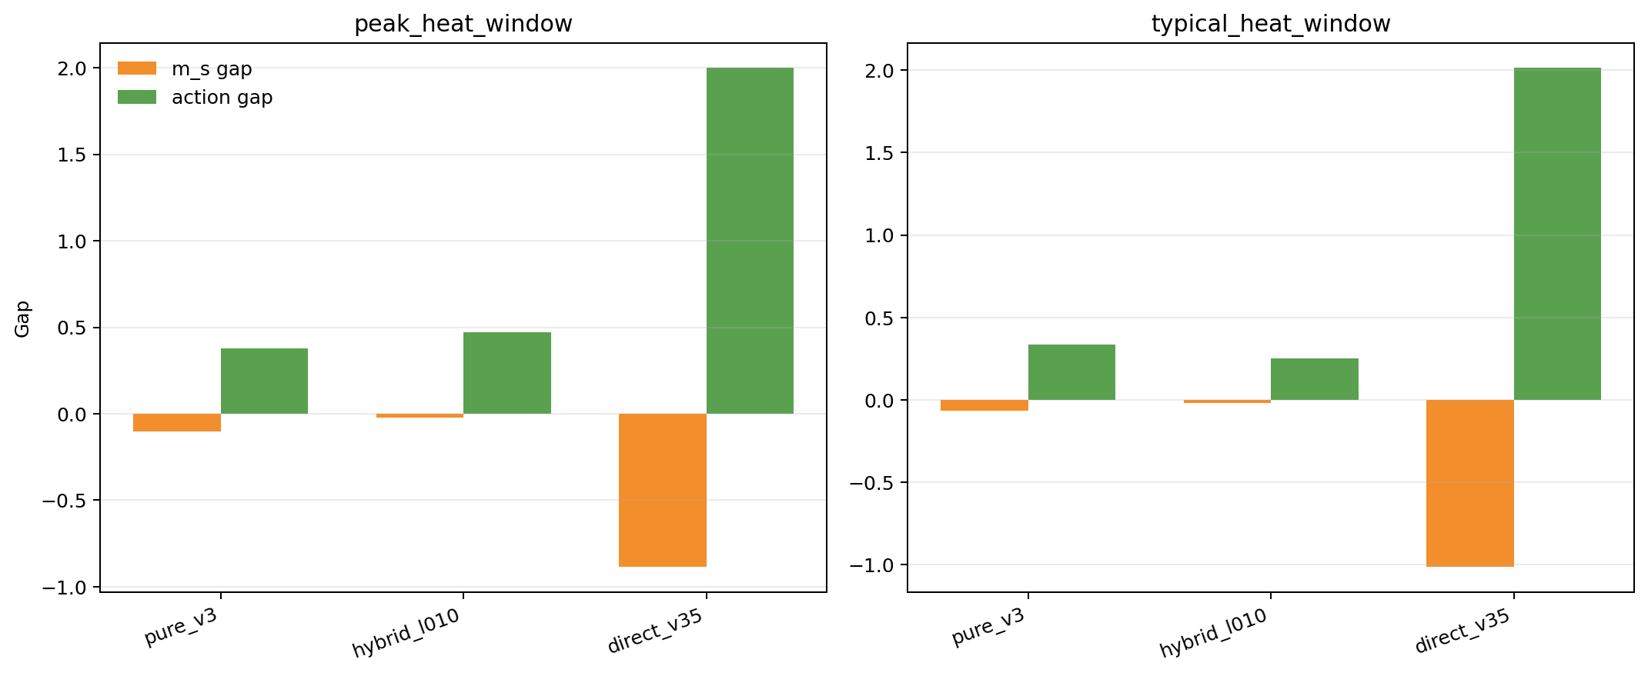
Figure S2.11. Surrogate-to-live transfer-gap comparison across pure v3, hybrid_l010, and direct v3.5. The hybrid narrows the surrogate→live ms_gap from |gap| ≈ 0.9–1.0 to ≈ 0.02.
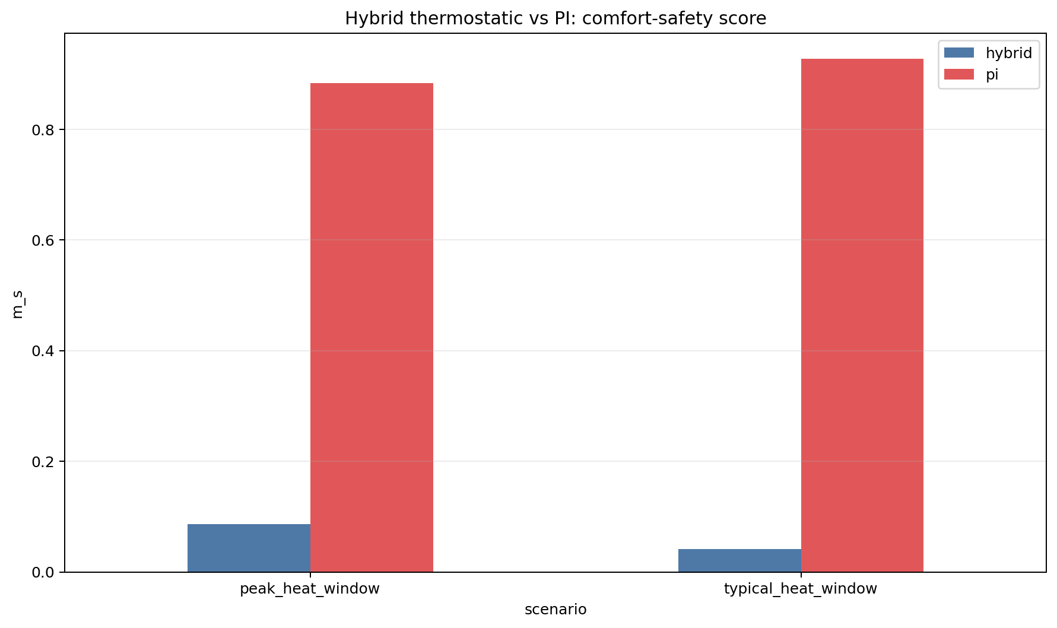
Figure S2.12a. Hybrid_l010 vs PI baseline — m_s comparison.
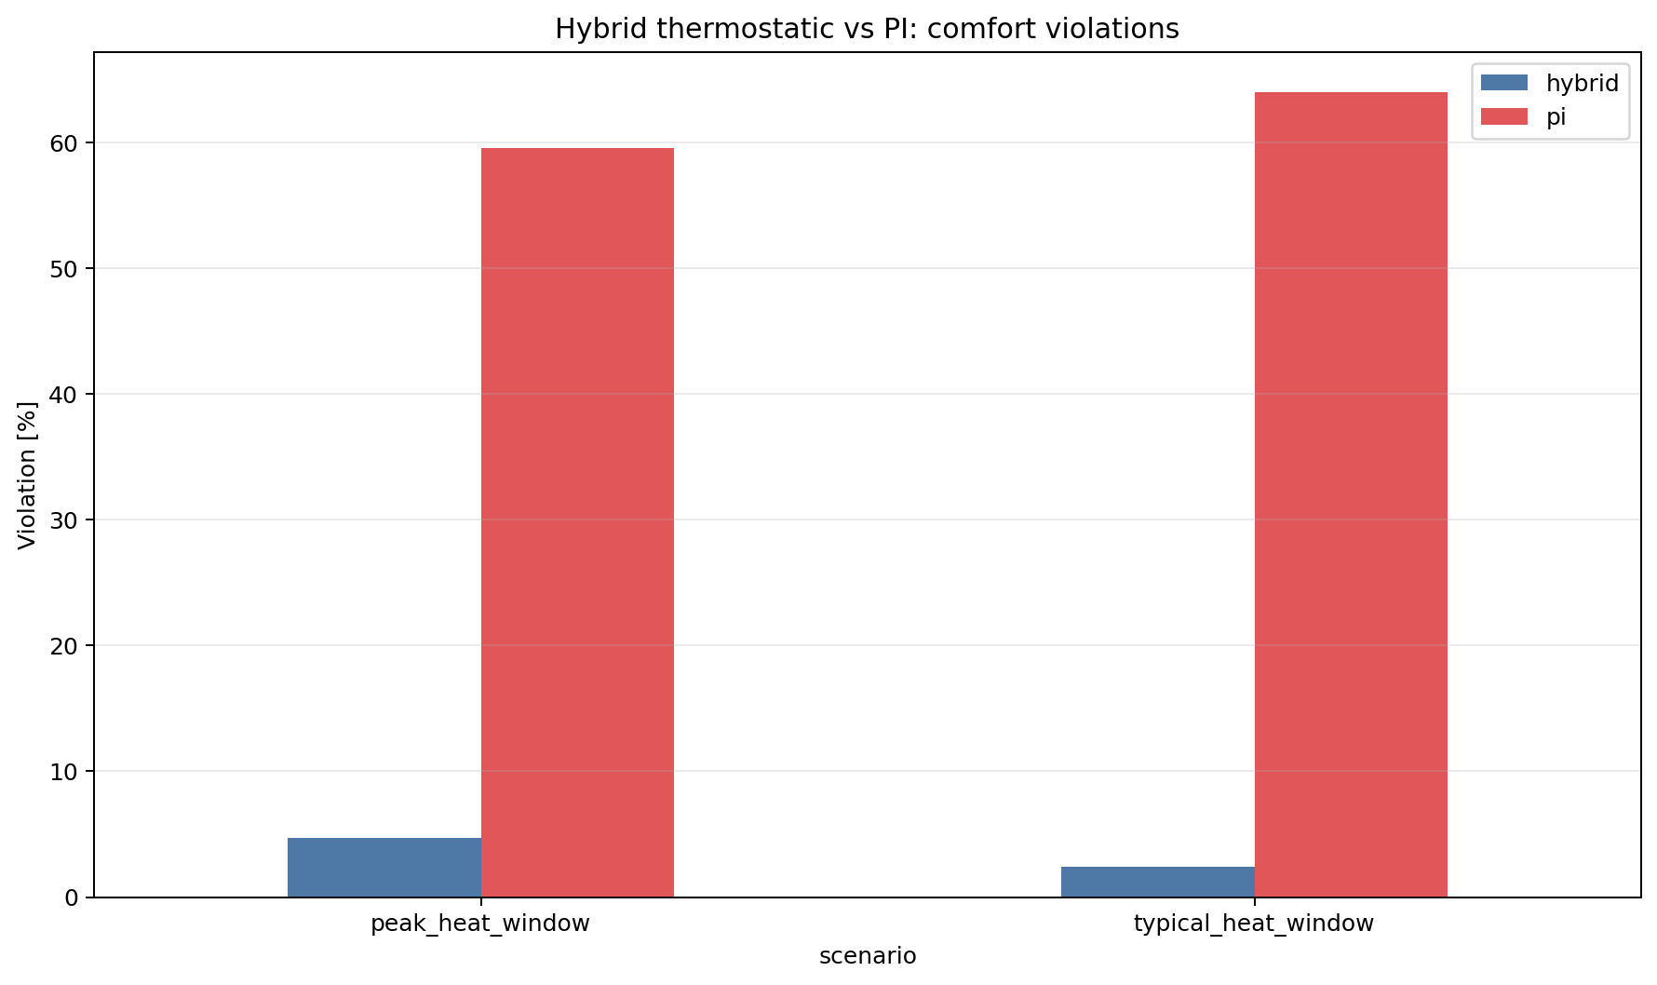
Figure S2.12b. Hybrid_l010 vs PI baseline — setpoint violation percentage comparison.
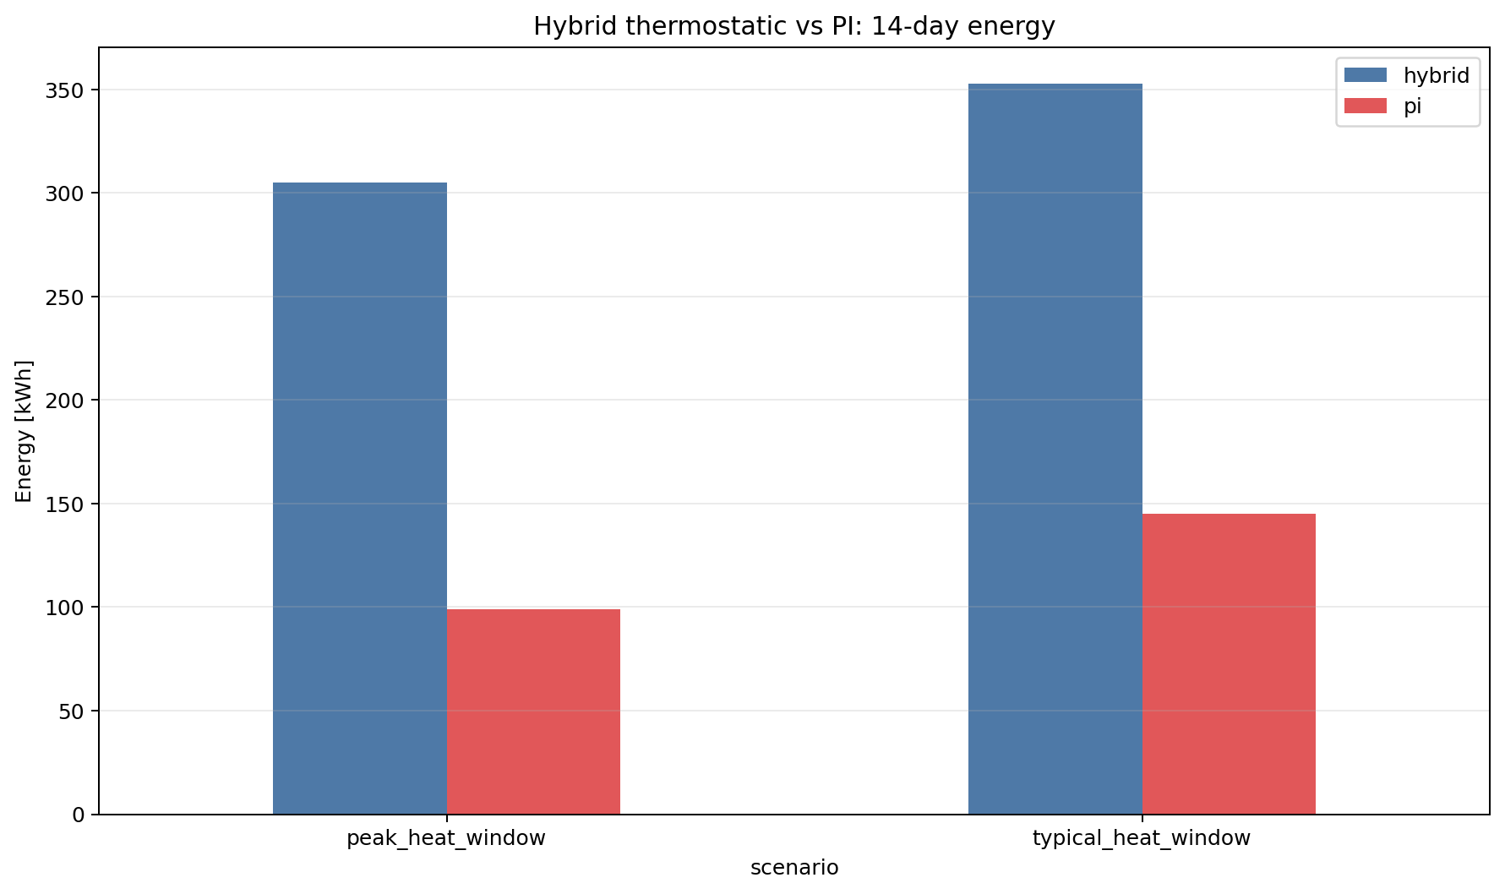
Figure S2.12c. Hybrid_l010 vs PI baseline — energy consumption comparison.

S3. Block 3 supplementary figures
These figures support the transferability analysis in Section 7. They include the pre-registered protocol schematic (S3.1), the testcase difficulty ladder (S3.2), the controller transfer verdict heatmap (S3.3), the full Stage A/B/C gain bar chart (S3.4), and the pre-registered predictions vs observed outcomes table (S3.5).
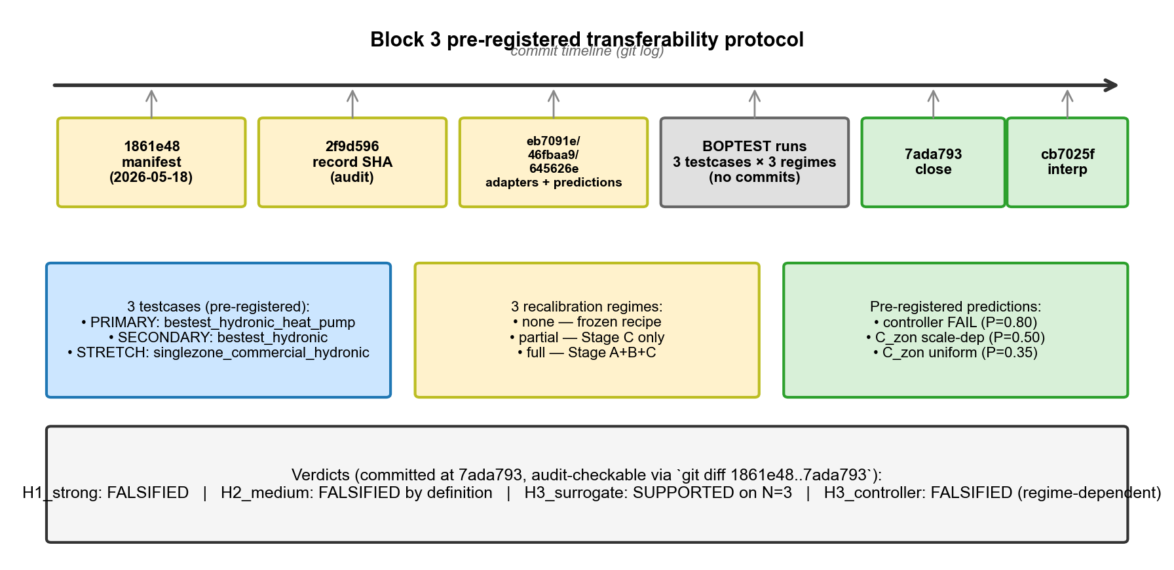
Figure S3.1. Pre-registered Block 3 transferability protocol with the 9-commit audit chain timeline. Bit-identical pre-registration block verifiable via `git diff 1861e48..7ada793`.
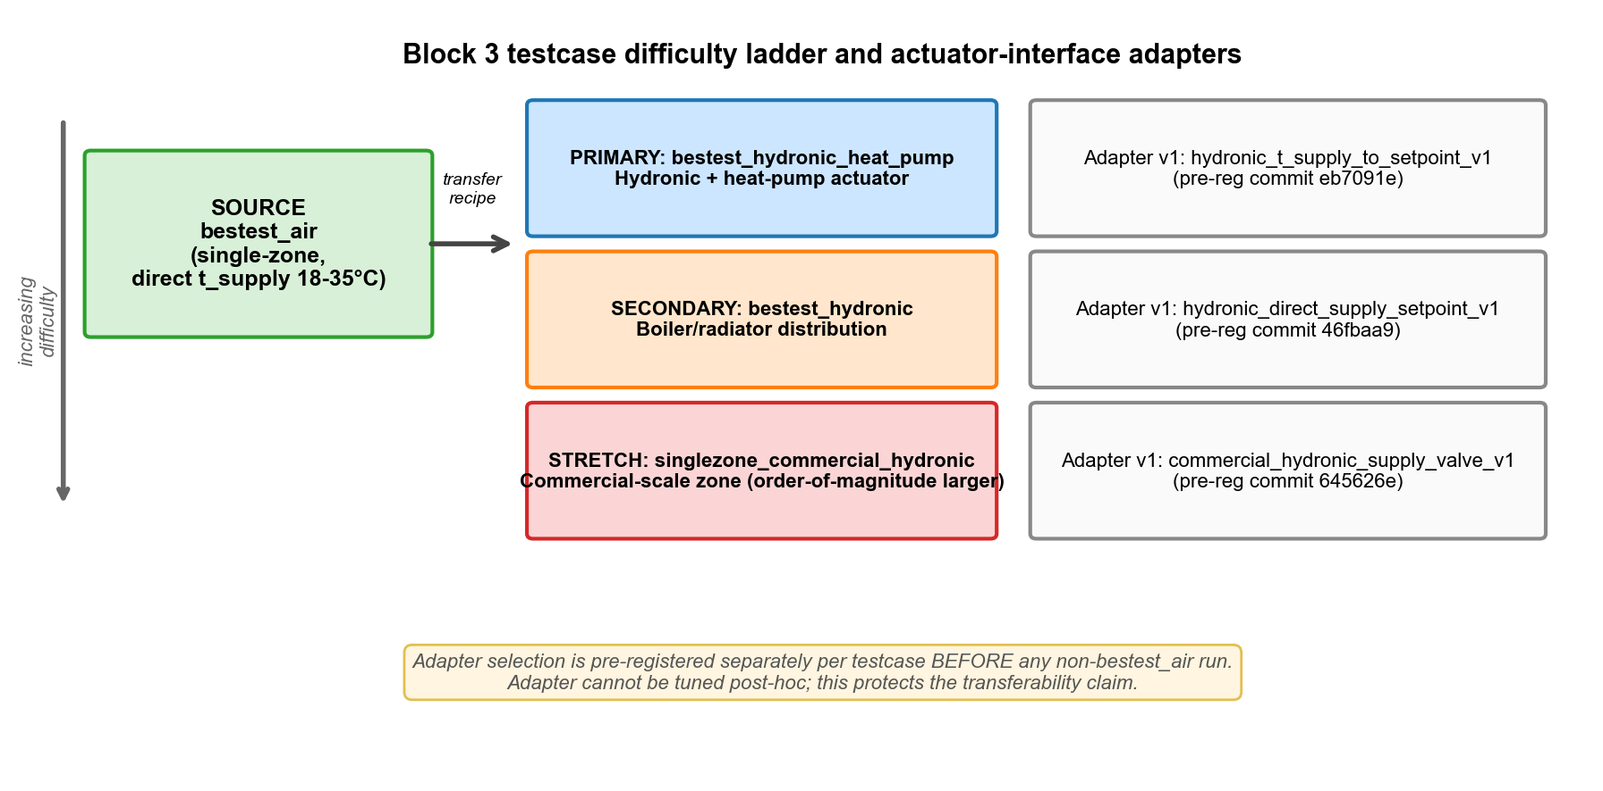
Figure S3.2. Block 3 testcase difficulty ladder: source (bestest_air) → primary (bestest_hydronic_heat_pump) → secondary (bestest_hydronic) → stretch (singlezone_commercial_hydronic), each with its pre-registered actuator adapter.
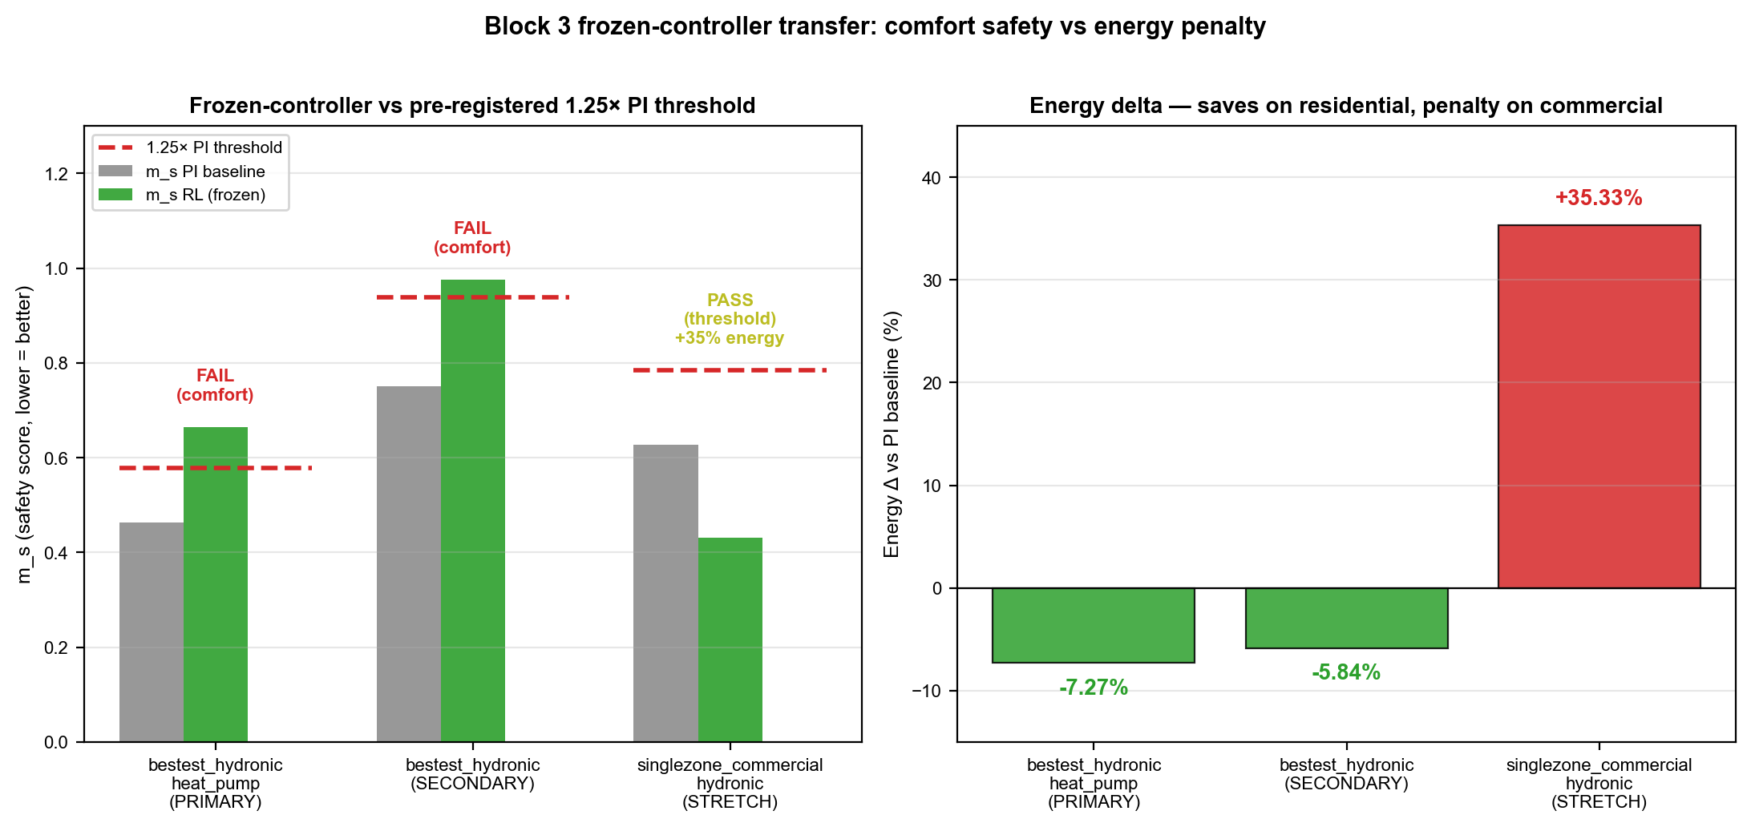
Figure S3.3. Frozen-controller transfer: m_s_RL vs 1.25× PI threshold and energy delta versus PI. Residential cases save energy but fail comfort; commercial passes safety but at +35.3% energy.
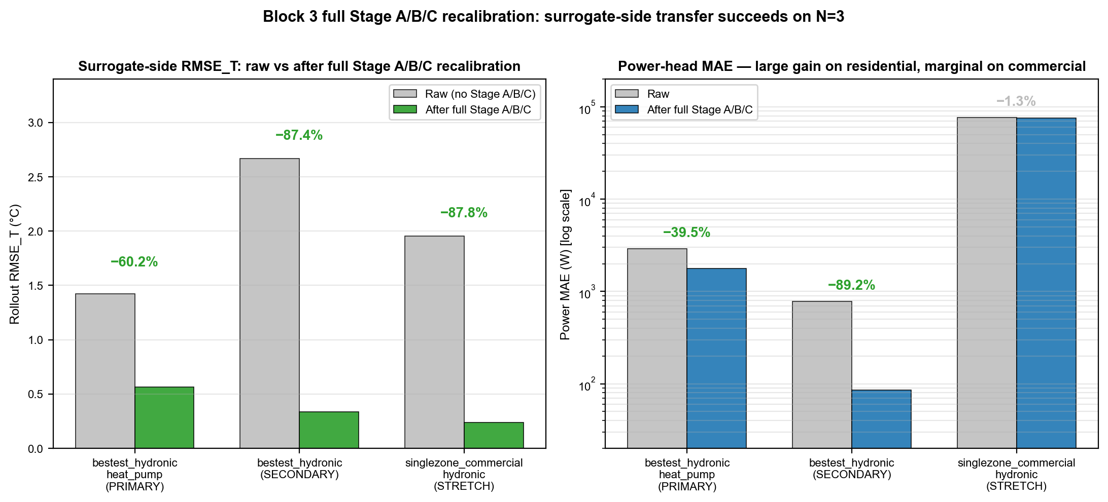
Figure S3.4. Full Stage A/B/C surrogate recalibration improves RMSE_T by 60.2 / 87.4 / 87.8 % on the three hydronic testcases; power-head MAE improvements are large on residential cases and marginal on commercial.
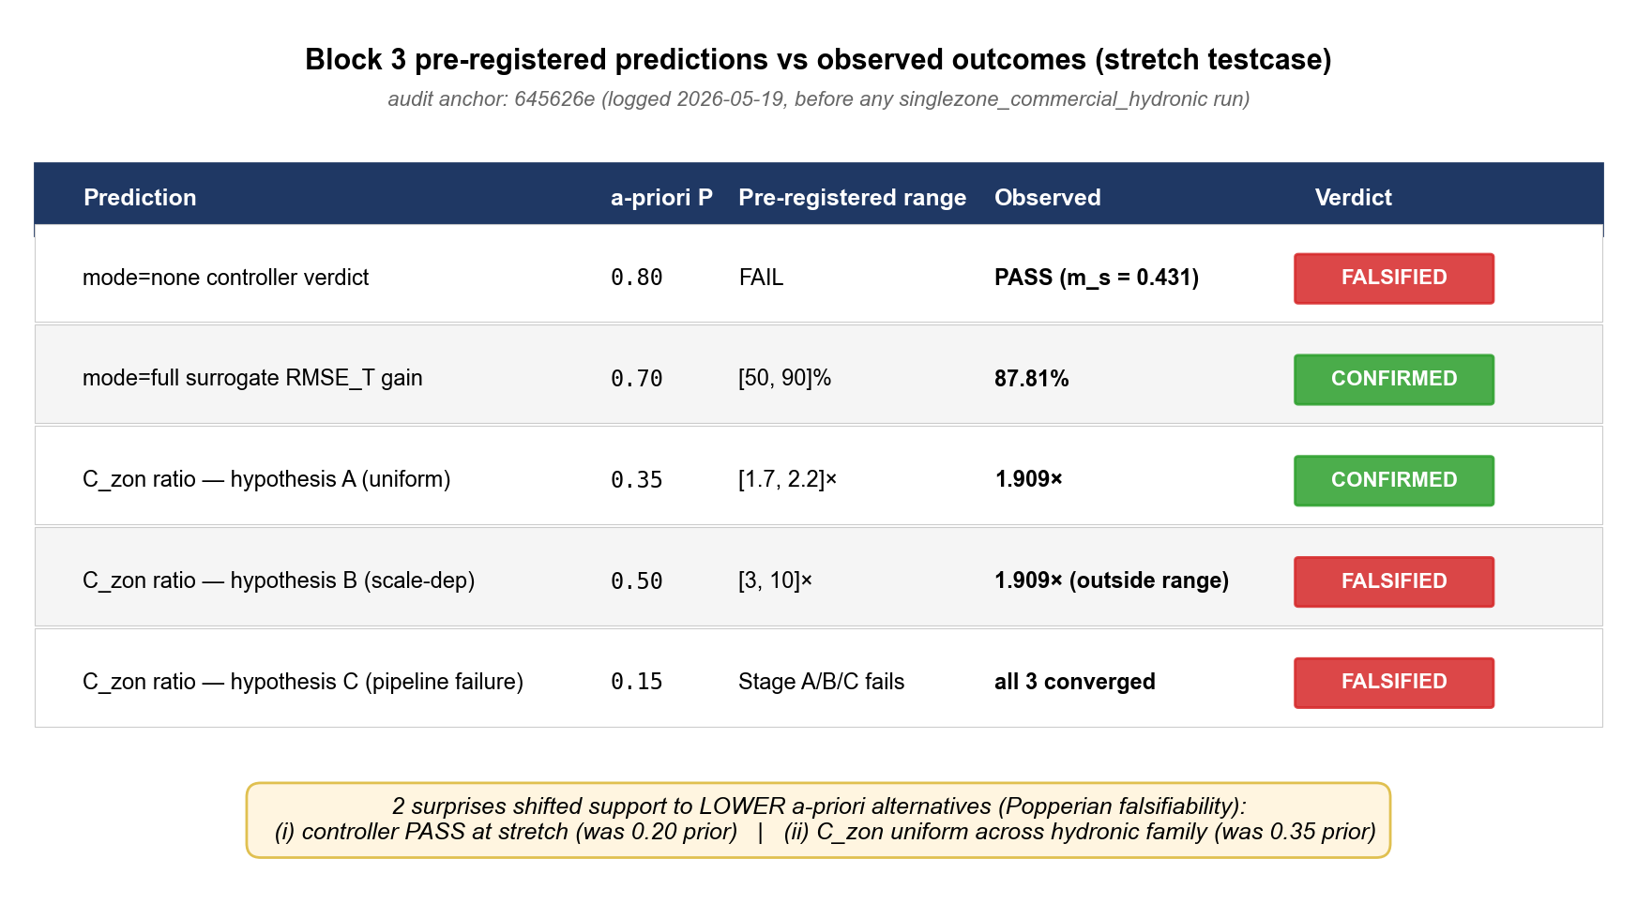
Figure S3.5. Pre-registered predictions vs observed outcomes (stretch testcase). Two predictions FALSIFIED (controller verdict; scale-dependent C_zon B); three CONFIRMED (RMSE gain; uniform C_zon A; pipeline convergence).

S4. Hou-and-Evins Reporting-Level-3 numerical-justification tables
Eleven tables (S4.1–S4.11) cover the Hou-and-Evins Section-5 reporting requirements: sample-generation provenance, sample-size justification, Stage A telemetry preprocessing, feature significance, input independence, split representativeness, channel scaling, training hyperparameters, architecture justification, targeted sensitivity, and replicative/predictive validity. Each table is reproduced verbatim from the corresponding CSV under paper/supplementary/. Per the compliance review, fifteen of the seventeen Hou-and-Evins Level-3 items are covered; the two not covered are physical co-simulation across independent Modelica engines and grid-tied multi-agent coordination, both out of scope for the single-zone testbed used here.

Table S4.1
Sample-generation provenance — origin, parameter ranges, and physical justification of each transition corpus.
dataset id | source file | rows | episodes or groups | step sec | controller or policy mix
v3_hourly_direct_tsup | data\surrogate_v2\boptest_v2_tsupply.csv | 51200 | 16 | 3600 | "cool
v35_prepared_15min_bootstrap | data/block_1_2_surrogate_rmse/boptest_block12_15min_prepared.csv | 10744 | 8 | 900 | "hdrl
v35_collected_15min_exploration | data/block_1_2_surrogate_rmse/boptest_block12_15min_collected.csv | 48384 | 24 | 900 | "cool

Table S4.2
Sample-size justification — numerical evidence for the chosen corpus sizes including learning-curve checks.
dataset id | rows | episodes or groups | step sec | new boptest collection minutes
v3_hourly_direct_tsup | 51200 | 16 | 3600
v35_prepared_15min_bootstrap | 10744 | 8 | 900 | 0.0000
collected_15min_exploration | 48384 | 24 | 900 | 17.1815
collected_15min_focus | 24192 | 12 | 900 | 9.4833

Table S4.3
Stage A telemetry preprocessing — latency compensation, bias removal, normalisation, denoise, causal delta.
stage a operation | implementation | parameter or rule | selection criterion | purpose
latency compensation search | _undo_delay_array over candidate lags | "lag in [0 | max_latency_search]" | choose lag minimizing surrogate one-step RMSE against observed next-step temperature | undo thermostat/telemetry delay before calibration
temperature bias removal | median residual offset subtraction | bias_est = median(t_obs_next - t_pred) | center residual distribution before Stage B/C calibration | avoid fitting static sensor bias as building physics
power affine normalization | least-squares fit p_obs ≈ scale * p_pred + bias | "scale_est | bias_p_est from linear solve" | reduce power-channel mismatch before nonlinear head refinement | separate systematic meter scaling from dynamic error
rolling denoise | rolling median + exponential moving average | smooth_window = 5 | suppress high-frequency telemetry noise without changing regime identity | stabilize downstream inverse calibration
causal delta recomputation | delta_t = t_zone_next - t_zone after preprocessing | derived from corrected current and next temperature | preserve state-transition consistency after artifact correction | avoid propagating artifact-driven temperature-history features

Table S4.4
Feature significance — per-feature retention rationale with quantitative selection criteria.
variant | obs ablation | delta feature mode | power feature mode | t zone feature mode
with_power_raw | none | raw | raw | raw
no_power | no_power | raw | raw | raw
no_delta_t | no_delta_t | raw | raw | raw
no_power_no_delta_t | no_power_no_delta_t | raw | raw | raw
no_prev_action | no_prev_action | raw | raw | raw
no_temp_history | no_temp_history | raw | raw | raw
causal_smooth | none | causal_smooth | raw | raw
no_delta_t_powerlog | no_delta_t | raw | clipped_log | raw
no_delta_t_powerlog_tzone | no_delta_t | raw | clipped_log | comfort_centered

Table S4.5
Input independence — Pearson and mutual-information independence checks across input channels.
feature i | feature j | pearson r | abs pearson r | normalized mutual info
t_zone | t_amb | -0.1451 | 0.1451 | 0.0624
t_zone | hour_sin | -0.3634 | 0.3634 | 0.0580
t_zone | hour_cos | -0.0029 | 0.0029 | 0.0562
t_zone | day_sin | -0.1439 | 0.1439 | 0.0501
t_zone | day_cos | 0.1120 | 0.1120 | 0.0509
t_zone | prev_action_a0 | 0.1303 | 0.1303 | 0.1106
t_zone | prev_action_a1 | 0.1482 | 0.1482 | 0.0474
t_zone | power_history_proxy | 0.2446 | 0.2446 | 0.0510
t_zone | delta_t_history | -0.1791 | 0.1791 | 0.0424
t_amb | hour_sin | -0.3076 | 0.3076 | 0.0840
t_amb | hour_cos | -0.3656 | 0.3656 | 0.0843
t_amb | day_sin | 0.0246 | 0.0246 | 0.2292
t_amb | day_cos | 0.0132 | 0.0132 | 0.1952
t_amb | prev_action_a0 | -0.8005 | 0.8005 | 0.2478
t_amb | prev_action_a1 | -0.0577 | 0.0577 | 0.1221
t_amb | power_history_proxy | -0.6381 | 0.6381 | 0.2267
t_amb | delta_t_history | 0.0609 | 0.0609 | 0.0160
hour_sin | hour_cos | -9.726246485875073e-05 | 9.726246485875073e-05 | 0.5734
hour_sin | day_sin | -0.0125 | 0.0125 | 0.0020
hour_sin | day_cos | 0.0124 | 0.0124 | 0.0074
hour_sin | prev_action_a0 | 0.4759 | 0.4759 | 0.0913
hour_sin | prev_action_a1 | -0.0460 | 0.0460 | 0.0346
hour_sin | power_history_proxy | 0.4277 | 0.4277 | 0.0846
hour_sin | delta_t_history | 0.0025 | 0.0025 | 0.0313
hour_cos | day_sin | 0.0008 | 0.0008 | 0.0018
hour_cos | day_cos | -0.0008 | 0.0008 | 0.0088
hour_cos | prev_action_a0 | 0.5486 | 0.5486 | 0.1198
hour_cos | prev_action_a1 | -0.2219 | 0.2219 | 0.0429
hour_cos | power_history_proxy | 0.2515 | 0.2515 | 0.0663
hour_cos | delta_t_history | -0.0748 | 0.0748 | 0.0373
day_sin | day_cos | -0.9857 | 0.9857 | 0.7608
day_sin | prev_action_a0 | 0.0614 | 0.0614 | 0.0592
day_sin | prev_action_a1 | 0.0087 | 0.0087 | 0.0462
day_sin | power_history_proxy | 0.0522 | 0.0522 | 0.0889
day_sin | delta_t_history | 0.0027 | 0.0027 | 0.0189
day_cos | prev_action_a0 | -0.0764 | 0.0764 | 0.0546
day_cos | prev_action_a1 | -0.0225 | 0.0225 | 0.0416
day_cos | power_history_proxy | -0.0693 | 0.0693 | 0.0688
day_cos | delta_t_history | -0.0027 | 0.0027 | 0.0203
prev_action_a0 | prev_action_a1 | -0.1125 | 0.1125 | 0.0829
prev_action_a0 | power_history_proxy | 0.7437 | 0.7437 | 0.3228
prev_action_a0 | delta_t_history | -0.1384 | 0.1384 | 0.0254
prev_action_a1 | power_history_proxy | 0.3881 | 0.3881 | 0.0948
prev_action_a1 | delta_t_history | 0.0266 | 0.0266 | 0.0139
power_history_proxy | delta_t_history | -0.0933 | 0.0933 | 0.0248

Table S4.6
Train/validation/test split representativeness — distributional checks between corpus partitions.
pipeline | split mode | train rows | val rows | test definition
v3_hourly_control_backbone | row_index_contiguous_80_20 | 40960.0000 | 10240.0000 | external 15-minute BOPTEST benchmark scenarios
v35_inverse_canonical_power_head_only | episode_id_80_20_plus_excitation_subselection | 8058.0000 | 2686.0000 | prepared rollout validation plus live thermostatic BOPTEST transfer benchmark
hybrid_thermostatic_downstream | no_internal_dataset_split |  |  | two unseen live BOPTEST heating scenarios: peak_heat_window and typical_heat_window

Table S4.7
Per-channel scaling and reverse-scaling logic — standardisation parameters reused at inference time.
variable | context | scaling method | parameters | source file
surrogate_t_zone | v3/v3.5 surrogate input | "affine min-max to [-1 | 1]" | min=15 C; max=35 C
surrogate_t_amb | v3/v3.5 surrogate input | "affine min-max to [-1 | 1]" | min=-10 C; max=40 C
hour | v3/v3.5 surrogate input and TSup controller observation | cyclic sine/cosine | sin(2*pi*hour/24); cos(2*pi*hour/24) | surrogate/rc_node_v2.py; envs/tsup_features.py
day | v3/v3.5 surrogate input and TSup controller observation | cyclic sine/cosine | sin(2*pi*day/365); cos(2*pi*day/365) | surrogate/rc_node_v2.py; envs/tsup_features.py
a0_raw | direct supply-temperature action | native action domain | "[-1 | 1] maps to 18..35 C supply temperature"
a1_raw | direct fan action | native action domain | "[-1 | 1.0000
p_total | "TSup controller observation | raw mode" | "affine min-max to [-1 | 1]"
p_total | canonical TSup controller observation | "clipped log transform to [-1 | 1]" | clip at 2500 W; 2*log1p(p)/log1p(2500)-1
delta_t | "TSup controller observation | raw mode" | linear clipping | "clip(delta_t/5 C
delta_t | MORL 17D TSup-style observation | causal smooth tanh | clip to +/-1.5 C; tanh(delta/1.25) | envs/tsup_features.py
controller_t_zone | "TSup controller observation | raw mode" | "affine min-max to [-1 | 1]"
controller_t_zone | "TSup controller observation | comfort-centered ablation" | comfort-centered clipping | "clip((T_zone-22.5 C)/3 C
power_head_output | v3 surrogate output | Softplus multiplied by P_MAX | P_MAX=5500 W | surrogate/rc_node_v2.py
C_zon | v3.5 physics backbone | positive reparameterization | softplus(log_c_zon)+c_min; c_min=5e4 J/K | surrogate/rc_node_v35.py

Table S4.8
Training hyperparameters — optimiser, learning rate, batch size, regularisation, and stopping criteria.
param | value | source file | justification
active_v3_training_entrypoint | surrogate/train_surrogate_backbone.py | surrogate/train_surrogate_backbone.py | Canonical comfort-oriented direct-TSup v3 backbone training script currently present in active contour.
legacy_train_surrogate_py | not present in active contour | surrogate/train_surrogate.py | The former generic entrypoint is not part of the current active contour; v3 training is reported through train_surrogate_backbone.py.
epochs | 500 | surrogate/train_surrogate_backbone.py | Default CLI value; upper budget constrained by early stopping.
batch_size | 256 | surrogate/train_surrogate_backbone.py | Default DataLoader batch size used for stable mini-batch estimates on the BOPTEST corpus.
learning_rate | 1e-3 | surrogate/train_surrogate_backbone.py | Default AdamW learning rate for the v3 backbone.
hidden_dim | 64 | surrogate/train_surrogate_backbone.py | Default hidden width used by RCNeuralODEv2 heat and power heads.
optimizer | AdamW | surrogate/train_surrogate_backbone.py | Weight-decayed Adam optimizer stabilizes the black-box residual heads without changing the physical inputs.
weight_decay | 1e-4 | surrogate/train_surrogate_backbone.py | Explicit optimizer regularization in the canonical v3 training loop.
scheduler | CosineAnnealingLR(T_max=epochs) | surrogate/train_surrogate_backbone.py | Smooth learning-rate decay over the configured epoch budget.
early_stopping | patience=30; improvement_threshold=1e-6 | surrogate/train_surrogate_backbone.py | Stops training when the selected validation metric no longer improves.
checkpoint_metric | val_loss default; rollout_rmse optional | surrogate/train_surrogate_backbone.py | Default keeps one-step supervised fidelity; rollout_rmse was added for rollout-aware selection when explicitly requested.
gradient_clip_norm | 1.0000 | surrogate/train_surrogate_backbone.py | Limits unstable updates from multi-step rollout loss.
multi_horizons | "[2 | 4]" | surrogate/train_surrogate_backbone.py | Default short rollout horizons for one-step-plus-local-rollout training.
loss_lambda_temp | 1.0000 | surrogate/train_surrogate_backbone.py | Primary temperature fidelity term.
loss_lambda_power | 0.1000 | surrogate/train_surrogate_backbone.py | Power-head term is normalized by P_MAX and weighted below the temperature term.
loss_lambda_multi | 0.5000 | surrogate/train_surrogate_backbone.py | Balances local rollout consistency against one-step fit.
loss_lambda_physics | 0.0500 | surrogate/train_surrogate_backbone.py | Penalizes implausibly large one-step temperature jumps.

Table S4.9
Architecture justification — layer widths, depths, activations, and ablation evidence.
variant | role | explicit physics | explicit c zon | block1 temp alignment rmse c
v3 | control-oriented direct-TSup surrogate | no | no
v35_calibrated | physics-oriented calibrated twin | yes | yes | 0.2319
hybrid_l010 | v3 dynamics regularized by calibrated v3.5 | partial | regularizer-only

Table S4.10
Targeted sensitivity analysis — per-hyperparameter sweep results including the λ_temp scan.
sensitivity axis | tested values | selection metric | winner | numerical reason
observation_ablation | "none | no_power | no_delta_t | no_power_no_delta_t
feature_encoding | "raw | causal_smooth | clipped_log | comfort_centered"
hybrid_lambda_temp_disagree | "0.05 | 0.1000 | 0.1500 | mean thermostatic m_s across peak/typical

Table S4.11
Replicative and predictive validity — one-step and multi-horizon rollout RMSE across all variants including the v3_15min_matched and raw_v35 reviewer-mitigation rows.
model | horizon | horizon steps 15min | RMSE T | MAE T | R2 T | RMSE P
v3 | 1h | 4 | 1.4710 | 1.2005 | -0.9824 | 1227.5593
v3 | 4h | 16 | 1.5786 | 1.2737 | -1.3033 | 1218.2046
v3 | 8h | 32 | 1.5793 | 1.2736 | -1.3546 | 1201.7231
v3 | 24h | 96 | 1.5575 | 1.2577 | -1.4114 | 1187.5808
v3.5_calibrated | 1h | 4 | 0.3213 | 0.2197 | 0.9054 | 688.7836
v3.5_calibrated | 4h | 16 | 0.5752 | 0.4237 | 0.6942 | 679.7849
v3.5_calibrated | 8h | 32 | 0.6378 | 0.4760 | 0.6160 | 664.6847
v3.5_calibrated | 24h | 96 | 0.6441 | 0.4817 | 0.5876 | 648.2194
hybrid_l010 | 1h | 4 | 1.4710 | 1.2005 | -0.9824 | 1227.5593
hybrid_l010 | 4h | 16 | 1.5786 | 1.2737 | -1.3033 | 1218.2046
hybrid_l010 | 8h | 32 | 1.5793 | 1.2736 | -1.3546 | 1201.7231
hybrid_l010 | 24h | 96 | 1.5575 | 1.2577 | -1.4114 | 1187.5808
v3_15min_matched | 1h | 4 | 0.8746 | 0.7101
v3_15min_matched | 4h | 16 | 0.8736 | 0.7099
v3_15min_matched | 8h | 32 | 0.8731 | 0.7098
v3_15min_matched | 24h | 96 | 0.8761 | 0.7124
raw_v35 | 1h | 4 | 1.4908 | 1.2359
raw_v35 | 4h | 16 | 1.4913 | 1.2355
raw_v35 | 8h | 32 | 1.4908 | 1.2355
raw_v35 | 24h | 96 | 1.4665 | 1.2208

S5. Pre-registration audit chain (verbatim git commit messages)
The Block 2 and Block 3 results in the main manuscript rely on a nine-commit pre-registration chain. Each commit SHA below is verifiable via `git log -1 <SHA>` against the project repository (https://github.com/Almaz-2001/HVAC_DRL_MORL.git). Reviewers can confirm the bit-identical pre-registration block by diffing 1861e48..7ada793 against the manifest body in configs/block3_testcase_manifest.yaml. The three falsified pre-registered predictions are the single-λ controller-family hypothesis (RQ2/H2), the stretch-testcase controller-FAIL prediction (a-priori probability 0.80), and the scale-dependent C_zon hypothesis B (a-priori 0.50).
SHA | Role | Verbatim commit message
93df9b3 | MORL pre-registration | pre-registration: seed45/46 falsification predictions for practical canonical
62dc859 | MORL post-N=5 result | post-N5 result: action-saturation hypothesis falsified
1861e48 | Block 3 manifest | Block 3 pre-registration: transferability testcase manifest
2f9d596 | Block 3 audit-pre | Block 3 audit: record pre-registration commit SHA
eb7091e | Hydronic adapter | Block 3 pre-registration: hydronic heat-pump actuator adapter
46fbaa9 | Secondary adapter | Block 3 pre-registration: bestest_hydronic direct supply adapter
645626e | Stretch predictions | Block 3 pre-registration: stretch testcase predictions and commercial hydronic adapter
7ada793 | Block 3 close | Block 3 audit: record close commit SHA
cb7025f | Block 3 interpretation | Block 3 interpretation: component-level transferability and threshold-pass caveat

S6. Per-seed MORL yearly metrics (N=5 falsification result)
Table S6.1 reports the full per-seed yearly evaluation for the two pre-registered MORL canonical weight pairs (50/50 neutral and 75/25 practical). The N=5 sample for each weight pair was pre-registered at audit anchor 93df9b3 before seeds 45 and 46 were trained; the falsification result is documented at audit anchor 62dc859. The high coefficient of variation (CV ≈ 0.42–0.61) is the core empirical evidence that the MORL canonical is promising but not deployment-stable at N=5 without explicit policy stabilisation (validation-based checkpoint selection or seed ensembling). Source: reports/morl_canonical_seedfix_yearly_per_seed.csv.

Table S6.1
Per-seed yearly MORL metrics across the two pre-registered canonical weight pairs.
weight pair | seed | RMSE_T mean | MAE_T mean | Within 1°C % | Violation % | Energy kWh | m_s mean
050/050 | 42 | 0.939 | 0.739 | 74.93 | 12.92 | 2843.6 | 0.193
050/050 | 43 | 0.769 | 0.618 | 82.93 | 6.77 | 2872.0 | 0.103
050/050 | 44 | 0.879 | 0.682 | 76.85 | 9.34 | 2858.4 | 0.141
050/050 | 45 | 0.895 | 0.706 | 77.72 | 11.97 | 2839.8 | 0.187
050/050 | 46 | 0.985 | 0.815 | 65.35 | 24.05 | 2554.1 | 0.310
075/025 | 42 | 0.700 | 0.552 | 83.30 | 3.08 | 2994.3 | 0.057
075/025 | 43 | 0.716 | 0.570 | 84.93 | 5.47 | 2963.9 | 0.087
075/025 | 44 | 0.769 | 0.622 | 81.68 | 7.82 | 2819.1 | 0.117
075/025 | 45 | 0.903 | 0.700 | 78.48 | 9.42 | 3036.7 | 0.160
075/025 | 46 | 0.909 | 0.743 | 70.32 | 20.37 | 2602.8 | 0.276

Table S6.2 — N=5 aggregate statistics
Summary across the per-seed values in Table S6.1.
Weight pair | RMSE_T mean ± std | Violation % mean ± std | m_s mean ± std | m_s CV | m_s min | m_s max
50/50 neutral | 0.893 ± 0.081 | 13.01 ± 6.62 | 0.187 ± 0.078 | 0.418 | 0.103 | 0.310
75/25 practical | 0.799 ± 0.100 | 9.23 ± 6.67 | 0.139 ± 0.085 | 0.613 | 0.057 | 0.276

End of Supplementary Material. For raw data files, training scripts, and full reproducibility instructions, see the project repository at https://github.com/Almaz-2001/HVAC_DRL_MORL.git.

