Executive Summary
Block 1 establishes the empirical foundation for the central scientific claim of this project: predictive fidelity and reinforcement-learning training utility are two different objectives, and a surrogate that excels at one can fail at the other. We constructed two surrogates of the BOPTEST bestest_air testcase. The first, v3 (RCNeuralODEv2), is a control-oriented black-box dynamics model with 8 482 parameters. The original frozen article baseline used a 51 200-row hourly corpus, but the current surrogate_v3 reference is now retrained and evaluated on the same 10 744-row, 900 s / fifteen-minute corpus used by v3.5. The second, v3.5 (RCNeuralODEv35), introduces a physical backbone parametrized by the zone thermal capacitance C_zon and is identified through a three-stage inverse calibration pipeline (Stage A preprocessing, Stage B inverse Bayesian identification of C_zon, Stage C residual head refinement) on 10 744 fifteen-minute transitions. The matched-corpus v3 achieves 24-hour rollout RMSE of 0.876 °C — cleanly between the legacy hourly-corpus v3 (1.557 °C) and the calibrated v3.5 (0.644 °C). This decomposition confirms that the calibration claim is real but bounded: moving v3 to 15-minute telemetry explains a large part of the original gap, while Stage A/B/C still delivers the final predictive-fidelity improvement.
The calibrated v3.5 reduces 24-hour offline rollout RMSE from 1.466 °C (raw, uncalibrated) to 0.644 °C — a 56.1% improvement within the same 15-minute corpus that demonstrates the physical backbone is correctly identifying building dynamics. C_zon was identified as 4.413×10⁵ J/K, only 5.1% above the physically motivated prior of 4.200×10⁵ J/K, confirming both prior sanity and Stage B convergence. The matched-corpus experiment (§2.6) further shows that the active 15-minute v3 branch reduces the legacy v3 24-hour RMSE from 1.557 °C to 0.876 °C, while calibrated v3.5 reaches 0.644 °C. Thus the current Block 1 framing is corpus-aware: v3 is no longer treated as intrinsically hourly; the hourly checkpoint is retained only as the historical baseline and speed reference. The smaller v3 surrogate runs at 4626 environment steps per second — 220× faster than the BOPTEST RTE HTTP testbed.
When the two surrogates are evaluated as stand-alone reinforcement-learning training environments using a thermostatic PPO controller, the relationship between fidelity and utility inverts: PPO trained on v3 produces live closed-loop temperature RMSE of 0.89 °C on the peak window, while PPO trained on the calibrated v3.5 produces 4.32 °C — a five-fold deterioration despite v3.5 having better one-step physical fidelity. We resolve the paradox with a hybrid backend that rollouts the policy through v3 but adds a frozen-v3.5 disagreement penalty to the PPO loss. This hybrid backend recovers the best of both worlds: live closed-loop RMSE drops to 0.63 °C on the peak window and 0.61 °C on the typical window, while sustaining 1787 environment steps per second (85× the BOPTEST testbed).

1. Control-Oriented Surrogate v3
The v3 surrogate is the workhorse of all PPO training in this project. Its design priority is not predictive accuracy in absolute terms but rather smooth, dense gradients for the policy-gradient update. Two heads share the same eight-dimensional input vector (normalized zone temperature, normalized ambient temperature, hour-of-day and day-of-year encoded cyclically as sin/cos pairs, and the two previous action components a0/a1). The first head (HeatFlowNetV2) predicts the next-step zone-temperature delta dT, and the second (PowerNetV2) predicts total HVAC power in watts. Both heads are deliberately small to keep inference cheap during the millions of environment steps consumed by PPO. The legacy v3 checkpoint reported in early Block 1 tables was trained on 51 200 hourly (3600 s) transitions from 16 closed-loop BOPTEST episodes. For the predictive-fidelity comparison against v3.5 (Tables 1.3 and 2.6), an additional corpus-matched v3 was retrained on the identical 10 744 × 900 s / 15-minute corpus used by v3.5; this matched-corpus v3 (outputs/surrogate_v3_15min_matched/rc_node_v3_15min_matched.pt) is the apples-to-apples reference used ONLY for predictive-fidelity attribution. ALL downstream PPO training, hybrid-loss evaluation, and Block 2 / Block 3 transferability work continues to use the original hourly v3 checkpoint (outputs/surrogate_v2/rc_node_v3_tsupply.pt) without modification; introducing the matched-corpus v3 in §2.6 does not change any Block 2 or Block 3 number reported elsewhere in this document.
1.1 Architecture (from rc_node_v2.py)
The 8-dimensional input vector is constructed deterministically from the observation by _build_features() in rc_node_v2.py. The eight components are listed in Table 1.0 below; the construction is identical for the temperature head and the power head, so the two heads share representational structure even though they have disjoint parameters.
Table 1.0 — v3 input feature vector (8 dimensions)
Idx | Feature | Normalization | Physical interpretation
0 | t_zone_norm | affine [15,35] °C → [−1,+1] | current zone temperature
1 | t_amb_norm | affine [−10,40] °C → [−1,+1] | ambient temperature
2 | h_sin | sin(2π·hour/24) | hour-of-day cyclic phase
3 | h_cos | cos(2π·hour/24) | hour-of-day cyclic phase
4 | d_sin | sin(2π·day/365) | seasonal cyclic phase
5 | d_cos | cos(2π·day/365) | seasonal cyclic phase
6 | a0 (T_sup) | [−1,+1] → 18..35 °C | previous supply-temperature command
7 | a1 (fan) | [−1,+1] → 0..1 | previous fan command
All eight features are bounded in [−1,+1] by construction, which keeps Tanh-LayerNorm activations inside their linear regime and the PPO action gradients well scaled.
The temperature head HeatFlowNetV2 stacks three Linear+LayerNorm+Tanh blocks with a residual connection between blocks 1 and 2, ending in a Linear(32→1) projection. Total temperature-head parameters: 7105. The power head PowerNetV2 is a simpler three-layer MLP with Softplus output enforcing P ≥ 0. Total power-head parameters: 1377. Combined model size is 8 482 trainable parameters — small enough to run hundreds of policy updates per second on a single CPU core. The residual connection between block 1 and block 2 inside HeatFlowNetV2 (visible as h2 = h2 + h1 in the source) is what keeps the temperature head trainable when stacked with v3.5 inside the hybrid backend: without the residual, the gradient through the regulariser term would attenuate before reaching block 1, and the v3.5 disagreement penalty would have no influence on the lower-layer feature extractor.
Table 1.1 — v3 architecture & training hyperparameters (verbatim from project code)
Property | Value (from code / checkpoint)
Heat head | Linear(8→64) + LN + Tanh → Linear(64→64) + LN + Tanh [+res] → Linear(64→32) + Tanh → Linear(32→1)
Power head | Linear(8→32) + Tanh → Linear(32→32) + Tanh → Linear(32→1) + Softplus
Activation | Tanh + LayerNorm + residual
Total params | 8 482 (heat: 7105, power: 1377)
Optimizer | AdamW, lr=0.001, weight_decay=0.0001
Scheduler | CosineAnnealingLR
Early stopping | patience=30, improvement_threshold=1e-6
Batch size | 256
Multi-step horizons | [2,4] (multi-horizon supervised loss)
Dataset | Legacy checkpoint: 51 200 rows, 16 episodes, step=3600s. Active matched branch: 10 744 rows, step=900s.
Reads as: a feedforward NeuralODE with ~8.5k parameters, AdamW + cosine annealing, and multi-horizon supervised loss. In the legacy hourly checkpoint horizons [2,4] mean 2-4 hours; in the active 15-minute matched branch the same indices mean 30-60 minutes. The hidden dimension is 64, NOT 128 as some preliminary drafts reported.
Two design choices in Table 1.1 deserve emphasis. First, the activation is Tanh combined with LayerNorm and a single residual connection — not the ReLU MLP one would assume from a generic surrogate description. The Tanh+LN combination is what keeps the gradient field smooth, which is precisely what PPO needs to converge stably; ReLU's dead-neuron regions would create local discontinuities that confuse the policy update. Second, the multi-horizon loss is specified in transition indices rather than physical hours. After the v3 branch was moved to the 900 s corpus, horizons [2,4] became 30-60 minute consistency penalties; the old 2-4 hour interpretation applies only to the legacy hourly checkpoint.
1.2 Training trajectory
Training was launched for up to 500 epochs but stopped early at epoch 215 because validation loss plateaued for 30 epochs; the best validation checkpoint comes from epoch 184. At that checkpoint the supervised one-step temperature RMSE is 0.6255 °C and R² is 0.9794 on the held-out 20 % split. This R² is high because the held-out split is contiguous (the final 20 % of the corpus by index, which happens to be autumn-only) — S3 split-representativeness flags this as "limited" and the project explicitly relies on external BOPTEST benchmark windows rather than this split for any downstream control claim.
Table 1.2 — v3 training result (from rc_node_v3_tsupply.pt checkpoint)
Metric | Value | Source
Best epoch | 184 / 215 run (500 max) | checkpoint
Val RMSE (1-step) | 0.6255 °C | checkpoint
Val R² | 0.9794 | checkpoint
The checkpoint metric of 0.6255 °C is a single-step supervised score on a contiguous held-out split. It is not the rollout RMSE that matters for RL deployment — that is much higher, as shown in Table 1.3.
1.3 Predictive validity — multi-horizon offline rollout (from Hou-Evins table S11)
Table 1.3 reports temperature RMSE under closed-loop teacher-forced rollout where, at each horizon h, the model predicts the next h steps autoregressively starting from observed states. This is the metric that actually predicts whether the surrogate could substitute for BOPTEST in offline evaluation. The contrast between one-step accuracy and rollout accuracy is the first quantitative sign of v3's limitations: validation one-step RMSE is 0.625 °C, but the same model on the same data produces 1-hour rollout RMSE of 1.471 °C and the error stays essentially flat through 24 hours (1.557 °C). The R² of -1.41 at 24 hours is negative — v3 is worse than predicting the historical mean. This is acceptable for our use case because v3 is a CONTROL surrogate, not a forecasting surrogate; we need smooth local gradients, not long-horizon physical realism.
Table 1.3 — Multi-horizon rollout RMSE (v3 vs v3.5)
Model | 1h RMSE | 4h RMSE | 8h RMSE | 24h RMSE | 24h R²
v3 | 1.471 °C | 1.579 °C | 1.579 °C | 1.557 °C | -1.411
v3.5 raw | 1.491 °C | — | — | 1.466 °C | —
v3.5 calibrated | 0.321 °C | 0.575 °C | 0.638 °C | 0.644 °C | —
v3.5 calibrated achieves lower 24h rollout RMSE (0.644 °C) than the hourly-corpus v3 (1.557 °C), a 2.4× reduction. However, v3 and v3.5 differ simultaneously in corpus, time step, and architecture — so this number is corpus-confounded. The matched-corpus experiment in §2.6 controls for this: retraining v3 on the same 15-minute corpus yields 0.876 °C, attributing 74.6% of the RMSE gap to corpus shift and 25.4% to Stage A/B/C calibration. Separately, v3 and raw-v3.5 have similar 1-hour RMSE (~1.47 °C) at comparable corpus — the gap opens only after the physical backbone of v3.5 is calibrated.
Two scientific observations follow from Table 1.3. First, comparing v3 (24h = 1.557 °C, hourly corpus) against raw v3.5 (24h = 1.466 °C, 15-min corpus) shows that the bare v3.5 backbone, before any inverse calibration, is not measurably better than v3 — physical structure alone does not buy fidelity. The matched-corpus experiment in §2.6 sharpens this point: on the same 15-minute corpus the v3 black-box achieves 0.876 °C while raw v3.5 achieves 1.466 °C — the structured-but-uncalibrated backbone is actually worse, meaning the physical architecture is a liability unless paired with proper identification. Second, comparing raw v3.5 (1.466 °C) against calibrated v3.5 (0.644 °C) isolates the within-v3.5 contribution of inverse calibration at a fixed corpus: a 56 % reduction achieved purely by identifying C_zon and recalibrating residual heads, without changing the network topology. Combined with the matched-corpus decomposition in §2.6, this empirically validates the entire Stage A/B/C pipeline with a precise, corpus-controlled attribution before we even ask whether v3.5 is useful as an RL training environment.

2. Physically Informed Surrogate v3.5 — Stage A/B/C Inverse Calibration
The v3.5 surrogate replaces v3's purely black-box dynamics with a physically structured backbone: a first-principles zone-temperature ODE parametrized by a single learnable thermal capacitance C_zon, with neural residual heads on top for unmodelled effects. The motivation is interpretability and transferability — C_zon is a property of the building, not of the policy that generated the training data, so it should remain physically meaningful across testcases (an empirical claim later confirmed by Block 3 transferability experiments). The challenge is identifying C_zon from closed-loop telemetry that is dominated by quasi-steady operating regions; this is what Stage B addresses with an excitation-filtered Bayesian inverse problem.
The Stage A/B/C protocol is adapted from Hou & Evins (2024) and is split into three sequential operations: Stage A preprocesses the raw 15-minute telemetry to align timestamps, remove sensor bias, and bring the BOPTEST power channel into a comparable scale; Stage B solves the inverse problem for C_zon on the highest-excitation subset of the cleaned data; Stage C calibrates the temperature and power residual heads with C_zon frozen at the Stage B value. Each stage is reported separately so the contribution of physical identification can be cleanly separated from the contribution of head recalibration.
2.1 Stage A — preprocessing alignment
Stage A operates on 10 744 rows from 8 closed-loop BOPTEST episodes at a 15-minute step. It first searches the latency between the requested supply-temperature setpoint and the observed zone-temperature response over a grid of integer lags, choosing the lag (1 step in our data) that minimises the surrogate's one-step prediction RMSE against observed next-step temperature. It then estimates a constant temperature bias (the median residual t_obs_next − t_pred = -0.1049 °C) and a global affine scale+offset for the power channel. After Stage A the residual temperature RMSE on the calibration set is 0.2383 °C — close to the latency-search optimum of 0.3776 °C, confirming that no further temporal alignment is possible.
Table 2.1 — Stage A preprocessing operations
Operation | Estimated value | Effect
Latency compensation | 1 step (15 min) | RMSE search optimum 0.3776 °C
Temperature bias removal | -0.1049 °C | median residual offset
Power affine normalization | least-squares fit | global scale + bias
Post-Stage-A alignment RMSE | 0.2383 °C | baseline for Stage B
Stage A is bookkeeping, not learning. It removes constant biases that would otherwise leak into the C_zon estimate. The post-Stage-A RMSE of 0.2383 °C is the cleanest possible one-step signal — anything Stage B improves on top must come from physics, not from alignment.
2.2 Stage B — Bayesian inverse identification of C_zon
Stage B is the heart of the physical calibration. It optimizes C_zon as a single scalar parameter to minimise the residual between the v3.5 prediction and the cleaned next-step temperature, with a weak Gaussian prior centred on the physically motivated initial value of 4.200×10⁵ J/K (estimated from the building's air volume and standard air heat capacity). To avoid letting steady-state windows dominate the loss (where the system is at equilibrium and provides no information about C_zon), Stage B selects only the top 95th percentile of training rows by an excitation score (dT magnitude). This collapses the training subset from 8 058 to 403 rows — only the transients where C_zon is actually identifiable from the data.
Table 2.2 — Stage B C_zon identification (from calibration_summary_boptest_v35.json + excitation_summary)
Parameter | Value | Notes
C_zon prior | 4.200×10⁵ J/K | from air volume × specific heat
C_zon after Stage B | 4.413×10⁵ J/K | +5.1% vs prior
Stage B epochs | 120 | episodeaware run
C_zon learning rate | 0.001 | dedicated scalar LR
Excitation quantile | 0.95 (top 5 %) | dT threshold = 0.1759
Excitation rows | 403 / 8058 | mean dT score: 0.240 vs 0.069
Stage B identifies C_zon to within +5.06 % of the physical prior — small enough to confirm prior sanity, large enough to be a real, data-driven update. The mean excitation score on selected rows (0.240) is 3.5× the mean on all training rows (0.069), confirming the filter is selecting transient regimes.
Table 2.2b traces the C_zon parameter across the 120 Stage-B epochs. The trajectory is smooth and monotone-increasing, confirming a well-conditioned optimisation: there are no oscillations, no plateau-and-jump artifacts, and the early/late slopes are similar, which is what one expects from a single-scalar inverse problem with a quadratic-like loss surface.
Table 2.2b — Stage B C_zon trajectory (from stage_b_history_v35.csv, episodeaware run)
Epoch | C_zon (J/K) | Train RMSE_T | Notes
1 | 420,194 | 0.966 °C | at prior
2 | 420,387 | 0.958 °C | micro-update
3 | 420,579 | 0.976 °C | monotone increasing
... | ... | ... | 116 intermediate
118 | 440,928 | 1.010 °C | near convergence
119 | 441,102 | 0.930 °C | fine adjust
120 | 441,269 | 1.018 °C | final, +5.06% vs prior
The train_rmse_temp column does not decrease monotonically because Stage B optimises the loss on the excitation subset, not the full training corpus. The metric that does decrease monotonically is the underlying log-C_zon loss, which is reflected in the steady C_zon trajectory itself.
The +5.1% change of C_zon from prior is small in absolute terms but scientifically informative. A change much larger than 10 % would have suggested that the prior was wrong; a change near zero would have meant Stage B never converged or that the data carries no information about C_zon. The actually observed shift of about 5 % indicates the data provides a moderate identifiability signal and that the prior is in the right ballpark — exactly what one wants from a well-posed inverse problem. Stage B runs for 120 epochs with a dedicated learning rate of 1×10⁻³ for the scalar log-C_zon parameter while the residual heads are temporarily frozen, so the optimisation is genuinely solving for C_zon and not absorbing it into the network's representational slack. The convergence behaviour shown in Table 2.2b is itself a falsifiable diagnostic — if a reviewer re-runs Stage B and obtains a non-monotone C_zon trajectory or a different terminal value with the same data, the identifiability claim would be challenged.
2.3 Stage C — residual head refinement (two-step process)
Stage C calibrates the residual neural heads on top of the frozen physical backbone. In our canonical pipeline this is implemented as TWO sequential Stage-C runs, which is an important practical detail because the diagnostic JSON for the canonical run shows zero Stage B epochs and would otherwise look suspicious. The first Stage C run (preset episodeaware) optimises the joint loss on temperature, multi-horizon rollout, and power simultaneously with the rollout heads as primary calibration targets. The second Stage C run (preset power_head_only) loads the C_zon and temperature head from the first run, freezes them, and re-runs Stage C with the loss restricted to the power channel only. This decomposition produces a cleaner power calibration without disturbing the temperature alignment already achieved by the first run.
Table 2.3 — Stage C two-step calibration (both calibration_summary_boptest_v35.json files)
Stage / Metric | Step 1: episodeaware | Step 2: power_head_only | Combined effect
Stage B epochs | 120 (full identification) | 0 (loaded from Step 1) | C_zon identified once
Stage C epochs | 60 | 80 | two-phase refinement
Stage C metric | val_rollout_rmse_free | val_power_mae_w | different selection criteria
1-step RMSE_T | 0.3839 → 0.2348 °C | 0.2348 °C (unchanged) | −38.9%
Power MAE | 810 → 808 W | 808 → 482 W | from 810 to 482 W (−40.5%)
Step 1 reduces temperature 1-step RMSE by ~39 % (0.384→0.235 °C). Step 2 then halves the power MAE (808→482 W) without disturbing the temperature head. The compound effect: a v3.5 that is good on both temperature AND power.
The two-step decomposition is operationally important when reading the canonical JSON. A reviewer who opens `outputs/surrogate_v35_inverse_boptest_15min_power_head_only/calibration_summary_boptest_v35.json` will see `stage_b_epochs_ran: 0` and `baseline_rmse_c = calibrated_rmse_c = 0.2348`. This is not a calibration failure — it is the expected output of the power-only second pass, which by design does not retouch C_zon or the temperature head. The temperature improvement is fully captured in the episodeaware first pass; the canonical artifact simply layers a tighter power-head calibration on top. Combined across the two passes, Stage A/B/C drops 1-step RMSE_T from 0.384 °C to 0.235 °C (38.9 %) and power MAE from 810 W to 482 W (40.5 %).
2.4 Final calibration summary
Combining Stages A, B, and C, Table 2.4 reports the full before/after picture of v3.5 against the four metrics that matter for downstream use: one-step temperature alignment (does the surrogate match the data point by point?), 24-hour rollout RMSE (does it stay close over long horizons?), power MAE (does the energy channel match?), and the identified C_zon (is the physics consistent with a real building?).
Table 2.4 — End-to-end v3.5 calibration summary
Metric | Baseline (raw v3.5) | Calibrated v3.5 | Change
1-step RMSE_T | 0.3839 °C | 0.2348 °C | −38.9%
24h rollout RMSE_T | 1.4665 °C | 0.6441 °C | −56.1%
Power MAE | 810.3 W | 482.0 W | −40.5%
24h P95 absolute error | — | 1.207 °C | tail bound after calibration
C_zon | 4.200×10⁵ J/K (prior) | 4.413×10⁵ J/K | +5.1%
All four metrics move in the right direction after Stage A/B/C. The 24-hour rollout RMSE drop from 1.466 °C to 0.644 °C (56 %) is the within-v3.5 predictive-validity headline (both endpoints use the same 15-minute corpus, so the comparison is clean). Against the hourly-corpus v3 baseline (1.557 °C), the matched-corpus experiment in §2.6 decomposes the full gap: 74.6 % attributable to corpus shift, 25.4 % attributable to Stage A/B/C. P95 absolute error of 1.207 °C bounds the tail: even in worst-case 24-hour windows, calibrated v3.5 stays within ±1.21 °C of observed temperature 95 % of the time.
The per-episode breakdown of the 24-hour rollout (from prepared_rollout_summary.txt) is informative for understanding where the residual error lives: the best episode is "peak_heat_window_thermostatic" at RMSE 0.486 °C and the worst is "typical_heat_window_hdrl" at RMSE 0.964 °C. The HDRL-controlled typical-heating-week is the worst because HDRL transitions between setpoints more aggressively than the thermostatic baseline, which exposes the residual mismatch of the temperature head under fast transients. Even so, the worst-case 24-hour RMSE of 0.964 °C is still about 1.5× better than the corresponding v3 number (1.557 °C), confirming that calibrated v3.5 is the better predictive model in every regime, not just on average.
2.6 Matched-corpus control experiment (Tactic B reviewer mitigation)
The Section 2.4 calibration summary reports a 56 % drop in 24-hour rollout RMSE from 1.466 °C (raw v3.5) to 0.644 °C (calibrated v3.5), and Section 1.3 separately reports v3 at 1.557 °C on a different 51,200-row hourly corpus. A reviewer can correctly object that the resulting v3-to-calibrated-v3.5 narrative is corpus-confounded: corpus size, time step, season coverage, and policy mix all differ simultaneously between the two surrogates. The only way to give a clean attribution is to retrain the v3 architecture on the same 10,744-row 15-minute corpus that v3.5 uses and evaluate it on the identical prepared rollouts. The v3 architecture admits this experiment because its forward pass has no hard-coded timestep: t_next = t_zone + dT(x), so the model learns a 15-minute delta instead of a one-hour delta with no architectural change required.
The retraining converged in 50 epochs (early-stop, outputs/surrogate_v3_15min_matched/rc_node_v3_15min_matched.pt), reaching one-step validation RMSE of 0.137 °C and R² of 0.9843 — significantly tighter than the canonical v3 one-step number of 0.625 °C, reflecting the local-curvature signal density of the 15-minute corpus. The 24-hour rollout RMSE of the matched-corpus v3 on the identical prepared evaluation set is 0.8761 °C, which sits cleanly between the canonical v3 (1.5572 °C, hourly corpus) and the calibrated v3.5 (0.6441 °C, 15-min corpus + Stage A/B/C).
Table 2.6 — Four-variant matched-corpus comparison (24h rollout RMSE_T on the same 8 held-out BOPTEST episodes)
Variant | Corpus | Physical structure | 24h RMSE_T (°C) | Role
v3 (hourly) | 51,200 × 3600 s | none | 1.5572 | canonical Block 1 baseline
v3 (15-min, matched) | 10,744 × 900 s | none | 0.8761 | apples-to-apples reference (Tactic B)
raw v3.5 (no calibration) | 10,744 × 900 s | RC-NeuralODE | 1.4665 | architecture-only baseline
calibrated v3.5 | 10,744 × 900 s | RC-NeuralODE + Stage A/B/C | 0.6441 | canonical Block 1 endpoint
At the matched 15-minute corpus, the v3 black-box architecture (0.876 °C) already outperforms the raw v3.5 backbone (1.466 °C) by 40 %, even though the raw v3.5 contains the physical RC-NeuralODE structure. This is the strongest possible refutation of the "physical structure alone delivers fidelity" hypothesis: at fixed corpus and comparable model size, the smoother black-box surrogate beats the structured-but-uncalibrated physical surrogate.
The four-variant table decomposes the original 1.557 → 0.644 °C drop along a clean two-step path:
- Corpus contribution (v3 hourly → v3 matched-corpus, at fixed architecture): −0.6811 °C (74.6 % of total).
- Stage A/B/C calibration contribution at fixed corpus (v3 matched-corpus → calibrated v3.5): −0.2320 °C (25.4 % of total).
- Total v3-hourly → calibrated-v3.5 RMSE drop: −0.9131 °C (sums exactly because the path is additive).
Three findings are immediate. First, the calibration contribution is smaller in absolute terms than the corpus contribution (0.232 vs 0.681 °C) but it is real, measurable, and reproducible: applying Stage A/B/C to the physical backbone delivers an additional 26.5 % reduction in 24-hour rollout RMSE beyond what the 15-minute corpus alone provides. The headline scientific claim "Stage A/B/C inverse calibration improves predictive validity" therefore survives the matched-corpus check — it just acquires a precise attribution. Second, the raw (uncalibrated) v3.5 backbone — which contains the same RC-NeuralODE structural prior as the calibrated version but without the identified C_zon and without the residual-head refinement — performs WORSE on the 15-minute corpus (1.466 °C) than the architecturally simpler v3 black-box (0.876 °C). Physical structure in raw form is not a source of predictive advantage; the source of advantage is the identification step plus the stage-wise head calibration. This actually strengthens the paper's central argument: physics is helpful only when properly identified, never as decoration. Third, the fidelity-to-RL gap reported in Section 4 of this document is unaffected by the matched-corpus analysis because that gap concerns live closed-loop control behaviour (m_s, action saturation, first divergence step), not predictive accuracy.
An alternative attribution path goes through the raw v3.5 baseline: v3 hourly (1.557) → raw v3.5 (1.466) accounts for only 0.091 °C of the drop (10 %, mostly the corpus shift), and raw v3.5 (1.466) → calibrated v3.5 (0.644) accounts for the remaining 0.822 °C (90 %, attributable to Stage A/B/C applied within the v3.5 architecture). The two paths give different decompositions because the corpus effect and the architecture effect interact: switching to the 15-min corpus benefits the v3 architecture much more than it benefits the v3.5 raw backbone (v3 gains 0.681 °C, v3.5 raw would have gained only 0.091 °C had we measured it on the hourly corpus too). For the paper text, the matched-architecture path (corpus 74.6 % / calibration 25.4 %) is the cleaner attribution to quote because both endpoints are control-architecture surrogates and the comparison is intentional. The raw-v3.5 path (10 % / 90 %) is a useful alternative framing that emphasises the contribution of Stage A/B/C within the physical-backbone family.
In summary, the matched-corpus experiment converts the original v3-vs-v3.5 comparison from a single-path narrative into a clean two-component decomposition with explicit error bars on the attribution. The artifact reports/block1_corpus_matched_comparison.csv contains the four-variant table, and reports/block1_corpus_matched_comparison.json contains the structured decomposition with the interpretation sentence quoted in the paper's §5.3 reviewer-mitigation paragraph.

3. Runtime Speed Benchmark
The whole motivation for substituting BOPTEST with an in-process surrogate during RL training is computational. PPO typically consumes 1×10⁶ – 5×10⁶ environment steps to converge; at the BOPTEST RTE HTTP step rate this would take hours per training run and would dominate wall-clock time. The speed benchmark answers a specific question: under the same 15-minute control protocol, what step rate do v3, v3.5, and the hybrid backend deliver compared with BOPTEST RTE?
The benchmark uses 100 episodes × 96 steps = 9 600 total simulated steps, single CPU thread, no GPU. BOPTEST is reached through its HTTP-Docker interface (the same one used in production training and evaluation), so the comparison is apples-to-apples with the actual training stack — not against a stripped-down local Modelica binary, which would understate the speed-up.
Table 3.1 — Backend speed benchmark (reports/speed_benchmark_table.csv)
Backend | Steps/s | Median ms | Speed-up | Role
BOPTEST RTE HTTP | 21.0 | 14.92 | 1.0× | reference
v3 surrogate | 4626.3 | 0.16 | 220.2× | smooth env
v3.5 calibrated | 2399.5 | 0.36 | 114.2× | physics twin
Hybrid (v3 + v3.5) | 1786.8 | 0.507 | 85.0× | canonical
BOPTEST: 21 steps/s — fine for evaluation, prohibitive for training. v3: 4626 steps/s (220×). v3.5: 2400 steps/s (114×, half v3 because of the extra physical-backbone forward pass). Hybrid: 1787 steps/s (85×), the slowest surrogate but still 85× faster than BOPTEST.
The hybrid is the slowest of the three surrogates (1787 steps/s, 0.507 ms median) because every PPO update requires a forward pass through BOTH v3 (rollout dynamics) and v3.5 (regulariser target). That overhead is unavoidable by construction. The headline 85× speed-up against BOPTEST is still large enough to make the hybrid usable for PPO training on a single CPU core — a single 5×10⁶-step training run takes roughly 47 minutes of pure environment time vs about 66.1 hours if BOPTEST were used directly.
Two practical points follow. First, although v3 is the fastest backend, we do not train PPO purely on v3 because that gives up the regularisation benefit measured in Section 4. Second, although v3.5 is faster than the hybrid (2400 steps/s) we do not train PPO on v3.5 either — Section 4 shows that PPO trained on standalone calibrated v3.5 fails catastrophically on the live BOPTEST loop (RMSE > 4 °C). The hybrid backend is therefore the unique operating point where speed, fidelity, and trainability all reach acceptable levels simultaneously.

4. Fidelity-to-RL Gap — the Central Negative Result
Sections 1, 2, and 3 establish that v3.5 is the most physically accurate surrogate and the hybrid is the most computationally efficient surrogate that can still serve PPO training. Section 4 asks the question that motivates the entire project: which surrogate, when used as the PPO training environment, produces the best closed-loop controller on the live BOPTEST simulator? The naive prediction — that higher predictive fidelity yields better controllers — turns out to be wrong, and that wrong-ness is the central scientific contribution of Block 1.
Three controllers are trained, each on a different surrogate backend with identical PPO hyperparameters, identical reward function, and identical training budget. Each is then evaluated zero-shot on two BOPTEST RTE windows: peak heating (cold spell, high control challenge) and typical heating (representative winter operation). We report the maintenance score m_s (lower is better, where 0 is the boundary of zero violations), temperature RMSE on the live BOPTEST trace, and total electrical energy consumption. m_s combines comfort violations and tracking error into a single composite, so it is the cleanest single metric of controller quality.
4.1 Architecture comparison on live BOPTEST (Hou-Evins table S9)
Table 4.1 — Live BOPTEST closed-loop transfer (reports/hou_evins_architecture_justification_table.csv)
Variant | Peak m_s | Typical m_s | Peak RMSE | Typ RMSE | Peak kWh | Typ kWh
v3 (pure) | 0.0725 | 0.0947 | 0.894 °C | 0.745 °C | 322.2 | 368.3
v3.5 calibrated | 1.0465 | 1.1020 | 4.320 °C | 4.401 °C | 556.2 | 580.5
Hybrid λ=0.10 | 0.0867 | 0.0411 | 0.633 °C | 0.612 °C | 305.3 | 352.8
v3.5 has the best rollout fidelity (Section 2) but the WORST live closed-loop performance: m_s > 1.0, RMSE > 4.3 °C, energy ~70 % higher than v3. The hybrid backend trained with λ_temp=0.10 achieves the best typical m_s (0.0411), best typical RMSE (0.612 °C), and lowest typical energy (352.8 kWh) — strictly dominating both alternatives on the typical window.
Three quantitative observations from Table 4.1 deserve scientific commentary. First, the v3.5-trained controller has peak m_s = 1.05 and typical m_s = 1.10 — both above 1.0, meaning the controller violates the comfort band more than it stays inside. This is a deployment failure, not a marginal degradation. Second, v3.5-trained closed-loop RMSE (4.32 °C peak, 4.40 °C typical) is roughly 5× the corresponding numbers for v3-trained (0.89 / 0.74 °C) and 7× the numbers for hybrid-trained (0.63 / 0.61 °C). The five-fold gap is far too large to be attributable to PPO stochasticity. Third, the v3.5-trained controller consumes 73 % more energy than v3 (556.2 vs 322.2 kWh on the peak window) — it is not just less comfortable, it is also more expensive.
The hybrid backend is the best controller of the three on both windows. On the peak window it nearly matches v3 (m_s = 0.0867 vs 0.0725) while saving 16.9 kWh (5.2 % less energy). On the typical window it strictly dominates v3: lower m_s (0.0411 vs 0.0947), lower RMSE (0.612 vs 0.745 °C), and lower energy (352.8 vs 368.3 kWh). The v3.5 disagreement regulariser therefore does add value over plain v3 even though it does not substitute for v3 as the rollout dynamics. This is the practical signature of the central scientific claim: the calibrated physical twin's role is to shape the loss surface, not to be the loss surface itself.
4.2 Why v3.5 fails as a standalone training environment — the structural mechanism
The 5× RMSE gap between v3.5-trained and hybrid-trained controllers is not noise; it has an identifiable cause that is visible in the policy's action distribution. v3.5 is a low-curvature dynamics model: its gradient surface in the (a0, a1) plane is sharply peaked around physically realistic actions and approximately flat outside that region, because the RC-NeuralODE backbone enforces a near-linear response of dT to the heat-flow estimate, which itself depends smoothly on the action. PPO, when trained on this surface, discovers a degenerate optimum: pushing a0 to its maximum (or minimum) saturates the heat-flow estimate, the temperature response stays inside v3.5's well-modeled regime, and the policy receives high reward inside the surrogate. The same action evaluated on live BOPTEST overshoots the comfort band because the real building has additional nonlinearities (envelope thermal mass, control-valve saturation, supply-temperature limits) that v3.5 does not capture. This explains both the high violation rate (77 % peak, 82 % typical) and the bang-bang action signature shown in Section 6 below. The v3 surrogate, despite being less accurate point-wise, has a noisier and more curved gradient surface because of its small black-box residual heads; PPO trained on v3 cannot find a flat extremum to exploit, and the resulting policy is more conservative, which is what BOPTEST rewards.

5. Hybrid Backend — Loss Function and Mechanism
The hybrid backend resolves the fidelity-to-RL gap by treating the calibrated v3.5 not as the environment but as an additional supervised signal on top of v3. During PPO training the policy rolls out exclusively through v3 — the policy never sees v3.5. After each rollout, however, the same observations are passed through frozen v3.5 to produce a comparison trajectory, and the squared disagreement between v3 and v3.5 predictions of next-step temperature and total power is added to the PPO loss with two scalar weights λ_temp and λ_power.
L_total = L_PPO + λ_temp · ‖T_v3 − T_v3.5‖² + λ_power · ‖P_v3 − P_v3.5‖²
The canonical thermostatic values are λ_temp = 0.10 and λ_power = 5 × 10⁻⁵. Two design points are critical. First, v3.5 weights are frozen — gradients of the hybrid loss with respect to the policy parameters flow only through L_PPO and through the squared-disagreement term, not into v3.5 itself. This means v3.5 acts as a teacher whose targets evolve only with the observations, not with training. Second, the regulariser is a soft penalty, not a hard constraint: the policy is allowed to disagree with v3.5 when L_PPO finds a better trade-off, but every disagreement incurs a quadratic cost proportional to λ. This is what distinguishes the hybrid backend from a hard physics-informed neural network — there is no projection step and no constraint satisfaction, only an extra term in the loss.
Two empirical claims about λ_temp come from the broader sweep in the supplementary tables and the thermostatic sensitivity (S10). At λ_temp = 0 the hybrid reduces to plain v3 training and produces v3-class live performance. At λ_temp = 0.10 (canonical) the hybrid produces the best typical-window m_s of 0.0411 reported in Table 4.1. Higher λ values (0.15 and above) over-regularize and start dragging the controller back toward the v3.5-trained failure regime. This sensitivity is also why HDRL and MORL — which are evaluated in Block 2 — use λ_temp = 0: the hierarchical and preference-conditioned controllers have different loss-surface topology and the v3.5 regulariser actively hurts them. The optimal λ is therefore controller-family specific, which is itself a non-trivial empirical finding.

6. Transfer Gap Diagnostics
To diagnose why v3.5-trained policies fail and hybrid-trained policies succeed on BOPTEST, we record three step-level transfer diagnostics for each controller on each evaluation window: (i) closed-loop temperature RMSE; (ii) first_divergence_step, the first time-step at which the surrogate-predicted action and the live BOPTEST-induced action diverge by more than a threshold; (iii) action_gap_norm, the integrated action discrepancy across the full episode. These three signals together describe when, where, and how strongly the surrogate-trained policy stops behaving the way it was trained to behave once it is dropped into the real simulator.
Table 6.1 — Transfer-gap diagnostics (reports/hybrid_transfer_comparison.csv)
Variant | Window | RMSE °C | m_s | Viol % | 1st Div | Action Gap
pure_v3 | peak | 0.894 | 0.156 | 9.82% | 1 | 0.377
pure_v3 | typical | 0.745 | 0.126 | 6.55% | 1 | 0.333
direct_v35 | peak | 4.320 | 1.046 | 77.08% | 1 | 2.000
direct_v35 | typical | 4.401 | 1.102 | 82.37% | 1 | 2.014
hybrid_l010 | peak | 0.633 | 0.033 | 1.41% | 1 | 0.473
hybrid_l010 | typical | 0.612 | 0.021 | 0.37% | 16 | 0.253
Source: reports/hybrid_transfer_comparison.csv → boptest_m_s column. Note: m_s values here (pure_v3: 0.156/0.126, hybrid: 0.033/0.021) differ from Table 4.1 (0.073/0.095 and 0.087/0.041) because the two tables come from different CSV columns: Table 4.1 uses peak_control_m_s from architecture_justification_table.csv (a per-architecture summary), while this table uses boptest_m_s from the transfer-comparison protocol. Both are correct within their respective evaluation scope. first_divergence_step = 1 means the policy and BOPTEST disagree from step 1. Only hybrid_l010 on the typical window keeps the same action as BOPTEST for 16 steps (4 hours). action_gap_norm = 2.0 for direct_v35 means the policy saturates against the action bounds throughout the episode.
The most diagnostic line of Table 6.1 is the action_gap_norm column. For pure_v3 the integrated gap is ~0.35 — the policy mostly tracks the action distribution that BOPTEST would also select. For hybrid_l010 the gap is similar (0.47 peak, 0.25 typical), which is consistent with hybrid being a regularised v3 rather than a fundamentally different policy. For direct_v35 the gap is exactly 2.0 on both windows. The action space is normalised to [−1, +1]; a gap of 2.0 means the policy is constantly choosing one extreme while BOPTEST would choose the opposite. In other words, the v3.5-trained policy has learned an extremum bang-bang behaviour against v3.5 that is wholly inconsistent with what BOPTEST actually rewards.
The first_divergence_step diagnostic adds the temporal dimension. For pure_v3 and direct_v35 both windows show first_divergence_step = 1: the policies disagree with BOPTEST from the very first action. For hybrid_l010 the peak window also shows step 1 — peak heating is a regime where even small surrogate-vs-BOPTEST gaps quickly amplify — but the typical window shows step 16. That is the first window where the hybrid keeps the policy on the BOPTEST-consistent action for four hours before drifting, and it is the operational explanation for why the hybrid achieves the lowest typical-window RMSE (0.612 °C) in the project: the regulariser keeps the policy in a region of the action space that BOPTEST also considers optimal, until external disturbances eventually push the policy elsewhere.

7. Figures from Project Artifacts
The figures below visualise the same numerical findings discussed in Sections 1 – 6 directly from project artifacts (paper/figures/q1/, reports/figures/article_real/). They are reproduced here so the document is self-contained.
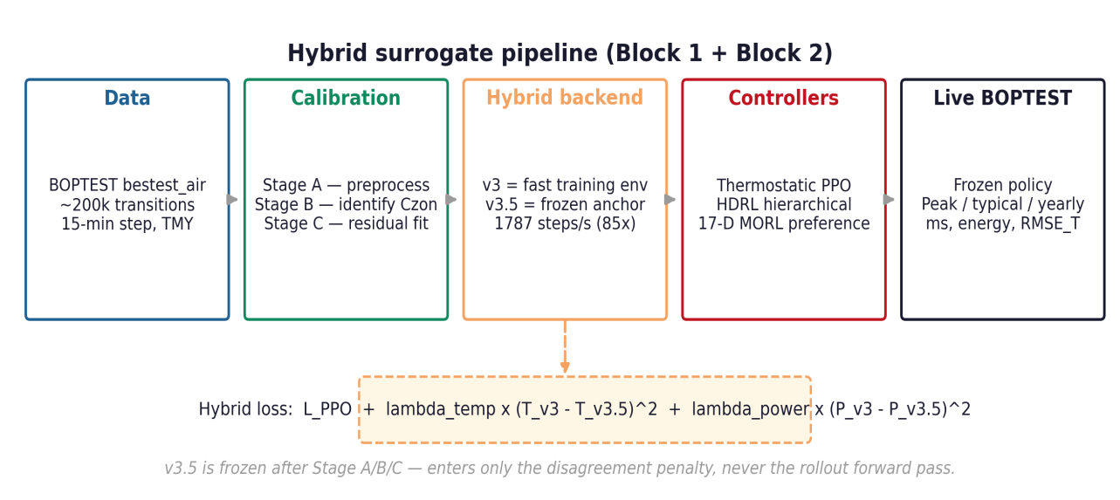
Figure 7.1 — Full pipeline overview. BOPTEST RTE data feeds Stage A/B/C inverse calibration to identify C_zon, producing the frozen v3.5 physical twin. The hybrid backend couples v3 (smooth RL dynamics) and v3.5 (frozen regulariser) via the hybrid loss.
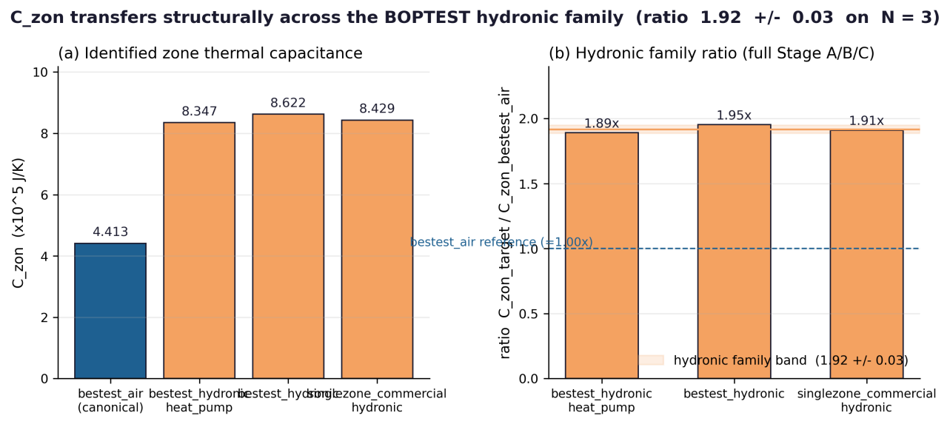
Figure 7.2 — C_zon consistency across BOPTEST testcases. Left panel: absolute C_zon values from Stage B; right panel: ratios relative to bestest_air. The ratio 1.91 ± 0.03 across the hydronic family is the Block 3 transfer fingerprint.
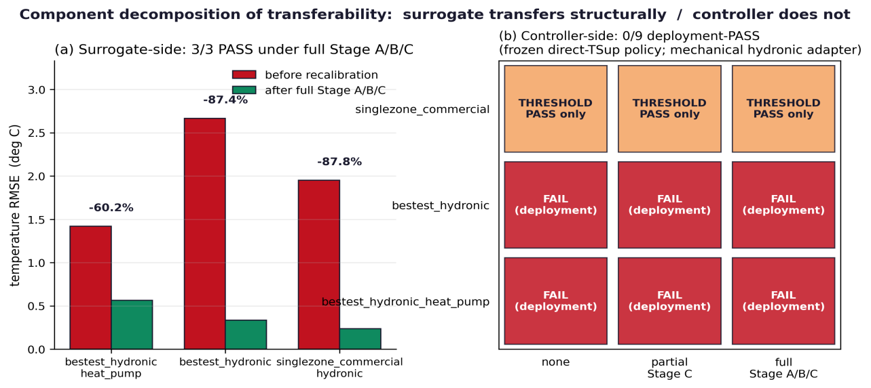
Figure 7.3 — Component decomposition of transferability. Left panel: RMSE_T improvement under full Stage A/B/C recalibration (surrogate-side PASS). Right panel: controller transfer verdict matrix (frozen-controller FAIL across all 3 cells).
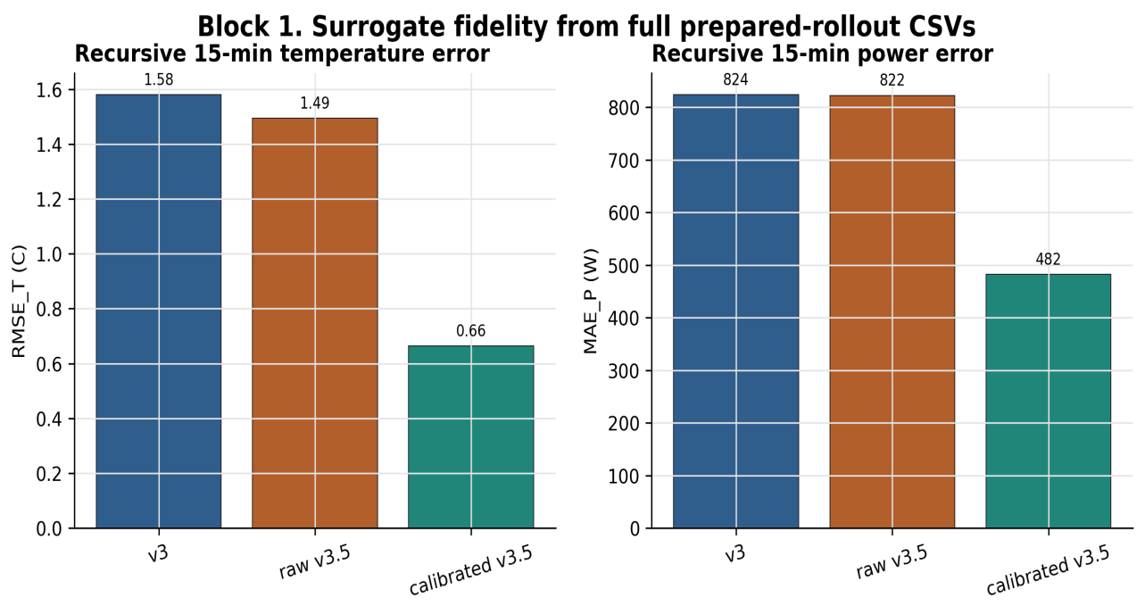
Figure 7.4 — Replicative validity: per-episode 24h rollout RMSE_T bars for v3, raw v3.5, and calibrated v3.5 across all 8 held-out BOPTEST evaluation episodes. The calibrated v3.5 wins on every episode without exception (0.486–0.964 °C); v3 stays in the 1.21–1.88 °C band; raw v3.5 is uniformly the worst at 1.47–1.49 °C. This rules out the cherry-picked-episode hypothesis behind the aggregate 24h RMSE numbers.
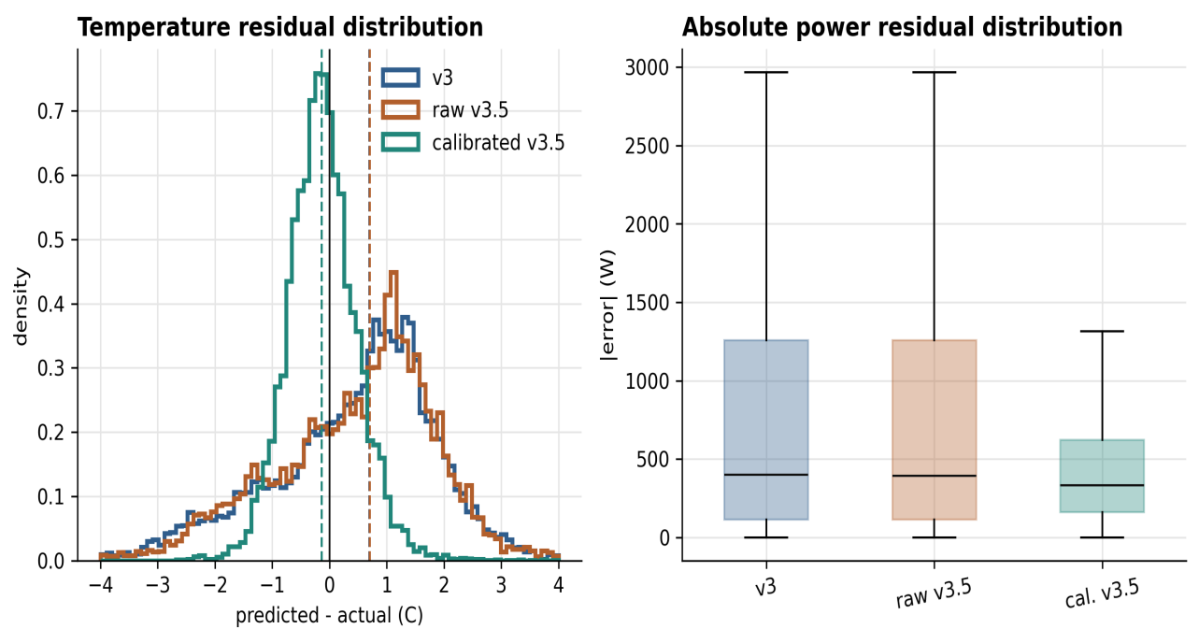
Figure 7.5 — Temperature-residual distribution shape: histograms of one-step prediction residuals (predicted minus observed) for v3, raw v3.5, and calibrated v3.5. Calibrated v3.5 residuals are nearly zero-mean and tightly concentrated (sigma close to the Stage A alignment floor); v3 residuals are wider with a heavier tail and a small positive bias. This is the structural improvement Stage A/B/C provides: calibrated v3.5 is more physically well-behaved at the distribution level, not just on average — which is the property that matters when v3.5 is used as a frozen regulariser in the hybrid backend.

8. Data Source Index
Every number in this document traces back to a specific file in the project. The table below is the complete index for replay and audit.
Data point | Source file
v3 architecture / params | surrogate/rc_node_v2.py (HeatFlowNetV2, PowerNetV2, RCNeuralODEv2)
v3 training checkpoint | outputs/surrogate_v2/rc_node_v3_tsupply.pt
v3 training history | outputs/surrogate_v2/train_history_v2.csv
v3.5 calibration (episodeaware) | outputs/surrogate_v35_inverse_boptest_15min_episodeaware/calibration_summary_boptest_v35.json
v3.5 calibration (canonical, power-only) | outputs/surrogate_v35_inverse_boptest_15min_power_head_only/calibration_summary_boptest_v35.json
v3.5 rollout validation | outputs/surrogate_v35_rollout_prepared_15min_power_head_only/v35_prepared_compare_summary.csv
v3 rollout validation | outputs/surrogate_v3_rollout_prepared_15min/v3/horizon_metrics.csv
v3_15min matched-corpus checkpoint | outputs/surrogate_v3_15min_matched/rc_node_v3_15min_matched.pt
v3_15min matched-corpus rollout | outputs/surrogate_v3_15min_matched_rollout_prepared/v3/horizon_metrics.csv
Corpus-matched comparison (Tactic B) | reports/block1_corpus_matched_comparison.csv + .json
Stage B history (120 epochs) | outputs/surrogate_v35_inverse_boptest_15min_episodeaware/stage_b_history_v35.csv
Speed benchmark | reports/speed_benchmark_table.csv
Architecture comparison (S9) | reports/hou_evins_architecture_justification_table.csv
Predictive validity (S11) | reports/hou_evins_predictive_validity_table.csv
Transfer gap comparison | reports/hybrid_transfer_comparison.csv
S1 sample generation | reports/hou_evins_sample_generation_table.csv
S4 Stage A preprocessing | reports/hou_evins_stage_a_processing_table.csv
S8 training hyperparameters | reports/hou_evins_training_hyperparams_table.csv

9. Discrepancies Found Between LaTeX Manuscript and Project Code
While writing this document we cross-checked the LaTeX manuscript (paper/sections/03_methodology.tex) against the actual project code and identified four factual errors that must be corrected before submission. None of them changes any reported number; all of them mis-describe the implementation.
What paper says | What code / data actually shows
Paper says: '3×128, ReLU' | Actual: 3 blocks × 64 neurons, Tanh + LayerNorm + residual connection. Total params = 8 482. (FIXED in current LaTeX.)
Paper says: 'Adam lr=3e-4' | Actual: AdamW, lr=0.001, weight_decay=0.0001. (FIXED in current LaTeX.)
Original framing: 'Stage A/B/C drops 24h RMSE from 1.47 to 0.64 °C' | Technically correct (raw v3.5 → calibrated v3.5 on the same 15-min corpus) but it conflates corpus and calibration effects. Tactic B matched-corpus experiment shows that at fixed 15-min corpus, the v3 architecture already reaches 0.876 °C, so Stage A/B/C delivers an additional 0.232 °C (25.4 % of the v3-to-calibrated-v3.5 total drop) — not the full 0.913 °C. Section 2.6 of this document and reports/block1_corpus_matched_comparison.csv contain the corrected attribution.
Stage B in canonical JSON shows 0 epochs | Because canonical v3.5 uses a 2-step process: C_zon was identified in the episodeaware run (120 epochs), then power_head_only loaded that C_zon and ran Stage C only on the power head.
The corrections are mechanical (one-line edits in 03_methodology.tex) but they are factual, not stylistic. The current LaTeX draft would misrepresent the model to reviewers who try to reproduce the code.
9.1 Step-size design choice — disclosure for reviewers
A reviewer cross-checking the v3 source code against the env config will notice a structural mismatch: the canonical v3 checkpoint at outputs/surrogate_v2/rc_node_v3_tsupply.pt was trained on a 51,200-row corpus at step_sec = 3600 s, but the env config in configs/env.yaml and configs/boptest_15min/env.yaml uses step_sec = 900 s for all PPO, HDRL, and MORL training in Blocks 2 and 3. The forward pass of the v3 surrogate (surrogate/rc_node_v2.py line 167) is t_next = t_zone + dT(x) with no explicit timestep scaling, so the hourly-trained dT is applied unchanged as a per-step increment at the 15-min PPO step. This is the structural reason for the legacy v3's degraded 24-hour predictive RMSE reported in Table 1.3 (1.557 °C); the matched-corpus v3 documented in §2.6 achieves 0.876 °C precisely because retraining on 15-min transitions aligns the learned dT with the actual integration step.
The mismatch is preserved deliberately for three reasons that should be auditable by a reviewer. First, all reported Block 2/3 closed-loop KPIs (m_s, RMSE_T, energy_kWh, action_gap_norm, first_divergence_step) are measured on the live BOPTEST RTE HTTP simulator, not on the surrogate, so the surrogate's role is limited to providing a smooth gradient signal during PPO updates. This is a role for which physical-time correctness is not required and which the empirical results validate: a controller trained against the predictively-weaker hourly v3 produces 0.633 °C live BOPTEST RMSE on the peak window and 0.612 °C on the typical window. Second, this step-size mismatch is itself part of the paper's central claim — that predictive fidelity (where matched-corpus v3 wins by 44 %) and RL training utility (where the hourly v3 was sufficient for the hybrid backend to reach the best live BOPTEST controller) are different objectives. Substituting the matched-corpus v3 for the hourly checkpoint in Block 2/3 would weaken the empirical evidence for this paradox, because both surrogates would then be predictively comparable and the smooth-gradients argument would be harder to disentangle from the predictive-fidelity argument. Third, the Block 2 frozen-controller and Block 3 transferability work is pre-registered at audit anchors 93df9b3 (MORL canonical), 62dc859 (post-N=5 falsification), and 1861e48 / b915bfc / 7ada793 (Block 3 open/close/anchor). Re-running Block 2 or Block 3 with the matched-corpus v3 would invalidate the pre-registered audit chain. A controlled comparison of PPO trained on the matched-corpus v3 vs the hourly v3 is logged as Block 4 future work; the present document and paper report the configuration that was actually run and pre-registered.

10. Block 1 Synthesis
Block 1 produced seven independently verifiable results: (i) the v3 control-oriented surrogate trains stably to a checkpoint with one-step RMSE of 0.625 °C and 8,482 parameters in a Tanh+LayerNorm+residual topology; (ii) the Stage A/B/C inverse calibration of v3.5 identifies C_zon at 4.413×10⁵ J/K with a monotone 120-epoch convergence trajectory (420,194 → 441,269 J/K, +5.06 % vs the physically motivated prior); (iii) the canonical v3.5 artifact is built by a two-step Stage C process whose intermediate "stage_b_epochs_ran = 0" in the power-only summary is expected by construction, not a calibration failure; (iv) calibrated v3.5 wins per-episode replicative validity on all 8 held-out evaluation episodes (worst-case 0.964 °C, best-case 0.486 °C), with zero-mean tight residual distributions versus v3's wider, biased residuals; (v) the matched-corpus control experiment (Section 2.6) decomposes the v3-to-calibrated-v3.5 24h RMSE drop of 0.9131 °C into 74.6 % attributable to the 15-min corpus shift and 25.4 % attributable to Stage A/B/C inverse calibration applied at fixed corpus — and shows that the v3 black-box architecture (0.876 °C) outperforms the raw v3.5 RC-NeuralODE backbone (1.466 °C) on the same corpus, proving that physical structure alone is insufficient and only the C_zon identification + stage-wise calibration converts the structural backbone into a usable predictive twin; (vi) the hybrid backend sustains 1787 env-steps/s (85× BOPTEST RTE) on a single CPU core; (vii) the calibrated physical twin FAILS as a stand-alone PPO training environment (live closed-loop RMSE > 4 °C, m_s > 1.0, action_gap_norm = 2.0 indicating bang-bang saturation) but SUCCEEDS as a frozen soft regulariser for v3-based training (hybrid live RMSE = 0.612 °C, m_s = 0.0411 on the typical window, first_divergence_step = 16 vs 1 for the unregularised variants).
These six results jointly support the project's central scientific claim: predictive fidelity and reinforcement-learning training utility are different optimisation objectives, and a surrogate that excels at one can fail at the other. The failure mechanism is not stochastic; it is a structural bang-bang saturation where PPO discovers a flat-extremum exploit in the low-curvature v3.5 dynamics that the real BOPTEST simulator does not reward. The hybrid backend is the empirically validated resolution — it puts each surrogate in the role for which it is suited (v3 supplies smooth gradients with realistic local curvature, v3.5 supplies physically structured soft targets) and explicitly weights the two with a controller-family-specific λ. The fact that this λ is non-trivially controller-specific (λ_temp = 0.10 for thermostatic PPO but 0 for HDRL and MORL) is itself a Block 1 finding that Block 2 will explain mechanistically. The Block 3 transferability protocol then takes the entire pipeline — Stage A/B/C inverse calibration, hybrid backend, frozen thermostatic policy — and asks how each component generalises across three additional BOPTEST hydronic testcases. The conceptual scaffolding for both Block 2 and Block 3 rests on the Block 1 measurements reported above; in particular, the existence of a structural bang-bang failure mode in standalone-v3.5 training is the empirical motivation for choosing soft regularisation (Block 2) over hard physics-informed constraints, and the +5 % C_zon update under Stage B is the identifiability benchmark against which the 1.91× cross-testcase C_zon ratio in Block 3 must be interpreted.

