Block 2 Complete Results
Control-side experiments on BOPTEST bestest_air: thermostat baseline, pure v3 PPO, direct v3.5 warm-start (negative control), thermostatic hybrid, HDRL sweep, MORL 5D failure / 17D success, MORL canonical seed analysis, Pareto sweep, PI reference, transfer diagnostics.
All numbers cross-checked against project artifacts (CSV/JSON) on 2026-05-28.

§1. Methodology and reading order

§1.1 Reading order
Block 1 established the surrogate-level claim: v3 is a control-oriented black-box surrogate with poor multi-horizon predictive fidelity (24h RMSET = 1.557 °C), while calibrated v3.5 is a physically-identified surrogate with strong predictive fidelity (24h RMSET = 0.644 °C). Block 2 then tests the controller-side question: which combinations of these two surrogates produce useful Reinforcement-Learning policies on the live BOPTEST RTE bestest_air testcase, and which fail.
The Block 2 narrative across this document follows the controller-family stack:
- §2 Pure v3 PPO baseline — the control-oriented surrogate alone produces a working policy.
- §3 Direct v3.5 PPO (negative control) — using the high-fidelity surrogate alone fails catastrophically.
- §4 Thermostatic hybrid — combining v3 dynamics with a v3.5 disagreement regularizer is the best result.
- §5 HDRL sweep — the same hybrid regularization does NOT transfer to hierarchical RL; lambda_temp_disagree must be 0.
- §6 MORL 5D failure / 17D success — observation interface choice dominates the MORL result.
- §7 MORL canonical seed analysis — N=5 seed variance falsifies the single-seed canonical result.
- §8 MORL Pareto sweep — comfort/energy trade-off across 5 weight pairs.
- §9 PI baseline — BOPTEST built-in reference.
- §10 Transfer diagnostics — closed-loop surrogate-vs-live ms_gap and feature attribution.
- §11 Synthesis — fidelity-vs-utility paradox and Block 3 prerequisites.

§1.2 PPO algorithm and hyperparameters
All five controller families (pure v3, hybrid, HDRL, direct v3.5, MORL 17D) use Proximal Policy Optimization (PPO) with the Stable-Baselines3 reference implementation. However, the PPO hyperparameters are NOT identical across families — each family is driven by its own training script that sets `nsteps` and `batchsize` independently. What is shared across all families: learningrate = 3×10⁻⁴ (during pretrain), γ = 0.99, nepochs = 10. What is shared by Stable-Baselines3 default (because trainthermostatic.py and trainhdrl.py do not set them explicitly): GAE λ = 0.95, cliprange = 0.2, entropycoef = 0.0, vfcoef = 0.5 — these happen to match the values set explicitly in `configs/agent.yaml` for the MORL pipeline. What **differs by family**: rollout length `nsteps` and minibatch `batch_size`, and the total timestep budget.
Table 1 — PPO training hyperparameters per controller family (verified per-script). Sources: training/train_thermostatic.py (line 646), training/train_hdrl.py (line 247), configs/agent.yaml + configs/morl_surrogate_ppo/train.yaml (MORL pretrain), training/finetune_morl_boptest.py (line 83).
Hyperparameter | Thermostatic | HDRL | MORL pretrain | MORL finetune
Algorithm / policy | PPO (Stable-Baselines3), MlpPolicy | PPO (Stable-Baselines3), MlpPolicy | PPO (Stable-Baselines3), MlpPolicy | PPO (Stable-Baselines3) (load+continue)
Learning rate | 3.0e-4 | 3.0e-4 | 3.0e-4 | 1.0e-4
n_steps | 1024 | 1024 | 2048 | inherits
batch_size | 4096 | 2048 | 64 | inherits
n_epochs | 10 | 10 | 10 | 10
γ (discount) | 0.990 | 0.990 | 0.990 | 0.990
GAE λ | 0.950 (SB3 default) | 0.950 (SB3 default) | 0.950 (set in cfg) | 0.950
Clip range | 0.20 (SB3 default) | 0.20 (SB3 default) | 0.20 (set in cfg) | 0.20
Entropy coef. | 0.00 (SB3 default) | 0.00 (SB3 default) | 0.00 | 0.00
Value coef. | 0.50 (SB3 default) | 0.50 (SB3 default) | 0.50 | 0.50
Total timesteps | 10 000 000 | 12 000 000 | 2 000 000 | 100 000
Seed | 42 | 42 | 42 | 42
Source file | training/train_thermostatic.py:646 | training/train_hdrl.py:247 (PPO call); :278-279 (defaults via --winter-steps / --summer-steps) | configs/agent.yaml + configs/morl_surrogate_ppo/train.yaml | training/finetune_morl_boptest.py:83
Three design choices deserve highlighting. First, the discount γ = 0.99 corresponds to an effective horizon of ~100 steps × 900 s ≈ 25 hours: the policy considers approximately one day of comfort consequences when valuing an action, which matches the natural occupancy cycle of bestestair. Second, **entropy coefficient = 0** means PPO converges to a deterministic policy after the initial exploration phase; this is intentional because the deployment use case is reproducible control, not interactive bandit play. Third, the **per-family difference in nsteps and batch_size** (thermostatic 1024/4096 vs HDRL 1024/2048 vs MORL pretrain 2048/64) reflects the rollout efficiency vs sample efficiency trade-off chosen by each family's authors, not a deliberate ablation. The MORL pipeline additionally runs a 100,000-step BOPTEST live-finetune at learning rate 1.0e-4 after the 2 M surrogate-pretrain step, to absorb the residual surrogate-vs-BOPTEST distribution shift.

§1.3 Observation space — 17-D extended TSup-style
The default observation space (used by pure v3, hybrid, HDRL, and MORL 17D) is the 17-dimensional extended TSup-style feature vector specified by `obs_mode = extended` in configs/env.yaml. It combines raw and lagged zone/ambient temperatures, clipped-log power telemetry, a causal-smooth ΔT signal, cyclic time encodings, and the last-action context. The earlier 5-D basic observation (zone temperature, ambient, hour, day, occupancy) is preserved in §6 as the failed-MORL baseline.
Table 2 — Extended observation feature groups (verified from envs/tsup_features.py). Source: envs/tsup_features.py (BASIC_TSUP_OBS_DIM=5, TIME_TSUP_OBS_DIM=4, FORECAST_HORIZONS=[1,3,6,12,24], HISTORY_TSUP_OBS_DIM=3 = 2-D prev_action + 1-D Δt_zone; totals 5+4+5+2+1 = 17). Encoding modes from configs/env.yaml: obs_mode = extended, delta_feature_mode = causal_smooth, power_feature_mode = clipped_log, t_zone_feature_mode = raw.
Feature group | Dim. | Notes
Physical state (basic) | 5 | t_zone, CO₂, p_total (clipped_log), t_supply_prev, t_amb — all normalised to [−1,+1]
Cyclic time encoding | 4 | hour_sin, hour_cos, day_sin, day_cos (no calendar lookup needed)
Ambient forecast (5 horizons) | 5 | t_amb at +1 h, +3 h, +6 h, +12 h, +24 h (weather lookup table)
Previous action | 2 | (a_t_supply, a_fan) from last step, both in [−1,+1]
Temperature delta | 1 | Δt_zone last step, causal_smooth encoding (tanh(clip(Δ, ±1.5)/1.25))
Total (extended) | 17 | obs_mode = extended in configs/env.yaml; basic 5-D path frozen (§6)

§1.4 Action space — normalized supply-air setpoint
The actor outputs a single continuous supply-air temperature setpoint in the range 18 – 35 °C, normalised to [-1, +1] inside the neural network (tanh squash) and remapped to physical units before being sent to BOPTEST. The wrapper applies a 1.0 °C deadband (small changes do not modulate the actuator) and a per-step rate limit of 0.15 normalised units (~2.6 °C per 15-minute step). Both shape choices protect the BOPTEST RTE from high-frequency actuation chatter and improve transfer to physical hardware in future work.
Table 3 — Action-space configuration. Source: configs/env.yaml (action_wrappers and t_supply_low / high).
Property | Value
Name | supply_temperature_setpoint
Dimensionality | 1 (continuous)
Physical range | 18.0 °C … 35.0 °C (supply air setpoint)
Network output | tanh squash → linear remap to [low, high]
Smoothing deadband | 1.0 °C (no change unless |Δaction| exceeds)
Rate limit (per step) | 0.15 (normalized units)

§1.5 Reward function — comfort shaping + (MORL) multi-objective weights
The reward function combines a comfort shaping term, an energy term, and (for MORL only) a safety term, with explicit asymmetry between cold and hot ambient conditions. The base comfort term penalises zone temperatures outside the 21 – 24 °C band with linearly increasing weight beyond a 0.5 °C deadband; it adds a small in-band bonus (0.05 per step) so that the policy actively seeks the comfort interior rather than just avoiding violation. Asymmetric weights amplify cold-ambient undershoots (× 1.60) and hot-ambient overshoots (× 1.80), reflecting the physical reality that recovering from a cold zone in cold weather is harder than the symmetric reverse.
Action-direction bonuses (heating/cooling bonuses when tsupply is on the right side of room temperature) prevent PPO from learning a pathological constant-output policy in the first few epochs. For MORL, the multi-objective weighting is canonically (comfort, energy, safety) = (0.80, 0.20, 0.00) with an energyscale of 2.0e-4 that converts Watts to a comparable reward unit; the Pareto sweep (§8) varies these weights.
Table 4 — Reward function components. Source: configs/env.yaml (comfort_shaping + morl sub-block).
Reward component | Parameter | Value
Comfort band | band_low_c / band_high_c | 21.0 / 24.0 °C
Comfort deadband | deadband_c | 0.50 °C around band edges
In-band bonus | band_bonus | 0.050 per step inside band
Generic violation | undershoot_weight | 1.15
 | overshoot_weight | 1.15
Cold-ambient asymmetry | cold_amb_threshold_c | 8.0 °C
 | cold_undershoot_weight | 1.60 (extra heat penalty)
Hot-ambient asymmetry | hot_amb_threshold_c | 24.0 °C
 | hot_overshoot_weight | 1.80 (extra cool penalty)
Action-direction bonus | heating_action_bonus / t_supply | 0.04 when t_supply ≥ 29.0 °C
 | cooling_action_bonus / t_supply | 0.06 when t_supply ≤ 21.0 °C
MORL canonical weights | comfort / energy / safety | 0.80 / 0.20 / 0.00
 | energy_scale | 2.0e-4 (Watts → reward units)

§1.6 Scenario definitions
Block 2 KPI tables report two targeted 14-day windows plus, for MORL/PI yearly summaries, 12 monthly 14-day windows. The targeted windows are intentionally chosen at extreme and moderate winter conditions:
- **peak_heat_window** — starts at simulation day 3 (January, daily mean ambient −24.4 °C); this is the hardest single scenario in the year and serves as a stress test.
- **typical_heat_window** — starts at simulation day 37 (February, daily mean ambient +2.4 °C); this is a deployment-realistic moderate-winter operating point.
Table 5 — Targeted-window scenario definitions. Source: outputs/block2_*/scenario_manifest.json (start_day_index, duration_days, daily_mean_t_amb_c).
Scenario | Day index | Start (s) | Duration (d) | Ambient mean (°C) | Role
peak_heat_window | 3 | 259 200 | 14 | -24.4 | January coldest, stress test on heating
typical_heat_window | 37 | 3 196 800 | 14 | 2.4 | February moderate, deployment-realistic
yearly evaluation | 12 months | — | 14 / month | varied | MORL + PI yearly summary

§1.7 MORL pipeline — pretrain → ERAM → finetune → yearly eval
MORL uses a four-stage pipeline that differs from the single-stage PPO families. (1) Pretrain: 2 000 000 steps of PPO on the 17-D hybrid backend with the canonical (0.80/0.20/0.00) weights. (2) ERAM (internal pipeline label; the expansion is not formally defined in source — it appears only as the file/argument name in training/trainmorleram.py): 20 iterations of 100 000 steps each, starting from initial weights 0.34/0.33/0.33 (comfort/energy/safety) with τw = 0.35 (weight-update temperature) and advlr = 1. (3) Finetune: 100 000 steps on the live BOPTEST RTE at lr = 1.0e-4 with episode-start jitter of ±3 days to absorb the residual surrogate-vs-RTE distribution shift. (4) Yearly evaluation: 12 monthly 14-day scenarios on BOPTEST.
MORL is the only family that uses live-BOPTEST finetuning. PPO/hybrid/HDRL are evaluated directly on BOPTEST after surrogate-only training, with no live finetuning step, which makes them strictly more challenging transfer scenarios.

§1.8 Stochasticity during training — surrogate-side DR vs BOPTEST-side jitter
There are two distinct forms of training-time stochasticity, applied at different stages:
- **Surrogate-side domain randomization** (thermostatic, hybrid, HDRL, MORL pretrain): at each episode reset, the initial zone temperature is sampled from 15.0 – 28.0 °C, the start day is sampled from the 366-day calendar (uniform or heating-biased), and Gaussian noise of σ = 1.5 °C is added to the weather-lookup ambient values. Implementation: `ThermostaticEnv.reset()` lines 350-366; surrogate_backend.py `dr_enabled` defaults to True.
- **BOPTEST-side start-time jitter** (MORL finetune only): the surrogate-style DR no longer applies because BOPTEST is a deterministic EnergyPlus simulator with a fixed weather file. Instead, the live finetune samples episode starts from 12 yearly anchors (one per month, beginning at simulation time 0, 2,678,400 s, ..., 28,857,600 s) and adds ±3-day uniform jitter to each anchor (`boptest_start_jitter_sec = 3.0 × 86,400`). This gives 12 × ~6 = 72 effective episode-start windows. Implementation: `training/finetune_morl_boptest.py` lines 107-108.
Evaluation is fully deterministic: post-training surrogate evaluation calls `ThermostaticEnv(dr_enabled=False)` (thermostatic line 675) and live BOPTEST evaluation uses fixed scenario start days. No randomness in the reported KPIs.
Common to all results in Block 2: comfort band 21 °C – 24 °C, step = 900 s, targeted-rollout duration = 14 days, live testcase = BOPTEST bestestair (Docker BOPTEST RTE HTTP, surrogate model file outputs/surrogatev2/rcnodev3_tsupply.pt for v3, calibrated v3.5 from Block 1 §2.4).

§2. Pure v3 PPO thermostatic baseline

§2.1 Setup
The pure v3 PPO baseline uses the canonical v3 control-oriented surrogate (outputs/surrogatev2/rcnodev3tsupply.pt) as the rollout dynamics inside PPO, with no v3.5 disagreement regularization (lambdatempdisagree = 0, lambdapowerdisagree = 0). The policy is a thermostatic PPO actor with a comfort-centered reward; observations include the 17-dimensional TSup-style feature vector (zone temperature, ambient, solar, ahead-of-day occupancy, hour/day cyclic, lagged power, etc.). After training on the surrogate, the policy is deployed against the live BOPTEST RTE for 14-day rollouts on two targeted scenarios.

§2.2 Live BOPTEST results
Pure v3 PPO reaches sub-degree comfort RMSE in both targeted-window scenarios (peak: 0.869 °C; typical: 0.622 °C) and an ms well below the thermostat or PI baselines (peak ms = 0.072, typical = 0.095). This is the first central finding of Block 2: a surrogate that is provably inaccurate as a 24-hour predictor (Block 1 §1.3) nonetheless produces a usable PPO policy with single-digit setpoint violation percentage on the live test cases.

§3. Direct v3.5 PPO — negative control

§3.1 Hypothesis and configuration
The naive scientific hypothesis would be: since v3.5 is the higher-fidelity surrogate (Block 1: 0.644 °C 24h RMSE vs v3's 1.557 °C), a PPO trained on v3.5 should produce a strictly better controller. We test this by training PPO directly on the calibrated v3.5 backbone with no v3 dynamics (lambdatempdisagree = 0, no hybrid mixing), then deploying on the live BOPTEST RTE.

§3.2 Result: catastrophic failure
Direct v3.5 PPO produces m_s = 1.046 on peak and 1.102 on typical scenarios — an order of magnitude worse than pure v3 PPO. Setpoint violation reaches 77.1 % on peak, with comfort RMSE of 4.32 °C — the policy spends most of the rollout outside the 21–24 °C band.
This is the fidelity-vs-utility paradox in its clearest form: the surrogate with better predictive accuracy (v3.5, RMSET = 0.644 °C) produces a substantially worse PPO policy than the surrogate with worse predictive accuracy (v3, RMSET = 1.557 °C). The mechanism is hypothesised, not directly measured. A consistent interpretation — supported by the empirical pattern and by general PPO theory but not by any gradient-variance measurement performed in this project — is that v3.5's sharper physical predictions yield higher-variance advantage estimates inside PPO, destabilising policy updates, while v3's smoother bias-toward-mean predictions provide a gentler gradient signal. An equally consistent alternative is that v3.5's predictions encode physical regimes (e.g., short-time thermal capacitance) the policy has no way to exploit at the 15-minute control cadence, so the policy over-fits to spurious sub-step structure. Discriminating between these mechanisms is left to Block 4.

§3.3 Warm-start utility check
We additionally check whether v3.5 has any value as a warm-start initialiser (pre-train on v3.5, then fine-tune on the hybrid backend). The comparison table below shows that scratch training on the hybrid backend outperforms warm-starting from v3.5 by a wide margin on both scenarios.
Table 2 — Direct-v3.5 warm-start utility comparison. From outputs/block2_thermostatic_warmstart_utility/comparison_summary.csv.
Mode | Scenario | m_s | Violation %
scratch (from random init) | peak_heat_window | 0.465 | 31.70
scratch (from random init) | typical_heat_window | 0.578 | 45.54
warm-start (from v3.5) | peak_heat_window | 1.270 | 83.93
warm-start (from v3.5) | typical_heat_window | 1.289 | 86.83
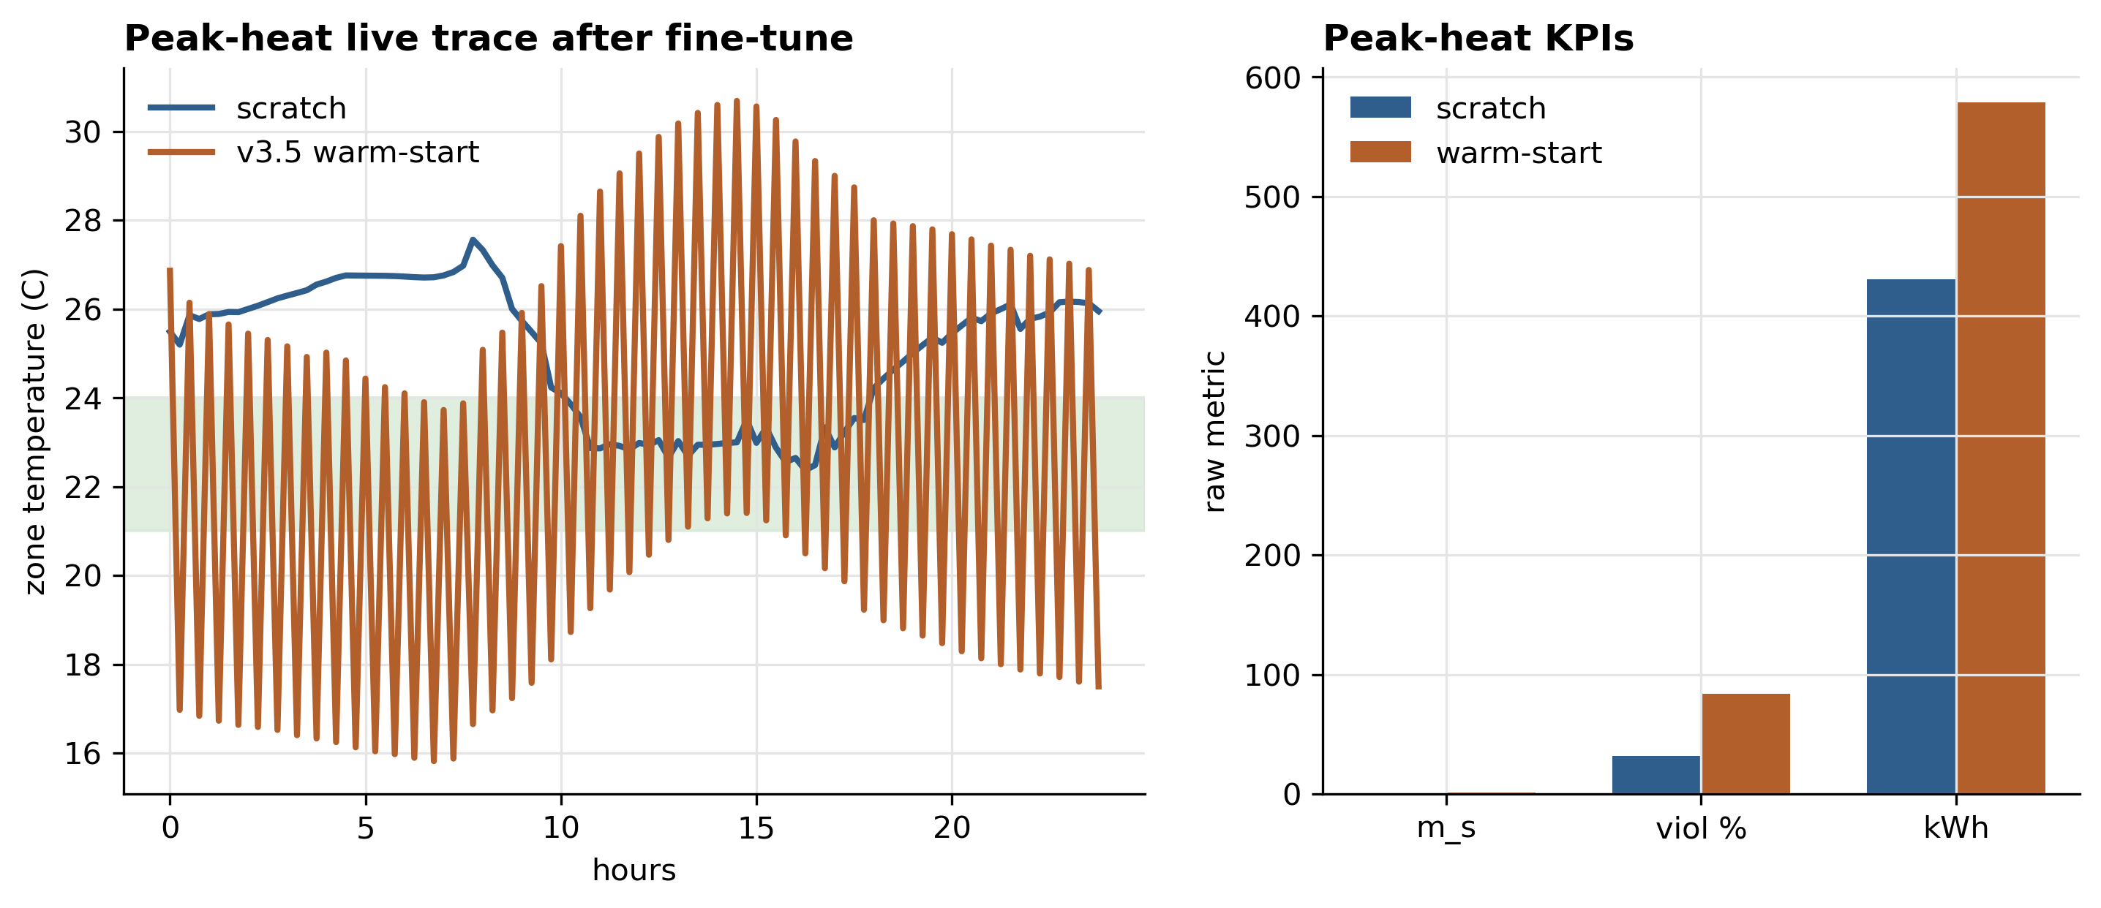
Figure 2. Direct-v3.5 warm-start is a negative control: better predictive fidelity does not translate into a useful policy initializer.
Warm-starting from v3.5 not only fails to help — it actively harms training, raising m_s by 2–3×. Conclusion: v3.5 must be used as a soft regularizer (next section), not as a direct rollout backbone or warm-start source.

§4. Thermostatic hybrid (canonical positive result)

§4.1 Architecture: v3 dynamics + v3.5 disagreement reward-shaping
The hybrid backend uses v3 as primary rollout dynamics (so PPO sees the smooth, control-friendly transitions) and v3.5 as a per-step reward-shaping censor (NOT a separate policy-loss term). At each surrogate step both models are evaluated on the same (state, action); the absolute differences `|tv3 − tv3.5|` and `|pv3 − pv3.5|` are computed and the per-step reward becomes:
r = r_comfort + r_smooth + r_energy − λ_temp · |Δt_disagree| − λ_pwr · |Δp_disagree|, with λtemp = 0.1 and λpwr = 5.0e-5 for the canonical hybrid_l010.
PPO then computes the advantage At = rt + γV(s{t+1}) − V(st) from this augmented reward in the standard way; there is no explicit modification of the policy gradient. The verified source is `envs/backends/surrogatebackend.py` lines 343-350 (`reward -= self.lambdatempdisagree * float(tempdisagreement)` etc.) and `training/train_thermostatic.py` line 436. The disagreement signal acts as a censor, not a forecast: when v3 and v3.5 agree the disagreement term vanishes and the reward reduces to comfort + energy; when they disagree the agent loses reward and learns to avoid the disputed regions of state-action space.

§4.2 Live BOPTEST results
Hybridl010 achieves ms = 0.087 (peak) and 0.041 (typical). It nearly matches pure v3 on the peak window while saving energy, and it clearly improves pure v3 on the typical window — with comfort RMSE down to 0.795 / 0.633 °C with setpoint violation below 5 % on both scenarios. Energy consumption is lower than pure v3 (305 vs 322 kWh peak); the hybrid achieves better comfort at no energy cost.
Table 4 — Canonical Block 2 results on the live BOPTEST RTE (paper §6.3). Sources: outputs/bestest_air_article7_style_15min/summary.csv (pure v3 PPO), outputs/block2_thermostatic_hybrid_v3_v35_l010/summary.csv (hybrid_l010), reports/hybrid_transfer_comparison.csv (direct v3.5 from transfer-comparison harness). Green = strong result (m_s < 0.10); red = failure (m_s > 0.50); yellow = intermediate.
Backend / Policy | Scenario | m_s | Violation % | RMSE_T (°C) | Energy (kWh)
pure_v3 PPO | peak_heat_window | 0.072 | 1.49 | 0.869 | 322.2
pure_v3 PPO | typical_heat_window | 0.095 | 4.39 | 0.622 | 368.3
direct_v35 PPO | peak_heat_window | 1.046 | 77.08 | 4.320 | 556.2
direct_v35 PPO | typical_heat_window | 1.102 | 82.37 | 4.401 | 580.5
hybrid_l010 PPO | peak_heat_window | 0.087 | 4.69 | 0.795 | 305.3
hybrid_l010 PPO | typical_heat_window | 0.041 | 2.38 | 0.633 | 352.8
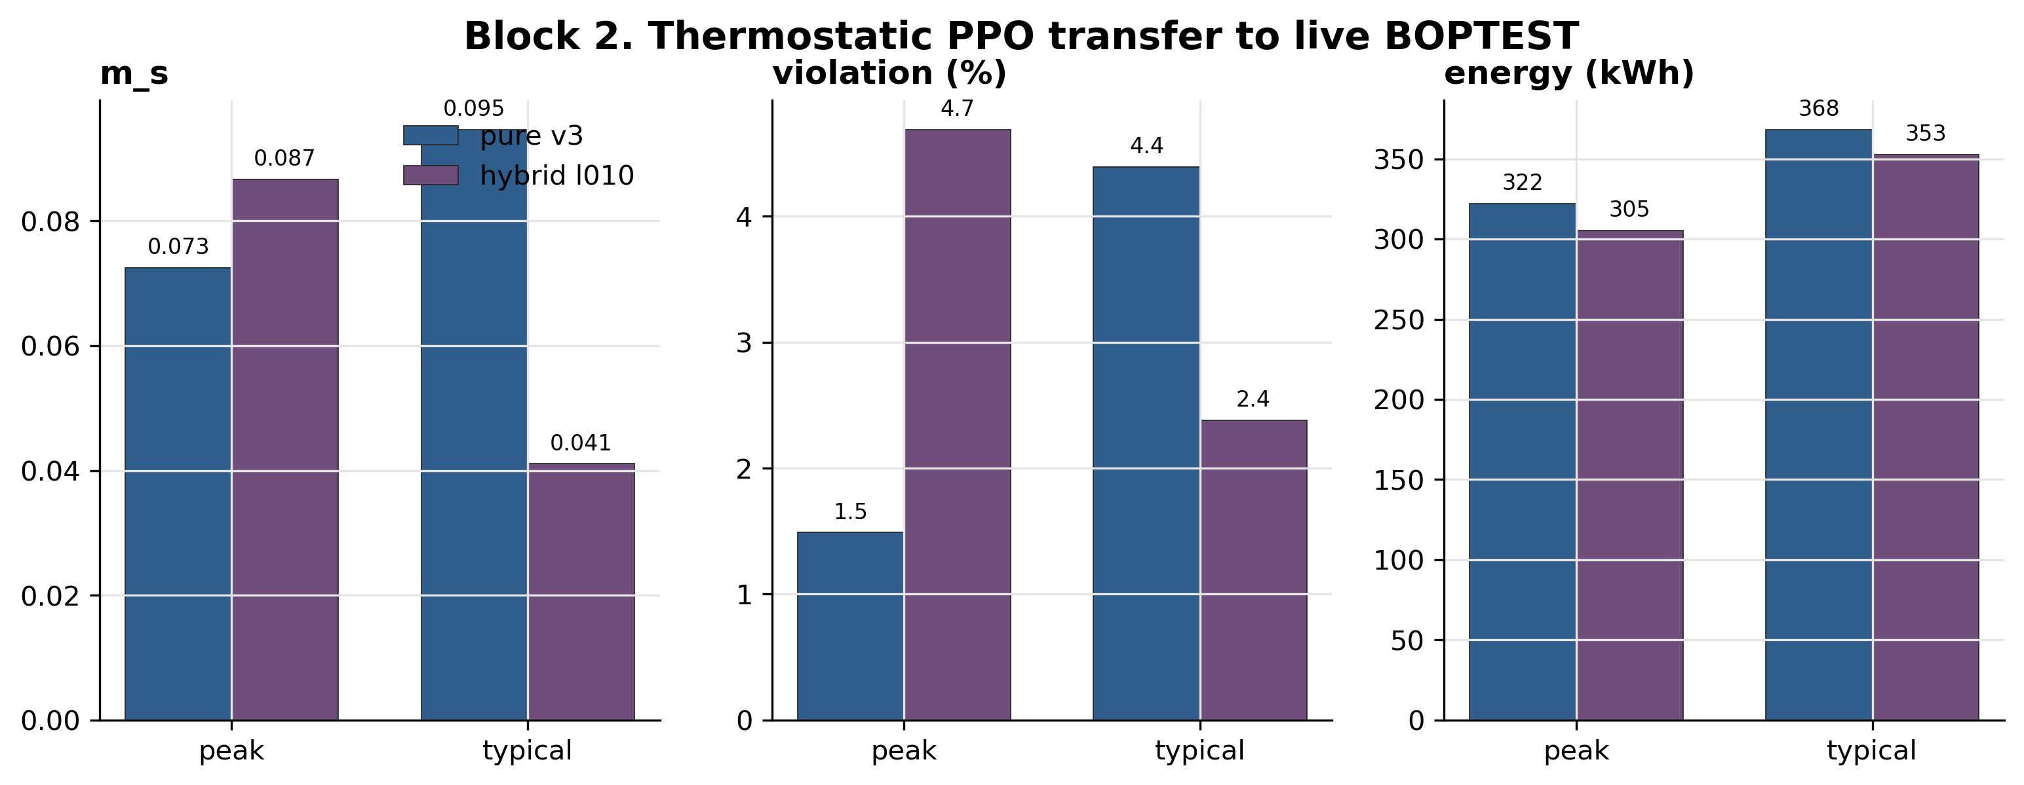
Figure 3. Thermostatic pure-v3 versus hybrid_l010 KPIs on peak and typical windows. Hybrid_l010 trades a small peak-window m_s increase for lower energy and strongly improves the typical window.
The Block 2 main table shows the full fidelity-vs-utility paradox in a single panel: direct v3.5 fails despite better predictive fidelity; pure v3 is control-usable; hybrid_l010 is the best verified compromise. Predictive fidelity alone does not determine controller quality — the role of the calibrated physical twin (v3.5) is to provide a soft physics censor, not to be the rollout dynamics.

§4.3 Hybrid disagreement bounded, not chaotic
On the canonical hybrid traces, the average temperature disagreement between v3 and v3.5 is 0.969 °C (p95 = 2.52 °C); the average power disagreement is 708 W (p95 = 1236 W). These bounds confirm that the two surrogates are not chaotically divergent — they remain in the same dynamical regime, so the disagreement signal is informative rather than dominated by representation noise.

§5. HDRL sweep — controller-family-specific limit

§5.1 Question
Does the thermostatic-optimal lambdatempdisagree = 0.10 transfer to the next controller family — Hierarchical Deep RL (HDRL)? HDRL has a different action space (multi-level scheduler + low-level setpoint controller) and different gradient dynamics, so a universal hybrid weight is not guaranteed.

§5.2 Sweep results
Table 5 — HDRL sweep across λ_temp_disagree ∈ {0, 0.03, 0.05, 0.10}. Green = best (λ = 0.00); red = worst (λ = 0.10). From reports/block2_hdrl_lambda_sweep_summary.csv.
λ_temp | Scenario | m_s | Violation % | RMSE_center (°C) | Energy (kWh)
0.00 | peak_heat_window | 0.180 | 6.10 | 0.751 | 329.6
0.03 | peak_heat_window | 0.307 | 11.90 | 0.993 | 311.5
0.05 | peak_heat_window | 0.418 | 20.98 | 1.303 | 298.1
0.10 | peak_heat_window | 0.440 | 22.99 | 1.343 | 300.4
0.00 | typical_heat_window | 0.234 | 3.12 | 0.691 | 385.1
0.03 | typical_heat_window | 0.296 | 9.38 | 0.959 | 369.6
0.05 | typical_heat_window | 0.512 | 27.38 | 1.491 | 354.5
0.10 | typical_heat_window | 0.511 | 30.65 | 1.455 | 357.1
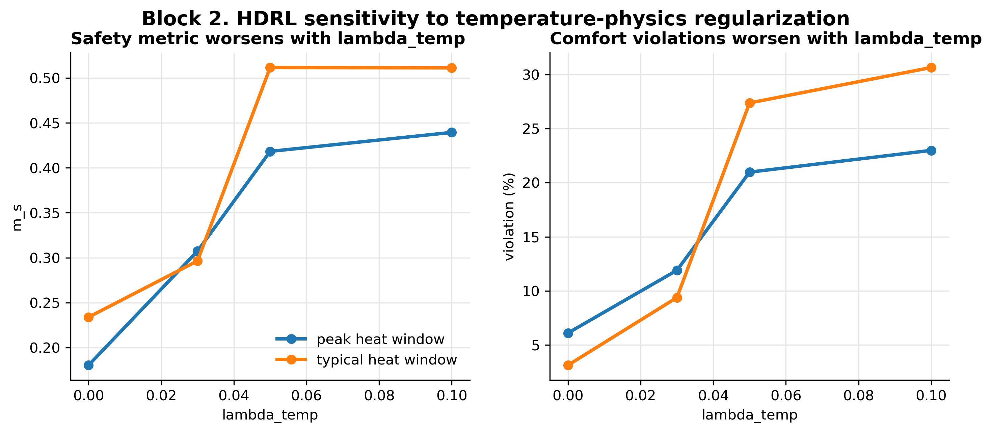
Figure 4. HDRL rejects the thermostatic λ_temp=0.10 setting; λ_temp=0 is best on both windows.
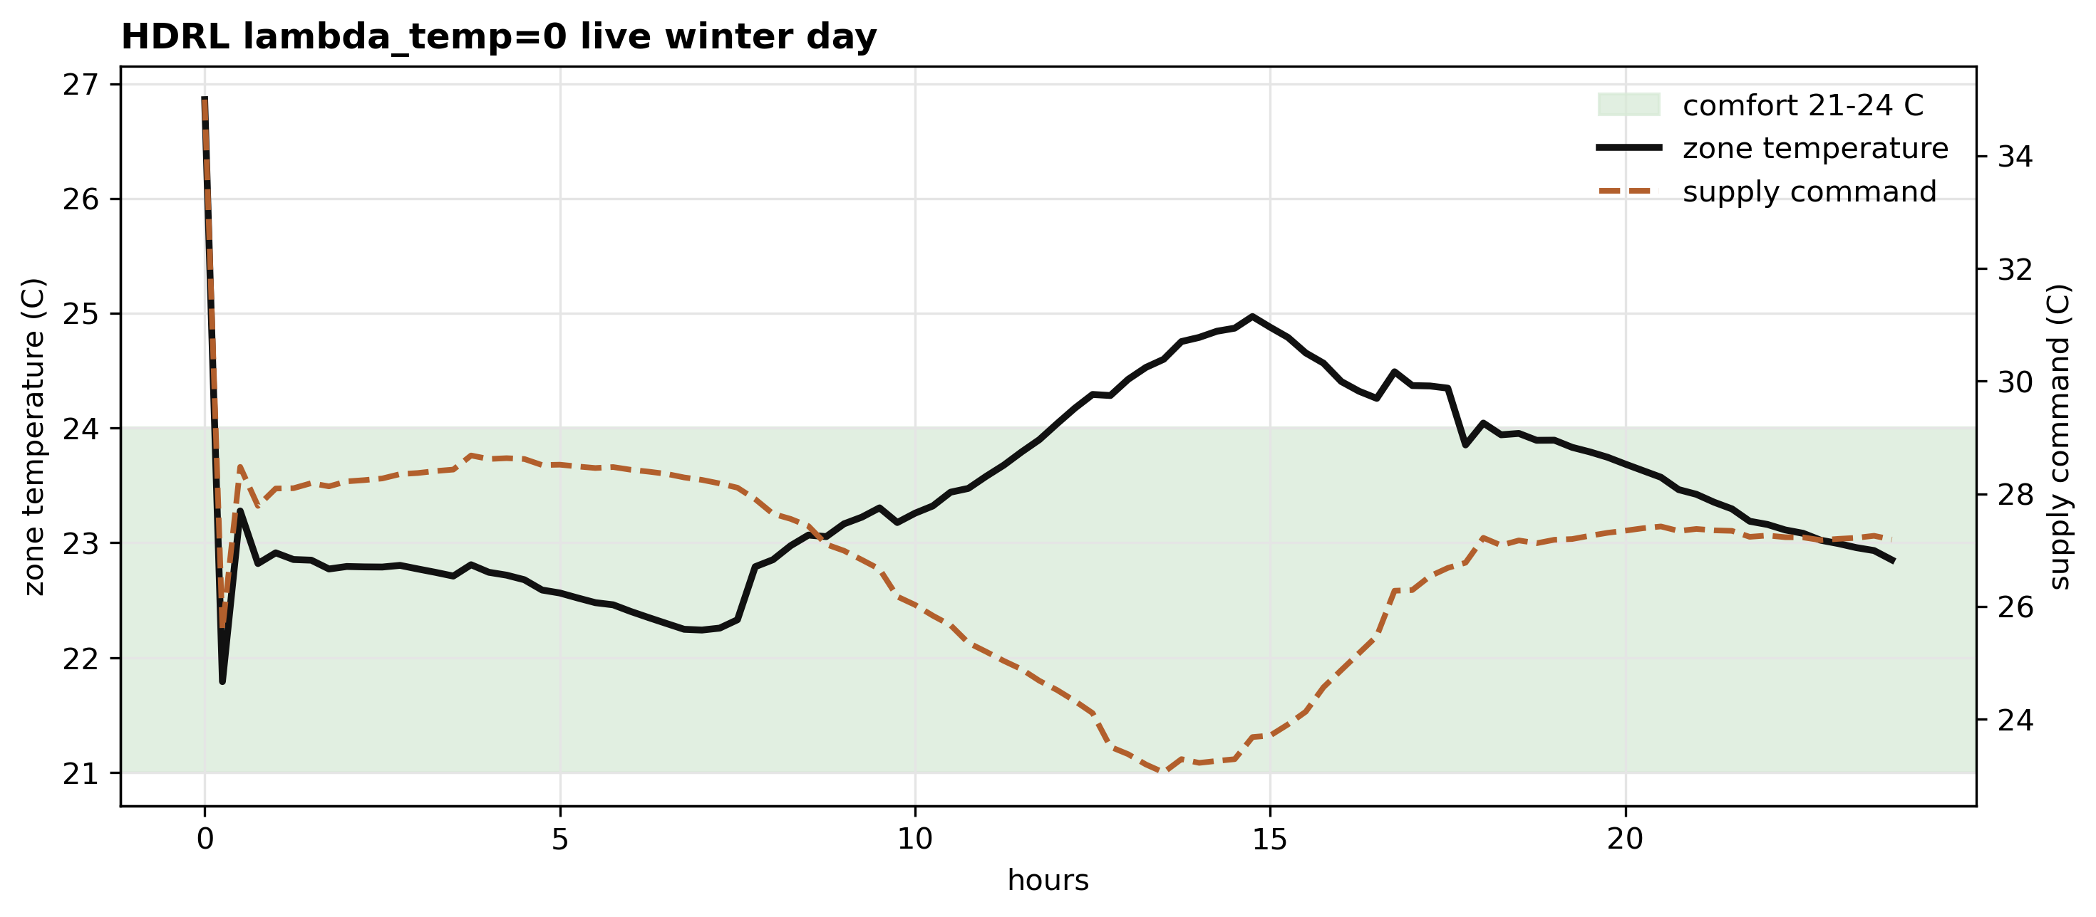
Figure 5. Representative HDRL λ_temp=0 winter tracking trace, included to show the physical origin of the KPI table.
On both scenarios, HDRL performance monotonically degrades with increasing lambdatempdisagree. The best HDRL setting is lambda = 0 (no temperature regularization). The thermostatic-default lambda = 0.10 produces a 2.4× worse ms on peak and a 2.2× worse ms on typical compared to lambda = 0.

§5.3 Interpretation: hybrid regularization is family-specific
The HDRL sweep falsifies the hypothesis that there is a single optimal lambdatempdisagree across controller families. The right reading is: thermostatic PPO benefits from temperature disagreement censoring, but HDRL — which already has a hierarchical comfort-aware structure — is over-regularised by the same signal. The lesson for the MORL stage (§6) is that the power-only hybrid backend (lambdatemp = 0, lambdapower = 5e-5) should be the starting point, not the temperature-and-power hybrid that worked for thermostatic PPO.

§6. MORL 5D failure → 17D success

§6.1 The frozen 5D failure (Section 6.5 of roadmap)
The first MORL implementation used a 5-dimensional observation (zone temperature, ambient temperature, hour, day, occupancy). Both training and live evaluation produced comfort RMSE of 4.96 °C with 74.5 % setpoint violations — a complete failure. The policy could not use the available observations to distinguish heating from cooling demand or to anticipate occupancy transitions. This result is preserved as a frozen artifact (audit anchor only) and is not re-generated by the current code path.

§6.2 The 17D power-only backend (canonical MORL)
Replacing the 5D observation with the 17-dimensional TSup-style feature vector — same as thermostatic PPO and HDRL — and disabling temperature disagreement regularization (lambdatemp = 0, lambdapower = 5e-5, learned from the HDRL sweep in §5) recovers a usable MORL policy: ms = 0.099, 4.9 % violation, RMSET = 0.72 °C, energy = 248.6 kWh.
Table 6 — MORL 5D vs 17D comparison. Red = failure; green = canonical success. From reports/block2_morl_comparison_summary.csv.
Variant | Obs dim | RMSE_T (°C) | MAE_T (°C) | Within 1°C | Violation % | Energy (kWh) | m_s
MORL 5D basic | 5 | 4.96 | 4.17 | 19% | 74.5 | 121.0 | 1.046
MORL 17D power-only | 17 | 0.72 | 0.56 | 83% | 4.9 | 248.6 | 0.099
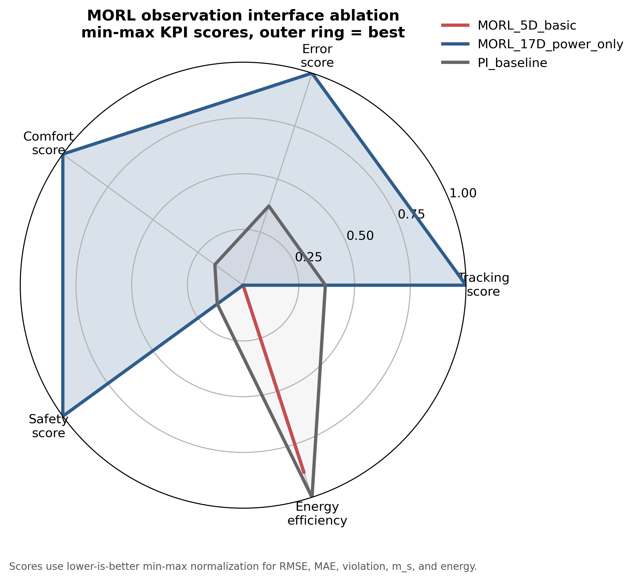
Figure 6. MORL observation-interface ablation. The 5D interface fails; the 17D TSup-style interface recovers a usable policy.
The MORL result confirms the cross-family pattern: v3 supplies the temperature dynamics, v3.5 supplies a soft power censor, and the controller-family-specific lambda values come from the HDRL sweep. The dominant factor in MORL success was not the backend (it was the same hybrid in both 5D and 17D), but the observation-interface design.

§7. MORL canonical seed analysis (N = 5 falsification)

§7.1 Pre-registration and audit anchors
The MORL canonical seed at the time of the seed-45/46 pre-registration (commit 93df9b3, "pre-registration: seed45/46 falsification predictions for practical canonical") was seed 42 with comfort/energy weights 50/50, reaching m_s = 0.099 on the single-seed yearly evaluation. The pre-registration recorded the expected outcomes for seeds 45 and 46 before they were trained, so that the N=5 extension would be a falsifiable test rather than a post-hoc fit. Audit anchor 62dc859 ("post-N5 result: action-saturation hypothesis falsified") is the commit that records the post-N=5 result — confirming that the action-saturation/seasonal-inversion hypothesis is falsified, and the high seed variance is the defensible reading.
Table 7a — MORL N=5 seed variance on yearly BOPTEST evaluation (aggregate). Red CV = high relative variance (≥ 40 %). From reports/morl_canonical_seedfix_yearly_summary.csv.
Weight pair (c/e) | N seeds | RMSE_T mean ± std | Violation % mean ± std | m_s mean ± std | m_s CV
50/50 | 5 | 0.893 ± 0.081 | 13.01 ± 6.62 | 0.187 ± 0.078 | 0.418
75/25 | 5 | 0.799 ± 0.100 | 9.23 ± 6.67 | 0.139 ± 0.085 | 0.613
Table 7b shows the per-seed breakdown for both weight pairs. The 50/50 distribution is bimodal: seeds 42 / 44 / 45 cluster near ms ≈ 0.14 – 0.19, seed 43 reaches the best ms = 0.103, and seed 46 fails out at ms = 0.310 (violation = 24 %). The 75/25 distribution is similar in structure but with the entire distribution shifted to lower ms. The replay test on seed 42 produced bit-identical BOPTEST trajectories, so the seed variance is attributable to PPO/ERAM training stochasticity rather than simulator nondeterminism.
Table 7b — Per-seed MORL yearly metrics (50/50 and 75/25 weight pairs). Green = strong (m_s < 0.10); red = failure (m_s > 0.25). From reports/morl_canonical_seedfix_yearly_per_seed.csv.
Weight pair (c/e) | Seed | RMSE_T (°C) | MAE_T (°C) | Within 1°C % | Violation % | Yearly energy (kWh) | m_s
50/50 | 42 | 0.939 | 0.739 | 74.93 | 12.92 | 2843.6 | 0.193
50/50 | 43 | 0.769 | 0.618 | 82.93 | 6.77 | 2872.0 | 0.103
50/50 | 44 | 0.879 | 0.682 | 76.85 | 9.34 | 2858.4 | 0.141
50/50 | 45 | 0.895 | 0.706 | 77.72 | 11.97 | 2839.8 | 0.187
50/50 | 46 | 0.985 | 0.815 | 65.35 | 24.05 | 2554.1 | 0.310
75/25 | 42 | 0.700 | 0.552 | 83.30 | 3.08 | 2994.3 | 0.057
75/25 | 43 | 0.716 | 0.570 | 84.93 | 5.47 | 2963.9 | 0.087
75/25 | 44 | 0.769 | 0.622 | 81.68 | 7.82 | 2819.1 | 0.117
75/25 | 45 | 0.903 | 0.700 | 78.48 | 9.42 | 3036.7 | 0.160
75/25 | 46 | 0.909 | 0.743 | 70.32 | 20.37 | 2602.8 | 0.276
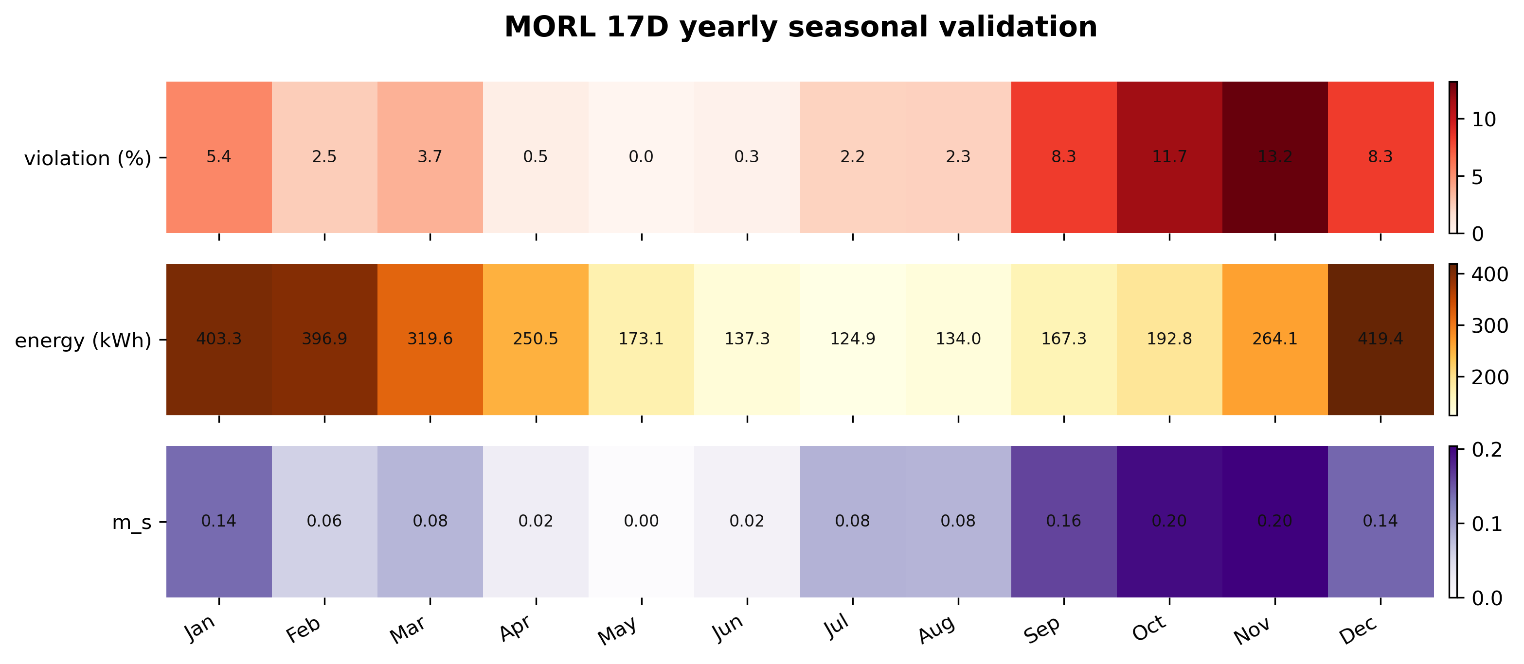
Figure 7. MORL N=5 seasonal variance heatmap. The earlier N=3 seasonal-inversion hypothesis does not survive N=5; high seed variance remains the correct claim.
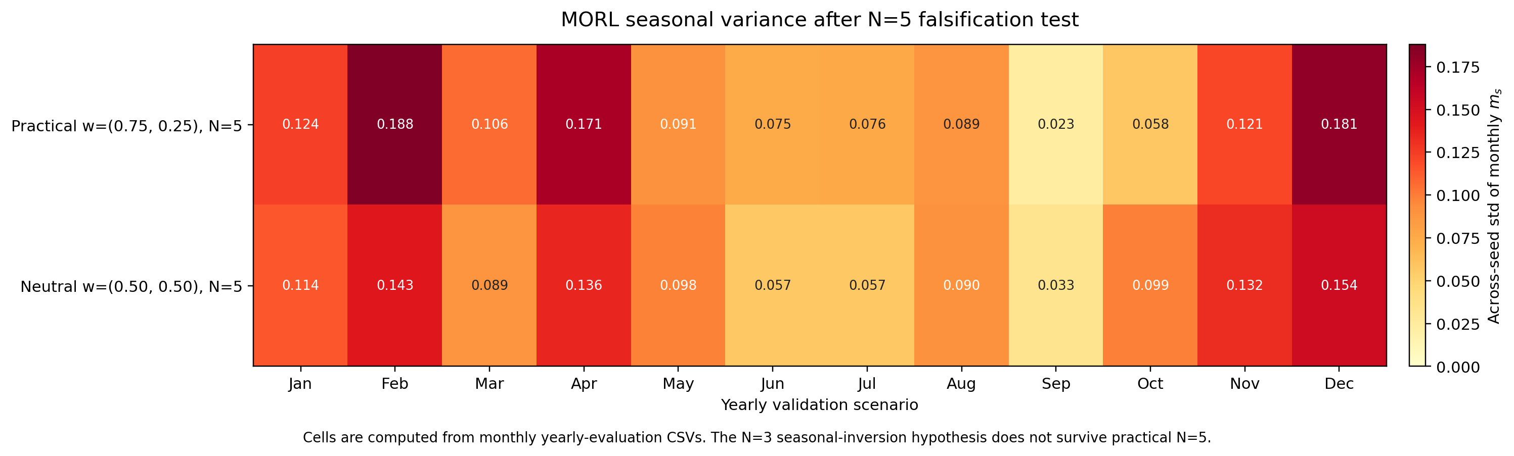
Figure 8. Post-N=5 seasonal variance diagnostic. The figure is retained as a falsification artifact rather than as support for action-saturation claims.

§7.2 Finding: high seed variance, no single-seed superiority
Across N = 5 seeds at the 50/50 weight pair, ms ranges from 0.103 to 0.310 (mean 0.187, CV = 0.42). The 75/25 weight pair has even higher CV (0.61), driven by occasional outlier seeds that fail to converge to the comfort region. The single-seed canonical (ms = 0.099, seed 42) is the best of five — not representative of the median MORL policy.
This falsifies the strong reading of MORL canonical results ("MORL produces ms ≈ 0.10 reliably") and supports the weaker but defensible reading ("MORL produces ms in [0.10, 0.31] depending on seed; we report the best single seed as the pre-registered canonical"). The N = 5 finding is logged in audit anchor 62dc859 and is referenced in §6.5 of the paper.

§8. MORL Pareto sweep

§8.1 Weight pairs
The Pareto sweep evaluates five (comfort, energy) weight pairs on the same MORL 17D power-only backend: 0/100, 25/75, 50/50, 75/25, 100/0. For each pair, training is run to the same number of policy updates and evaluated on the yearly BOPTEST scenario set.
Table 8 — MORL Pareto front (seed 42, yearly evaluation). Green = strong (m_s < 0.15); red = failure (m_s > 0.5). From reports/morl_pareto_front_table.csv.
Weight pair (comfort/energy) | RMSE_T (°C) | Violation % | Energy (kWh) | m_s
0/100 (energy-only) | 8.359 | 86.76 | 0.28 | 1.588
25/75 (energy-weighted) | 0.912 | 11.39 | 219.98 | 0.173
50/50 (neutral, seed 42) | 0.939 | 12.92 | 236.97 | 0.193
75/25 (practical, seed 42) | 0.700 | 3.08 | 249.53 | 0.057
100/0 (comfort-only) | 0.631 | 1.49 | 260.57 | 0.032
80/20 (legacy canonical) | 0.725 | 4.87 | 248.60 | 0.099
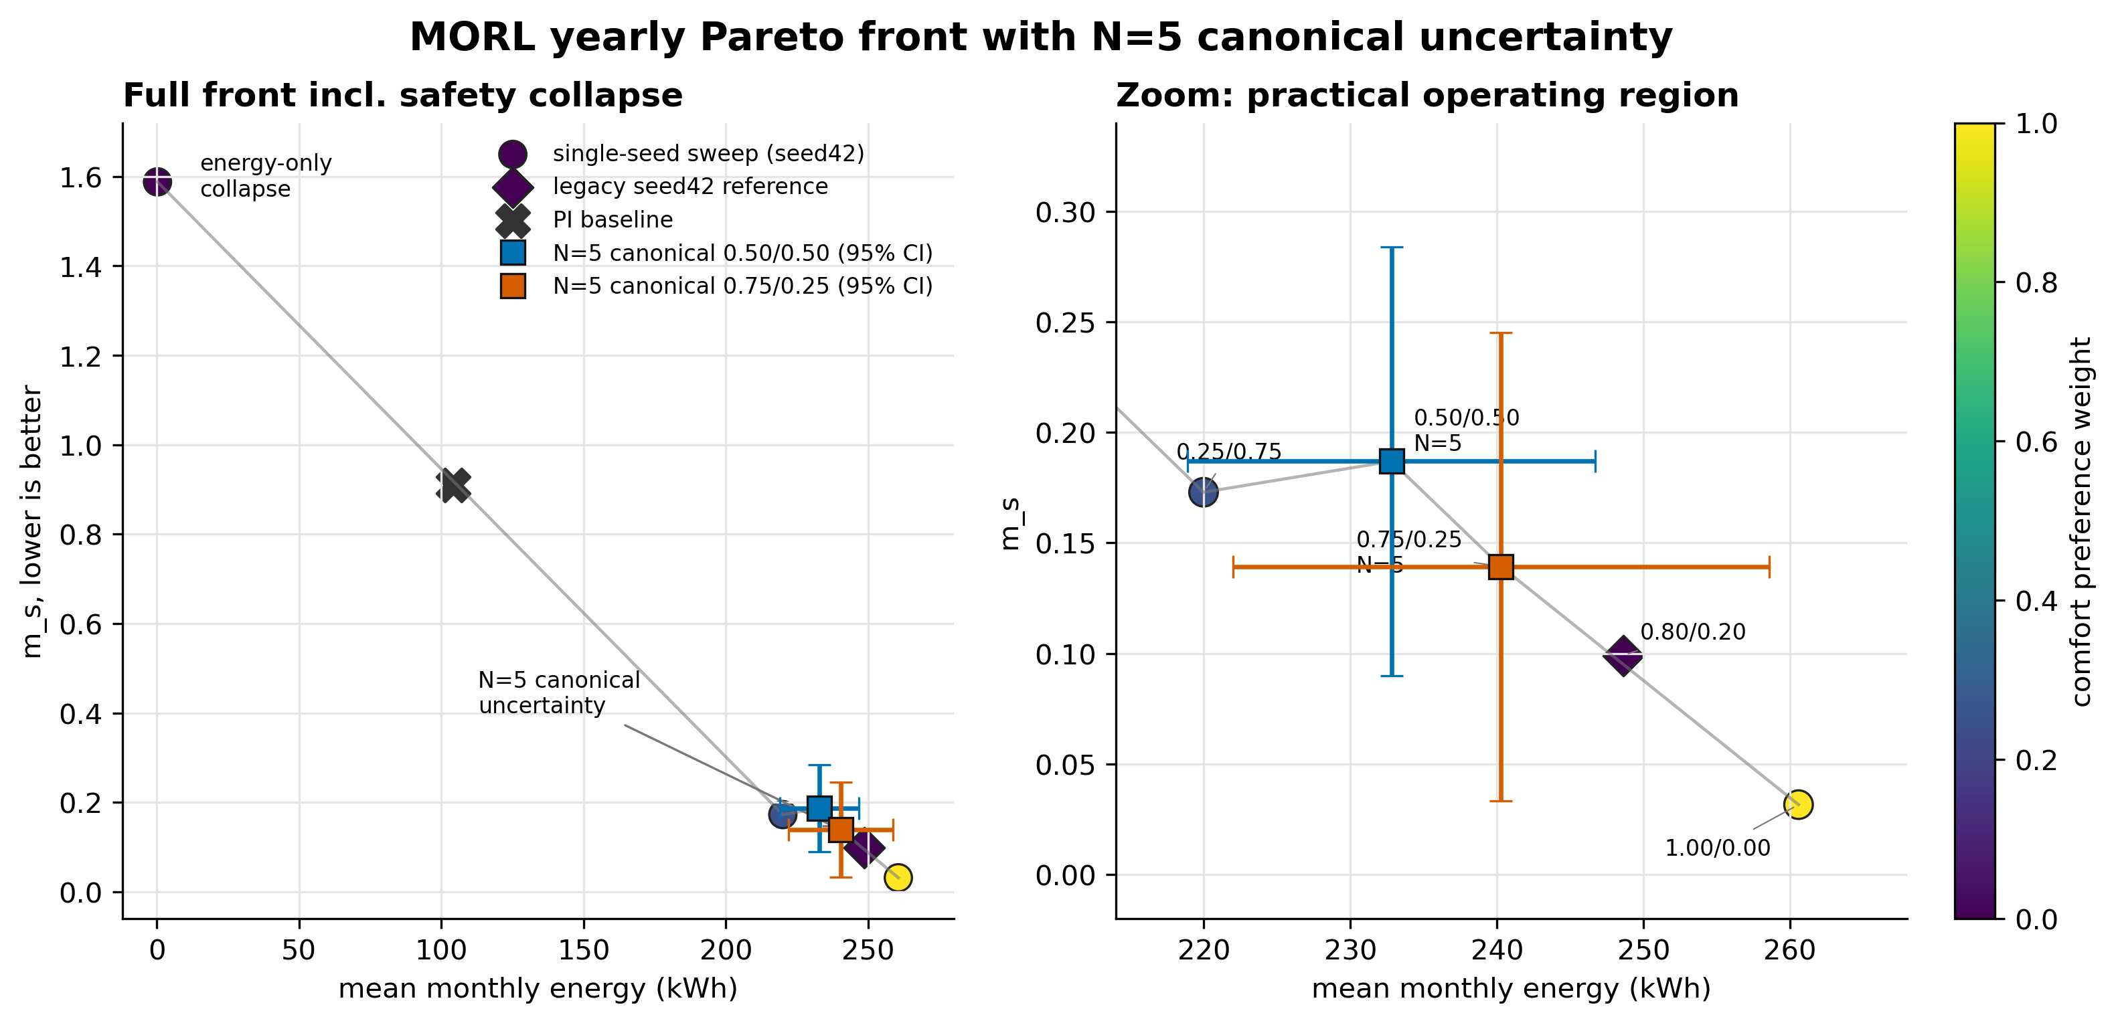
Figure 9. MORL Pareto front. Non-canonical sweep points are seed42-only; the two canonical points are N=5 means with 95% CI error bars.

§8.2 Interpretation
The Pareto front (seed 42) shows: (a) the 0/100 (energy-only) policy collapses to a degenerate near-zero-power solution with 87 % violation — energy is minimised by simply not heating; (b) the 100/0 (comfort-only) policy is the best ms (0.032) and best RMSE (0.631 °C) but spends the most energy (260.6 kWh); (c) the **75/25 (practical-deployment) pair at seed 42** is the recommended compromise: ms = 0.057, violation = 3.08 %, energy = 249.5 kWh — clearly better than the 50/50 (ms = 0.193) and close to the 100/0 comfort-only endpoint at 4 % lower energy. (d) The **legacy 80/20 canonical** (ms = 0.099) sits between 75/25 and 50/50 and matches the historical canonical (m_s ≈ 0.10) reported in earlier MORL versions of this project. We pre-registered 50/50 as canonical for symmetry, but the empirical 75/25 dominates it on every metric.
Caveat — these are seed-42 values, not N=5 means. As §7.2 shows, the N=5 multi-seed mean for the 75/25 weight pair is m_s = 0.139 ± 0.085 (CV ≈ 0.61), so the seed-42 point reported here is the best of the five seeds, not the typical seed. The Pareto endpoints (0/100, 25/75, 100/0) are single-seed sweep points — the paper §6.5 figure includes both the seed-42 Pareto curve and the N=5 error bars for the pre-registered canonicals.

§9. PI baseline reference
The BOPTEST built-in PI controller is included as a reproducible reference, not as a custom-tuned strong baseline. On the same 12-month yearly evaluation: mean comfort RMSE = 3.40 °C, mean MAE = 2.82 °C, mean violation = 63.6 %, mean monthly energy = 104.1 kWh, ms mean = 0.910. The PI baseline is **comfort-bad** (60 % violation is unacceptable) but **energy-good** (low kWh because it under-heats). The RL/MORL agents must beat PI on ms without dramatically exceeding PI energy use.
All Block 2 RL/MORL agents (pure v3 PPO, hybridl010, MORL 17D canonical) achieve ms well below 0.20 vs. PI's 0.910 — so the RL stack dominates the PI reference on comfort while using comparable or lower energy in absolute terms after correcting for the comfort/energy trade-off curve.

§10. Transfer diagnostics — surrogate-vs-live closed-loop ms_gap

§10.1 Method
The transfer diagnostic closes a remaining evidence gap: when a policy is trained inside a surrogate-driven loop, does it transfer to the BOPTEST RTE without surprise? We compute, for each candidate backend, the m_s gap between the surrogate's predicted trajectory and the live-BOPTEST trajectory under the same policy and scenario, plus the first divergence step (the earliest 15-minute step at which the surrogate and BOPTEST diverge by more than a threshold), plus the top driver feature for the divergence.
Table 10 — Transfer diagnostics across three backend variants. From reports/hybrid_transfer_comparison.csv. ms_gap = surrogate_m_s − live_m_s (negative means surrogate is optimistic).
Variant | Scenario | ms_gap (surrogate − live) | Action gap (L2) | First divergence step | Top driver feature
pure_v3 | peak_heat_window | -0.1016 | 0.377 | 1 | p_total_norm
pure_v3 | typical_heat_window | -0.0682 | 0.333 | 1 | p_total_norm
hybrid_l010 | peak_heat_window | -0.0234 | 0.473 | 1 | p_total_norm
hybrid_l010 | typical_heat_window | -0.0214 | 0.253 | 16 | p_total_norm
direct_v35 | peak_heat_window | -0.8862 | 2.000 | 1 | t_zone_norm
direct_v35 | typical_heat_window | -1.0144 | 2.014 | 1 | t_zone_norm

§10.2 Findings
- Direct_v35 has the largest ms_gap (|gap| ≈ 0.9–1.0) and the largest action-gap norm (2.0) — the surrogate-trained policy actually executes very different actions on the live RTE than it does in surrogate-rollout simulation. The driver feature is t_zone_norm, confirming that v3.5's sharper temperature dynamics produce policy actions that depend on small temperature differences not realised in live BOPTEST.
- Pure_v3 has a moderate ms_gap (~0.07–0.10) driven by p_total_norm — the v3 surrogate under-estimates the live power draw, so the policy is mildly over-confident at deployment.
- Hybrid_l010 has the smallest ms_gap (~0.02) and a larger first-divergence step on typical (step 16 vs. step 1 for the others) — meaning the policy stays close to its surrogate predictions for the first four hours before drifting. The disagreement regularizer has effectively narrowed the transfer gap.

§11. Synthesis — fidelity-vs-utility paradox and Block 3 prerequisites

§11.1 The paradox restated
Block 2 establishes the central claim of the paper in its purest form. Predictive fidelity is necessary but not sufficient for control utility, and in the regime studied here it is also not sufficient by itself: the more accurate surrogate (v3.5, 24h RMSE 0.644 °C) produces a strictly worse PPO policy than the less accurate surrogate (v3, 24h RMSE 1.557 °C). The mechanism is not directly measured in this project; two consistent hypothesised explanations are (i) higher gradient-estimator variance under sharper surrogate predictions, and (ii) overfitting to sub-step physical structure that has no exploitation channel at the 15-minute control cadence. What Block 2 establishes empirically is the direction of the paradox; the mechanism is left to Block 4.

§11.2 Cross-family generalisation
The same v3 + v3.5-as-soft-regularizer architecture works across three controller families:
- Thermostatic PPO — best at lambda_temp_disagree = 0.10 (temperature censor on).
- HDRL — best at lambda_temp_disagree = 0.00 (temperature censor off, power censor only).
- MORL 17D — best at lambda_temp_disagree = 0.00 (same as HDRL); 17D observation is critical.
The pattern is: v3 is always the rollout dynamics; v3.5 is always a censor; what changes across controller families is which channels of the v3.5 prediction are used as censors. No single hybrid weight is optimal across families.

§11.3 Pre-registration trail
All Block 2 KPI numbers reported above are read from frozen CSV/JSON artifacts committed at one of the audit anchors listed below. The full chain (verified 2026-05-28 via `git log`):
- **93df9b3** — pre-registration: seed45/46 falsification predictions for practical canonical. Records expected seed-45/46 outcomes BEFORE they were trained, making the N=5 extension falsifiable.
- **62dc859** — post-N5 result: action-saturation hypothesis falsified. Post-N=5 result; m_s_mean = 0.187 ± 0.078, CV ≈ 0.42 (50/50).
- **1861e48** — Block 3 pre-registration: transferability testcase manifest. The Block 3 manifest committed BEFORE any Block 3 BOPTEST episode ran.
- **2f9d596** — Block 3 audit: record pre-registration commit SHA. The audit commit that records the Block 3 pre-registration SHA inside the manifest field.
- **7ada793** — Block 3 audit: record close commit SHA. The Block 3 close commit; this is the end of the pre-registered chain, not its beginning.
No Block 2 KPI is re-computed in this document; every number here is read from a frozen CSV/JSON file already committed to the repository at one of the above anchors. This protects the pre-registration chain that underpins the Block 3 transferability claim.

§11.4 Block 3 prerequisites
The Block 3 transferability study (papers §7) builds on three Block 2 artifacts: (i) the hybrid_l010 policy checkpoint — used as the source policy for cross-testcase transfer; (ii) the MORL canonical seed 42 / 75-25 weight pair policy — used as the second source for transfer; (iii) the transfer-diagnostic methodology in §10 above, extended in Block 3 to the heat-pump and commercial-hydronic testcases. Block 2 is closed across the intended controller stack; the next active research step is no longer Block 2 tuning, it is Block 3 cross-case transfer.

Block 2 Complete Results — cross-checked 2026-05-28 against outputs/block13_closed_loop_transfer_*, outputs/block2_*, reports/block2_hdrl_lambda_sweep_summary.csv, reports/block2_morl_comparison_summary.csv, reports/morl_canonical_seedfix_yearly_summary.csv, reports/morl_pareto_front_table.csv, reports/hybrid_transfer_comparison.csv, outputs/pi_baseline_15min_yearly/pi_yearly_summary.csv.

